- Introduction

This assignment investigates Multiple access problem and different algorithms to solve the situation. Multiple access problem is the problem of multiple devices trying to use same medium to transfer data. All code and original files are viewable here: https://github.com/jepuli124/WirelessCommunicationCourse
- Task 1: Random access and collisions
Code snippet:
for N = NumberOfDevices % different devices amount
idleList = [];
succList = [];
collList = [];
for M = NumberOfTimeSlots %choosing different amount of timeslots
timeSlotList = []; % creating the timeSlotList
for index = 0:M
timeSlotList(index+1) = 0;
end
for deviceNumber = 0:N % devices choose random slot to use
randomM = randi(M);
timeSlotList(randomM) = timeSlotList(randomM) + 1;
end
idles = 0; % counts idle states
succ = 0; % counts succ states
colls = 0; % counts colls states
for timeSlot = 1:length(timeSlotList) %counting states
if(timeSlotList(timeSlot) == 0)
idles = idles + 1;
end
if(timeSlotList(timeSlot) == 1)
succ = succ + 1;
end
if(timeSlotList(timeSlot) > 1)
colls = colls + 1;
end
end
Result, success state are similar to slotted AHOLA’s success curve:
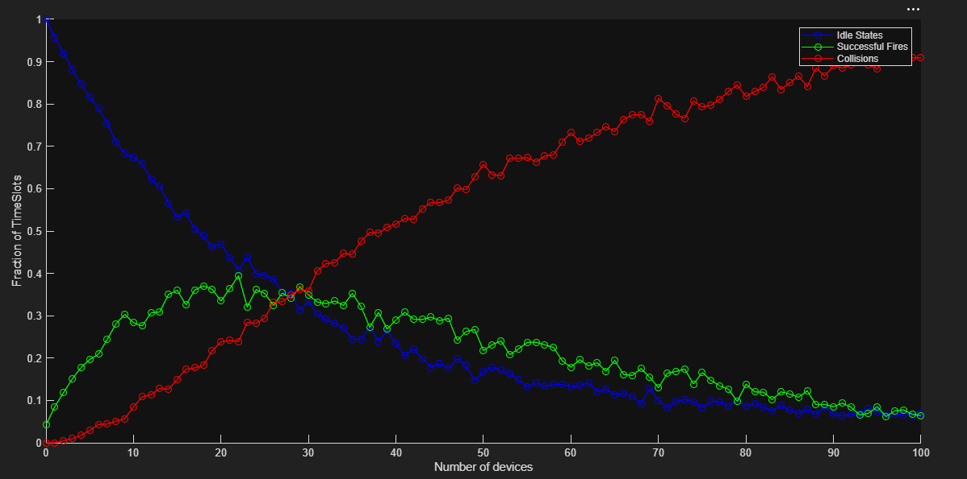
Why does the number of successful slots first increase and then eventually stop improving or degrade? Since number of collisions increase preventing successful ones.
Why do collisions become dominant at high load? More devices try to use the shared medium at the same time.
What is the effect of increasing the number of available slots M? More idle and succesful slots appear while collisions decrease.
How does this relate to random access in wireless systems? It simulates devices trying to access shared medium randomly.
- Task 2: ALOHA throughput
S_pure=Ge^(−2G) and S_slotted = Ge^(−G) are similar but pure’s output S declines faster than Slotted’s when input G grows.

Matlab Code and their output:
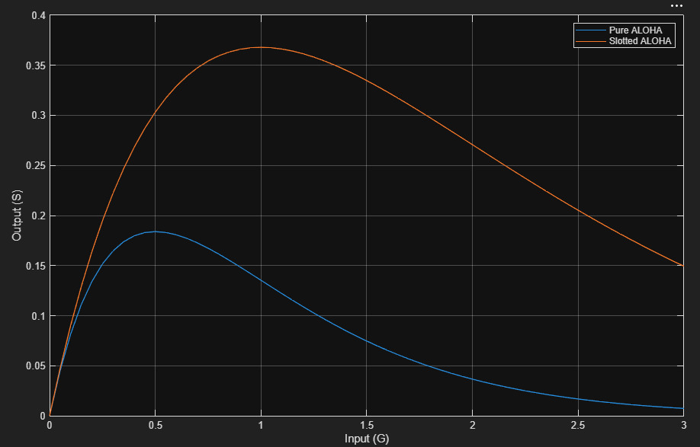
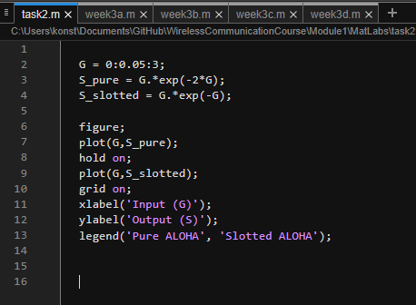

Slotted performs way better than pure and yet at its best it can only succesfully transmit ~0.368 packages per packet time.
* What does G represent?
- How many attempted transmissions per packet time devices are trying to put through ALOHA
* What does S represent?
- How many successful transmissions per packet time are getting through ALOHA.
* At approximately what value of G is the throughput maximized for pure ALOHA?
- From matlab: G = 0.5
* At approximately what value of G is the throughput maximized for slotted ALOHA?
- From matlab: G = 1
* Why does slotted ALOHA perform better than pure ALOHA?
- Slotted access reduces the vulnerable period
* What is the practical limitation of using this simple mathematical model?
- Devices might sent a lot in burst and then be idle for long. Hence, the mathematical model predicts constant usage which is rarely reality.

- Task 3: TDMA scheduling
  - Frame/slot explanation.
  - MATLAB result.
  - Interpretation.
In TDMA, each device gains a equal sized slot in a frame which is a slot amount times time for a slot. Code snippet that check if the slot is used or not:
devicesProbability = 0.2:0.05:1;
numberOfDevices = 0:50;
UsedSlotsList = [];
UnUsedSlotsList = [];

for P = devicesProbability
usedSlots = 0;
unUsedSlots = 0;
for N = numberOfDevices
if(rand() < P)
usedSlots = usedSlots + 1;
else
unUsedSlots = unUsedSlots + 1;
end
end
UsedSlotsList(end + 1) = usedSlots/N;
UnUsedSlotsList(end + 1) = unUsedSlots/N;
end
result:
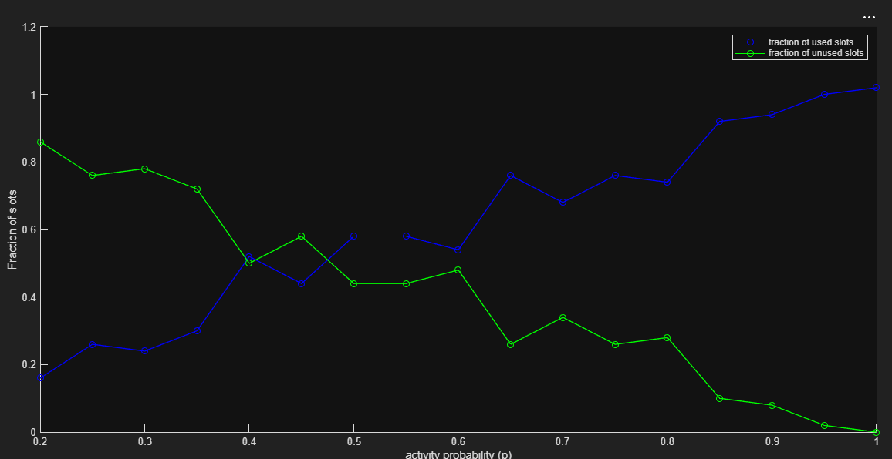
What is the relation between a frame and a slot? A frame is a slot amount times time for a slot
Why does TDMA reduce collisions? No devices should be accessing the shared medium at the same time
Why can TDMA waste resources when traffic is sparse? Devices that do not have something to send waste their slot.
For what type of application is TDMA attractive? Industrial communication that needs reliable and consistent access to shared medium
For what type of application might TDMA be inefficient? Personal usage where need for shared medium comes in bursts.
- Task 4: Scenario comparison
Scenario: industrial robot control with CSMA/CA and scheduled TDMA. CSMA/CA was chosen so devices wouldn’t talk over each other. TDMA was chosen for it’s simplicity to simulate.
Parameters: Number of devices, how many rounds it takes, allowed time to sent in scheduled, data transfare rate, probability to activate, amount of data needed to be sent.
Assumptions: If device has nothing to send, it is satisfied. 1 data is transfared in 1 time unit. 1 slot is 1 time unit. Scheduled has 1 unit of time per frame for overhead. Each device has 1 data to be sent, the higher this is, the better random random than scheduled, but likely robots have constant data flow. I assume that devices use same amount of energy regardless is they are active or not.
Limits: Too many calculation for my computer to handle thus the range in numbers is smaller than I had hoped. CSMA/CA is also simulated as slotted to improve the efficiency of the simulation.
code snippet, in slotted random, this asks each device if they wish to use the shared medium and if a successful fire happened it is stored in device progress, then it checks if all devices are succeeded:
allDevicesNOTSatisfied = true;
while allDevicesNOTSatisfied
DevicesTryingToFireOf = [];
for device = 1:N
if(rand() <= P)
DevicesTryingToFireOf(end + 1) = device;
end
end
if(length(DevicesTryingToFireOf) == 1)
deviceNumber = DevicesTryingToFireOf(end);
deviceProgress(deviceNumber) = 1;
roundTime = roundTime + D;
if(~ismember(0, deviceProgress))
allDevicesNOTSatisfied = false;
end
end
end
result:
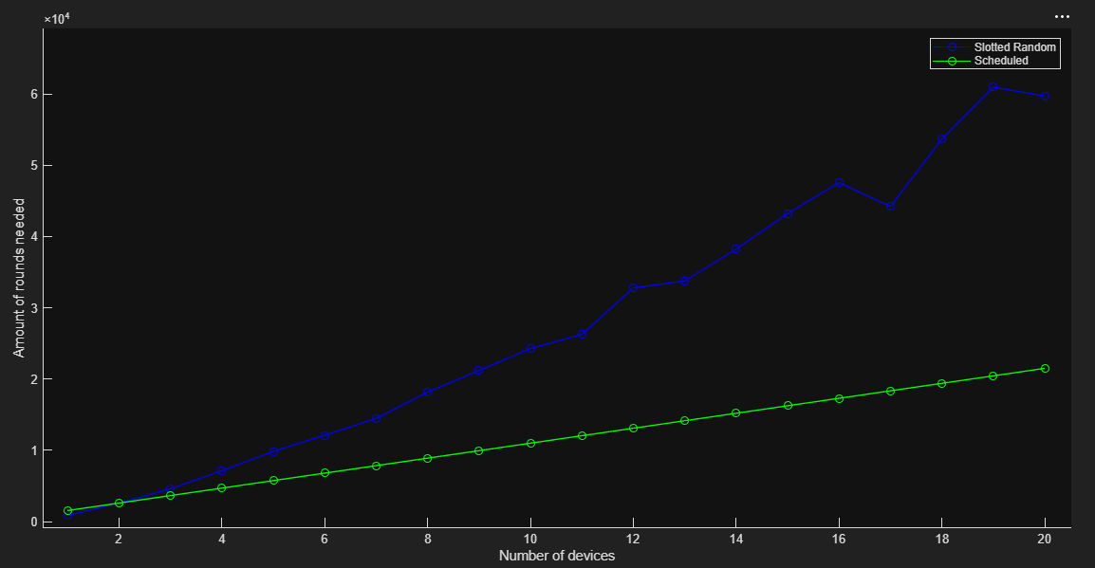
Slotted CSMA/CA is faster when there is only 1 device, equvalent with 2 devices and loses if there is more devices constantly sending data.

Which method gives better resource utilization in your scenario? TDMA
Which method gives more predictable access? TDMA
Which method is more scalable? TDMA
Which method is more energy-efficient under your assumptions? TDMA
Which method would you recommend for your selected application? TDMA
- Task 5: Conceptual comparison
Method | Seperation | Advantage | Limitation | Example Application
Random access | By Change | Low to No overhead | Collisions | Wi-Fi
FDMA | By frequency | Shared medium can be used by multiple devices at the same time | Wastes frequencies if no data is sent | Radio phones
TDMA | By time | Equal access to shared medium | Wastes time if no data is sent | When consistent data flow is must have, Industrial machines
CDMA | By code | Shared medium can be used by multiple devices at the same time | Wastes code if no data is sent | Multiple devices need constant data flow, Smart meters
OFDMA | By frequency and time | Shared medium can be used by multiple devices at the same time while limiting time usage. | Complex overhead | Cellular broadband

- Reflection on AI use
I used AI in these tasks. It was used to understand how matlab works.

Used model: Brave’s Leo AI. (Matlab has the auto fill in but is it AI? Anyway it sucks in its purpose.)

Used prompts:
(task 1):
matlab list has element
matlab if not
matlab add to list
matlab list length
matlab array start index (WHY IS IT 1!)
(task 2, done before task 1):
how e can be expressed in matlab
how G = 0:3 can be done with 0.1 steps
How to plot multiple curves into single figure

All these were checked in matlab do they work.

I learned to use matlab.
matlab array start index is 1 and I hate it.

