Estimation and inference for step-function selection models in meta-analyses with dependent effects

James E. Pustejovsky1, Martyna Citkowicz2, and & Megha Joshi2

1 University of Wisconsin-Madison
2 American Institutes for Research June 23, 2026

Author Note

Correspondence concerning this article should be addressed to James E. Pustejovsky, 1082C Educational Sciences, 1025 W Johnson St. Madison, WI 53706-1706. E-mail: pustejovsky@wisc.edu

Abstract
Meta-analyses in social science fields face multiple methodological challenges arising from how primary research studies are designed and reported. One challenge is that many primary studies report multiple relevant effect size estimates, leading to a data structure with dependent observations. Another is selective reporting bias, which arises when the availability of study findings is influenced by the statistical significance of results. Although many selective reporting diagnostics and bias-correction methods have been proposed, few are suitable for meta-analyses involving dependent effect sizes. Among available methods, step-function selection models are conceptually appealing and have shown promise in previous simulations, but tend to understate uncertainty in parameter estimates if dependent effects are ignored. We study methods for estimating step-function models from data involving dependent effect sizes, focusing specifically on estimating parameters of the marginal distribution of effect sizes and accounting for dependence using cluster-robust variance estimation or bootstrap resampling. We describe two estimation strategies, demonstrate them by re-analyzing data from a previous synthesis on ego depletion effects, and evaluate their performance through an extensive simulation study under both univariate and multivariate selection processes. Simulation findings indicate that selection models provide low-bias estimates of average effect size and clustered bootstrap confidence intervals provide acceptable coverage levels for meta-analyses with at least 30 studies. Although unadjusted estimates are more efficient when selective reporting is absent or minimal, the proposed methods provide a robust and useful approach for evaluating the potential biases arising when selective reporting is present in meta-analyses with dependent effects.
Keywords: meta-analysis; dependent effect sizes; selection models; selective reporting; publication bias

Highlights
What is already known
- Selective reporting of primary study results can distort the findings from meta-analyses.

- In many fields of application, meta-analyses include primary studies providing multiple, statistically dependent effect size estimates.
- Step-function selection models are a theoretically appealing tool for correcting bias from selective reporting, but these models were developed for meta-analyses that include only one effect size estimate per study.

What is new
- We examine strategies for estimating step-function selection models in meta-analyses with dependent effect sizes.
- We report a large simulation study demonstrating that step-function models can be estimated using penalized maximum likelihood methods, combined with bootstrapping techniques to account for dependent effect size estimates.

Potential impact for RSM readers
- The proposed estimation methods can be applied to adjust for selective reporting of study results in meta-analyses with 30 or more studies that include dependent effect sizes.
- This strategy complements other existing methods for examining selective reporting bias in meta-analyses with dependent effect sizes.

Estimation and inference for step-function selection models in meta-analysis
with dependent effects
The validity of conclusions from meta-analytic syntheses depend critically on the reporting practices of researchers, journal editors, and peer reviewers. If the findings accessible to meta-analysts are not a representative record of the research that has been conducted on a topic, then meta-analytic summaries may be systematically biased.1 Of particular concern is the possibility that results from primary studies are selectively reported in ways that distort the evidence available for synthesis, such as by reporting findings that are statistically significant but omitting findings that are null or not consistent with researchers’ hypotheses.2,3
Selective reporting practices can occur at the level of the entire study or at the level of a specific finding within a study. At the study level, publication bias occurs when full study reports are withheld from public availability as a function of some aspect of their findings.3,4 Reports with statistical conclusions that support research hypotheses may be more likely to be published than those that do not. At the level of the individual finding, a study that clears the hurdle of publication might still include results for only a subset of analyses conducted or outcome measures examined, leading to outcome reporting bias.4,5
Evidence from medical, educational, and social sciences provides indications of the prevalence of selective reporting. For example, studies have found that statistically significant outcomes were 2.4 to 4.7 times more likely to be published than non-significant outcomes in the medical sciences6 and 2.4 times more likely in education.7 Studies examining various fields, including clinical trials of antipsychotics8, psychology research9,10, management science11, economics, and environmental sciences12, have found widespread selective outcome reporting on the basis of statistical significance.
Because selective reporting is of such central concern for meta-analysis, a wide range

of statistical tools have been developed for detecting its presence and reducing the biases it creates.1,13 One common graphical diagnostic is the funnel plot, a simple scatterplot of effect size estimates versus a measure of their precision.14 Widely used statistical diagnostics include the rank correlation test15; Egger’s regression test16; the trim-and-fill adjustment17; and various regression adjustment methods including the precision effect test (PET), precision effect estimate with standard error (PEESE), PET-PEESE technique18, and endogenous kink meta-regression.19 Another class of methods for assessing and correcting selective reporting are p-value selection models, which build on summary meta-analysis or meta-regression models by making explicit assumptions about how the probability that an effect size estimate is reported relates to the sign and statistical significance level of the effect. Building on earlier proposals,20–22 Vevea and Hedges proposed step-function models where the selection function is piece-wise constant, with steps at fixed significance thresholds.23,24 The step-function model captures simple but plausible forms of selective reporting, such as shifts in selection probability at the psychologically salient thresholds of p = 0.05 or p = 0.01.2,25–27
Step-function selection models have several advantages over other available methods for diagnosing and adjusting for selective reporting bias. First, they are generative models with parameters that directly describe the selective reporting process, making them more interpretable than regression adjustments for small-study effects, which are agnostic with respect to the specific mechanism of selective reporting. Second, they can incorporate both discrete and continuous moderators, enabling one to distinguish between selective reporting bias and systematic differences in effect size that can be predicted by primary study characteristics. Third, findings from simulations indicate that simple forms of step-function models outperform alternative bias adjustment methods when effect sizes are heterogeneous because they allow for the inclusion of a random effect term.28–30
Step-function models also have drawbacks that should be considered. Notably, they

are more complex—and perhaps less intuitive—than regression adjustments or trim-and-fill. The thresholds in the step function must be chosen a priori, and so may not correspond to the true selective reporting process. Furthermore, the models are built on the assumption that the selection process is homogeneous across study features other than statistical significance, such as study size or funding status. Step-function models also require a larger number of effect sizes for accurate estimation of the model parameters, particularly when a more complex (i.e., multiple-step) selection process is assumed. Despite these complexities, the plausible selective reporting process expressed by the step-function model, coupled with its demonstrated performance in past simulations28,31, makes it a promising approach for analyzing and correcting the bias arising from selective reporting.

Dependent effect sizes
The vast majority of the work on selective reporting has focused on methods appropriate for relatively simple summary meta-analyses in which each included study contributes a single independent effect size estimate. This presents a problem for syntheses in education, psychology, and many other areas, where meta-analyses routinely include studies with multiple, dependent effect sizes. Effect size dependencies occur when multiple effect sizes are extracted from the same sample, resulting in statistically dependent estimates. Dependent effect size estimates commonly occur (1) when multiple outcome measures are collected on the same sample; (2) when the same sample is measured over multiple time points; or (3) when multiple treatment groups are compared to the same control group.32 These phenomena lead to estimates with correlated sampling errors, or what we refer to as a correlated effects dependence structure. Dependence can also arise when effect sizes are extracted from multiple samples involving the same operational features, such as multiple studies conducted by the same research group, leading to a hierarchical effects dependence structure.33
Effect size dependencies are very common in social science synthesis, as well as in

other research areas.34 For example, for the more than 1,000 educational intervention studies reviewed by the What Works Clearinghouse since 2017, 73% included more than one intervention effect estimate, with a median of four effect sizes per study (WWC, 2020).
Surveys of systematic reviews on topics in psychology35, education36, environmental sciences37, and neurobiology38 have also documented a high prevalence of dependent effect sizes. Thus, multiple effects are often the norm rather than the exception.
Meta-analysts now have access to an array of methods for summarizing and modeling dependent effect sizes. For hierarchical effects dependence, analysts can apply multi-level meta-analytic models that provide estimates of effect heterogeneity at each of several levels.39,40 For some specific forms of correlated effects dependence such as studies with multiple treatment groups or factorial treatment structure, multivariate meta-analysis methods are available that treat findings from a given study as a vector with distinct dimensions.41–43 However, many instances of dependent effects involve both correlated and hierarchical effects structure; in other instances, the multiple findings reported in some studies do not have a regular dimensional structure; and commonly, the information needed to estimate the correlation structure of effect size estimates is not available in primary study reports.36,44
In circumstances where the exact dependence structure of effects does not fit neatly into multilevel or multivariate models, a technique known as robust variance estimation (RVE)33 has proven to be an attractive strategy. RVE is useful because it provides a means to assess uncertainty in model parameter estimates that does not rely on strong assumptions about the exact dependence structure of the effect size estimates. Instead, RVE involves specifying a tentative working model for the dependence structure, but calculating standard errors, hypothesis tests, and confidence intervals using sandwich estimators that do not require the working model to be correct. RVE can also augment other modeling techniques by specifying working models that capture multiple forms of dependence, as in the

correlated-and-hierarchical effects model proposed by Pustejovsky and Tipton, which allows for correlated effect estimates as well as heterogeneity of true effects both within and across studies.44 A closely related strategy is to use bootstrap re-sampling to approximate the distribution of test statistics.45 However, extant developments in RVE and bootstrapping methods are limited to summary meta-analysis and meta-regression models. Applications to selection models remain to be explored.

Investigating selective reporting with dependent effect sizes
Methodologists have only recently begun to examine selective reporting detection or bias correction methods in meta-analysis involving dependent effect sizes. Mathur and VanderWeele proposed a sensitivity analysis based on the simplest possible form of the step-function selection model, with effect size dependence handled using RVE.46 This sensitivity analysis provides an estimate of the average effect size after correcting for selection with a single, threshold statistical significance level, where the maximum strength of selection is pre-specified by the analyst. This approach is premised on an assumed degree of selective reporting; thus, it does not estimate the strength of selection, nor does it have extensions to more complex step functions with multiple thresholds. Another alternative is to use a regression test for small-study effects, or association between effect sizes and standard errors, combined with RVE or multilevel meta-analysis to handle dependent effect sizes.47,48 This method has limited power to detect selective reporting under common meta-analytic scenarios.48 It also has the same limitations as univariate Egger’s regression, in that it tests for a pattern of small-study effects, which could have causes other than selective reporting.49
Chen and Pustejovsky reviewed a range of existing techniques for estimating average effect sizes in the presence of selective reporting and dependent effect sizes.50 They also proposed adaptations of several existing methods that can be formulated as meta-regressions, such as PET/PEESE and the endogenous kink method, with dependence addressed using a particular working model combined with RVE. In an extensive simulation study, they

examined the performance of proposed adaptations alongside existing methods that ignore effect size dependence, under scenarios where the selective reporting process was consistent with a one-step (α₁ = 0.025) or two-step selection model (α₁ = .025 and α₂ = .500).
Although no single bias-correction method performed best across all conditions examined, simple forms of the step-function selection model emerged as strong candidates. Across a wide range of conditions, one-step and two-step selection models yielded average effect size estimates with low bias that were usually more accurate than alternative bias-adjusted estimators. The strong performance of step-function models may be explained by the alignment between the assumptions of the step-function model and the mechanism used to introduce selective reporting in the data-generating process of the simulations. However, because the step-function models involve the assumption that all effect sizes are independent, confidence intervals generated from the selection models did not have accurate coverage.
These findings underscore the need to further develop selection models that can account for dependent effect sizes.
To address this need, we investigate how to estimate selection models and provide valid assessments of uncertainty in parameter estimates for meta-analyses that involve dependent effect sizes. In applying selection models to datasets involving dependent effects, we propose to model the marginal distribution of the effect size estimates rather than the joint distribution of the dependent effects within each study. This means we model each estimate considered as a single observation, without explicitly accounting for its dependence on other effect sizes from the same study. To account for dependence, we consider
cluster-robust variance estimation and clustered bootstrap inference methods that allow for dependent observations even though it is not directly modeled. This strategy does have the limitation that the model parameter estimates pertain only to the marginal distribution and do not distinguish between selective publication of full studies versus selective reporting of individual outcomes.

Despite this limitation, we believe that the strategy of modeling the marginal distribution is worth pursuing for at least three reasons. First, this strategy captures a plausible form of selection, in which reporting is influenced by the significance level of individual effect size estimates. In contrast, developing a multivariate selection model would require specifying assumptions about the probability that each of many possible subsets of effect sizes are reported or censored. Little past work on reporting practices has considered reporting of multiple findings within a study, so there is currently little empirical basis to support assumptions about multivariate selection processes.∗ Moreover, it seems reasonable to assume that the statistical significance level of individual effect size estimates would still be a major consideration in more nuanced, multivariate selection models.
Second, focusing on the marginal distribution allows for computational tractability, whereas fitting even quite basic multivariate models would require computing selection probabilities over high-dimensional spaces of possible outcomes. Recent work attempting to implement multivariate selection models in a Bayesian framework noted that such models become computationally intractable when primary studies include more than three dependent effect sizes.52
Third, the marginal modeling strategy has several precedents within the meta-analytic and broader statistical literature. For instance, generalized estimating equations often use a “working independence” structure to estimate parameters in
longitudinal data without requiring specification of the joint distribution of the repeated measurements.53 Similarly, the unrestricted weighted least squares approach for
meta-regression relies on marginal modeling to provide a simpler alternative to complex hierarchical structures,54 and pseudo-likelihood estimators for multivariate meta-analysis simplify the problem by focusing on the marginal likelihoods of individual variates.55 Thus,
∗ For one exception, recent work developed a multivariate publication bias model in which full studies are published or censored on the basis of whether a set of multiple effects are all statistically significant.51

we focus on developing marginal step-function selection models as a practical and feasible tool, which could also serve as a building block for more complex multivariate models.
The remainder of the paper is organized as follows. In the next section, we describe the marginal step-function selection model and detail two different strategies for estimating model parameters: one using penalized maximum likelihood estimation methods and a novel strategy based on a re-weighted random effects model with inverse probability of selection weights. We also describe extensions of RVE and bootstrap re-sampling techniques to assess uncertainty in selection model parameter estimates. In the following section, we provide an empirical example that illustrates the methods by re-analyzing data from a previously reported meta-analysis. In subsequent sections, we describe the methods and results from a simulation study that evaluates the performance of point estimators and confidence intervals across a wide range of meta-analytic conditions involving a single-step selection process. In the final section, we discuss findings, limitations, and implications for practice.

Models and Estimation Methods
Step-function selection models involve two components.56 The first component, which we call the evidence-generating process, involves assumptions about the distribution of effect size estimates prior to selective reporting. This component is usually a random effects model or meta-regression model. The second component, which we call the selection process, involves assumptions about how effect size estimates come to be observed and therefore available for inclusion in the meta-analysis. Combining these components leads to a model for the distribution of observed effect size estimates.
We will use the following notation to describe the model and estimation methods. Let Φ() denote the standard normal cumulative distribution function and ϕ() denote the standard normal density function. Consider a meta-analytic sample consisting of J studies, in which study j reports k_{j} effect size estimates. Let y_{ij} denote observed effect size estimate i from study j, defined so that positive values are consistent with theoretical expectations.

Each estimate is accompanied by a standard error σ_{ij} and corresponding one-sided p-value p_{ij} = 1 − Φ(y_{ij}/σ_{ij}), where the one-sided p-value is defined with respect to the null hypothesis that the effect is less than or equal to zero and the alternative hypothesis that the effect is positive. Let x_{ij} be a 1 × x row-vector of predictors that encode characteristics of the effect sizes, samples, or study procedures.

Evidence-generating process
We consider an evidence-generating process based on a conventional meta-regression model. Let Y ∗ denote an effect size estimate that has been generated from primary study data but might or might not be reported; let σ∗, p∗, and x∗ denote the corresponding standard error, one-sided p-value, and predictor vector.∗ The evidence-generating process can then be expressed as
(Y ∗|σ∗, x∗) ∼ N (︂x∗β, τ ² + σ^{∗2})︂ , (1)

where β is an x × 1 vector of regression coefficients that relate the predictors to average effect size and τ ² is the variance of the distribution of effect size parameters. This
random-effects meta-regression treats each observed effect size as if it were independent, even though the data may include multiple, statistically dependent effect size estimates generated from the same sample. As a result, the regression coefficients β describe the overall expected effect size (given the predictors) and the variance parameter τ ² describes the heterogeneity of the marginal effect size distribution, rather than decomposing the heterogeneity into within-study and between-study components.

Selection process
At a general level, a p-value selection process is defined by a selection function, which specifies the probability that an effect size estimate is reported given its p-value. Letting O
∗ We use ∗ to signify variables in the evidence-generating process that might or might not be observed. Variables without ∗ are the corresponding observed quantities.

be an indicator for whether the effect size estimate Y ∗ is observed, the selection process involves the assumption that Pr(O = 1 | p∗) is proportional to a function w (p∗; λ) that maps p-values in the interval [0, 1] to strictly positive weights based upon an unknown H × 1 parameter vector λ = (λ₁, ..., λ_{H}).
Vevea and Hedges24 described a random effects meta-regression model where selection weights vary depending on a set of pre-specified thresholds for the one-sided p-value, chosen based on conventional, psychologically salient cut-offs for judging statistical significance. Let α₁, ..., α_{H} be a set of thresholds for the one-sided p-values, and set α₀ = 0, α_{H+1} = 1, and λ₀ = 1. A step function selection model can be written as

or equivalently as
H
w(p∗; λ) = λ_{h} I (α_{h} < p∗ α_{h+1}) , (2)
∑︂ × ≤
h=0

w(Y ∗, σ∗; λ) = ∑︂ λ_{h} × I (︂σ∗Φ−1 (1 − α_{h+1}) ≤ Y ∗ < σ∗Φ−1 (1 − α_{h}))︂ . (3)
H
h=0

Setting λ₀ = 1 is necessary for identification because the absolute probabilities of selection cannot be estimated. The remaining parameters are therefore interpreted as relative probabilities of selection, compared to the selection probability of a finding with p∗ ≤ α₁.
In practice, meta-analysts will often use only a small number of steps in the selection model. One common choice is the three-parameter selection model, which has a single step at α₁ = .025, as depicted in Figure 1a. With this choice of threshold, positive effects that are statistically significant at the two-sided level of p < .05 have a different probability of selection than effects that are not statistically significant or not in the anticipated direction. Another possibility is to use two steps at α₁ = .025 and α₂ = .500, which allows for different probabilities of selection for effects that are positive but not statistically significant and effects that are in the opposite of the expected direction, as depicted in Figure 1b.

Distribution of observed effect size estimates
Combining the assumptions of the evidence-generating process and the selection process leads to a model for an observed effect size estimate. The marginal distribution of an observed effect size estimate Y with standard error σ is equivalent to the distribution of Y ∗ given that O = 1, with density function

(Y = y|σ, x) =
w (y, σ; λ)
(
1
) × √
ϕ (︄ y − xβ
)︄ , (4)

f A x, σ; β, τ 2, λ
τ 2 + σ2
√τ 2 + σ2

where

(x, σ; β, τ ², λ) = ∫︂
A
R

w (y, σ; λ) × √ 1

ϕ (︄ y − xβ

)︄ dy. (5)

If w(y, σ; λ) = 1 for all possible y, then there is no selective reporting, A(x, σ; β, τ ², λ) = 1, and the density reduces to the unweighted density of a random-effects meta-regression model. The A(x, σ; β, τ ², λ) term can be computed using the expression
τ 2 + σ2
√τ 2 + σ2

H
∑︂
A(x, σ; β, τ ², λ) = λ_{h}B_{h} (6)
h=0
where B_{h} = Φ (c_{h}) − Φ (c_{h+1}) and c_{h} = [σΦ−1 (1 − α_{h}) − xβ] /√τ 2 + σ2 for h = 0, ..., H.24

Estimation Methods
Past developments of selection models have focused on maximum likelihood estimation23,24 or Bayesian estimation under the assumption that all effect sizes are mutually independent57,58 or on sensitivity analysis methods that treat the selection model as known46,59. We consider two estimation strategies that build upon and generalize past approaches, including maximum penalized marginal likelihood and an alternative based on re-weighting the Gaussian likelihood of the evidence-generating process. For purposes of estimation, we write the likelihoods using natural log transformations of the variance parameter and selection parameters, with γ = log τ ², ζ_{h} = log λ_{h}, and ζ = [ζ₁, ..., ζ_{H}]′.

With both estimation approaches, we incorporate prior penalty terms on all model parameters, which regularize the likelihood and markedly improve the convergence properties of the estimation algorithms.60,61 The penalty terms are equivalent to putting independent priors on each element of the parameters.62 Let p_{β}(β), p_{γ}(γ), and p_{ζ}(ζ) denote the log-prior penalties on the corresponding parameters. We describe the specific form of the penalty terms after outlining the estimation methods.
With both estimation approaches, we also allow for incorporation of weights, which permits efficient calculation for a variety of bootstrapping techniques. Let a₁₁, ..., a_{Jk} be an arbitrary set of weights assigned to each effect size estimate. In a typical, unweighted analysis, all weights will be equal to a_{ij} = 1.
j

Maximum penalized marginal likelihood
Composite marginal likelihood techniques involve working with the marginal distribution of each observed effect size estimate as if they were all mutually independent.63,64 Thus, we make the working assumption that the observed effect size estimates were generated from Equation (4). The log of the marginal likelihood contribution for effect size estimate i from study j is given by

l^{M} (β, γ, ζ) = log f (Y = y_{ij}|σ_{ij}, x_{ij})
ij
= log w (y_{ij}, σ_{ij}; ζ) − log A (x_{ij}, σ_{ij}; β, γ, ζ)
− 1 (yij − xij β) − 1 log (︂exp(γ) + σ² )︂ − 1 log(2π). (7)
ij
2
2 exp(γ) + σ²
2
ij
2

The weighted, penalized marginal log-likelihood across all J studies is then

J kj
l^{M} (β, γ, ζ) = ∑︂ ∑︂ a_{ij}l^{M} (β, γ, ζ) + p_{β}(β) + p_{γ}(γ) + p_{ζ}(ζ). (8)
ij
j=1 i=1

The penalized marginal likelihood (PML) estimators, denoted as βˆ, γˆ, and ζˆ, are obtained as the set of parameter values that maximize the penalized marginal log-likelihood for the

observed data, as given in Equation (8).

If the true parameter values are not at the extremes of their ranges, the PML estimator can also be defined as the solution of the weighted score equations,
∑︂ S (︂ ˆ ˆ ˆ)︂ + ′ (︂ ˆ ˆ ˆ)︂ = 0 (9)
J
j
β, γ, ζ
p
β, γ, ζ
j=1

where S_{j} (β, γ, ζ) denotes the score vector for study j, consisting of derivatives of the likelihood contributions for study j with respect to the component parameters, and
p′(β, γ, ζ) denotes the vector of derivatives of the prior penalty terms with respect to the component parameters. Online Appendix A provides exact expressions for the score vectors and derivatives of the prior penalties.
Robust variance estimators, or sandwich estimators, are a commonly used technique for quantifying the uncertainty in composite marginal likelihood estimators. Let H denote the Hessian matrix of the composite log-likelihood,
J
H( ) = ∑︂ ∂S_{j}(β, γ, ζ) , (10)
β, γ, ζ
_{j=1} ∂ (β′ γ ζ′)

exact expressions for which are given in Online Appendix A. Let Sˆj = S_{j}(βˆ, γˆ, ζˆ) and
Hˆ = H(βˆ, γˆ, ζˆ) denote the score vectors and Hessian matrix evaluated at the maximum of
the penalized likelihood. A cluster-robust sandwich estimator of the sampling variance of the CML estimator is then

VCML
= Hˆ −1
⎛∑︂J
Sˆ Sˆ′ ⎞ Hˆ
−1.
(11)

⎝j=1 j j ⎠
We construct confidence intervals (CIs) for model parameters using VCML with Wald-type large sample approximations. For instance, the (1 − 2α)-level large-sample CI for a

meta-regression parameter β_{g} is constructed as

βˆg ± Φ−1(1 − α) × √︂V CML,
gg

where V ^{CML} is the g^{th} diagonal entry of VCML.
gg

Augmented, re-weighted Gaussian likelihood
Penalized marginal likelihood is not the only possible basis for deriving estimators of selection model parameters. As a sensitivity analysis for worst-case selection bias, Mathur and VanderWeele46 proposed using regular meta-analytic estimators for β, but with weights defined by the inverse probability of selection under a one-step selection model (with
α₁ = .025). As a sensitivity analysis, they assumed a maximum plausible degree of selection rather than estimating the selection parameter, so that the weights are fixed quantities. In contrast, here we will consider a more general model, possibly with multiple steps, using weights derived by estimating the selection parameter. We term this approach the augmented, re-weighted Gaussian likelihood (ARGL) estimator because the Gaussian likelihood of the evidence-generating process is re-weighted based on the selection process, with selection process parameters identified by augmenting the likelihood with an additional estimating equation. We study this additional estimation method because it is computationally less demanding than the PML estimator and because it is based on a different estimation framework. It might therefore have better convergence rates or different robustness properties than the PML estimator.
Given the parameters of the selection process, we can calculate relative probabilities of selection for each effect size estimate, w_{ij}(ζ) = w(y_{ij}, σ_{ij}; ζ). We use these selection probabilities to form weighted estimating equations for the evidence-generating process.
Under the evidence-generation model, the marginal log-likelihood of effect size estimate i

from study j is Gaussian, given by
_{G} 1 (y_{ij} − x_{ij}β)2 1 ₂ 1
lij (β, γ) = −2 exp(γ) + σ2 − 2 log(exp(γ) + σij ) − 2 log(2π).
ij
Allowing for weights, the re-weighted Gaussian log-likelihood contribution of study j is
l^{G}(β, γ, ζ) = ∑︂ ij × l^{G}(β, γ)
kj a
j
w_{ij}(ζ)
ij
i=1

and the penalized likelihood of all J studies is given by

J kj
a_{ij}
l^{G}(β, γ, ζ) = ∑︂ ∑︂ × l^{G}(β, γ) + p (β) + p (γ). (12)
wij
(ζ)
ij
β
γ
j=1 i=1

If the selection parameter was known, we could find estimators for β and γ by maximizing l^{G}(β, γ, ζ) for a fixed value of ζ. To estimate the full set of model parameters, we augment the Gaussian likelihood by borrowing the estimating equation for ζ from the penalized marginal likelihood approach.
The ARGL estimator can be defined more precisely by a set of estimating equations. Let SG (β, γ, ζ) and SG (β, γ, ζ) denote the derivatives of l^{G}(β, γ, ζ) with respect to β and
βj γj j
γ, respectively, the exact form of which is given in Online Appendix B. Let S_{ζj} (β, γ, ζ) denote the derivative with respect to ζ of the contribution of study j in Equation (8) . Stacking these derivatives as
SG (β, γ, ζ)
⎡⎢ βj ⎤⎥

M_{j}(β, γ, ζ) =
⎢⎢⎣
S^{G} (β, γ, ζ)
S_{ζj}(β, γ, ζ)
γj
, (13)
⎥⎥⎦

we define the ARGL parameter estimators β˜, γ˜, and ζ˜ as the solution to the penalized

estimating equations
p
β, γ, ζ

∑︂ M ( ˜ ˜
J
j
β, γ, ζ
j=1

˜) +

′ (︂ ˜ ˜

˜)︂ = 0
,

(14)

with p′ (β, γ, ζ) as defined in Equation (9).

For inference with the ARGL approach, we use cluster-robust variance estimators that have the same form as (11). Online Appendix B provides further details. We construct CIs for model parameters using Wald-type large sample approximations, just as with the PML estimators.

Prior penalties
For both estimation methods, we propose weak prior penalties for meta-analyses of standardized mean difference effect sizes. These priors are selected to regularize outlying values without substantially shifting the estimator in most datasets. To this end, we use L₄-norm prior penalties for the mean parameters β, given by
p (β) = − 1 ∑︂ β⁴. (15)
x
β
p
16 p=1
This prior penalty is depicted in Figure 2a. The penalty is nearly flat when |β_{p}| < 1, but becomes sharper and more informative when |β_{p}| > 2. It is strictly weaker than the penalty corresponding to a N (0, 1) prior when |β_{p}| < 2.8. For the log of the heterogeneity parameter, we use
p (γ) = 1 γ − 5 exp (︃ γ )︃ , (16)
γ
2
2

as depicted in Figure 2b. This penalty corresponds to putting a Γ(1, ¹ ) prior on τ , as used in past work on priors for variance parameters in multilevel models.62 The penalty term reaches a maximum at γ = log(0.22) and remains weak for smaller degrees of heterogeneity; because of its asymmetric form, it more heavily penalizes large values of γ. For the log-scale selection
5

parameters ζ, we use L₄-norm prior penalties, given by

p_{ζ}(ζ) = −54
1
H
h∑︂=1
(︃ζ_{h} − log
(︃ 1 )︃)︃4
2

(17)

and depicted in Figure 2c. This penalty is centered at a selection weight of λ = 1 so that it
2
remains very weak over the range of λ = 1 (strong selective reporting) to λ = 1 (no selective reporting), consistent with the range of selective reporting observed in an empirical review of meta-analyses in psychology and clinical medicine.65 It more heavily penalizes extremely strong selection levels (λ < ¹ ) and selective reporting that strongly favors non-significant
20
50
findings (λ > 8).

It is important to recognize that these proposed priors for β and γ are scale dependent. Consequently, the proposed penalty terms will require adjustment when applied to other effect metrics such as correlations, raw mean differences, or log-odds ratios. A detailed review of methods for deriving priors for random effects model parameters is available elsewhere, with special attention to the connection between the effect metric and the unit information standard deviation, is available elsewhere.66

Bootstrap inference
Sandwich estimators such as those in Equations (11) require a large number of independent clusters (i.e., large J) to produce accurate assessments of uncertainty. We consider alternative inference techniques based on bootstrapping, which might provide more accurate inference with a limited number of clusters. Bootstrap techniques involve generating many new pseudo-samples of observations by randomly perturbing the original sample, then re-calculating an estimator using each pseudo-sample. The distribution of the estimator across pseudo-samples serves as a proxy for the actual sampling distribution of the estimator, providing a basis for calculating standard errors and CIs.67
Many different bootstrap sampling schemes have been described that apply to

different data structures and require different assumptions.68 In order to fully capture the uncertainty of the parameter estimates, it is crucial that the process used to generate pseudo-samples accounts for the dependence structure of the observations. Techniques that do so include the non-parametric clustered bootstrap, two-stage bootstrap,69,70 and fractional random weight bootstrap.71 Here, we focus on the two-stage bootstrap; details about other bootstrap techniques can be found in Online Appendix C.1.
In the two-stage bootstrap, each pseudo-sample is generated by randomly drawing J
clusters of observations with replacement from the original sample and then randomly re-sampling observations with replacement from each selected cluster.70 This process
amounts to simulating a set of weights. Let a^{(b)} be a first-stage weight for cluster j and a^{(b)}
j ij
be the weight assigned to observation i in cluster j for pseudo-sample b. The two-stage
bootstrap is equivalent to first drawing ^{(b)} ^{(b)} from a multinomial distribution with J

a1 , ..., aJ
trials and equal probability on each of J categories, then drawing

(b)

(b)

from a

a1j , ..., akj j
multinomial distribution with a^{(b)} × k_{j} trials and equal probability on each of k_{j} categories,
j
for j = 1, ..., J.

For constructing CIs, bootstrapping entails generating a total of B pseudo-samples, where B is a large number such as 1999, and re-calculating the estimator for each
pseudo-sample. There are several methods for constructing CIs from a bootstrap distribution. We consider four standard methods,68 including the percentile CI, basic CI, studentized CI, and bias-corrected-and-accelerated CI.72 Online Appendix C.2 provides further details about the bootstrap CI calculations.

Empirical Example
To demonstrate the proposed modeling strategy and examine potential differences between PML and ARGL estimation methods, we re-analyzed the data from a meta-analysis reported by Carter and colleagues.73 The original meta-analysis examined a large corpus of primary studies on the ego depletion effect, which refers to the theory that an individual’s

ability to exercise self-control diminishes with repeated exertion.74 Carter and colleagues argued that the apparent strength of ego-depletion effects may be overstated due to selective reporting. Their review included a variety of self-control manipulation tasks as well as a range of outcomes. Effect sizes were measured as standardized mean differences, defined so that positive effects correspond to depletion of self-control. Without adjustment for selective reporting, they estimated an overall average effect of 0.43, with a 95% CI of [0.34, 0.52].73 However, more recent, pre-registered replication studies aggregating samples collected across dozens of laboratories present a stark contrast, finding average effects near zero75,76 or substantially smaller than in prior meta-analyses77. This discrepancy highlights the importance of investigating selective reporting bias in meta-analytic datasets.
To mitigate possible effects of selective reporting, Carter and colleagues’s review included many unpublished studies, so that the full meta-analysis included 116 effects from 66 studies. For illustrative purposes, we re-analyzed the findings from the subset of published studies only; we also excluded a single outlying effect size estimate that was greater than 2. This analytic sample includes 68 effect size estimates from 45 distinct studies. Fourteen of the studies contributed two effects and three studies contributed four effects each, leading to dependent effect sizes. We conducted the analyses using R Version 4.4.3.78
If selective reporting were not a concern, an analyst might summarize the distribution of ego depletion effects with a correlated-and-hierarchical effects (CHE) model, a flexible model that accounts for both correlated and hierarchical dependent data structures.44 Based on a CHE model, the overall average effect estimate was 0.46, 95% CI [0.34, 0.59].
Alternately, one could apply a CHE model with inverse sampling covariance weighting (CHE-ISCW), which places relatively more weight on larger studies (those with smaller sampling variances) and thus is less biased by selective reporting.50 Applying CHE-ISCW reduces the overall effect estimate to 0.39, 95% CI [0.24, 0.54]. As a further point of comparison, we estimated the overall average effect using the PET/PEESE regression

adjustment,18 clustering the standard errors by study to account for dependent effects. This yielded an overall average effect of -0.09, 95% CI [-0.76, 0.58]. The CHE and CHE-ISCW estimates are positive, statistically significant, and similar in magnitude. The PET/PEESE estimate is negative and much smaller, indicating a pattern of small study effects.
We used the selection_model() function from the metaselection package79 to fit a single-step selection model with a threshold at α₁ = 0.025 and a two-step model with thresholds at α₁ = 0.025 and α₂ = 0.5. For comparison purposes, we estimated model parameters using both PML and ARGL and computed cluster-robust and percentile bootstrap CIs. For all estimators, we used the weakly informative priors as described above. For bootstrapping, we used two-stage cluster bootstrap re-sampling with 1999 replicates.
Table 1 presents the parameter estimates from the one-step and two-step selection models. The estimated selection parameters are similar across the one- and two-step models and across both estimators, all indicating that non-significant or negative effect size estimates were less likely to be reported than statistically significant, affirmative effects. The one-step and two-step selection model estimates of average effect size are positive but substantially smaller than the CHE-ISCW estimates, ranging from 0.23 to 0.27 depending on the model specification and estimation method. In contrast to the PET/PEESE estimate, the PML estimates of the average effect size are positive and statistically distinct from zero, along with a substantial amount of heterogeneity. Thus, an analyst would reach different conclusions about overall average effect size depending on whether they use an unadjusted summary model, a step-function model, or the PET/PEESE adjustment.∗
The estimates in Table 1 point towards some potential differences between estimation

∗ The estimates from both step-function models suggest that the distribution of ego depletion effects is positive but heterogeneous, which seems inconsistent with the findings of more recent multi-lab registered replications.75–77 This discrepancy could be because of remaining biases in how the primary studies are reported, such as forms of p-hacking for which our selection model cannot fully correct.80 Alternately, it may be because the multi-lab replications focus on a narrow set of ego-depletion inductions and outcome measures than those represented in the meta-analysis.81

methods. Generally, the PML and ARGL parameter estimates are similar in magnitude, but the CIs for the PML estimator are narrower than those for the ARGL estimator. For the PML estimator, the bootstrap CIs are similar or slightly wider than the cluster-robust CIs. For the two-step model, the cluster-robust standard errors for the ARGL estimator are much larger than for the PML estimator; this is a consequence of the small number of negative estimates in the dataset, which are very influential observations for the ARGL estimating equations and thus lead to inflated uncertainty. These patterns suggest that there may be differences in the performance of the estimators, as well as differences in performance between the step-function estimators and alternative adjustment methods such as PET/PEESE. However, these results are based on a single empirical dataset. To draw firmer conclusion about these methods, we conducted simulations to evaluate their performance characteristics across a range of conditions.

Simulation Methods
We conducted a Monte Carlo simulation study to examine the performance of the PML and ARGL estimators for a step-function selection model with a single step, under a wide range of conditions where primary studies contribute multiple, statistically dependent effect size estimates. We examine two distinct selection processes that differ in the extent to which they align with our focus on estimating the marginal distribution of effects. First, we examine a univariate selection process where the probability of selection depends only on the p-value of the individual effect size estimate, which fully aligns with the marginal modeling approach. Second, we examine a more complex, multivariate selection process in which the probability of selection is influenced by the significance of other outcomes in the same study, a scenario where the marginal model is less well aligned.
We compared the performance of our novel estimators to two available alternatives: a summary meta-analysis that addresses the dependency structure but does not correct for selective reporting and the PET-PEESE adjustment.18 We evaluated the estimators in terms

of convergence rates, bias, accuracy, and CI coverage for recovering the average effect size prior to selective reporting. To limit computational burden, we evaluated the performance of bootstrap CIs only for a subset of the conditions.
We ran the simulation in R Version 4.4.178 using the high-throughput computing cluster at the University of Wisconsin - Madison.82 The simulation code made use of several R packages, including metafor83, clubSandwich84, simhelpers85, optimx86, nleqslv87, and tidyverse88.

Data generation
We simulated meta-analyses based on a CHE working model in which effect size parameters vary both between and within studies and effect size estimates within a given study have correlated sampling errors. Individual effect size estimates are selected for inclusion based on a generalization of the step-function selection model that encompasses both univariate and multivariate selection.
To generate each meta-analytic dataset, we first sampled effective sample sizes∗ and numbers of effects per study from an empirical distribution based on the What Works Clearinghouse database, where study j had an effective sample size of N_{j} and contributed k∗ ≥ 1 effect size estimates prior to selective reporting. We then generated r_{j}, an outcome correlation for study j, by drawing from a beta distribution with mean ρ and standard deviation 0.05. This approach produces a plausible dependence structure in which all within-study correlations are positive, as when multiple outcomes measure the same underlying construct or the same construct at different time points. For simplicity, we assumed a constant correlation between pairs of outcomes within a primary study but allowed the correlation to vary slightly from study to study.
j
∗ For studies that involved cluster-level treatment assignment, we computed effective sample sizes that account for the nesting of observations within clusters rather than using the raw participant-level sample sizes.

We then simulated raw outcomes for each primary study. To do so, we first generated an average effect size per study, δ_{j}, from a normal distribution with mean µ and variance of
2 ∗ (︂ )︂′
j
τB . Given δ_{j}, we generated kj effect size parameters per study, δ_{j} =
δ_{1j}, ..., δ_{k}∗j
, drawing
δ_{ij} from a normal distribution with mean of δ_{j} and variance of ω². We generated two-arm group comparisons with N_{j}/2 participants per group groups, with individual outcome vectors simulated from multivariate normal distributions as

T ∼ N (δ_{j}, Ψ_{j}) and YC ∼ N (0, Ψ_{j}).
Y
hj
hj

Here, YT and YC are k∗ × 1 vectors of outcomes for participant h in the treatment or
hj
hj
j
control group of study j and Ψ_{j} is the covariance matrix for outcomes in study j, with the diagonal elements equal to 1 and off-diagonal elements equal to r_{j}.∗ From the raw outcome data, we calculated standardized mean differences using Hedges’ g bias correction for each of
the correlated outcomes, yielding effect size estimates y∗ for i = 1, ..., k∗ and j = 1, ..., J∗.
ij
j
We calculated the sampling variances using conventional formulas89 and computed one-sided
p-values based on two-sample t-tests for the null of H₀ : δ_{ij} ≤ 0.

After simulating results for study j, we applied a generalized step-function selection model to the individual effect size estimates, with a one-sided selection threshold at
α₁ = 0.025. Under the generalized model, the probability that a given effect is reported depends both on whether it is affirmative (i.e., statistically significant and in the expected direction) and potentially on the number of other affirmative results in the same study. Let
s_{ij} be an indicator equal to 1 if effect i in study j is affirmative, s_{ij} = I(p_{ij} ≤ .025), and let
k^{A} = ∑︁kj s denote the number of affirmative effect size estimates in study j. We assume
j
i=1
ij

∗ The structure of Ψ_{j} is plausible for meta-analyses with dependent effects and simplifies the data-generating process. The assumption of a unit sampling variance is a standard practice when simulating data for standardized effect sizes like Hedges’ g because it does not affect the distribution of generated effect size estimates.

that effect size estimate i in study j is observed with probability π_{ij}, where

log(π_{ij}) = (1 − s_{ij}) × (k^{A} + 1)ψ × log(λ₁), (18)
j

for ψ ≥ 0. When ψ = 0, the probability that a non-affirmative result is reported depends only on its own p-value, so the selection process is univariate. When ψ > 0, the probability that a non-affirmative result is reported is affected by the number of affirmative results within the same study, with more affirmative results leading to a higher probability that a non-affirmative result will also be reported. Under this multivariate process, λ₁ can be interpreted as the probability that a non-affirmative result is reported when there are no affirmative findings in the study (i.e., when k^{A} = 0).
j
We repeated the process of generating studies until the database included a total of J studies with at least one observed result, where observed study j includes k_{j} effect size estimates for 1 ≤ k_{j} ≤ k∗.
j

Estimation methods
We estimated step-function selection models with a single step at α₁ = 0.025, so that the assumed marginal selection process is aligned with the actual selective reporting process when ψ = 0. We estimated PML and ARGL estimators and calculated cluster-robust CIs as described in Section 2.4. For comparison purposes, we also computed model-based CIs constructed using the inverse Hessian matrix of the PML estimator, which do not account for the dependence structure of the data; therefore, we expect that they would have coverage levels below the nominal level. For a subset of simulation conditions, we examined percentile, basic, studentized, and bias-corrected-and-accelerated bootstrap CIs based on the
non-parametric two-stage bootstrap, clustered bootstrap, and fractional random weight bootstrap as described in Online Appendix C.
We compared the step-function PML and ARGL estimators to two alternative

methods. First, we estimated a summary meta-analysis model without any correction for selective reporting, using the CHE-ISCW working model to account for effect size dependency.50 We estimated the variance components using restricted maximum likelihood and assumed a sampling correlation of 0.8 for all pairs of effect size estimates from the same study, which leads to a degree of mis-specification when the average correlation used in the data-generating process differs from 0.80. This assumption aligns with the default correlation structure used by robumeta90, a widely used R package for meta-analysis with RVE. Second, we implemented a variation of the PET/PEESE estimator, adapted to accommodate dependent effect sizes.∗ We combined the estimators by using PEESE if the PET estimator is statistically distinct from zero at an α-level of 0.10, and otherwise using PET.18 For the PET/PEESE and CHE-ISCW estimators, we calculated CIs using cluster-robust variance estimation with the CR2 small-sample correction and Satterthwaite degrees of freedom.50

Experimental design
Table 2 summarizes the experimental design for this study. Manipulated parameters included the number of observed studies (J), primary study sample size distribution, overall average standardized mean difference (µ), between-study heterogeneity (τ_{B}), within-study heterogeneity ratio (ω²/τ ² ), average correlation between outcomes (ρ), dependence of the selection process (ψ), and probability of selection for non-affirmative results (λ₁).
B
We examined a wide range of conditions for the number of primary studies included

∗ The PET estimator is based on the working model

= + β × 2 + e
√︁

(19)

T_{ij} µ
ij
N_{j}

The PEESE estimator is similar, but uses the sampling variance instead of the sampling standard error:
4
T_{ij} = µ + β × N + e_{ij} (20)
j
We use functions of the sample size (N_{j}) in place of the standard error or variance. This approach addresses the fact that for many effect size metrics, such as Hedges’ g, the sampling variance is functionally related to the effect size estimate itself, which introduces artificial correlation between the estimates and their standard errors.91 For both estimating equations, sampling errors are assumed to have fixed variances Var(e_{ij}) = σ²
ij
and constant sampling correlation within studies, cor(e_{hj}, e_{ij}) = ρ.50

in the meta-analysis, ranging from relatively small databases of J = 15 to very large databases with J = 120 studies. We chose these values to cover the conditions found in real meta-analyses of education and psychology research.34,36
We manipulated the primary study sample size while varying the number of effect sizes per study (k_{j}) based on an empirical distribution. For the typical primary study sample sizes, we used the empirical distribution of effective sample sizes in the What Works Clearinghouse database of findings from educational intervention studies. These sample sizes ranged from 37 to 2295 with a median of 211 (IQR 79 - 731). Within these conditions, we also drew k_{j} from the same database, where the number of effect sizes per study ranged from 1 to 48 with a median of 3 (IQR 2 - 6). To explore the influence of the effective sample size distribution, we also ran conditions in which we divided the sample sizes from the What Works Clearinghouse database by three to represent primary studies with smaller sample sizes, such as those used in psychology laboratory studies.
We examined values for the overall average SMD (µ) ranging from 0.0 to 0.80, which covers the range of effects observed in a review of 747 randomized control trials of education interventions.92 We used values of τ ranging from 0.05 (a small degree of heterogeneity) to
0.45 (a large degree of heterogeneity). We specified the degree of within-study heterogeneity in relative terms, by setting the ratio within-study heterogeneity to between-study heterogeneity at either 0 (i.e., no within-study heterogeneity) or 0.5. For the average correlation between outcomes from the same study, we examined the values of 0.40 or 0.80. The default value of the average correlation in software packages that implement RVE is
0.80. Thus, in conditions where ρ is 0.80, the working model used in CHE-ISCW and PET/PEESE is approximately correctly specified. We included conditions where ρ = 0.4 to examine performance when this working model is not correctly specified.
We considered two conditions for the selective reporting process. First, we examined conditions with ψ = 0 so that the selection process was univariate, depending only on the

one-sided p-value of each effect. Second, we examined conditions with ψ = 1, a multivariate selection process where the selection probability for a non-affirmative result depends on the number of affirmative results obtained in the same study. For both processes, we examined a wide range of values for the base probability of selection for non-affirmative effect sizes, ranging from no selective reporting (λ₁ = 1) to very severe selective reporting (λ₁ = 0.02).
Parameters were fully crossed for a total of 5 × 2 × 4 × 4 × 2 × 2 × 2 × 6 = 7, 680 conditions in the full simulation study. Due to the computational demands of bootstrapping, we focused the bootstrap simulations on conditions with fewer studies per meta-analysis, for which we expected large-sample cluster-robust CIs to be relatively less effective. We also reduced the number of parameter values for factors where we did not observe much variation in results in the full simulation (e.g., excluding τ = 0.15). This resulted in
3 × 2 × 4 × 3 × 2 × 1 × 2 × 3 = 864 conditions for the bootstrap simulations. For each condition, we generated 2,400 replications. This number of replications was chosen to ensure adequate precision; specifically, with 2,400 replications, the expected Monte Carlo standard error for a 95% CI coverage rate is approximately 0.004, and even in the most conservative case (coverage of 50%), the standard error remains below 0.01.

Performance criteria
We evaluated the performance of these methods in terms of convergence rates, bias, root mean-squared error (RMSE), CI coverage, and CI width for the overall average effect size µ. The PML estimator did not converge for every replication. To compute performance measures for this estimator, we substituted results for the ARGL estimator for replications where the PML estimator did not converge, so that performance of all methods was measured across the same set of replications.93
For CIs based on cluster-robust variance estimation, we calculated coverage rates as the proportion of simulated intervals that included the true parameter. For bootstrap CIs, estimation of coverage rates is complicated by the fact that coverage is affected by the

number of bootstrap replications. To mitigate computational demand, we used B = 299 although this is far fewer bootstraps per replication than recommended for analysis of real data. To estimate coverage rates for CIs as would be used in practice, we used an extrapolation technique.94 For each replication, we computed bootstrap CIs not only for
B = 299, but also for B = 49, 99, and 199 bootstraps, randomly selected without replacement. We computed coverage rates separately for each value of B, fit a linear regression of the coverage rate on 1/B, and then used this regression to predict the coverage rate of CIs based on B = 1999 bootstraps. Online Appendix C.3 provides further details and demonstrates the performance of the extrapolation technique.

Simulation Results
We organize our presentation of simulation results by first considering the properties of point estimators for the average effect size. For this parameter, we compare the bias and accuracy of the PML and ARGL estimators to that of the CHE-ISCW estimator and the PET/PEESE estimator. We then examine the calibration and width of cluster-robust and bootstrap confidence intervals based on the PML and ARGL estimators. Online Appendix E includes additional results regarding the bias and accuracy of estimators of the marginal variance of the effect size distribution; Online Appendix F has additional results on the performance of the PML and ARGL estimators for the selection parameter.

Convergence
The CHE-ISCW and PET/PEESE estimators produced results for every replication in every condition. The PML and ARGL estimators for the step-function selection model had very high convergence rates across most conditions. For the PML estimator, convergence exceeded 98% in 7191 out of 7680) conditions in the full simulation, but fell below 98% under conditions with the lowest degree of heterogeneity (τ = 0.05), with the lowest convergence rate of 92.8%. For the ARGL estimator, convergence was 100% across all conditions. Supplementary Figure D1 depicts the range of convergence rates of the PML estimator. For purposes of computing further performance measures, we substituted results

for the ARGL estimator for replications where the PML estimator did not converge.

Bias
Figure 3 depicts the bias of each estimator of average effect size (represented on the vertical axis of each plot) as a function of the strength of selective reporting (horizontal axis), average effect size parameter (varying by grid column), and between-study heterogeneity (τ_{B}, varying by grid row) across scenarios with a univariate selection process (ψ = 0). The box plot for each estimator depicts variation in bias over the remaining factors in the simulation design, which include the heterogeneity ratio, correlation between effect size estimates, number of observed studies, and primary study sample size distribution. Note that the range of the vertical axis differs by grid row because the bias of some estimators is strongly influenced by the degree of heterogeneity. Following the same construction, Supplementary Figure D2 depicts the bias of the estimators across scenarios with a multivariate selection process (ψ = 1).
Under the univariate selection process, bias is generally lower for the PML and ARGL estimators than for the comparison methods across all conditions, and markedly so when the between-study heterogeneity and strength of selection are not extreme (τ ≤ 0.3, λ₁ ≥ 0.05). The maximum absolute bias reaches 0.28 for PML and 0.27 for ARGL; these are not trivial biases but are still substantially lower than the bias of the comparison methods under the same conditions. The maximum bias occurs for both estimators when selective reporting is extreme, average effect size is zero, and heterogeneity is very high. For both the PML and ARGL estimators, bias above 0.10 occur only under conditions with a small number of primary studies, very strong selection (λ₁ < .05), and high heterogeneity (τ ≥ 0.30).
Supplementary Figure D3 provides greater detail about the bias under these conditions, showing that substantial degrees of bias are almost entirely confined to conditions with the smallest number of primary studies (J = 15) and most extreme level of selection (λ₁ = .02). These conditions are ones where the prior penalties are relatively more influential, leading to

bias when the sample size is small that disappears as sample size increases and the composite likelihood begins to dominate the prior.
There is a performance trade-off between the two estimators of the step-function selection model: Bias is lower for the ARGL estimator than the PML estimator when
µ = 0.0 but higher when (µ ≥ 0.2). For both estimators, bias decreases as the average effect increases, as heterogeneity decreases, and as the probability of selection increases towards 1. Of course, the assumptions of the selection model on which the estimators are based aligns with the univariate selection process used to generate the data, which contributes to their strong performance relative to the comparison methods. However, a very similar pattern holds under the multivariate selection process (Supplementary Figures D2 and D4), where the PML and ARGL estimators still show substantially lower bias than the comparison methods, and consistently low bias except under extreme selective reporting and very large heterogeneity.
In contrast to the estimators based on the marginal selection model, the CHE-ISCW and PET/PEESE estimators are systematically biased under many conditions. The
CHE-ISCW estimator, which does not directly adjust for selective reporting, is systematically biased under both the univariate and multivariate selection processes across all conditions with non-null selection. When average effect size is large (µ = 0.8), its bias remains quite small even when selective reporting is very strong. This result is not surprising because the large average effect size and low heterogeneity mean that the vast majority of results are statistically significant, leaving little opportunity for censoring of non-significant results. However, the bias of CHE-ISCW grows stronger when selection is stronger (lower λ₁), when average effect size is smaller, and when heterogeneity is larger; its bias can exceed
0.50 when µ = 0, τ = 0.45, and λ₁ = 0.02.

Although the PET/PEESE estimator uses a regression adjustment to account for possible selective reporting, it too becomes severely biased when selective reporting is strong.

For smaller values of average effect size (µ ≤ 0.2), the bias of PET/PEESE tracks the bias of the CHE-ISCW estimator but is somewhat less pronounced. Its bias grows larger (and closer to that of CHE-ISCW) for smaller values of average effect size and higher levels of heterogeneity. For large average effect size (µ = 0.8), the PET/PEESE estimator is negatively biased, systematically under-estimating the average effect size—especially at high levels of heterogeneity. These patterns are consistent across the univariate and multivariate selection processes.

Root Mean-Squared Error
RMSE combines both bias and variability into an overall measure of inaccuracy.
Figure 4 depicts the RMSE of each estimator of average effect size across scenarios with an univariate selection process; Supplementary Figure D5 depicts the corresponding RMSE values across scenarios with a multivariate selection process. Supplementary Figures D6 through D10 in Online Appendix D provide greater detail about the relative accuracy of the four methods by plotting the ratio of RMSEs for each pair of methods while distinguishing between the univariate and multivariate selection processes. These figures illustrate several patterns.
First, across most data-generating conditions, the ARGL estimator has higher RMSE than the PML estimator. As evident in Figure D6, the RMSE ratio comparing ARGL to PML is greater than one across most conditions examined. Averaging across all conditions, the RMSE of ARGL is approximately 6% larger than that of PML. The ARGL estimator has lower RMSE only under conditions of higher heterogeneity and larger average effect size. Thus, the PML estimator will generally be preferred to the ARGL estimator.
Second, considering both the selection model estimators and comparison methods, no single method achieves the lowest RMSE uniformly across all conditions examined. Instead, all methods face bias-variance trade-offs. Under conditions with small or moderate average effect size and moderate or strong selection, the selection model estimators generally have

lower RMSE than the CHE-ISCW and PET/PEESE estimators. The PML estimator has lower RMSE than CHE-ISCW under most conditions where selective reporting creates meaningful bias—specifically, for λ₁ <= 0.2 and µ ≤ 0.2 (Figure D7). However, as would be expected, CHE-ISCW is more efficient than the PML estimator when selective reporting is absent; on average across conditions where λ₁ = 1, its RMSE is 82% that of PML. The relative accuracy of the ARGL estimator versus CHE-ISCW follows a similar pattern (Figure D8).
Third, the PML estimator also has lower RMSE than PET/PEESE under conditions where selective reporting creates meaningful bias, although it is not uniformly more accurate than PET/PEESE (Figure D9). Instead, PET/PEESE is more accurate under some conditions involving moderate or large effect size (µ ≥ 0.4) and varying degrees of
between-study heterogeneity, which correspond to conditions where the bias of PET/PEESE is small. Under other conditions, PET/PEESE is much less accurate that the PML estimator, with RMSE ratios that sometimes exceed a factor of 2. The relative accuracy is consistent across the univariate and multivariate selection processes, but it is difficult characterize because it follows a non-linear pattern involving interactions among the remaining data-generating parameters. Averaging across all conditions, the RMSE of PET/PEESE is approximately 39% larger than that of PML. The pattern of relative accuracy is very similar for the ARGL estimator (Figure D10).

Confidence Interval Coverage
Figure 5 shows the coverage rates of 95% CIs based on large-sample cluster-robust variance estimators (CRVE) for the CHE-ISCW, PET/PEESE, PML, and ARGL estimators under the univariate selection process.∗ Supplementary Figure D11 depicts the coverage rates of the same estimators under the multivariate selection process. Coverage rates are below the nominal rate of 0.95 for all methods across most conditions. The PML and ARGL
∗ To provide greater detail, the vertical axis of Figure 5 is limited to the range [0.5, 1.0], and coverage rates of the CHE-ISCW and PET/PEESE intervals are not depicted when they fall below 0.5.

estimators have higher coverage rates than the comparison methods under many conditions—particularly those with higher between-study heterogeneity. Between the two selection model estimators, coverage rates are generally higher for the PML estimator than the ARGL estimator, although neither consistently achieves the nominal rate.∗ Under the univariate selection process, intervals based on the PML and ARGL estimators have coverage levels that improve towards 0.95 as the number of studies increases, but are often still unacceptably low even when J is 90 or greater.
Intervals based on CHE-ISCW and PET/PEESE are often wildly mis-calibrated and, unlike the PML and ARGL intervals, do not improve for larger sample sizes. Under conditions where CHE-ISCW and PET/PEESE are biased by selective reporting, their confidence intervals do not center on the true parameter. Consequently, as the number of studies increases, the standard error of the estimators decreases (as does the width of confidence intervals) and their coverage rates degrade towards zero.†
Under the multivariate selection process (Supplementary Figure D11), coverage rates of all methods are still consistently below nominal across most conditions, and the
CHE-ISCW and PET/PEESE intervals follow the same patterns as under the independent selection process. However, coverage levels of cluster-robust CIs for the PML and ARGL estimators tend to be worse than under the independent selection process. Particularly under conditions where average effects are small, their coverage rates are unacceptably low even when the number of studies exceeds J = 90.
Bootstrap intervals for the step-function model provide more accurate coverage levels. Due to the computational demands of bootstrapping, we evaluated the bootstrap confidence
∗ As expected, coverage rates of model-based confidence intervals that ignore the dependence structure were generally far below nominal levels and did not improve when the number of studies per meta-analysis was larger (Supplementary Figure D12).
† The poor coverage rates of CHE-ISCW and PET/PEESE are not attributable to working model misspecification. The value of the average correlation between outcomes (ρ) has virtually no effect on the coverage results for any method (Figure D13).

intervals under a more limited range of data-generating conditions, with a maximum sample size of J = 60. Figure 6 depicts the coverage levels of confidence intervals based on the PML estimator under the univariate selection process, including intervals based on large-sample cluster-robust variance methods and percentile intervals using either two-stage, multinomial, or exponential (fractional reweighted) bootstrap resampling.∗ Supplementary Figure D15 shows the coverage levels of the same interval estimators under the multivariate selection process.
Although none of the intervals provide exactly nominal coverage under univariate selection, the percentile intervals based on two-stage or multinomial bootstrap resampling have coverage that is closer to nominal than the intervals based on CRVE. The percentile intervals with two-stage clustered bootstrap re-sampling provide the best coverage levels, achieving or exceeding 90% coverage when selection is moderate (λ₁ ≥ 0.2), even with only J = 15 primary studies per meta-analysis. When selection is strong (λ₁ = 0.05) and sample size is small (J = 15), coverage levels are poor under some conditions, but improve as the number of studies per meta-analysis increases to J = 30 or above. Broadly similar patterns hold under the multivariate selection process (Supplementary Figure D15), with the the two-stage bootstrap percentile intervals achieving coverage levels that are closer to nominal than all other methods. Coverage levels of intervals based on the ARGL estimator follow very similar patterns to those for the PML estimator (Supplementary Figures D22-D29).

Confidence Interval Width
Figure 7 shows the average widths of 95% CIs for selected estimators under the univariate selection process; Supplementary Figure D30 shows corresponding results under the multivariate selection process. For the PML estimator, we depict the width of the percentile CIs based on the two-stage bootstrap because these intervals have coverage levels that are generally closest to the nominal level. For comparison purposes, we include the
∗ Coverage levels of the other bootstrap intervals, including studentized, basic, and BCA intervals, were not as accurate as percentile intervals. See Supplementary Figures D16-D21 for detailed results.

widths of CRVE-based intervals for the CHE-ISCW and PET/PEESE estimators, even though these have coverage levels that are often unacceptably low.
The average width of all the intervals is strongly affected by the degree of heterogeneity. The percentile bootstrap intervals and CRVE intervals based on the PML estimator tend to be somewhat wider that the CHE-ISCW intervals, as would be expected due to the greater complexity of the selection model. However, the percentile bootstrap intervals are only moderately wider than the CHE-ISCW intervals; on average across conditions for which we computed bootstrap CIs, the percentile bootstrap intervals have average width that is 9% larger than the average width of the CRVE intervals for
CHE-ISCW under the univariate selection process (5% larger under the multivariate selection process). The CRVE intervals for PET/PEESE are often markedly wider than those of the other methods, especially for smaller sample sizes (J ≤ 30). On average, across the conditions for which we computed bootstrap CIs, the percentile bootstrap intervals have average width that is 19% smaller than the average width of the PET/PEESE intervals under the univariate selection process (23% smaller under the multivariate selection process). Considering that intervals based on the CHE-ISCW and PET/PEESE estimators often badly mis-calibrated coverage, the average widths of the percentile bootstrap intervals based on the PML estimator do not appear to be excessive.

Discussion
We have described and evaluated several methods for estimating step-function selection models while accounting for dependent effect sizes, a common feature of
meta-analyses in many fields. We focused on the step-function selection model because it offers a number of advantages over other available methods for diagnosing and correcting selective reporting bias. First, step-function models are generative, in that they include parameters describing the selective reporting process under simple yet plausible forms of selection connected to statistical significance. In contrast, regression-based estimators such

as PET/PEESE18 or the endogenous kink meta-regression19 are agnostic as to selection mechanisms and thus are only indirectly informative about the strength or form of selection. The step-function model also embeds a familiar evidence-generating model that allows for heterogeneity of effects through inclusion of random effects and predictors of average effect size (i.e., meta-regression).24 In contrast, well-known methods such as trim-and-fill17,95 and more recent proposals such as p-curve96 and p-uniform97,98 are not as flexible and have been found to perform poorly when effects are heterogeneous.28
We treated the step-function model as a description of the marginal distribution of the effect size estimates, ignoring the dependence structure for purposes of estimating the model but accounting for it when assessing uncertainty in the parameter estimates. This strategy is appealing for its feasibility and because it connects to a univariate selection process in which each individual effect size is selected on the basis of its statistical significance. Our simulations also examined the performance of marginal selection models under a more complicated, multivariate selection process in which the probability that a non-significant result is reported depends on the number of significant results in the same study. We also studied two estimation methods, PML estimation and ARGL estimation, and two inference strategies, based on either cluster-robust sandwich estimators or clustered bootstrap resampling.
Our simulations examined how well these estimators and inference techniques perform for recovering the average effect size under a selection process with a single step (at
α₁ = .025), compared to an estimator that accounts for dependence but not selection (i.e., the CHE-ISCW model) and to a variant of PET/PEESE that uses cluster-robust variance estimation. Across a broad range of conditions, we found that both estimators of the marginal step-function model consistently out-perform PET/PEESE and CHE-ISCW under conditions with meaningful selective reporting and show little bias except in datasets with

few studies, high heterogeneity, and very strong selective reporting.∗ However, all the estimators face bias-variance trade-offs, which arise because the CHE-ISCW estimator (which does not directly adjust for selection) is substantially biased by selective reporting, whereas the PML and ARGL estimators have at most small biases. Under conditions where selection is absent or small and where average effect size is larger, the CHE-ISCW estimator has greater precision than the estimators that adjust for selective reporting. Because selective reporting does not create much bias under such conditions, the additional variability that comes with estimating a selection model or PET/PEESE adjustment dominates the small reduction in bias that these methods provide. As a result, the
step-function estimators are less accurate than the CHE-ISCW estimator under conditions where selective reporting is not strong or does not create meaningful bias.
The simulation results also demonstrated that the marginal step-function model estimators have more accurate and more consistent CI coverage compared to the other methods, with coverage rates of the two-stage bootstrapped percentile confidence intervals approaching the nominal level of 0.95 for moderate sample sizes. Compared to the ARGL estimator, the PML estimator of the marginal mean is usually more accurate and had CI coverage rates closer to nominal levels, although differences are fairly small. PML consistently out-performs ARGL for estimating between-study heterogeneity and the strength of selective reporting.

Limitations and Future Directions
Our approach of modeling the marginal distribution of effect sizes was motivated by the computational tractability of marginal models and by findings from prior simulations showing that univariate selection models perform well relative to alternative regression-based
∗ The conditions where the PML and ARGL estimators were biased correspond to ones where the prior penalty term is relatively more influential because the penalty functions assign small prior probability to the heterogeneity and selection parameters and the sample size is not large enough for the composite likelihood to dominate the prior. The bias of the estimators could likely be reduced by using prior penalties that were better aligned to the true data-generating conditions.

models to adjust for selective reporting bias.50 However, this approach has several conceptual limitations that are important to note. First, such models do not reflect the structure of dependence among effect size estimates drawn from the same sample, but instead describe only the overall average and overall degree of heterogeneity of the effect size distribution.
Because of this, they do not fully align with contemporary approaches for meta-analysis, which emphasize modeling the correlational and hierarchical structure of dependent effect sizes.40,44 Marginal modeling strategies may also be misaligned for syntheses of some types of primary studies, such as factorial designs, where the selection process might hinge on the statistical significance of one contrast among the effects (e.g., an interaction effect) rather than on all the individual effect size estimates. In further developing marginal step function models, it would be useful to allow for more flexibility by, for instance, letting the heterogeneity parameter vary as a function of covariates as in location-scale models99 or allowing for the strength of selection to vary based on study characteristics.100
Second, the marginal model does not distinguish between study-level publication bias and effect-level selective outcome reporting. This strategy therefore precludes examination of some more nuanced forms of selection, such as the multivariate selection process we examined in the simulations or other selection processes in which the probability that a result is reported depends on some other feature of the study’s results.51
Third, focusing on the marginal distribution likely entails some loss of precision in parameter estimates. Further adapting the estimation methods to account for dependent effects, such as by refining the analytic weights, might improve the precision of the estimators.
Fourth, our marginal modeling approach could be sensitive to informative cluster sizes, which occurs when the number of effect sizes per study is correlated with the magnitude of the underlying effects. Because our strategy treats each effect size as a marginal observation, studies that contribute a large number of effects carry more weight in the

estimation of the average effect size than studies with fewer effects. Although cluster-robust variance estimation handles the dependency for the purpose of confidence interval coverage, it does not necessarily correct for the potential bias in point estimates if larger clusters are systematically different from smaller ones.52 Further research should investigate how these weighting dynamics interact with different selective reporting mechanisms.
Another direction for further exploration is to consider how the marginal step function model could be incorporated into an ensemble estimator. Methodological work on publication bias in univariate meta-analysis has combined step-function selection models with PET/PEESE regression adjustments and summary (unadjusted) meta-analysis models via Bayesian model averaging.101 Recent extensions allow for hierarchical dependence structures to be incorporated, although the models are computationally demanding and do not accommodate fully multivariate dependence.52 It could be useful to further extend such ensemble techniques to include marginal step function models or other forms of selection model.
In addition to conceptual limitations, the simulation study’s findings also need to be interpreted cautiously in light of its scope limitations. First, although the simulations covered a wide range of plausible conditions, the results are generalizable only to the
data-generating process examined. Of particular note, we generated data following a CHE effects model with primary study sample sizes and the number of effect sizes per study drawn from an empirical distribution of educational research studies. The performance of the
step-function selection models and alternative selective reporting adjustments could change based on features of studies included in the synthesis, such as studies drawn from research areas that use smaller or larger samples or that tend to assess a smaller or larger number of outcomes. Likewise, there remains a need to investigate the robustness of the models to other evidence-generating processes, such as non-normal random effects distributions.102
Second, the simulations examined a univariate selection process that was closely

aligned with the assumed step-function model model and a multivariate selection process that, while not fully aligned, was still defined by a step function in the one-sided p-value with a threshold at α₁ = .025. Further research is needed to evaluate the robustness of marginal selection models under a more diverse range of selection processes, such as the recently introduced multivariate study-level publication bias model.51 An outstanding challenge in pursuing this further is the need to identify plausible alternative selection mechanisms that can be applied to studies reporting multiple outcomes. Other simulations have shown that a one-step model can be more accurate than a more complex two-step model, even when the true data-generating process aligns with the latter model.50 It may require a large number of primary studies to feasibly estimate models that include multiple steps in the selection function. Nonetheless, there may be meta-analytic datasets where a more complex set of steps is more appropriate, such as when the data include a substantial number of negative effect size estimates.
Third and related to the previous point, the simulations were limited to
evidence-generating processes that did not involve systematic predictors of the effect size distribution and where the strength of selective reporting was uniform and solely dependent on the p-value of each individual effect size. Other factors besides statistical significance of findings might affect a study’s publication status. For instance, results from pre-registered replication studies might be insulated from selective reporting or subject to different reporting pressures than other forms of primary research.103 Further evaluation of the PML and ARGL estimators is warranted to assess their performance in models involving moderators and their robustness to other selection mechanisms.
Fourth and finally, the simulation findings we have reported here focused mostly on the performance of the estimators and CIs for the overall average effect size, heterogeneity parameter, and selection parameter. We have not directly evaluated how well the estimators work as diagnostic tests for the presence of selective reporting of study results, although the

below-nominal coverage rates of CIs for the selection parameter suggests that they may not work well diagnostically. In univariate random effects models, likelihood ratio tests based on step-function selection models have much stronger power for detecting selective reporting compared to alternatives such as Egger’s regression test.91 Extension of such tests for
meta-analyses of dependent effects requires further development.

In light of these limitations, we view the simulations that we have presented here as consistent with Phase II or early Phase III methodological research based on the schema proposed by Heinze and colleagues.104 Further research is needed to evaluate the robustness of the PML and ARGL estimators under a broader range of conditions and research contexts, including under other publication bias and selective outcome reporting mechanisms that are less aligned with the assumptions of the step-function selection process.

Conclusions
Selective reporting of affirmative, statistically significant findings in primary studies can potentially distort the results of meta-analyses. Detecting and adjusting for this form of bias is notoriously challenging—even in the simple setting where each sample contributes no more than a single effect size estimate. These challenges are amplified with more complex data structures where the same study contributes multiple dependent effects. Nonetheless, meta-analysts must critically evaluate the evidence summarized in a synthesis, and this includes weighing the potential for bias from selective reporting and selective publication of primary study findings.
Based on the simulation results we have presented, we recommend using marginal step-function selection models as a tool to assess selective reporting bias in syntheses of dependent effect sizes, possibly alongside other analytic approaches. We recommend using PML estimation with two-stage clustered bootstrap CIs for inference, with the caveat that J = 30 or more studies may be needed for estimators to have low bias even under high levels of selection and for bootstrap CIs to provide close-to-nominal coverage. Our findings suggest

that the protection against systematic bias provided by step-function selection models outweighs the potential loss in efficiency compared to unadjusted estimates, particularly because the latter can be severely misleading when selective reporting is present. As a parametric model built on specific assumptions about the selection process, the marginal step-function selection model provides a useful and complementary alternative to more agnostic techniques for identifying small-study effects, such as funnel plots and regression adjustment methods, the bias and accuracy of which are quite variable across
data-generating processes. Likewise, estimated step-function models could inform the use of sensitivity analysis46 by using estimates of the strength of selection to guide assumptions about the maximal plausible degree of selection.
Consistent with recommendations from past work in the context of independent effect sizes28,31, interpretation of any bias-corrected effect estimates needs to give consideration to the conditions under which the method could be expected to perform well. Interpretation of marginal step-function selection models should focus mostly on the bias-adjusted average effect size, and selection parameter estimates should be interpreted cautiously in light of the mis-calibrated coverage levels of cluster bootstrapped CIs. More broadly, when applying and interpreting step-function models, meta-analysts must consider the context of the evidence included in the synthesis, such as whether the effect size estimates are for focal results or merely incidental findings and whether studies were conducted under conditions where pressures to selectively reporting findings are present. As with inferences from any model, one’s conclusions should be informed not only by the statistical results but also by knowledge of the research context.

Author Contributions
JEP: Conceptualization, Methodology, Software, Validation, Investigation, Resources, Writing - original draft, Writing - review & editing, Supervision, Formal Analysis. MC: Conceptualization, Methodology, Investigation, Writing - original draft, Writing - review &

editing, Project administration, Funding acquisition. MJ: Methodology, Software, Validation, Investigation, Writing - original draft, Writing - review & editing, Visualization, Formal Analysis.

Funding
This work was supported, in part, by the Institute of Educational Sciences, U.S. Department of Education through grant R305D220026 to the American Institutes of Research. The opinions expressed are those of the authors and do not represent the views of the Institute of the U.S. Department of Education.

Acknowledgements
We thank Laura Michaelson for feedback on a draft version of this article.

Data and Replication Materials
Code and data for replicating the empirical example and the Monte Carlo simulation study are available on the Open Science Framework at https://osf.io/v25rx/.

Conflict of Interest Statement
The authors declare no conflicts of interest.

References

- Rothstein HR, Sutton AJ, Borenstein M. Publication bias in meta-analysis. In: Rothstein HR, Sutton AJ, Borenstein M, eds. Publication Bias in Meta-Analysis: Prevention, Assessment, and Adjustments. John Wiley & Sons; 2005:1-7. doi:10.1002/0470870168
- Greenwald AG. Consequences of prejudice against the null hypothesis. Psychological Bulletin. 1975;82(1):1-20. doi:10.1037/h0076157
- Sutton A. Publication bias. In: The Handbook of Research Synthesis and Meta-Analysis. Russell Sage Foundation; 2009:435-445.
- Dwan K, Gamble C, Williamson PR, Kirkham JJ, the Reporting Bias Group. Sys-tematic review of the empirical evidence of study publication bias and outcome reporting bias — an updated review. Boutron I, ed. PLoS ONE. 2013;8(7):e66844. doi:10.1371/journal.pone.0066844

- Williamson PR, Gamble C, Altman DG, Hutton JL. Outcome selection bias in meta-analysis. Statistical Methods in Medical Research. 2005;14(5):515-524. doi:10.1191/0962280205sm415oa
- Chan AW, Hróbjartsson A, Haahr MT, Gøtzsche PC, Altman DG. Empirical evidence for selective reporting of outcomes in randomized trials: Comparison of protocols to published articles. JAMA. 2004;291(20):2457-2465.
- Pigott TD, Valentine JC, Polanin JR, Williams RT, Canada DD. Outcome-reporting bias in education research. Educational Researcher. 2013;42(8):424-432.
- Lancee M, Lemmens C, Kahn R, Vinkers C, Luykx J. Outcome reporting bias in randomized-controlled trials investigating antipsychotic drugs. Translational psychiatry. 2017;7(9):e1232-e1232.
- Franco A, Malhotra N, Simonovits G. Underreporting in psychology experiments: Evi-dence from a study registry. Social Psychological and Personality Science. 2016;7(1):8-
12. doi:10.1177/1948550615598377
- Aert RCM van, Wicherts JM, Assen MALM van. Publication bias examined in meta-analyses from psychology and medicine: A meta-meta-analysis. Macleod MR, ed. PLOS ONE. 2019;14(4):e0215052. doi:10.1371/journal.pone.0215052
- O’Boyle Jr EH, Banks GC, Gonzalez-Mulé E. The chrysalis effect: How ugly initial results metamorphosize into beautiful articles. Journal of Management. 2017;43(2):376-399.
- Bartoš F, Maier M, Wagenmakers E, et al. Footprint of publication selection bias on meta-analyses in medicine, environmental sciences, psychology, and economics. Research Synthesis Methods. 2024;15(3):500-511. doi:10.1002/jrsm.1703
- Marks-Anglin A, Chen Y. A historical review of publication bias. Res Syn Meth. 2020;11(6):725-742. doi:10.1002/jrsm.1452
- Sterne JAC, Becker BJ, Egger M. The funnel plot. In: Rothstein HR, Sutton AJ, Borenstein M, eds. Publication Bias in Meta-Analysis: Prevention, Assessment, and Adjustments. John Wiley & Sons; 2005:73-98. doi:10.1002/0470870168
- Begg CB, Mazumdar M. Operating characteristics of a rank correlation test for publication bias. Biometrics. Published online 1994:1088-1101.
- Egger M, Smith GD, Schneider M, Minder C. Bias in meta-analysis detected by a simple, graphical test. BMJ. 1997;315(7109):629-634.

- Duval S, Tweedie R. A nonparametric “trim and fill” method of accounting for publication bias in meta-analysis. Journal of the american statistical association. 2000;95(449):89-98.
- Stanley TD, Doucouliagos H. Meta-regression approximations to reduce publication selection bias. Research Synthesis Methods. 2014;5(1):60-78.
- Bom PRD, Rachinger H. A kinked meta-regression model for publication bias correction.
Research Synthesis Methods. 2019;10(4):497-514. doi:10.1002/jrsm.1352
- Hedges LV. Estimation of effect size under nonrandom sampling: The effects of censoring studies yielding statistically insignificant mean differences. Journal of Educational Statistics. 1984;9(1):61-85.
- Iyengar S, Greenhouse JB. Selection models and the file drawer problem. Statistical Science. 1988;3(1):109-117. doi:10.1214/ss/1177013012
- Dear KBG, Begg CB. An approach for assessing publication bias prior to performing a meta-analysis. Statistical Science. 1992;7(2):237-245.
- Hedges LV. Modeling publication selection effects in meta-analysis. Statistical Science. 1992;7(2):246-255.
- Vevea JL, Hedges LV. A general linear model for estimating effect size in the presence of publication bias. Psychometrika. 1995;60(3):419-435. doi:10.1007/BF02294384
- Nelson N, Rosenthal R, Rosnow RL. Interpretation of significance levels and effect sizes by psychological researchers. American Psychologist. 1986;41(11):1299-1301. doi:10.1037/0003-066X.41.11.1299
- Rosenthal R, Gaito J. The interpretation of levels of significance by psychological researchers. The Journal of Psychology: Interdisciplinary and Applied. 1963;55(1):33-
38. doi:10.1080/00223980.1963.9916596
- Rosenthal R, Gaito J. Further evidence for the cliff effect in the interpretation of levels of significance. Psychological Reports. 1964;15(2):570. doi:10.2466/pr0.1964.15.2.570
- Carter EC, Schönbrodt FD, Gervais WM, Hilgard J. Correcting for bias in psychology: A comparison of meta-analytic methods. Advances in Methods and Practices in Psychological Science. 2019;2(2):115-144.
- Terrin N, Schmid CH, Lau J, Olkin I. Adjusting for publication bias in the presence of heterogeneity. Statistics in Medicine. 2003;22(13):2113-2126. doi:10.1002/sim.1461

- Hong S, Reed WR. Using Monte Carlo experiments to select meta-analytic estimators.
Research Synthesis Methods. 2021;12(2):192-215. doi:10.1002/jrsm.1467
- McShane BB, Böckenholt U, Hansen KT. Adjusting for publication bias in meta-analysis an evaluation of selection methods and some cautionary notes. Perspectives on Psychological Science. 2016;11(5):730-749. doi:10.1177/1745691616662243
- Becker BJ. Multivariate meta-analysis. In: Brown SD, Tinsley HEA, eds. Handbook of Applied Multivariate Statistics and Mathematical Modeling. Academic Press; 2000:499-
525. doi:10.1016/B978-012691360-6/50018-5
- Hedges LV, Tipton E, Johnson MC. Robust variance estimation in meta-regression with dependent effect size estimates. Research Synthesis Methods. 2010;1(1):39-65. doi:10.1002/jrsm.5
- Wu W, Duan J, Reed WR, Tipton E. What can we learn from 1,000 meta-analyses across 10 different disciplines? Research Synthesis Methods. 2026;17(1):123-156. doi:10.1017/rsm.2025.10035
- Tipton E, Pustejovsky JE, Ahmadi H. Current practices in meta-regression in psy-chology, education, and medicine. Research synthesis methods. 2019;10(2):180-194.
- Pellegrini M, Pigott TD, Chubb CS, Pruitt N, Scarbrough HF. Exploring the method-ological quality of education intervention meta-analyses: A meta-review. Review of Educational Research. Published online November 29, 2025:00346543251389938. doi:10.3102/00346543251389938
- Nakagawa S, Yang Y, Macartney EL, Spake R, Lagisz M. Quantitative evidence synthesis: A practical guide on meta-analysis, meta-regression, and publication bias tests for environmental sciences. Environ Evid. 2023;12(1):8. doi:10.1186/s13750-023-00301-6
- Yang Y, Macleod M, Pan J, Lagisz M, Nakagawa S. Advanced methods and im-plementations for the meta-analyses of animal models: Current practices and fu-ture recommendations. Neuroscience & Biobehavioral Reviews. 2023;146:105016. doi:10.1016/j.neubiorev.2022.105016
- Konstantopoulos S. Fixed effects and variance components estimation in three-level meta-analysis: Three-level meta-analysis. Research Synthesis Methods. 2011;2(1):61-
76. doi:10.1002/jrsm.35
- Noortgate W van den, López-López JA, Marín-Martínez F, Sánchez-Meca J. Three-level meta-analysis of dependent effect sizes. Behavior Research Methods. 2013;45(2):576-
594. doi:10.3758/s13428-012-0261-6

- Jackson D, Riley R, White IR. Multivariate meta-analysis: Potential and promise.
Statistics in Medicine. Published online 2011:n/a-n/a. doi:10.1002/sim.4172
- Kalaian HA, Raudenbush SW. A multivariate mixed linear model for meta-analysis.
Psychological Methods. 1996;1(3):227-235. doi:10.1037/1082-989X.1.3.227
- Van Houwelingen HC, Arends LR, Stijnen T. Advanced methods in meta-analysis: Multivariate approach and meta-regression. Statistics in Medicine. 2002;21(4):589-624. doi:10.1002/sim.1040
- Pustejovsky JE, Tipton E. Meta-analysis with robust variance estimation: Ex-panding the range of working models. Prevention Science. 2022;23:425-438. doi:10.1016/j.jsp.2018.02.003
- Joshi M, Pustejovsky JE, Beretvas SN. Cluster wild bootstrapping to handle dependent effect sizes in meta-analysis with a small number of studies. Research Synthesis Methods. 2022;13(4):457-477. doi:10.1002/jrsm.1554
- Mathur MB, VanderWeele TJ. Sensitivity analysis for publication bias in meta-analyses.
J R Stat Soc C. 2020;69(5):1091-1119. doi:10.1111/rssc.12440
- F ernández-Castilla B, Declercq L, Jamshidi L, Beretvas SN, Onghena P, Noortgate W van den. Detecting selection bias in meta-analyses with multiple outcomes: A simulation study. The Journal of Experimental Education. Published online April 2019:1-20. doi:10.1080/00220973.2019.1582470
- Rodgers MA, Pustejovsky JE. Evaluating meta-analytic methods to detect selective re-porting in the presence of dependent effect sizes. Psychological methods. 2021;26(2):141.
- Sterne JAC, Sutton AJ, Ioannidis JPA, et al. Recommendations for examining and interpreting funnel plot asymmetry in meta-analyses of randomised controlled trials. BMJ. 2011;343:d4002. doi:10.1136/bmj.d4002
- Chen M, Pustejovsky JE. Adapting methods for correcting selective reporting bias in meta-analysis of dependent effect sizes. Published online October 23, 2024. doi:10.31222/osf.io/jq52s
- Van Aert RCM, Riley R, Jackson D. Correcting for publication bias in multivariate and multilevel meta-analysis: A multivariate step function selection model approach. doi:10.31234/osf.io/rk4mn_v1
- Bartoš F, Maier M, Wagenmakers EJ. Robust Bayesian multilevel meta-analysis: Adjusting for publication bias in the presence of dependent effect sizes. Behav Res. 2026;58(6):165. doi:10.3758/s13428-026-03023-y

- Liang KY, Zeger SL. Longitudinal data analysis using generalized linear models.
Biometrika. 1986;73(1):13-22.
- Stanley TD, Doucouliagos H. Neither fixed nor random: Weighted least squares meta-analysis. Statistics in Medicine. 2015;34(13):2116-2127. doi:10.1002/sim.6481
- Chen Y, Hong C, Riley RD. An alternative pseudolikelihood method for multivariate random-effects meta-analysis: An alternative pseudolikelihood method for multi-variate random-effects meta-analysis. Statistics in Medicine. 2015;34(3):361-380. doi:10.1002/sim.6350
- Hedges LV, Vevea J. Selection method approaches. In: Rothstein HR, Sutton AJ, Borenstein M, eds. Publication Bias in Meta-Analysis. John Wiley & Sons, Ltd; 2005:145-174. doi:10.1002/0470870168.ch9
- Guan M, Vandekerckhove J. A Bayesian approach to mitigation of publication bias.
Psychonomic Bulletin & Review. 2016;23(1):74-86. doi:10.3758/s13423-015-0868-6
- Larose DT, Dey DK. Modeling publication bias using weighted distributions in a Bayesian framework. Computational Statistics & Data Analysis. 1998;26(3):279-302. doi:10.1016/S0167-9473(97)00039-X
- Vevea JL, Woods CM. Publication bias in research synthesis: Sensitivity analysis using a priori weight functions. Psychological Methods. 2005;10(4):428-443. doi:10.1037/1082-989X.10.4.428
- Van Houwelingen JC. Shrinkage and penalized likelihood as methods to improve predictive accuracy. Statistica Neerlandica. 2001;55(1):17-34. doi:10.1111/1467-9574.00154
- Cole SR, Chu H, Greenland S. Maximum likelihood, profile likelihood, and penalized likelihood: A primer. Am J Epidemiol. 2014;179(2):252-260. doi:10.1093/aje/kwt245
- Chung Y, Rabe-Hesketh S, Dorie V, Gelman A, Liu J. A nondegenerate penalized likelihood estimator for variance parameters in multilevel models. Psychometrika. 2013;78(4, 4):685-709. doi:10.1007/s11336-013-9328-2
- Lindsay BG. Composite likelihood methods. In: Prabhu NU, ed. Contem-porary Mathematics. Vol 80. American Mathematical Society; 1988:221-239. doi:10.1090/conm/080/999014
- Varin C. On composite marginal likelihoods. AStA. 2008;92(1):1-28. doi:10.1007/s10182-008-0060-7

- Mathur MB, VanderWeele TJ. Estimating publication bias in meta-analyses of peer-reviewed studies: A meta-meta-analysis across disciplines and journal tiers. Research Synthesis Methods. 2021;12(2):176-191. doi:10.1002/jrsm.1464
- Röver C, Bender R, Dias S, et al. On weakly informative prior distributions for the heterogeneity parameter in bayesian random-effects meta-analysis. Research Synthesis Methods. 2021;12(4):448-474. doi:10.1002/jrsm.1475
- Boos DD. Introduction to the bootstrap world. Statistical science. 2003;18(2):168-174.
- Davison AC, Hinkley DV. Bootstrap Methods and Their Applications. Cambridge University Press; 1997.
- Field CA, Welsh AH. Bootstrapping clustered data. Journal of the Royal Statistical Society Series B: Statistical Methodology. 2007;69(3):369-390. doi:10.1111/j.1467-9868.2007.00593.x
- Leeden RVD, Meijer E, Busing FMTA. Resampling multilevel models. In: Leeuw JD, Meijer E, eds. Handbook of Multilevel Analysis. Springer New York; 2008:401-433. doi:10.1007/978-0-387-73186-5_11
- Xu L, Gotwalt C, Hong Y, King CB, Meeker WQ. Applications of the fractional-random-weight bootstrap. The American Statistician. 2020;74(4):345-358. doi:10.1080/00031305.2020.1731599
- Efron B. Better bootstrap confidence intervals. Journal of the American Statistical Association. 1987;82(397):171-185. doi:10.1080/01621459.1987.10478410
- Carter EC, Kofler LM, Forster DE, McCullough ME. A series of meta-analytic tests of the depletion effect: Self-control does not seem to rely on a limited resource. Journal of Experimental Psychology: General. 2015;144(4):796.
- Hagger MS, Wood C, Stiff C, Chatzisarantis NLD. Ego depletion and the strength model of self-control: A meta-analysis. Psychological Bulletin. 2010;136(4):495-525. doi:10.1037/a0019486
- Hagger MS, Chatzisarantis NLD, Alberts H, et al. A multilab preregistered replication of the ego-depletion effect. Perspectives on Psychological Science. 2016;11(4):546-573. doi:10.1177/1745691616652873
- Vohs KD, Schmeichel BJ, Lohmann S, et al. A multisite preregistered paradig-matic test of the ego-depletion effect. Psychological Science. 2021;32(10):1566-1581. doi:10.1177/0956797621989733

- Dang J, Barker P, Baumert A, et al. A multilab replication of the ego de-pletion effect. Social Psychological and Personality Science. 2021;12(1):14-24. doi:10.1177/1948550619887702
- R Core Team. R: A Language and Environment for Statistical Computing. R Founda-tion for Statistical Computing; 2025. https://www.R-project.org/
- Pustejovsky JE, Joshi M, Citkowicz M. Metaselection: Meta-Analytic Selection Models with Cluster-Robust and Cluster-Bootstrap Standard Errors for Dependent Effect Size Estimates.; 2025. https://github.com/jepusto/metaselection
- Kvarven A, Strømland E, Johannesson M. Comparing meta-analyses and preregis-tered multiple-laboratory replication projects. Nat Hum Behav. 2019;4(4):423-434. doi:10.1038/s41562-019-0787-z
- Lewis M, Mathur MB, VanderWeele TJ, Frank MC. The puzzling relationship between multi-laboratory replications and meta-analyses of the published literature. R Soc open sci. 2022;9(2):211499. doi:10.1098/rsos.211499
- Center for High Throughput Computing. Center for high throughput computing. Published online 2006. doi:10.21231/GNT1-HW21
- Viechtbauer W. Conducting meta-analyses in R with the metafor package. Journal of Statistical Software. 2010;36(3):1-48.
- Pustejovsky JE. clubSandwich: Cluster-Robust (Sandwich) Variance Estimators with Small-Sample Corrections.; 2024. https://CRAN.R-project.org/package= clubSandwich
- Joshi M, Pustejovsky JE. Simhelpers: Helper Functions for Simulation Studies.; 2024. https://CRAN.R-project.org/package=simhelpers
- Nash JC, Varadhan R. Unifying optimization algorithms to aid software sys-tem users: optimx for R. Journal of Statistical Software. 2011;43(9):1-14. doi:10.18637/jss.v043.i09
- Hasselman B. Nleqslv: Solve Systems of Nonlinear Equations.; 2023. https://CRAN.R-project.org/package=nleqslv
- Wickham H, Averick M, Bryan J, et al. Welcome to the tidyverse. Journal of Open Source Software. 2019;4(43):1686. doi:10.21105/joss.01686
- Borenstein M, Hedges LV. Effect sizes for meta-analysis. The handbook of research synthesis and meta-analysis. 2019;3:207-243.

- Fisher Z, Tipton E, Zhang H. Robumeta: Robust Variance Meta-Regression.; 2024. https://CRAN.R-project.org/package=robumeta
- Pustejovsky JE, Rodgers MA. Testing for funnel plot asymmetry of standardized mean differences. Research Synthesis Methods. 2019;10(1):57-71.
- Kraft MA. Interpreting effect sizes of education interventions. Educational researcher. 2020;49(4):241-253.
- Pawel S, Bartoš F, Siepe BS, Lohmann A. Handling missingness, failures, and non-convergence in simulation studies: A review of current practices and recommendations. doi:10.48550/arXiv.2409.18527
- Boos DD, Zhang J. Monte carlo evaluation of resampling-based hypothesis tests. Journal of the American Statistical Association. 2000;95(450):486-492. doi:10.1080/01621459.2000.10474226
- Duval S, Tweedie R. Trim and fill: A simple funnel-plot–based method of testing and adjusting for publication bias in meta-analysis. Biometrics. 2000;56(2):455-463.
- Simonsohn U, Nelson LD, Simmons JP. P-curve and effect size: Correcting for pub-lication bias using only significant results. Perspectives on Psychological Science. 2014;9(6):666-681. doi:10.1177/1745691614553988
- Assen MALM van, Aert RCM van, Wicherts JM. Meta-analysis using effect size distri-butions of only statistically significant studies. Psychological Methods. 2015;20(3):293-
309. doi:10.1037/met0000025
- Aert RCM van, Wicherts JM, Assen MALM van. Conducting meta-analyses based on p values: Reservations and recommendations for applying p -uniform and p -curve. Per-spectives on Psychological Science. 2016;11(5):713-729. doi:10.1177/1745691616650874
- Viechtbauer W, López-López JA. Location-scale models for meta-analysis. Research Synthesis Methods. Published online April 2022:jrsm.1562. doi:10.1002/jrsm.1562
- Coburn KM, Vevea JL. Publication bias as a function of study characteristics. Psy-chological Methods. 2015;20(3):310-330. doi:10.1037/met0000046
- Bartoš F, Maier M, Wagenmakers EJ, Doucouliagos H, Stanley TD. Robust Bayesian meta-analysis: Model-averaging across complementary publication bias adjustment methods. Research Synthesis Methods. 2023;14(1):99-116. doi:10.1002/jrsm.1594

- Hedges LV, Vevea JL. Estimating effect size under publication bias: Small sample properties and robustness of a random effects selection model. Journal of Educational and Behavioral Statistics. 1996;21(4):299. doi:10.3102/10769986021004299
- Aert RCM van. Meta-analyzing nonpreregistered and preregistered studies. Psycho-logical Methods. Published online February 17, 2025. doi:10.1037/met0000719
- Heinze G, Boulesteix AL, Kammer M, Morris TP, White IR, Initiative the SP of the
S. Phases of methodological research in biostatistics—Building the evidence base for new methods. Biometrical Journal. 2024;66(1):2200222. doi:10.1002/bimj.202200222

Table 1
Single-step and two-step selection model parameter estimates fit to ego depletion effects data from Carter et al. (2015)

PML estimator ARGL estimator

Parameter Estimate
(SE)

One-step
β 0.25 (0.09) | [ 0.07, 0.43] | [0.05, 0.47] | 0.27 (0.07) | [ 0.14, 0.40] | [0.11, 0.45]
τ ² 0.10 (0.03) | [ 0.06, 0.20] | [0.03, 0.18] | 0.11 (0.04) | [ 0.06, 0.21] | [0.02, 0.21]
λ₁ 0.27 (0.14) | [ 0.10, 0.73] | [0.07, 0.82] | 0.30 (0.09) | [ 0.16, 0.55] | [0.07, 1.13]
Two-step  β 0.23 (0.10) | [ 0.04, 0.43] | [0.02, 0.49] | 0.25 (0.76) | [-1.23, 1.74] | [0.04, 0.52]
τ ² 0.11 (0.03) | [ 0.06, 0.20] | [0.03, 0.18] | 0.11 (0.17) | [ 0.01, 2.15] | [0.01, 0.20]
λ₁ 0.27 (0.13) | [ 0.10, 0.70] | [0.08, 0.82] | 0.29 (0.89) | [ 0.00,>100] | [0.08, 1.09]
λ₂ 0.23 (0.15) | [ 0.06, 0.84] | [0.06, 1.16] | 0.26 (1.15) | [ 0.00,>100] | [0.04, 2.61]

Cluster-Robust CI
Percentile Bootstrap CI
Estimate (SE)
Cluster-Robust CI
Percentile Bootstrap CI

Note: ARGL = augmented, reweighted gaussian likelihood; PML = penalized maximum likelihood; CI = confidence interval; SE = standard error.

Table 2
Parameter values examined in the simulation study

B
Parameter | Full Simulation | Bootstrap Simulation
Number of observed studies (J) | 15, 30, 60, 90, 120 | 15, 30, 60
Primary study sample size | Typical, Small | Typical, Small
Overall average SMD (µ) | 0.0, 0.2, 0.4, 0.8 | 0.0, 0.2, 0.4, 0.8
Between-study heterogeneity (τ_{B}) | 0.05, 0.15, 0.30, 0.45 | 0.05, 0.15, 0.45
Heterogeneity ratio (ω²/τ ² ) | 0.0, 0.5 | 0.0, 0.5
Average correlation between | 0.40, 0.80 | 0.80
Dependence of the selection process | 0, 1 | 0, 1
Probability of selection for | 0.02, 0.05, 0.10, 0.20, 0.50, 1.0 | 0.05, 0.20, 1.0

outcomes (ρ) (ψ)
non-affirmative effects (λ₁)

(a) One-step selection with λ₁ = 0.4 (b) Two-step selection with λ₁ = 0.4, λ₂ = 0.2

1.00 1.00
.025
.025
.500

0.75 0.75
Selection probability
Selection probability

0.50 0.50

0.25 0.25

0.00
0.0 0.2 0.4 0.6 0.8 1.0
p−value (one−sided)
0.00
0.0 0.2 0.4 0.6 0.8 1.0
p−value (one−sided)

Figure 1
Examples of step functions

(a) Prior penalty for mean parameter β. Dashed line

corresponds to a standard normal penalty.
0

−1

−2
pβ(β_{p})

−3

−4
−3 −2 −1 0 1 2 3
β_{p}

(c) Prior penalty for selection parameter ζ
0
(b) Prior penalty for heterogeneity parameter γ
0

−1

−2
p_{γ}(γ)

−3

−4
0.01 0.05 0.10 0.20 0.40 0.60 1.0
τ = exp(γ 2)

−1

−2
pζ(ζ_{q})

−3

−4
0.02 0.05 0.10 0.20 0.50 1.00 2.00 4.00 8.0
λ_{q} = exp(ζ_{q})

Figure 2
Prior penalty functions for step function model parameters





0.15
0.10
0.05
0.00
−0.05

0.2

0.1

0.0
Bias

0.4

0.2

0.0

−0.2
0.50
0.25
0.00
−0.25
Estimator PML ARGL CHE−ISCW PET/PEESE
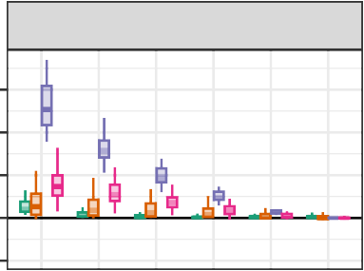
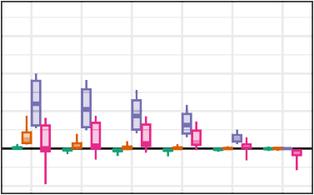
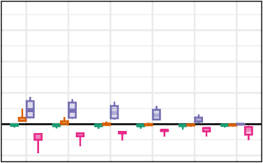
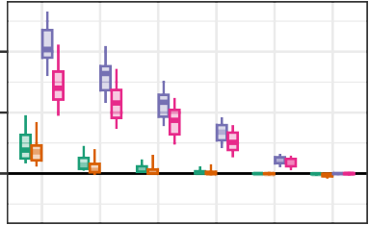
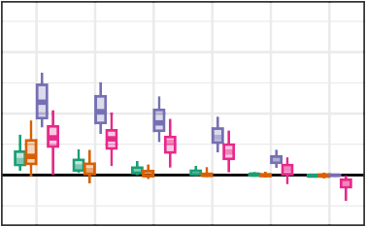
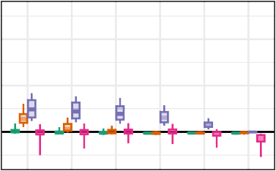
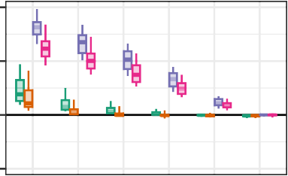
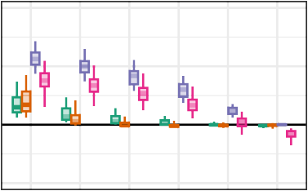
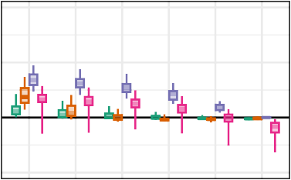
μ = 0
μ = 0.2
μ = 0.4

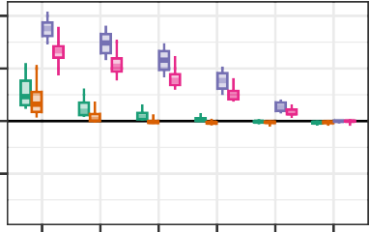
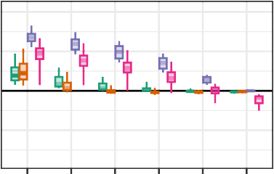
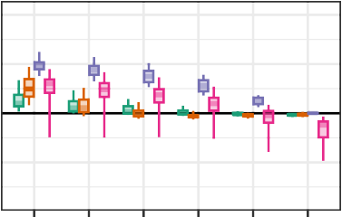
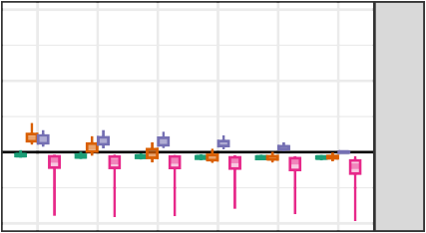
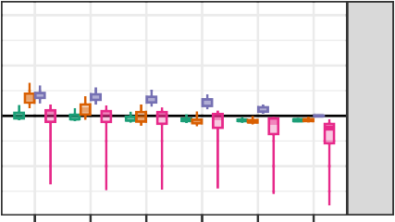
0.02
τ_{B} = 0.45
0.05 0.10 0.20 0.50 1.00
0.02
0.05 0.10 0.20 0.50 1.00
0.02
0.05 0.10 0.20 0.50 1.00
0.02
0.05 0.10 0.20 0.50 1.00

(Strong)

Figure 3
(None) (Strong)
(None) (Strong)
Selection probability
(None) (Strong)
(None)

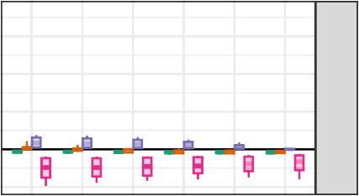
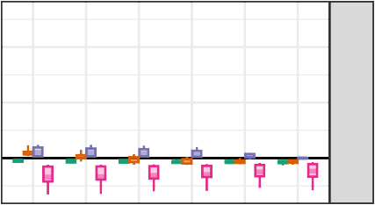
Bias for estimators of average effect size by selection probability, average SMD, and between-study heterogeneity across scenarios with a univariate selection process (ψ = 0)
μ = 0.8
STEP-FUNCTION SELECTION MODELS
60
τ_{B} = 0.05
τ_{B} = 0.15
τ_{B} = 0.3

Estimator  PML  ARGL  CHE−ISCW  PET/PEESE

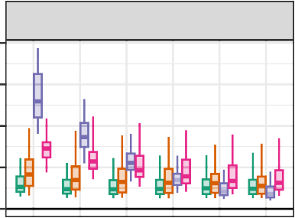
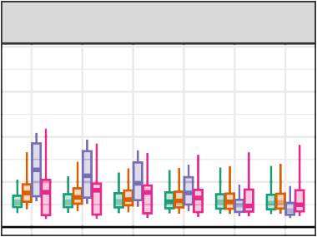
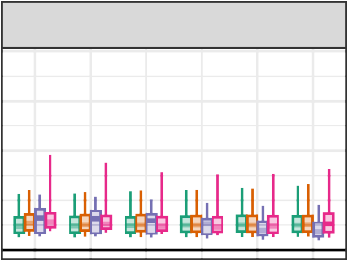
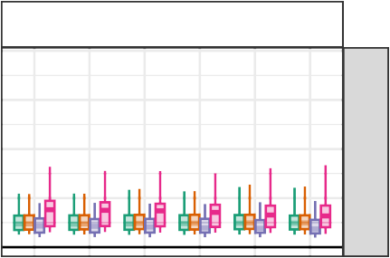
0.20
μ = 0
μ = 0.2
μ = 0.4
μ = 0.8
0.15
τ_{B} = 0.05
0.10
0.05
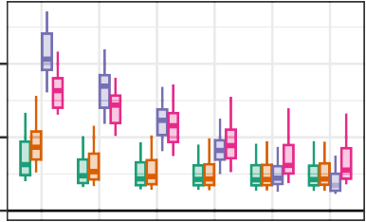
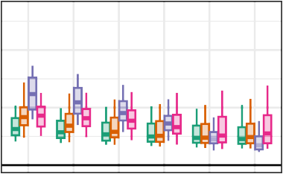
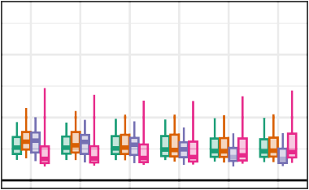
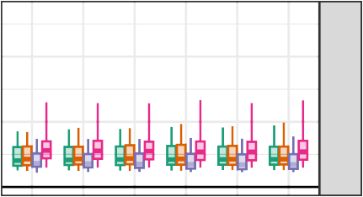
0.00

0.2
τ_{B} = 0.15
Root Mean−Squared Error

0.1

0.0
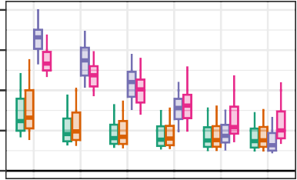
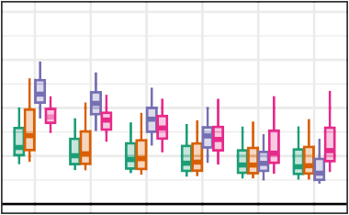
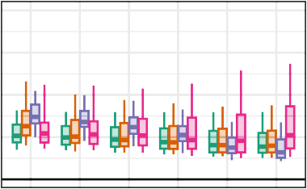
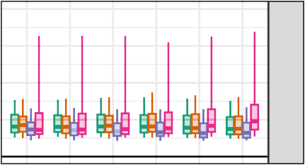
0.4
0.3
τ_{B} = 0.3
0.2
0.1
0.0
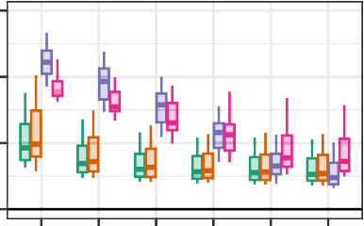
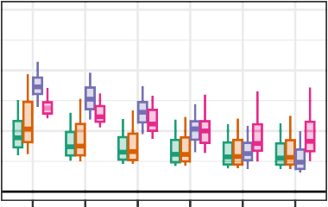
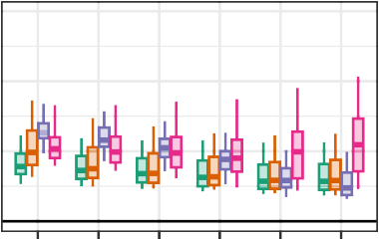
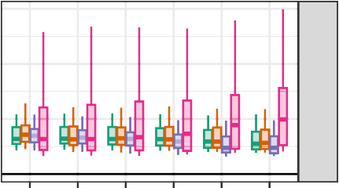
0.6

0.4
τ_{B} = 0.45

0.2

0.0

0.02

0.05 0.10 0.20 0.50 1.00

0.02

0.05 0.10 0.20 0.50 1.00

0.02

0.05 0.10 0.20 0.50 1.00

0.02

0.05 0.10 0.20 0.50 1.00

(Strong)

Figure 4
(None) (Strong)
(None) (Strong)
Selection probability
(None) (Strong)
(None)

Root mean-squared error for estimators of average effect size by selection probability, average SMD, and between-study heterogeneity across scenarios with a univariate selection process (ψ = 0)
STEP-FUNCTION SELECTION MODELS
61





Estimator PML ARGL CHE−ISCW PET/PEESE
STEP-FUNCTION SELECTION MODELS
62

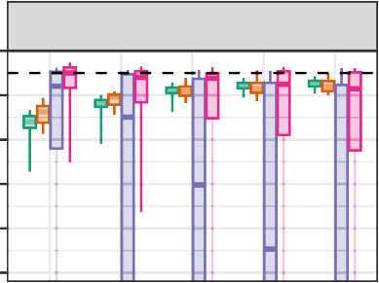
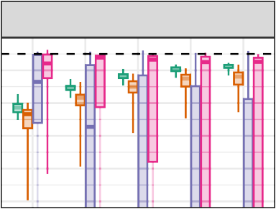
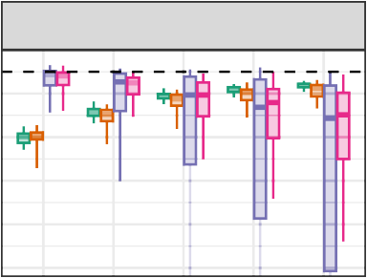
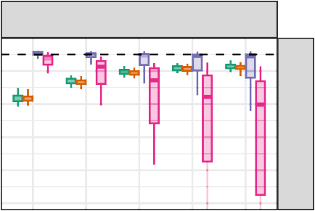
1.0
μ = 0
μ = 0.2
μ = 0.4
μ = 0.8
0.9
0.8
τ_{B} = 0.05
0.7
0.6
0.5
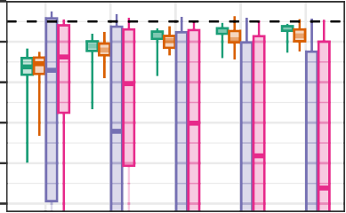
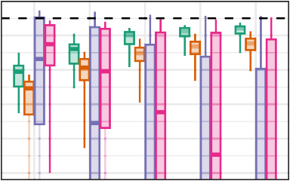
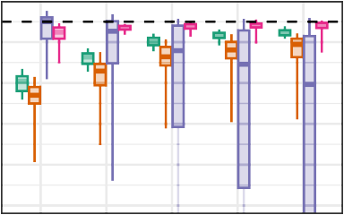
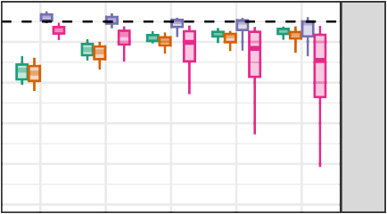
1.0
0.9
0.8
τ_{B} = 0.15
0.7
Coverage rate
0.6
0.5
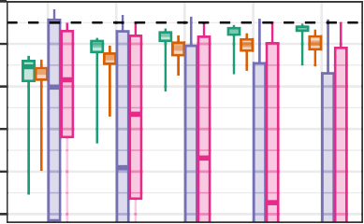
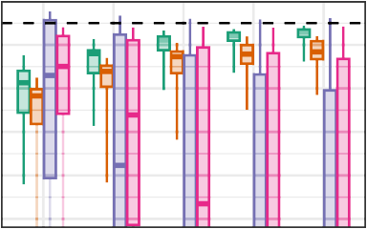
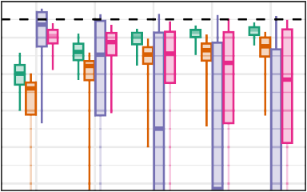
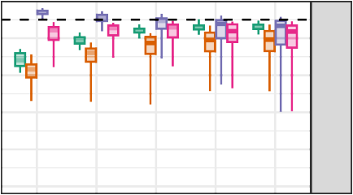
1.0
0.9
0.8
τ_{B} = 0.3
0.7
0.6
0.5
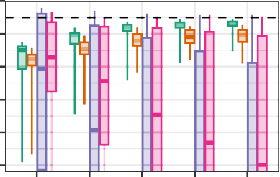
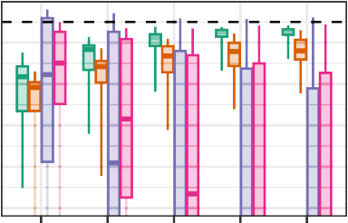
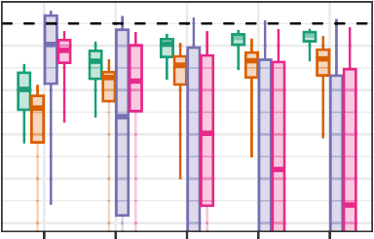
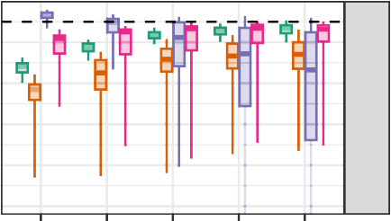
1.0
0.9
0.8
τ_{B} = 0.45
0.7
0.6
0.5
15 30 60 90 120 15 30 60 90 120 15 30 60 90 120 15 30 60 90 120
Number of studies (J)

Figure 5
Coverage levels of confidence intervals for average effect size based on cluster-robust variance approximations, by number of studies, average SMD, and between-study heterogeneity across scenarios with a univariate selection process (ψ = 0). Dashed lines correspond to the nominal confidence level of 0.95. Coverage rates of the CHE-ISCW and PET/PEESE intervals are not depicted when they fall below 0.5.





0.95
0.90
0.85
0.80
0.75
0.70
0.65

0.95
Coverage rate
0.90
0.85
0.80
0.75
0.70
0.65
λ₁ = 1
Method cluster−robust percentile (two−stage) percentile (multinomial) percentile (exponential)
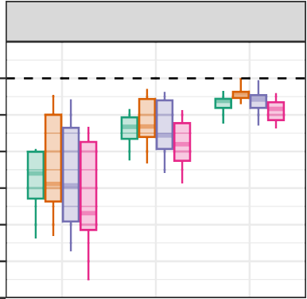
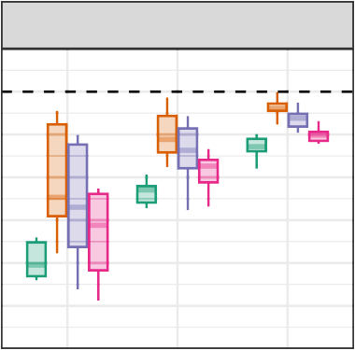
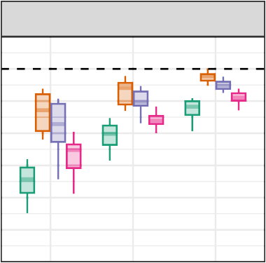
μ = 0
μ = 0.2
μ = 0.4

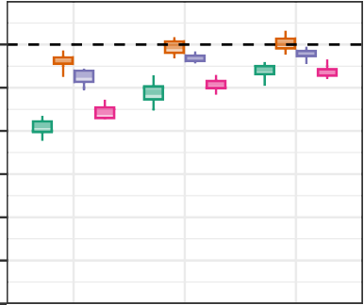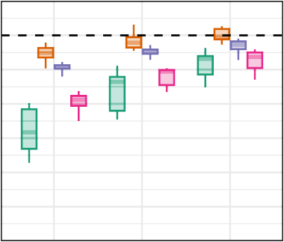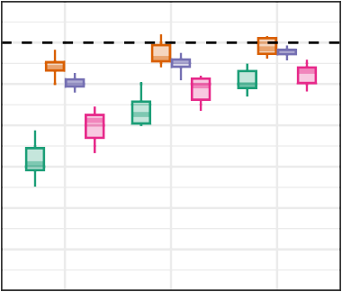

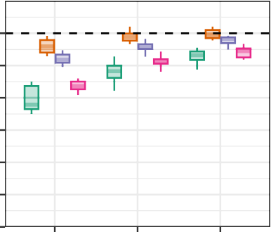
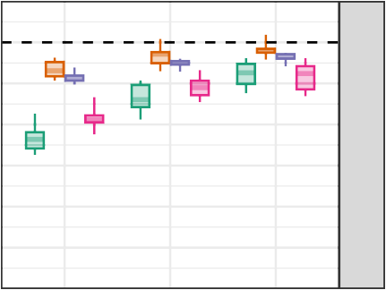
0.95
λ₁ = 0.2
0.90
0.85
0.80
0.75
0.70
0.65

Figure 6

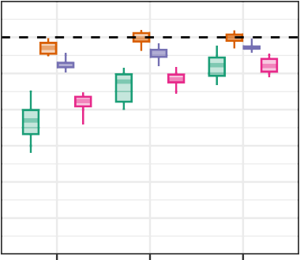
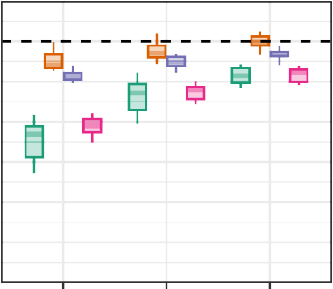
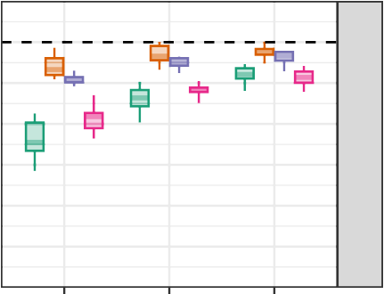
15 30 60 15 30 60 15 30 60 15 30 60
Number of studies (J)

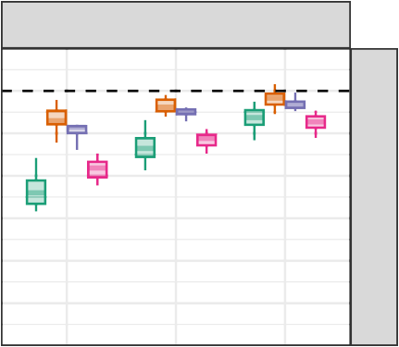
Coverage levels of confidence intervals for average effect size based on the PML estimator, by number of studies, average SMD, and strength of selection across scenarios with a univariate selection process (ψ = 0). Dashed lines correspond to the nominal confidence level of 0.95.
μ = 0.8
STEP-FUNCTION SELECTION MODELS
63
λ₁ = 0.05

Method  PML (percentile two−stage bootstrap)  PML (large−sample)  CHE−ISCW  PET/PEESE
STEP-FUNCTION SELECTION MODELS
64

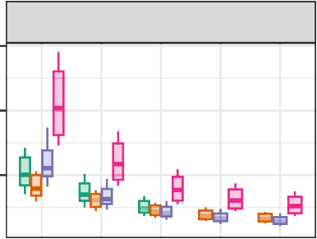
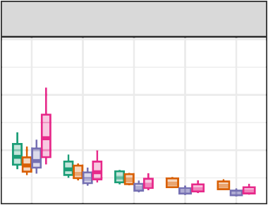
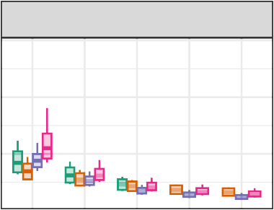
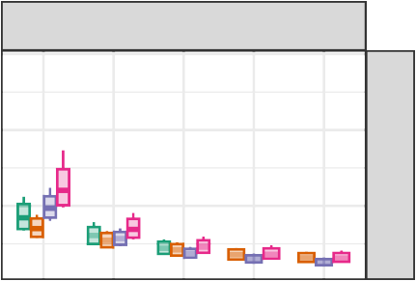
0.6
μ = 0
μ = 0.2
μ = 0.4
μ = 0.8

0.4
τ_{B} = 0.05

0.2

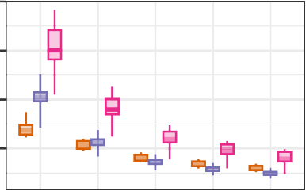
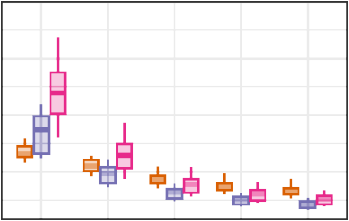
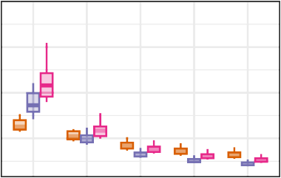
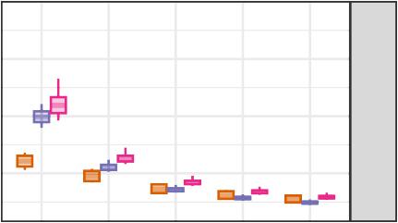
0.8

0.6
τ_{B} = 0.15

0.4
Average width

0.2

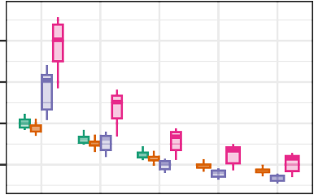
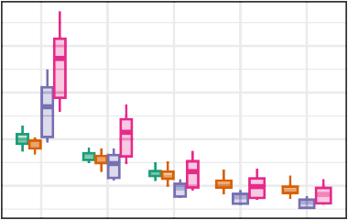
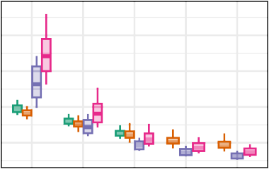
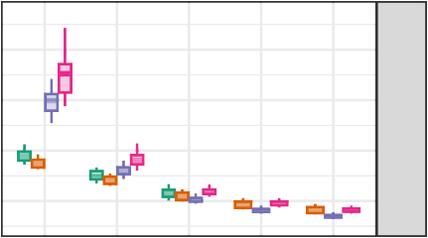
1.00
0.75
τ_{B} = 0.3
0.50
0.25

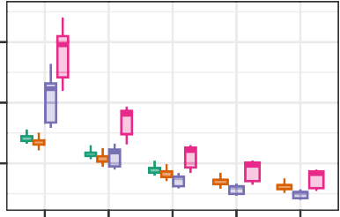
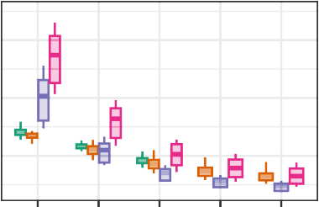
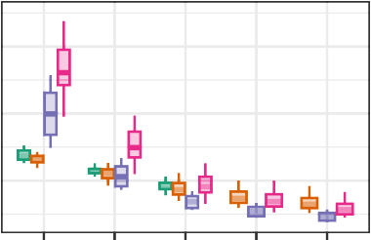
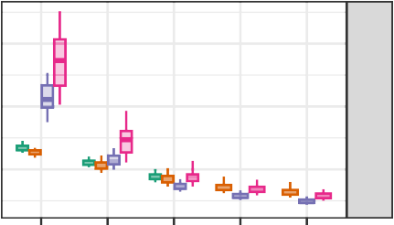
1.5
τ_{B} = 0.45

1.0

0.5

15 30 60 90 120 15 30 60 90 120 15 30 60 90 120 15 30 60 90 120
Number of studies (J)

Figure 7
Average width of confidence intervals for average effect size based on selected methods, by number of studies, average SMD, and between-study heterogeneity across scenarios with a univariate selection process (ψ = 0). Results are limited to scenarios with ρ = 0.8 and λ₁ = 0.05, 0.20, 1.0 to allow comparison between bootstrap CIs and large-sample CIs.

