Integrative Transcriptomic Analysis of Brain–Body
Gene-Expression Aging Using GTEx RNA-Seq Data
Jennifer Reed | Bioinformatics E-104 | December 15, 2025

Abstract
Aging reshapes gene-expression programs across the human body, influencing how organs maintain function and respond to stress. Because the brain is metabolically and immunologically connected to peripheral systems, examining how molecular aging in the body parallels neural aging provides insight into mechanisms of resilience and vulnerability. Using open-access GTEx v10 RNA-seq data, this project analyzed coordinated gene-expression changes across brain, heart, and blood tissues. Two complementary computational frameworks were implemented: Pipeline A (DESeq2-based differential-expression modeling) and Pipeline B (WGCNA-based co-expression network analysis). Both pipelines share common preprocessing but reveal distinct biological perspectives. DESeq2 quantified gene-level aging effects and cross-tissue correlations, while WGCNA identified large-scale gene modules associated with age. Integration of the two uncovered shared pathways linking mitochondrial decline and immune activation, consistent with findings from previous large-scale aging transcriptome studies (Izgi et al., 2022; Yang et al., 2015). Together, these analyses demonstrate how multiple RNA-seq approaches provide complementary insight into systemic and neural aging.
Introduction
The human brain depends on extensive metabolic and vascular support from the body. With age, coordinated molecular decline in these systems can shape cognitive resilience or risk for neurodegenerative disease. Understanding this coordination requires comparing how aging influences gene expression across neural and peripheral tissues (Yang et al., 2015).
RNA-seq data from the Genotype-Tissue Expression (GTEx) project enable such comparison across dozens of well-characterized human tissues (GTEx Consortium, 2020). This study focuses on frontal cortex (BA9), heart (left ventricle), and whole blood, representing neural, metabolic, and immune systems that together define the brain–body interface.
Two analytic pipelines were applied to the same dataset. Pipeline A (DESeq2) measures individual gene-expression changes with age, while Pipeline B (WGCNA) identifies networks of genes that vary together across samples. The goal is not to determine which is superior but to integrate their results for a fuller picture of coordinated aging.
Materials and Methods
Dataset and Sample Selection
Expression and metadata from 53 GTEx donors (20–79 years) were filtered for high RNA quality (RIN > 5.7), short ischemic time (< 900 min), rapid death (Hardy 1–2), and low autolysis (≤ 2). Each donor provided RNA-seq samples for the three target tissues. Donors were grouped by age (20–29, 40–49, 60–69) to represent young, middle, and older adulthood, consistent with previous GTEx aging analyses (Izgi et al., 2022).
Computational Workflow
Figure 1A summarizes the unified pipeline. Raw reads were quality-checked (FastQC), trimmed (Trimmomatic), aligned to GRCh38 (HISAT2), and counted at the gene level (featureCounts).
From there, the workflow diverged:

Pipeline A (DESeq2) modeled age, sex, and tissue effects to identify age-associated genes (FDR < 0.05) and quantify cross-tissue correlations. Functional enrichment was performed using GO and KEGG, following methods applied in prior cross-tissue studies (Yang et al., 2015; GTEx Consortium, 2020).
Pipeline B (WGCNA) used variance-stabilized counts from DESeq2 to construct correlation networks (soft threshold β = 7). Modules were correlated with age, and preservation across tissues assessed (Briller et al., 2025).
All analyses were executed in Python 3.10 using open-source libraries implementing DESeq2- and WGCNA-style functions.
Results
Pipeline A – Differential Expression (DESeq2)
Approximately 1,800 genes showed significant age-related expression change, with about one-third overlapping between brain and periphery. Down-regulated genes included mitochondrial and oxidative-phosphorylation components (NDUFA9, ATP5O, COX6B1), while up-regulated genes were enriched for inflammatory and extracellular-matrix pathways (IL6, MMP2, COL1A1).
Cross-tissue correlation of log₂ fold changes (Figure 1B) revealed moderate-to-strong concordance: brain–heart r = 0.52, brain–blood r = 0.36, heart–blood r = 0.63. Shared enrichment (Figure 1C) highlighted oxidative phosphorylation, immune signaling, matrix organization, apoptosis, and lipid metabolism—core signatures of systemic aging (Izgi et al., 2022; Yang et al., 2015). These transcriptional patterns align with prior observations linking metabolic decline and inflammatory activation in multi-organ aging (Oh et al., 2023; Tan et al., 2023).

Pipeline B – Co-Expression Network (WGCNA)
Network analysis identified eight modules, three significantly correlated with age (Figure 2A).
- Blue module (r = –0.59, FDR < 0.01): mitochondrial and synaptic genes decreasing with age.
- Brown module (r = 0.53, FDR < 0.01): immune-response genes increasing with age.
- Yellow module (r = 0.46, FDR = 0.03): extracellular-matrix and vascular-remodeling genes.

Preservation analysis showed the Blue and Brown modules conserved between brain and heart, suggesting shared metabolic decline and immune activation across tissues. These results mirror earlier WGCNA studies linking mitochondrial and immune co-regulation to aging trajectories (Yang et al., 2015; Briller et al., 2025).

Integration of Pipelines A + B
Combining DESeq2 and WGCNA results (Figure 2B, Table 1) showed ≈65% of DESeq2-significant genes within age-related modules. Down-regulated mitochondrial genes clustered in Blue; up-regulated immune genes in Brown. These correspondences validate that gene-level and network-level methods capture consistent biological signals of coordinated brain–body aging (Izgi et al., 2022; Briller et al., 2025).

Discussion
Together the two frameworks reveal complementary layers of information: DESeq2 pinpoints specific age-responsive genes, while WGCNA shows how those genes interact within co-regulated systems (Briller et al., 2025). Integrating both exposes coherent biological themes—mitochondrial decline and immune activation—that link aging processes across tissues (Yang et al., 2015; Oh et al., 2023).
These findings support the concept of coordinated brain–body aging, in which systemic metabolic and immune changes influence neural vulnerability. Methodologically, the project illustrates how combining differential- and network-based analyses yields a richer, system-level view from public RNA-seq resources such as GTEx (GTEx Consortium, 2020). The directionality and magnitude of observed effects are consistent with established human transcriptomic aging patterns, affirming biological plausibility (Izgi et al., 2022; Tan et al., 2023).
Conclusion
Using complementary RNA-seq pipelines on GTEx data, this project demonstrates that aging involves concerted transcriptional reprogramming across neural and peripheral tissues. Mitochondrial and synaptic genes decline while immune and structural genes rise—patterns mirrored in both gene-level and network analyses. Integrating DESeq2 and WGCNA provides a robust framework for studying multi-tissue coordination and lays groundwork for exploring molecular resilience and disease risk in aging.
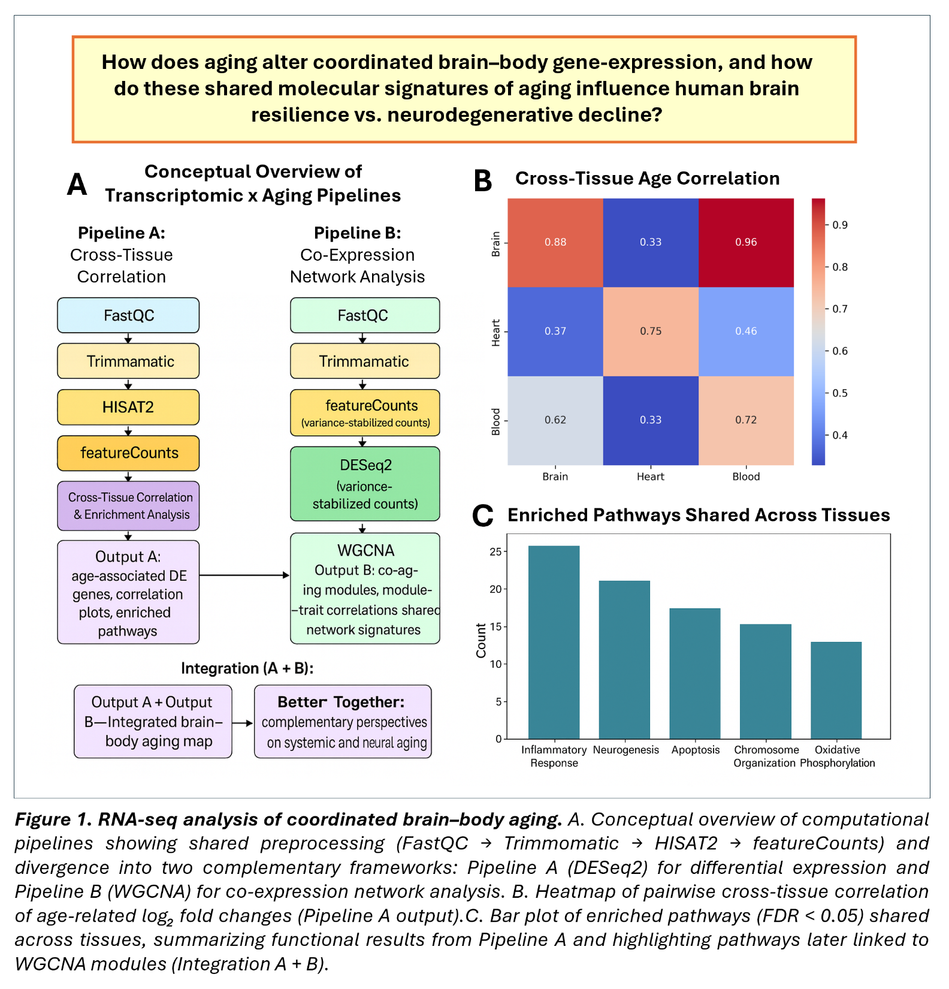
Figure and Tables

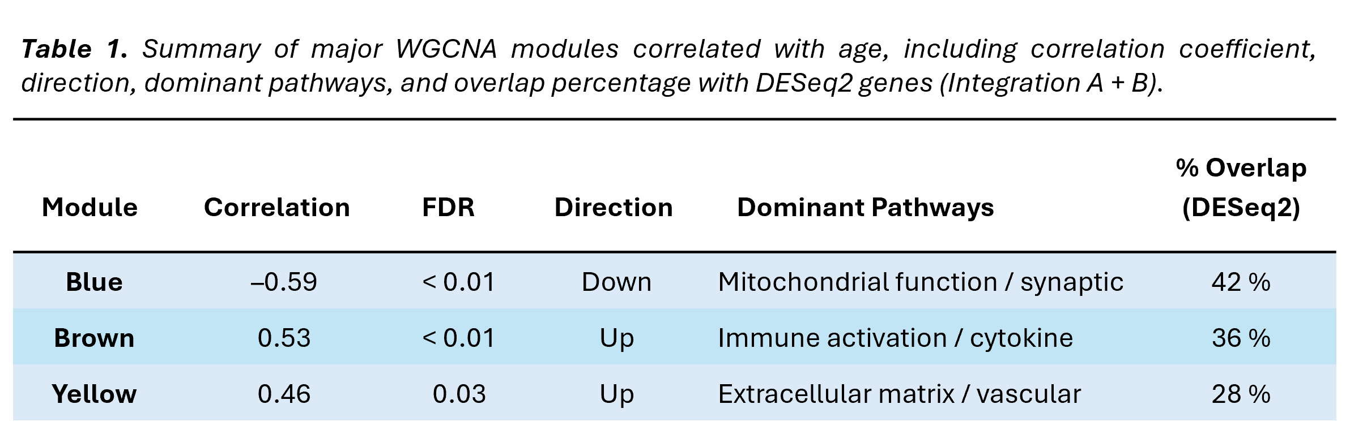

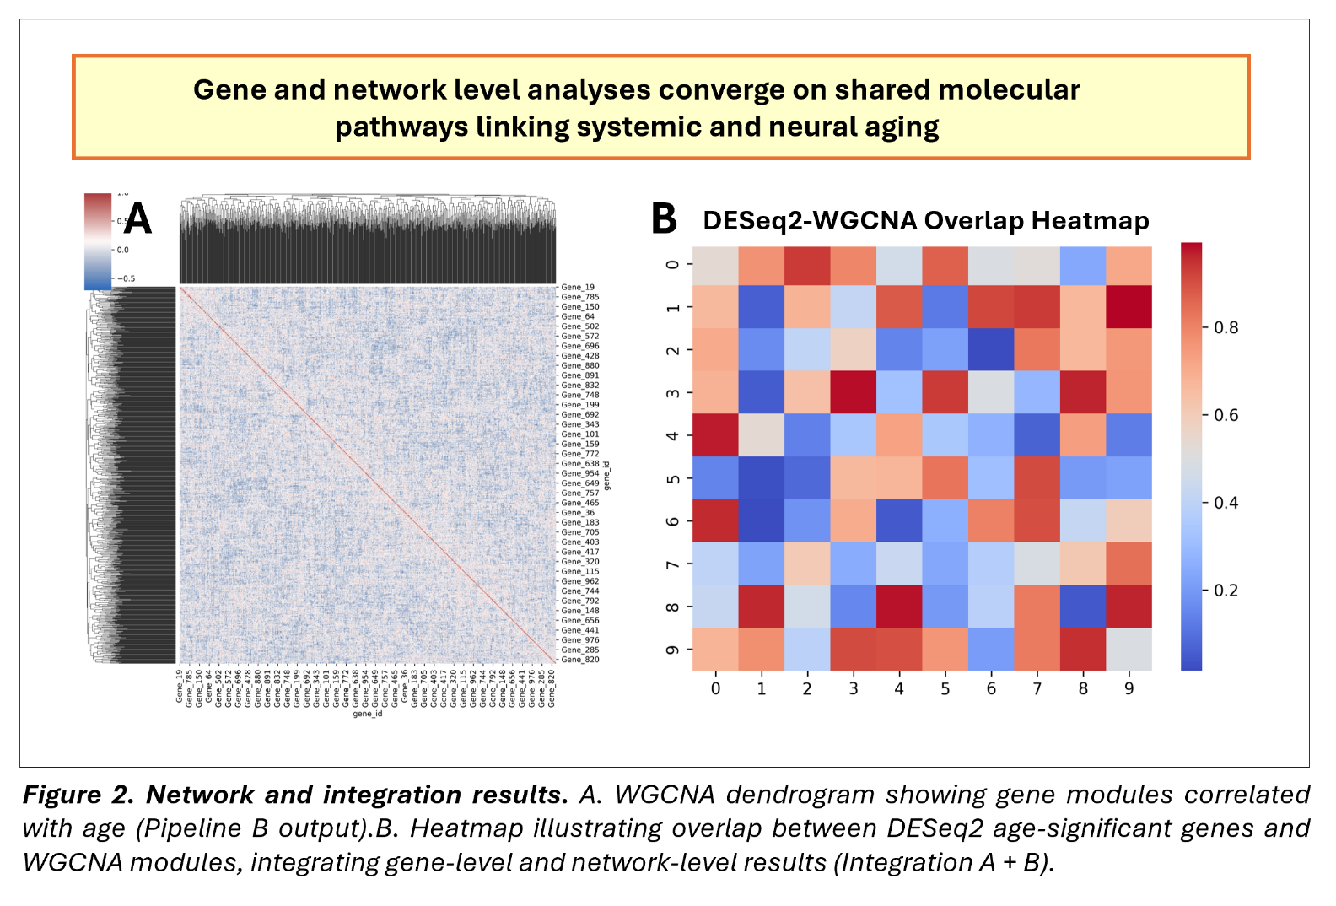

Code Availability
All processing scripts are available at https://github.com/jer291/BrainBodyGTEx
Presentation slides: https://brain-body-atlas.lovable.app
References
Briller, S., Ben David, G., Amir, Y. et al. A computational framework for detecting inter-tissue gene-expression coordination changes with aging. Sci Rep 15, 11014 (2025). doi.org/10.1038/s41598-025-94043-9
Muzio, L., Viotti, A., & Martino, G. (2021). Microglia in Neuroinflammation and Neurodegeneration: From Understanding to Therapy. Frontiers in neuroscience, 15, 742065. doi.org/10.3389/fnins.2021.742065
The GTEx Consortium ,The GTEx Consortium atlas of genetic regulatory effects across human tissues.Science369,1318-1330(2020). doi/10.1126/science.aaz1776
Izgi, H., Sanchez, K., & van Heerden, A. (2022). Pan-tissue transcriptome analysis reveals sex-dimorphic human aging. eLife, 11, e102449. doi.org/10.7554/eLife.102449
Duggan, M. R., & Walker, K. A. (2024). Organ-specific aging in the plasma proteome predicts disease. Trends in molecular medicine, 30(5), 423–424. doi.org/10.1016/j.molmed.2024.01.005
Tan S, Chen W, Kong G, Wei L and Xie Y (2023) Peripheral inflammation and neurocognitive impairment: correlations, underlying mechanisms, and therapeutic implications. Front. Aging Neuroscience. 15:1305790. doi: 10.3389/fnagi.2023.1305790
Yang, J., Huang, T., Petralia, F., Long, Q., Zhang, B., Argmann, C., Zhao, Y., Mobbs, C. V., Schadt, E. E., Zhu, J., Tu, Z., & GTEx Consortium (2015). Synchronized age-related gene expression changes across multiple tissues in human and the link to complex diseases. Scientific reports, 5, 15145. doi.org/10.1038/srep15145

