Cricket Tournament Management

Team Members: Manoej KR, Jerin Joji

Problem Statement:

Local sports enthusiasts, especially amateur cricket players, face difficulties organizing and managing their games. Without a dedicated platform, it’s hard to schedule matches, register players, track scores, or monitor team performance. A community-driven solution is needed to streamline the organization of local matches, manage player participation, and track real-time scores and statistics, creating a better experience for both players and fans.

1. **Understanding of the Problem Statement:**
2. **Explanation of the Problem Context:**

The problem statement highlights a common issue faced by local sports enthusiasts, particularly amateur cricket players, who struggle with the logistics of organizing and managing their games. Currently, there isn’t a centralized platform for scheduling matches, registering players, or tracking important metrics like scores and team performance. As a result, the process is often disorganized and time-consuming, leading to frustration among players and fans who want a seamless experience for game management and real-time scorekeeping.

**Business Case:** The core of this issue lies in the absence of a digital solution that can streamline match scheduling, player participation, and performance tracking for local cricket teams. The business case for addressing this need is strong because an effective solution would allow teams and players to focus on the game itself rather than on administrative burdens. It could also encourage higher engagement and participation by making it easier for players to join games, organize teams, and track their progress. Additionally, fans of local cricket could enjoy a more engaging experience by staying updated on scores and following players’ performances.

**Intended Users or Beneficiaries:**

1. **Amateur Cricket Players:** Players are the primary beneficiaries, as the platform would streamline match organization, making it easy for them to join games, register for matches, and track their performance stats.
2. **Team Managers and Organizers:** These individuals could use the platform to coordinate matches, organize teams, and ensure a seamless experience for participants. This would reduce the administrative workload and improve the efficiency of event management.
3. **Key Requirements Identified:**

For the MVP (Minimum Viable Product) of a community-driven cricket management platform, the solution should focus on core functionalities that address the primary pain points for players, organizers, and fans. Here’s a list of the essential requirements identified to ensure the solution provides immediate value within the timeline:

1. **Match Scheduling and Organization:**

* **Create and Schedule Matches**: Allow users (especially organizers) to create and schedule matches with details like date, time, location, and teams involved.
* **Join and Register for Matches**: Enable players to register for matches easily, indicating their availability and position preference.
* **Manage Teams and Players**: Provide organizers the ability to create and manage team rosters, with options to add, remove, or swap players before the match.

1. **Player Profiles:**

* **Basic Player Profiles:** Allow players to create basic profiles that include their name, contact details, preferred position, and skill level.
* **Profile Linking:** Ensure players can be linked to multiple teams if they participate in different matches or leagues.

1. **Solution Overview:**
2. **Solution Summary:**

Our proposed solution is a **mobile-friendly, web-based platform** specifically designed to address the organizational challenges of amateur cricket matches. The platform will act as a central hub where players, team managers, and fans can come together to coordinate games, track scores, and follow their favorite teams and players in real time. By focusing on key functionalities such as match scheduling, player registration, real-time score tracking, and performance statistics, our platform aims to streamline match management and enhance the overall experience for all users.

1. **Objective:**

The primary objective of this solution is to create a centralized platform that simplifies the organization and management of amateur cricket matches while enhancing the experience for players, organizers, and fans. By streamlining game coordination, score tracking, and player/team management, the platform aims to eliminate the logistical difficulties faced by local cricket enthusiasts and foster a more connected sports community.

**Streamline Match Organization and Scheduling:** Simplify the process of creating, scheduling, and managing matches to reduce the time and effort spent on coordination.

**Enable Real-Time Score Tracking and Statistics:** Provide real-time score updates and essential performance metrics during matches to keep players and fans informed and engaged.

**Facilitate Player and Team Management:** Offer an easy-to-use system for creating and managing player profiles, team rosters, and match lineups to enhance team-building and ensure balanced games.

1. **Features and Functionalities:**
2. **Core Features:** These are the primary features designed to address the key requirements and deliver immediate value to players, organizers, and fans:
3. **Match Scheduling and Organization:**

* Create, schedule, and manage matches with details such as date, time, location, and participating teams.
* Player registration for matches, allowing players to indicate availability and confirm participation.

**ii) Player Profiles:**

* Player profiles with basic information (e.g., name, position, skill level) to facilitate team assembly and tracking.
* Team profiles displaying current roster, recent match history, and cumulative stats.

**iii) Statistics and Performance Tracking:**

* Track individual player stats (e.g., runs scored, wickets taken) and team performance metrics over multiple games.
* Maintain match history for teams to view past performances and stats.

1. **Additional Features:** These extra features go beyond the core requirements, enhancing the platform’s usability and engagement:
2. **Payment Gateway Integration:**

**Description**: Integrate a secure and reliable payment gateway (such as Stripe or PayPal) to facilitate online transactions directly through the platform. This feature allows teams and players to seamlessly pay registration fees or other tournament-related expenses without leaving the platform.

1. **Integrated Scoreboard for Real-Time Match Scores:**

**Description**: Introduce a dedicated scoreboard section within the platform where users can view live match scores and updates. Organizers can update scores in real time, which are then displayed instantly for players and fans to follow along.

1. **Match Location Display with Venue Details and Geographical Coordinates:**

**Description**: Display detailed information about each match venue, including the address and geographical coordinates (latitude and longitude), to help users locate the venue easily. Additionally, integrate map functionality to show the venue’s position for better navigation.

1. **User Flow:** These are the primary user flows that outline how different users (players, team organizers, and fans) interact with the platform to accomplish essential tasks.
2. **Player Flow:**

* **Register for a Team**: Players can join a team by registering.
* **View Tournaments**: Players can browse upcoming tournaments and view tournament details.
* **View Profiles**: Players can access team and player profiles to track stats and performance.

1. **Organizer Flow:**

* **Create Team**: Organizers can set up new teams within the platform.
* **Create Tournament**: Organizers can establish new tournaments, specifying details such as dates, locations, and participating teams.
* **Add Teams to Tournament**: Organizers can add registered teams to specific tournaments.
* **Create Matches**: Organizers can schedule matches between teams within a tournament.
* **Update Scorecard**: During and after matches, organizers can update the scoreboard, ensuring real-time and final scores are recorded and accessible.

**4. Architecture Diagram:**

**i) System Architecture:**

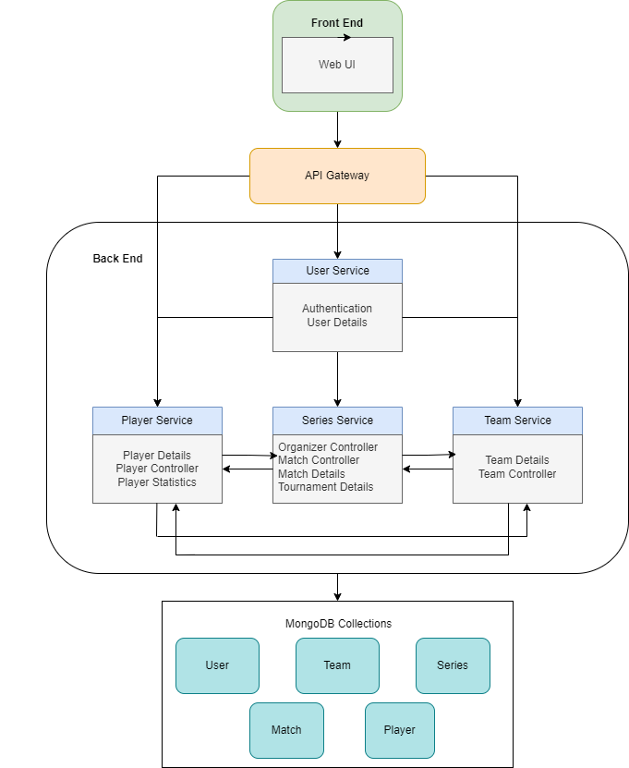

**ii) Key Components:**

**Frontend (User Interface):**

**Role**: The frontend provides the interface through which users interact with the application. It is built using **React** and **Material UI**, offering a dynamic, responsive, and easy-to-navigate UI for players, teams, and organizers.

**Backend (API Server):**

**Role**: The backend is powered by **Node.js** and **Express** and serves as the central hub for handling HTTP requests, processing business logic, and interacting with the database.

**Database (MongoDB):**

**Role**: The **MongoDB** database stores the application’s data in a NoSQL document format. It is designed to manage unstructured data like user profiles, teams, tournaments, and match scores.

**5. Technical Stack:**

**i) Frontend:**

React with TypeScript: React is used to build a dynamic, component-based UI, while TypeScript adds type safety, making the development process more robust and error-free. This ensures better maintainability and scalability for the application.

**Material UI:**

Material UI is used to design a sleek and consistent user interface, providing pre-built components that follow Google's Material Design principles, ensuring a responsive and modern user experience.

1. **Backend:**

Node.js and Express:

Node.js is used as the runtime environment, and Express.js is the framework for building RESTful APIs. These technologies ensure the backend is lightweight, scalable, and can handle high concurrent requests efficiently, providing the necessary functionality for user registration, match management, and real-time updates.

1. **Database:**

MongoDB:

MongoDB is a NoSQL database used for document-based storage, ideal for handling dynamic and flexible data models. It allows the storage of unstructured data, such as player profiles, match results, and team details, in a JSON-like format.

**IV) Other Technologies**:

Cloudinary:

Cloudinary is used for storing and managing images (e.g., player photos, team logos, or tournament banners). It simplifies image uploading, transformation, and optimization, ensuring that media files are served efficiently across the platform.

**6. Prerequisites and requirements:**

**A) Technical Requirements:**

* A **Node.js server** for hosting the backend application.
* **Express.js** framework installed and configured to handle HTTP requests.
* **MongoDB Database** instance for storing user data, teams, matches, and tournament details.
* **Cloudinary** account for storing and managing images (e.g., player profiles, tournament banners, logos).

1. **Data requirements:** 
   * **Player Data**: Names, contact details, profile photos, team associations.
   * **Team Data**: Team names, player lists, statistics, logos, and tournament affiliations.
   * **Team Data**: Team names, player lists, statistics, logos, and tournament affiliations.
   * **Tournament Data**: Tournament names, dates, participating teams, and match results.
2. **Access Permissions:**

* **MongoDB Atlas**: Access to the MongoDB database instance for managing collections, indexes, and schemas.
* **Cloudinary**: Access to the Cloudinary account to configure image upload and storage services.

**7. Future Improvements:**

* Payment Gateway Integration: Add secure payment options to streamline registration fees and other tournament-related transactions, making it easy for teams and players to register and pay directly through the platform.
* Integrate a scoreboard section to display real-time match scores.
* Display the match location, providing details of the venue and its geographical coordinates.

**8. Conclusion:**

The solution we have developed successfully addresses the core challenges faced by local sports enthusiasts and amateur cricket players in organizing and managing their matches. By creating a platform that streamlines tournament registration, team management, score tracking, and real-time updates, we have built an intuitive and efficient tool that simplifies the entire process for both players and organizers.