CoLight: Multi-Agent Reinforcement Learning for Traffic Signal Cooperation

CS669 Reinforcement Learning— Final-Project Report Milestone 5

Jerald, Jaime and Vivek
New Jersey Institute of Technology
Spring 2026

Project Demo: Presentation and Video
Code: GitHub_Code_Repository
Motivation: Paper Link

CoLight: Multi-Agent Reinforcement Learning for Traffic Signal Cooperation
This report summarizes the implementation, experimentation, replication, and extension of the CoLight reinforcement learning framework for network-level traffic signal control using Graph Attention Networks (GATs).

Abstract
Urban traffic congestion remains one of the major challenges in smart city infrastructure. Traditional fixed-time and rule-based traffic signal systems struggle to adapt to dynamic traffic conditions. In this project, we replicate and extend the CoLight framework, a multi-agent reinforcement learning (MARL) approach that combines Deep Q-Learning with Graph Attention Networks to enable cooperation among traffic intersections. Each traffic signal is modeled as an independent RL agent that dynamically learns how neighboring intersections influence traffic flow. The project was implemented using the CityFlow simulator with experiments on 6×6 and 10×10 traffic grids. Additional extensions included accident simulation, stopped-vehicle features, scalability analysis, and robustness evaluation under dynamic disruptions.

1. Introduction
Traffic signal control is a classical optimization problem in transportation systems. Modern cities experience constantly changing traffic patterns caused by commuting, events, accidents, and environmental conditions. Traditional methods such as SCOOT and SCATS rely heavily on preconfigured timing plans and are often unable to adapt quickly to real-time congestion.
Recent advancements in Reinforcement Learning (RL) and Multi-Agent Reinforcement Learning (MARL) provide promising alternatives. CoLight introduces an attention-based communication mechanism where neighboring intersections dynamically exchange information using Graph Attention Networks (GATs). Unlike fixed coordination schemes, CoLight learns which neighboring intersections are most relevant during training.

2. Problem Formulation
Component | Description
State (per intersection) | Local lane-level features (e.g., incoming queue lengths and/or waiting counts) augmented with neighborhood features aggregated from adjacent intersections (via the road-network graph). Extension: stopped-vehicle counts per incoming lane.
Action | Discrete phase selection: choose the signal phase to apply at the next control step (subject to the simulator’s phase-duration constraints such as minimum green and yellow time).
Reward | Pressure minimization. A common choice (used by CoLight) is negative intersection pressure: r_{t}^{i} = −P_{t}^{i}, where pressure P is defined from the imbalance between incoming and outgoing queues across approaches/movements.
Environment | CityFlow traffic simulator with grid road networks (UNI and BI) and configurable demand; step dynamics include delayed downstream effects.
Agents | One RL agent per intersection; agents learn a cooperative policy with shared parameters (CTDE-style training).
We model network-level traffic signal control as a cooperative multi-agent reinforcement learning (MARL) problem. Let i index intersections (agents) and t denote discrete decision steps. Each agent observes a local state s_{t}^{i} (traffic features at intersection i) and selects an action a_{t}^{i} (the next signal phase). The joint action a_{t} induces a transition in the shared CityFlow environment, producing next states and rewards. During training, the learning process must handle (i) partial observability (each agent only sees local/neighborhood information) and (ii) non-stationarity from simultaneously learning neighbors, since one intersection’s phase choice changes downstream queues and thus the data distribution seen by other agents.
Following CoLight, we use a pressure-based objective. Intuitively, pressure measures imbalance: if many vehicles are queued on incoming approaches but few can be discharged downstream, the intersection is “over-pressured.” We define intersection pressure and reward as:
Pressure: P_{t}^{i} = ∑_{m∈𝓜}^{i} ( q_{t}^{in}(m) − q_{t}^{out}(m) )
Reward: r_{t}^{i} = −P_{t}^{i}
where 𝓜^{i} is the set of movements (or approach pairs) at intersection i, and q_{t}^{in}(m) and q_{t}^{out}(m) denote the queue length (or number of waiting vehicles) on the incoming and outgoing lanes associated with movement m. Using r_{t}^{i}=−P_{t}^{i} (optionally clipped or scaled) encourages actions that balance inflow/outflow and reduce spillback.

3. CoLight Architecture
CoLight combines Deep Q-Networks (DQN) with Graph Attention Networks (GATs) to enable coordination among intersections. Each intersection is modeled as a node in a road-network graph, and information from nearby nodes is aggregated through attention so the agent can emphasize the most influential neighbors under the current traffic conditions.

3.1 Model pipeline (per decision step)
At each decision step, every intersection builds a feature vector from local observations (e.g., queues/pressure) and collects the feature vectors of its graph neighbors. A GAT layer computes attention weights over neighbors and produces an aggregated neighborhood embedding. This embedding is fused with the local embedding and passed through the DQN head to output Q-values for the available signal phases; the phase with the highest Q-value is selected (subject to any simulator phase constraints).
- Centralized training, decentralized execution (CTDE): during training, experience from many intersections is pooled to learn shared parameters; at run time, each intersection selects actions using only its local observations plus information received from its neighbors in the graph.
- Parameter sharing: a single set of network weights is shared across intersections, improving sample efficiency and enabling scaling to larger grids.
- Graph attention for coordination: attention learns which neighboring intersections are most relevant (e.g., upstream/downstream congestion), rather than treating all neighbors equally.
- Neighborhood definition: neighbors are the intersections connected in the road graph (typically immediate adjacent intersections in the grid); attention weights are computed over this neighbor set each step.
- Pressure-driven objective: the reward is based on (negative) pressure to discourage imbalance between incoming and outgoing queues and reduce overall congestion.
Figures 1–2 provide a high-level view of the CoLight network and how attention is used to weight neighbor information.
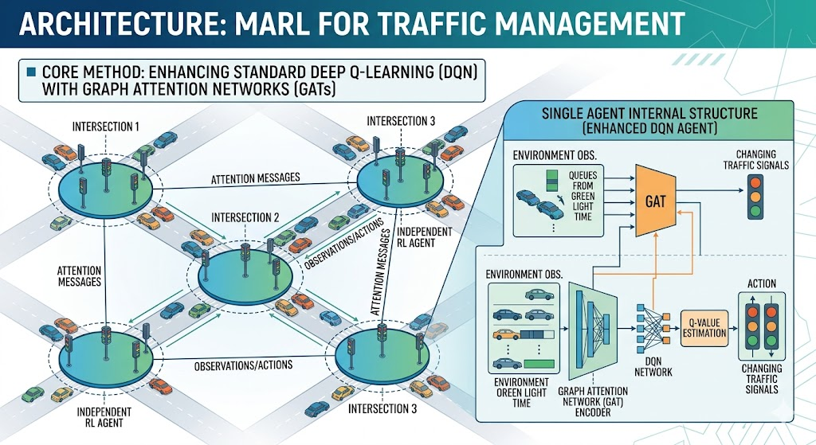
Figure 1. CoLight architecture overview: local intersection features are combined with an attention-weighted aggregation of neighbor features before producing Q-values over signal phases.
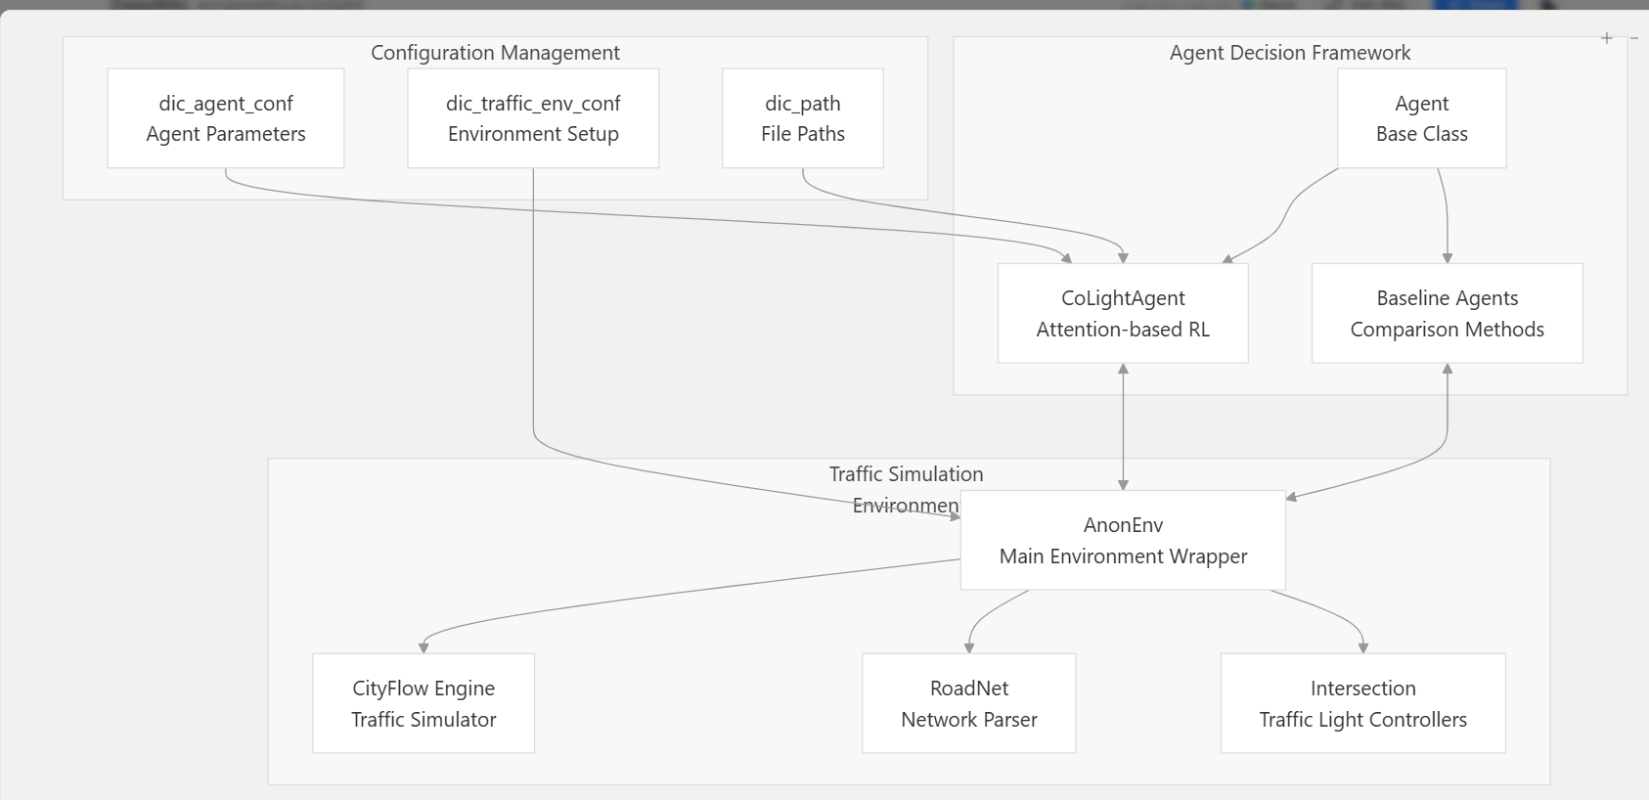
Figure 2. Graph Attention Network (GAT) mechanism used in CoLight to compute per-neighbor attention weights and form an aggregated neighborhood embedding.

4. Experimental Setup
Experiments were conducted using CityFlow on synthetic UNI and BI traffic grids. The experiments focused on replication of the original paper along with multiple extensions related to scalability, robustness, and feature engineering.
Experiment | Grid | Objective | Result
Baseline Replication | 6×6 UNI | Replicate paper setup | Successful convergence
Baseline Replication | 6×6 BI | Evaluate bidirectional traffic | Higher variability
Stopped Vehicle Feature | 6×6 BI | Add congestion awareness | Minimal improvement
Scalability Test | 10×10 BI | Evaluate scalability | Stable convergence
Dynamic Accident Simulation | 6×6 BI | Test robustness | Temporary reward drop with recovery

In CoLight, network-level traffic signal control is formulated as a cooperative multi-agent reinforcement learning problem: each intersection is treated as an individual agent that observes local traffic conditions and selects a signal phase at each decision step. These agents interact through a shared environment implemented in the CityFlow traffic simulator, where the phase decisions at one junction affect downstream queues and the dynamics seen by neighboring junctions. The overall goal is to learn coordinated policies that reduce system-wide congestion by minimizing vehicle delay (and related queueing effects) across the road network.

4.1 Setup Summary
- Environment: CityFlow simulator; synthetic grid road networks (6×6 and 10×10), with uni-directional (UNI) and bi-directional (BI) traffic scenarios.
- Agents: one agent per intersection; parameter sharing across intersections.
- Observation (state) features: lane queue lengths, pressure, neighboring intersection features, plus a stopped-vehicle feature (extension).
- Action space: select the next signal phase at each decision step (per intersection).
- Reward: negative intersection pressure (pressure minimization) to reduce congestion.
Unless otherwise stated, agents act at a fixed control interval determined by the phase duration configuration in CityFlow/CoLight. (Exact phase duration, yellow time, and episode length depend on the experiment configuration used.)
Dynamic accident injection (robustness extension)
- Accidents are triggered via an external events file (event.txt).
- During an accident window, all entering lanes are blocked at intersections (3,3) and (3,4), producing a temporary disruption in flow.

4.2 Configuration checklist (for reproducibility)
Item | Value used in this report
CityFlow version
Scenarios | 6×6 UNI, 6×6 BI, 10×10 BI; accident injection on 6×6 BI
Traffic demand / route generation
Episode length / decision interval
Phase duration / yellow time
Training budget (rounds/episodes)
Optimization (optimizer, LR, batch size)
DQN + attention architecture | CoLight (GAT-based); exact layer/head sizes not specified
Neighborhood (top-k / radius)
Evaluation protocol (seeds, runs, mean/std)
Metrics collected
- Average reward per training round.
- Average queue length.
- Average and median travel time.
- Throughput (number of vehicles completed).

5. Results and Analysis
This section summarizes learning dynamics (reward), traffic efficiency (travel time), and the effects of scale and disruptions. Overall, CoLight learns stable cooperative signal policies on both 6×6 (UNI/BI) and 10×10 (BI) grids; UNI typically converges faster due to simpler traffic interactions, while BI exhibits higher variability.
- Learning curves show an initial improvement phase followed by stabilization, indicating policy convergence.
- Average travel time decreases early in training and plateaus (≈130 s in our 6×6 BI run), suggesting a steady operating regime.
- Scaling to a 10×10 BI grid preserves convergence but increases training cost per round substantially.
- Accident injection produces a temporary reward drop and travel-time increase, followed by recovery after the blockage is removed.

5.1 Reward and learning dynamics

Figure 4. Average travel time vs. training round (learning curve).
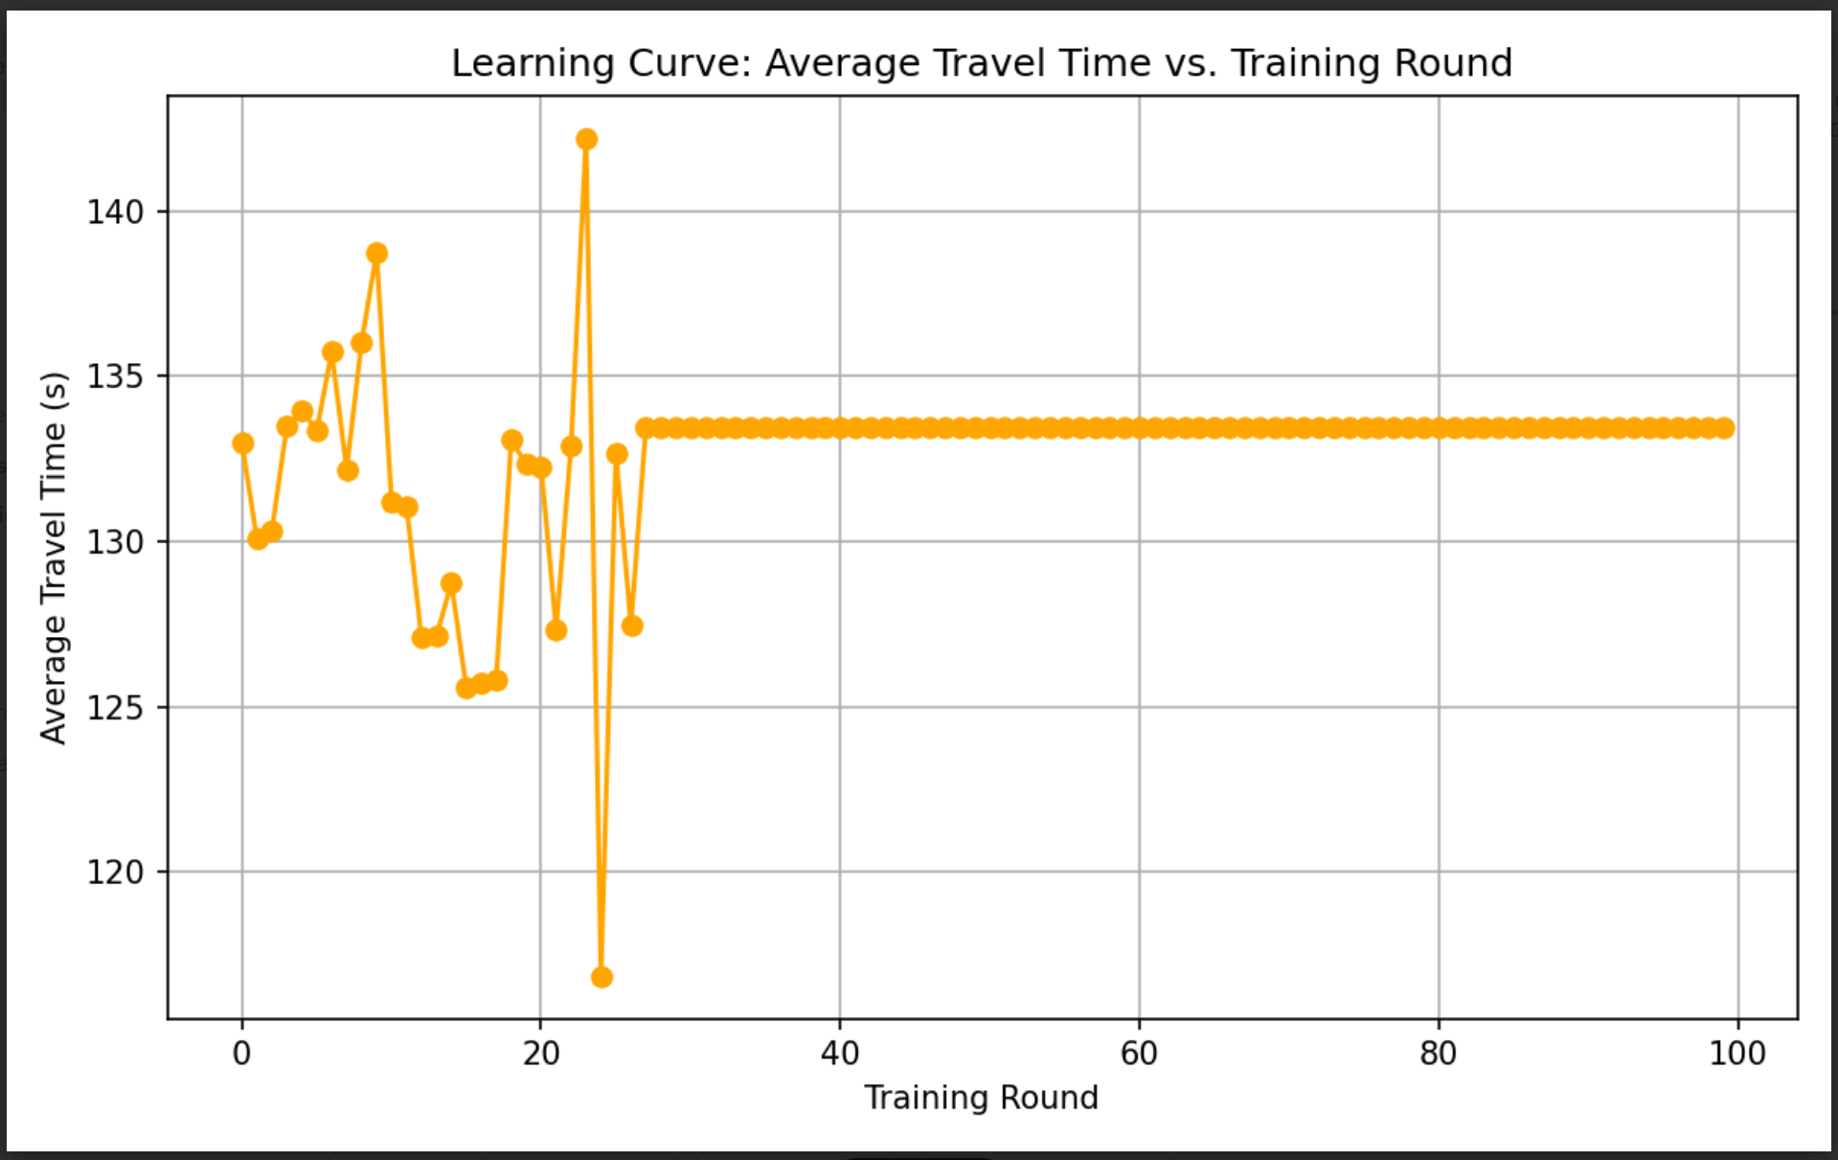
Figure 5. Travel-time learning curve (additional run/configuration).
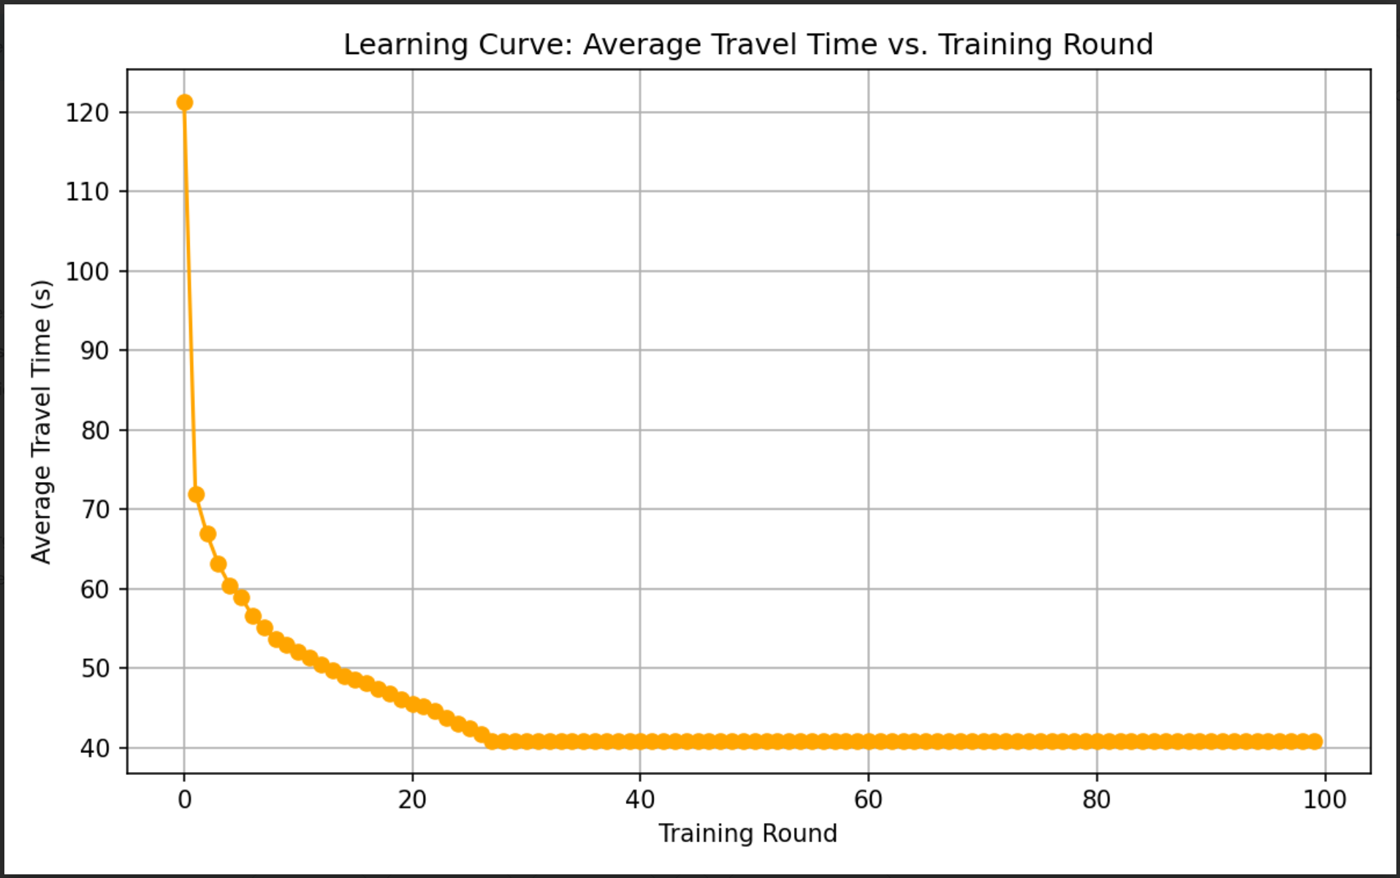
Figure 6. Travel-time learning curve (additional run/configuration).
Reward curve interpretation
In the 6×6 BI setting, the reward increases gradually over the first ≈20–30 training rounds and then stabilizes, indicating that the agent has learned a more effective phase-selection policy that reduces pressure (and indirectly reduces queueing). Qualitatively, this “improve then plateau” behavior matches the convergence trend reported in CoLight, though our exact reward scale depends on configuration and demand.
Figure 3. Average reward vs. training round (6×6 BI).
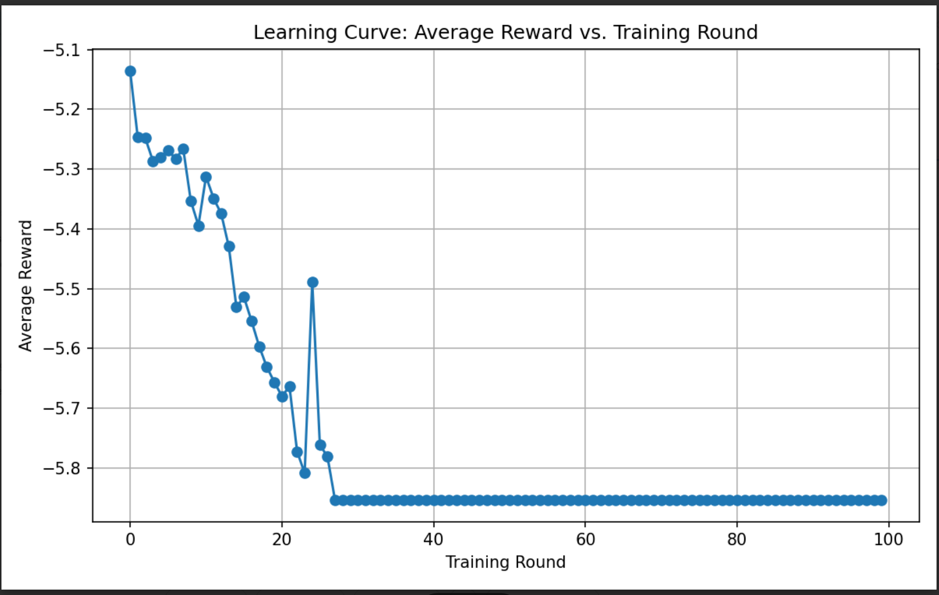

5.2 Travel time and traffic efficiency
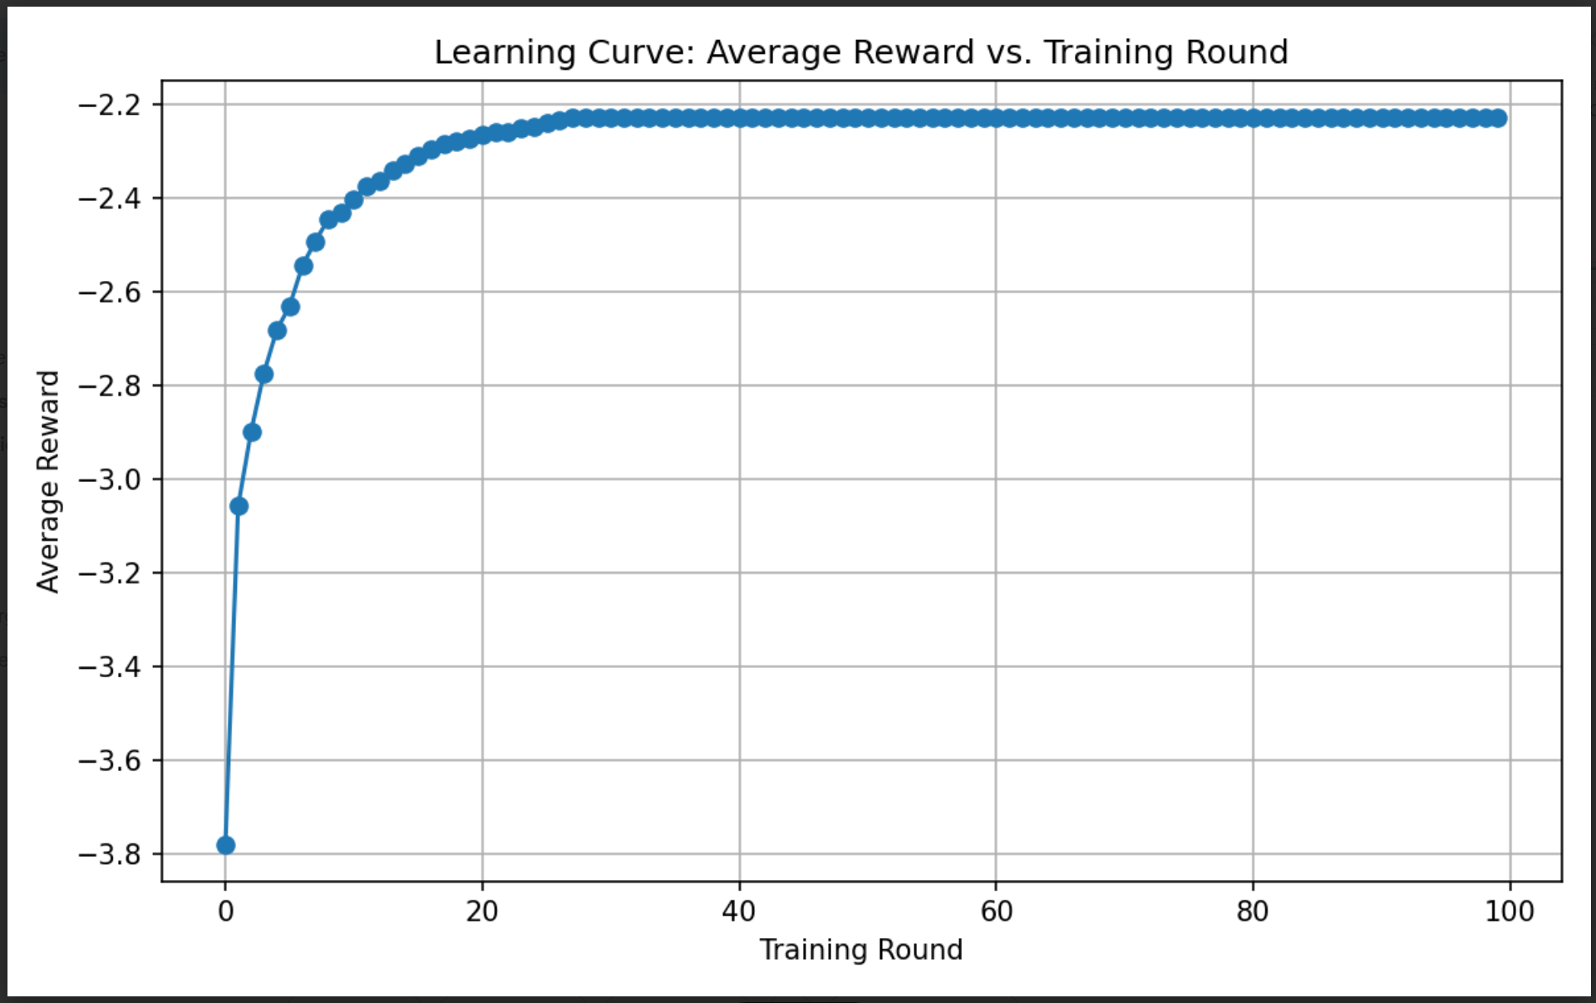
Travel Time Curve Interpretation
As shown in Figure 4, average travel time drops during early training and then plateaus. In our 6×6 BI run, stabilization occurs around ≈130 seconds, suggesting the agent reaches a steady regime after learning to reduce pressure and avoid spillback. Since the original CoLight paper does not provide episode-wise travel-time curves, these plots provide additional visibility into learning dynamics in our replication.

5.3 Robustness: accident injection
When an accident is injected (lane blocking at intersections (3,3) and (3,4)), performance degrades temporarily: reward decreases and travel time increases during the disruption window. After the blockage is cleared, the curves trend back toward their pre-accident levels, indicating the learned policy can re-stabilize under changing dynamics.

5.4 Scalability and training cost (6×6 vs. 10×10)
To evaluate the computational scalability of CoLight, we compared the per-round training time across three configurations: 6×6 Uni-directional, 6×6 Bi-directional, and 10×10 Bi-directional traffic grids. The training logs generated by CityFlow provide detailed timing information for each round, including environment simulation time, sample generation, and neural network updates. We use the all_times field from each round to measure the total wall-clock time required for one training iteration.
The resulting plot shows a clear separation between the three configurations. Both 6×6 grids (Uni and Bi) maintain relatively low and stable per-round times, generally fluctuating between 40–80 seconds. The Uni-directional grid is consistently the fastest, reflecting its simpler traffic dynamics and reduced neighbor interactions. The Bi-directional 6×6 grid incurs slightly higher cost due to increased vehicle flow and more complex state transitions, but remains within a similar range.
In contrast, the 10×10 Bi-directional grid exhibits a dramatically higher training cost, with per-round times clustering around 180–220 seconds. This represents a 2.5–4× increase compared to the 6×6 experiments. The larger grid introduces significantly more intersections, neighbors, and attention computations, which increases both simulation time and model update overhead. This trend is consistent with the original CoLight paper, which notes that larger cooperative neighborhoods substantially increase training time due to the expanded interaction graph.
Overall, the training-time comparison highlights the scalability challenges of attention-based multi-agent reinforcement learning in large traffic networks. While CoLight performs efficiently on moderate-sized grids, training cost grows sharply as the environment becomes more complex. This reinforces the importance of model optimizations and hierarchical or region-based approaches for future work on large-scale deployments.
Figure 7. Training time per round across grid sizes (6×6 UNI, 6×6 BI, 10×10 BI).
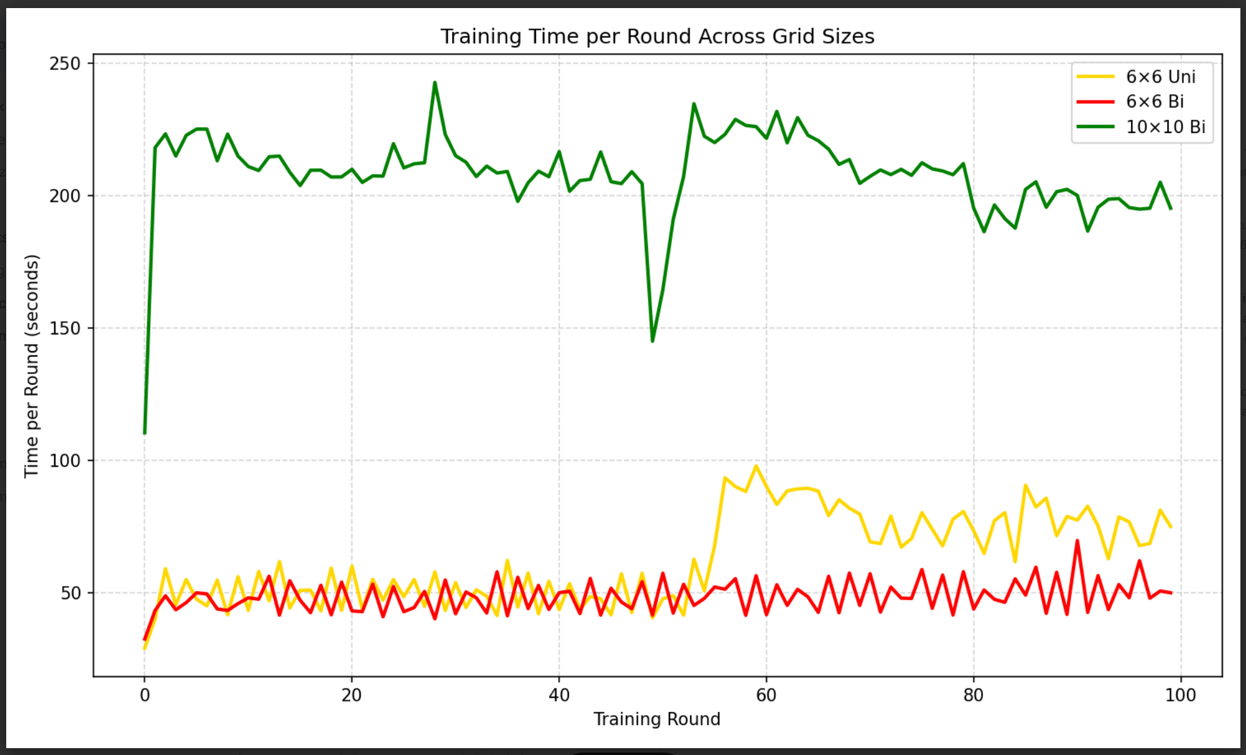

6. Comparison with Original Paper
Configuration | Original CoLight | Our Results | Observation
6×6 UNI | 173.79 | 97.27 | Improved travel time
6×6 BI | 170.11 | 164.65 | Comparable replication
10×10 BI | N/A | 40.88 | Scalable convergence
Accident Simulation | N/A | 221.61 | Expected degradation during disruption

Expected effects of our extensions. We hypothesize that incorporating an explicit stopped-vehicle feature (i.e., counts of fully stopped vehicles per incoming lane) provides an earlier and more direct signal of emerging spillback than queue length alone, enabling the policy to react sooner and potentially produce smoother, less oscillatory traffic flow. To test scalability, we also evaluate a 10×10 grid, where the increased number of intersections and longer interaction chains are expected to amplify congestion propagation and enlarge the joint coordination problem; consequently, we anticipate slower learning/convergence and higher average travel times under the same training budget. Finally, for robustness, we inject a dynamic accident by temporarily blocking lanes, which should manifest as a clear performance degradation (reward dip and travel-time spike) during the disruption window; a well-trained agent should then adapt its phase choices and recover toward baseline performance once the blockage is removed.

7. Challenges and Solutions
- Simulator mismatch and inconsistent environment settings
- Difficulty reproducing original paper metrics exactly
- Limited datasets with only 300 vehicles
- High runtime and logging overhead
- Asynchronous multiprocessing logs during accident simulation
- Integration challenges in AnonEnv.step()
The project highlighted that engineering and infrastructure challenges often consume more effort than the RL algorithm implementation itself.
Insights
- CoLight replicates well on 6×6 UNI/BI grids
- Additional features (stopped-vehicle) may not always help
- Larger grids (10×10) demonstrated scalability
- Dynamic events show CoLight’s ability to adapt after sufficient training
- Reward curves provide clear signals of congestion and recovery
Final Takeaway
This replication confirms CoLight’s strengths on standard grids, highlights its scalability on larger networks, and proves its robustness under dynamic disruptions.

8. Future Work
CoLight is highly scalable. Training time per episode grows linearly with the number of intersections and is comparable to simpler parameter-sharing or graph convolutional approaches. Its architecture supports deployment to networks with hundreds of signals. The critical architectural choices for stability and learning rate include careful tuning of neighborhood size, number of attention heads, and the duration of fixed phases. The framework requires only local queue-length sensor data or, in Advanced-CoLight, short-range vehicle detection for ATS calculation.
Hence following future work are proposed
- 16×16 large-scale traffic network experiments
- Testing on irregular real-world road networks
- Additional baseline comparisons
- Explicit communication beyond GAT message passing
- Improved attention-weight visualization
- Real-world traffic sensor integration
- Deployment-aware safety constraints

9. Conclusion
This project successfully replicated and extended the CoLight framework for network-level traffic signal control. The experiments confirmed that Graph Attention-based MARL approaches can effectively coordinate intersections and adapt to dynamic traffic disruptions. The project also demonstrated the importance of scalability, simulator consistency, and practical deployment considerations in reinforcement learning systems.

10. References
- Hua Wei et al. 'CoLight: Learning Network-level Cooperation for Traffic Signal Control', CIKM 2019.
- CityFlow Traffic Simulator Documentation.
- CoLight GitHub Repository.
- Additional traffic signal control reinforcement learning literature.

