

Refund Protect API

Version 0.1

May 23, 2022

Moez Vallani

**Table of Contents**

Document Control 3

1. Overview 4

1.1. Purpose 4

1.2. Scope 4

2. Refund Protect Overview 4

2.1. Overview 4

2.2. API Documentation 4

2.3. Support 4

3. Refund Protect Booking Flow 5

4. UI Flow 6

4.1 Checkout Page 6

4.2 Refund Protect Email Confirmation 7

5. API Mapping 9

5.1 Request Headers 9

5.2 Sales Offering 10

New Bookings (POST) 10

Change Booking (PATCH) 13

5.3 Cancellation 14

# Document Control

|  |  |  |  |
| --- | --- | --- | --- |
| **Date** | **Author** | **Version** | **Change** |
| May 23 2022 | Moez Vallani | 0.1 | Initial Version |
|  |  |  |  |
|  |  |  |  |

# Overview

## Purpose

The purpose of this document is to describe the functional requirements for Refund Protect API

## Scope

The scope of the feature is to allow customers to purchase cancellation insurance for a 100% refund on their trip based on sickness, home emergency, etc

# Refund Protect Overview

## Overview

Refund Protect offers your clients an upgrade on their booking to make it refundable if the booking holder(s) cannot attend for a wide range of reasons. This means they can apply for a refund of 100% of their transaction value, including booking fees and any extras. Protect Group handles the entire refund process, paying refunds directly to the booking holder’s chosen bank account on your behalf.

## API Documentation

<https://www.protectgroup.co/api-guide/refundprotect>

## Support

API Support: [commercial@protectgroup.com](mailto:commercial@protectgroup.com)

Account Manager: Kevin Bolin [kevin.bolin@nfp.com](mailto:kevin.bolin@nfp.com)

Commercial Manager: Julio Martinez [juliom@protectgroup.com](mailto:juliom@protectgroup.com)

Partnership Manager: Cagdas Duran [cagdasd@protechgroup.com](mailto:cagdasd@protechgroup.com)

# Refund Protect Booking Flow

# UI Flow

## 4.1 Checkout Page

**\*\*This is a sample from Refund Protect on the wording but layout/format can be custom. \*\***

| **ID** | **Element** | **Comments** |
| --- | --- | --- |
|  | Refund Protect Form | Display sample form above in Checkout Page, wording can be found in the API documentation ([https://www.protectgroup.co/api-guide/refundprotect#3submitting-a-transaction](https://www.protectgroup.co/api-guide/refundprotect%233submitting-a-transaction)) |
| 1 | Display Booking Total | Choose cancellation protection and receive a total refund of **$XXX.XX** for many reasons including. (Sample Text) |
| 2 | Cost for the service | **$XX.XX**  Cost for insurance (% of booking total) - TBD |
| 3 | More Details | Display Link and URL for More Details  (https://www.refundable.me/covid/) |
| 4 | Terms and Conditions | Display Link and URL for Terms and Conditions (https://www.refundable.me/extended/en/) |
| 5 | Option Button | Add Option for Non Refundable Booking |

## 4.2 Refund Protect Email Confirmation

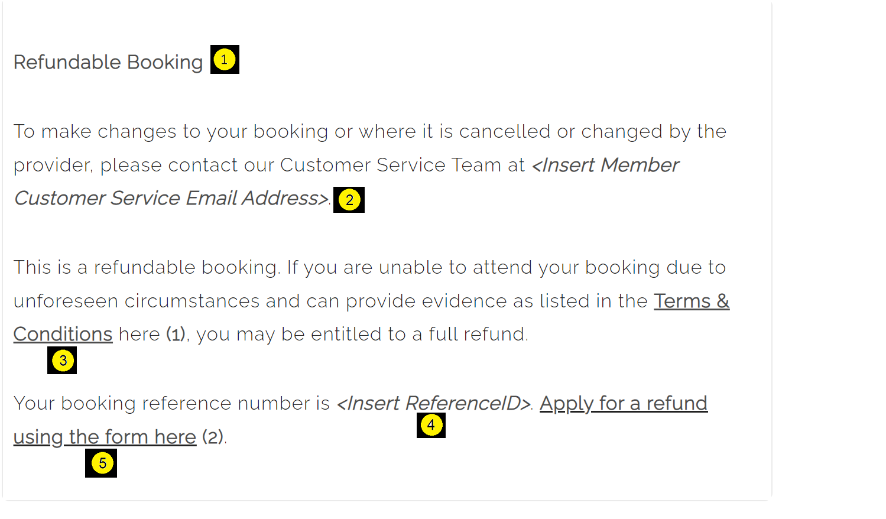This should be a separate email confirmation for Refund Protect that has the following details. Add Logo, Customer Details, Booking Details, etc

| **ID** | **Element** | **Comments** |
| --- | --- | --- |
| 1 | Refundable Booking Section | Add a new section in Email Confirmation called Refundable Booking with the details above. |
| 2 | <Insert Customer Service Email> | Add Travel Agency contact information |
| 3 | Terms Conditions | https://www.refundable.me/extended/en/ |
| 4 | <Reference ID> | UniqueID for the booking  **Multi product:** Use CartID, OrderID, etc, this will be the ID for booking multiple products booking.  **Single Booking**: confirmation number for AIR, HOTEL or CAR Rental. |
| 5 | Refund Form | https://form.refundable.me/forms/refund?memberId=<XXX>&bookingReference=<BookingConfirmationNumber>  Add MemberID (email Julio Martinez [juliom@protectgroup.com](mailto:juliom@protectgroup.com)) and Booking Confirmation ID in the URL.  Example  <https://form.refundable.me/forms/refund?memberId=183&bookingReference=ABC123> |

# API Mapping

## 5.1 Request Headers

**Test URL**: https://test.api.protectgroup.co/api/v1/

| **ID** | **Element** | **Value** |
| --- | --- | --- |
| 1 | X-RefundProtect-VendorId | ven_local_e78078716503454e82d57e43da2310f3 |
| 2 | X-RefundProtect-AuthToken | sk_local_099e80fda05a460d9fca495e504ab3db |

VendorId and AuthToken(Key) needs to be added to each request headers.

## 5.2 Sales Offering

### New Bookings (POST)

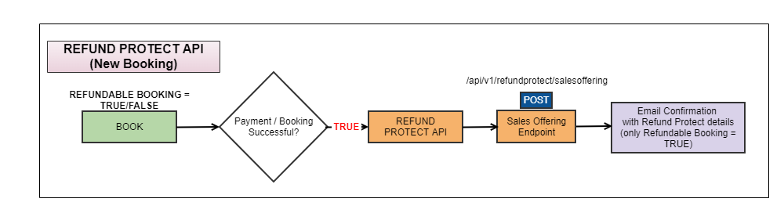Endpoint: https://test.api.protectgroup.co/api/v1/refundprotect/salesoffering

We need to receive all transactions in the format provided below. We also need to know when the customer chooses not to select a Refundable Booking as this helps us to improve commercial performance and prevent fraud.

| **POST** | | |
| --- | --- | --- |
| **Element** | **Description** | **Comments** |
| vendorCode | VendorID | ven_local_e78078716503454e82d57e43da2310f3 |
| vendorSalesReferenceID | Order ID | UniqueID for the booking  **Multi product:** Use CartID, OrderID, etc, this will be the ID for booking multiple products booking.  **Single Booking**: confirmation number for AIR, HOTEL or CAR Rental. |
| VendorSalesDate | Date of the booking | YYYY-MM-DDTHH:mm:ss.ssss |
| CustomerFirstName | First Name of customer | Primary Customer First Name |
| CustomerLastName | Last Name of customer | Primary Customer Last Name |
| paymentProviderId | Provider id | Not Required |
| paymentTransactionId | Transaction id | Not Required |
| products | List of products | List of objects containing the product details |
| products/productCode | Type of the main product | It could be:  TKT: A single ticket or reservation for an event, transportation, tour, activity, or any other non-refundable entry ticket.  PKG: A package comprises a mix of a ticket/tour/transportation AND lodging, travel, and other services.  HTL: This refers to any non-refundable or non-cancelable lodging reservation.  Use PKG when 2+ products are booked (flights, hotels, cars, etc)  HTL, when is just a hotel. Doesn't matter the refund terms. TKT for all other sales |
| products/currencyCode | Currency code | Currency code in which product was bought. |
| products/productPrice | Price | Cost of the product along with booking fees, payment fees, refund protect fees, etc. |
| products/premiumRate | Rate of premium | The customer is charged this percentage for the service (e.g 8%). |
| products/offeringMethod | Method | The Refund Protect method you're offering and must be one of the following values:  OPTION-IN — The customer must choose to be protected.  OPTION OUT – The service is either pre-selected for the customer or built into the transaction automatically. |
| products/sold | Product’s sales status | If the customer has selected Refund Protect on their booking, this informs the Protect Platform. The content should be "true" if it is sold. The text should be "false" if the consumer has not chosen to protect their booking. |
| products/insuranceEndDate | Insurance end date | Day when the booking starts |

**Example Request**

{

"vendorCode": "myVendorID",

"vendorSalesReferenceId": "REF123456",

"vendorSalesDate": "2019-03-15T09:16:54.06792+02:00",

"customerFirstName": "James",

"customerLastName": "Bond",

"products": [

{

"productCode": "TKT",

"currencyCode": "ZAR",

"productPrice": 500,

"premiumRate": 8.5,

"offeringMethod": "OPT-IN",

"sold": true,

"insuranceEndDate": "2019-09-13T18:30:00+02:00"

}

]

}

| **Response** | |
| --- | --- |
| **Code** | **Description** |
| 200 | OK Signal |
| 202 | OK Signal, delay more than 3 seconds occurred |
| 400 | Bad Request, Request Call not implemented |
| 401 | Not-authorised; you are missing authorisation |
| 405 | Current method not allowed; needs to be PUT/POST method |
| 408 | Request timeout response taking too much time to complete |
| 413 | Request entity too large or submitted entry too large |
| 422 | Entity unable to be processed as it is missing data (e.g. missing productPrice value) |
| 500 | Internal server error, no data stored |
| 507 | Insufficient storage, no data stored |

### Change Booking (PATCH)

Endpoint : https://test.api.protectgroup.co/api/v1/refundprotect/salesoffering

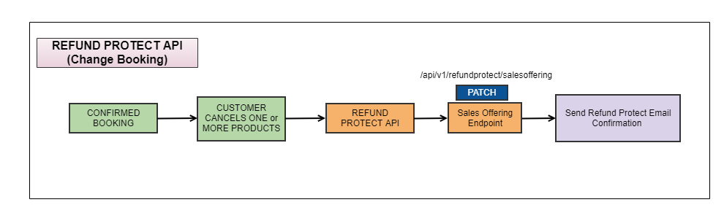

The Patch is used to update our platform of changes in value and/or end date when the customer makes changes to their booking.

The initial transaction will be made with the method "Post". If you'd like to amend this transaction value or end date you can send a second transaction with the exact same reference number with the method "Patch".

PATCH is treated as additional to what is already there; it doesn't replace the data that is already there.

## 5.3 Cancellation

Endpoint : [https://test.api.protectgroup.co/api/v1/refundprotect/{VendorSalesReferenceId}](https://test.api.protectgroup.co/api/v1/refundprotect/%7bVendorSalesReferenceId%7d)

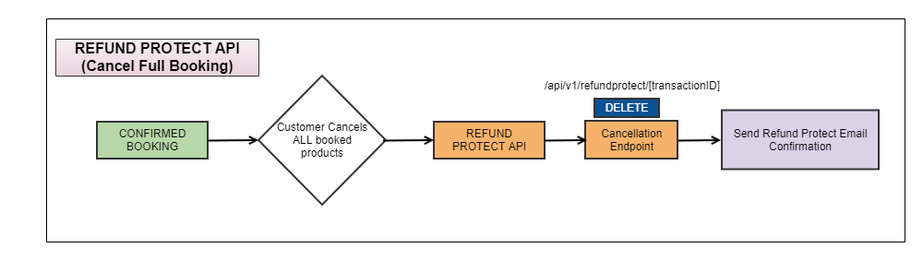

| **Request** | | |
| --- | --- | --- |
| **ID** | **Element** | **Comments** |
| 1 | vendorSalesReferenceId | To be sent in the URL at the end after a ‘/’ such as:  <https://test.api.protectgroup.co/api/v1/refundprotect/REF654321>  Pass the Confirmation Number for the booking in the URL |

| **Response** | |
| --- | --- |
| **Code** | **Description** |
| 200 | OK Signal |
| 202 | OK Signal, delay more than 3 seconds occurred |
| 400 | Bad Request, Request Call not implemented |
| 401 | Not-authorised; you are missing authorisation |
| 405 | Current method not allowed; needs to be PUT/POST method |
| 408 | Request timeout response taking too much time to complete |
| 413 | Request entity too large or submitted entry too large |
| 422 | Entity unable to be processed as it is missing data (e.g. missing productPrice value) |
| 500 | Internal server error, no data stored |
| 507 | Insufficient storage, no data stored |