Online multi-tenant  
air travel platform

Design Document

acuomo@ctw.travel

Abstract

The purpose of this document is to provide functional design for a project to build an online air travel booking platform using CTW as back-end service provider





# Executive summary

Xeniapp has requested that CTW provide a design for an end-to-end online air travel sales platform for the purpose of building and adding to the Xeniapp platform an air business component.

This document provides a detailed business and technical design for a project intended to build an online air travel booking platform using the CTW Platform APIs as back-end service provider.

This design document details the main workflows for air itineraries and ancillaries offer shop, price, book, ticket, reshop, reprice, exchange and refund for B2C and B2B clients as well as mobile, administrators and super administrators. Screens and actions taken by different user roles are described.

B2C users have the ability to perform all modern online travel agencies functions. B2B users have access to the same tools they are used to in a GDS environment but in a user-friendly GUI form. Administrators can manage B2B clients and the air content provided to downstream clients. Management reporting and business intelligence modules are included for administrators and super administrators.

The system is intended as a white-labeled product which can be branded based on clients’ specifications allowing the customer to operate different web applications from the same linearly scalable production environment.

Table of Contents

Executive summary 1

Glossary 7

CTW Platform API services 7

Overview 7

Authentication, Authorization and Session management 8

Offer services 8

Itinerary Shop 8

Itinerary Price 8

Itinerary Reshop 8

Itinerary Reprice 9

Ancillaries Shop 9

Ancillaries Price 9

Ancillaries Reshop 9

Ancillaries Reprice 9

Order services 9

Order Booking Create 10

Order Booking Change 10

Order Ticket Issue 10

Order Ticket Change 10

Auxiliary services 10

Fares Text Rules 10

Flights 10

Itinerary Seatmap 11

Common workflows 11

Workflow Transitions for issuing and servicing tickets 11

Workflow Transitions for issuing and servicing ancillaries 12

Shop 12

General description 12

User input 13

Response Visualization and actions 15

Selecting a solution 15

Sorting and Filtering the results 15

Shop Expand a solution 16

General description 16

Sections 16

Price (Add to Cart) 18

General Description 18

Sections 18

Actions 19

Book 19

General description 19

Actions 19

Ticket issue/Order View 20

General description 20

Actions 20

Reshop 20

General description 20

User input 21

Response Visualization and actions 22

Selecting a solution 22

Sorting and Filtering the results 22

Reshop expand solution 23

Sections 23

Exchange Cart 24

General description 24

Sections 25

Refund 25

General description 25

Void PNR (for UTL-2 only) 26

General description 26

Actions 26

Screens for Workflow B – Ancillaries issuance and servicing 27

Ancillaries Shop 27

Free baggage allowance section 27

Paid baggage section 28

Amenities section 28

Seats section 29

Ancillaries book 29

Ancillaries reshop, reprice 29

Ancillaries rebook 30

Ancillaries refund 30

Ancillaries void 30

Administrative screens 30

Description 30

Administrative Screen for UTL1 (ADM-1-UTL1) 30

Section User Profile ADM-1-UTL1-PRF-LST 31

Section User Profile ADM-1-UTL1-PRF-EDT 31

Fields 31

Security details 31

Personal details 31

FoP Details 32

Frequent Flier Info 32

FoID 32

Visas details 32

Actions 32

Section Transaction history (Air) (ADM-1-UTL1-HST) 33

Fields 33

Actions 33

Administrative Screen for UTL2 (ADM-2-UTL2) 33

Section User Profile (ADM-2-UTL2-PRF) 34

Section Order history (Air) (ADM-2-UTL2-HST) 34

Section Add User (ADM-2-UTL2-ADD) 34

Section Manage Users (ADM-2-UTL2-UMG) 34

Fields 34

Actions 34

Section Manage Add Mark-up rule (ADM-2-UTL2-MUP-ADD) 35

Fields 35

Actions 35

Section View/Edit Mark-up rules (ADM-2-UTL2-MUP-LST) 35

Fields 35

Actions 35

Administrative Screen for UTL3 (ADM-3-UTL3) 36

Section User Profile (ADM-2-UTL3-PRF) 36

Section Transaction history (Air) (ADM-2-UTL3-HST) 36

Section Add User (ADM-3-UTL3-ADD) 37

Section Manage Users (ADM-3-UTL3-UMG) 37

Fields 37

Actions 37

Section Manage Add Mark-up rule (ADM-3-UTL3-MUP-ADD) 37

Section View/Edit Mark-up rules (ADM-3-UTL3-MUP-LST) 37

Administrative Screen for UXL1 (ADM-4-UXL1) 37

Section User Profile (ADM-4-UXL1-PRF) 38

Section Transaction history (Air) (ADM-4-UXL1-HST) 38

Section Add User (ADM-4-UXL1-ADD) 38

Section Manage Users (ADM-3-UXL1-UMG) 38

Fields 38

Actions 38

Section Add Tenant (ADM-4-UXL1-TN-ADD) 39

Section View / Modify Tenants (ADM-4-UXL1-TN-LST) 39

Fields 39

Actions 39

Section Manage Add Mark-up rule (ADM-4-UXL1-MUP-ADD) 40

Section View/Edit Mark-up rules (ADM-4-UXL1-MUP-LST) 40

Content management 40

Screen block content to tenant (CM-1-BL) 40

Description 40

Section Add new restriction (CM-1-BL-ADD) 40

Fields 40

Actions 40

Section Existing restrictions (CM-1-BL-LST) 41

Fields 41

Actions 41

Screen set PCC for tenant (CM-2-PCC) 42

Description 42

Section New assignment of PCC to tenant (CM-2-PCC-ADD) 42

Fields 42

Actions 42

Section Existing restrictions (CM-2-PCC-LST) 43

Fields 43

Actions 43

Screen set limits for tenant (CM-3-LIM) 43

Description 43

Section New Limit for tenant (CM-3-LIM-ADD) 44

Fields 44

Actions 44

Section List existing limits (CM-3-LIM-LST) 44

Fields 44

Actions 44

Separate CTW accounts for Tenants (CM-4-MU) 45

Security Module (CM-5-SEC) 45

Screen Add / View / Modify Volume restrictions (CM-5-SEC-VOL) 46

Section Add Volume restriction (CM-5-SEC-VOL-ADD) 46

Section View / Modify Volume restrictions (CM-5-SEC-VOL-LST) 46

Screen Add / View / Modify Usage restrictions (CM-5-SEC-USG) 47

Section Add Volume restriction (CM-5-SEC-USG-ADD) 47

Section View / Modify Volume restrictions (CM-5-SEC-USG-LST) 47

Screen Add / View / Modify a PCC (CM-5-SEC-PCC-1) 48

Section Add PCC (CM-5-SEC-PCC-1-ADD) 48

Section View / Modify PCC (CM-5-SEC-PCC-1-LST) 48

Screen Add / View / Modify Tenant-PCC associations (CM-5-SEC-PCC-2) 48

Section Add PCC-tenant association (CM-5-SEC-PCC-2-ADD) 48

Section View / Modify PCC-Tenant association (CM-5-SEC-PCC-2-LST) 48

Content Optimization Module (CM-6-OPT) 49

Screen Add / View / Modify a COR (CM-6-OPT) 49

Section Add COR (CM-6-OPT-ADD) 49

Section View / Modify COR (CM-6-OPT-LST) 50

Section Upload CORs (CM-6-OPT-UPL) 50

Management reporting 51

Screen with management reporting graphs (MR-1-GRP) 52

Time series line graphs 52

Relevance describing Bar graphs 53

Mark-ups processing, Middleware 53

Client UI 56

Admin UI 56

Admin Backend 56

Security/Markup DB 57

Search Results DB 57

Middleware Server 57

Technology and Scalability 57

Authentication requests 58

Shop requests workflow 58

Price requests workflow 58

Subsequent order requests 58

# Glossary

* User definitions:
  + UTL1 – User Tenant Level 1. This is the level for (B2C) end-users
  + UTL2 – User Tenant Level 2. This is the level for Sales agent of an agency
  + UTL3 – User Tenant Level 3. This is the level for Command center of an agency
  + UXL1 – User Xeniapp Level 1. This is the level for user Xeni (super administrator).
* TBGI – Tenant branded graphical user interface instance (front-end). This is an instance of the UI that is branded for a specific tenant.
* MW – middleware – this is the name of the module that will be responsible for changing requests before they are sent to CTW and after they are received from CTW and before they are sent to the TBGI for visualization.
* GK – Gate Keeper - a security module that is described in section Content Management – CM-5-SEC.
* COM – Content optimization module, used to decide the best potential PCC that a TBGI should use for each request.
* COR – Content optimization rule – defined in the COM; these rules determine the best PCC with which a request will be sent based on request criteria.

# CTW Platform API services

## Overview

CTW Platform provides Online Air Travel Management API web-services accessed over the internet (HTTPS). There are two types of services: Offer and Order.

Offer services generate air travel itinerary and ancillaries offers only which are "fire-and-forget", i.e. they are not persisted and it is up to the user to use the content of the offer for further processing.

Order services deal with the generation and management of Passenger Name Records (PNRs), electronic tickets (ETKTs) and electronic miscellaneous documents (EMDs) in a Global Distribution System (GDS) or airline passenger reservation system (PSS).

A GDS is a computerized system that enables transactions between airlines and travel agencies, i.e. it is the marketplace where travel agencies can book flight segments and issue electronic tickets on behalf of airlines. Once a PNR is created or an ETKT is issued in the GDS, it gets sent and copied to all of the PSSs of the airlines involved in the journey.

A PSS is a computerized system that stores and manages airlines’ inventory and bookings.

A PNR is a record in the GDS or airlines’ PSS system. It contains as a minimum the full name of all passengers on the reservation. Other important pieces of information usually stored in a PNR are flight segments bookings, airfare pricing, electronic ticket numbers, EMDs for purchased ancillaries (such as paid seats, extra paid baggage, etc.) when the reservation is made through the GDS.

An electronic ticket (ETKT) is the document needed for air travel. It is issued based on a reservation of flights and associated fare pricing.

## Authentication, Authorization and Session management

Authentication and authorization are done using username and password. Each middleware server should acquire session token using the credentials and use it to authenticate each request it issues to the CTW servers.

## Offer services

Offer services are the backbone of CTW Platform. To successfully generate itinerary and ancillaries offers the engine uses airlines airfares, brands and fare rules filed in ATPCO, air schedules from OAG, additional rules (e.g. exchange rates, interline agreements, EMA, TPM / MPM, etc.) from IATA, flight inventory and availability information from the airlines' PSS systems. Detailed technical documentation can be found at [https://api.ctw.direct](https://api.ctw.direct/)

### Itinerary Shop

This service generates a list of cheapest offers on a variety of airlines and routings for a specified list of Origin-and-Destinations and travel dates. Its input is the intended booking environment (seller), passengers' information and request segments (OnD + travel dates). Output is the list of itinerary offers complete with full pricing and booking information. Additional options for itinerary shop are calendar (+/-14 days on a single airline), flex (+/-3 days on multiple airlines), half round-trip. CTW Platform endpoint is /itinerary_shop. This service is to be used on the Shop screen.

### Itinerary Price

This service generates a list of multi-cabin and branded fares offers for a specified set of flights. Its input is the intended booking environment (seller), passengers' information and specified flights. Output is the list of itinerary offers in different cabins and brands complete with full pricing and booking information. An additional option for itinerary price is ancillaries offers related to every itinerary offer. CTW Platform endpoint is /itinerary_price. This service is used on the Cart screen.

### Itinerary Reshop

This service generates a list of itinerary exchange offers for a specified unused or partially flown ETKT. Its input is the intended booking environment (seller), passengers' information and ETKT. Output is the list of cheapest itinerary exchange offers complete with full exchange and booking information. CTW Platform endpoint is /itinerary_reshop. This service is used on the Reshop screen.

### Itinerary Reprice

This service generates a list of multi-cabin and branded fares offers for an unused or partially flown ETKT and specified set of new flights OR a refund offer. Its input is the intended booking environment (seller), passengers' information, ETKT and specified flights. Output is the list of itinerary offers in different cabins and brands complete with full pricing and booking information OR refund information. CTW Platform endpoint is /itinerary_reprice. This service is used on the Refund screen and Exchange Cart screen.

### Ancillaries Shop

This service generates a list of ancillaries offers for a specified itinerary offer OR already booked itinerary. Its input is the intended booking environment (seller), passengers' information and (booked or not) itinerary offer. Output is the list of ancillaries offers complete with full pricing and booking information. CTW Platform endpoint is /ancillaries_shop. This service is to be used on the Cart screen and Order View screen (for adding additional ancillaries to an already booked / ticketed order).

### Ancillaries Price

While ancillaries shop gives a menu of ancillaries options, this service gives exact total pricing for a list of ancillaries associated with an itinerary that were selected by the user. If any bundle discounts are available, this service would calculate them. CTW Platform endpoint is /ancillaries_price. This service is to be used on the Cart screen and Order View screen (for adding additional ancillaries to an already booked / ticketed order).

### Ancillaries Reshop

This service generates a list of ancillaries' exchange offers when an ETKT is to be exchanged. Its input is the intended booking environment (seller), passengers' information and exchange (ticketed or not) itinerary offer. Output is the list of ancillaries' exchange offers complete with full pricing and booking information. CTW Platform endpoint is /ancillaries_reshop. This service is to be used on the Exchange Cart screen.

### Ancillaries Reprice

While ancillaries Reshop gives a menu of ancillaries options, this service gives exact total pricing for a list of ancillaries associated with an exchange itinerary that were selected by the user. If any bundle discounts are available, this service would calculate them. CTW Platform endpoint is /ancillaries_reprice. This service is to be used on the Exchange Cart screen.

## Order services

Order services store and manage Orders in CTW Platform as well as transacts with the backend booking and ticketing environments (GDS and PSS). These use offers generate by the offer system as input. Detailed technical documentation can be found at [https://api.ctw.direct](https://api.ctw.direct/)

### Order Booking Create

Creates an order in CTW Platform and also creates a PNR in the relevant booking environment (GDS and PSS). The relevant booking environment is determined by the seller specified in the request. Input for this service is input is the intended booking environment (seller), passengers' information (incl. full names and accurate date of birth) and an itinerary offer to be booked. Alternatively, just a list of flights might be booked without pricing information. That can be is useful to agents for holding flights before deciding on pricing. Output is an Order Id and the result of the transactions in the booking environment. CTW platform endpoint service is /order_booking_create . This service is to be used on the Book screen.

### Order Booking Change

Manages an order in CTW Platform and the booking environment. Can be used to cancel / rebook flights, change pricing information, add passenger details. Alternatively, just a list of flights might be booked without pricing information. That can be is useful to agents for holding flights before deciding on pricing. Output is an Order Id and the result of the transactions in the booking environment. CTW platform endpoint service is /order_booking_change. The service is to be used on the Exchange Cart and Refund screen.

### Order Ticket Issue

Issues Electronic Tickets and Electronic Miscellaneous Documents in the booking and ticketing environment (GDS and PSS). The order must be complete with flights, passengers and pricing information. If any bookable ancillaries are also present in the order and are due for ticketing, they will be ticketed, too. CTW Platform endpoint is /order_ticket_issue. It is to be used on the Book screen and Cart screen.

### Order Ticket Change

Reissues Electronic Tickets and Electronic Miscellaneous Documents OR issues a Refund. That is determined based on the new pricing record stored in the order – if it is an exchange pricing record, an exchange will be transacted. If it is a refund pricing record, a refund will be issued. Same for ancillaries.

## Auxiliary services

CTW Platform offers a few additional services to aid agents in their daily work.

### Fares Text Rules

Provides a full list of human-readable fare rules for a specified fare. CTW Platform endpoint is /fares_text. Used on the cart screen.

### Flights

A flights connection builder between two OnDs and travel date. This service does not include any pricing information. Endpoint is /flights. Used on the B2B Cart screen.

### Itinerary Seatmap

Provides a seatmap complete with seat availability and pricing for a flight based on a specified itinerary offer. Endpoint is /itinerary_seatmap. Used on the Cart screen.

## Common workflows

The usual B2C workflow for original ticket issue is:

1) Itinerary Shop (Shop screen)

2) Itinerary Price (Cart screen)

2.1) (Optional) Ancillaries Shop

2.2) (Optional) Ancillaries Price

3) Order Booking Create + Order Ticket Issue (Book screen)

The usual B2B workflow for original ticket issue is:

1) Itinerary Shop (Shop screen)

2) Itinerary Price (Cart screen)

2.1) (Optional) Ancillaries Shop (Cart screen)

2.2) (Optional) Ancillaries Price (Cart screen)

3) Order Booking Create (Book screen)

3.1) (Optional) Order Booking Change (Order View screen)

4) Order Ticket Issue (Order View screen)

The usual B2C workflow for ticket exchange is:

1) Itinerary Reshop (Reshop screen)

2) Itinerary Reprice (Exchange Cart screen)

2.1) (Optional) Ancillaries Reshop (Exchange Cart screen)

2.2) (Optional) Ancillaries Reprice (Exchange Cart screen)

3) Order Booking Change + Order Ticket Change (Exchange Cart screen)

The usual B2B workflow for ticket exchange is:

1) Itinerary Reshop (Reshop screen)

2) Itinerary Reprice (Exchange Cart screen)

2.1) (Optional) Ancillaries Reshop (Exchange Cart screen)

2.2) (Optional) Ancillaries Reprice (Exchange Cart screen)

3) Order Booking Change (Exchange Cart screen)

4) Order Ticket Change (Exchange Cart screen)

# Workflow Transitions for issuing and servicing tickets

There are ten screens in total for issuing and servicing tickets as described in Project Scope A1-A11. Those are as follows:

Shop – Shop Expand Solution – Price (Cart) – Book – Order View – Reshop – Reshop Expand Solution – Exchange Cart – Refund – Void (PNR).

See wireframes here: <https://www.figma.com/proto/aJ9LyACPhcLC6IZSwNNKsD/CTW-Flow>

# Workflow Transitions for issuing and servicing ancillaries

* Shop, Reshop-Ancillaries shop
* Cart, Exchange Cart-Ancillaries shop, price
* Ancillaries price-Ancillaries book
* View-Ancillaries view
* Ancillaries view-Ancillaries reshop, reprice
* Ancillaries reshop, reprice-Ancillaries rebook
* Ancillaries view-Ancillaries refund (offer)
* Ancillaries refund (offer)-Ancillaries refund (action)
* Ancillaries view-Ancillaries void

See wireframes here: <https://www.figma.com/proto/aJ9LyACPhcLC6IZSwNNKsD/CTW-Flow>

Note: there is a second flow called Ancillaries flow, it is selectable in Figma design tool via the top left navigation.

# Shop

### General description

The purpose of this screen is to return flight combination solutions and pricing satisfying the intended travel plans of the customer, including one-way, round-trip, multi-city, calendar search, flex and half-roundtrip journeys. It is possible to request different cabins and/or different brands/fare families for each portion of the itinerary. Each portion of the intended travel is called a segment. In the request each segment describes at a minimum two points between which the customer wants to travel along with the intended departure date.

Once logged in the user fills in the segments info, which consists of city pair(s) and date(s) and provides the number and types (ADT = Adult, CNN = Accompanied child, INF = Infant without a seat) of passengers for which an offer is required. They must specify at least one segment and each segment must have exactly one origin and one destination. Up to 6 segments are allowed. Then they hit the search button and results start to visualize.

This screen is accessible by UTL1, UTL2.

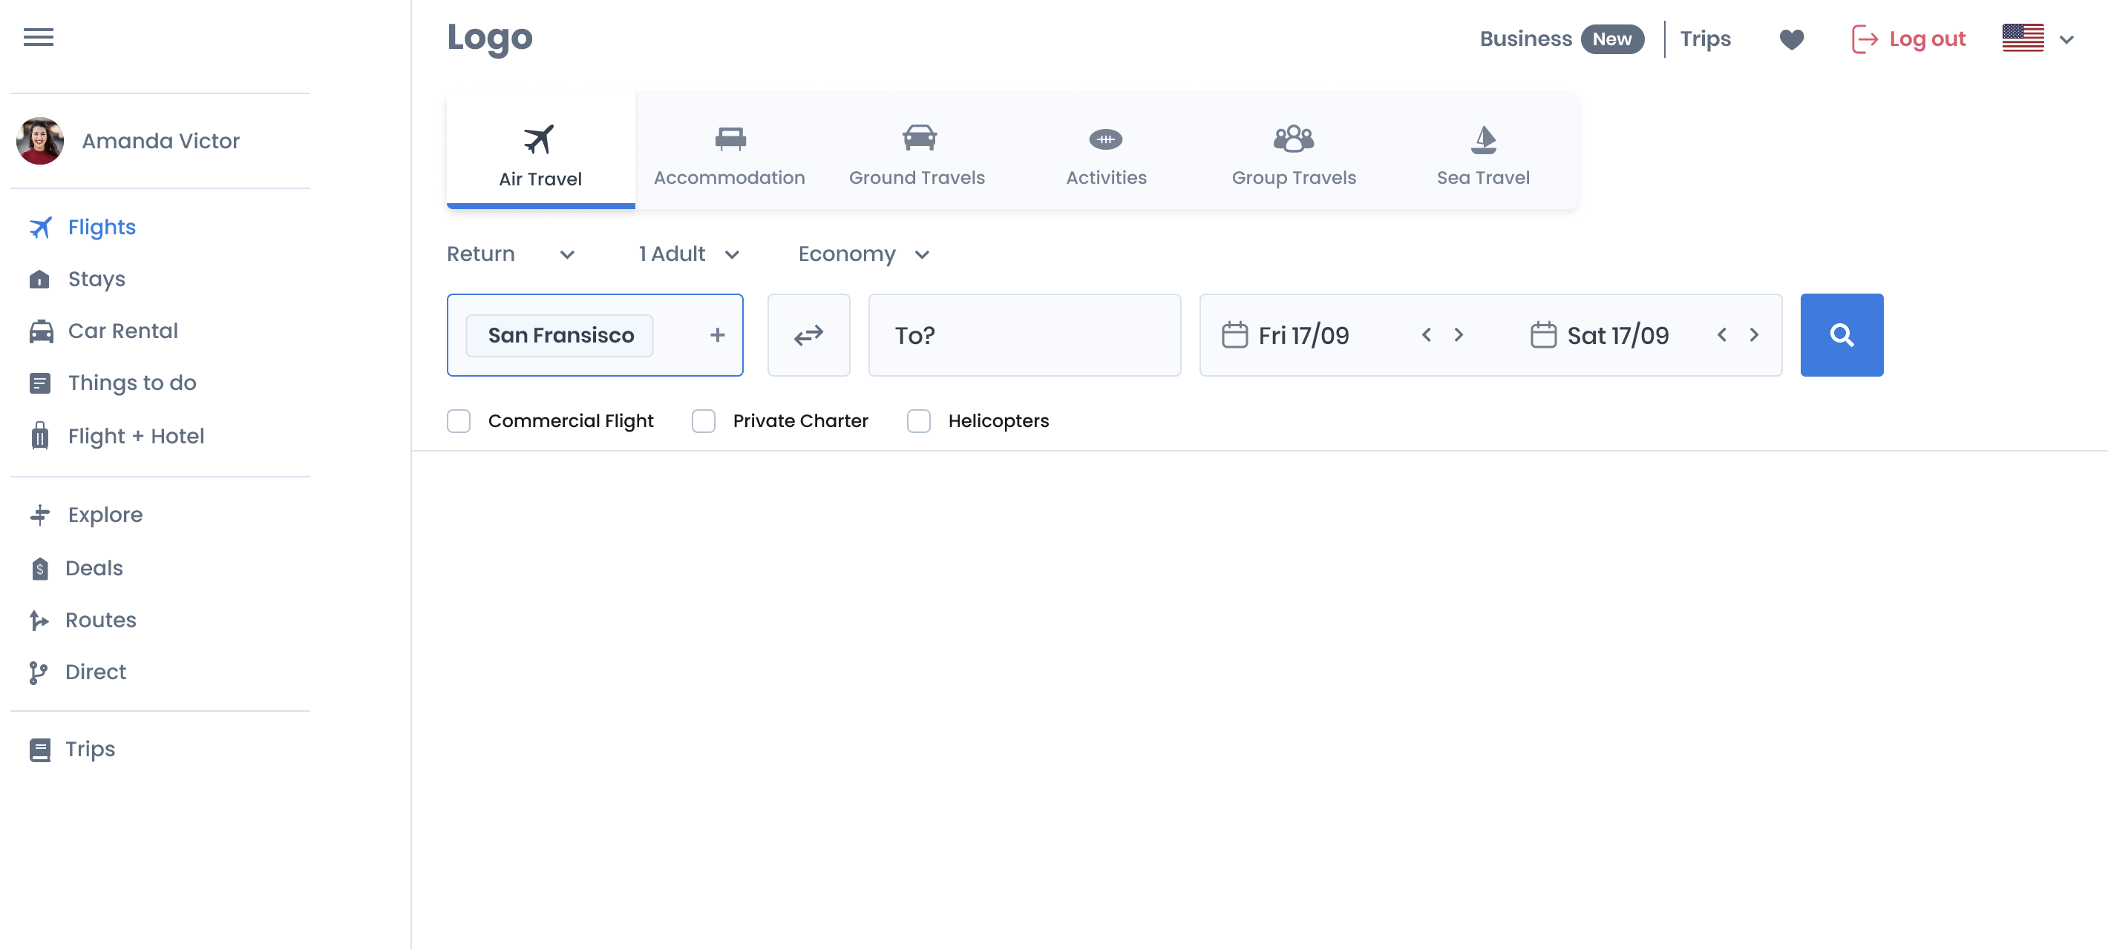

### User input

The screen has three sections:

* Section Add Segments info
  + Required fields:
    - From;
    - To;
    - Departure Date
  + Optional fields:
    - Flex – specifies an interval of dates (days before and/or days after) around the departure date and the arrival date of the travel. The limit for flex search is 6 days in total around the specified departure date. No carrier needs to be specified for the search – solutions for all carriers will be returned.
    - Calendar – Very similar to flex search. The only difference is the date range can be a maximum of 30 days (incl. specified departure date) and a carrier must be specified. Solutions only with the specified carrier will be returned.
    - Fare Airlines (required for the Calendar search) - only offers featuring fares filed by that carrier will be returned, Alliance – only fares filed by airlines members of the selected alliance will be returned. Multi-cabin (cannot be combined with Flex and Calendar searches) -- for each set of flights multiple pricing (cabin) offers will be returned. In each offer the flights can be in different cabins (e.g. a solution where the first flight is in ECONOMY, the second is in BUSINESS, the third is in FIRST, etc.)
    - Multi-step (at least two request segments required; not applicable to one-way searches) – display the outbound flights (and cabins, if coupled with Multi-cabin) first and only after selecting those, then a new request is sent and inbound flights (and their cabins, if coupled with Multi-cabin) start to appear.
    - Max number of Allowed Stops;
    - Cabins (economy, premium economy business, first);
    - Preferred/Excluded Transfer Points – only offers containing or forbidding certain connection points will be returned. Useful if the passenger would like to avoid certain airports for their connections;
    - Depart Before/Depart After – only applicable for the departure of the first flight of the request segment;
    - Allow Overnight Stay – allow offers with connection of more than 4 hours and landing after 10pm local time;
    - Marketing carrier – force or forbid a specified marketing carrier for all or a part of the flights in all returned offers. A marketing airline is the airline that markets the flight; it could be the same airline that operates the flight, or it could be a codeshare flight operated by another airline.
    - Operating carrier – force or forbid offers for which all flights or a portion of the flights are operated by a specific airline.
* Section Passengers info (can be provided at a later stage)
  + Passenger type (PTC) -- can be Adult, Accompanied child, Infant, Student, Military, Seaman, etc. This is used to screen fares filed for specific types of passengers. By default, the Adult passenger type is included in all requests.
  + Date of Birth – some fares are valid only for passengers of a certain age (children, students, youth, senior citizens)
  + Nationality – some countries exempt their nationals from paying certain air travel related taxes. Some airlines file preferential fares for nationals of specific countries. This field is used to screen for such taxes and fares.
  + Residence – some countries exempt their residents from paying certain air travel related taxes. Some airlines file preferential fares for residents of specific countries. This field is used to screen for such taxes and fares.
* Section Advanced Options (has pre-set default values that can be overwritten)
  + Seller (Agent) info – this field is very important for correctly filtering private (consolidator and corporate) content and is also used for correctly determining in which booking environment the eventual booking and ticketing will take place.
  + Account Codes – as per ATPCO definition those are unique codes assigned by each carrier that identifies a particular fare program contracted with a company for that carrier. Useful for UTL-2 agents only.
  + Changeable/Refundable Ticket – force or allow offers which fares are changeable / refundable
  + Currency – show offers converted in a user specified currency
  + Multi-tickets – the solutions returned may include travel on more than one ticket (virtual interline), potentially requiring the customer to re-check at a connecting point. Multiple ticket solutions are returned only if they are cheaper or if they are the only possible solution for a given set of flights.

Frequently used options will be:

* Specify fare owner carriers – filter only offers filed by the specified carrier for each segment
* Specify marketing/operating carrier for each segment
* Choose cabin – every segment may be requested in a different physical cabin. Virtual cabins can additionally be turned on or off. There is an option to allow the customer to specify the cabin only for the most significant of each fare component. Feeder flights may be offered in lower cabin if the higher cabin is not available or if booking the feeder flight in lower cabin results in cheaper total price.
* Set display currency and payment currency – by default all offers are returned in the currency of the seller point of sale, specified by the IATA regulations. This is different from the currency of payment in the passenger field which specifies the currency in which the customer wishes to pay for the ticket. This currency will override the Seller Point of Sale currency as the equivalent currency used for issuing the ticket. If not specified, the Seller Point of Sale currency will be used.

### Response Visualization and actions

After itinerary shop offers start streaming in they are displayed on the screen. Every offer is the cheapest available itinerary offer for the specific flight combination, i.e. the offer uses the cheapest filed fares that satisfie all fare rules for the journey and are also available for sell on all flights in the flight combination.

A new section with a list of offers and their total number appears. Each of the results consists of price, flight origin, destination, departure date and time, marketing and operating carrier, flight number, number of stops, duration, mileage, free baggage allowance, and onboard amenities information. Once the first offers appear, the user has the option to:

* Select a solution (add to Cart)
* Expand solution
* Sort and Filter the results (based on numerous criteria described below)

### Selecting a solution

A button with the total price of offer appears next to each result returned, giving the option to add it to the Cart for detailed review.

### Sorting and Filtering the results

There are a couple of ways to sort and filter the returned results. The three main sorting once are the following:

* Best – a sort score combination of lowest price, minimum flight/stopover/layover time and least number of connections
* Cheapest – the results sorted by price in ascending/descending order
* Fastest – minimum duration travel time across all segmentsFiltering can be applied by multiple criteria such as:
* Number of max stops
* Number of free bags
* Refund offered – free, paid or not offered
* Ticket change offered -- free, paid or not offered
* Intermediate stops; Long layover; Overnight stay
* Operating airline
* Prices slider
* Departure and arrival time sliders
* Departure/Arrival/Connecting airports
* On-board amenities (Movie, WIFI, Telephone, Audio programming, Duty free sales, In-seat power source, etc.)
* Fresh food/Beverage – meal, light meal, snack, alcoholic/non-alcoholic beverage
* Seat legroom

*\*Please note that filters can be applied on sorted results.*

## Shop Expand a solution

### General description

The user can choose to expand the solution before adding it to the Cart. This helps them have a more detailed information for their journey. The information provided will include everything from the initial Response Visualization section, plus additional sub-sections.

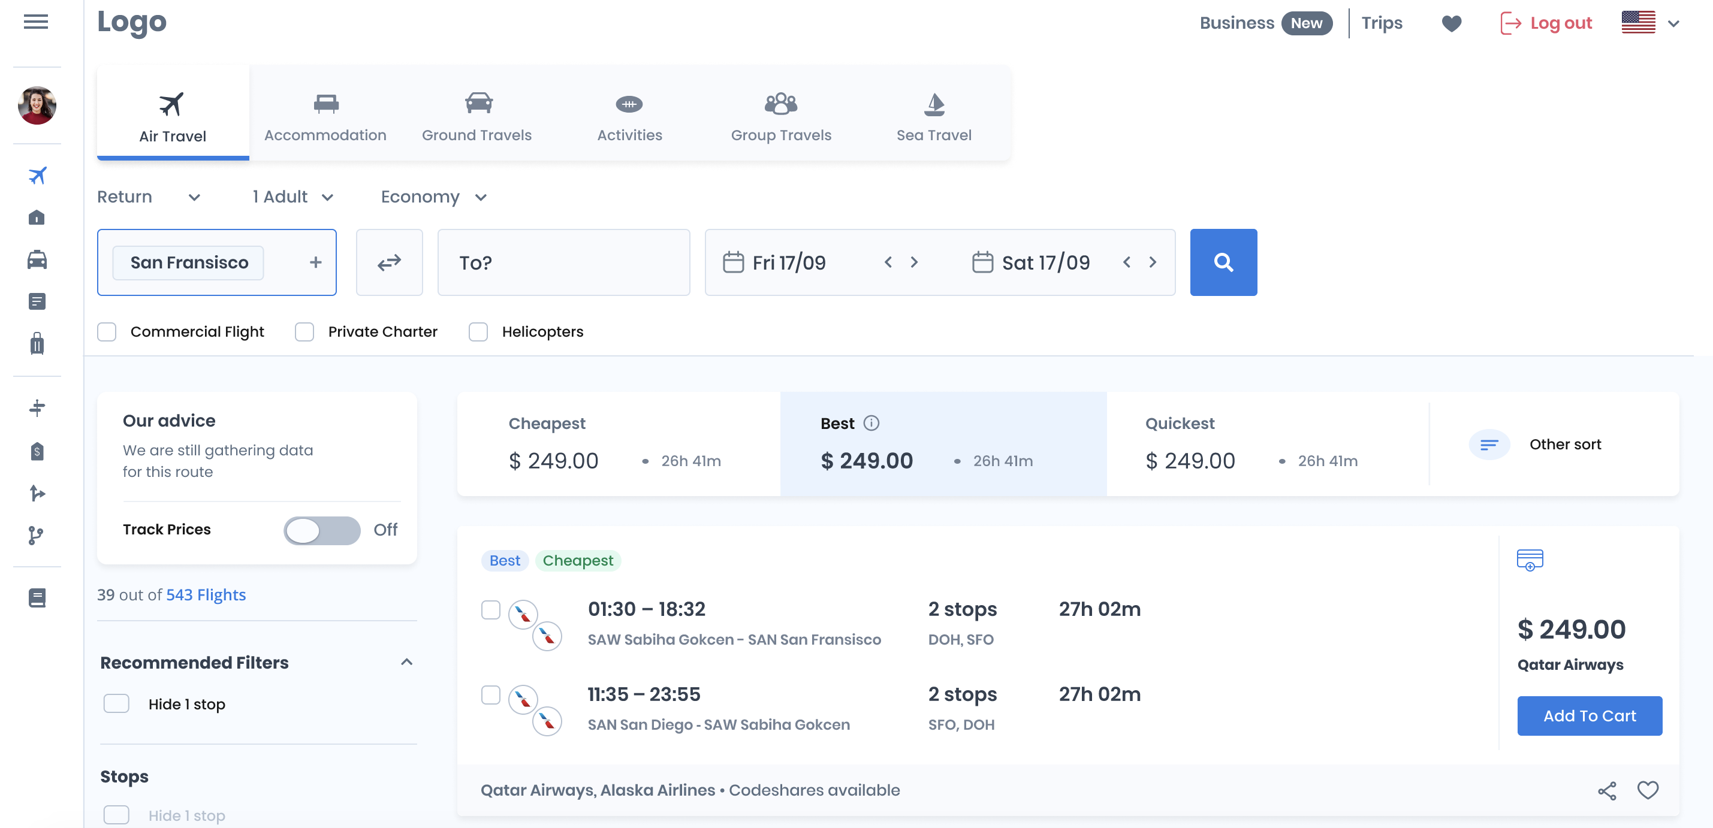

### Sections

* Flights
  + RBD of each of the flights – as per ATPCO definition this is the code used in reservation transactions to identify the booking class.
  + Aircraft Type
* Cabins – Price matrix of all the available cabins for this flight combination. The user can select any of them (for instance Economy Flex or Business Standard, etc.) and then add them to the Cart. Hovering over each of the Cabins will give the user a detailed representation of what is provided in each cabin and fare brand, if available (free baggage, paid baggage, amenities, etc.). Fare brands allow airlines to combine fares and ancillaries in a single package to better segment the market and provide value to passengers. For example, ECONOMY LIGHT, ECONOMY FLEX, ECONOMY STANDARD are all economy fares that would seat the passenger in the same physical compartment on the airplane but can provide additional benefits such as extra checked-in bags, refund and exchange without fees, etc.
* Pricing:
  + Base fare price, IATA and YQYR taxes and Total price;
  + FBC (fare basis code) is an alphanumeric code that airlines use to define the rules associated with different types of airfares. It is clickable and displays all the applicable fare text rules used to validate the fare for the journey;
  + A section next to the FBC indicating whether the fare is changeable/refundable;
  + Ticket mask – the ticket mask contains all the information required to book and ticket an offer in the booking environment. It consists of the following fields:
    - Seller (Agency)
    - Date
    - Ticket type (Domestic or International)
    - Origin/Destination
    - Plating carrier
    - Detailed info of the itinerary
      * Stopover(s)
      * Cities
      * Carrier
      * Flight number
      * Class
      * Date and time
      * Status
      * FBC
      * NVB/NVA
      * Baggage pieces
    - Base and Equivalent fare
    - BSR
    - Taxes
    - Total fare price
    - FOP
    - Endorsements/Restrictions
    - Fare calculation line – a structured text line consisting of the most important pricing information from the offer. Very useful for UTL-2 agents.
* Free Baggage allowance
  + Free Checked baggage type and amount/weight allowed
  + Free Carry-on baggage type and amount/weight allowed
* Paid Baggage – type, amount/weight allowed and the corresponding price for each extra piece
* Amenities (breakdown for each of the flights)
  + Meals/Snack/Beverages
  + WIFI
  + Media/USB
* Seats – Display of the seat map where the user can see the compartment layout, available seats and their characteristics and choose their seat.

# Price (Add to Cart)

### General Description

Each itinerary price offer includes complete itinerary pricing for specific user requested flights along with ticketing fees, free baggage allowance and ancillaries as part of the brand definition of the fares. There areother sections on this screen that visualize multi-cabin combinations, flights, ancillary offers, ticket mask(s) and fare rules.

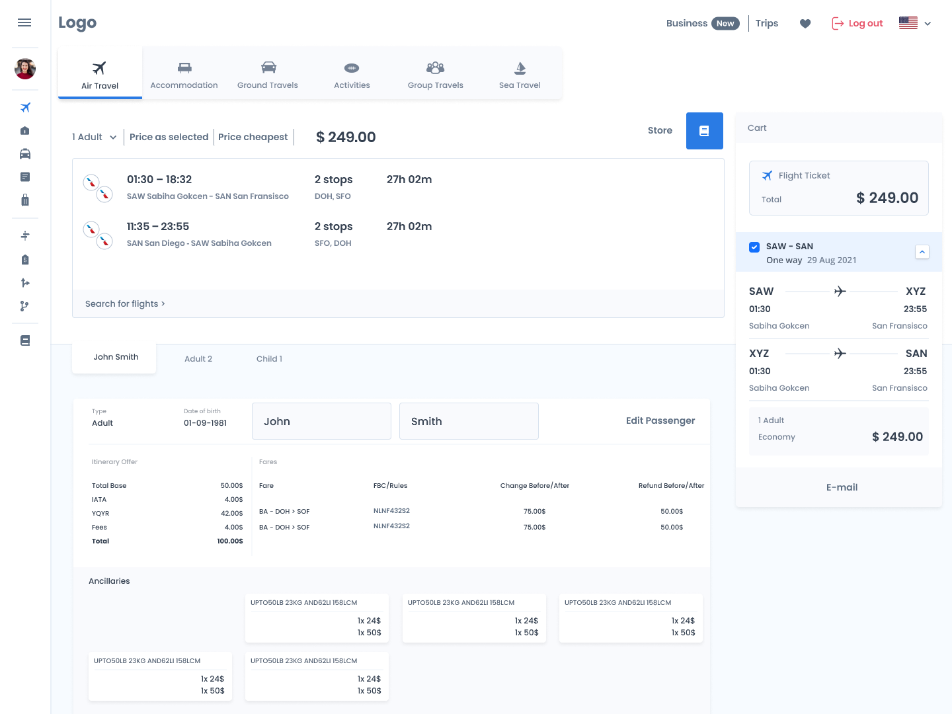

### Sections

Visualize multi-cabin and fare brands combinations – price matrix displaying all possible cabin and fare brands combinations for the specified flights (e.g. Economy, Economy Flex, Premium Economy, Business, Business Flex, First). By clicking on each of the prices in the matrix, the user changes/”locks” the selected cabin thus changing the fare and RBD (Reservation Booking Code).

Visualize flights – underneath the price matrix are the specified flights with their corresponding departure and arrival date and time, airport and aircraft type. For each of the flights there is an icon with the available amenities on the flight. Next to each flight the user can click on a button and see where on the world map those origin and destination are located.

Display pricing – price breakdown, including base fare, each specific IATA and YQYR tax along with the total price in the user-specified display currency. Underneath are the fares used for pricing with their origin and destination and filing carrier. Clicking on each of the fares displays the fare text rules with all ATPCO category rules applied. Next to the FBC is a quick indication of whether the fare is changeable/refundable. The user can also choose to display the ticket mask with all its attributes as described in Shop Expand Solution -> Section -> Pricing -> Ticket mask.

### Actions

UTL1 can to choose from the following options:

* Get multi-cabin/branded offers – get upsell optionsSpecified flight cabin – get offers for specific cabins
* Get only changeable/refundable offers
* Add/update age, name, FoP, FoID, email, frequent flyer number, carrier and level – can be saved in the user’s profile and only entered once.
* Proceed to booking screen

UTL2 will be able to choose from the following options (all of UTL1 + the once bellow):

* Show public price to compare with the private price (if any)
* Select the cheapest offer (from both public and private fares)
* Select a specific RBD and get lowest pricing offer available
* Select a specific RBD and get lowest pricing offer possible
* Input agent mark-up on the total price (not seen by passenger)
* Input agent service fee on the total price (seen by passenger)
* Link to ticket mask
* Link to send itinerary to passenger’s email address

# Book

### General description

Create a new order based on retrieved itinerary and ancillaries offer(s). The request must include the passenger(s) full names, gender and title along with the itinerary and ancillaries offers. The info can either be filled by UTL1 or UTL2. There will also be the option of UTL2 sending the link to UTL1 to only fill in the details:

* Add full names, gender and title for all passengers
* Add form of payment
* Add form of id
* Add contact details – e-mail and phone number to be used by the airline

### Actions

* Proceed to ticket issue – for UTL-2 only. UTL-1 book and ticket in one step.
* Go back to Cart

# Ticket issue/Order View

### General description

The user requests that a specific order or order element be ticketed. The order must contain payment information for each passenger and a valid, non-expired pricing offer for each order element.

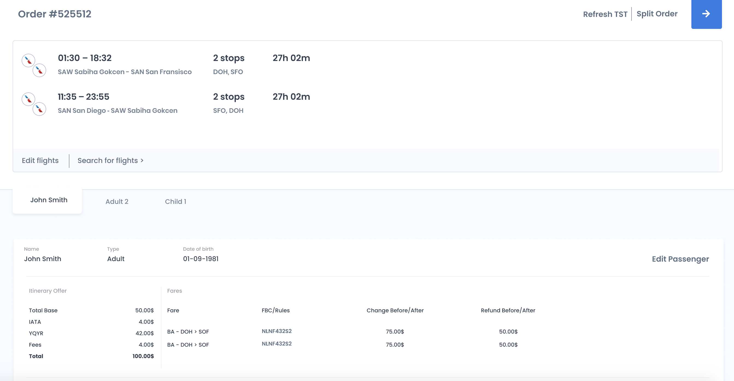

### Actions

UTL1 can:

* View the status of the PNR
* View/edit the FoP informationView/edit FoID (cannot change the name of the passenger)
* Request to change/cancel existing order element
* Add ancillaries
* Add billing address
* UTL2 can:
* All of UTL-1 actions
* - Issue ticket
* - Void ticket
* - Add markup and service fee
* Add / cancel flights
* - Change flight RBDs and retrieve new pricing
* - Add / remove pricing records in the PNR

# Reshop

### General description

The purpose of this screen is to return exchange offers satisfying the changed travel plans of the passenger, including one-way, round-trip, multi-city, calendar and flex. It is possible to request multiple offers for different cabins and/or different brands/fare families for each itinerary. Each offer includes complete flights with itinerary pricing along with the free baggage allowance, ticketing fees, and the ancillary offer elements that are filed as part of the brand definition for the fares used in the offers. Additionally, each offer includes a summary of the charges associated with the change, including old and new base fare, old and new tax information, and any penalty fees imposed by the airline and/or refunds.

Here is some detail on how to treat the existing flights in the PNR:

* FLOWN flights: the flight has departed and the passenger was boarded on it.
* KEEP flights: the flight has NOT departed and the passenger intends to use it.
* CANCELED flights: the passenger does NOT intend to use the flight or the passenger missed the flight (the flight departed and the passenger was not boarded on it).

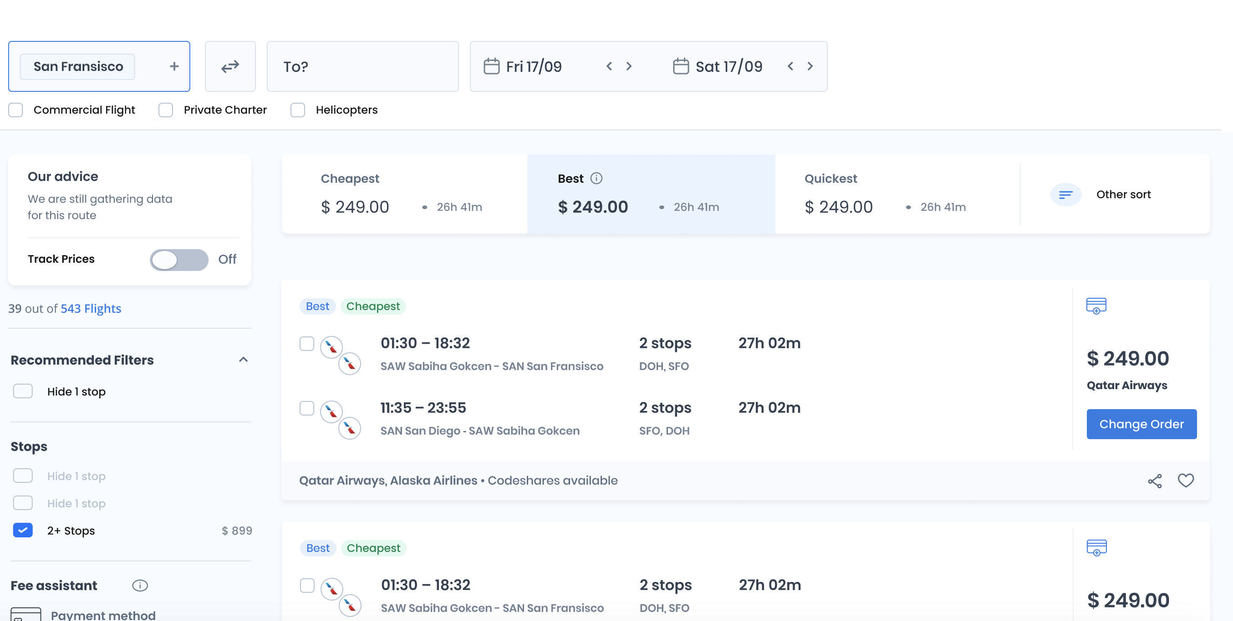

### User input

The screen has three sections:

* Section Reprice Status – the user is required to specify the reprice status for each flight from the active PNR (whether the flight was flown, needs to be canceled and then changed or will be kept as is)
* Section Add Segments info for the new flights
  + Required fields:
    - From;
    - To;
    - Departure Date
  + Optional fields:
    - Flex;
    - Calendar;
    - Fare Airlines (required for the Calendar search*), Alliance;
    - Multi-cabin/Multi-step (cannot be combined with Flex and Calendar searches)
    - Number of Allowed Stops; Cabins; Preferred/Excluded Transfer Points; Depart Before/Depart After; Allow Overnight Stay; Marketing/Operating Airlines
* Section Passengers info (can all be provided on a later stage)
  + PTC
  + Date of Birth
  + Nationality
  + Residence
* Section Advanced Options (has pre-set default values that can be overwritten)
  + Plating Carrier (for UTL-2 only)
  + Account Codes (for UTL-2 only)
  + Changeable/Refundable Ticket
  + Display currency
  + Multi-tickets

Frequently used options will be:

* Choose cabin – every segment may be requested in a different physical compartment. Virtual cabins can additionally be turned on or off. There is an option to allow the passenger to specify the cabin only for the most significant of each fare component. Feeder flights may be offered in lower cabin if the higher cabin is not available or if booking the feeder flight in lower cabin results in cheaper total price.
* Set display currency and payment currency – by default all offers are returned in the currency of the seller point of sale, specified by the IATA regulations. This is different from the currency of payment in the passenger field which specifies the currency in which the customer wishes to pay for the ticket. This currency will override the Seller Point of Sale currency as the equivalent currency used for issuing the ticket. If not specified, the Seller Point of Sale currency will be used.

### Response Visualization and actions

This screen is identical to the shop screen with responses.

A new section with a list of solutions and their corresponding count appears. Each of the results consists of price, flight origin, destination, departure date and time, plating and operating carrier, flight number, number of stops, duration, mileage, baggage and multimedia info. Once the first couple of results appear, the user has the option to:

* Select an exchange offer (update PNR) – sendto the Exchange screen
* Expand solution
* Sort and Filter the results (based on criteria described below)

### Selecting a solution

A button with the add/collect or refund amount of the exchange offer appears next to each result returned, giving the option to update the existing PNR and reissue the ticket(s).

### Sorting and Filtering the results

There are a couple of ways to sort and filter the returned results. The three main sorting ones are the following:

* Best – a sort score combination of lowest price for the ticket change, minimum flight/stopover/layover time and least number of connections
* Cheapest – the results sorted by price in ascending/descending order
* Fastest – minimum flight/stopover/layover time

Filtering can be applied by multiple criteria such as:

* Number of max stops
* Number of free bags
* Refund offered – free, paid or not offered
* Ticket change offered -- free, paid or not offered
* Intermediate stops; Long layover; Overnight stay
* Marketing airline
* Price slider
* Departure and arrival time sliders
* Departure/Arrival/Connecting airports
* Services (Movie, WIFI, Telephone, Audio programming, Duty free sales, In-seat power source, etc.)
* Fresh food/Beverage – meal, light meal, snack, alcoholic/non-alcoholic beverage
* Seat legroom

*\*Please note that filters can be applied on sorted results.*

## Reshop expand solution

This screen is identical to the shop expand solution.

The user can choose to expand the solution before updating the PNR. This helps them have a more detailed information for their updated journey. The information provided will include everything from the initial Response Visualization section, plus a couple more sub-sections. The only difference is that when clicking on a result, multi-cabin reprice matrix is displayed and not multi-cabin price.

### Sections

* Flights
  + RBD of each of the flights
  + Aircraft Type
* Cabins – Reprice matrix of all the available cabins for this flight combination. The user can select any of them (for instance Economy Flex or Business Standard, etc.) and then add them to the Cart. Hovering over each of the Cabins will give the user a detailed representation of what is provided in each cabin (free baggage, paid baggage, amenities, etc.)
* Pricing:
  + Base fare price, IATA and YQYR taxes and Total price;
  + FBC which is clickable and displays all the fare rules;
  + A section next to the FBC indicating whether the fare is changeable/refundable;
  + Ticket Mask, consisting of the following fields:
    - Seller (Agency)
    - Date
    - Ticket type (Domestic or International)
    - Origin/Destination
    - Plating carrier
    - Detailed info of the itinerary
      * Stopover(s)
      * Cities
      * Carrier
      * Flight number
      * Class
      * Date and time
      * Status
      * FBC
      * NVB/NVA (Not valid before; not valid after)
      * Baggage pieces
    - Base and Equivalent fare
    - BSR
    - Taxes
    - Total fare price
    - Form of payment
    - Fare Calculation (fareline)
    - Endorsements/Restrictions
* Free Baggage, displaying
  + Free Checked baggage type and amount/weight allowed
  + Free Carry-on baggage type and amount/weight allowed
* Paid Baggage – type, amount/weight allowed and the corresponding price for each extra piece
* Amenities (breakdown for each of the flights)
  + Meals/Snack/Beverages
  + WIFI
  + Media/USB
* Seats – Display of the seat map where the user can choose their seat.

# Exchange Cart

### General description

The exchange cart will be very similar to the existing Cart, already described above. The only difference will be that it includes the historical journey description and reprice information.

Each price offer will include complete itinerary historical pricing for specific user requested flights along with ticketing fees, free baggage allowance and ancillaries as part of the brand definition of the fares. There are numerous other sections on this screen that visualize multi-cabin combinations, flights, ancillary offers, ticket mask(s) and fare rules.

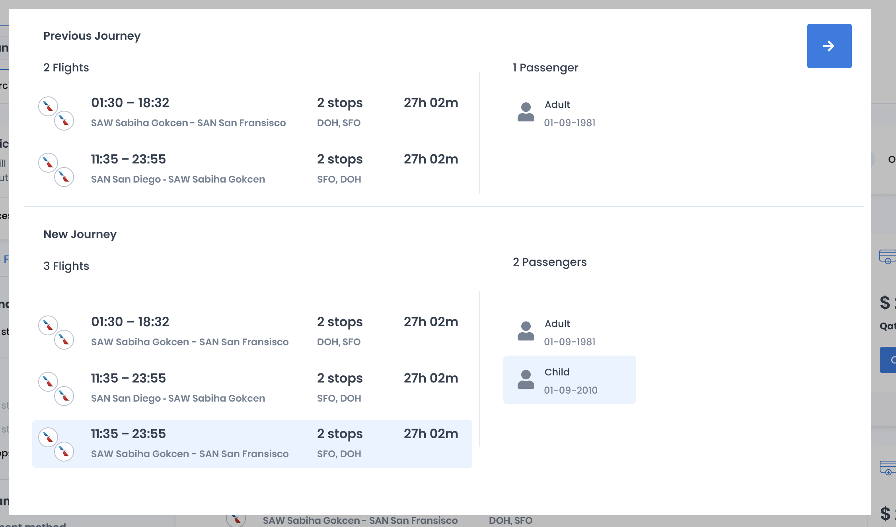

### Sections

Visualize multi-cabin combinations – price matrix displaying all possible cabin combinations (physical and virtual cabins) for the specified flights (e.g. Economy, Economy Flex, Premium Economy, Business, Business Flex, First, etc.). By clicking on each of the prices in the matrix, the user changes/”locks” the selected cabin thus changing the fare and RBD.

Visualize flights – underneath the price matrix are the specified flights with their corresponding departure and arrival date and time, airport and aircraft type. For each of the flights there is an icon with the available amenities on the flight. Next to each OnD the user can click on a button and see where on the map those origin and destination are located exactly.

Display pricing – price breakdown, including base fare, each specific IATA and YQYR tax together with the total price. Can be displayed in any currency. Underneath are the fares used for pricing with their origin and destination and filing carrier. Clicking on each of the fares displays the fare rules with all ATPCO category rules applied. Next to the FBC is a quick indication of whether the fare is changeable/refundable. The user can also choose to display the ticket mask with all its attributes as described in Shop Expand Solution -> Section -> Pricing -> Ticket mask.

# Refund

### General description

This screen will be similar in functionality to the reshop one as it aims to display the reprice summary information of the refund that the user will get. If all flights on the existing order are canceled or flown and no new flights are included, the request is processed as a refund.

Display pricing – price breakdown, including base fare, each specific IATA and YQYR tax together with the total price. Can be displayed in any currency. Underneath are the fares used for pricing with their origin and destination and filing carrier.

# Void PNR (for UTL-2 only)

### General description

Void PNR requires an order with at least one ticket issued. The system will attempt to void all or only the specified tickets and optional services EMDs included in the order.

### Actions

From View PNR screen we can select to void the existing PNR. The ETKTs to be voided are selected from a list and void action is confirmed.

# Screens for Workflow B – Ancillaries issuance and servicing

## Ancillaries Shop

Ancillaries Shop section gives you a full overview of what ancillaries are available for the selected flights in a certain flow. The ancillaries are published in ATPCO by airlines in the Service Record 7 or Amenities records and are visualized with the help of dictionaries and matching data structures in the Data Library.

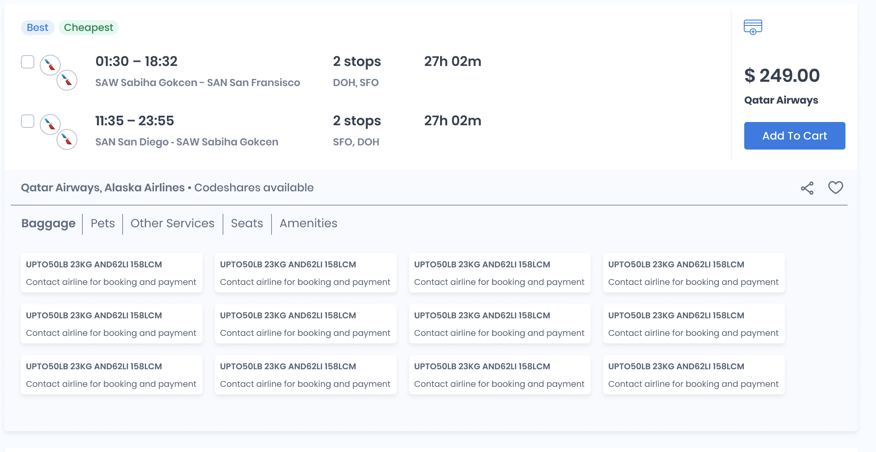

This screen is visible as part of screens Shop, Price, Order View, Reshop, it includes the following sections:

### Free baggage allowance section

The free baggage allowance section identifies all baggage filed for the fare selected in the Price Matrix in the Cabins tab in Shop Expanded Solution, Reshop Expanded Solution or directly in screens Cart and Order View.

There are two types of baggage defined. Carry-on and Checked baggage with their relative piece numbers and weight. Each of the allowed free baggage can have different characteristics which are defined by the service element of the filled carry-on or checked baggage. These characteristics are displayed via expanding the baggage solution.

The baggage information is shown by flight (or segment), i.e. there can be different pieces and weight on the different flights (or segments) in the journey.

This free baggage allowance differs per different cabins and brands, so it changes when the user selects a brand in the Price Matrix in Shop/Reshop Expanded solutions and in Cart. In the Order view screen the baggage is already defined by the flights in the order, if the flights are changed this information shall differ.

### Paid baggage section

Paid baggage is returned after the ancillaries_shop or itinerary_price (with ancillaries included) APIs are called. The response includes information about each ancillary available for the said itinerary offer:

1. Type of ancillary – can be baggage, sporting equipment, specialty item, etc.
2. Name/Description of the ancillary
3. Price of the ancillary
4. How many items can be purchased of each ancillary – the price might differ for 2nd , 3rd and so on ancillaryMethod of purchase – if it should be booked in the airline directly or if it can be booked and ticketed through the GDS and the airline will confirm by SSR.

NOTE: there are some sub-groups of ancillaries that can be in categorized and shown in different sections, not PAID BAGGAGE. These ancillaries are meals, rule busters, upgrades, pets and other services. The behavior is the same as for the baggage ancillaries, same fields are present.

In Price and Booking/Ticketing screens ancillaries can be selected and priced along with the attached itinerary offer. The user can select one or more ancillaries of each type, depending on the number pieces’ limitation for purchasing. There is a warning message if ancillaries of different types are selected for pricing which are incompatible, if the warning message is shown, no ancillaries are added to the cart.

Ancillaries similarly to the free baggage are selected per flight or segment of the journey. This is reflected in the visual representation layer (the UI) and the user is informed of the pricing for each segment.

Actions in Cart and Order view: Select pieces and types of baggage and price them, confirm selection

### Amenities section

Amenities are data fields filed for each flight through ATPCO, these fields are used to enrich the marketing information available for each flight. Information about beverages and food served on board, entertainment and WiFi availability, USB/power outlets and so forth. For each flight in a journey there are different amenities filed and these are visualized per flight in the Shop expanded section and Price screens.

Special service requests – SSRs (UTL-2 only)

Special service requests are services that airlines offer to the passenger which can be requestd prior to flight departure but need to be confirmed by the airline. These can be requests after the creation of a PNR in the booking environment and the agent can select certain SSRs such as but not limited to: type of meal (baby, vegan, diabetic, hindu etc.), assistance for a passenger (blind passenger, intellectual disability, oxygen etc.) or special baggage request (wheelchair). Based on the input the SSR will be sent for the selected flight(s) airline for the created PNR. After SSRs are sent the airline must confirm them or there is no guarantee the airline will honor the request. Requesting an SSR is not guaranteed and might not be obeyed by the airline servicing the whole or part of the journey.

Actions in Cart, Order view: Select SSR per flight, confirm selection

### Seats section

Seat visualization is shown with price and seat characteristics in the Shop expanded screen. Seat pricing can be performed in the Price/Cart screen and in the Booking screen. Each seat has information about where it is placed in the aircraft, is aisle/middle/window seat, emergency exit seat, whether it is an extra legroom seat or not, etc. Each seat also has information if it is available or not and what is the price for it. In the Price screen seats can be chosen as ancillary and priced accordingly.

Actions: Select seat(s) on the seat-map, view seat characteristics, confirm selection

## Ancillaries book

As ancillaries are purchased separately after a PNR is created or sometimes even after a ticket is issued (e.g. paid bags ancillaries are ticketed after the itinerary has been ticketed), there is a separate book flow for them. This booking flow is available only after a PNR is created.

* + Add FoP – This payment info can be taken directly from the User profile or added separately. For UTL1 flow the booking of ancillaries will be done in the same flow as PNR/Ticketing of the order.
  + Actions:
    - Ancillaries ticket (issue EMD)
    - Back to Order View Screen

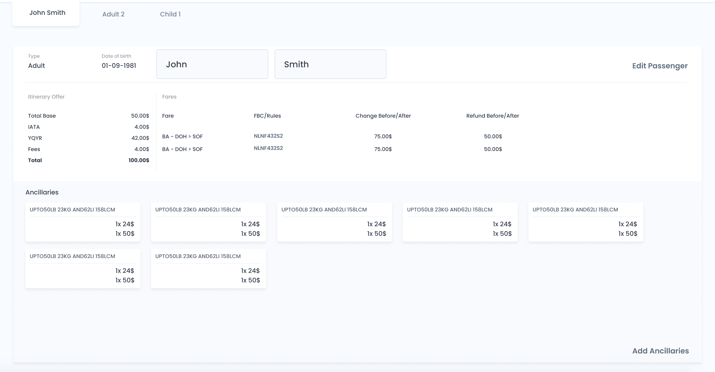

## Ancillaries reshop, reprice

Reached from order view screens Order View. Similar to Ancillaries shop screen, the difference is that the add-collect will be displayed as the price. New ancillaries type and count can be selected and confirmed to reach ancillaries rebook screen. The actual ancillaries rebook/reprice will do EMD refund and new EMD issue, while as FoP can be selected the refunded amount from the old ancillaries (only if the subCodes of the old and new ancillaries match, this will be dealt by the service)

## Ancillaries rebook

* + Similar to screen Ancillaries book, the difference is that add-collect will be displayed as price for the new ancillaries.
  + Actions:
    - Ancillaries issue(EMD) - same flow as Ancillaries Book
    - Back to Ancillaries reshop, reprice screen

## Ancillaries refund

* + Screen accessible from order and ancillaries view screen Order View
  + Ancillaries are selected from an ETKT (along with EMD) to be refunded and a confirmation is made for the refund action. Displays reprice summary information for the refund of the selected ancillaries.

## Ancillaries void

* + Screen accessible from order and ancillaries view screen Order View
  + A screen is opened from view PNR screen. The ancillaries to be voided are selected and the void action is confirmed.

# Administrative screens

## Description

The purpose of the administrative screens is either editing of user data and privileges or seeing a filter-able and sortable list of their transactions. Clicking on a transaction will visualize its details and forward the user to view-order (itinerary / ancillaries) for workflow A or B.

The users have strict hierarchy with UXL1 able to administer all users across all tenants and able to act as all of them. UXL1 can administer tenants, including the ability to create a tenant, disable / enable tenants, and manage their access to content. See **Content Management** section for further details. UTL3 can act as either UTL2 or UTL1 (within this tenant), and administer their data. ULT2 can act as an UTL1 (within this tenant) and administer their data.

The screens for all users will be organized identically, with users with more privileges having more sections for user / content management and security.

## Administrative Screen for UTL1 (ADM-1-UTL1)

The purpose of this screen is to enable end-users, B2C, UTL1 to fill-in their data that will facilitate faster checkout when issuing tickets and visualize a list of their orders (itineraries and ancillaries). Upon clicking on an item on the list, the user will be forwarded to workflow A or B, as described below. The screen has the following sections:

* List user profiles
* User profileOrders

UTL1s can define personal details of additional passengers (e.g. family members). These are shown as different passenger profiles. Details are be entered for each of the profile(s) independently. A customer can have up to 9 passenger profiles.

### Section User Profile ADM-1-UTL1-PRF-LST

The different profiles are shown in a list with options to add / edit / remove existing.

Actions:

* List profiles (read table **Users** from external DB)
* Disable profile (execute a query to external DB changing a property for a profile)
* Edit profile (read profile data for a particular profile id and visualize existing information with the option to edit the data)
* Add profile (open a screen with blank fields to input data)
* Remove profile (execute a query to external DB changing a property for a profile)

### Section User Profile ADM-1-UTL1-PRF-EDT

This section is opened when either edit profile or add profile action is triggered from ADM-1-UTL1-PRF-LST.

#### Fields

The fields are grouped in several groups:

* Security details
* Personal details
* Form of Payment details
* Frequent Flier information
* Form of identification
* Visa details

##### Security details

* E-mail (not changeable by UTL1, can be changed by UTL2)
* Password (changeable, through a pop-up in which old password is put and the new password and re-entering of the new password). Actions on the pop-up are Confirm, Cancel.
* 2 factor authentication status – enabled / disabled (if supported through a Xeniapp mobile application)
* Mobile number – used for password retrieval process

##### Personal details

* Sex
* Title
* First Name
* Middle Name (optional)
* Last Name
* DoB (YYYY, MMM, DD)
* Nationality
* Residency (optional), if not filled in TBGI to include in requests same as nationality

##### FoP Details

* Type (see enumeration in formOfPayment->type). Can be one of Cash, Check, Card, Voucher
* ~~Number~~
* ~~Card Token (card information is tokenized and can be used in the future)~~
* CVV
* Expiration date (MMM / YY)
* Card holder (pre-filled in First Name and Last Name from Personal Details)

##### Frequent Flier Info

* CXR
* Number
* Level (integer). A list of FF levels to be displayed with the user having ability to select one option). CTW shall provide a dictionary with correspondence FF description -> integer.
* coveredFlights (optional), if not filled in TBGI to include all flights with the first FF info

##### FoID

* type of Document (drop-down – National ID, Passport, Drivers license, Employment card. Values to correspond to correspond to passenger->foid->type from JSON schema.
* Number
* Issuing Country
* Issue Date (YYYY, MMM, DD)
* Expiration Date (YYYY, MMM, DD)
* Sex (value to be pre-filled with the value in Personal details section, can be changed).

##### Visas details

Note: It is possible to store more than one visa per passenger. The passenger will be able to select one visa when booking an itinerary (or fill in visa details) in screen in workflow A.

* Issuing Country
* Number
* Issue date
* Country for which the visa applies
* Maximum stay (optional)
* Earliest date of entry (optional)
* Latest date of entry (optional)

#### Actions

The following actions are present for each group of fields in the User Profile section:

* Initially, when the screen is loaded editing is prohibited, fields are greyed out. To start editing, an Edit action is triggered.
* For the visa group of fields:
  + Clickable list of visas to display one of them
  + Add new visa (for the visa group of fields)
* Update (saves changes)
* Cancel (discard changes)

### Section Transaction history (Air) (ADM-1-UTL1-HST)

This section will include a filter-able, sort-able list with the Air transactions by the customer with the option for the user to download a csv file with this information.

The export-able fields for the list of itineraries are identical to the list of fields described in the **Management Reporting** section (excluding the linked tables).

#### Fields

Тhe list hast the following columns:

* Common fields (relevant for itinerary and ancillaries)
* ID – ETKT number for ticketed itineraries and EMD id for ancillaries
* Date-time of ticketing
* Departure date-time from journey origin
* Origin (3 letter IATA code)
* Destination (of first request segment)
* Total amount (amount)
* Fields for ancillaries only
  + Merchandise type – defines the type of ancillaries – corresponds to byte 21 from ATPCO Rec S7
  + Service Sub Code – further defines the type of ancillaries – corresponds to bytes 8-10 from ATPCO Rec S7, EMD mask field rfiSubCode
  + Name – corresponding to EMD mask field productCharacteristics

#### Actions

The following actions are supported in this section:

* Click on a section to open TBGI in a new tab and view order screen from Workflow A, B.
* Sort (by any of the presented columns)
* Filter (by any of the presented columns)
* Download list (in csv format)

## Administrative Screen for UTL2 (ADM-2-UTL2)

This screen is like the Administrative screen for UTL1 with several exceptions. First, the UTL2 has ability to view / edit / act-as all UTL1s with the same tenant as the UTL2. Second, the UTL2 can visualize as part of the transaction history also the mark-ups and revenue generated from each air transaction.

The screen is comprised of three sections:

* Section User profile
* Section Orders history
* Section Add User
* Section View / Manage Users
* Section Add Mark-up
* Section View / Manage Mark-ups

### Section User Profile (ADM-2-UTL2-PRF)

This section is with identical structure to the ADM-1-UTL1-PRF screen. The difference is that UTL2 does not have a limit of 9 profiles per account. Also, in workflows A and B, UTL2 can use profiles that are either 1) generated by the UTL2 (do not have separate log-in); or 2) belong to another UTL1 – one that has its own username and password.

### Section Order history (Air) (ADM-2-UTL2-HST)

This section is with identical structure to the ADM-1-UTL1-HST screen. The difference is that there are additional fields that describe the agent revenue:

* Agent mark-up in Currency of payment (CoP)
* Agent mark-up in USD
* Agent Service fee (SVC fee) in CoP
* Agent SVC fee in USD

### Section Add User (ADM-2-UTL2-ADD)

This section allows UTL2 to add a new UTL1. A new user is added by specifying an e-mail and clicking the action button add. An information e-mail is sent to the e-mail. Further changes to the newly added user (e.g. adding personal details is achieved through log-in-as functionality).

### Section Manage Users (ADM-2-UTL2-UMG)

The purpose of this section is to allow UTL2 to enable / disable UTL1s and to act as them. ULT1s are visualized as a sortable filterable list. Next to each name are the actions.

#### Fields

The following columns are present for each user in the list:

* E-mail
* First Name
* Last Name
* DoB

#### Actions

* Load screen (retrieve information from an External DB, filter the users table by tenant id to be equal to the tenant id of the UTL2)
* Enable/Disable toggle (change status for a particular user)
* View User details – opens screen ADM-1-UTL1-PRF-LST (retrieve information from an external DB)
* Log-in-as user – change current log-in as if the UTL1 is logged-in. When clicking log-out the user is returned to its original role.
* Go-to **Management reporting** section for this UTL1 (the UTL1 will be selected as a filter for the transactions).
* Sort by column name (visualization only, no new data fetched)
* Filter by column name (visualization only, no new data fetched)

### Section Manage Add Mark-up rule (ADM-2-UTL2-MUP-ADD)

The purpose of this section is to allow for setting up rules for automated mark-ups that shall be applied to private fares for UTL1s when completing transaction on their own (not via UTL2).

#### Fields

* Priority (starting from 1 meaning highest priority)
* Origin (3 letter IATA location code)
* Destination (3 letter IATA location code)
* Carrier
* Cabin
* RBD
* FBC wildcard match
* Fare type (Public / Private, IT/BT, corresponding to fareTypes from JSON definitions).
* Status (enabled, disabled)
* Mark-up percentage
* Mark-up absolute amount
* Service fee absolute amount

#### Actions

* Add – The action stores the current mark-up rule and refreshes the page.

### Section View/Edit Mark-up rules (ADM-2-UTL2-MUP-LST)

This section visualizes a sortable and filterable list of existing mark-up rules.

#### Fields

Each of the fields (columns) can be used for filtering and/or sorting. The list of the fields is identical to the fields in sub-section for adding mark-up rule - ADM-2-UTL2-MUP-ADD.

#### Actions

The following actions are present in the sub-section for viewing / editing mark-up rules:

* Enable / Disable (toggle) that changes the status of the mark-up rule
* Edit (opens a pop-up with pre-populated with values from the existing mark-up rule. The actions in the popup are confirm (means save changes) and close (means discard changes).
* Delete – delete a mark-up rule
* Sort – for each of the columns there should be a sorting option
* Filter – for each of the columns there should be a filtering option

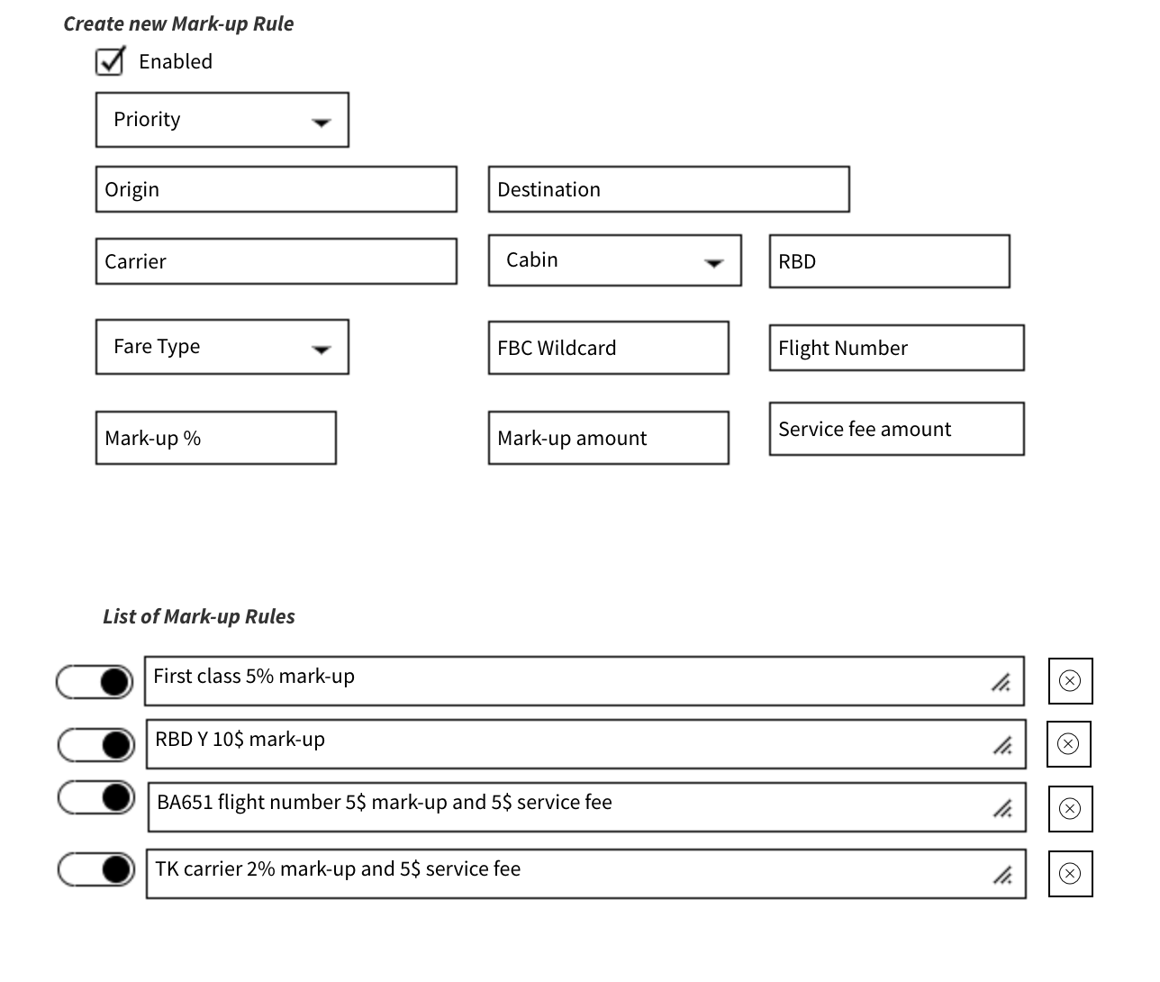

## Administrative Screen for UTL3 (ADM-3-UTL3)

The screen for user UTL3 has identical organization to the screen for user UTL2. The differences are that UTL3 has privileges to act as any other UTL2, UTL1 within the tenant and change user rights to UTL1 / UTL2 users.

The screen is comprised of three sections:

* Section User profile
* Section Transaction history
* Section Add User
* Section View / Manage Users
* Section Add Mark-up
* Section View / Manage Mark-ups

### Section User Profile (ADM-2-UTL3-PRF)

This section is with identical structure to the ADM-1-UTL1-PRF screen.

### Section Transaction history (Air) (ADM-2-UTL3-HST)

This section is with identical structure to the ADM-2-UTL2-HST screen.

### Section Add User (ADM-3-UTL3-ADD)

This section allows UTL3 to add a new user with user rights UTL1 or UTL2. A new user is added by specifying an e-mail and clicking the action button add. An information e-mail is sent to the e-mail. Changes to the user – including setting privileges (UTL1 or UTL2), enabling or disabling user – are done through the user management section (ADM-3-UTL3-UMG).

### Section Manage Users (ADM-3-UTL3-UMG)

The purpose of this section is to allow UTL3 to manage enable or disable UTL1s and/or UTL2s, change their privileges and to act as them. ULT1s and UTL2s are visualized as a sortable filterable list. Next to each name are the actions.

#### Fields

The screen has identical structure to ADM-2-UTL2-UMG. The difference is the new column displaying the user role. The following columns are present for each user in the list:

* E-mail
* First Name
* Last Name
* DoB
* User access level (UTL1 / UTL2)

#### Actions

* Load screen (retrieve information from an External DB, filter the users table by tenant id to be equal to the tenant id of the UTL2)
* Same actions as the ones on screen ADM-2-UTL2-UMG (Enable/Disable toggle, View User details, log-in as user, go to **Management reporting**, sort, filter
* Change user role action opens a pop-up with the possible roles – UTL1, UTL2 with options to either confirm (save changes) or cancel (discard changes).

### Section Manage Add Mark-up rule (ADM-3-UTL3-MUP-ADD)

This section is identical to the section for UTL2. The difference in processing is that this mark-up and service fee shall be applied prior to the mark-up and service fee applied by UTL2. Please see the **Mark-ups Processing** section for additional information.

### Section View/Edit Mark-up rules (ADM-3-UTL3-MUP-LST)

This section is identical to the section for UTL2. The difference in processing is explained above.

## Administrative Screen for UXL1 (ADM-4-UXL1)

The screen for user UXL1 has identical organization to the screen for user UTL3. The first difference is that UXL1 has privileges to act as any UTL1, UTL2 and UTL3 user for all tenants. Second, some of the sections of the screen redirect to the **Content Management** screen. Finally, UXL1 can create new tenants.

The screen is comprised of three sections:

* Section User profile
* Section Transaction history
* Section Add User
* Section View / Manage Users
* Section Add tenant
* Section View / Manage Tenants
* Section Add Mark-up
* Section View / Manage Mark-ups

### Section User Profile (ADM-4-UXL1-PRF)

This section is with identical structure to the ADM-1-UTL1-PRF screen.

### Section Transaction history (Air) (ADM-4-UXL1-HST)

This section is with identical structure to the ADM-2-UTL2-HST screen.

### Section Add User (ADM-4-UXL1-ADD)

This section allows UXL1 to add a new user with user rights UTL1, UTL2 or UTL3. A new user is added by specifying an e-mail and clicking the action button add. An information e-mail is sent to the specified e-mail. Changes to the user – including setting privileges, enabling or disabling user – are done through the user management section (ADM-3-UXL1-UMG).

### Section Manage Users (ADM-3-UXL1-UMG)

The purpose of this section is to allow UTL3 to manage enable or disable UTL1s and/or UTL2s, change their privileges and to act as them. ULT1s, UTL2s and UTL3s, are visualized as a sortable filterable list. Next to each name are the actions.

#### Fields

The screen has identical structure to ADM-2-UTL3-UMG. The new column is tenant. The following columns are present for each user in the list:

* Tenant
* Role
* E-mail
* First Name
* Last Name
* DoB
* User access level (UTL1 / UTL2 / UTL3)

#### Actions

* Same actions as on screen ADM-2-UTL2-UMG (Enable/Disable toggle, View User details, log-in as user, go to **Management reporting**, sort, filter)
* Change user role action opens a pop-up with the possible roles – UTL1, UTL2 with options to either confirm (save changes) or cancel (discard changes).
* Go to Tenant goes to Tenant View/Modify section in which a filter is applied to show only this tenant

### Section Add Tenant (ADM-4-UXL1-TN-ADD)

This section allows UXL1 to add a new tenant. Tenant subscription level must be selected when a new tenant is added. For the tenant to become usable, UTL3, UTL2 or UTL1 need to be added as well. Adding a tenant is achieved by specifying a name for the tenant and clicking the action button add. The following fields are visible:

* Tenant ID (auto generated)
* Tenant Name
* Tenant subscription
* Status (enabled / disabled)

The screen has only Add action which adds a tenant after a confirmation window is shown with options Confirm (saves the tenant) and Cancel (returns to previous screen).

Further modifications of the tenant are done through View / Modify Tenants section – ADM-4-UXL1-TN-LST – or directly through the **Content Management** screens.

### Section View / Modify Tenants (ADM-4-UXL1-TN-LST)

The purpose of this section is to allow UXL1 to manage tenants. Some actions forward the user to the **Content Management** screens.

#### Fields

The screen has identical structure to ADM-2-UTL3-UMG. The new column is tenant. The following columns are present for each user in the list:

* Tenant ID
* Tenant Name
* Tenant Subscription

#### Actions

* Same actions as on screen ADM-2-UTL2-UMG (Enable/Disable toggle, go to **Management reporting**, sort, filter)
* See blocked content – goes to screen CM-1-BL-LST filtered for this tenant. There is an action to block new content (go to screen CM-1-BL-ADD).
* Set PCC – redirects the user to screen CM-2-PCC filtered for this tenant. The user has the option to proceed to the section for assigning a PCC for the tenant.
* See Limits for tenant – redirects the user to screen CM-3-LIM-LST. There is an action to proceed to add new limit screen CM-3-LIM-ADD.
* Security: Set volume restrictions – redirects to security module to screen CM-5-SEC-VOL-LST filtered for this tenant. The user has the option to add a new volume restriction.
* Security: PCCs – redirects to security module to screen CM-5-SEC-PCC-2-LST filtered for this tenant. The user has the option to add a new association to PCCs.

### Section Manage Add Mark-up rule (ADM-4-UXL1-MUP-ADD)

This section is identical to the section for UTL2. The difference in processing is that this mark-up and service fee shall be applied prior to the mark-up and service fee applied by UTL2 and UTL3. Please see the **Mark-ups Processing** section for additional information.

### Section View/Edit Mark-up rules (ADM-4-UXL1-MUP-LST)

This section is identical to the section for UTL2. The difference in processing is explained above.

# Content management

There are six separate areas that are part of content management. Each of them is described in a separate sub-section.

## Screen block content to tenant (CM-1-BL)

### Description

The purpose of this screen is to define content that should be blocked for a particular tenant. For example, CXR TK is forbidden to be displayed / sold to tenant “Kofi”.

This screen is accessible by UXL1 only. The purpose of this screen is to 1) visualize restrictions and 2) administer restrictions regarding itinerary shop, price, reshop and reprice requests.

The screen has two sections:

* Section Add new restriction
  + in the top part are blank fields that allow filling a new restriction rule
* Section Existing restrictions
  + This section includes a list (filter-able and sort-able) of existing restriction rules

### Section Add new restriction (CM-1-BL-ADD)

#### Fields

* Origin (3 letter IATA location code)
* Destination (3 letter IATA location code)
* Carrier
* Cabin
* RBD
* Flight number
* Tenant (upon typing Tenant Name, a list of tenants is visualized). A tenant can be chosen (by a mouse click or Enter).
* Service type (e.g. itinerary shop, itinerary price, itinerary reshop, etc.)
* Status (enabled, disabled)

#### Actions

* Screen load (with empty fields, no external information accessed)
* Auto-complete Tenant – a query is made to the MW
* Add – The action stores the current restriction rule and refreshes the page. The information is stored in an external DB

The Middleware module will attach the relevant content restrictions (blocking) rules before sending each JSON request for processing. For further information see section Middleware.

### Section Existing restrictions (CM-1-BL-LST)

This section visualizes a sortable and filterable list of existing restrictions.

#### Fields

Each of the fields (columns) can be used for filtering and/or sorting. The list of the fields is:

* Id (a unique identifier of the restriction record)
* Tenant (name of the tenant for which the restriction applies)
* Origin, Destination, Carrier, Cabin, RBD, Flight number
* Status (enabled / disabled)

#### Actions

* Screen load (information is extracted from external DB – table content restrictions)
* Enable / Disable (toggle) that changes the status of the restriction rule (update information of a particular record from the external DB)
* Edit (opens a pop-up with identical field names as screen CM-1-BL-ADD). Fields on this pop-up are pre-populated with values from the existing restriction rule. The actions in the popup are confirm and close (means discard changes). (for visualization request is made to retrieve the data, for save another update request is sent)
* Delete – delete a restriction rule (update request sent to external DB)
* Sort – for each of the columns there should be a sorting option (visualization only)
* Filter – for each of the columns there should be a filtering option (visualization only)
* New Limit – goes to section CM-1-BL-ADD
* By default, 100 restriction rules to be displayed that match the input criteria. There will be pagination – go to next 100, previous 100.

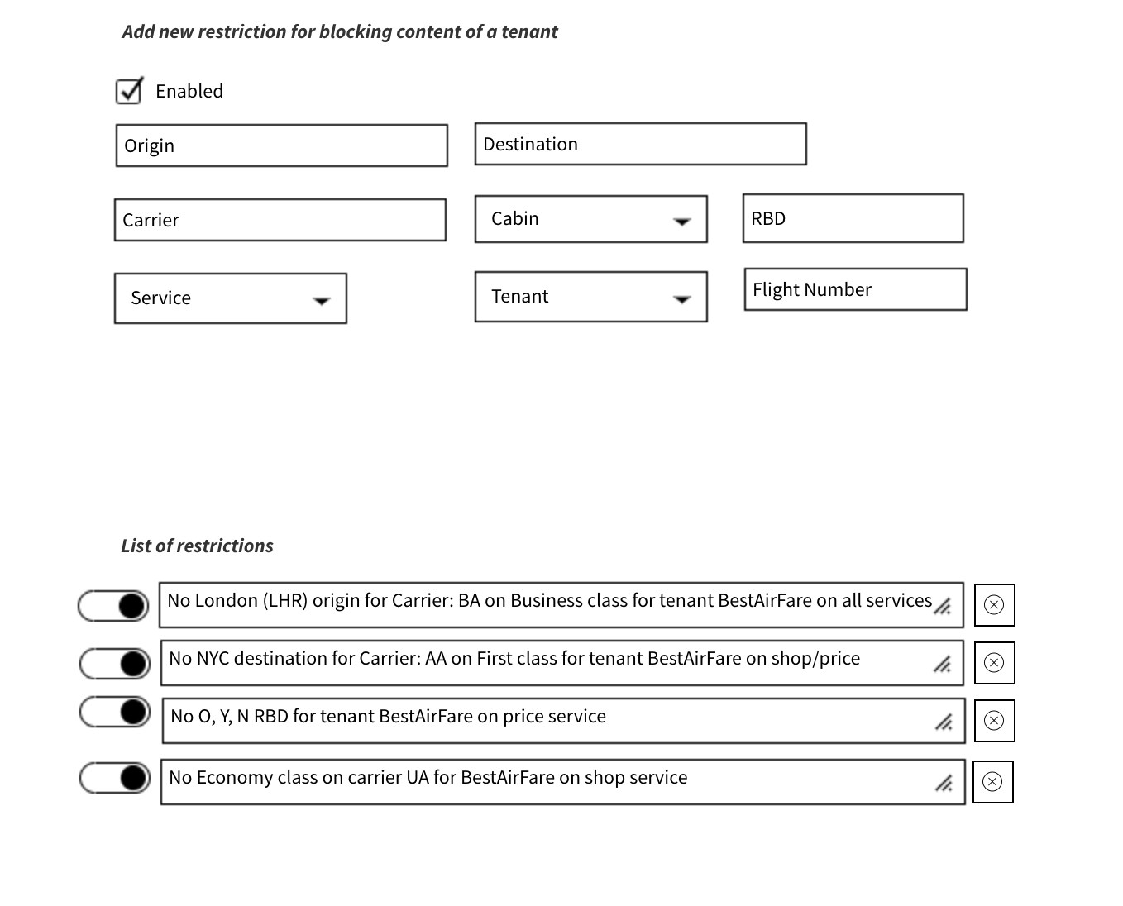

## Screen set PCC for tenant (CM-2-PCC)

### Description

Module that select which Xeniapp tenants can use which PCC among the PCCs that are available to Xeniapp. The screen is organized in a way like screen CM-1-BL.

The screen has two sections:

* Section Add new rule
  + Contains blank fields to assign a tenant with a PCC.
* Section Existing rules
  + This section includes a list (filter-able and sort-able) of existing assigned PCCs

### Section New assignment of PCC to tenant (CM-2-PCC-ADD)

#### Fields

* Tenant (upon typing Tenant Name, a list of tenants is visualized). A tenant can be chosen (by a mouse click or Enter)
* PCC (upon typing PCC OID or IATA number, a list of PCCs is visualized). A PCC can be chosen (by a mouse click or Enter)
* Status (enabled, disabled)

#### Actions

* Add – The action stores the current assignment rule and refreshes the page.

Note: Initially only 1 PCC shall be assignable to a tenant. When a the security module, as described in CM-5-SEC becomes live, to be discussed if each tenant shall be given access to more than one of the PCCs, that are available to Xeniapp.

### Section Existing restrictions (CM-2-PCC-LST)

This section visualizes a sortable and filterable list of existing assignments.

#### Fields

Each of the fields (columns) can be used for filtering and/or sorting. The list of the fields is:

* Id (a unique identifier of the assignment record)
* Tenant (name of the tenant for which the restriction applies)
* PCC
* Status (enabled / disabled)

#### Actions

* Enable / Disable (toggle) that changes the status of the assignment rule
* Edit (opens a pop-up with identical field names as screen CM-2-PCC-ADD). Fields on this pop-up are pre-populated with values from the existing assignment rule. The actions in the popup are confirm and close (means discard changes).
* Delete – delete an assignment rule

**Note:** There is a rule with blank Tenant and filled-in PCC. This rule is applied for all tenants, for which there is no PCC assigned. This rule cannot be deleted.

* Sort – for each of the columns there is a sorting option
* Filter – for each of the columns there is a filtering option
* By default 100 rules that match the input criteria are displayed. There is pagination – go to next 100, previous 100. Only the first 1,000 rules that match the filtering / sorting criteria are displayed.

## Screen set limits for tenant (CM-3-LIM)

### Description

The purpose of this module is to set limits to tenants by criteria (e.g. O&D or amount or number of tickets). The limits concern the quantity of tickets issued and / or the total face value of tickets and is independent of the number of shopping / pricing / re-shopping / repricing requests that are sent. This limit is checked when request for booking is made. For further information on the booking flow see Workflows A, B. The screen is accessible from user UXL1 only. The organization of the field is like the organization of screens CM-1-BL, CM2-PCC).

Before a booking request is sent to CTW, a check with the fields relevant for limiting is made by the MW module. If the booking limit for the tenant is exceeded, a relevant error message is returned by the MW and a message is displayed in the TBGI. In that case, a booking request is not sent to CTW. For further information see the description of MW module.

There are two sections in the screen:

* Add new limit
  + Allows the user to fill in a new limit (individual screens are listed below)
* List existing limits
  + Visualizes a sort-able and filter-able list of limits per tenant

### Section New Limit for tenant (CM-3-LIM-ADD)

#### Fields

* Tenant (upon typing Tenant Name, a list of tenants is visualized). A tenant can be chosen (by a mouse click or Enter)
* Limiting criteria (can be blank). If the limiting criteria are blank, then the limits apply for bookings by the tenant.
  + Origin (3 letter IATA location code)
  + Destination (3 letter IATA location code)
* Limit of number of issued tickets per week
* Limit of total value of issued tickets per week
* Status (enabled, disabled)

#### Actions

* Load screen (no external requests made, blanks fields visualized)
* Auto-complete tenant (request to external DB to look-up compatible tenants)
* Add – The action stores the current limit and refreshes the page. (adds a new record in the limits table in external DB)

### Section List existing limits (CM-3-LIM-LST)

This section visualizes a sortable and filterable list of existing limits.

#### Fields

Each of the fields (columns) can be used for filtering and/or sorting. The list of the fields is:

* Id (a unique identifier of the limit record)
* Tenant (name of the tenant for which the restriction applies)
* Origin, Destination, Limit of number of issued tickets, Limit of total value of issued tickets
* Status (enabled / disabled)

#### Actions

* Load screen (information is extracted from external DB)
* Enable / Disable (toggle) that changes the status of the assignment rule (a field for a particular record is updated)
* Edit (opens a pop-up with identical field names as screen CM-3-LIM-ADD).
  + Fields on this pop-up are pre-populated with values from the existing limit rule. (information that was previously extracted, during screen load is visualized)
  + The actions in the popup are confirm and close (means discard changes). (The confirm action updates a record in the limits table).
* Delete – delete a limit (deletes a record in the limits table)
* Sort – for each of the columns there is a sorting option (no external action, visualization only)
* Filter – for each of the columns there is a filtering option (no external action, visualization only)
* By default, 100 records that match the input criteria are displayed. There is pagination – go to next 100, previous 100.

## Separate CTW accounts for Tenants (CM-4-MU)

It is possible different tenants to have their own exclusive content, that is otherwise not accessible to other Xeniapp tenants. All requests by tenants go through the MW of Xeniapp. The tenants could have a separate agreement with content providers, or their own PCC in the GDS. However, enabling this exclusive content in the multi-tenant Xeniapp Platform will be performed through the Xeniapp MW. Individual Xeniapp tenants will NOT have independent accounts to CTW.

The exclusive content shall be secured by any or all of these: Channel, OID, IATA, POS, Account codes. A PCC shall be defined in the Xeniapp MW using this security (see screen assign PCC to tenant). Xeniapp will guarantee that they will NOT allow other tenants to use this PCC through configuration in the content management modules without consent by the tenant.

## Security Module (CM-5-SEC)

The security module can be referred also as a Gate Keeper module. It is a completely independent subsystem with a separate DB and frontend. It is accessible only by UXL1.

It is acting as an intermediary between the individual tenant-branded-UI-instances and CTW. All requests pass through the MW & security module have their JSON parsed, some properties are validated and changes to the JSON could be made.

The security module checks 1) if a user has the right to send a request – volume restrictions are not met – and 2) if a user has the right to send a request that has these JSON properties / preferences. The checks are explained in further detail below.

For requests generated by TBGI to pass through the security module, each UTL1, UTL2, UTL3 has a username/password that are passed through as a header in the JSON request (or encoded as a JSON property if WS is used). The security module reads this username / password or token, validates credentials permissions (e.g. which PCC is used in the request) and if the request is valid further modifications and checks of the request are made by the MW.

To

When a TBGI goes above the limits or violates a usage restriction, as defined in the security module two actions are performed:

* an error message in JSON format in human readable format is returned by the security module. This error message is visualized in the TBGI. The possible error message texts are:
  + “Request limit reached, please try again later” (in case TPS, concurrent or Volume per week limit is reached).
  + “Request parameters are incorrect, please refresh or check request and try again” (if a usage restriction is violated)
* an e-mail is triggered to a pre-defined Xeniapp e-mail with technical information – e.g. current TPS and allowed TPS, JSON request and the usage restriction that failed.

The GK allows for each TBGI more than one PCC to be active. Combined with the content optimization module, this could allow the TBGI to optimize the PCC in the shop / price / re-shop / reprice request based on O&D, CXR, etc. Having multiple PCCs for one TBGI may allow UTL2 to select a PCC from a drop-down list which shall be used in the JSON request.

The security module has several screens:

* Add / View / Modify volume restrictions
* Add / View / Modify usage restrictions
* Add / View / Modify PCC accesses

### Screen Add / View / Modify Volume restrictions (CM-5-SEC-VOL)

The screen is organized in a way identical to CM-1-BL. It has two sections:

* Add new volume restriction
* View / Modify existing volume restrictions

#### Section Add Volume restriction (CM-5-SEC-VOL-ADD)

This section is organized in a way identical to CM-1-BL-ADD. It has blank fields and an Add action.

The fields are:

* Tenant Id
* Service – described the CTW service for which the restriction apply – e.g. itinerary shop, itinerary price, etc.
* TPS limit
* Concurrent requests limit
* Volume limit per week
* Status – enabled / disabled

Actions:

* Screen load (no external information retrieved; blank fields presented on screen)
* Add (add a record to the volume restrictions table in external DB)

#### Section View / Modify Volume restrictions (CM-5-SEC-VOL-LST)

This section is organized in a way identical to CM-1-BL-LST. It has a list of volume restrictions per tenant that are sortable, filterable and editable. There are two actions:

* Toggle status (enable / disable) (update a record from the volume restrictions table in an external DB)
* Modify – opens a screen like CM-5-SEC-VOL-ADD in which the values of the fields are pre-populated. It has two actions:
  + Modify (update a record in the volume restrictions table) and
  + Close (discard changes).

### Screen Add / View / Modify Usage restrictions (CM-5-SEC-USG)

The purpose of this screen is to reject requests that have specific JSON parameters and/or change content of JSON request that pass through the security module for specific tenant and type of service. The use case of the usage restrictions is to 1) disable capabilities that are not handled by TBGI – e.g. calendar, flex 2) disable debug options in requests 3) disable specifying specific preferences – e.g. setting a particular CXR as plate.

The difference between content blocking by the security module and blocking through the MW (see screens CM-1-BL) is that the usage restrictions defined in the security module apply for all requests (according to their type), while for a blockage rules to apply it needs to match the itinerary by geography, cabin, etc.

The screen is organized in a way identical to CM-1-BL. It has two sections:

* Add new usage restriction
* View / Modify existing usage restrictions

#### Section Add Volume restriction (CM-5-SEC-USG-ADD)

This section is organized in a way identical to CM-1-BL-ADD. It has blank fields and an Add action.

The fields are:

* Tenant Id
* Service – described the CTW service for which the restriction applies – e.g. itinerary shop, itinerary price, etc.
* Usage restriction string: This string shall describe paths to JSON properties and their allowed values, e.g. preferences.debug.returnPriceRequests=False . CTW will provide additional pre-defined values that are interpreted by the security module (e.g. disable_debug_preferences=True)
* JSON overrides: This string instructs the security module to override the JSON request (for example, preferences.carrier.faresForbiddenCarriers=CX)
* Status – enabled / disabled

#### Section View / Modify Volume restrictions (CM-5-SEC-USG-LST)

This section is organized in a way identical to CM-1-BL-LST. It has a list of usage restrictions per tenant that are sortable, filterable and editable. There are two actions:

* Toggle status (enable / disable)
* Modify – opens a screen like CM-5-SEC-USG-ADD in which the values of the fields are pre-populated. It has two actions – Modify an Close (discard changes).

### Screen Add / View / Modify a PCC (CM-5-SEC-PCC-1)

This screen is used to describe new PCCs that can be later associated to one or more tenant IDs. When a provider agrees to distribute content to Xeniapp or one of its tenants, the PCCs that contain the security for the content (OID, IATA, Channel, POS) need to be defined. Then, the tenant(s) that have access to that PCC(s) needs to be defined. This is done by assigning one or more PCCs to a tenant.

The organization of the screen for adding a new PCC is identical to CM-1-BL. It has two sections:

* Add PCC
* View / Modify existing PCCs

#### Section Add PCC (CM-5-SEC-PCC-1-ADD)

This section is used to define a new PCC. It is organized in a way identical to CM-1-BL-ADD. There is one action – Add, which completes the actions of defining the new PCC. The fields are the following:

* OID (Office ID)
* Channel (e.g. 1A, 1S, 1W, etc.)
* Owned by CXR (e.g. BA)
* IATA
* POS

#### Section View / Modify PCC (CM-5-SEC-PCC-1-LST)

This section is used to view the list of PCCs that Xeniapp has access to and/or modify data of a PCC. It is organized in a way identical to CM-1-BL-LST.

### Screen Add / View / Modify Tenant-PCC associations (CM-5-SEC-PCC-2)

The purpose of this screen is to define new or enable / disable existing associations between a tenant and a PCC. Once a tenant has access to a particular PCC, users of the TBGI of that tenant can access the content that is secured by this PCC (upon next log-in).

The screen is organized in a way identical to CM-1-BL. It has two sections:

* Add new PCC association for a tenant
* View / Modify existing associations between a tenant and a PCC

#### Section Add PCC-tenant association (CM-5-SEC-PCC-2-ADD)

This section is organized in a way identical to CM-1-BL-ADD. It has blank fields and an Add action. The fields are:

* Tenant Id
* PCC OID (upon typing OID a list of compatible OIDs is presented and a selection is made via mouse click or enter)
* Status (enabled or disabled)

#### Section View / Modify PCC-Tenant association (CM-5-SEC-PCC-2-LST)

This section is organized in a way identical to CM-1-BL-LST. It has a list associations between a tenant and one or more PCCs that are sortable, filterable and editable. There are two actions – toggle status (enable / disable) and modify – that opens a screen like CM-5-SEC-PCC-2-ADD.:

## Content Optimization Module (CM-6-OPT)

The purpose of the content optimization module is to store a set of business rules that could allow a TBGI to pre-select the best PCC, among the PCCs that are available to the tenant, for each Shop / Price / Reshop / Reprice request. The business rules define a priority of each PCC for a combination of route / carrier / cabin.

Before sending a request, a TBGI checks the list of content management rules. A match is attempted, based on request criteria to a rule. Match to content management rules contains a location match and CXR match. A content management rule is matched if both location match and CXR match pass. The matching process is the following:

* Location match is made starting from most specific location – exact location match, then state, country / zone, area.
* If there is a CXR in the content management rule and
  + There is no identical faresAllowedCarriers CXR preference in the shop request
  + or not all flights are with the same CXR in price / reprice requests, then

then there is no match, else CXR match is made to the content management rule.

Content management rules define a priority for each PCC. Default priority of a PCC (if no rule for that PCC is matched is 999. Priorities range from 1 to 999, where 999 means the lowest priority. A request is sent with the PCC that has highest priority based on the matched content management rule. If two or more PCCs have the same priority, the first (with lowest internal ID) is used.

**Note**: To fill in business rules in the COM, an experienced QA team should regularly run large number of shop and price requests for various O&Ds and/or re-run a portion of production traffic with corresponding liveDate and different PCCs and analyze the results.

The GK is a prerequisite for the COM, as GK allows each tenant to have access to more than one PCC. The COM has one screen that is explained below.

### Screen Add / View / Modify a COR (CM-6-OPT)

This screen is used to describe new rules for content optimization. The organization of the screen is identical to CM-1-BL. It has two sections:

* Add Rule
* View / Modify existing Rule

#### Section Add COR (CM-6-OPT-ADD)

This section is used to define a new Content Optimization Rule. It is organized in a way identical to CM-1-BL-ADD. There is one action – Add, which completes the actions of defining the new rule. The fields are the following:

* Origin (can be ATPCO Area, Zone, State, Country, 3 letter IATA code)
* Destination (can be ATPCO Area, Zone, State, Country, 3 letter IATA code)
* CXR
* PCC
* Priority (defines a priority for the PCC, the lower integer the bigger priority)

#### Section View / Modify COR (CM-6-OPT-LST)

This section is used to view the list of Content Optimization Rules that Xeniapp has access to and/or modify one of them. It is organized in a way identical to CM-1-BL-LST.

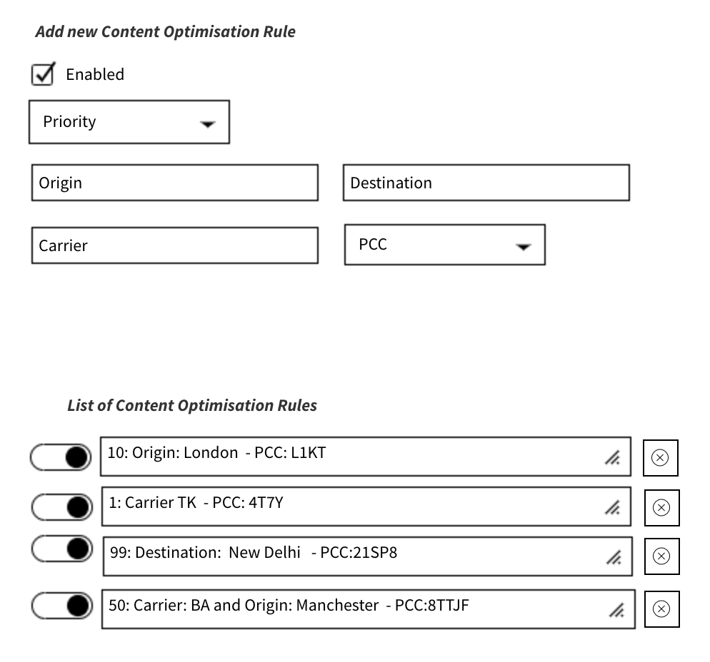

#### Section Upload CORs (CM-6-OPT-UPL)

This section allows the user to upload a csv with the fields described in section CM-6-OPT-ADD. This csv will fully replace all existing content optimization rules. There is a button upload, a pop-up allows file selection. After a file is selected there is a pop-up that warns the user that all CORs shall be overridden. Upon confirmation, the new file overrides all CORs.

# Management reporting

The management reporting module has a separate DB and front-end. It provides sales data that can be grouped / filtered by CXR, geography and type (itinerary vs ancillaries). It is accessible to UTL2, UTL3 and UXL1. The screen organization is identical, with the only difference being the possibility to group by additional criteria – i.e. group by UTL2 Name if the user is UTL3 and group by Tenant Name if the user is UXL1. The management reporting module allows for download or export of data in csv format for additional reporting purposes.

When an itinerary or ancillaries fulfillment is completed, the following fields are stored in the management reporting DB. If one order has multiple ticket masks or EMDs, the values are filled-in separately for each of them. The date is stored in two tables and has references to several other tables The fields are:

* Common fields (relevant for itinerary and ancillaries)
* ID – ETKT number for ticketed itineraries and EMD id for ancillaries
* Customer ID (UTL1)
* Agent ID (UTL2), blank if the ticket is issued B2C (not through an agent)
* Tenant ID (UTL3)
* Date-time of ticketing in UTC
* Departure date-time from journey origin
* Type of trip
  + One-way
  + Round-trip
  + Multi-city
* Origin (3 letter IATA code)
* Origin city (3 letter IATA code)
* Origin state
* Origin country
* Origin zone
* Origin area
* Destination
* Destination city
* Destination state
* Destination country
* Destination zone
* Destination area
* Weeks ahead (calculated column based on the previous two, rounded up)
* Plating CXR
* Marketing CXRs in the journey /separate table/
* Operating CXRs in the journey /separate table/
* Request segment O&Ds /separate table/
* Flights (O&D, CXR) /separate table/
* Group size – the number of passengers (number of ETKTs in the order)
* Base Fare (amount and CCY)
* Equivalent Fare (amount and CCY)
* IATA taxes (amount)
* Total amount (amount)
* Total amount in USD (converted at time of ticketing, used for reporting)
* Tenant revenue in currency of payment and in USD:
  + Mark-up
  + SVC fee
* Agent revenue in CoP and in USD:
  + Mark-up
  + SVC fee
* Xeniapp revenue in CoP and in USD
  + Mark-up
  + SVC fee
* Fields only relevant to itineraries:
  + YQ/YR
* Fields for ancillaries only
  + Number of booked ancillaries – the number of booked ancillaries in the order
  + Merchandise type – defines the type of ancillaries – corresponds to byte 21 from ATPCO Rec S7
  + Service Sub Code – further defines the type of ancillaries – corresponds to bytes 8-10 from ATPCO Rec S7, EMD mask field rfiSubCode
  + Name – corresponding to EMD mask field productCharacteristics

## Screen with management reporting graphs (MR-1-GRP)

The screen that contains management reporting graphs has the following section: sales, revenue, volumes. Sales implies the ticket face value, revenue implies the Xeniapp or tenants revenue, volume is in number of tickets. The sections have identical organization. The sales section will be described in detail, while the difference with the other two is that on the Y axis will be presented revenue and volumes instead of sales.

Each graph has the following action buttons:

* Download data series

### Time series line graphs

On the top are presented three time series line graphs for 1Y, overlapping for the last 5Y, with aggregation by month for the total sales volume.

* The graph has buttons that can filter the data set – ALL, ITINERARY, ANCILLARIES.
* The graph has the option to change period to the following:
  + 24 hours, 7 days
  + Last month (overlay same month from last year)
  + Last year (overlay last 5Y)
* There is an option to download in csv format the data points used to draw the graph

The structure of DB queries necessary to implement this functionality is presented in the technical analysis section.

### Relevance describing Bar graphs

On the bottom is presented a bar graph showing in absolute and percentage amounts in descending order the top 100 records by criteria. The criteria are:

* Tenant (for user UXL1)
* UTL2 (for user UTL3)
* Origin
* Destination
* Route – Origin and Destination – this criterion has several sub-criteria: Airport, City, State, Country, Zone, Area
* CXR
* Weeks ahead
* Merchandise type (for Ancillaries only)
* Service Sub Code (for Ancillaries only)

The structure of DB queries necessary to implement this functionality is presented in the technical analysis section. The following queries shall be defined:

* Group by either of the following criteria: tenant, UTL2, Origin, Destination, Route (Airport, City, State, Country, Zone, Area), CXR, Weeks ahead, Merchandise type, Service Sub Code
  + Filter by corresponding date-time period for date-time of ticket issuance (ETKT or EMD)
    - Sum Revenue, sort in descending order

or

* + - Sum Volume, sort in descending order

or

* + - Count of issued tickets per, sort in descending order

# Mark-ups processing, Middleware

To enable calculation of mark-ups and service fees, created by different parties within a transaction, the following features will be implemented:

* Enable UXL1 to specify mark-up as percentage or absolute amount to be added to base fare amount, specify service fee as an absolute amount
* Enable UTL2 to specify mark-up and/or service fee
* Enable UTL3 to specify mark-up and/or service fee

These mark-ups and SVC fees will be applied based on characteristics of a particular journey. For further information see ADM-2-UTL2-MUP-ADD.

The mark-ups and the content management rules are added as necessary information to the JSON rquest by the MW. Module. The MWmodule also 1) strips information that should not be visualized from the JSON response and 2) stores the itinerary price / reprice responses with unique ID, for booking purposes.

The following actions are performed by the Middleware module:

* Receive a request from UXL1, UTL3, UTL2, UTL1
* Mark-ups:
  + Extract the relevant mark-up and SVC fee rules from external DB (match by journey characteristics)
  + Add to the JSON request these relevant mark-up / SVC fee rules
* Content management:
  + Extract the relevant content management rules from external DB (match by journey characteristics)
  + Add content blockage rules
  + Check booking limit rues. If a booking limit is exceeded, return JSON error response to the TBGI for visualization, processing is finished
  + Add to the JSON request the relevant content management rule (e.g., forbidden CXRs)
* Receive a JSON response that has all mark-ups and price points pre-calculated
  + If the type of response is a price / reprice, the data shall be stored in a DB and a reference to the offer shall be returned to the TBGI (offer ID).
* Mark ups:
  + Markup fields will be stripped from JSON data that is forwarded to the TBGI for visualization (e.g. UXL1 and UTL3 mark-ups will NOT be visible when the user is UTL1).
* Forward the JSON response to the TBGI for visualization.

On the TBGI the end-user price is visualized (after all mark-ups and SVC fees). The TBGI will visualize all mark-up / SVC fees information that is included in the JSON response. For example, UXL1 shall see all mark-ups and SVC fees, while user UTL1 shall see only the end-user price.

See diagram below:

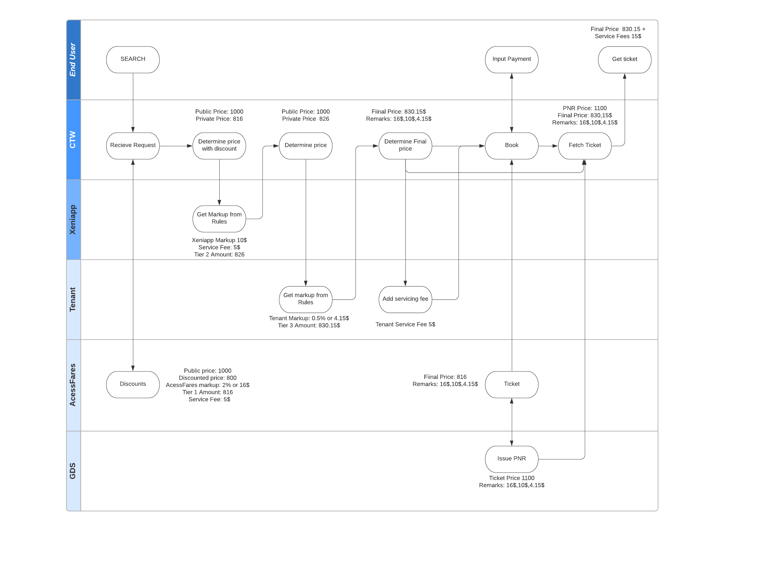

Technical Overview

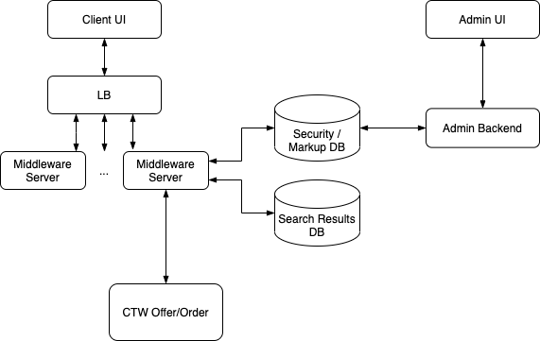

# Client UI

The client UI for air travel is a JavaScript application that receives data from and sends requests to the middleware server. It is based on React and Bootstrap frameworks with a though to be integrated into the Xeniapp complete UI.

There are 10 screens for issuing and servicing tickets (workflow A) and 6 screens for issuing and servicing ancillaries (workflow B). These are described in detail in the Design document.

From a technical standpoint each screen should make the appropriate API calls to the middleware and display the returned information.

# Admin UI

The admin UI is JavaScript application similar to the client UI, but will have screens dedicated to managing users, markups, specifying content permissions and limits. These screens are described in detail in the Design document in sections Administrative Screens, Content Management, Management reporting. From a technical standpoint each screen should make the appropriate API calls to the admin backend to retrieve and modify the corresponding information.

# Admin Backend

The admin backend is the server counterpart of the admin UI that will persist the settings specified by the admin UI in the user/security/markup DB. It will also generate reports for the admin UI to display.

The admin server will mostly consist of a series of RESTful controllers over a database and one or more report generating controllers.

Implementation-wise two approaches are viable.

1. The admin backend to be implemented with the same technology stack as the rest of Xeniapp admin panel and these controllers to be implemented in a similar manner and as an extension of that panel
2. The admin backend to be implemented with the same technology stack as the middleware server. This aligns with the fact that the middleware server will be the main user of the markup and security DB and the models can be shared and kept consistent.

# Security/Markup DB

The security and markup database holds data about the markups and security restrictions of the users. It should closely represent the fields described in the design document in the appropriate sections.

Similarly to the admin backend, two implementation approaches are viable.

1. The security/markup database to be the same entity as the user database that will be mainly managed by Xeniapp.
2. A separate database by instance (and potentially type – SQL). This approach should be considered only if approach number 2 is decided for the admin backend.

# Search Results DB

The search result DB is solely used by the middleware server and serves as a temporary storage for offers returned by the CTW system that the client can book in a limited window of time.

When offers are returned by the offer system the client must receive a stripped version of them, containing only the information needed for display and none of the sensitive information concerning markups. The full offers should be stored in the DB and later used to issue additional requests to the offer/order systems.

The database should be high performance, scalable key/value store that supports automatic expiration of values.

# Middleware Server

All requests from the client UI are sent to the middleware server. Its main purpose is to serve as a smart proxy to the CTW offer/order system. It does authentication and security checks on all requests. It modifies requests based on the rules in the markup database and stores the offers in results database for future reference in book requests.

## Technology and Scalability

There is high performance and high volume requirement for the middleware server so the technology of choice is a Java server based on the Jetty HTTP server framework. Additionally, the server is linearly scalable, allowing to run multiple instances in parallel on as much separate servers as needed.

## Authentication requests

The server provides a simple API for the user to authenticate with username and password and to acquire a session token to be used in the future requests in the current client session.

## Shop requests workflow

The shop requests are the initial requests in the workflows that will query the CTW offer system.

When received, these requests are first subject to security and rate limit checks. Then they are appropriately modified to include the markup information that applies to the current user. And finally, they are sent to the CTW offer system.

Once the response is returned, it is stripped from the sensitive and redundant information and then it is returned to the client UI.

## Price requests workflow

Once a specific shop offer is selected in the client UI it will produce a price request. When received, it will be subject to security and rate limit checks. Then it will be modified to include the markup information that applies to the current user. Finally, it will be sent to CTW offer system.

When the response is returned it is stored in the Search Results database. Then it is stripped from the sensitive and redundant information and is returned to the client UI.

## Subsequent order requests

All subsequent requests based on the price offers refers to them by unique id. Then the specific offer is fetched from the Search Results database and request is built and sent to the CTW order system.