EDTA Complete Showcase
Experience-Driven Targeting Architecture — Governed, Explainable, Trust-Aware Personalization
Author: Jerald Selvaraj · jerald.cs@gmail.com
Version: Showcase v1 — July 2026 · Reference implementation v2.4
Live demo: https://edta-api.onrender.com/scenario-demo
GitHub repository: https://github.com/jeraldcs/edta-complete-api
OpenAPI / Swagger: https://edta-api.onrender.com/docs

This document is a single showcase package for architects, engineers, product leaders, and publication reviewers. It explains what EDTA is, how the live demo works, how to integrate the API into any application, why it benefits every industry, and where the project is headed.

Table of Contents
- 1. Executive Summary
- 2. Why EDTA Is Useful for Everyone
- 3. Problem Statement
- 4. Traditional vs EDTA — Comparison Framework
- 5. Architecture Overview
- 6. Core Components & Code Map
- 7. How the Live Demo Works
- 8. API Integration Guide
- 9. Benefits — Engineering, Business, Compliance
- 10. Multi-Industry Applicability
- 11. Benchmarks & Evidence
- 12. Security, Deployment & Operations
- 13. Future Roadmap
- 14. Publication & InfoQ Materials
- 15. Resources & Quick Start

1. Executive Summary
Enterprise teams are adopting large language models for personalization faster than they are adopting governance for personalization. The result is often relevant but risky recommendations: opaque scores, uncontrolled token cost, and weak answers when product, compliance, or trust teams ask why a recommendation was shown.
EDTA (Experience-Driven Targeting Architecture) is an open-source reference implementation (FastAPI, Python) that decomposes personalization into explicit, auditable modules instead of a single black-box model.
Acronym | Name | Role
TKGE | Temporal Knowledge Graph Engine | Journey timeline, inferred intent
EML | Experience Memory Layer | Trust, fatigue, preferences, outcomes
HAOE | Hybrid AI Orchestration Engine | Rules → SLM → ML → optional LLM
EDS | Experience DNA Score | Explainable relevance breakdown
TAPL | Trust-Aware Personalization Layer | show / soften / delay / suppress in ranking
OSE | Outcome Simulation Engine | Conversion, revenue, trust, compliance risk

The LLM enriches and explains; it does not own consent, compliance, fatigue, or final trust governance. A live browser demo, OpenAPI contract, 167 automated tests, and reproducible benchmarks are included.

2. Why EDTA Is Useful for Everyone
- Software architects: Reference pattern for multi-tier AI routing, policy externalization, and API-native explainability.
- Backend / ML engineers: Runnable code for intent, journey, TAPL, outcome simulation, and ranker modules with clear boundaries.
- Product managers: Demo shows before/after trust and fatigue, TAPL actions, and outcome scores — not only candidate IDs.
- Compliance & trust teams: TAPL modifies ranking; audit trails in SQLite; rules fired and tier visible in every response.
- Industry vertical teams: Swap YAML rule packs, candidate catalogs, and empathy profiles — keep the same engine core.
- Researchers & publishers: Reproducible four-tier benchmarks, architecture diagrams, and honest scope limits for articles.

3. Problem Statement
context → model → ranked recommendation
This pattern fails enterprise requirements:
Gap | Consequence
Opaque ranking | Cannot answer why in production incidents
LLM-first design | Unbounded cost, latency, provider dependency
Trust as metadata only | Consent/fatigue logged but not enforced in ranking
Single-channel thinking | Web, chatbot, IoT need unified policy
No outcome view | Optimizes clicks, not expected business outcome
Vertical monolith | Each industry rewrites the engine instead of policy layers

4. Traditional vs EDTA — Comparison Framework
EDTA is a demo and reference implementation built from experience with traditional personalization architectures — rule engines, single-model rankers, and batch CRM campaigns — then extended with modern AI under explicit governance.
EDTA does not replace traditional personalization — it completes it. Rules stay fast and auditable; ML stays for catalog fit; AI enters only where ambiguity demands it; and governance, memory, and explainability sit inside the decision path, not in a downstream dashboard.

4.1 Three traditional patterns
Pattern | Strengths | Breaks when…
Rule-based personalization | Auditable, fast, cheap | Multi-channel NLP and journey memory are required
Monolithic ranker | Strong catalog match | Consent/fatigue must change the rank, not only logs
LLM bolt-on | Handles ambiguity | Cost, latency, and audit become first-class requirements

4.2 What you can prove in the live demo
Dimension | Traditional (typical) | EDTA
Explainability | Score only or post-hoc SHAP | Rules, tier, TAPL, EDS, explanation in JSON
Governance in rank | Consent outside the ranker | TAPL show/soften/delay/suppress/fallback
Memory | Stateless or batch segments | EML trust/fatigue across sessions
Outcome view | Click-optimized rank | OSE conversion/revenue/trust risk
Cost control | Fixed infra or unbounded LLM | HAOE Rules → SLM → ML → optional LLM
Vertical reuse | Rewrite engine per industry | Same core; swap YAML + catalog

4.3 Five-minute comparison script
- Rules-era upsell — structured SUV booking; show TAPL + EDS + explanation (chip: Rules-era upsell).
- ML ranker era — family vacation with cargo; Semantic alone is not final (chip: ML ranker era).
- LLM bolt-on risk — ambiguous one-liner; inference tier visible, TAPL still governs (chip: LLM bolt-on risk).
- EDTA governed — loyalty family SUV with consent; full stack panels (chip: EDTA governed).
- Governance contrast — No consent → generic_fallback; High fatigue → delay/soften.

4.4 Evidence and honesty bounds
- Travel matrix: docs/TRAVEL_SCENARIO_SCORES.md — alignment proxy, not production A/B lift.
- Four-tier benchmarks: docs/BENCHMARKS.md — use local Docker for engine latency; label Render cold start separately.
- Counterfactuals: POST /v1/compare-outcomes — outcome simulation before live experiments.
- Full exhibit: docs/TRADITIONAL_VS_EDTA.md — reusable for InfoQ and customer reviews.

5. Architecture Overview
Customer Context
→ Profile Lookup + Experience Memory (EML)
→ Temporal Knowledge Graph (TKGE)
→ Hybrid AI Orchestration (HAOE) — Rules / SLM / ML / LLM
→ Intent + Journey Inference
→ Per-candidate: EDS → TAPL → OSE → Final Ranker
→ Explanation + Memory Update + Feedback Learning
→ Recommendation

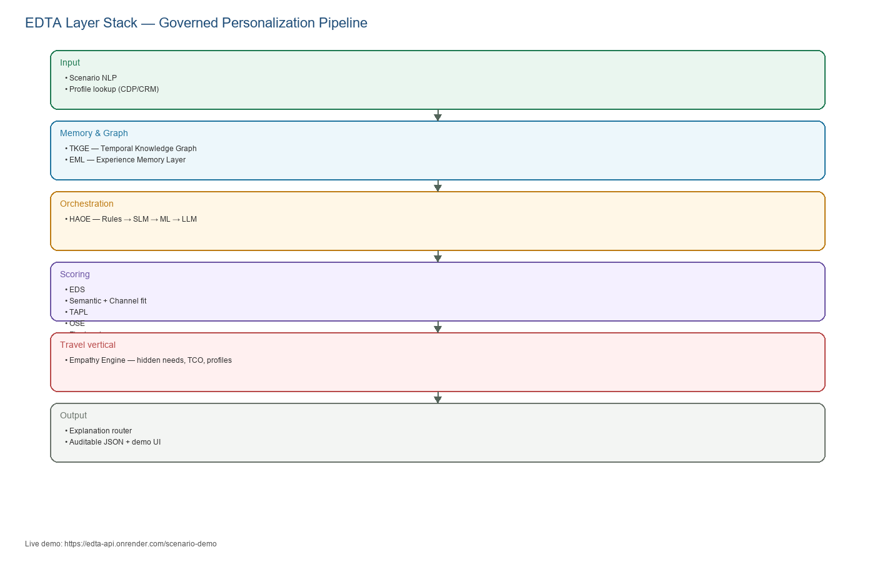
Figure 1 — EDTA logical layer stack

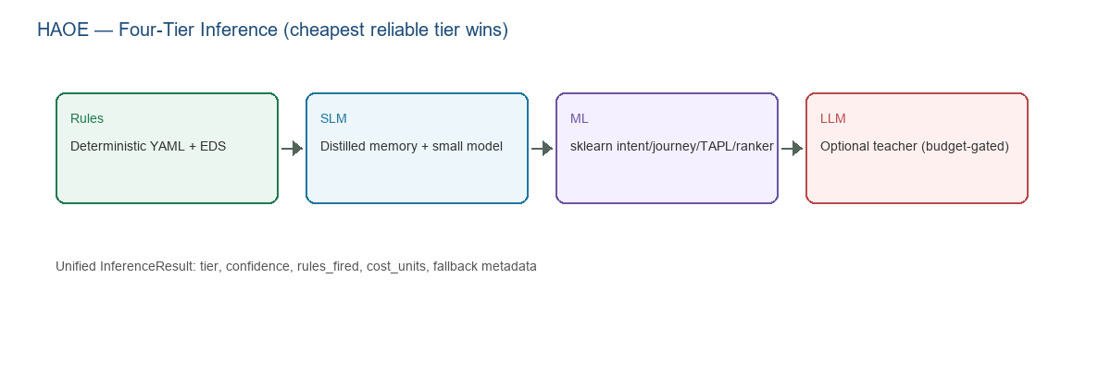
Figure 2 — HAOE four-tier inference routing

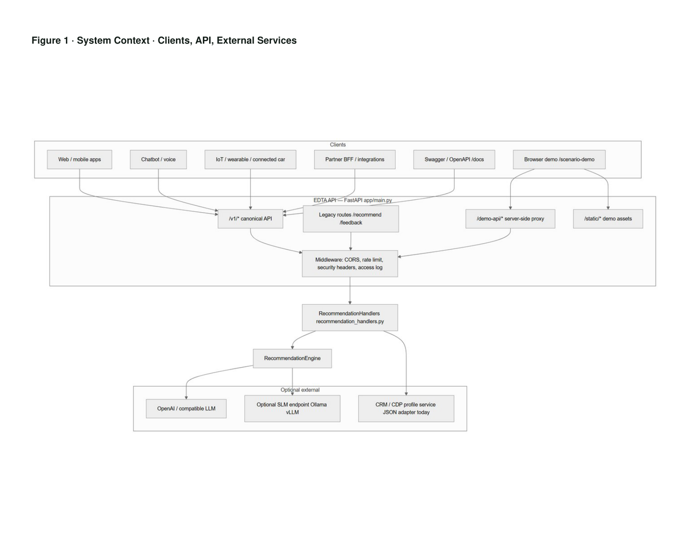
Figure 3 — System context (clients, API, external services)

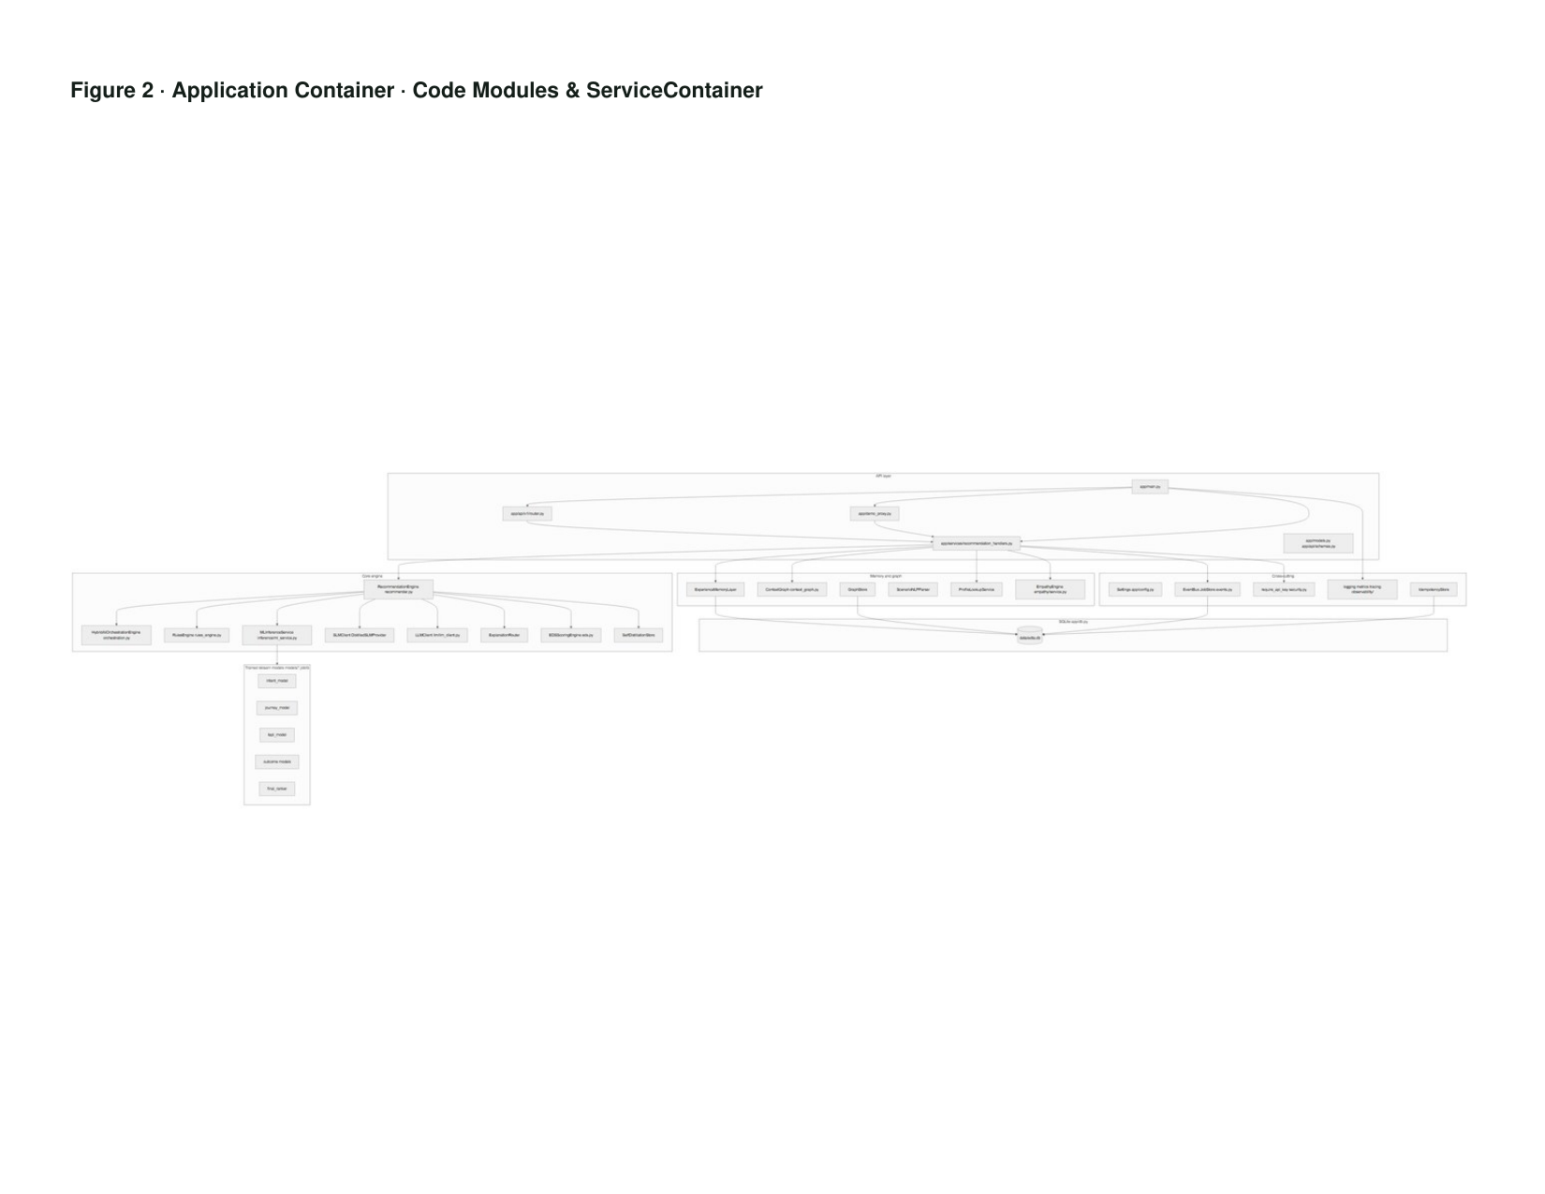
Figure 4 — Application container and code modules

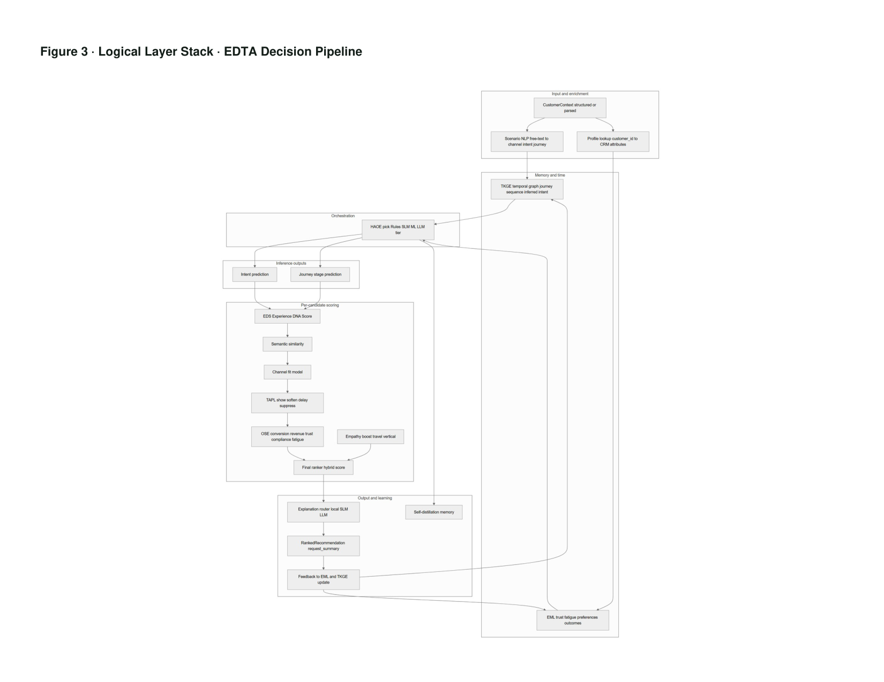
Figure 5 — End-to-end recommend sequence

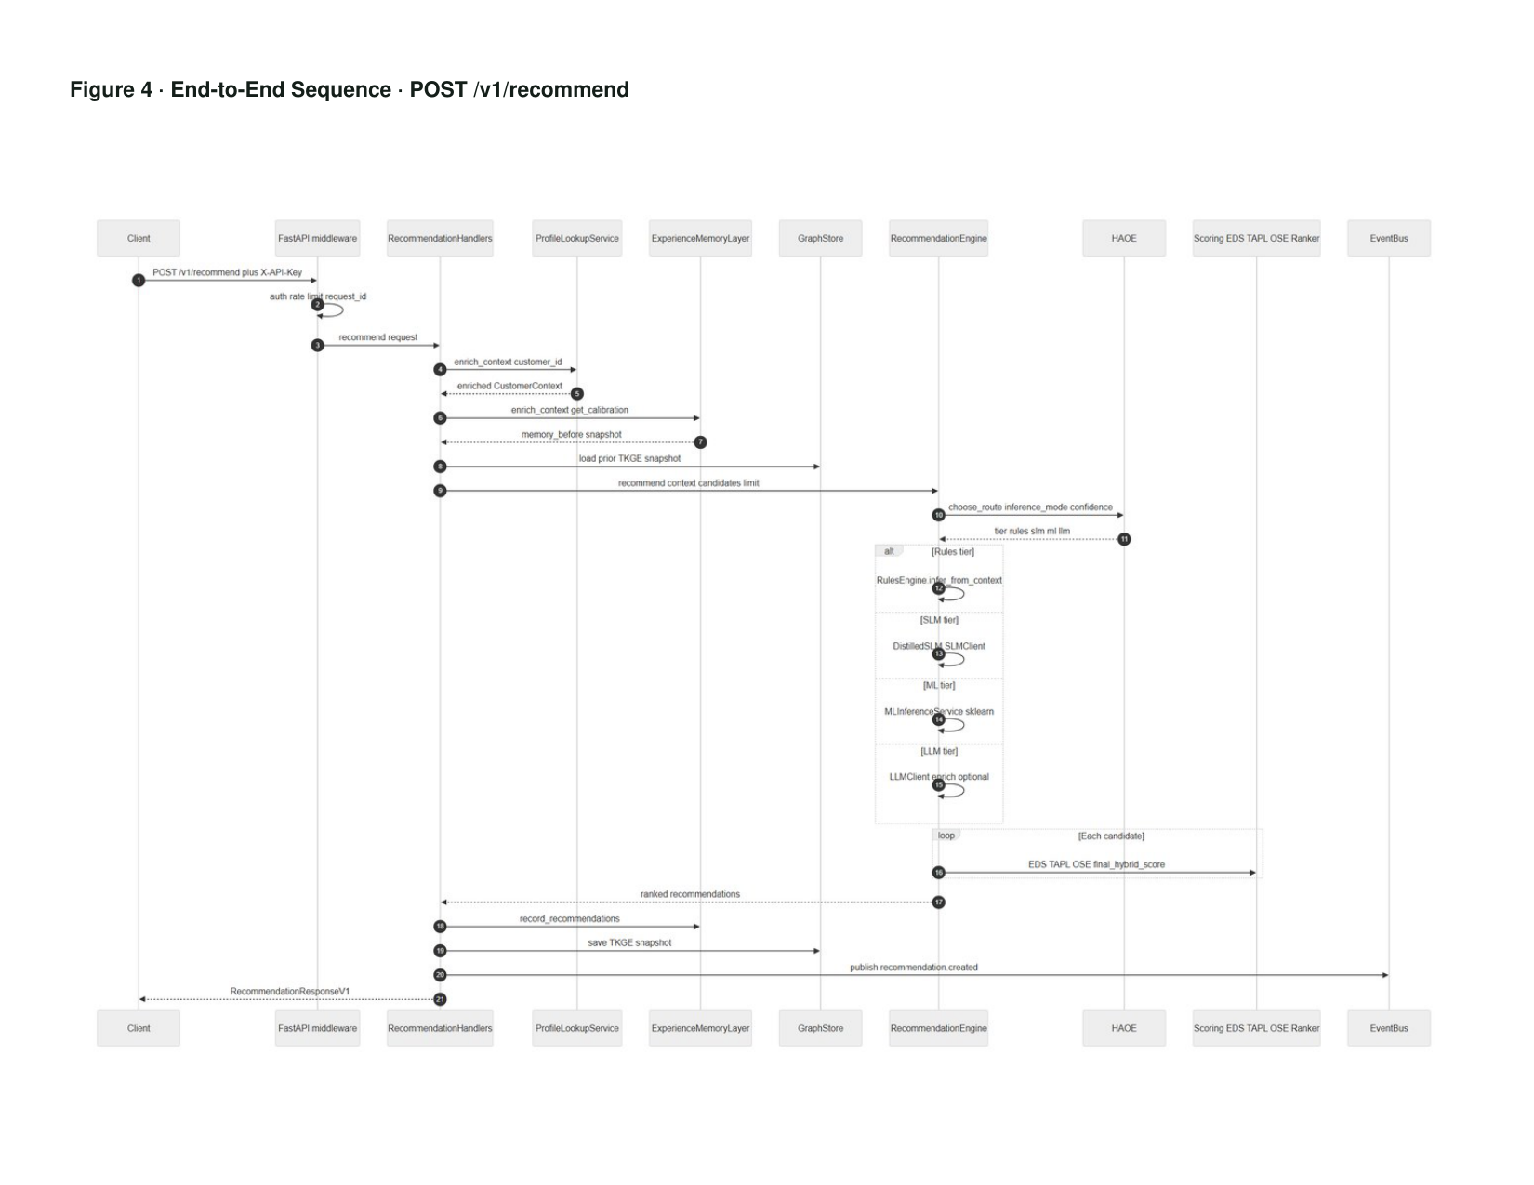
Figure 6 — Scenario demo path

6. Core Components & Code Map
Repository layout (github.com/jeraldcs/edta-complete-api):
edta-complete-api/
├── app/
│ ├── main.py # FastAPI entry, middleware, routes
│ ├── api/v1/router.py # Canonical /v1 API
│ ├── demo_proxy.py # Server-side auth for browser demo
│ ├── container.py # ServiceContainer wiring
│ ├── services/recommendation_handlers.py # Request orchestration
│ ├── recommender.py # RecommendationEngine rank loop
│ ├── orchestration.py # HAOE tier selection
│ ├── experience_memory.py # EML
│ ├── context_graph.py # TKGE
│ ├── empathy/service.py # Travel empathy engine
│ ├── inference/ # ML service, explanation router
│ ├── ai/ # sklearn model wrappers
│ ├── llm/ # Optional OpenAI / SLM clients
│ └── db.py # SQLite schema
├── config/ # TAPL, HAOE, rules, empathy YAML
├── data/ # Catalogs, training CSV, profiles
├── models/ # Trained *.joblib artifacts
├── static/ # scenario-demo UI
├── tests/ # 167 pytest tests
└── scripts/ # train, benchmark, load test
Module | File | Responsibility
API handlers | recommendation_handlers.py | Enrich → rank → persist → respond
Rank engine | recommender.py | Candidate loop, tier execution, hybrid score
HAOE | orchestration.py | Rules/SLM/ML/LLM routing, cost budget
TAPL | ai/tapl_model.py + tapl_policies.yaml | Trust governance actions
EML | experience_memory.py | Trust, fatigue, preferences, history
TKGE | context_graph.py + graph_store.py | Temporal journey graph
Empathy | empathy/service.py | Hidden needs, TCO, constraints (travel)

7. How the Live Demo Works
URL: https://edta-api.onrender.com/scenario-demo

7.1 User flow
- Open /scenario-demo in a browser (Render may cold-start ~30s on free tier).
- Select a trained scenario chip or type free-text (e.g. family SUV airport rental).
- Optional: use Compare vs traditional chips (Rules-era, ML ranker, LLM bolt-on, EDTA governed) — same Recommend API.
- Click Recommend — demo-api.js calls the API (production uses /demo-api proxy with server-side auth).
- View top recommendation with EDS, TAPL, outcome scores, and explanation.
- Architecture panels show TKGE, EML, HAOE, and OSE summaries from the response JSON.
- Optional: scroll the 11-scenario travel benchmark matrix; click a row to load and run that scenario.
- Feedback buttons (Click / Convert / Dismiss) update EML and TKGE for the scenario subject.

7.2 Server-side demo path
scenario_text
→ ScenarioNLPParser (channel, intent, journey, consent hints)
→ scenario_anonymous_id() — isolates EML/TKGE per trained profile
→ ProfileLookupService (customer_id → CRM mock JSON)
→ ExperienceMemoryLayer enrich + calibration
→ EmpathyEngine.process() — hidden needs, TCO, constraints
→ Merge vehicle catalog candidates
→ RecommendationEngine.recommend()
→ JSON response + architecture panels

7.3 Demo modes
Mode | Endpoint | Purpose
Recommend | POST /recommend-from-scenario | Full stack ranking from free text
Simulate | POST /simulate | Outcome simulation without full rank response
Experience memory | GET /experience-memory | Trust/fatigue snapshot for subject
Travel benchmark | GET /travel-scenario-benchmark | 11-scenario score matrix
Empathy | POST /empathy/simulate | Hidden needs + TCO bundle

8. API Integration Guide
New integrations should use the versioned /v1 API. Legacy root routes remain for the web demo.

8.1 Authentication
When EDTA_API_KEY is set, send X-API-Key on mutating and protected read requests. Browser demos on production use /demo-api/* proxy (same origin, no client key).

8.2 Core endpoints
Method | Path | Purpose
POST | /v1/recommend | Structured CustomerContext + optional candidates
POST | /v1/recommend-from-scenario | Free-text scenario (demo-friendly)
POST | /v1/recommend/batch | Async batch (202 + job polling)
POST | /v1/feedback | Click / convert / dismiss → EML update
POST | /v1/compare-outcomes | Counterfactual A vs B
GET | /v1/context-graph | TKGE export for subject
GET | /v1/experience-memory | EML snapshot
GET | /v1/orchestration-status | HAOE telemetry
POST | /v1/webhooks | Register HTTPS webhook (SSRF-validated)

8.3 Example — structured recommend (curl)
curl -X POST "https://your-host/v1/recommend" \
-H "Content-Type: application/json" \
-H "X-API-Key: YOUR_EDTA_API_KEY" \
-d @sample_requests/web_family_suv.json

8.4 Example — scenario recommend (JavaScript fetch)
const response = await fetch("https://your-host/v1/recommend-from-scenario", {
method: "POST",
headers: {
"Content-Type": "application/json",
"X-API-Key": process.env.EDTA_API_KEY,
},
body: JSON.stringify({
scenario_text: "Family of four needs SUV for Orlando theme park trip with luggage.",
limit: 3,
use_ai_models: true,
include_empathy: true,
}),
});
const data = await response.json();
// data.request_summary.inference.tier — rules | slm | ml | llm
// data.recommendations[0].ai_score.tapl.action — show | soften | delay | suppress
// data.recommendations[0].explanation — human-readable rationale

8.5 Integration patterns
- Web / mobile app: Call POST /v1/recommend from BFF with enriched CustomerContext from your CDP.
- Chatbot / voice: Use POST /recommend-from-scenario for NLP input; set channel to chatbot in parsed context.
- Partner API: Use /v1 with API key; poll /v1/jobs/{id} for batch campaigns.
- Event-driven: Register POST /v1/webhooks; subscribe to recommendation.created and feedback.received.
- Idempotency: Send Idempotency-Key header on POST /v1/recommend and /v1/feedback for safe retries.

8.6 Response fields integrators should persist
- request_summary.request_id — correlate logs and support tickets
- request_summary.inference.tier — which AI tier ran
- recommendations[].ai_score.tapl.action — governance decision
- recommendations[].eds_score — explainable relevance breakdown
- recommendations[].explanation_source — local | slm | llm

9. Benefits — Engineering, Business, Compliance

9.1 Engineering benefits
- Modular testability — 167 pytest tests; force inference_mode per tier for benchmarks.
- Cost control — HAOE session budget, LLM circuit breaker, SLM distilled memory.
- Provider independence — runs fully without OpenAI; LLM is optional enrichment.
- API-native explainability — no log archaeology for why a recommendation was shown.
- Policy as code — TAPL, HAOE, rules in YAML without redeploying ranker code.

9.2 Business benefits
- Outcome-oriented ranking — OSE estimates conversion and revenue, not only similarity.
- Fatigue-aware engagement — EML + TAPL reduce over-exposure and banner blindness.
- Cross-channel consistency — same engine for web, mobile, chatbot, IoT, partner API.
- Faster vertical experiments — swap catalog + YAML; keep orchestration and memory layers.
- Empathy-aware travel upsell — TCO and hidden-needs matching for rental scenarios.

9.3 Compliance & trust benefits
- Consent enforcement — TAPL generic_fallback when personalization consent is false.
- Sensitive channel governance — suppress/soften on SMS, wearable, IoT for high-compliance content.
- Audit trail — TAPL decisions logged to SQLite with reason strings.
- Healthcare education scope — HCP content routing with disclaimers; not clinical DSS.
- Problem+JSON errors with request_id — production-safe error correlation.

10. Multi-Industry Applicability
EDTA is vertical-agnostic at the engine layer and vertical-specific at the policy and catalog layer. The same four-tier pipeline applies; teams supply domain rules, approved candidates, and empathy profiles.
Industry | Example candidates | EDTA mechanisms | Demo scenario
Travel / car rental | SUV upgrade, booking discount | Empathy, TCO, TKGE | 11 road-trip scenarios
Hotel / hospitality | Room offer, reservation assist | Rules + journey stage | hotel_reservation_assist
Restaurant | QR menu, dish promo | Channel fit, mobile | mobile_restaurant_qr_menu
Banking | Product offer, advisor content | TAPL compliance sensitivity | banking rules pack
Healthcare | HCP education content | TAPL suppress on SMS/wearable | obesity_product_hcp_education
Retail / e-commerce | Upsell, retention offer | EML preferences + OSE | catalog JSON swap
IoT / connected car | Location assist, service nudge | Channel=connected_car | connected_car_location_assist

How to adapt for a new industry (checklist):
- Add candidates to data/catalog/ or pass candidates in the API request.
- Create or extend config/rules/packs/{industry}.yaml.
- Review config/tapl_policies.yaml for consent, fatigue, and channel rules.
- Add training rows to data/scenario_training_master.csv; run scripts/train_all_models.py.
- Optional: add empathy or enrichment profiles under config/empathy/.
- Point PROFILE_LOOKUP_ADAPTER at your CDP/CRM instead of json_file.

11. Benchmarks & Evidence

11.1 Travel scenario matrix (11 scenarios)
100% top-rank vehicle alignment on the demo training set (alignment proxy — not production A/B lift). See docs/TRAVEL_SCENARIO_SCORES.md and GET /travel-scenario-benchmark.

11.2 Four-tier benchmarks
Tier | p95 target (local) | Cost | Use case
Rules | < 50 ms | ~0 units | Structured context, auditable
SLM | < 100 ms | Low | Distilled pattern memory
ML | < 300 ms | Medium | sklearn classifiers
LLM | 3–8 s | Highest | Ambiguous rich context (optional)

python scripts/load_test_tiers.py --base-url http://127.0.0.1:8000

11.3 Test suite
pytest # 167 tests — API, TAPL, empathy, HAOE, security, scenarios

12. Security, Deployment & Operations
Topic | Implementation
Authentication | X-API-Key when EDTA_API_KEY set; demo proxy in production
CORS | Explicit allowlist in production
Webhooks | HTTPS only; SSRF validation on registration
Rate limiting | Per-IP in memory; use edge limiter at scale
Health probes | /live (liveness), /ready (readiness), /metrics (Prometheus)
Storage | SQLite (EML, TKGE, audit); mount persistent disk for production
Deploy | Docker, Render blueprint (render.yaml), docker-compose locally

Production checklist:
- Set EDTA_API_KEY and EDTA_ENVIRONMENT=production
- Set EDTA_CORS_ORIGINS to your app origin
- Use /ready for load balancer health checks
- Enable EDTA_LOG_FORMAT=json and scrape /metrics
- Review config/tapl_policies.yaml for your regulatory context

13. Future Roadmap

Completed (v2.4 reference stack)
- Four-tier HAOE with benchmarks and distilled SLM memory
- EML + TKGE with feedback loop
- Empathy engine — hidden needs, TCO, 11 travel profiles (Phase 6A–6B largely complete)
- Production hardening — auth on reads, demo proxy, webhook SSRF, idempotency, SQLite feedback
- 167-test CI with ML eval and OpenAPI export

Near-term (Phase 6C–7)
Phase | Focus | Outcome
6C | Live weather/route/gas enrichment APIs | AWD boost with forecast evidence
6D | Dedicated empathy simulator UI polish | Enhanced public demo UX
7 | Empathy accuracy evaluation vs baseline filters | Published benchmark exhibit
Ops | PostgreSQL adapter option | Multi-instance production deploy
Ops | Redis rate limiting + webhook retry DLQ | Scale-out readiness

Medium-term
- HTTP CDP/CRM profile adapter (replace json_file mock)
- Partner production case study with A/B metrics
- Kubernetes Helm chart and horizontal pod autoscaling guide
- Optional federated learning hook for ranker retraining
- Expanded healthcare and banking rule packs with compliance review templates

14. Publication & InfoQ Materials
Supporting documents in the docs/ folder for architecture publication and InfoQ submission:
- EDTA_PUBLICATION_DOCUMENT.md: Full publication package
- EDTA_ARCHITECTURE_DOCUMENT.md: Detailed architecture reference
- edta_architecture_diagrams_full.pdf: 11 architecture diagrams
- TRADITIONAL_VS_EDTA.md: Traditional vs EDTA comparison exhibit
- INFOQ_EDITOR_PITCH.md: Editor submission email template
- INFOQ_ARTICLE_OUTLINE.md: ~3,000-word article outline
- edta_llm_personalization_article_draft.md: Extended article draft
- EDTA_POSITIONING.md: Travel vs healthcare narrative angles

Suggested working title for publication:
Governed Personalization: A Four-Tier Architecture for Explainable, Trust-Aware Recommendations

15. Resources & Quick Start
Live demo: https://edta-api.onrender.com/scenario-demo
GitHub repository: https://github.com/jeraldcs/edta-complete-api
OpenAPI / Swagger: https://edta-api.onrender.com/docs

Local quick start:
git clone https://github.com/jeraldcs/edta-complete-api.git
cd edta-complete-api
python -m venv .venv
.venv\Scripts\activate # Windows
pip install -r requirements.txt
python scripts/train_all_models.py
uvicorn app.main:app --reload --port 8000
# Demo: http://localhost:8000/scenario-demo
pytest

Regenerate this showcase document:
python docs/generate_showcase_docx.py

Regenerate architecture diagram PDF:
python docs/generate_architecture_diagrams_pdf.py

