EDTA Architecture Document
Experience-Driven Targeting Architecture for Governed, Explainable, Trust-Aware Personalization
Author: Jerald Selvaraj
Version: 1.0 — July 2026
Live demo: https://edta-api.onrender.com/scenario-demo
GitHub repository: https://github.com/jeraldcs/edta-complete-api
API documentation: https://edta-api.onrender.com/docs

Table of Contents
- 1. Executive Summary
- 2. Problem Statement
- 3. System Context & Diagrams
- 4. Architecture Layer Stack
- 5. End-to-End Request Flow
- 6. Layer-by-Layer Design
- 7. Empathy Engine (Travel)
- 8. Four-Tier Inference (HAOE)
- 9. Why EDTA Is Unique
- 10. Benefits
- 11. Live Demo Walkthrough
- 12. GitHub Repository Guide
- 13. Benchmarks & Evidence
- 14. Scope & Limits

1. Executive Summary
EDTA (Experience-Driven Targeting Architecture) is an open reference implementation that treats enterprise personalization as a governed decision pipeline—not a single black-box model. It combines temporal journey context, experience memory, four-tier AI orchestration, trust-aware policy (TAPL), outcome simulation, and optional empathy-aware travel ranking.
- TKGE — Temporal Knowledge Graph for live journey context
- EML — Experience Memory for trust, fatigue, and preferences
- HAOE — Hybrid AI Orchestration: Rules → SLM → ML → optional LLM
- EDS — Experience DNA Score for explainable relevance
- TAPL — Trust-Aware Personalization Layer affecting rank, not only logs
- OSE — Outcome Simulation Engine for conversion and revenue impact
- Empathy Engine — Hidden needs, route enrichment, TCO (travel demo)
The LLM enriches and explains; it does not own consent, compliance, fatigue, or final trust governance.

2. Problem Statement
context → model → ranked item
This pattern fails when teams need explainability, cost control, and trust enforcement:
Gap | Consequence
Opaque ranking | Cannot answer why an offer was shown
LLM-first design | Unbounded cost, latency, provider lock-in
Trust as metadata | Consent/fatigue logged but not enforced in ranking
Single channel | Web, chatbot, IoT need unified policy
No outcome view | Optimizes clicks, not expected business outcome

3. System Context & Architecture Diagrams
The following diagrams illustrate runtime flow and codebase layering. Publish this document alongside the GitHub repository and live demo URL above.

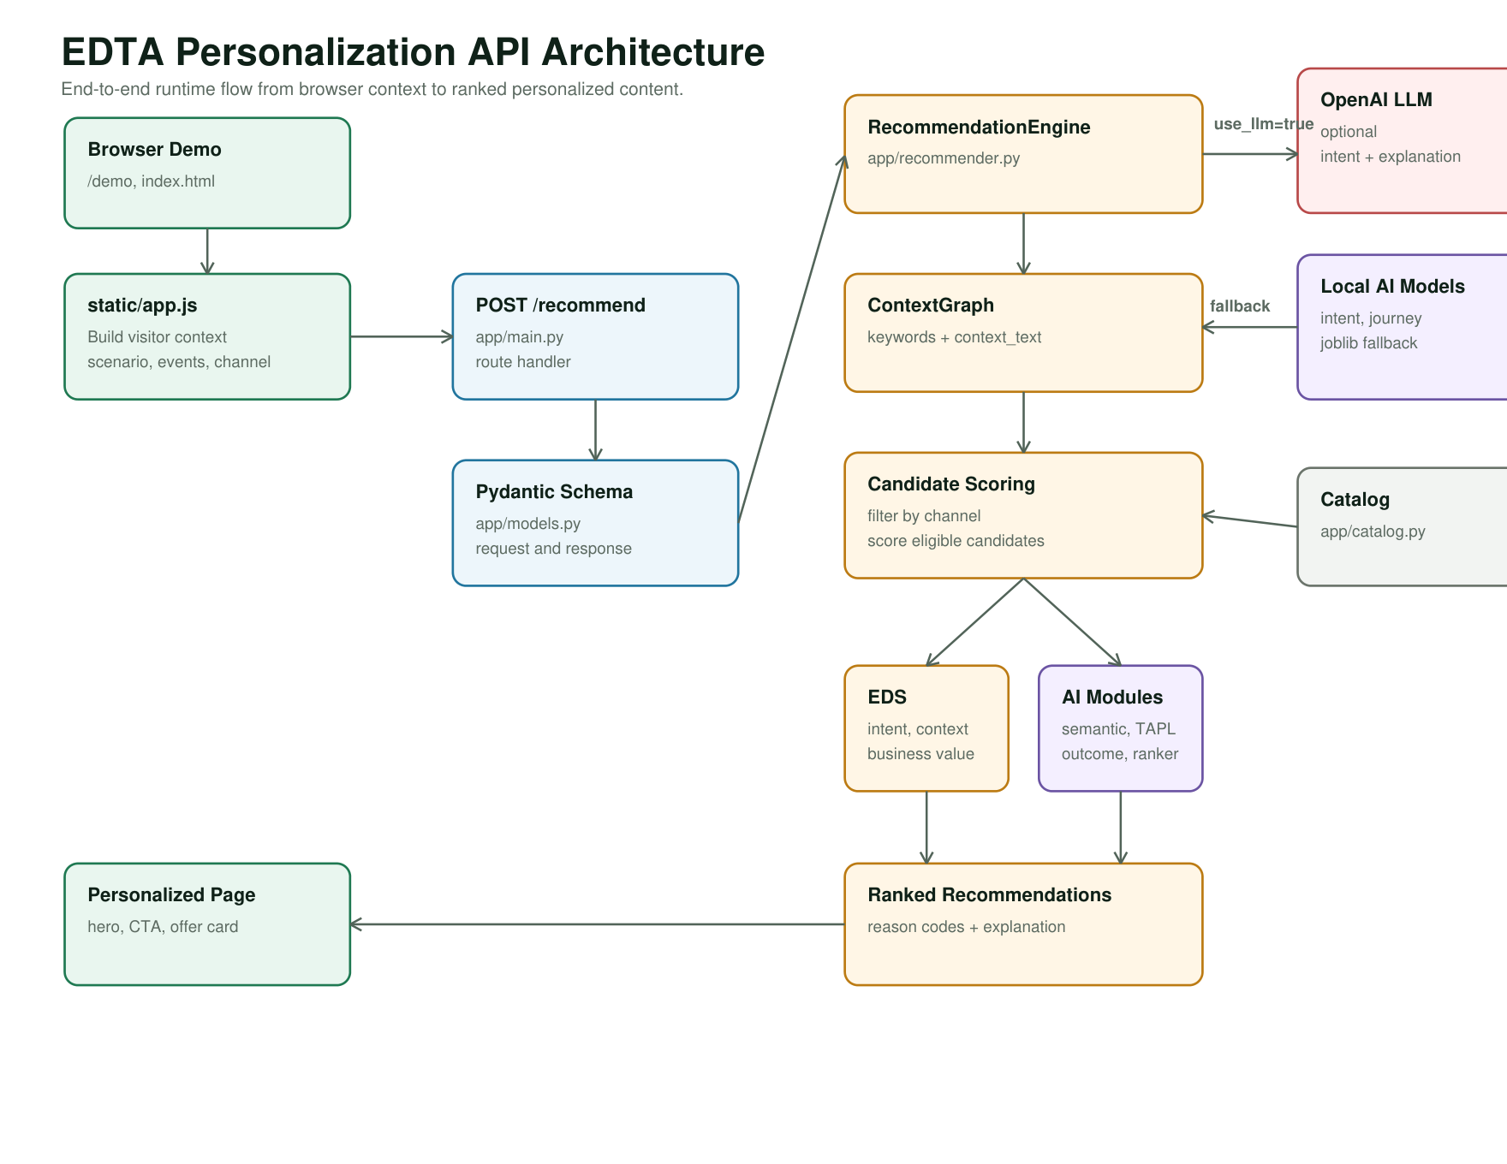
Figure 1 — End-to-end runtime flow (Browser → API → Engine → AI → Response)

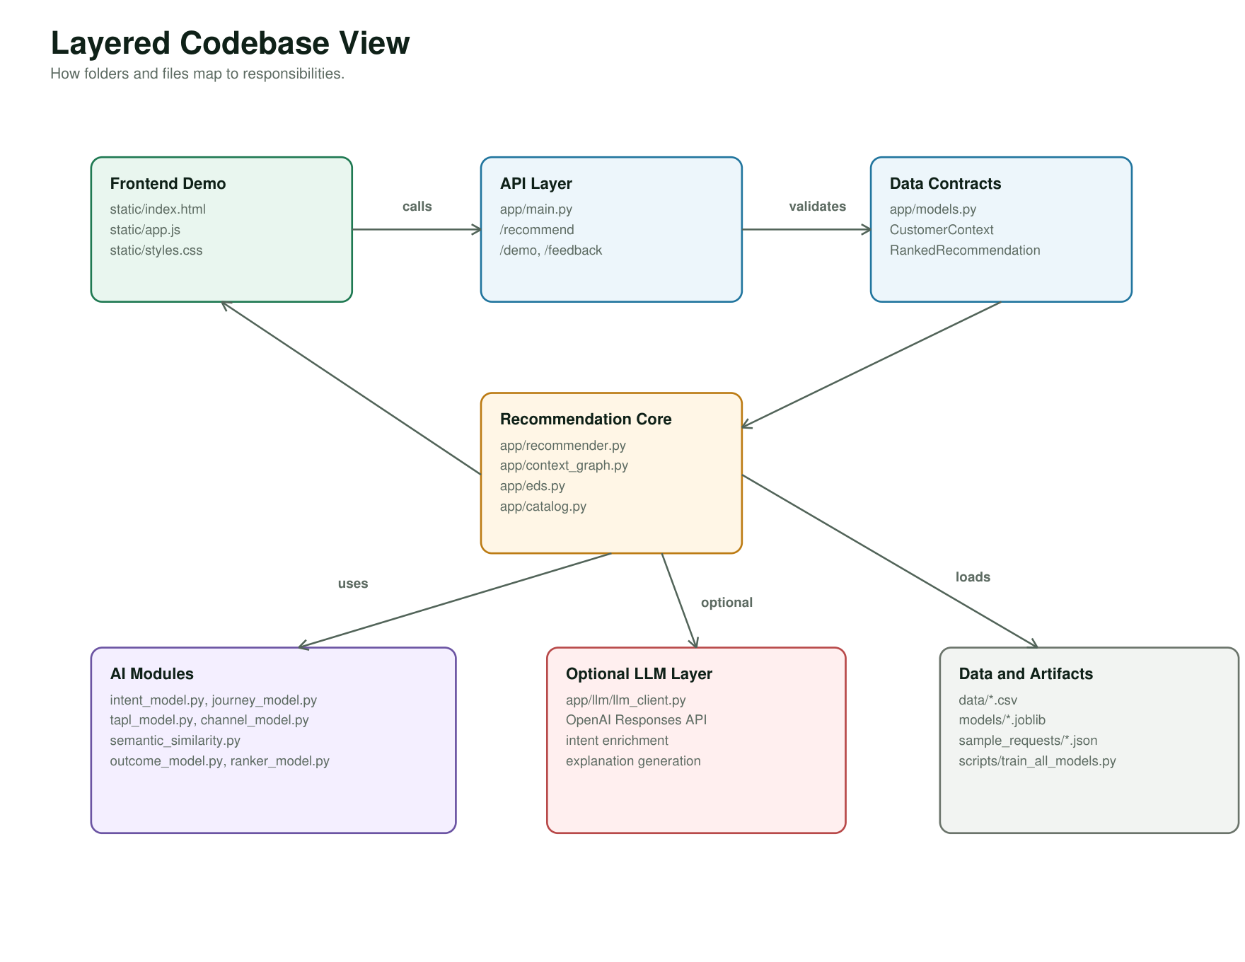
Figure 2 — Layered codebase view (folders and responsibilities)

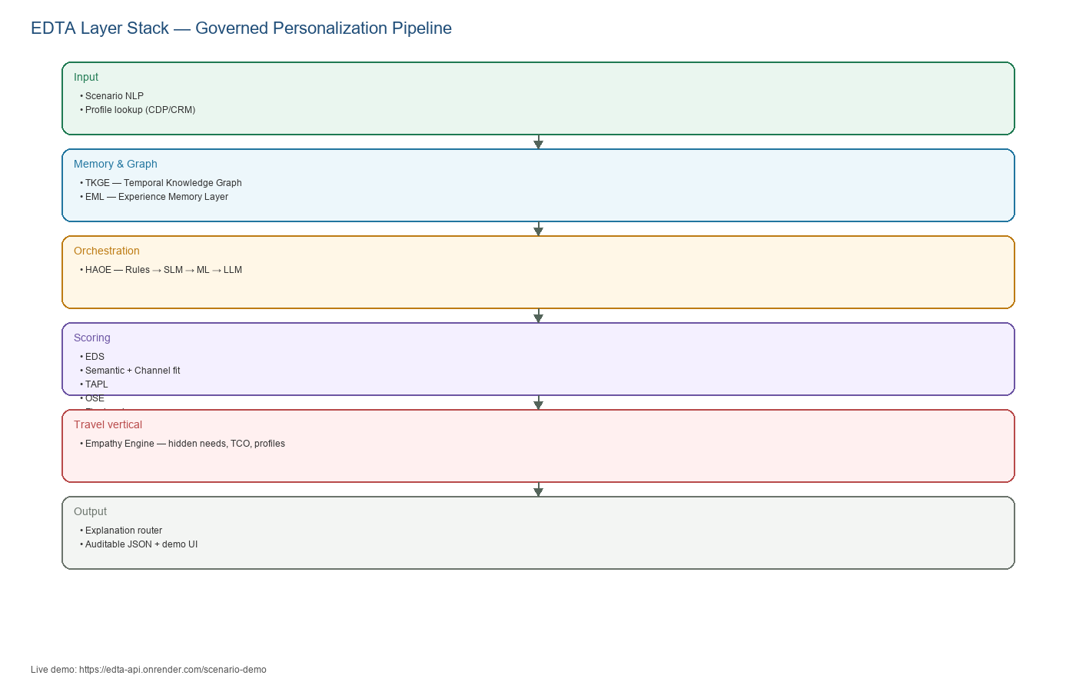
Figure 3 — EDTA logical layer stack

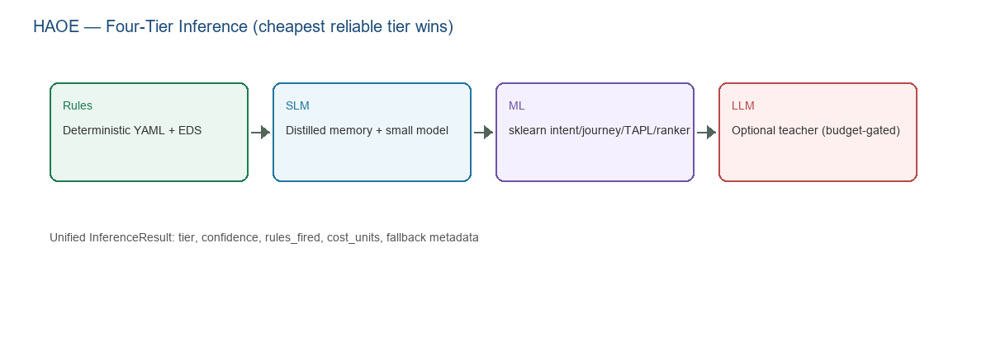
Figure 4 — HAOE four-tier inference routing

4. Architecture Layer Stack
Acronym | Name | Role
TKGE | Temporal Knowledge Graph Engine | Journey timeline, inferred intent, per-scenario subjects
EML | Experience Memory Layer | Trust, fatigue, preferences, outcome history
HAOE | Hybrid AI Orchestration Engine | Rules / SLM / ML / LLM tier selection
EDS | Experience DNA Score | Explainable relevance before ranker fusion
TAPL | Trust-Aware Personalization Layer | show / soften / delay / suppress / generic_fallback
OSE | Outcome Simulation Engine | Conversion, revenue, expected outcome score

5. End-to-End Request Flow

Structured API (POST /recommend)
CustomerContext → Profile enrich → EML enrich → TKGE graph
→ HAOE tier select → For each candidate:
EDS → Semantic → TAPL → OSE → Ranker → Empathy boost
→ Record EML → Return auditable JSON

Free-text demo (POST /recommend-from-scenario)
scenario_text → ScenarioNLPParser → scenario_anonymous_id()
→ EmpathyEngine.process() → merge vehicle catalog
→ RecommendationEngine → empathy panels + architecture summary

6. Layer-by-Layer Design

6.1 Scenario NLP
Implementation: app/scenario_nlp.py — Parses free text to CustomerContext: channel, intent, journey, consent, events.

6.2 Profile Lookup
Implementation: app/profile_service.py — Merges CRM/CDP data (cust-789 demo) outside the ranker.

6.3 TKGE
Implementation: app/context_graph.py — Builds temporal graph; live_journey_sequence; per-profile anonymous IDs.

6.4 EML
Implementation: app/eml_store.py — SQLite trust/fatigue/preferences; OSE calibration from historical outcomes.

6.5 EDS
Implementation: app/eds.py — Intent, engagement, business value, journey, context overlap, risk adjustment.

6.6 TAPL
Implementation: app/ai/tapl_model.py — Policy YAML overrides; rank caps for suppress/delay; SQLite audit.

6.7 OSE
Implementation: app/ai/outcome_model.py — Conversion, revenue, trust/journey impact; heuristic+ML blend.

6.8 Ranker
Implementation: app/recommender.py — Hybrid score + empathy boost; ai_rank_score vs final_hybrid_score.

6.9 Explanation
Implementation: app/inference/explanation_router.py — SLM first, LLM escalation when enabled.

7. Empathy Engine (Travel Vertical)
Eleven trained scenarios (cust-789 loyalty rental + 10 road-trip archetypes) are defined in config/empathy/trained_scenarios.yaml and config/empathy/scenario_profiles.yaml.
# | Profile | Expected vehicle | Objective
0 | loyalty_family_rental | family_friendly_suv | cust-789 SFO family SUV rental
1 | winter_mountain_denver | awd_suv | Winter Denver 500-mile trip
2 | long_family_vacation | large_family_suv | NJ → Orlando family of five
3 | business_executive | luxury_sedan | 35k annual business miles
4 | national_park_adventure | awd_suv | Multi-park adventure
5 | urban_commuter | hybrid_midsize | 18k urban commute
6 | electric_vehicle | electric_midsize | First EV purchase
7 | luxury_winter_suv | premium_suv | Colorado luxury winter
8 | first_time_driver | economy_compact | New driver
9 | rental_seattle_vacation | awd_suv | Seattle 7-day rental
10 | wet_weather_hurricane | awd_suv | Hurricane season Southeast

8. Four-Tier Inference (HAOE)
HAOE (app/orchestration.py) selects the cheapest tier that meets confidence and policy thresholds. Session cost budget and LLM circuit breaker prevent runaway token spend.

9. Why EDTA Is Unique
Typical pattern | EDTA difference
LLM-first personalization | LLM optional; TAPL + rules own governance
Monolithic ranker | EDS + TAPL + OSE + ranker — each auditable
Trust as logging | TAPL modifies rank and action
Hidden model routing | Public tiers with InferenceResult contract
Stateless API | EML + TKGE across sessions
Vertical rewrite | Same core; swap YAML rules, catalog, empathy profiles

10. Benefits

Engineering
- 149+ pytest cases; travel benchmark with 100% vehicle alignment
- Modular adapters for profile, rules, catalog
- Graceful degradation: LLM off → ML/rules → heuristics
- OpenAPI + stable request_summary contract

Product & compliance
- Explain why this offer, why now, why this channel
- Demonstrate consent and fatigue (TAPL delay/suppress)
- Healthcare scope: HCP education routing — not clinical decision support

11. Live Demo Walkthrough
URL: https://edta-api.onrender.com/scenario-demo

5-minute demo script:
- Default cust-789 scenario — loyalty family SUV, high trust, loyalty_family_rental profile
- Paste Winter Denver scenario — awd_suv, mountain constraints
- Add 'personalization consent false' — TAPL generic_fallback
- Add 'fatigue count 8' — TAPL delay
- Scroll to benchmark table — 11 scenarios with distinct scores

12. GitHub Repository Guide
https://github.com/jeraldcs/edta-complete-api
Path | Purpose
app/recommender.py | Main ranking loop
app/services/recommendation_handlers.py | API handlers + scenario route
app/empathy/ | Empathy engine + trained profiles
app/context_graph.py | TKGE
app/eml_store.py | EML persistence
config/empathy/ | Scenario profiles and trained corpus
static/scenario.html | Browser demo UI
tests/ | pytest suite
scripts/benchmark_travel_scenarios.py | Regenerate score matrix

pip install -r requirements.txt
uvicorn app.main:app --reload
# Demo: http://localhost:8000/scenario-demo
python scripts/benchmark_travel_scenarios.py
pytest

13. Benchmarks & Evidence
Travel scenario matrix: docs/TRAVEL_SCENARIO_SCORES.md — 11 scenarios, 100% vehicle match. Four-tier benchmarks: docs/BENCHMARKS.md. API: GET /travel-scenario-benchmark.

14. Scope & Honest Limits
- Reference implementation on demonstration training data—not Netflix-scale production traffic.
- ML models use heuristic blend when predictions saturate.
- Healthcare: approved HCP education routing only; not clinical decision support.
- Hosted demo latency includes Render cold-start overhead.

