Live demo: https://edta-api.onrender.com/scenario-demo
GitHub: https://github.com/jeraldcs/edta-complete-api
OpenAPI: https://edta-api.onrender.com/docs

EDTA — InfoQ Publication Document

Governed Personalization: A Four-Tier Architecture for Explainable, Trust-Aware Recommendations
Author: Jerald Selvaraj
Contact: jerald.cs@gmail.com
Version: Publication package v2 — July 2026
Status: Ready for InfoQ Architecture / AI, ML & Data Engineering submission
Resource | URL
---------- | -----
**Live demo** | https://edta-api.onrender.com/scenario-demo
**GitHub** | https://github.com/jeraldcs/edta-complete-api
**OpenAPI** | https://edta-api.onrender.com/docs
**Architecture PDF** | `docs/edta_architecture_diagram.pdf` (3 pages — regenerate: `python docs/generate_architecture_pdf.py`)
**Word export** | `docs/INFOQ_PUBLICATION_DOCUMENT.docx`

Editor summary (50 words)
Enterprise teams adopt LLMs for personalization faster than governance. EDTA (Experience-Driven Targeting Architecture) is an open reference for a governed decision pipeline: explicit Rules / SLM / ML / LLM tiers, trust-aware ranking (TAPL), outcome simulation, and API-native explainability. A live travel demo runs eleven trained road-trip scenarios with auditable scores. LLMs enrich and explain; they do not own consent or compliance.

Table of contents
- [Abstract](#1-abstract)
- [Key takeaways](#2-key-takeaways)
- [Problem statement](#3-problem-statement)
- [Reference architecture](#4-reference-architecture)
- [Implementation overview (latest code)](#5-implementation-overview-latest-code)
- [Data contract](#6-data-contract)
- [Layer-by-layer design](#7-layer-by-layer-design)
- [Empathy engine and travel vertical](#8-empathy-engine-and-travel-vertical)
- [Four-tier inference (HAOE)](#9-four-tier-inference-haoe)
- [Trust-aware personalization (TAPL)](#10-trust-aware-personalization-tapl)
- [Live demo walkthrough](#11-live-demo-walkthrough)
- [Benchmarks and evidence](#12-benchmarks-and-evidence)
- [Why EDTA is different](#13-why-edta-is-different)
- [Operational considerations](#14-operational-considerations)
- [Lessons learned](#15-lessons-learned)
- [Scope and honest limits](#16-scope-and-honest-limits)
- [GitHub repository guide](#17-github-repository-guide)
- [Suggested InfoQ submission package](#18-suggested-infoq-submission-package)
- [Architecture diagrams](#19-architecture-diagrams)

1. Abstract
Enterprise personalization systems are often implemented as opaque ranking services: a customer context enters the model, a recommendation comes out, and surrounding teams infer *why* the system made the decision. That approach breaks when personalization must operate across web, mobile, chatbot, IoT, wearable, connected vehicle, and partner API channels — especially when trust, consent, fatigue, compliance, and explainability matter.
This document presents EDTA (Experience-Driven Targeting Architecture) — an implementation-oriented reference for a governed decision pipeline, not a single model. The design combines:
- A Temporal Knowledge Graph Engine (TKGE) for live journey context
- An Experience Memory Layer (EML) for trust, fatigue, and preference state
- A Hybrid AI Orchestration Engine (HAOE) with explicit Rules → SLM → ML → optional LLM tiers
- Experience DNA Score (EDS) for explainable relevance
- Trust-Aware Personalization Layer (TAPL) that affects ranking, not only logs
- Outcome Simulation Engine (OSE) for expected conversion and revenue impact
- An Empathy Engine for travel scenarios — hidden needs, route enrichment, TCO, and constraint-based vehicle fit
- A FastAPI surface with auditable API contracts and a browser scenario demo
The LLM is optional: it enriches and explains; it does not own consent, compliance, fatigue, or final trust governance.

2. Key takeaways
- Personalization is a governance problem, not only a ranking problem.
- Four explicit inference tiers (Rules, SLM, ML, LLM) beat a hidden routing layer for testability, cost control, and benchmarks.
- TAPL must affect ranking — consent, fatigue, compliance sensitivity, and channel constraints are first-class inputs.
- Distilled SLM memory reduces LLM cost on repeat journeys; explanation routing prefers SLM before LLM escalation.
- A runtime context graph (TKGE) converts live behavioral, profile, device, and business signals into reusable features.
- Known-user personalization requires profile lookup before scoring; live session behavior still influences the final decision.
- Explainability belongs in the API contract — rules fired, inference tier, TAPL decision, outcome simulation, and explanation source.
- Travel demo proves vertical extension without rewriting the core — empathy profiles, constraints, and 11-scenario benchmark matrix.

3. Problem statement
Many recommendation systems reduce personalization to:
context → model → ranked recommendation
That pattern fails enterprise requirements:
Gap | Consequence
----- | -------------
Opaque ranking | Product and compliance cannot answer *why*
LLM-first design | Unbounded cost, latency, and provider dependency
Trust as metadata | Consent/fatigue logged but not enforced in ranking
Single-channel thinking | Web, chatbot, IoT, wearable need unified policy
No outcome view | Optimizes click-through, not expected business outcome
Weak explainability | No rules fired, tier, TAPL action, or score breakdown in API
Vertical monolith | Each industry rewrites the engine instead of policy layers

EDTA decomposes personalization into testable modules with explicit responsibilities and API-visible decisions.

4. Reference architecture

4.1 System context
Channel clients (web, chatbot, IoT, partner API)
→ FastAPI (POST /recommend, POST /recommend-from-scenario)
→ RecommendationHandlers
→ Profile lookup + EML enrich + TKGE graph + HAOE tier
→ EmpathyEngine (travel scenario path)
→ RecommendationEngine (EDS → TAPL → OSE → ranker)
→ Explanation router (SLM first, LLM optional)
→ Auditable JSON + demo architecture panels
Deployment: Public demo on Render (render.yaml); local/Docker for latency benchmarks.

4.2 Logical layer stack
Acronym | Name | Role
--------- | ------ | ------
**TKGE** | Temporal Knowledge Graph Engine | Journey timeline, inferred intent, per-scenario subjects
**EML** | Experience Memory Layer | Trust, fatigue, preferences, recommendation history
**HAOE** | Hybrid AI Orchestration Engine | Rules / SLM / ML / LLM tier selection
**EDS** | Experience DNA Score | Explainable relevance before ranker fusion
**TAPL** | Trust-Aware Personalization Layer | show / soften / delay / suppress / generic_fallback
**OSE** | Outcome Simulation Engine | Conversion, revenue, expected outcome score
**Empathy** | Travel vertical extension | Hidden needs, constraints, TCO, trained profiles

See Section 19 and docs/edta_architecture_diagram.pdf for visual diagrams aligned with the current codebase.

5. Implementation overview (latest code)

5.1 Two primary request paths
Structured API — `POST /recommend`
CustomerContext
→ ProfileLookupService.enrich_context()
→ ExperienceMemory.enrich_context() (EML)
→ ContextGraph + graph_store timeline (TKGE)
→ HAOE.select_tier()
→ RecommendationEngine.recommend()
loop candidates: EDS → semantic → channel fit → TAPL → OSE → ranker
→ record EML + save graph snapshot
→ ExplanationRouter → RecommendationResponse
Free-text demo — `POST /recommend-from-scenario`
Used by https://edta-api.onrender.com/scenario-demo and the travel benchmark:
scenario_text
→ ScenarioNLPParser.parse() [app/scenario_nlp.py]
→ scenario_anonymous_id() [app/empathy/scenario_profiles.py]
→ ProfileLookupService + EML enrich
→ EmpathyEngine.process() [app/empathy/service.py]
→ merge vehicle_candidates() catalog
→ RecommendationEngine.recommend()
→ attach empathy vehicle + TKGE/EML/HAOE/OSE/TAPL panels
→ RecommendationResponse
Entry point: app/services/recommendation_handlers.py → recommend_from_scenario().

5.2 Demo UI stack
Component | File | Purpose
----------- | ------ | ---------
Scenario page | `static/scenario.html` | Textarea, Recommend form, result panels
Client logic | `static/scenario_app.js` | Form submit, fetch, panel rendering
Shared UI | `static/demo-shared.js` | TAPL, architecture cards, benchmark table
Server inject | `app/demo_html.py` | Inline `window.__EDTA_DEMO_CONFIG__`, cache-bust
Benchmark API | `GET /travel-scenario-benchmark` | 11-scenario score matrix

5.3 Service wiring
app/container.py wires:
- RecommendationEngine (app/recommender.py)
- EmpathyEngine (app/empathy/service.py)
- ScenarioNLPParser (app/scenario_nlp.py)
- ExperienceMemory + EMLStore + GraphStore
- HAOEOrchestrator (app/orchestration.py)
- ML models under app/ai/
- Optional LLM clients under app/llm/

6. Data contract
The API contract starts with CustomerContext (app/models.py):
class CustomerContext(BaseModel):
anonymous_id: Optional[str] = None
customer_id: Optional[str] = None
channel: Channel = Channel.web
journey_stage: Optional[JourneyStage] = None
current_intent: Optional[IntentType] = None
session_events: List[str] = Field(default_factory=list)
search_terms: List[str] = Field(default_factory=list)
profile_attributes: Dict[str, Any] = Field(default_factory=dict)
business_context: Dict[str, Any] = Field(default_factory=dict)
consent: Dict[str, bool] = Field(default_factory=lambda: {"personalization": True})
Runtime switches on RecommendationRequest:
use_ai_models: bool = True
use_llm: bool = False
use_llm_explanation: bool = False
These switches allow local-only operation, LLM enrichment when budget allows, and graceful fallback when providers are unavailable.

7. Layer-by-layer design

7.1 Scenario NLP
Files: app/scenario_nlp.py
Parses free text into channel, intent, journey stage, consent flags, fatigue/trust hints, session events, and search terms. Parser confidence is exposed for HAOE tier routing.

7.2 Profile lookup
Files: app/profile_service.py, app/profile/adapters/json_file.py
Identity resolution stays outside the recommender. Demo profile cust-789 provides loyalty tier, SFO home airport, family traveler flags, and business eligibility.

7.3 TKGE — Temporal Knowledge Graph
Files: app/context_graph.py, app/graph_store.py
Builds nodes and temporal edges from context; maintains live_journey_sequence; persists per-subject timeline. Scenario runs use isolated subjects like anonymous:travel-winter_mountain_denver so demo scenarios do not overwrite each other.

7.4 EML — Experience Memory
Files: app/experience_memory.py, app/eml_store.py
SQLite persistence for trust, fatigue, preferences, and outcome history. Influences TAPL inputs and OSE calibration (historical_cvr). Demo panels show trust/fatigue before → after each run.

7.5 EDS — Experience DNA Score
Files: app/eds.py
Transparent scoring: intent match, engagement, business value, journey momentum, context overlap (TKGE keywords), minus risk adjustment. Returns human-readable reason codes (intent_match, context_overlap:suv, etc.).

7.6 OSE — Outcome Simulation
Files: app/ai/outcome_model.py
Estimates conversion probability, revenue impact, trust/journey impact, compliance and fatigue risk. Blends ML with heuristics when models saturate; applies EML historical calibration.

7.7 Final ranker
Files: app/recommender.py, app/ai/ranker_model.py
Hybrid score from EDS, semantic similarity, channel fit, TAPL trust, OSE expected outcome, business value, and penalties. Returns:
- ai_rank_score — base rank before TAPL cap
- final_hybrid_score — after TAPL and empathy adjustments

7.8 Explanation router
Files: app/inference/explanation_router.py, app/llm/slm_client.py, app/llm/llm_client.py
Order: SLM / local template first → LLM escalation if enabled and budget allows. API field: explanation_source — local, slm, llm, local_fallback.

8. Empathy engine and travel vertical
Travel is the primary demo vertical with 11 trained scenarios (cust-789 loyalty rental + 10 road-trip archetypes).

8.1 Pipeline
Scenario text
→ Hidden needs extractor (hidden_needs.yaml — word-boundary rules)
→ Scenario profile matcher (scenario_profiles.yaml — 11 profiles)
→ Trip extractor + route planner
→ Weather / route enrichment
→ Constraint matcher (AWD, ISOFIX, EV range, cargo)
→ TCO calculator
→ Empathy vehicle + pitch → merged into ranking via empathy boost

8.2 Key modules
Module | File | Function
-------- | ------ | ----------
Orchestration | `app/empathy/service.py` | Wires empathy into `business_context`
Hidden needs | `app/empathy/hidden_needs.py` | Pattern rules with word-boundary matching
Profiles | `app/empathy/scenario_profiles.py` | Keywords, persona, preferred vehicle, scoring hints
Corpus | `config/empathy/trained_scenarios.yaml` | Canonical texts for tests and benchmark
Constraints | `app/empathy/constraint_matcher.py` | Maps needs → vehicle specs
TCO | `app/empathy/tco_calculator.py` | Rental + fuel trip cost comparisons
Benchmark | `app/services/travel_benchmark.py` | Score extraction for 11 scenarios

8.3 Trained scenario matrix
# | Profile | Expected vehicle | Objective
--- | --------- | ------------------ | -----------
0 | loyalty_family_rental | family_friendly_suv | cust-789 SFO family SUV rental
1 | winter_mountain_denver | awd_suv | Winter Denver 500-mile trip
2 | long_family_vacation | large_family_suv | NJ → Orlando, family of five
3 | business_executive | luxury_sedan | 35k annual business miles
4 | national_park_adventure | awd_suv | Multi-park adventure
5 | urban_commuter | hybrid_midsize | 18k urban commute
6 | electric_vehicle | electric_midsize | First EV purchase
7 | luxury_winter_suv | premium_suv | Colorado luxury winter
8 | first_time_driver | economy_compact | New driver
9 | rental_seattle_vacation | awd_suv | Seattle 7-day rental
10 | wet_weather_hurricane | awd_suv | Hurricane season Southeast

Regenerate scored matrix: python scripts/benchmark_travel_scenarios.py → docs/TRAVEL_SCENARIO_SCORES.md.

9. Four-tier inference (HAOE)
Files: app/orchestration.py, app/haoe_policy.py, config/haoe_policies.yaml
Rules → deterministic YAML packs + EDS + TKGE-boosted confidence
SLM → distilled pattern memory + optional endpoint + rules fallback
ML → sklearn intent / journey / TAPL / outcome / ranker
LLM → optional teacher (intent enrichment, explanation, synthetic labels)
HAOE selects tier by confidence, session cost budget, and policy YAML. Each tier returns a unified InferenceResult: tier, confidence, rules fired, cost units, fallback metadata.
Benchmark: scripts/load_test_tiers.py, docs/BENCHMARKS.md.
Tier | Typical p95 (Docker) | Tier match | Explainability
------ | ---------------------: | -----------: | ----------------
Rules | ~20–50 ms | 100% | rules_fired
SLM | ~50–150 ms | 100% | pattern + rules fallback
ML | ~200–400 ms | 100% | feature-level scores
LLM | ~3–8 s | varies | natural language

*Hosted Render demo adds platform cold-start overhead — report separately from engine benchmarks.*

10. Trust-aware personalization (TAPL)
Files: app/ai/tapl_model.py, app/tapl_policy.py, config/tapl_policies.yaml, app/tapl_audit.py
TAPL evaluates consent, fatigue, compliance sensitivity, channel constraints, and trust score. Actions:
Action | Effect on ranking
-------- | -------------------
`show` | Full hybrid score
`soften` | Score × 0.85
`delay` | Score × 0.55
`suppress` / `generic_fallback` | Cap score at 0.15

Policy examples:
- No personalization consent → generic_fallback
- Fatigue ≥ threshold → delay
- Sensitive channel + high compliance content → suppress
TAPL decisions are SQLite-audited and returned in every recommendation response.

11. Live demo walkthrough
URL: https://edta-api.onrender.com/scenario-demo

Demo UI sections
Section | What it shows
--------- | ----------------
Scenario input + Recommend | Free-text → `POST /recommend-from-scenario`
Recommendation result | Top candidate, hybrid score, TAPL action, empathy badge
Parsed NLP context | Channel, intent, journey, parser confidence
Empathy panels | Hidden needs, weather/terrain, TCO, empathy pitch
Architecture panels | TKGE, EML, HAOE, OSE, TAPL per run
API request/response | Raw JSON for integrators
Travel benchmark table | 11 scenarios with EDS, outcome, trust, rank scores

5-minute demo script
- Default cust-789 — loyalty family SUV, high trust, loyalty_family_rental profile
- Winter Denver — paste scenario 1 → awd_suv, mountain constraints
- Consent false — add “personalization consent false” → TAPL generic_fallback
- High fatigue — “fatigue count 8” → TAPL delay
- Benchmark table — scroll to 11 scenarios with distinct scores

12. Benchmarks and evidence

Travel scenario matrix
- 11/11 vehicle match (100%) — see docs/TRAVEL_SCENARIO_SCORES.md
- API: GET /travel-scenario-benchmark
- Tests: tests/test_trained_travel_scenarios.py

Test suite
pytest # 149+ passed — API, TAPL, empathy, trained scenarios, demo UI

Four-tier benchmarks
See docs/BENCHMARKS.md — tier routing fidelity, latency, cost units, fallback rates.
Not claimed without partner data: Production A/B conversion lift or Netflix-scale generalization.

13. Why EDTA is different
Pattern | Typical approach | EDTA difference
--------- | ------------------ | -----------------
LLM-first personalization | One prompt → recommendation | LLM optional; TAPL + rules own governance
Monolithic ranker | Single model score | EDS + TAPL + OSE + ranker — each auditable
Trust as logging | Trust score in analytics only | TAPL modifies rank and action
Hidden routing | Ad hoc if/else | HAOE with YAML policy + InferenceResult
Stateless API | Each request independent | EML + TKGE timeline across sessions
Vertical rewrite | New engine per industry | Same core; swap YAML, catalog, empathy profiles
Travel recommender | Filter by category | Hidden needs + constraints + TCO + trained profiles

Original contribution: A governed, multi-tier, memory-aware personalization pipeline with API-native explainability — implemented as open reference code with live demo and reproducible benchmarks.

14. Operational considerations

Observability
Log request ID, channel, predicted intent source, EDS breakdown, TAPL action, outcome score, final rank, reason codes, LLM availability, and empathy profile match.

Governance testing
Test missing consent, high fatigue, sensitive channels (SMS, wearable, IoT), LLM failure, and unknown profiles.

Profile lookup boundary
Keep profile lookup as a facade — CRM, CDP, loyalty platform, or feature store adapters swap without changing the ranker.

Healthcare scope (secondary vertical)
HCP education content routing with TAPL suppress on sensitive channels — not clinical decision support.

15. Lessons learned
- LLMs should not own governance. Use them for enrichment and explanation; keep consent, fatigue, and compliance in TAPL and rules.
- Explainability must be in the API contract. Return EDS breakdowns, TAPL decisions, tier, rules fired, and explanation source — not only candidate ID and score.
- Merge profile history with live session context. Static profiles and live sessions alone are both incomplete.
- Per-scenario memory isolation matters for demos. scenario_anonymous_id() prevents cross-contamination in TKGE/EML during benchmark runs.
- Word-boundary rule matching prevents false empathy triggers. Substring matches (e.g. “son” in “personalization”) caused incorrect toddler-family constraints until fixed.
- ML saturation requires heuristic blend. When sklearn models saturate, blend with profile-aware heuristics so benchmark scores vary meaningfully across scenarios.

16. Scope and honest limits
- Reference implementation on demonstration training data — not production traffic at scale.
- ML models use synthetic/generated training data; heuristic blend when predictions saturate.
- Healthcare: approved HCP education routing only; not clinical decision support.
- Empathy: rule + profile based for travel demo; not full LLM extraction at scale.
- Hosted demo latency includes Render cold-start overhead.

17. GitHub repository guide
Repository: https://github.com/jeraldcs/edta-complete-api
edta-complete-api/
├── app/ # FastAPI core — recommender, empathy, orchestration
├── config/ # YAML — rules, TAPL, HAOE, empathy profiles
├── docs/ # InfoQ publication, architecture PDF, benchmarks
├── static/ # scenario-demo UI
├── tests/ # pytest (149+)
├── scripts/ # train, benchmark, load test
└── render.yaml # hosted demo

Run locally
pip install -r requirements.txt
uvicorn app.main:app --reload
# Demo: http://localhost:8000/scenario-demo
python scripts/benchmark_travel_scenarios.py
pytest

Regenerate publication assets
python docs/generate_architecture_pdf.py # 3-page PDF diagrams
python docs/generate_infoq_publication_docx.py # Word document with embedded figures

18. Suggested InfoQ submission package
Artifact | Path
---------- | ------
**This publication document** | `docs/INFOQ_PUBLICATION_DOCUMENT.md`
**Word export (with diagrams)** | `docs/INFOQ_PUBLICATION_DOCUMENT.docx`
Narrative article draft | `docs/infoq_edta_llm_personalization_article_draft.md`
Architecture reference | `docs/INFOQ_ARCHITECTURE_DOCUMENT.md`
Positioning / cover note | `docs/INFOQ_POSITIONING.md`
Architecture PDF (3 pages) | `docs/edta_architecture_diagram.pdf`
Travel benchmark | `docs/TRAVEL_SCENARIO_SCORES.md`
Four-tier benchmarks | `docs/BENCHMARKS.md`
Live demo | https://edta-api.onrender.com/scenario-demo
Source code | https://github.com/jeraldcs/edta-complete-api

19. Architecture diagrams

Embedded architecture diagrams (July 2026 codebase)

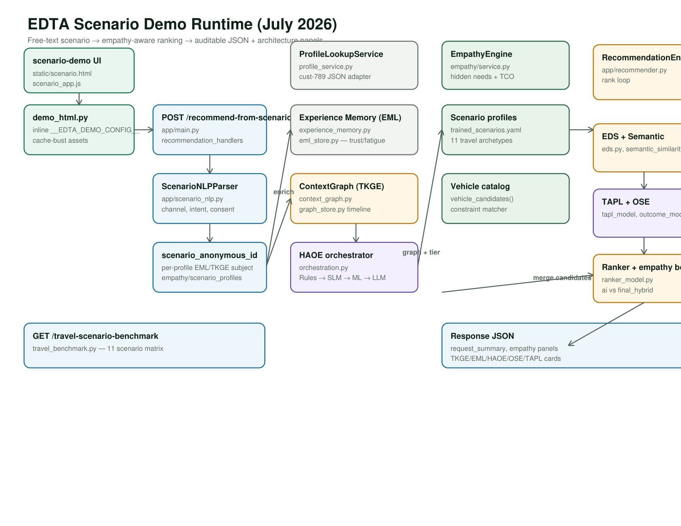
Figure 1 — Scenario demo runtime (scenario-demo → recommend-from-scenario → empathy → ranker → panels)

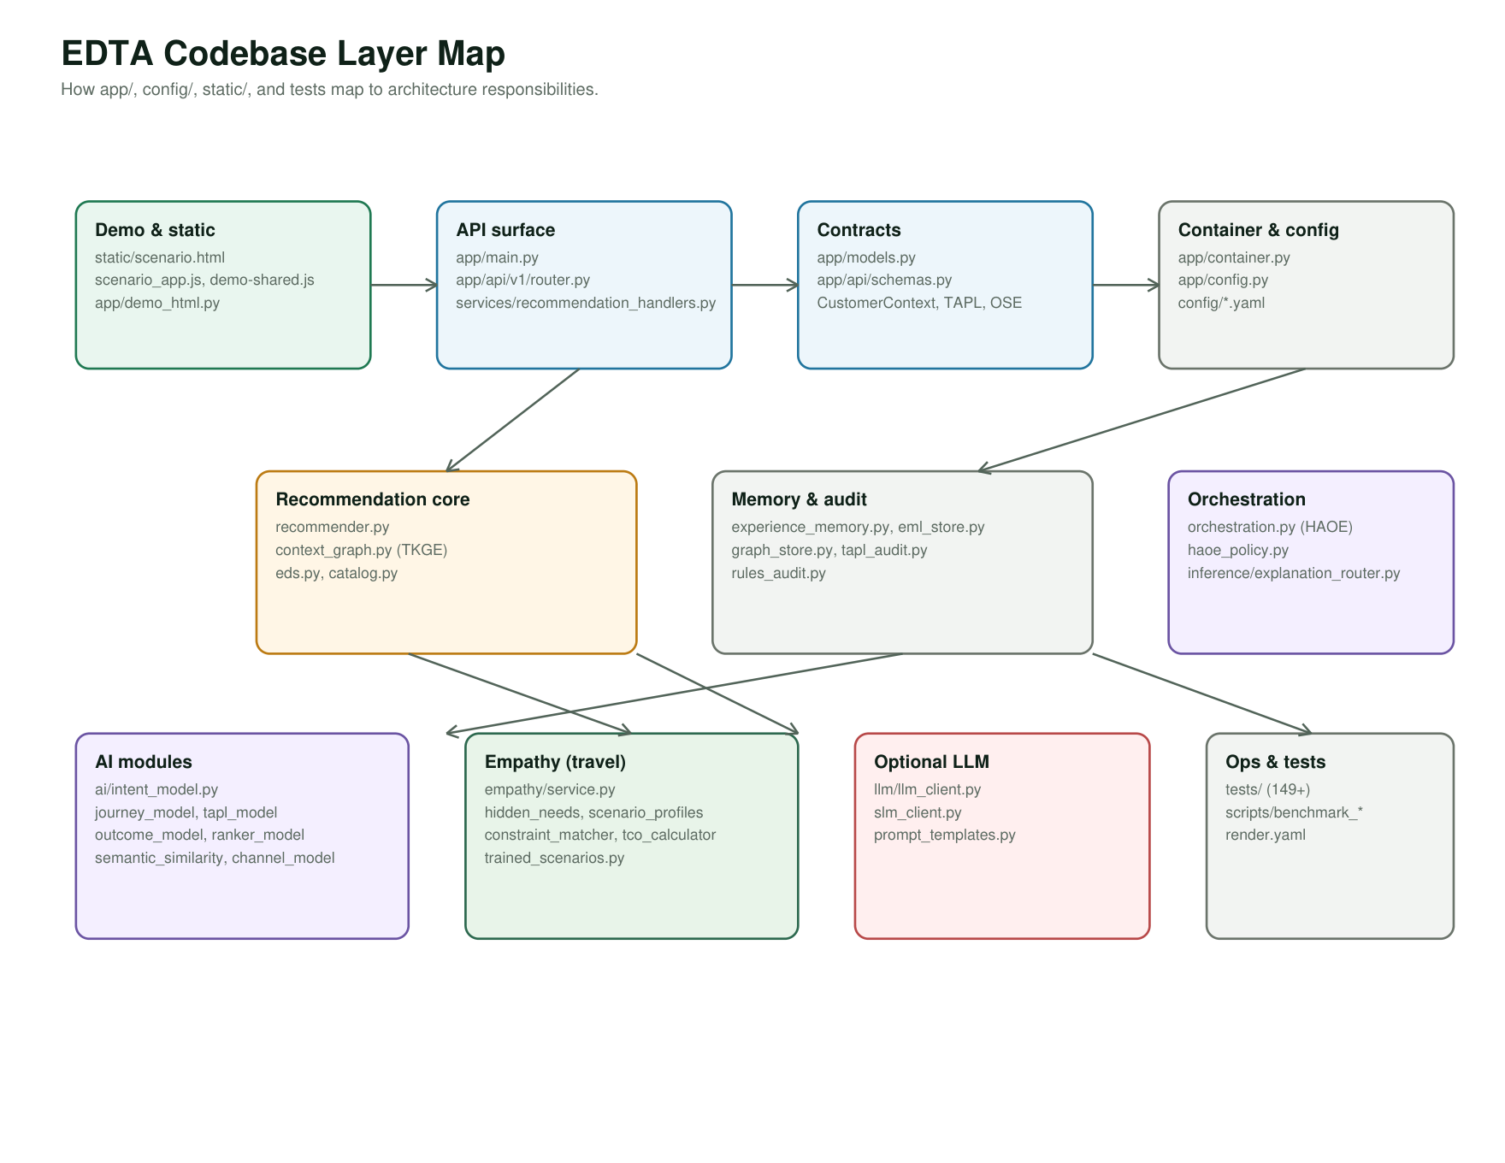
Figure 2 — Codebase layer map (app/, config/, static/, empathy and AI modules)

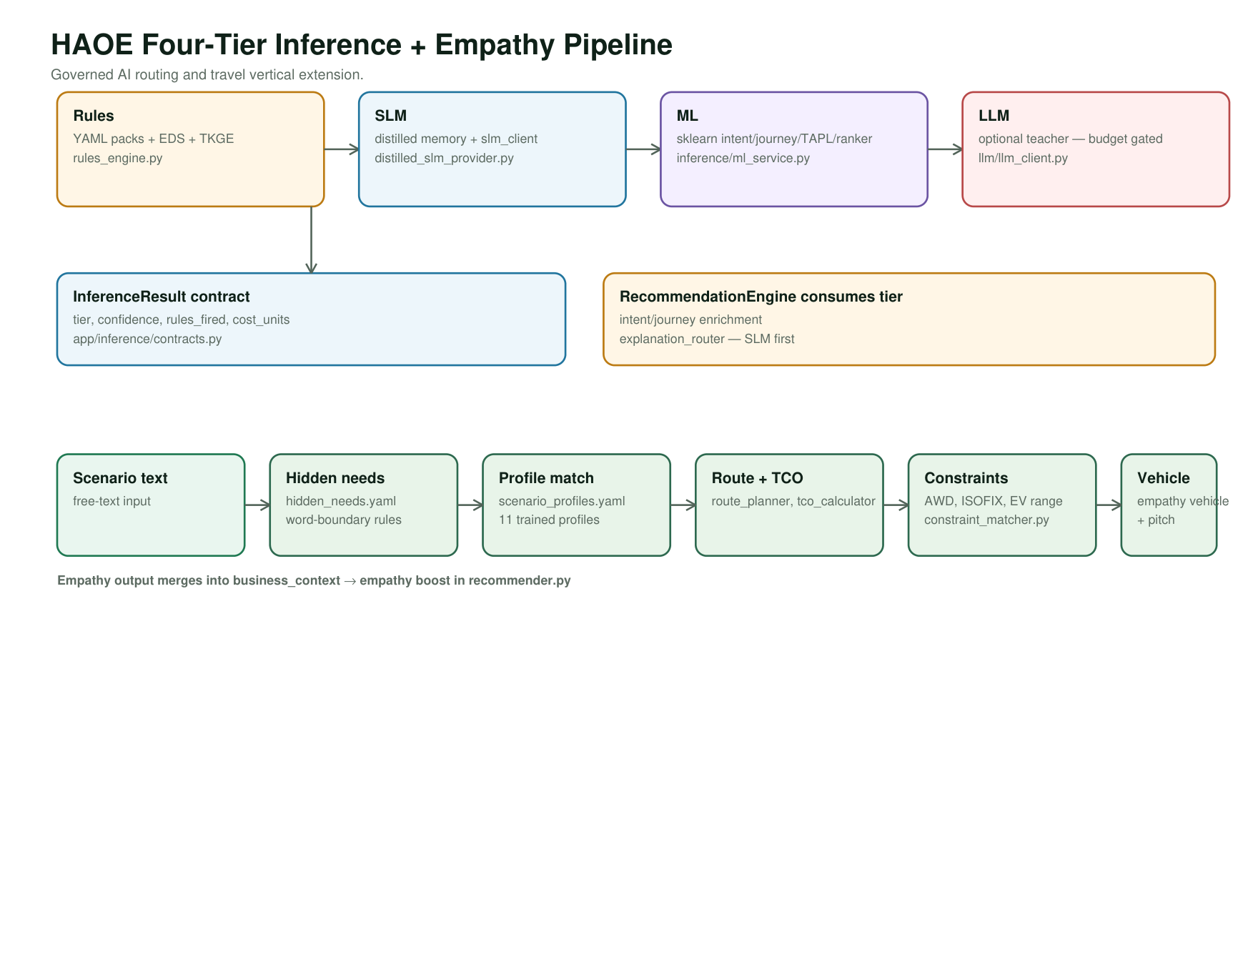
Figure 3 — HAOE four-tier inference + empathy pipeline
Three PDF pages (July 2026 codebase) — embed in article or attach to submission:
Figure | Title | Content
-------- | ------- | ---------
**Figure 1** | Scenario demo runtime | `scenario-demo` → `/recommend-from-scenario` → NLP → EML/TKGE → Empathy → ranker → panels
**Figure 2** | Codebase layer map | `app/`, `config/`, `static/`, empathy and AI module layout
**Figure 3** | HAOE + empathy pipeline | Four-tier routing + travel empathy constraint flow

Generate: python docs/generate_architecture_pdf.py
File: docs/edta_architecture_diagram.pdf

Suggested author bio
Jerald Selvaraj is an enterprise architecture and digital experience technology leader focused on AI-enabled personalization, omnichannel platforms, customer experience architecture, and responsible recommendation systems. His work spans experience decisioning, marketing technology, platform modernization, and applied AI architectures for scalable digital ecosystems.

*Document prepared for InfoQ submission — EDTA reference implementation, Jerald Selvaraj, July 2026.*

