Overview
This file is a specification of the model created by UML definition

Package List
Full Name | Summary
[Root]
asn4

[Root] Package

Classifier List
Name | Type | Summary
ConfigItemContext<parameter0> | Class
ConfigItemContext<Map<String,Map<String,String>> | Class
ConfigItemContext> | Class
Context<T | Class
Context> | Class
List<Context> | Class
List<Resource> | Class
Map<?,?> | Class
Map<String,?> | Class
Map<String,AccessToken> | Class
Map<String,Command> | Class
Map<String,Context> | Class
Map<String,Credential> | Class
Map<String,FeatureObserver> | Class
Map<String,Map<String,String> | Class
Map<String,Map<String,String>> | Class
Map<String,Observer> | Class
Map<String,Predicate<ConfigItemContext<Map<String,Map<String,String>>>> | Class
Map<String,Predicate<ConfigItemContext>> | Class
Map<String,Predicate<ConfigItemContext>> | Class
Map<String,Predicate<Context<T>> | Class
Map<String,Predicate<T>> | Class
Map<String,Rule> | Class
Map<String,RulePredicate<T>> | Class
Map<String,String | Class
Map<String,String> | Class
Observer | Class
Predicate<parameter0> | Class
Predicate<ConfigItemContext<Map<String,Map<String,String>>> | Class
Predicate<ConfigItemContext>> | Class
Predicate<ConfigItemContextCollection> | Class
Predicate<Context<T> | Class
Predicate<Context>> | Class
Predicate<List<Context>> | Class
Predicate<T> | Class
Predicate<Triple> | Class
Resource | Class
Set<parameter0> | Class
Set<FeatureObserver> | Class
Set<Observer> | Class
String | Class

Class

ConfigItemContext [Class]

Declaration
public class ConfigItemContext<parameter0>

Namespace
[Root]

Template Parameter
Name | Type | Default Value
parameter0

ConfigItemContext<Map<String,Map<String,String>> [Class]

Declaration
public class

Namespace
[Root]

Relation (From Source To Target)
Name | Type | Target | Summary
 | Template Binding | ConfigItemContext | ConfigItemContext<parameter0->Map<String,Map<String,String>>

ConfigItemContext> [Class]

Declaration
public class ConfigItemContext>

Namespace
[Root]

Context<T [Class]

Declaration
public class Context<T

Namespace
[Root]

Context> [Class]

Declaration
public class Context>

Namespace
[Root]

List<Context> [Class]

Declaration
public class

Namespace
[Root]

Relation (From Source To Target)
Name | Type | Target | Summary
 | Template Binding | List | List<parameter0->Context>

List<Resource> [Class]

Declaration
public class

Namespace
[Root]

Relation (From Source To Target)
Name | Type | Target | Summary
 | Template Binding | List | List<parameter0->Resource>

Map<?,?> [Class]

Declaration
public class

Namespace
[Root]

Relation (From Source To Target)
Name | Type | Target | Summary
 | Template Binding | Map

Map<String,?> [Class]

Declaration
public class

Namespace
[Root]

Relation (From Source To Target)
Name | Type | Target | Summary
 | Template Binding | Map | Map<parameter0->String>

Map<String,AccessToken> [Class]

Declaration
public class

Namespace
[Root]

Relation (From Source To Target)
Name | Type | Target | Summary
 | Template Binding | Map | Map<parameter0->String,parameter1->AccessToken>

Map<String,Command> [Class]

Declaration
public class

Namespace
[Root]

Relation (From Source To Target)
Name | Type | Target | Summary
 | Template Binding | Map | Map<parameter0->String,parameter1->Command>

Map<String,Context> [Class]

Declaration
public class

Namespace
[Root]

Relation (From Source To Target)
Name | Type | Target | Summary
 | Template Binding | Map | Map<parameter0->String,parameter1->Context>

Map<String,Credential> [Class]

Declaration
public class

Namespace
[Root]

Relation (From Source To Target)
Name | Type | Target | Summary
 | Template Binding | Map | Map<parameter0->String,parameter1->Credential>

Map<String,FeatureObserver> [Class]

Declaration
public class

Namespace
[Root]

Relation (From Source To Target)
Name | Type | Target | Summary
 | Template Binding | Map | Map<parameter0->String,parameter1->FeatureObserver>

Map<String,Map<String,String> [Class]

Declaration
public class

Namespace
[Root]

Relation (From Source To Target)
Name | Type | Target | Summary
 | Template Binding | Map | Map<parameter0->String,parameter1->Map<String,String>

Map<String,Map<String,String>> [Class]

Declaration
public class

Namespace
[Root]

Relation (From Source To Target)
Name | Type | Target | Summary
 | Template Binding | Map | Map<parameter0->String,parameter1->Map<String,String>>

Map<String,Observer> [Class]

Declaration
public class

Namespace
[Root]

Relation (From Source To Target)
Name | Type | Target | Summary
 | Template Binding | Map | Map<parameter0->String,parameter1->Observer>

Map<String,Predicate<ConfigItemContext<Map<String,Map<String,String>>>> [Class]

Declaration
public class

Namespace
[Root]

Relation (From Source To Target)
Name | Type | Target | Summary
 | Template Binding | Map | Map<parameter0->String,parameter1->Predicate<ConfigItemContext<Map<String,Map<String,String>>>>

Map<String,Predicate<ConfigItemContext>> [Class]

Declaration
public class

Namespace
[Root]

Relation (From Source To Target)
Name | Type | Target | Summary
 | Template Binding | Map | Map<parameter0->String,parameter1->Predicate<ConfigItemContext>>

Map<String,Predicate<ConfigItemContext>> [Class]

Declaration
public class

Namespace
[Root]

Relation (From Source To Target)
Name | Type | Target | Summary
 | Template Binding | Map | Map<parameter0->String,parameter1->Predicate<ConfigItemContext>>

Map<String,Predicate<Context<T>> [Class]

Declaration
public class

Namespace
[Root]

Relation (From Source To Target)
Name | Type | Target | Summary
 | Template Binding | Map | Map<parameter0->String,parameter1->Predicate<Context<T>>

Map<String,Predicate<T>> [Class]

Declaration
public class

Namespace
[Root]

Relation (From Source To Target)
Name | Type | Target | Summary
 | Template Binding | Map | Map<parameter0->String,parameter1->Predicate<T>>

Map<String,Rule> [Class]

Declaration
public class

Namespace
[Root]

Relation (From Source To Target)
Name | Type | Target | Summary
 | Template Binding | Map | Map<parameter0->String,parameter1->Rule>

Map<String,RulePredicate<T>> [Class]

Declaration
public class

Namespace
[Root]

Relation (From Source To Target)
Name | Type | Target | Summary
 | Template Binding | Map | Map<parameter0->String,parameter1->RulePredicate<T>>

Map<String,String [Class]

Declaration
public class Map<String,String

Namespace
[Root]

Map<String,String> [Class]

Declaration
public class

Namespace
[Root]

Relation (From Source To Target)
Name | Type | Target | Summary
 | Template Binding | Map | Map<parameter0->String,parameter1->String>

Observer [Class]

Declaration
public class Observer

Namespace
[Root]

Predicate [Class]

Declaration
public class Predicate<parameter0>

Namespace
[Root]

Template Parameter
Name | Type | Default Value
parameter0

Predicate<ConfigItemContext<Map<String,Map<String,String>>> [Class]

Declaration
public class

Namespace
[Root]

Relation (From Source To Target)
Name | Type | Target | Summary
 | Template Binding | Predicate | Predicate<parameter0->ConfigItemContext<Map<String,Map<String,String>>>

Predicate<ConfigItemContext>> [Class]

Declaration
public class

Namespace
[Root]

Relation (From Source To Target)
Name | Type | Target | Summary
 | Template Binding | Predicate | Predicate<parameter0->ConfigItemContext>>

Predicate<ConfigItemContextCollection> [Class]

Declaration
public class

Namespace
[Root]

Relation (From Source To Target)
Name | Type | Target | Summary
 | Template Binding | Predicate | Predicate<parameter0->ConfigItemContextCollection>

Predicate<Context<T> [Class]

Declaration
public class

Namespace
[Root]

Relation (From Source To Target)
Name | Type | Target | Summary
 | Template Binding | Predicate | Predicate<parameter0->Context<T>

Predicate<Context>> [Class]

Declaration
public class

Namespace
[Root]

Relation (From Source To Target)
Name | Type | Target | Summary
 | Template Binding | Predicate | Predicate<parameter0->Context>>

Predicate<List<Context>> [Class]

Declaration
public class

Namespace
[Root]

Relation (From Source To Target)
Name | Type | Target | Summary
 | Template Binding | Predicate | Predicate<parameter0->List<Context>>

Predicate<T> [Class]

Declaration
public class

Namespace
[Root]

Relation (From Source To Target)
Name | Type | Target | Summary
 | Template Binding | Predicate | Predicate<parameter0->T>

Predicate<Triple> [Class]

Declaration
public class

Namespace
[Root]

Relation (From Source To Target)
Name | Type | Target | Summary
 | Template Binding | Predicate | Predicate<parameter0->Triple>

Resource [Class]

Declaration
public class Resource

Namespace
[Root]

Set [Class]

Declaration
public class Set<parameter0>

Namespace
[Root]

Template Parameter
Name | Type | Default Value
parameter0

Set<FeatureObserver> [Class]

Declaration
public class

Namespace
[Root]

Relation (From Source To Target)
Name | Type | Target | Summary
 | Template Binding | Set | Set<parameter0->FeatureObserver>

Set<Observer> [Class]

Declaration
public class

Namespace
[Root]

Relation (From Source To Target)
Name | Type | Target | Summary
 | Template Binding | Set | Set<parameter0->Observer>

String [Class]

Declaration
public class String

Namespace
[Root]

asn4 Package

Classifier List
Name | Type | Summary
AccessChecker | Class
AccessToken | Class
Checkable | Class
Class13 | Class
Class15 | Class
Class16 | Class
Class2 | Class
Class21 | Class
Class3 | Class
Class4 | Class
Class7 | Class
Control0 | Control
Credential | Interface
Entitlement | Interface
ExpiredAccessTokenException | Class
HouseMateEntitlementService | Interface | Public API for creating users and entitlements, as well as providing admin sessions access and voice_print validations.
HouseMateEntitlementServiceImpl | Class
InvalidLoginException | Class
InvalidTokenException | Class
InventoryManager | Class
List<Resources> | Class
Password | Class
Permission | Class
PermissionMode | Class
PermissionType | Class
Permisson | Class
Resource | Class
Role | Class
User | Class
Visitor | Interface
VoicePrint | Class

Diagram

asn4::House Mate Entitlement Service[Class Diagram]

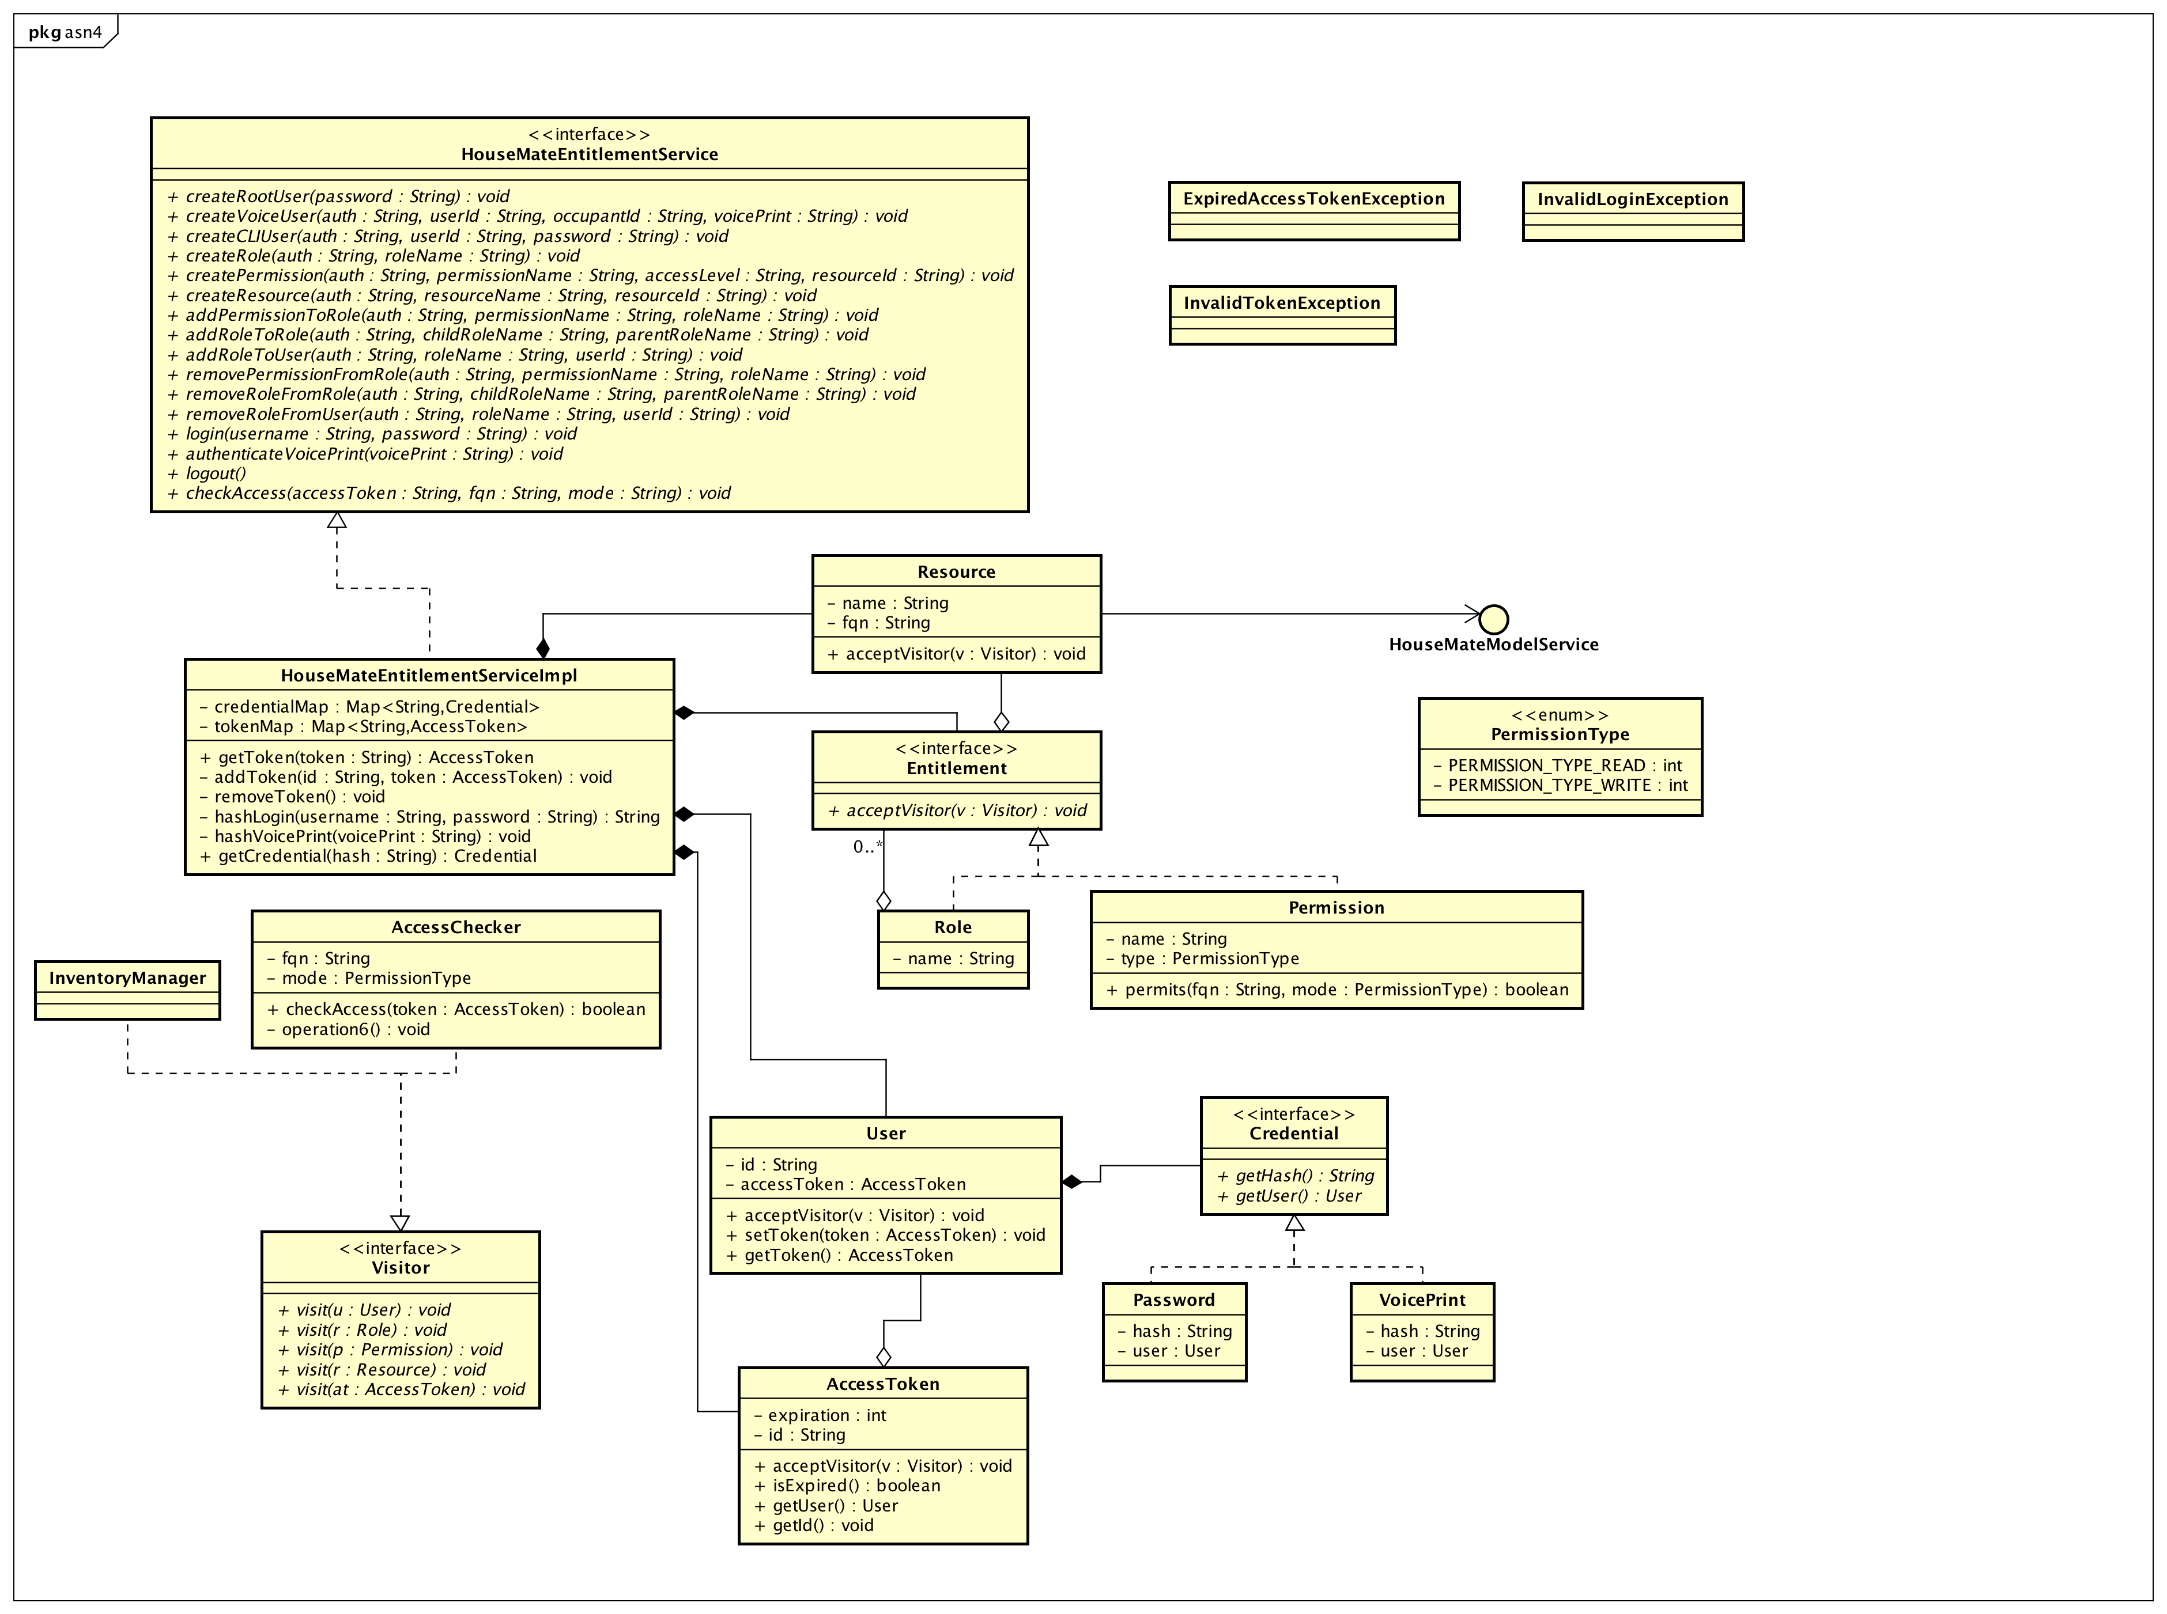

figure 1: asn4::House Mate Entitlement Service[Class Diagram]

asn4::Check Access[Sequence Diagram]

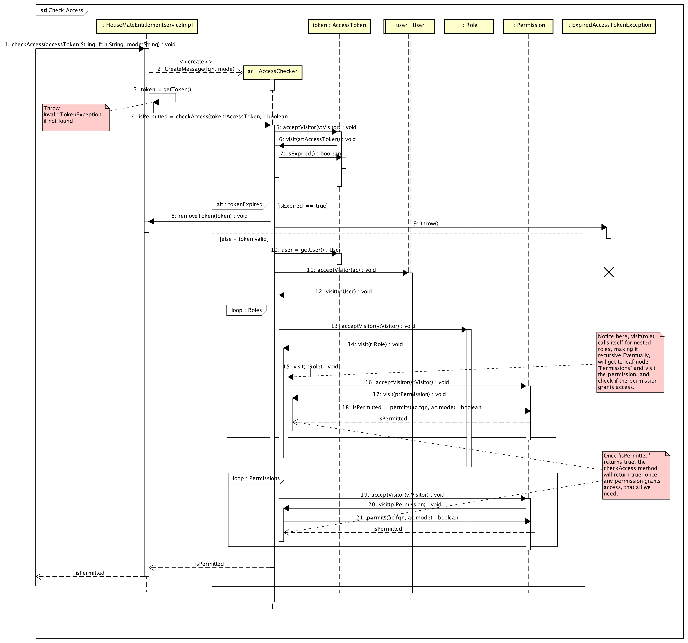

figure 2: asn4::Check Access[Sequence Diagram]

asn4::Invoke Protected Voice Command[Sequence Diagram]

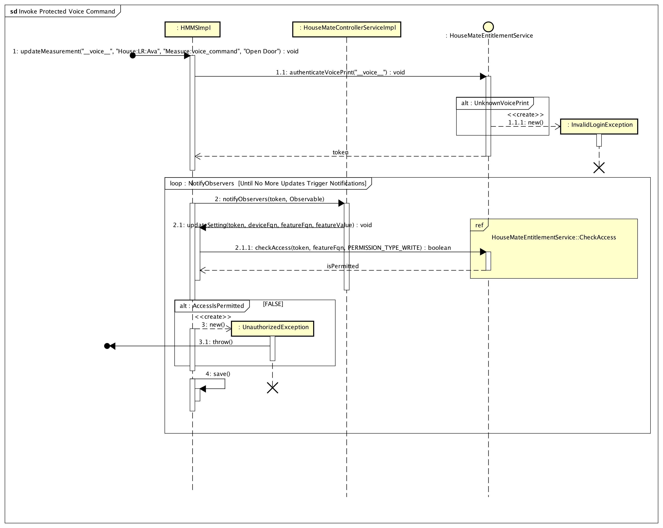

figure 3: asn4::Invoke Protected Voice Command[Sequence Diagram]

asn4::Login[Sequence Diagram]

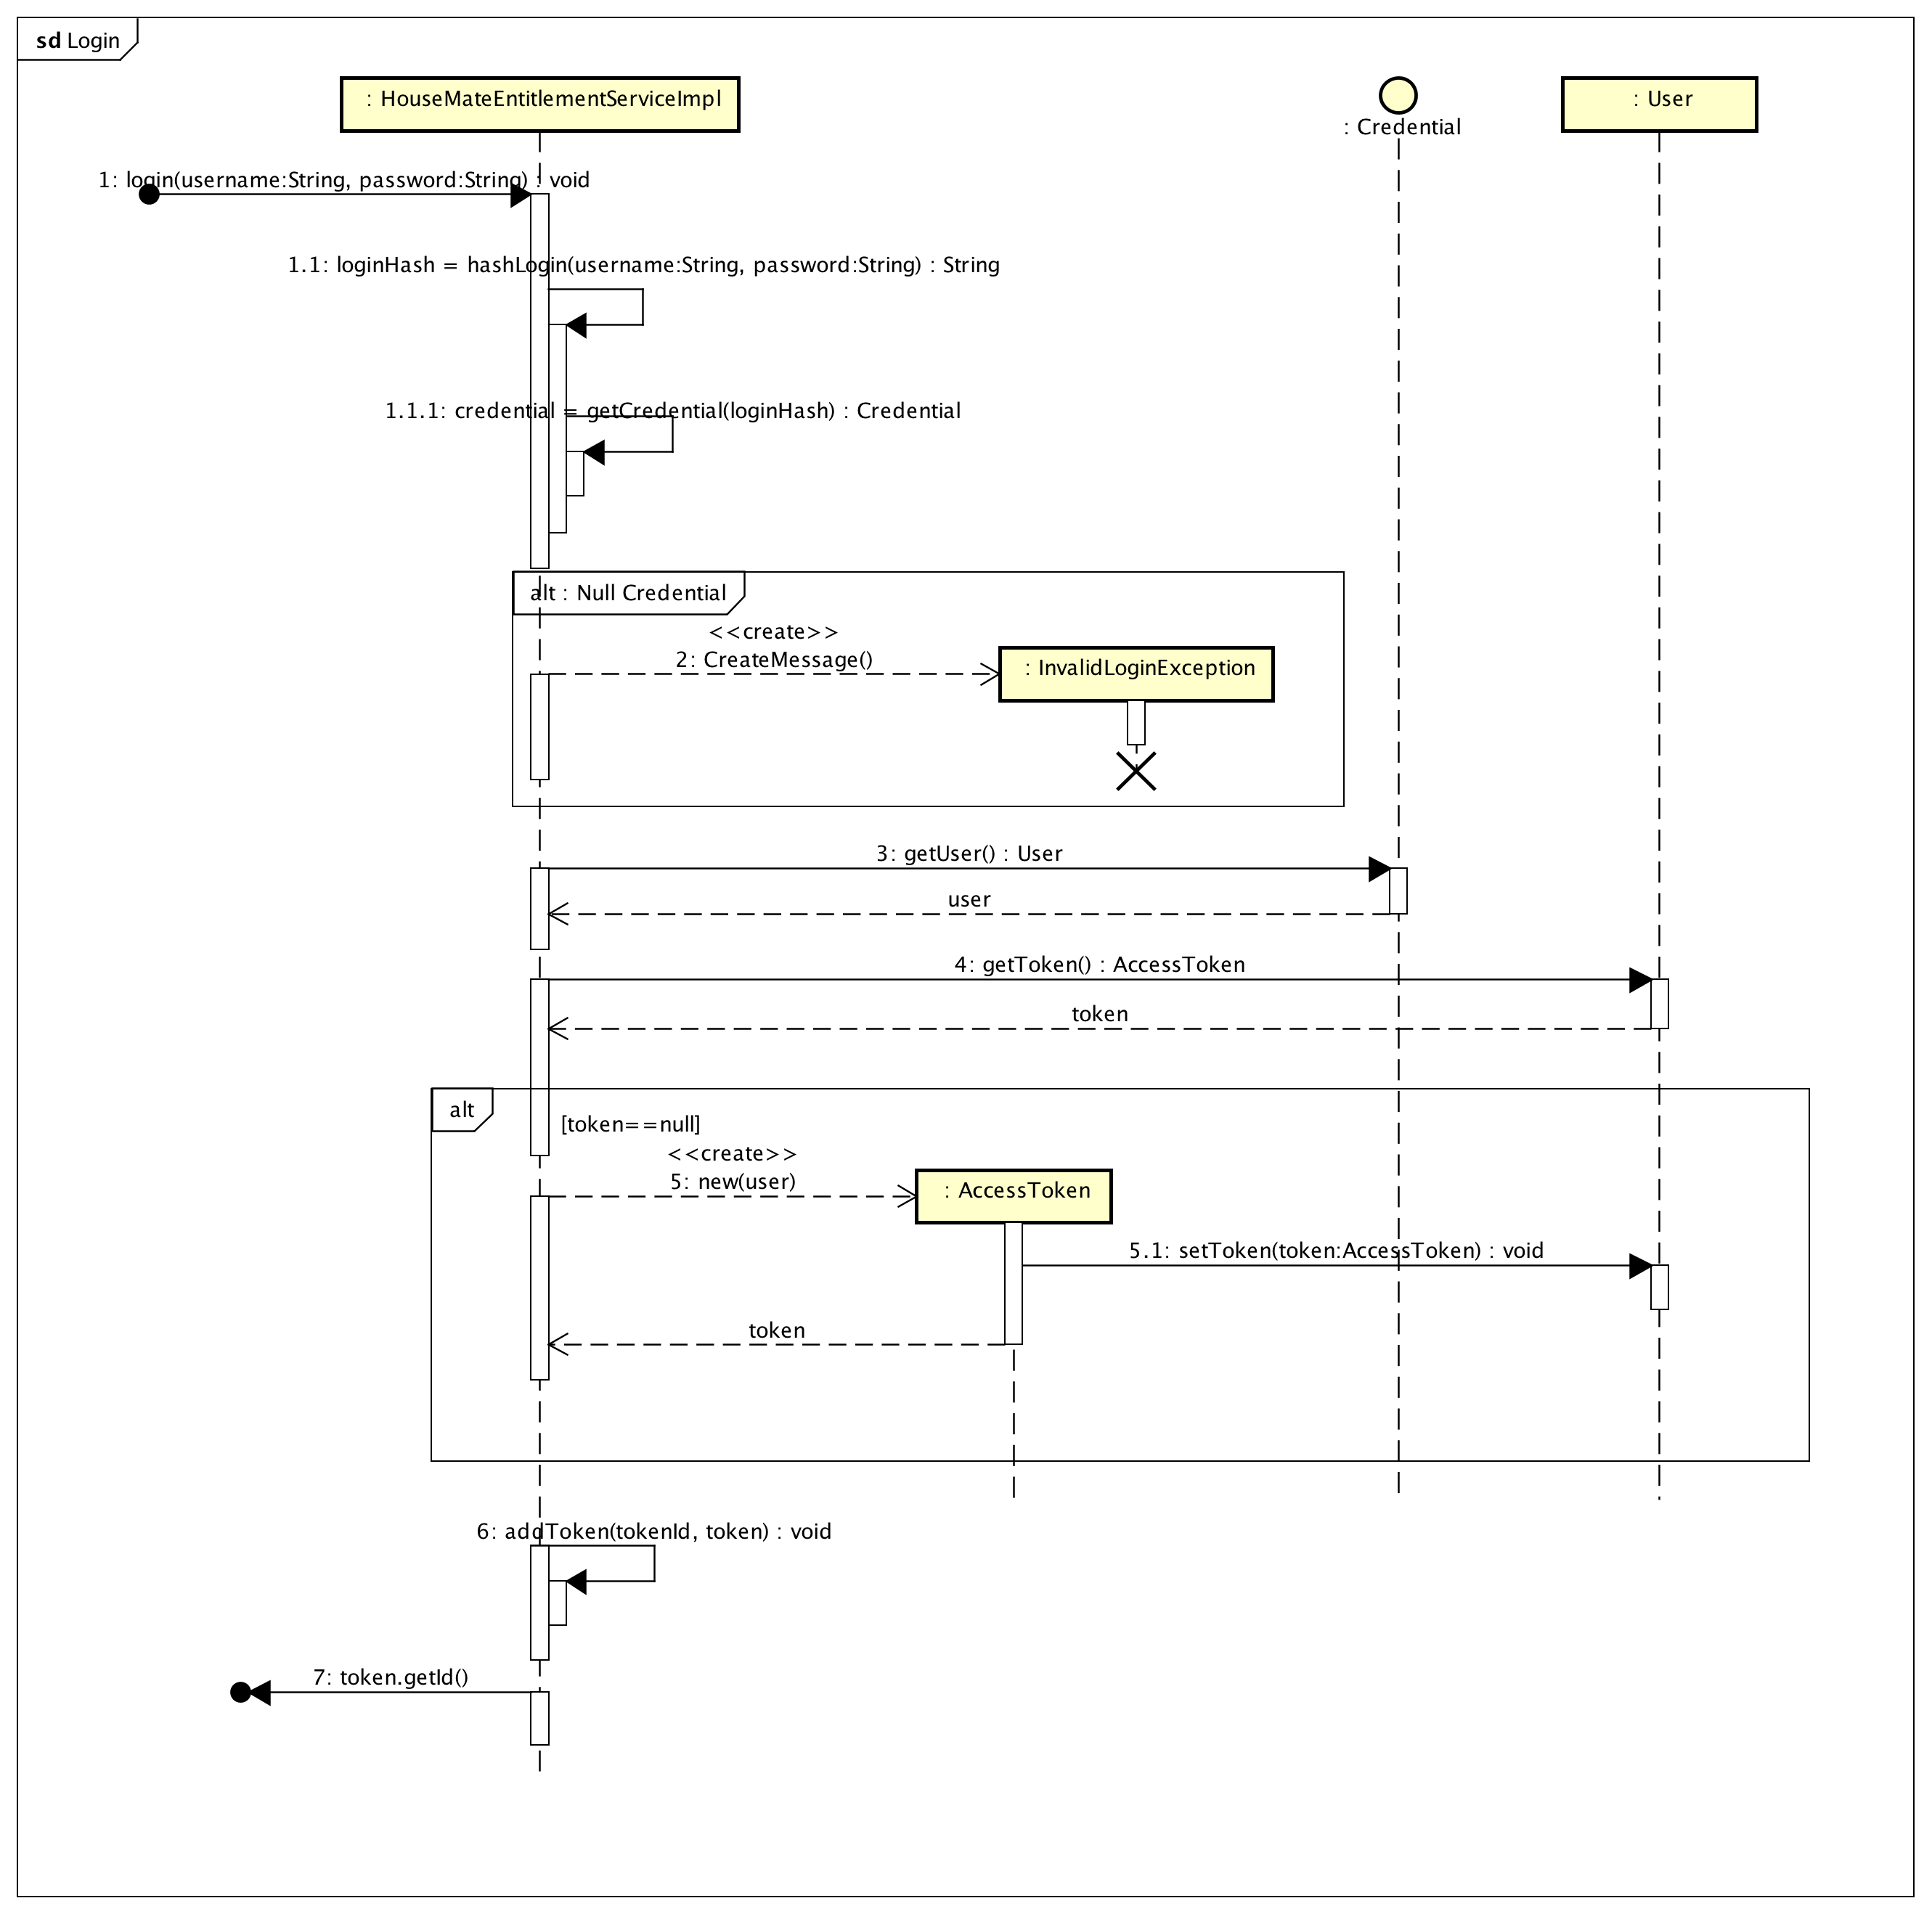

figure 4: asn4::Login[Sequence Diagram]

Class

AccessChecker [Class]

Declaration
public class AccessChecker
implements Visitor

Namespace
asn4

Attribute
Name | Type | Summary
fqn | private String
mode | private PermissionType

Operation
Name | Type | Summary
checkAccess  (AccessToken) | public boolean  [Parameters]  in token: AccessToken
operation6 | private void

Relation (From Source To Target)
Name | Type | Target | Summary
 | Realization | Visitor

AccessToken [Class]

Declaration
public class AccessToken

Namespace
asn4

Attribute
Name | Type | Summary
expiration | private int
id | private String

Operation
Name | Type | Summary
acceptVisitor  (Visitor) | public void  [Parameters]  in v: Visitor
isExpired | public boolean
getUser | public User
getId | public void

Relation (From Source To Target)
Name | Type | Target | Summary
 | Association | User
 | Association | User
 | Association | User

Checkable [Class]

Declaration
public class Checkable

Namespace
asn4

Class13 [Class]

Declaration
public class Class13

Namespace
asn4

Class15 [Class]

Declaration
public class Class15

Namespace
asn4

Class16 [Class]

Declaration
public class Class16

Namespace
asn4

Class2 [Class]

Declaration
public class Class2

Namespace
asn4

Class21 [Class]

Declaration
public class Class21

Namespace
asn4

Class3 [Class]

Declaration
public class Class3

Namespace
asn4

Class4 [Class]

Declaration
public class Class4

Namespace
asn4

Class7 [Class]

Declaration
public class Class7

Namespace
asn4

Control0 [Control]

Declaration
public class Control0

Namespace
asn4

Stereotype
<<control>>

Credential [Interface]

Declaration
public class Credential

Namespace
asn4

Stereotype
<<interface>>

Operation
Name | Type | Summary
getHash | public String
getUser | public User

Relation (From Source To Target)
Name | Type | Target | Summary
 | Association | User
 | Association | User

Entitlement [Interface]

Declaration
public class Entitlement

Namespace
asn4

Stereotype
<<interface>>

Operation
Name | Type | Summary
acceptVisitor  (Visitor) | public void  [Parameters]  in v: Visitor

Relation (From Source To Target)
Name | Type | Target | Summary
 | Association | Role
 | Association | Resource

ExpiredAccessTokenException [Class]

Declaration
public class ExpiredAccessTokenException

Namespace
asn4

HouseMateEntitlementService [Interface]

Declaration
public class HouseMateEntitlementService

Namespace
asn4

Stereotype
<<interface>>

Definition
Public API for creating users and entitlements, as well as providing admin sessions access and voice_print validations.

Operation
Name | Type | Summary
createRootUser  (String) | public void  [Parameters]  in password: String | [Definition]  Creates a root user/password combination that can be used to create administrators. Root user has universal access.  Takes only a "password" as the static username will be "root"
createVoiceUser  (String, String, String, String) | public void  [Parameters]  in auth: String,  in userId: String,  in occupantId: String,  in voicePrint: String
createCLIUser  (String, String, String) | public void  [Parameters]  in auth: String,  in userId: String,  in password: String
createRole  (String, String) | public void  [Parameters]  in auth: String,  in roleName: String
createPermission  (String, String, String, String) | public void  [Parameters]  in auth: String,  in permissionName: String,  in accessLevel: String,  in resourceId: String
createResource  (String, String, String) | public void  [Parameters]  in auth: String,  in resourceName: String,  in resourceId: String
addPermissionToRole  (String, String, String) | public void  [Parameters]  in auth: String,  in permissionName: String,  in roleName: String
addRoleToRole  (String, String, String) | public void  [Parameters]  in auth: String,  in childRoleName: String,  in parentRoleName: String
addRoleToUser  (String, String, String) | public void  [Parameters]  in auth: String,  in roleName: String,  in userId: String
removePermissionFromRole  (String, String, String) | public void  [Parameters]  in auth: String,  in permissionName: String,  in roleName: String
removeRoleFromRole  (String, String, String) | public void  [Parameters]  in auth: String,  in childRoleName: String,  in parentRoleName: String
removeRoleFromUser  (String, String, String) | public void  [Parameters]  in auth: String,  in roleName: String,  in userId: String
login  (String, String) | public void  [Parameters]  in username: String,  in password: String
authenticateVoicePrint  (String) | public void  [Parameters]  in voicePrint: String
logout | public
checkAccess  (String, String, String) | public void  [Parameters]  in accessToken: String,  in fqn: String,  in mode: String

HouseMateEntitlementServiceImpl [Class]

Declaration
public class HouseMateEntitlementServiceImpl
implements HouseMateEntitlementService

Namespace
asn4

Attribute
Name | Type | Summary
credentialMap | private Map<String,Credential>
tokenMap | private Map<String,AccessToken>

Operation
Name | Type | Summary
getToken  (String) | public AccessToken  [Parameters]  in token: String
addToken  (String, AccessToken) | private void  [Parameters]  in id: String,  in token: AccessToken
removeToken | private void
hashLogin  (String, String) | private String  [Parameters]  in username: String,  in password: String
hashVoicePrint  (String) | private void  [Parameters]  in voicePrint: String
getCredential  (String) | public Credential  [Parameters]  in hash: String

Relation (From Source To Target)
Name | Type | Target | Summary
 | Realization | HouseMateEntitlementService
 | Association | Resource
 | Association | Entitlement
 | Association | User
 | Association | AccessToken
 | Association | InventoryManager
 | Association | AccessChecker
 | Association | AccessToken

InvalidLoginException [Class]

Declaration
public class InvalidLoginException

Namespace
asn4

InvalidTokenException [Class]

Declaration
public class InvalidTokenException

Namespace
asn4

InventoryManager [Class]

Declaration
public class InventoryManager
implements Visitor

Namespace
asn4

Relation (From Source To Target)
Name | Type | Target | Summary
 | Realization | Visitor

List<Resources> [Class]

Declaration
public class List<Resources>

Namespace
asn4

Password [Class]

Declaration
public class Password
implements Credential

Namespace
asn4

Attribute
Name | Type | Summary
hash | private String
user | private User

Relation (From Source To Target)
Name | Type | Target | Summary
 | Realization | Credential

Permission [Class]

Declaration
public class Permission
extends Entitlement
implements Entitlement

Namespace
asn4

Attribute
Name | Type | Summary
name | private String
type | private PermissionType

Operation
Name | Type | Summary
permits  (String, PermissionType) | public boolean  [Parameters]  in fqn: String,  in mode: PermissionType

Relation (From Source To Target)
Name | Type | Target | Summary
 | Realization | Entitlement
 | Association | Resource
 | Generalization | Entitlement

PermissionMode [Class]

Declaration
public class PermissionMode

Namespace
asn4

PermissionType [Class]

Declaration
public class PermissionType

Namespace
asn4

Stereotype
<<enum>>

Attribute
Name | Type | Summary
PERMISSION_TYPE_READ | private int
PERMISSION_TYPE_WRITE | private int

Permisson [Class]

Declaration
public class Permisson

Namespace
asn4

Resource [Class]

Declaration
public class Resource

Namespace
asn4

Attribute
Name | Type | Summary
name | private String
fqn | private String

Operation
Name | Type | Summary
acceptVisitor  (Visitor) | public void  [Parameters]  in v: Visitor

Relation (From Source To Target)
Name | Type | Target | Summary
 | Association | HouseMateModelService
 | Association | HouseMateModelService

Role [Class]

Declaration
public class Role
extends Entitlement
implements Entitlement

Namespace
asn4

Attribute
Name | Type | Summary
name | private String

Relation (From Source To Target)
Name | Type | Target | Summary
 | Realization | Entitlement
 | Association | Role
 | Association | Entitlement
 | Association | Entitlement
 | Generalization | Entitlement

User [Class]

Declaration
public class User

Namespace
asn4

Attribute
Name | Type | Summary
id | private String
accessToken | private AccessToken

Operation
Name | Type | Summary
acceptVisitor  (Visitor) | public void  [Parameters]  in v: Visitor
setToken  (AccessToken) | public void  [Parameters]  in token: AccessToken
getToken | public AccessToken

Relation (From Source To Target)
Name | Type | Target | Summary
 | Association | Role
 | Association | Entitlement
 | Association | HouseMateEntitlementServiceImpl
 | Dependency | HouseMateModelService
 | Dependency | HouseMateModelService

Visitor [Interface]

Declaration
public class Visitor

Namespace
asn4

Stereotype
<<interface>>

Operation
Name | Type | Summary
visit  (User) | public void  [Parameters]  in u: User
visit  (Role) | public void  [Parameters]  in r: Role
visit  (Permission) | public void  [Parameters]  in p: Permission
visit  (Resource) | public void  [Parameters]  in r: Resource
visit  (AccessToken) | public void  [Parameters]  in at: AccessToken

VoicePrint [Class]

Declaration
public class VoicePrint
implements Credential

Namespace
asn4

Attribute
Name | Type | Summary
hash | private String
user | private User

Relation (From Source To Target)
Name | Type | Target | Summary
 | Realization | Credential

