si el input de un problema de novelty detection siempre es

LS, pues no hay dos clases... xq no anda 100pre PCA

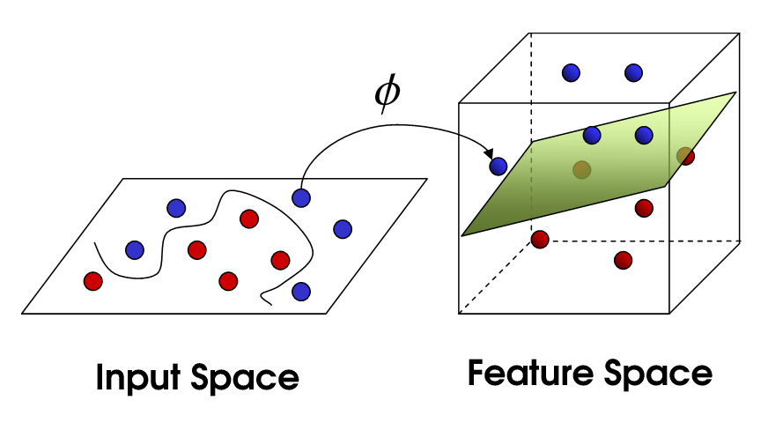

<https://www.youtube.com/watch?v=9NrALgHFwTo>

<http://rvlasveld.github.io/blog/2013/07/12/introduction-to-one-class-support-vector-machines/>

<http://www.cs.princeton.edu/courses/archive/spr08/cos424/scribe_notes/0424.pdf>

<http://www.robots.ox.ac.uk/~davidc/pubs/NDreview2014.pdf> muchos ejemplo p introd

Y te muestra bien dónde estás parado. La secc 4 nos corresponde.

<https://www.whitman.edu/Documents/Academics/Mathematics/2015/Final%20Project%20-%20Welch.pdf> ESTE DIVINO ME EXPLICA EL PAPER STEP BY STEP

y te dice CLARÍSIMAMENTE QUÉ CHOTA ERA EL ERROR DE RECONSTRUCCIÓN! =)

https://stats.stackexchange.com/questions/131138/what-makes-the-gaussian-kernel-so-magical-for-pca-and-also-in-general

A PRIORI NO USARÉ:

<http://www.cs.mcgill.ca/~dprecup/courses/ML/Lectures/ml-lecture13.pdf>

The RBF kernel function will always return a value between 0.0 and 1.0. If x and x’ are the same, RBF gives 1.0. The further apart x and x’ get, the smaller the value of RBF, going down to, but not quite reaching 0.0. Therefore, the RBF kernel is a measure of similarity.