User inputs number of nodes and a node to send the token. All requests made during runtime are random. After sending ‘stop’, shut down procedure is initiated and no new requests can be send. If a node isn’t waiting for token, it’s request list is empty and it doesn’t hold the token, it can be shut down and leave. No further actions are done on the site, previous site changes it’s ‘next’ field reference to next node after the one that shut down.

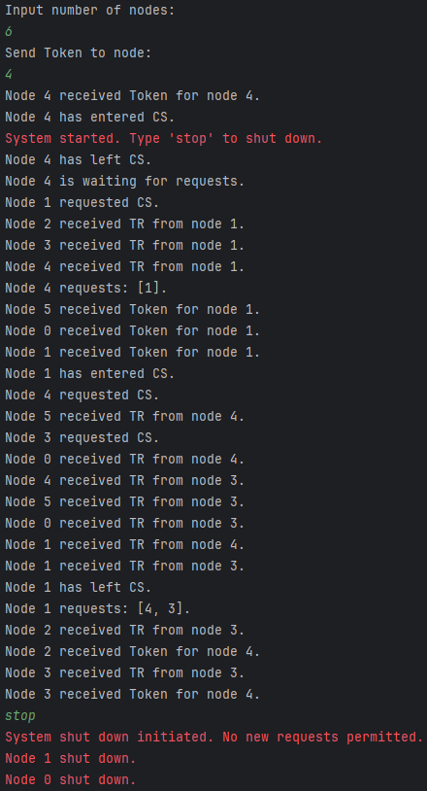Set 1:

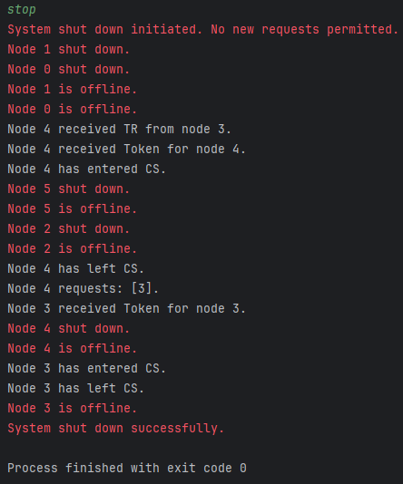

Set 2 (traffic messages disabled for readability)

