Supplementary workflow and rainfall observations
The workflow summarizes the complementary observational analyses. Table S10 reports how grid-days were distributed across the rainfall categories used in the conditional analysis.
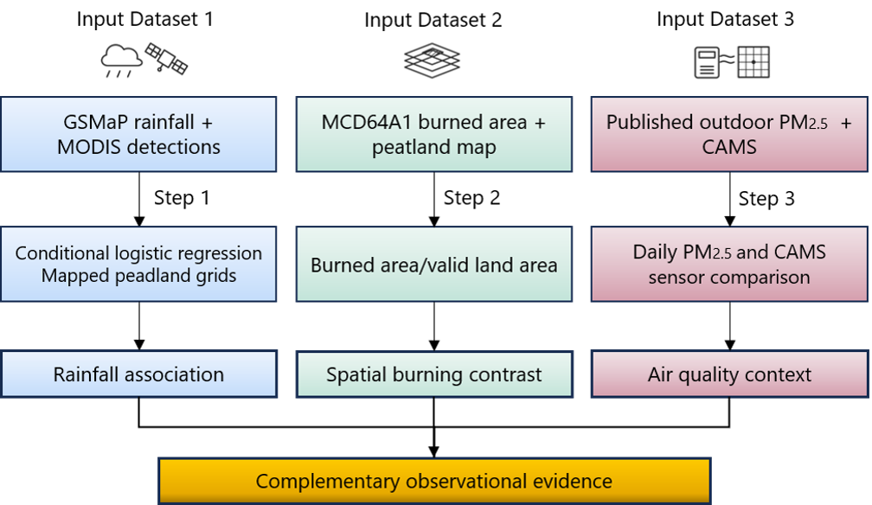
Figure S1. Overview of the observational analysis workflow. Rainfall and MODIS records were used to examine antecedent rainfall associations during 2020–2025. Burned-area observations were compared within and outside mapped peatland in Central Kalimantan during August–November 2023. Published outdoor PM₂.₅ measurements and atmospheric reanalysis provided supporting air-quality context.

Table S10. Distribution of analytic grid-days and recorded vegetation-fire detection grid-days across preceding seven-day rainfall categories, 2020–2025.
Preceding seven-day rainfall (mm) | Grid-days in the complete analytic panel | Grid-days in informative strata | Recorded detection grid-days in informative strata
0–10 | 136,716 | 9,974 | 1,498
>10–30 | 272,585 | 9,244 | 758
>30–60 | 500,096 | 11,413 | 499
>60–100 | 460,728 | 8,023 | 214
>100 | 324,291 | 4,629 | 90
Total | 1,694,416 | 43,283 | 3,059
Informative strata contained both detection and non-detection grid-days within the same grid cell and year-month. Counts describe the observations available to the analysis and should not be interpreted as population-wide fire probabilities.
The binary outcome indicates at least one recorded MODIS detection classified as presumed vegetation fire (type = 0) on a grid-day. Seven-day rainfall covers D−7 to D−1. A grid-day with no recorded detection is not independently verified as a clear-sky, fire-free observation.

