SVMs

# [Intro](https://youtu.be/efR1C6CvhmE?list=PLblh5JKOoLUICTaGLRoHQDuF_7q2GfuJF)

1. A classification technique that determines the optimal thresholds via soft margins/thresholds that allow misclassfications (introduce bias) to prevent overfitting and improve (decrease) variance
2. **Maximal Margin Classifier (MMC)**
   1. 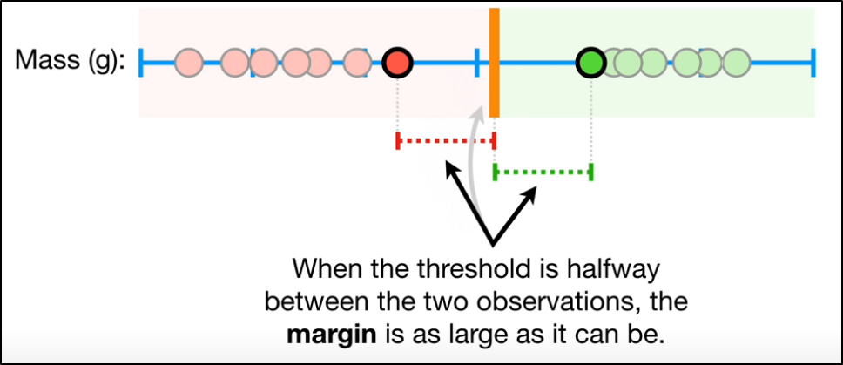
3. Outliers cause problems for MMCs
   1. 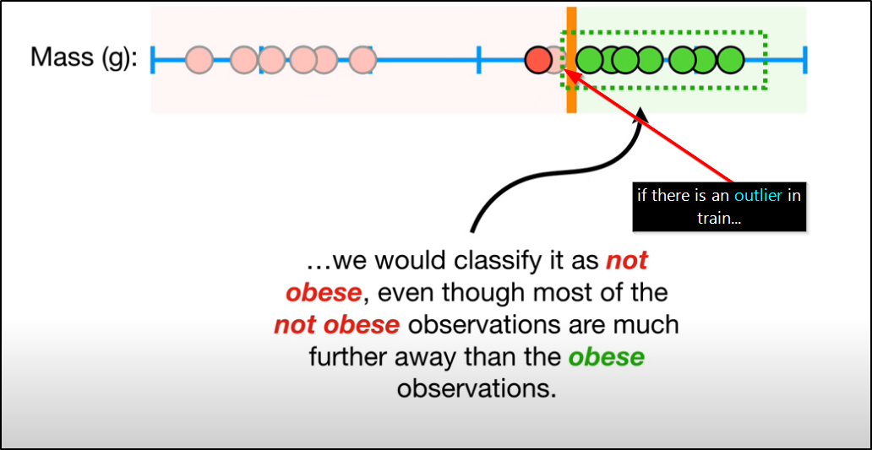
   2. Not a very good threshold/classifier
4. Misclassifications **must** be allowed to prevent overfitting, lower variance
   1. i.e. Introduce bias [in train] for lower variance [between train and test]
   2. **Soft Margin**
      1. 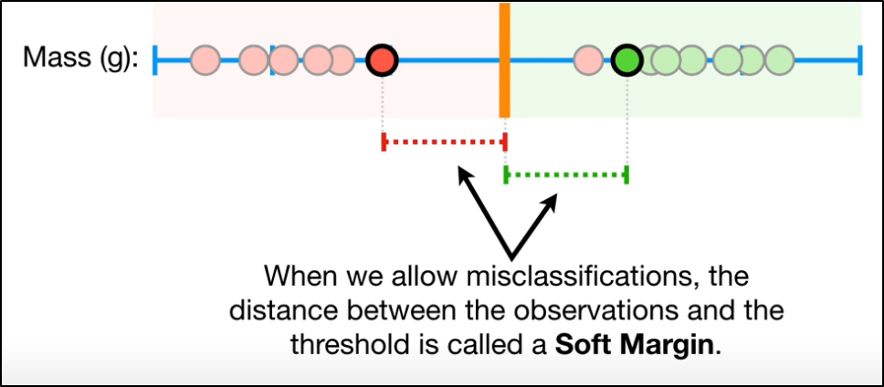
      2. Less sensitive to outliers | threshold determined via cross-validation
      3. **Support Vector Classification**
         1. 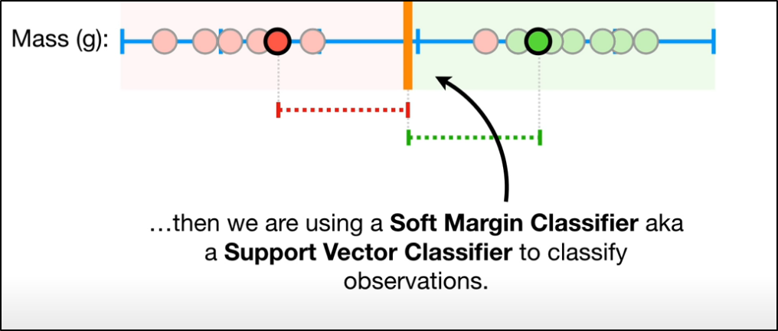
         2. 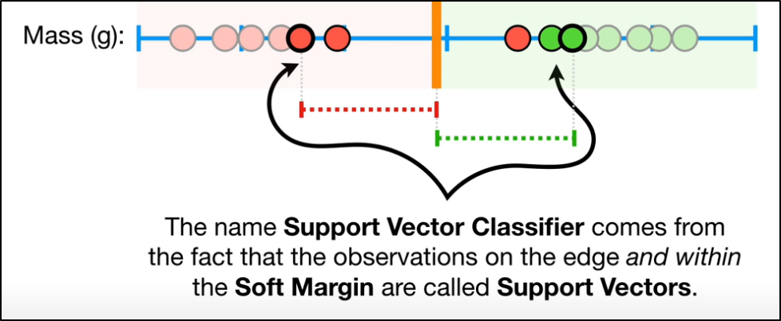
5. We usually have 4 or more dimensions, so the **Support Vector Classifier** is a hyperplane
6. Limitations of Support Vector ***Classifier***
   1. When all test observations lie within train observations range
   2. 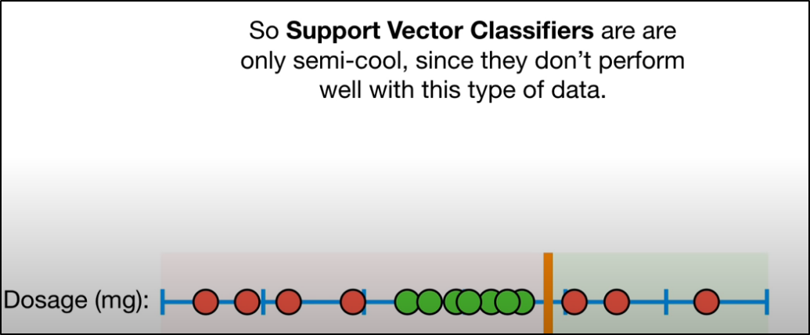
   3. Solution?
      1. Support Vector ***Machines (SVMS)***
7. SVMs
   1. Main Ideas
      * 1. 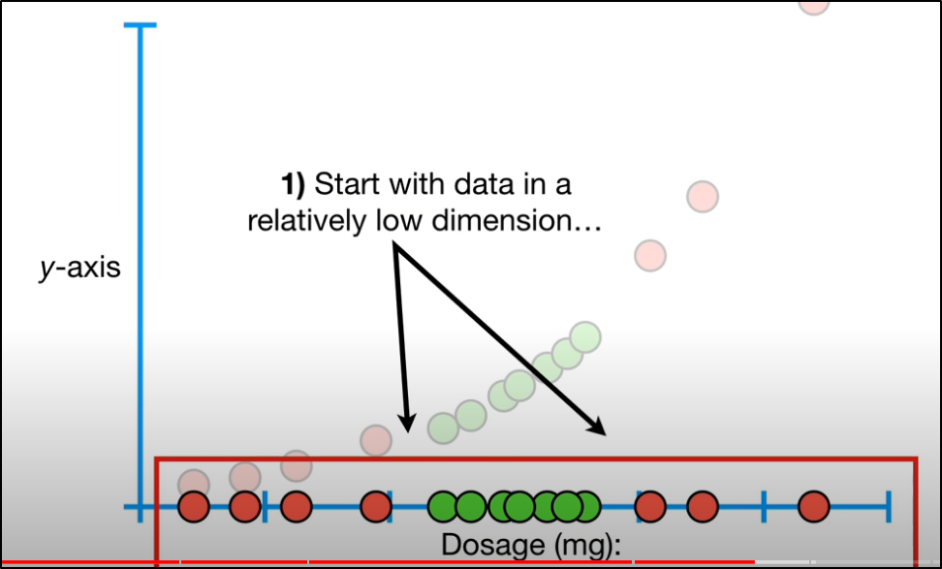
        2. 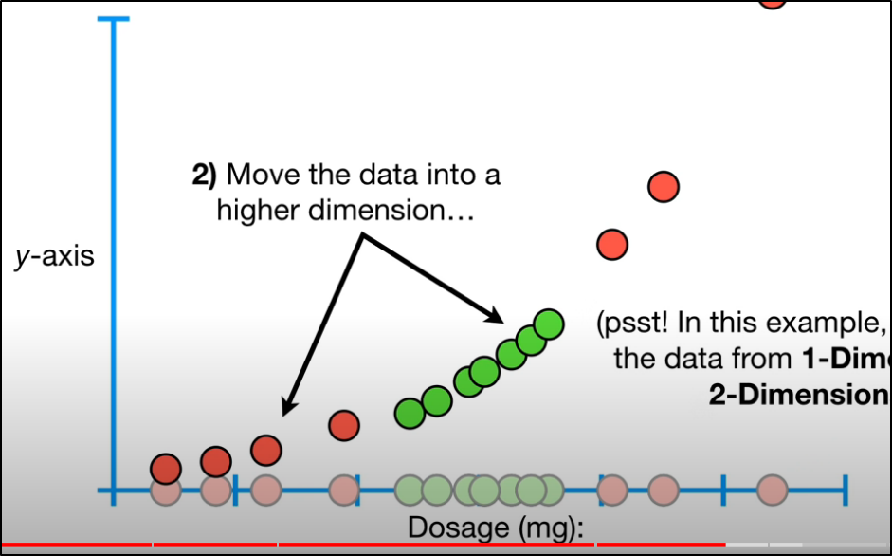
        3. 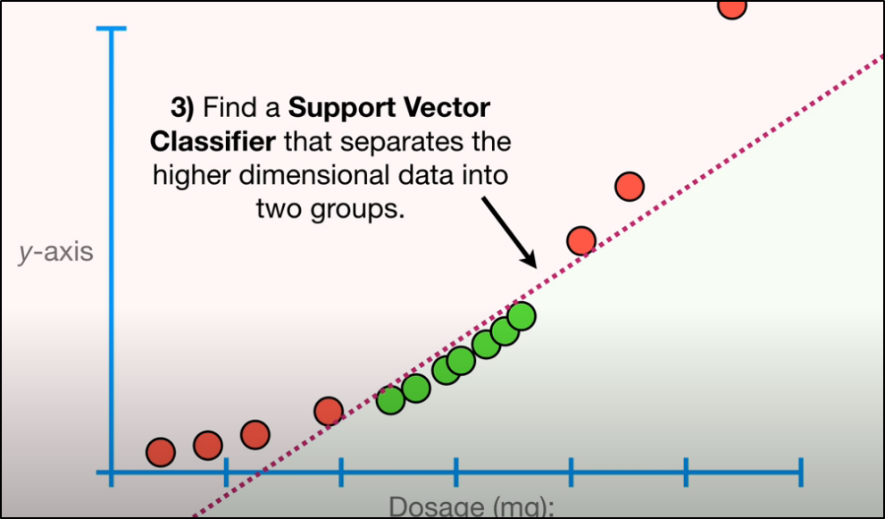
   2. In step 2) above, how is what dimension (squared, cubed, etc.) to use determined?
      1. 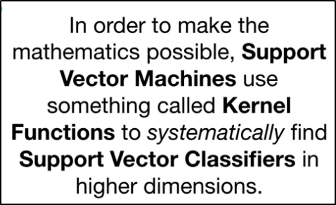
      2. 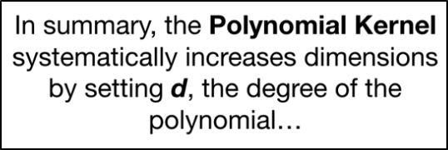
         1. ‘d’ is found by cross-validation
      3. 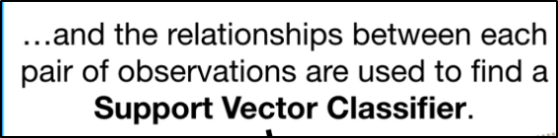
      4. **The Kernel Trick**
         1. 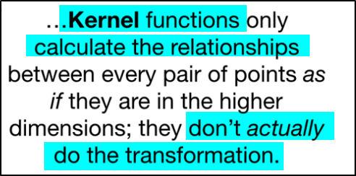
         2. Reduces needed computational power

# The Polynomial Kernel

# The Radial Kernel (RBF)