**Site Purpose**: The purpose of my sight is to provide relevant information for local business owners about the chamber of commerce, Bozeman’s history, and a method through which they can join the chamber.

**Target Audience**: Target audiences are small to medium sized local business owners. The site is intended for business owne’s that want to cultivate their relationships with other business owners in the community so that they can work together for growth.

**Site Map**: 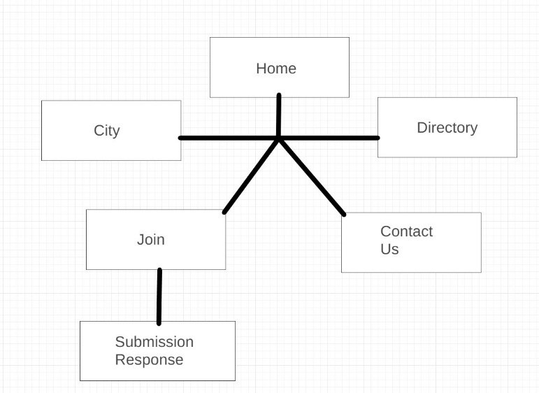

**Color Scheme**: I will primarily be utilizing two main colors on a backdrop of white.

|  |  |
| --- | --- |
| Text | #841818 |
| Background | #ffffff |
| Links | #841818 |
| Borders | #e0bb20 |

**Typography:** I will be utilizing two fonts from the Google Font API, 'IM Fell Double Pica', 'Tajawal'. I will use IM Fell Double for the Header Logo and Tajawal for the rest of the font on the site.

**Wireframe Sketches:** 