CS5381 Round 2 — Individual Experiment Data (Arefeh Khojasteh Sani)

1) Configuration
- Generations: 10
- Fitness weights: w1=0.50 (score), w2=0.30 (survival time), w3=0.20 (steps cost)
- Runtime: 1.50 seconds
- Tool: AlgoChat Streamlit UI (streamlit run UI/AlgoChat.py)
- Initial code: baseline placeholder (def solve(): return "baseline")
2) Captured Results
- Best fitness: 884.688
- Best score (raw): 1838
- survival_time: 44.29
- steps: 238
- Steps per generation: Not shown in UI (only final steps metric displayed)

3) Screenshots
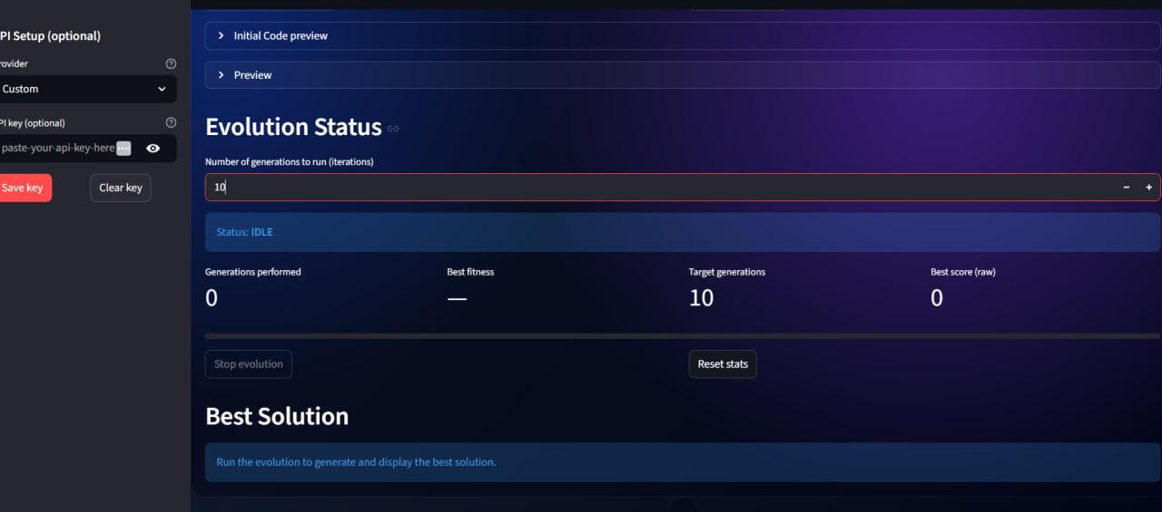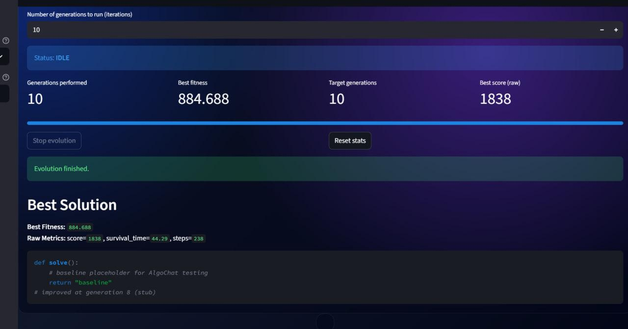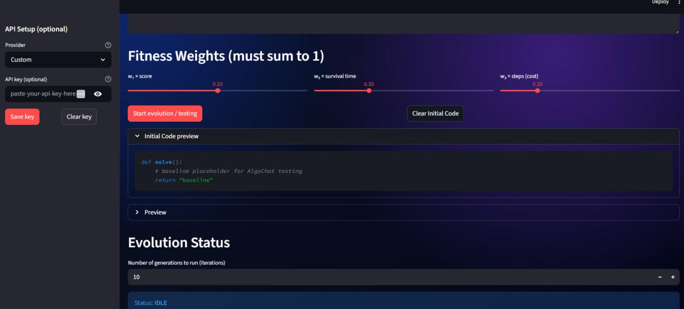

4) Short analysis
- The system completed 10 generations and returned best fitness 884.688.
- The best candidate achieved score 1838 with survival_time 44.29 and steps 238.
- Runtime for this configuration was 1.50 seconds.
- The UI provides final/best metrics but does not export per-generation fitness.

