QuickCart AWS Order Request Queue & Processing System
Architecture, Networking, Security, Monitoring, Disaster Recovery & End-to-End Terraform Implementation

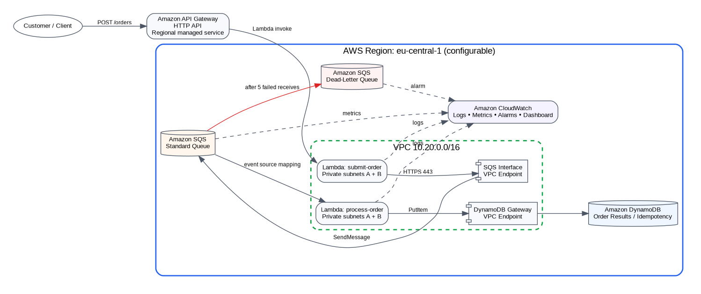
Figure 1. Final end-to-end AWS architecture, including private VPC execution and managed regional services.
Project duration: 4 weeks | Prototype scope: asynchronous order ingestion and processing | Default Region: eu-central-1
Based on the supplied “AWS Order Request Queue & Processing System” project brief.

Contents
1. Executive Summary
2. Scope, Prototype Boundary and Requirements
3. Architecture Overview
4. AWS Networking Design
5. End-to-End Message Flow and Reliability
6. Security Design
7. Monitoring and Operations
8. Disaster Recovery and Business Continuity
9. Terraform Implementation
10. GitHub Repository and Branching
11. Step-by-Step Build and Test
12. AWS Service Trade-offs
13. Four-Week Delivery Structure
14. From Prototype to Industry Standard
15. Final Review Checklist
Important scope statement: This report describes a working prototype that focuses on one bounded part of an e-commerce platform: reliable order acceptance into a durable queue and asynchronous processing. Payment, inventory, fulfillment and a complete customer identity layer are intentionally outside the implementation scope and are addressed in the industry-evolution section.

1. Executive Summary
QuickCart’s current synchronous order path creates a direct availability and capacity dependency between the customer-facing application and the order processor. The proposed system changes that failure boundary: an order is considered accepted only after it has been persisted to Amazon SQS, and processing occurs asynchronously.
The selected implementation is a managed, serverless AWS design with explicit VPC networking: API Gateway HTTP API invokes a producer Lambda attached to private subnets; the producer sends to SQS through an Interface VPC Endpoint; SQS triggers a consumer Lambda in the same private application tier; the consumer writes an idempotent result to DynamoDB through a Gateway VPC Endpoint. Repeatedly failing messages are isolated in a dead-letter queue, while CloudWatch provides logs, metrics, alarms and dashboarding.
Concern | Design response
Decoupling | SQS separates request acceptance from worker availability.
Burst handling | Queue absorbs short spikes; Lambda consumer scales under a configured maximum concurrency.
Retries | Failed records become visible again after the SQS visibility timeout.
Poison messages | After five receives, messages are moved to the DLQ.
Duplicate delivery | DynamoDB conditional writes make the consumer idempotent for the prototype result operation.
Networking | Two-AZ VPC; private Lambda subnets; SQS interface endpoint; DynamoDB gateway endpoint; no NAT in prototype.
Security | Least-privilege IAM, private execution, encryption at rest, no embedded credentials.
Operations | CloudWatch logs, SQS/Lambda metrics, log metric filter, alarms and dashboard.
DR | Multi-AZ within one Region; documented path to backups and multi-Region DR.
Infrastructure as Code | Final Week 4 stack is fully represented in Terraform.

2. Scope, Prototype Boundary and Requirements

2.1 Source-derived project requirements
The supplied project brief requires acceptance of customer order requests, durable storage until processing, asynchronous decoupling, traffic-spike handling, retry behavior, a DLQ, visibility into waiting messages, logging/monitoring, security best practices, cost awareness, and Terraform structure. It also explicitly requires students to justify service choices and trade-offs.

2.2 Prototype boundary
- Implemented: HTTP order submission, durable queueing, producer/consumer decoupling, asynchronous processing, retry/DLQ flow, idempotent result persistence, VPC networking, monitoring, security, Terraform and test scaffolding.
- Not implemented: payment processing, stock reservation, fraud checks, fulfillment, customer identity lifecycle, multi-service sagas, multi-Region automated failover, enterprise SIEM/SOC integration and full CI/CD promotion between accounts.
- The controlled `simulateFailure` field exists only to demonstrate retries and DLQ behavior; it is not a production API feature.
Why call it a prototype: The project is intentionally small and educational. Adding enterprise services merely to make the diagram larger would weaken the design. The final section explains how to evolve the same pattern into an industry-grade platform.

3. Architecture Overview
Figure 2. Final logical architecture and service boundaries.

3.1 Runtime components
Component | Purpose | Availability/scaling behavior
API Gateway HTTP API | Public HTTP ingestion endpoint | Managed regional service; throttles configured on stage.
Producer Lambda | Validate request, generate order ID, send to SQS, return 202 | Stateless; attached to both private subnets.
SQS Standard | Durable asynchronous buffer | Regional managed queue; at-least-once delivery.
Consumer Lambda | Process queue records and persist result | Native event-source mapping; maximum concurrency intentionally capped.
DynamoDB | Prototype result/idempotency store | On-demand billing; conditional write on order ID.
SQS DLQ | Failure isolation | Receives poison messages after configured receive threshold.
CloudWatch | Logs, metrics, alarms, dashboard | Regional operational visibility.

3.2 Acceptance contract
The producer returns HTTP 202 only after SQS `SendMessage` succeeds. This is the critical reliability contract: acceptance means the request has crossed into a durable managed queue. If the consumer is down or throttled, accepted messages wait rather than requiring the customer request to remain connected to the worker.

3.3 Scaling behavior
SQS absorbs burst traffic and Lambda polls the queue. The prototype caps SQS-triggered consumer concurrency at 10 to protect downstream capacity. Production tuning must be based on measured processing rate, queue-age SLOs and service quotas.

4. AWS Networking Design
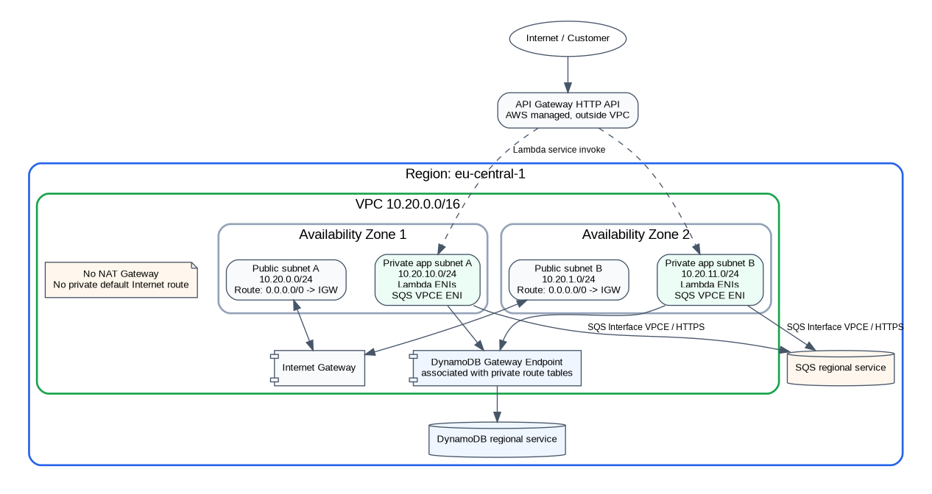
Figure 3. VPC, Availability Zone, subnet, CIDR, routing and private endpoint topology.

4.1 Region, AZ and CIDR plan
Network element | CIDR / placement | Role
VPC | 10.20.0.0/16, one Region | Project routing and security boundary.
Public subnet A | 10.20.0.0/24, AZ 1 | Reserved public tier; route to IGW.
Public subnet B | 10.20.1.0/24, AZ 2 | Reserved public tier; route to IGW.
Private app subnet A | 10.20.10.0/24, AZ 1 | Producer/consumer Lambda ENIs and SQS endpoint ENI.
Private app subnet B | 10.20.11.0/24, AZ 2 | Second-AZ Lambda/endpoint placement.
SQS endpoint | Interface endpoint in both private subnets | Private HTTPS access from producer to SQS.
DynamoDB endpoint | Gateway endpoint on private route tables | Private DynamoDB route without NAT.

4.2 Routing
- Public subnets share a route table with `0.0.0.0/0 -> Internet Gateway`.
- Private subnets have no default Internet route and therefore do not become public merely because the VPC has an Internet Gateway.
- DynamoDB Gateway Endpoint is associated with both private route tables.
- SQS Interface Endpoint uses private DNS; the producer resolves the normal regional SQS hostname to private endpoint addresses.
- No NAT Gateway is deployed in the prototype.

4.3 Why the Lambdas are private
A Lambda function does not require public-subnet placement to be invoked by API Gateway. API Gateway invokes the Lambda service, while the Lambda execution environments use ENIs in the configured private subnets. The consumer likewise receives SQS events through the managed Lambda event-source integration; the application code itself needs DynamoDB network access for `PutItem`.

4.4 Public subnet purpose
No runtime EC2 or load balancer is placed in the public subnets. They are included to demonstrate a complete VPC topology and reserve future capacity for an Internet-facing ALB, NAT Gateway or other justified public-tier component. Adding a bastion just to populate the subnet would increase attack surface without meeting a current requirement.

4.5 Networking trade-off
Cost implication: The original minimal serverless design could leave Lambda outside a customer VPC. This revision intentionally adds VPC networking and an SQS Interface Endpoint. That is architecturally meaningful but increases hourly/data-processing cost. Destroy the prototype when not in use.

5. End-to-End Message Flow and Reliability
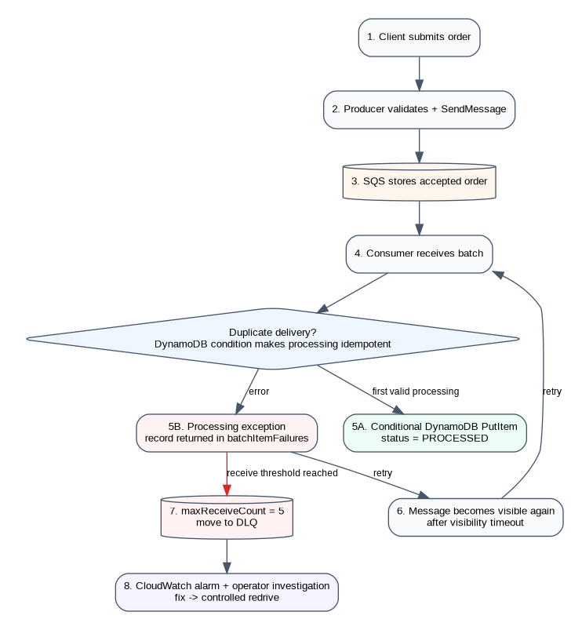
Figure 4. Success, retry, partial-batch failure and DLQ lifecycle.

5.1 Success path
1. Client sends `POST /orders`.
2. Producer validates payload and creates an order UUID/timestamp.
3. Producer sends normalized JSON to SQS.
4. Only after successful `SendMessage`, the API returns 202 Accepted.
5. SQS event-source mapping supplies records to consumer Lambda.
6. Consumer performs a conditional DynamoDB write and records `PROCESSED`.

5.2 Failure path
The consumer returns `batchItemFailures` for individual failed SQS records. Successful records in the same batch are not deliberately failed again. A failed message becomes visible after the 60-second visibility timeout and is retried. The redrive policy moves a message to the DLQ after five receives.

5.3 Idempotency
SQS Standard is an at-least-once service. Duplicate delivery is therefore a normal condition to design for. The consumer writes the result using `ConditionExpression="attribute_not_exists(order_id)"`. If a duplicate reaches the consumer after a successful write, the conditional failure is treated as an already-processed order rather than a second business action.
Industry caution: A conditional result write is sufficient for this prototype, but payment capture or inventory decrement requires a stronger end-to-end idempotency/transaction design. Do not assume a single DynamoDB result record makes every downstream side effect idempotent.

6. Security Design

6.1 IAM
Principal | Allowed runtime actions | Reason
Producer Lambda role | sqs:SendMessage on the main queue; own log writes; required EC2 ENI actions | Can ingest but cannot consume or modify DynamoDB.
Consumer Lambda role | SQS receive/delete/get attributes on main queue; DynamoDB PutItem on result table; own logs; ENI actions | Can process but cannot submit arbitrary new orders.
Terraform deploy identity | Infrastructure creation permissions | Used only at deployment; not embedded in runtime.

6.2 Network controls
- Lambda security group has no ingress rules.
- SQS endpoint security group permits TCP/443 only from the Lambda security group.
- Private subnets have no Internet default route.
- Service endpoint policies restrict SQS sending and DynamoDB writes to the intended resources.

6.3 Data protection and secrets
SQS uses server-side encryption. DynamoDB encrypts at rest. Service calls use TLS. Queue payloads should be minimized and should not contain payment card data or unnecessary PII. No static AWS keys are embedded in the repository. Future external/database secrets should be stored in Secrets Manager or SSM Parameter Store with scoped read permissions.

6.4 Prototype security gaps
- The public API is intentionally unauthenticated for the demonstration.
- AWS WAF is not deployed.
- Customer-managed KMS keys are not used.
- Organization-level GuardDuty/Security Hub/Config/centralized CloudTrail are outside the prototype.
For production, these are not optional omissions to ignore; they are backlog items that must be evaluated against threat model, data classification, compliance obligations and business risk.

7. Monitoring and Operations

7.1 What is monitored
Signal | Why it matters | Prototype action
SQS visible messages | Backlog growth / worker not keeping up | Queue-depth alarm + dashboard.
Age of oldest message | Direct indicator of processing delay | Alarm above 120 seconds for two periods.
DLQ visible messages | Poison message requiring investigation | Alarm at >= 1 message.
Lambda errors/duration | Consumer health and latency | Dashboard; production should add explicit error/throttle alarms.
PROCESSING_FAILED logs | Application-level processing failures | CloudWatch log metric filter and alarm.
API access logs | Request status and integration failures | Dedicated API log group.

7.2 Operational correlation
Order IDs and SQS message IDs are logged so an operator can trace an accepted order through producer, queue and consumer events. Logs should contain identifiers and error context, not full customer payloads.

7.3 Runbooks
- DLQ alarm: inspect failed messages and consumer logs; identify code/data cause; deploy fix; redrive only after verifying idempotency.
- Oldest-message alarm: inspect Lambda throttles/concurrency, downstream errors and queue depth; increase concurrency only if downstream capacity is known.
- API 5xx: inspect API access logs, producer logs, Lambda VPC configuration, endpoint DNS/security group and SQS IAM/endpoint policy.
- DynamoDB errors: inspect consumer logs, account limits, table state and gateway endpoint policy.

7.4 Production evolution
Industry operation should define SLOs (accepted-order availability, end-to-end processing latency and DLQ rate), then derive alerts from error budgets. Integrate alarms with an incident channel/on-call platform, add distributed tracing where useful, and maintain versioned runbooks with ownership.

8. Disaster Recovery and Business Continuity

8.1 Prototype DR posture
The implementation is Multi-AZ inside a single Region, not Multi-Region. The VPC uses two AZs and the SQS interface endpoint has ENIs in both private subnets. Regional managed services remain a regional failure domain. Therefore, a complete Region outage is explicitly outside the automated prototype recovery scope.
Scenario | Prototype response | Industry-standard improvement
One AZ impaired | Lambda can use private subnet/endpoints in the second AZ. | Game-day validation; verify quotas and endpoint health.
Consumer deployment bug | Messages retry and ultimately isolate in DLQ. | Canary deployment + automatic rollback + controlled DLQ replay.
DynamoDB accidental deletion | No guaranteed point-in-time restore when PITR disabled. | Enable PITR, backup policies and deletion protection controls.
Region outage | Wait for Region recovery or manually redeploy elsewhere. | Warm standby/active-active design, replicated state and traffic failover.
Terraform state loss | Local state is a prototype risk. | Remote S3 state, locking, versioning, restricted state access.

8.2 RTO/RPO framing
For a prototype, recovery targets are indicative, not contractual. A production architecture must obtain business-approved RTO/RPO values before selecting expensive DR mechanisms. For queued work, note that SQS queues are regional; near-zero-RPO cross-Region recovery requires an explicit replication or recoverable event-source strategy, not simply “turning on” a second queue.

8.3 Backup and replay
Terraform exposes `enable_pitr` for DynamoDB. Production should enable PITR and scheduled/on-demand backups. The DLQ is not a backup; it is a failure-isolation queue. Redrive must occur only after the underlying cause is fixed and replay safety is understood.

9. Terraform Implementation

9.1 Final Terraform objects
File | Primary resources
networking.tf | VPC, subnets, IGW, route tables, security groups, SQS interface endpoint, DynamoDB gateway endpoint
sqs.tf | main queue, DLQ, redrive policy, encryption
lambda.tf | producer/consumer Lambda and SQS event source mapping
iam.tf | Lambda trust and least-privilege runtime policies
api_gateway.tf | HTTP API, route, integration, stage and API logging
dynamodb.tf | on-demand result/idempotency table, TTL, optional PITR
cloudwatch.tf | metric filter, alarms and dashboard
package.tf | Lambda source ZIP packaging
variables.tf / outputs.tf | configuration and deployment outputs
providers.tf / versions.tf | provider and Terraform version requirements

9.2 Terraform dependency graph highlights
- VPC/subnets/security groups must exist before Lambda VPC attachment.
- SQS queue exists before endpoint policy can scope `sqs:SendMessage` to its ARN.
- DynamoDB table exists before the DynamoDB endpoint policy scopes PutItem to the table.
- IAM permissions are required before SQS event-source mapping becomes fully operational.
- API Gateway integration references the producer Lambda invoke ARN.

9.3 Prototype state vs production state
Local Terraform state is acceptable for a disposable individual lab but is not an industry-standard team design. Production should use an encrypted/versioned remote state backend, state locking, isolated environment/account state, restricted state access, CI plan artifacts and approval-controlled apply.

10. GitHub Repository and Branching

10.1 Repository structure
order-request-processing/
├── README.md # all prerequisites + deploy/test instructions
├── CONTRIBUTING.md
├── .github/workflows/ci.yml
├── week-1-design/
├── week-2-core-implementation/
├── week-3-reliability-monitoring/
└── week-4-production-readiness/
├── architecture/ # DOT + SVG + PNG diagrams
├── networking/
├── security/
├── monitoring/
├── disaster-recovery/
├── industry-evolution/
├── src/
├── tests/
└── terraform/ # final deployable source of truth

10.2 Branch strategy
Use `main` as the only permanent branch. For a one- or two-person four-week project, maintaining a separate long-lived `develop` branch creates merge overhead without meaningful release isolation.
- feature/QC-101-networking
- feature/QC-102-order-api
- feature/QC-103-dlq-monitoring
- fix/QC-104-idempotency
- docs/network-dr-update
- chore/provider-upgrade

10.3 Pull request controls
- Require at least one review where team size permits.
- Require CI: Python tests, Terraform fmt, init -backend=false and validate.
- Prevent direct/force pushes to main.
- Do not commit credentials, .terraform, tfstate, generated ZIP files or local environment files.
- For industry use, add IaC security scanning, dependency/SAST scanning and signed artifact/provenance controls.

11. Step-by-Step Build and Test

11.1 Prerequisites
- AWS account with IAM/VPC/Lambda/SQS/DynamoDB/API Gateway/CloudWatch/VPC Endpoint creation permissions.
- AWS CLI v2 authenticated with short-lived credentials or SSO; default Region eu-central-1 (configurable).
- Terraform >= 1.6, Python 3.12+, Git and curl.
- Budget awareness: the SQS Interface VPC Endpoint has hourly and data-processing cost.

11.2 Deploy
cd order-request-processing/week-4-production-readiness/terraform
cp terraform.tfvars.example terraform.tfvars
terraform init && terraform fmt -recursive && terraform validate
terraform plan -out=tfplan && terraform apply tfplan
API_URL=$(terraform output -raw api_url)
terraform output network_summary

11.3 Functional and decoupling test
1. POST a valid order to `$API_URL/orders`; expect HTTP 202 only after SQS accepts the message.
2. Confirm the order result appears in DynamoDB.
3. Temporarily stop/disable the SQS event-source mapping, submit several orders, and observe SQS backlog increase while intake still returns 202.
4. Re-enable processing and observe the queue drain.

11.4 Failure, DLQ and tests
Submit an order with `simulateFailure: true`; observe retries, `PROCESSING_FAILED` logs and eventual DLQ movement after five receives. Run `pytest -q week-4-production-readiness/tests` for unit tests.

11.5 Cleanup
terraform destroy

12. AWS Service Trade-offs
Decision | Selected | Alternative | Trade-off / reason
Queue | SQS Standard | SQS FIFO | Standard fits no-ordering requirement; idempotency is required because duplicate/out-of-order delivery can occur.
Compute | Lambda | ECS/Fargate, EC2 | Lambda minimizes operations for short event-driven tasks; containers/EC2 fit long-running or specialized workloads.
API | API Gateway HTTP API | REST API / ALB | HTTP API is sufficient for simple routes; REST API offers broader API-management features.
Result store | DynamoDB | Aurora/RDS | Conditional serverless writes are simple; SQL is preferable for relational transactions/querying.
Networking | Private Lambda + endpoints | Lambda outside VPC / NAT Gateway | Demonstrates private networking and controlled egress; more cost/complexity than default Lambda networking.
SQS access | Interface VPC Endpoint | NAT Gateway | PrivateLink-style service access; each interface endpoint costs money and only solves specific services.
DynamoDB access | Gateway Endpoint | NAT / interface-style design | Gateway endpoint is a natural private route for DynamoDB and avoids NAT for this service.
Workflow | Direct SQS -> Lambda | Step Functions | Single processing step does not justify workflow orchestration; add Step Functions when stateful multi-step coordination appears.
Events | SQS only | EventBridge + SQS | Queue is sufficient for one consumer. EventBridge becomes useful for fan-out/routing across multiple consumers.
Region | Single Region, Multi-AZ | Multi-Region | Right-sized for prototype; regional DR remains a known limitation.
Encryption | SSE-SQS / default DynamoDB encryption | Customer KMS key | Low management overhead; CMK is appropriate for governance/control requirements.

13. Four-Week Delivery Structure
Week | Goal | Repository evidence
Week 1 - Design | Understand synchronous failure mode, requirements, queue behavior and alternatives. | requirements/, architecture/, initial diagram and message-flow decision records.
Week 2 - Core implementation | Build submission, queue, consumer, IAM and logging concepts. | src/, Terraform learning snapshot and core implementation README.
Week 3 - Reliability/monitoring | Demonstrate retry, DLQ, idempotency, controlled failures and CloudWatch. | reliability/, monitoring/, tests/, Terraform reliability resource map.
Week 4 - Production readiness | Add networking, security review, DR, cost, final Terraform, repository polish and industry roadmap. | Final architecture diagrams, networking/, security/, monitoring/, disaster-recovery/, industry-evolution/, complete Terraform stack.

13.1 Why only Week 4 contains the deployable Terraform source of truth
The earlier weeks contain learning snapshots and implementation artifacts appropriate to their milestones. Maintaining three divergent partial Terraform stacks would create ambiguity about which infrastructure should be deployed. Week 4 therefore contains the cumulative, end-to-end deployable configuration, while Weeks 2 and 3 document the resource types introduced at those stages.

14. From Prototype to Industry Standard
The correct path to industry quality is not to add every AWS service at once. It is to harden the same bounded workflow according to measurable business and risk requirements.
Area | Next industry step
Accounts/environments | Separate dev/test/stage/prod accounts; Organizations/Control Tower; centralized logging/security.
API security | JWT/OIDC authorizer, WAF where justified, schema validation, abuse/rate controls, custom domain/TLS/DNS.
Delivery | Terraform modules, remote state, CI policy/security scanning, controlled apply, canary Lambda deployments and rollback alarms.
Domain services | Separate payment/inventory/fulfillment; use EventBridge for fan-out and SQS per consumer for buffering/backpressure.
Orchestration | Add Step Functions for explicit multi-step state, retries, timeouts and compensations when workflow complexity appears.
Idempotency | Client idempotency keys, state-machine transitions, audit events, transactional outbox/CDC for atomic state+event publication.
Observability | Formal SLOs/error budgets, tracing, structured logs, incident routing, runbooks and game days.
Networking | Additional VPC endpoints or controlled NAT/egress proxy as integrations grow; multi-account network architecture only when scale requires it.
DR | PITR/backups, warm standby/active-active second Region where RTO/RPO justify it, replicated state and tested failover.
Scale | Load-test at 10/100/1,000+ orders/s, tune batch/concurrency, quotas and downstream protection based on measurements.
Security | GuardDuty, Security Hub, Config, Access Analyzer, CloudTrail, SCPs, KMS governance, secret rotation and secure SDLC.

14.1 Potential future architecture
A mature implementation could evolve from “one queue, one processor” into an event-driven domain: Order API -> durable order command queue -> order service -> domain events -> EventBridge -> separate SQS queues for payment, inventory, fulfillment and notification consumers. Step Functions should be introduced only for workflows that truly require centralized orchestration; otherwise choreography with well-defined events may remain simpler.

14.2 Performance validation
Do not claim the architecture supports 1,000 orders/second solely because SQS and Lambda are managed services. Industry readiness requires measured load tests, queue-age behavior, consumer throughput, Lambda concurrency, downstream write capacity, VPC ENI/service quotas, API quotas, error rate and cost per order under target traffic.

15. Final Review Checklist
- ☐ Architecture diagram shows customer, API Gateway, Lambda producer/consumer, SQS main/DLQ, DynamoDB and CloudWatch.
- ☐ Networking diagram shows Region, two AZs, VPC CIDR, four subnet CIDRs, IGW, route intent and VPC endpoints.
- ☐ Both Lambdas are attached to the private application subnets in Terraform.
- ☐ SQS interface and DynamoDB gateway endpoints are represented in Terraform.
- ☐ Root README lists workstation tools, AWS permissions, credentials/Region expectations, cost warning, deployment, tests and cleanup.
- ☐ Repository is separated into four weekly folders with week-specific artifacts.
- ☐ Report explicitly covers Networking, Security, Monitoring and Disaster Recovery.
- ☐ Prototype scope and non-goals are explicit.
- ☐ Industry-standard expansion path is explicit and does not pretend the prototype is already enterprise production.
- ☐ Retries, visibility timeout, partial batch failures, idempotency and DLQ behavior are documented and testable.
- ☐ Trade-offs include SQS Standard/FIFO, Lambda/containers, HTTP/REST API, DynamoDB/relational DB, endpoints/NAT and single-/multi-Region.
- ☐ Terraform final stack can be planned/applied from the Week 4 folder and the lab can be destroyed after testing.

Conclusion
The revised design meets the project’s central architectural principle: temporary processor failure should not turn into a lost accepted order. It also demonstrates the additional networking and operational disciplines expected in an AWS architecture project while remaining explicit about prototype limitations and the work required to reach industry standards.

