R Markdown Legacy

Jeremy Allen

2024-04-23

Table of Contents

## What is R Markdown?

An authoring framework for data science

A document format (.Rmd)

An R package named rmarkdown

A file format for making dynamic documents with R, can include Python, SQL, and more

A tool for integrating prose, code, and results

A computational document

An ecosystem of packages and tools for reports, dashboards, websites, books, and more

Superseded by Quarto

See <https://rmarkdown.rstudio.com/> and Dr Allison Hill’s [Intro to R Markdown](https://rstd.io/rmd4cdc).

## Tell Me about your existing R Markdown projects

* reports?
* with templates?
* with Shiny components?
* websites?
* books?
* data prep scripts?
* scheduled?
* how do your share them?

## R Markdown Ecosystem: many ways to solve your research and business problems

* **Literate Programming**
* **Control Documents**
* **Templating**
* **Data products**

### Literate Programming

**captures code, prose, and output in a single document enhancing learning and repeatability**

For example, I can use prose to explain the following code chunks:

In this code chunk I am loading the R packages that will be required for my analysis. The tidyverse is an umbrella package of other packages, including the ggplot2 package. I do not have to load ggplot2 explicitly. The previous two sentences would be a bit much for an in-code comment, but are fine for prose located close to the code.

library(tidyverse)

diamonds |>  
 ggplot2::ggplot(aes(x = carat, y = price, color = cut)) +  
 geom_point(alpha = .3) +  
 labs(  
 title = "Diamonds: Price as a Function of Carat",  
 subtitle = "by cut",  
 x = NULL,  
 y = NULL  
 ) +  
 theme_minimal()

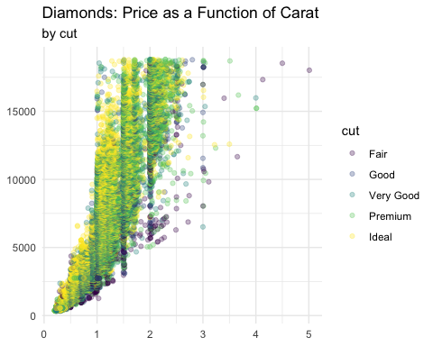

**More languages:**  
Literate programming in R Markdown is not just for R. knitr, which computes code in R Markdown, has [many language engines](https://bookdown.org/yihui/rmarkdown/language-engines.html#language-engines). Over 50! Try names(knitr::knit_engines$get()).

**More reproducible:** Combining comments and documentation with your code increases the chance that others, including future you, will understand your project.

**More exploration:** See [David Robinson’s videos](https://youtube.com/playlist?list=PL19ev-r1GBwkuyiwnxoHTRC8TTqP8OEi8) in which he quickly explores data sets using R Markdown documents.

### Control Documents

**scale data science, automate data tasks, and create data pipelines**

R Markdown can be a meta-document that lets you bring in other code or automate processes.

* Automation with parameters: such as run a report for state, region, or body of water
* Child Documents: in one document include the content from another .Rmd
* Conditional child docs, [see guide](https://bookdown.org/yihui/rmarkdown-cookbook/child-document.html#child-document)
* ETL in .Rmd, especially when scheduled in Posit Connect
* RMarkdown for Emails, see [the blastula package](https://github.com/rstudio/blastula)

Let’s add content from a child document right here (set eval to TRUE):

### Templating

**simplifies and reduces error in important but repetitive production**

Templating through R Markdown templates:

* standard report layouts
* standard themes
* directories
* load standard libraries
* share through packages
* see [more in the guide](https://bookdown.org/yihui/rmarkdown/document-templates.html)

Templating through parameters:

* I live in Atlanta
* see [more in the cookbook](https://bookdown.org/yihui/rmarkdown-cookbook/parameterized-reports.html#parameterized-reports)

Templating through code loops

* knit the doc loops-example.Rmd

### Comfortable Data Products

**use R Markdown to compute, report, and deliver findings to colleagues and decision makers**

* Presentations
* Dashboards
* Reports
* Websites
* Books
* Package sites

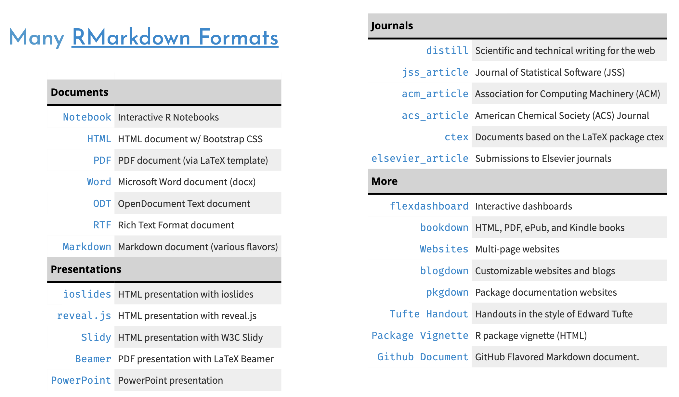

The large R Markdown Ecosystem

### Some of the nuts and bolts

**Let’s play!**

* YAML
  + remove table of contents
  + add inline R code for the date using Sys.time()
* Chunk options
* themes
  + change html_document to tufte::tufte_html: default
  + see bslib theme example in directory
* Add static ggplot2 graph to the flexdashbaord example
* parameters
  + regions, states, bodies of water, years
  + what parameters are you already using?
* Remember citations ? (Welcomme et al. 2010)

**Here are four incredible resources on the nuts and bolts**

* [R Markdown: The Definitive Guide](https://bookdown.org/yihui/rmarkdown/)
* Dr. Allison Hill’s [Intro to R Markdown](https://rstd.io/rmd4cdc)
* Dr. Tom Mock’s Higher Faster Further [presentation](https://themockup.blog/posts/2020-07-25-meta-rmarkdown/) and [video](https://youtu.be/WkF7nqEYF1E)
* NOAA examples: Emily Markowitz’s package [NMFSReports](https://emilymarkowitz-noaa.github.io/NMFSReports/index.html) and Dr. Eli Holmes’s workshop [R Markdown Reports](https://rverse-tutorials.github.io/RWorkflow-NWFSC-2021/week4.html)

## Looking ahead to Quarto

* single framework, you don’t need other packages for books, websites, or presentations
* consistent syntax across types
* R is not required, you can use Python or Julia or Observable JS natively in Quarto
* extensible through pandoc extensions
* [compare to what’s available in R Markdown](https://quarto.org/docs/faq/rmarkdown.html#i-use-x-bookdown-blogdown-etc..-what-is-the-quarto-equivalent)

## Q&A

[code](https://github.com/jeremy-allen/rmarkdown-legacy-webinar)

Welcomme, Robin L., Ian G. Cowx, David Coates, Christophe Béné, Simon Funge-Smith, Ashley Halls, and Kai Lorenzen. 2010. “Inland Capture Fisheries.” *Philosophical Transactions of the Royal Society B: Biological Sciences* 365 (1554): 2881–96. <https://doi.org/10.1098/rstb.2010.0168>.