Computing and Data Analysis Project

The grading mindset is to evaluate your implication and your learning gradient :
One grade (CC) related to the reports + implication (coef 0.5)
• one 2-pages status document to provide end of November. The idea is to present your project subject + short sum-up of the achieved work so far, and remaining tasks
• one final report to provide begining of January
• your implication + continuity of the work
One grade (ET) associated to an oral presentation (mid-end January, coef 0.5)

Numerical modelling: Courants de surface océanique
Shallow water equation
file:///C:/Users/brice/OneDrive/Bureau/UGA/M2/Ocean%20dynamics/Poly%20cours.pdf (p.21-23)
The ocean is very very flat: typical depth (H=4km) typical horizontal scale (L=10 000 km)
Sea water has only small density differences ∆ρ/ρ ≈ 3 · 10−3
Using this we will try to model the ocean as a shallow homogeneous layer of fluid.
Hydrostatic approximation
Homogeneity ∆ρ = 0
$∂_{z}u=∂_{z}v=0$ : We have neglected bottom friction (and with the wind)
The ocean has what we call a free surface with a height variation denoted by η.
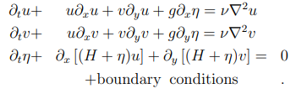
Partie 1 : The One-dimensional Shallow Water Equations
Independent of y, v=0.
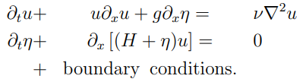
Paramètres :
$ν = {10}^{-6}{ m}^{2}.s^{-1}$ $H=4 km$ Longueur du domaine L : $L=10 000km$
$$g=9,81 m.s^{2}$$

Approximation des dérivées (centré sauf pour la dérivée double). Schéma d’Euler explicite. (Runge-Kutta explicite ordre 1).

