Refactoring the Beast: Week 12 Teaching Guide
CS2 | computer_science_2/week_12/refactor_beast | Session of 2026-11-02
Purpose. This is a durable record of how we set up the beast.py refactor lab: making a protected original, branching, understanding what the program does, mapping it, locking a baseline, and writing the first unit test with a coding assistant. Use it to teach the lab again next time.
1. What beast.py actually does
beast.py is a working but ugly experiment generator. Everything happens inside one function, go(), and the work is tracked with module-level global counters.
Part | What happens | Output
Sorting | Sizes 10, 20, 40, 80, 160; inputs random, sorted, reversed; 5 seeded trials each. Runs bubble, bubbleearly, insertion, selection, Python sort. | sort_counts.csv (comparisons, swaps), timings.csv
Searching | For each size, a sorted list and 200 lookups (half present, half absent). Linear vs. binary search. | search_counts.csv (average probes)
Report | Draws two plots, glues LaTeX strings together, runs pdflatex. | sort_counts.png, search_probes.png, report.tex, report.pdf

Global | Meaning
C | comparisons
S | swaps (shifts, for insertion sort)
P | probes during searching
R | results dictionary, keys glued with "|"
T | trials per cell (5)

Quirks to lock in with characterization tests:
- Binary search adds to P twice on a step that misses (one for ==, one for <). That is why n=160 shows about 13.4 probes.
- For insertion sort, S counts shifts, not true swaps.
- Functions: bs, bs2, ins, sel, pysort (with nested cmp), lin, binr, go. go() only runs under if __name__ == "__main__", so importing beast is safe.
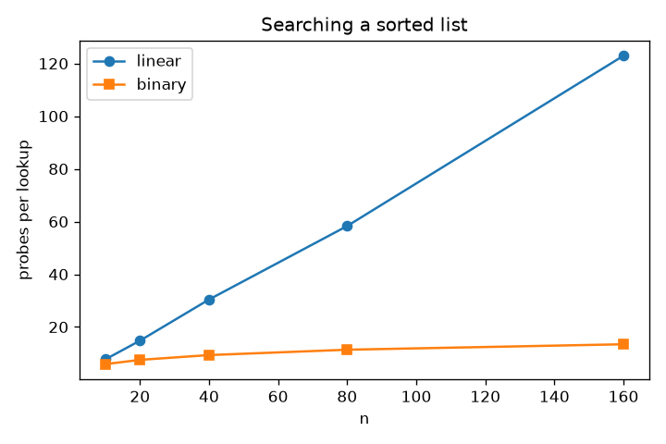
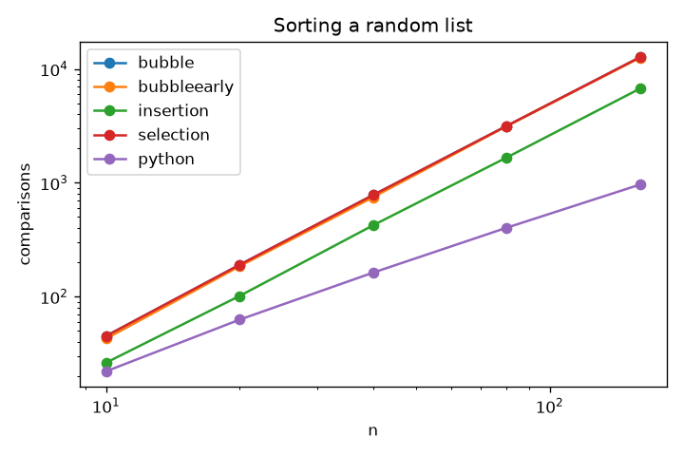
2. Protect the original
Before anything else, make a read-only copy. The name beast_as_given.py matches the Step 00 commit message, sorts next to beast.py, and does not start with test_, so pytest ignores it.
Copy-Item .\beast.py .\beast_as_given.py
Set-ItemProperty .\beast_as_given.py -Name IsReadOnly -Value $true
Get-ChildItem .\beast*.py | Select-Object Name, Length, IsReadOnly
To unlock on purpose: Set-ItemProperty .\beast_as_given.py -Name IsReadOnly -Value $false
3. Make the refactor branch
git switch -c refactor
git branch --show-current
git push -u origin refactor
A plain git push on a new branch fails with "no upstream branch." The -u (or --set-upstream) flag fixes that once; later pushes are just git push.
4. Codex prompt: inventory the functions (read-only)
You are helping a CS2 class start a careful refactor of beast.py in
week_12/refactor_beast. We are on the branch "refactor".

THIS STEP IS READ-ONLY. Do not edit, create, rename, or delete any file.
Do not run pip install. Do not run beast.py. Just read the code and report.

For EACH function (including nested ones), one Markdown table row:
| function | what it does | inputs | return value |
| globals it reads or changes | other side effects |
| testable as-is? (yes / yes-with-reset / no) | why |

For every "yes" or "yes-with-reset" function:
1. Use a tiny list (3-4 numbers) and work out BY HAND the exact result
and exact counter values (C, S, or P). Show the steps.
2. Point out anything surprising about how it counts.

For go(): list its jobs in order with line numbers, say which outputs are
deterministic and why, and recommend what a characterization test
should compare against baseline/.

Finish with a "Protect these first" list, easiest to hardest.
Describe the code as it IS. Plain, student-friendly language.
If unsure about a count, say so instead of guessing.
5. Mermaid maps
A Mermaid chart is a diagram written as plain text inside a ```mermaid code block. VS Code preview (Ctrl+Shift+V, with a Mermaid extension) and GitHub draw it as boxes and arrows. Because it is text, git can diff the before map against the after map.
The README asks the before map to show functions, calls, shared global state, and where the mess is. The first draft only drew calls. Gaps to fix:
- Draw the globals C, S, P, R as nodes, with dotted arrows for who changes them.
- Break go() into its real jobs and show each output file.
- Mark smells (globals, copy-pasted loops, magic numbers, glued LaTeX) with a red class.
- Move the maps from out/ (regenerated every run) to maps/.
We are on branch "refactor" in week_12/refactor_beast. Improve the
"before" map of beast.py. Describe the code as it IS today.
Do not edit beast.py or any other code file.
Never modify, regenerate, or delete anything in baseline/ or beast_as_given.py.

1. Move out/before_map.md and out/before_map_viewing_guide.md to maps/
(git mv if tracked). Update the path in the viewing guide.
2. Rewrite maps/before_map.md with TWO fenced mermaid diagrams:
A "Who calls whom, and what they share" (flowchart LR):
keep all function nodes and call edges; add C, S, P, R as
database nodes in a subgraph "shared mutable state"; dotted
arrows labeled "+=" or "reset" only where the code really does it.
B "What go() does, in order" (flowchart TD):
one node per job with beast.py line range; each out/ file as a
node; mark timings.csv "changes every run".
3. classDef "smell" (red border) on the messy nodes; under each diagram
list every smell with one sentence and a line number.
4. Labels of 5 words or fewer. No HTML except <br/>.
5. Anything unsure goes under the diagram as "Unverified:".
6. Show me the diff. Do not commit.
6. Step 07: Save the baseline (and lock it)
Say: The baseline is our definition of "still works." Once saved, nobody edits it. If a test disagrees with the baseline, the code is wrong, not the baseline.
Do (no AI): run fresh, copy exactly three files, fingerprint them, lock them.
python .\beast.py
New-Item -ItemType Directory -Force .\baseline | Out-Null
Copy-Item .\out\sort_counts.csv, .\out\search_counts.csv, .\out\report.tex .\baseline\
Get-FileHash .\baseline\* -Algorithm SHA256 | ForEach-Object { "{0} {1}" -f $_.Hash, (Split-Path $_.Path -Leaf) } | Set-Content .\baseline\SHA256SUMS.txt
Get-ChildItem .\baseline\* | ForEach-Object { $_.IsReadOnly = $true }
Get-ChildItem .\baseline | Select-Object Name, Length, IsReadOnly
Commit it by itself:
git add baseline
git commit -m "Save locked baseline: the output is the spec"
git push
Not timings.csv (clock time changes every run). Not the PDF (pdflatex can stamp dates). Prove it later (prints nothing if untouched):
Get-FileHash .\baseline\*.csv, .\baseline\*.tex -Algorithm SHA256 | ForEach-Object { "{0} {1}" -f $_.Hash, (Split-Path $_.Path -Leaf) } | Compare-Object (Get-Content .\baseline\SHA256SUMS.txt)
Git on Windows does not store the read-only flag, so each clone runs the lock line. The commit and hash check protect everyone.
7. Step 09: One tiny test
Say: One real test, run once, beats ten pages of plans. A test you have never seen fail is a test you cannot trust.
git status
python -m pytest --version
Paste to the assistant (exactly):
Task: create ONE new file named test_beast.py in the current folder.

The file must contain exactly this, and nothing else:

from beast import lin

def test_linear_search_finds_seven_at_index_one():
assert lin([4, 7, 9], 7) == 1

Rules:
- Do NOT edit beast.py.
- Do NOT create, edit, or delete any other file.
- Never modify, regenerate, or delete anything in baseline/ or beast_as_given.py.
- Do NOT add fixtures, classes, comments, extra tests, or a conftest.py.
- Do NOT run git commands.
- Reply with only the contents of test_beast.py.
Review (no AI):
git status --short
python -m pytest -q test_beast.py
Expect exactly ?? test_beast.py and 1 passed. Anything else means the AI went off the rails: git restore . then git clean -n.
Make it fail on purpose: change == 1 to == 2, rerun, see 1 failed, change it back, green again.
git add test_beast.py
git commit -m "Add first unit test: lin finds 7 at index 1"
git push
Why the prompt is so strict: small local models over-deliver (extra tests, fixtures, edits to beast.py). Exact contents make step 09 a test of following instructions. Later, when tests check P, each test must set beast.P = 0 first. That pain is the reason to refactor the globals away.
8. Side question: how long can a function name be?
Python has no length limit on identifiers. The real limits are readability and PEP 8's 79-character lines. Names use letters, digits, and underscores and cannot start with a digit. Long names are normal for tests because pytest prints them on failure: a test name should read like a sentence about what must be true; a regular function name should say what it does in a few words.
9. Standing rules for every AI prompt
- Say whether the step is read-only.
- Never modify, regenerate, or delete anything in baseline/ or beast_as_given.py.
- Name exactly which files may change; ask for the diff; do not commit.
- Run the tests after every step: green keeps going, red means undo.

