Something I noticed when going through submissions for the Chapter 12 homework was a common output result from some of the programs: “Usage: Java Exercise_12_16 file oldString newString”. I imagine many of you did not know what this meant, so hopefully this little tutorial will help!
Providing arguments from the console when running a program is very common and a useful tool in programming. This is easy to do if you are running your code from the command line, however most of you are writing your code in eclipse and how you accomplish this is a little tedious.
The first step is click on the "Run" tab in the menu above your code window.
Next click on "Run Configurations..."
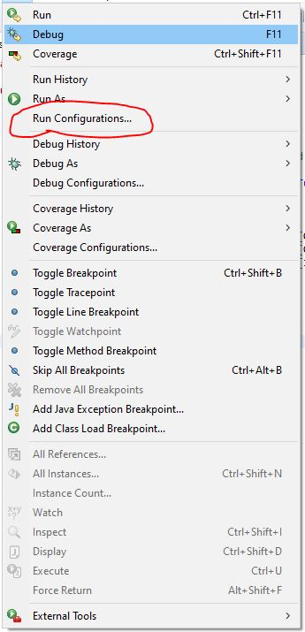
After that you should get a new window pop up from Eclipse; In this window click on the Arguments tab.
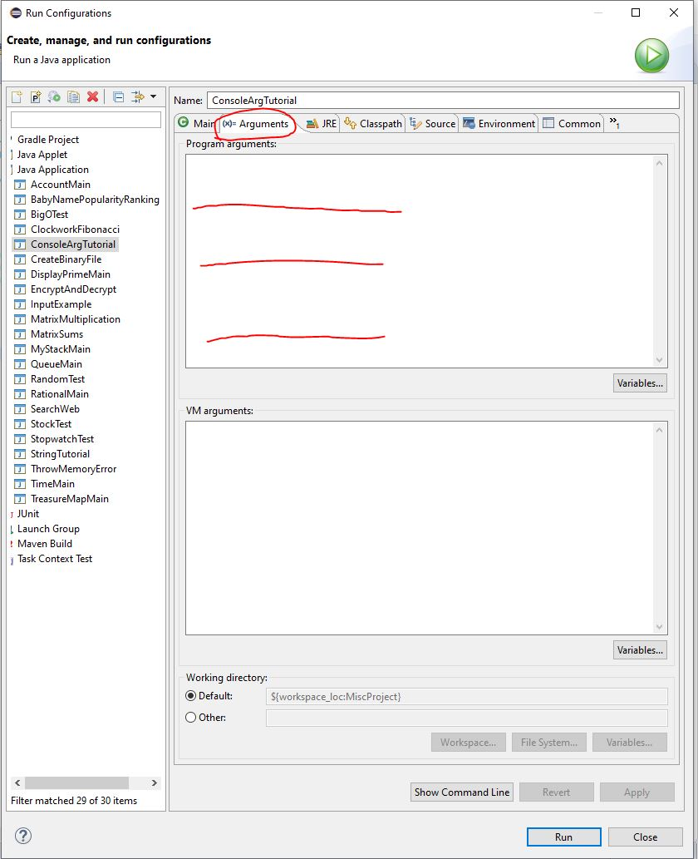
What should appear is a text box, this is where you will enter your arguments that your code will run with (as indicated by the red lines).

Each argument is separated by a space. if you want to provide multiple words then use quotation marks, like denoting a String variable.
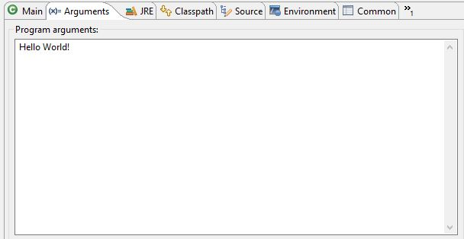
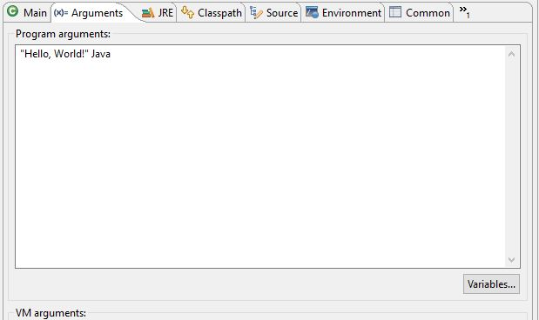
Now when you run your code, the args[] array defined in the main method should have the arguments you entered stored in the order they were provided. You can reference those values the same as any other array.
If you need any more help figuring this out, don't hesitate to ask Dr. Evert or I for assistance!

