1. { {1,1}, {2,2}, {3,1}, {4,1}, {5,2}, {6,3}, {7,3}, {8,2}, {9,4}, {10,1} }
2. 1. False

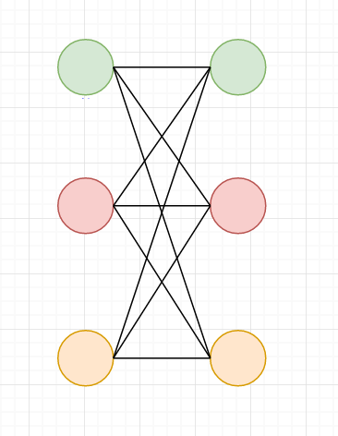

* 1. True