MSDS610 Data Engineering

Week 3 Lab – Instructions for installing PostgreSQL on your PC (this is not required, but this an option to have a local copy)

as of 9/10/2019

**In the lab 3 assignment, click on the postgreSQL link. After reading the “brief overview of PostgreSQL”, click on the install PostgreSQL link highlighted in yellow below to install the software on your PC.**

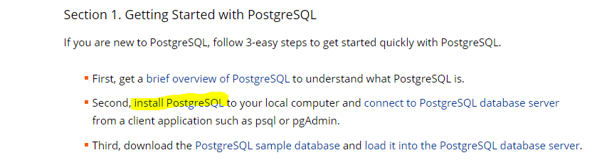

**Scroll down the page. This start now is an ad and not installation instructions. ☹**

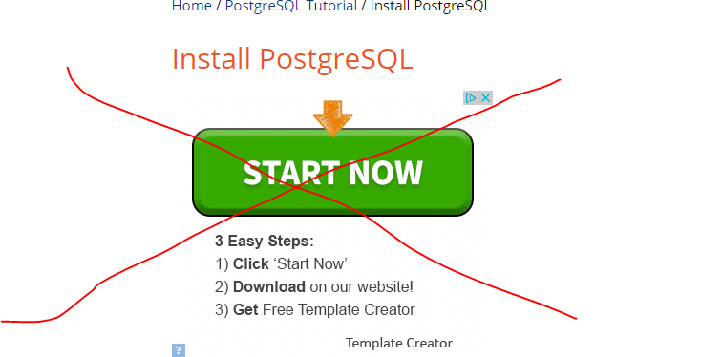

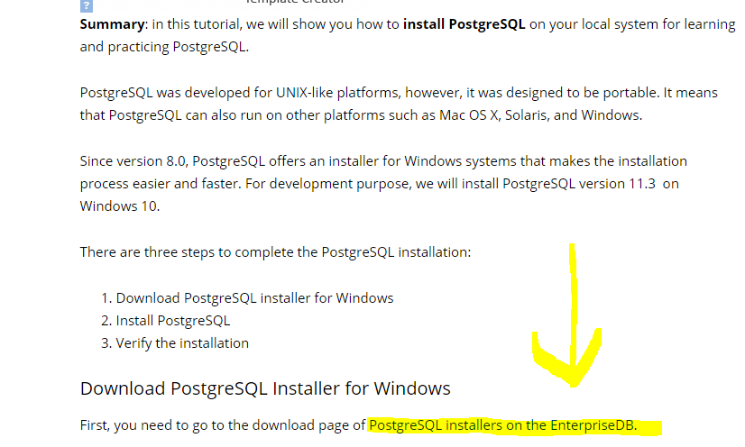

**Under the Windows system application (or on your mac), check your processor and O/S. In the example below, I have a 32-bit OS running Windows 10.**

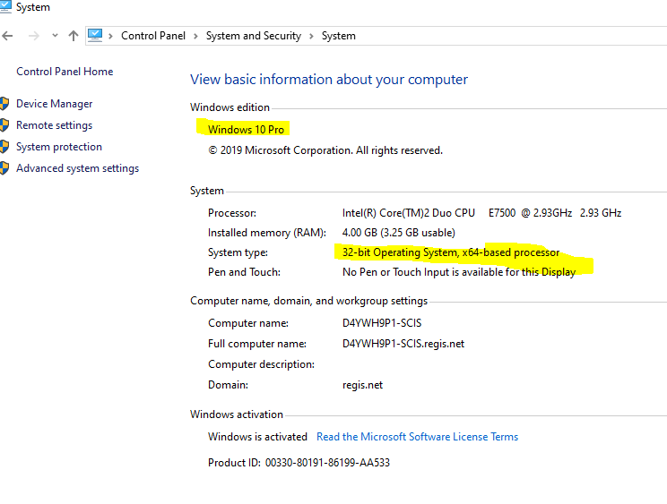

**I’m going to download the Windows 10.10 32-bit version for my PC, as indicated below.**

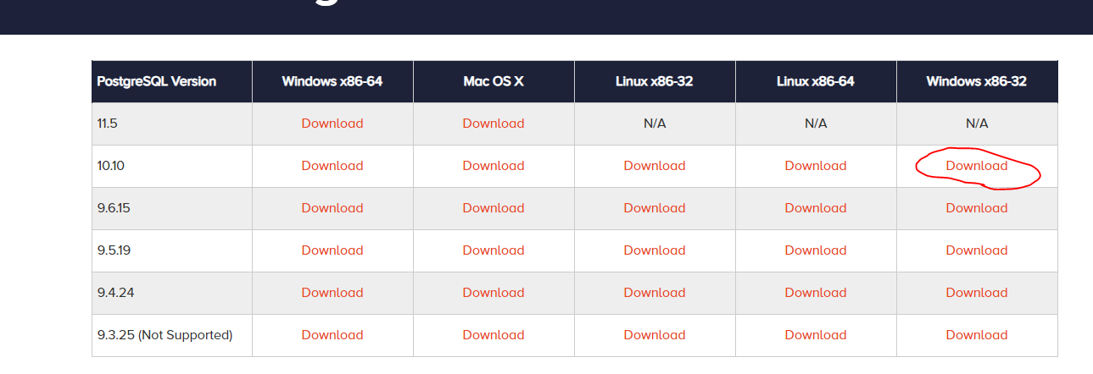

**Notice PostgreSQL is downloaded below. Click open to install the software on your PC.**

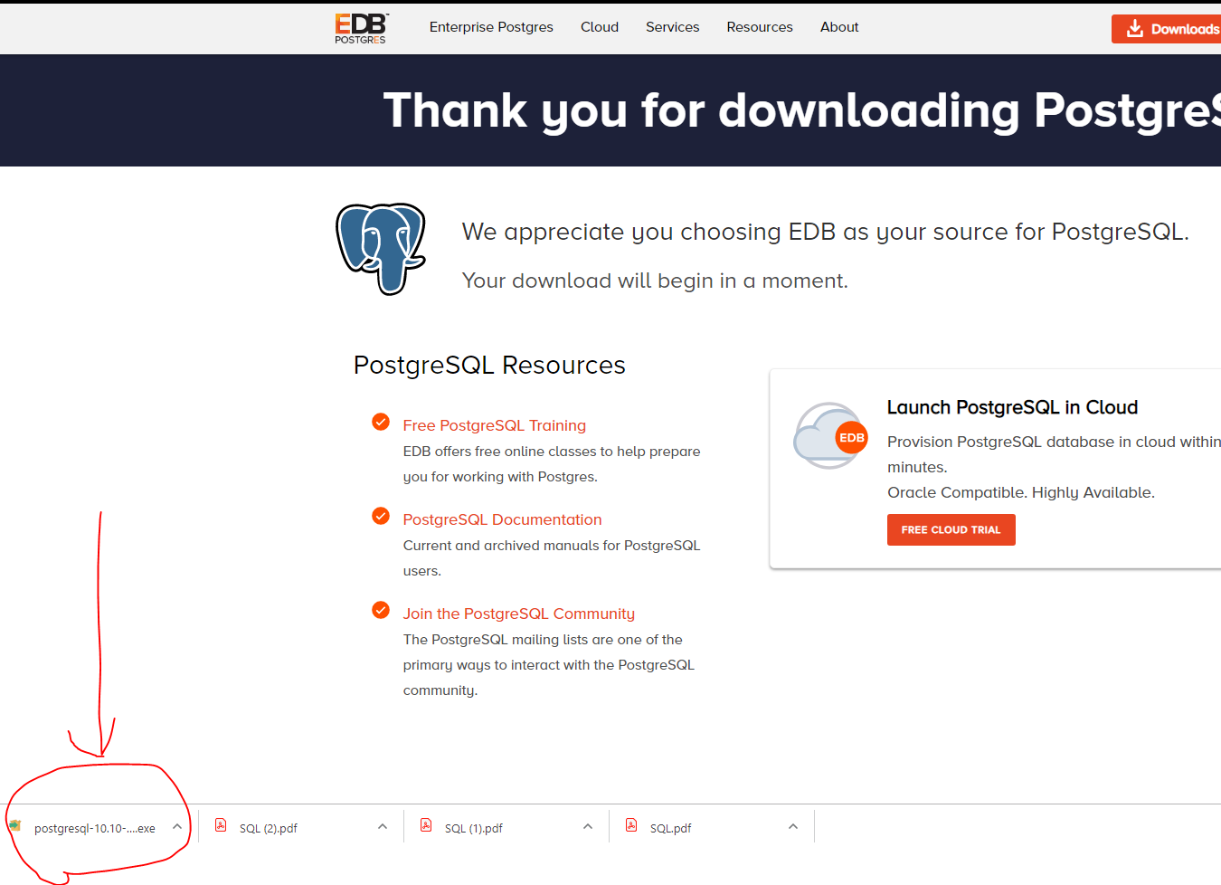

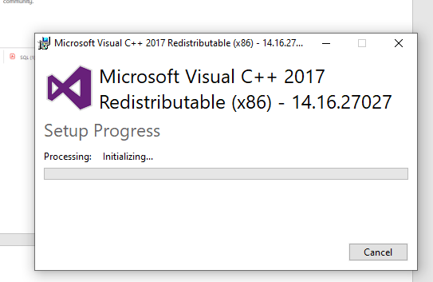

**Click the next button through the defaults of the next few windows.**

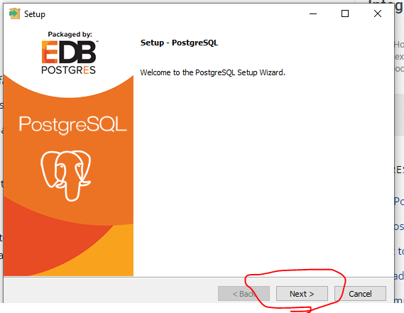

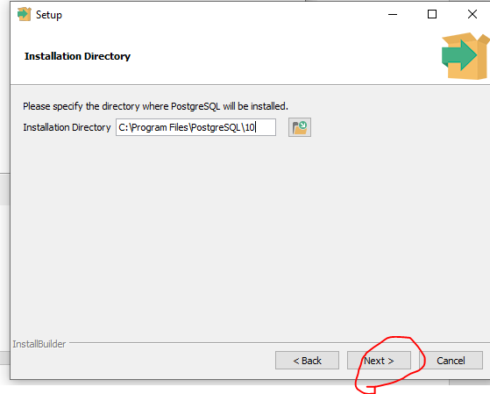

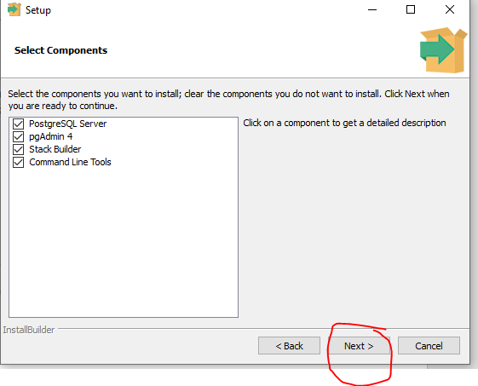

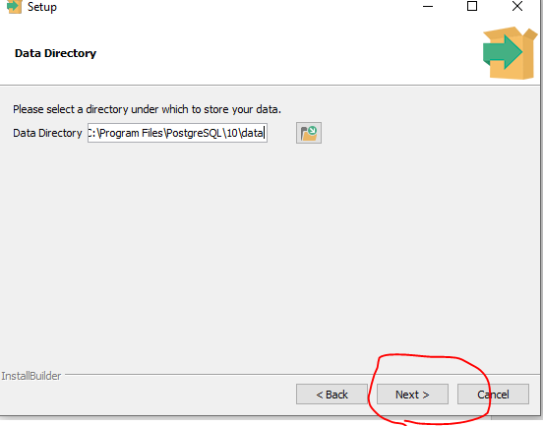

Enter passwords that match and click on Next >

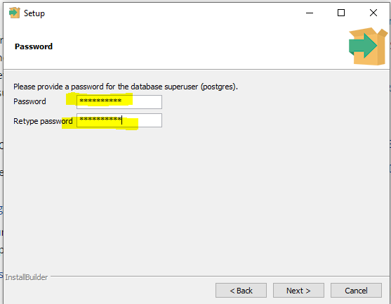

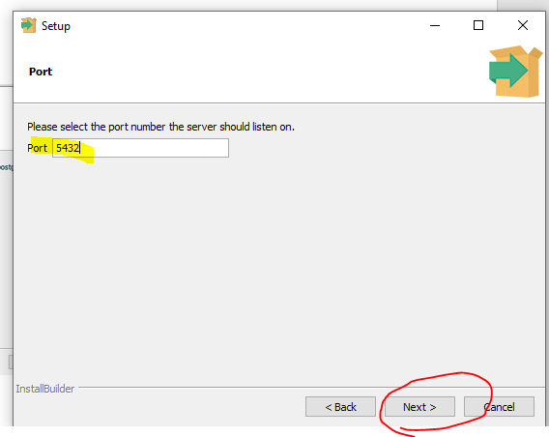

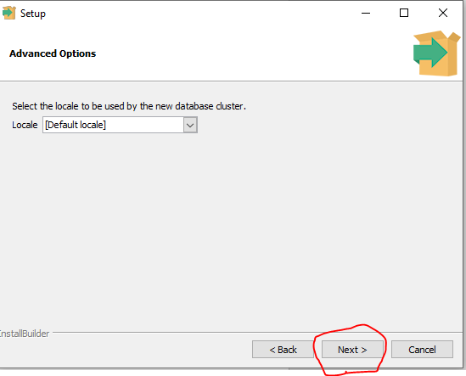

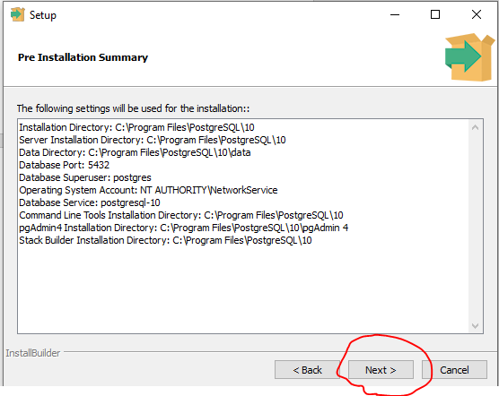

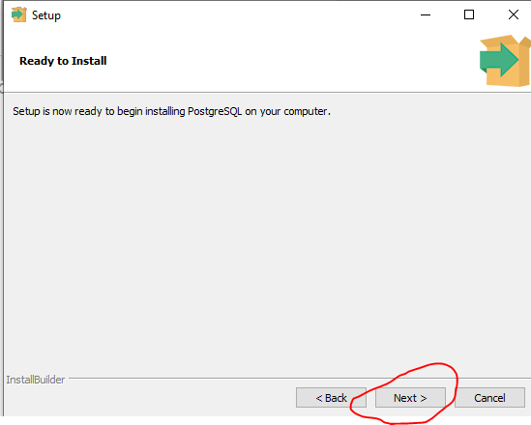

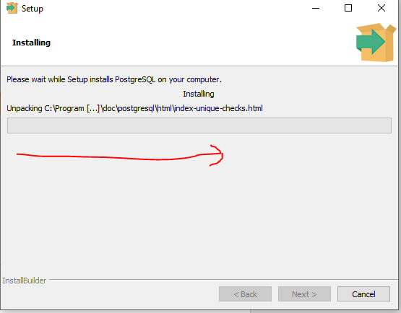

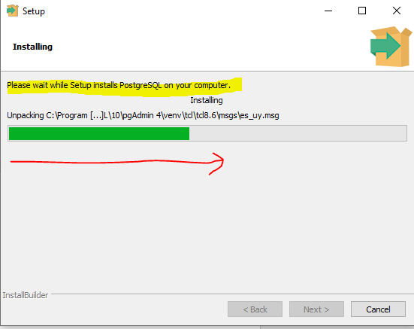

**Click Finish to complete the installation.**

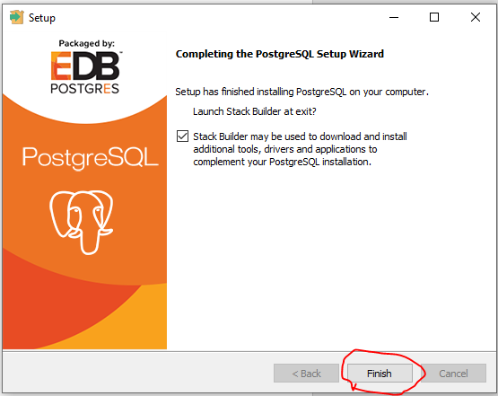

Using the drop down box, change the value to the new version you installed. Click next.

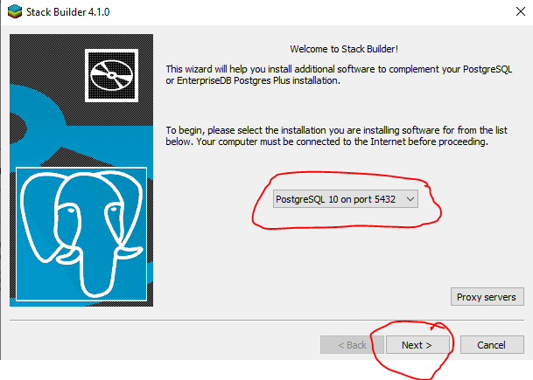

**I selected the following add-ons in case I need them later. Including, Web Development. Then click Next.**

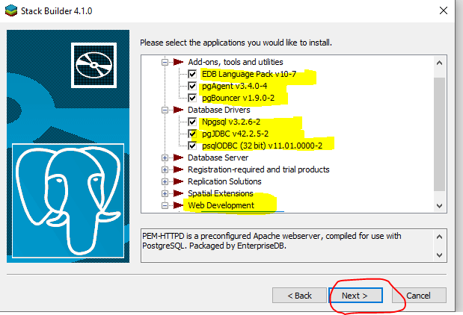

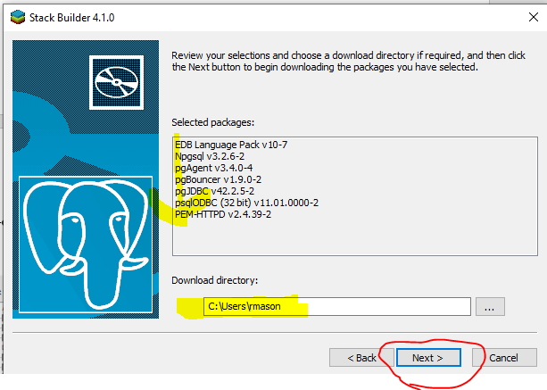

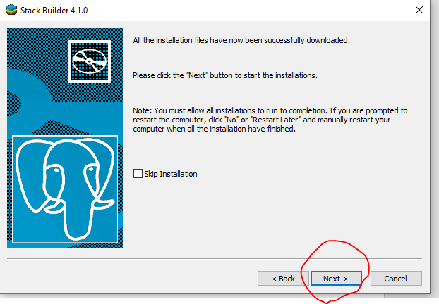

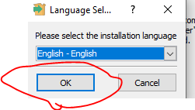

**Continue to click Next through the remaining installation windows that appear.**

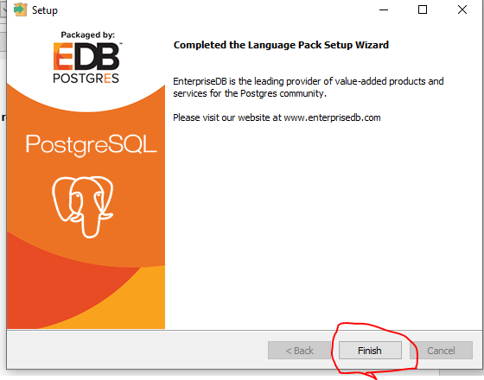

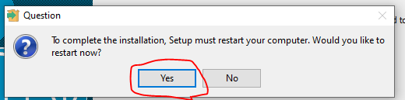

**After your PC restarts, then you can use psql to connect to PostgreSQL.**

**From the start menu of your PC, start the psql shell as shown below.**

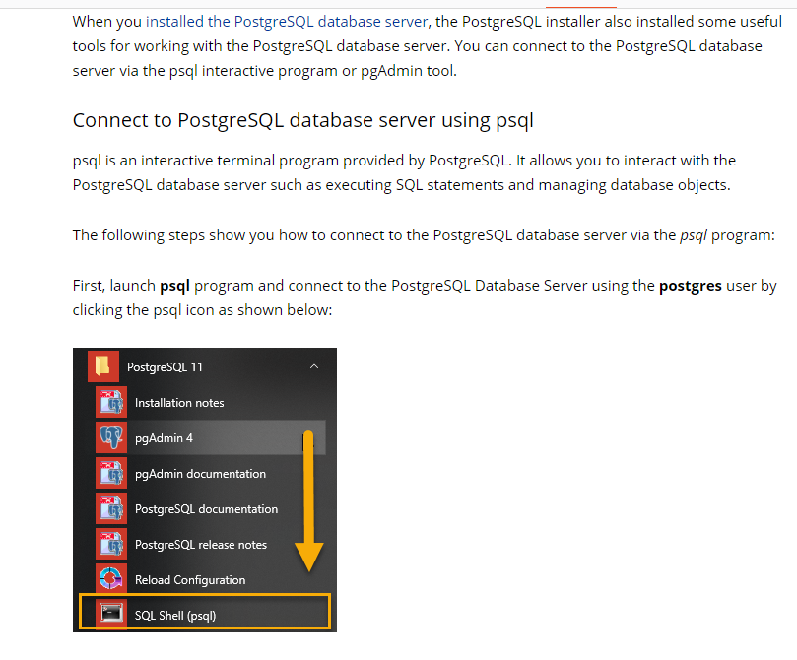

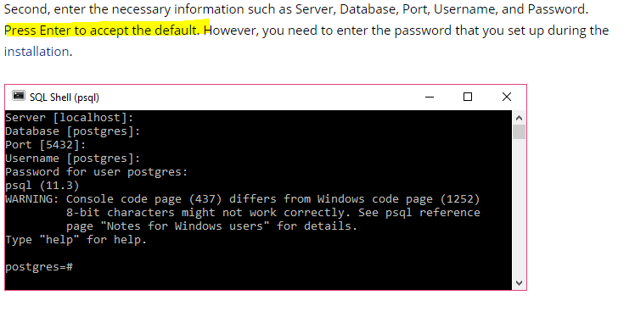

**Example of what I did to login. I left the defaults and entered my password I created earlier.**

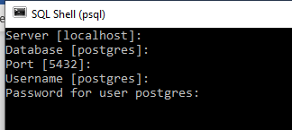

**After I entered the password, it logged me into the local version I just installed.**

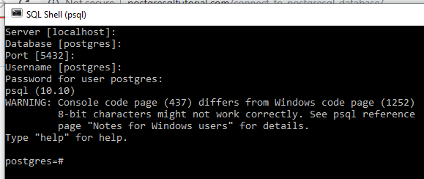

Run the **SELECT version();** command as shown below to see the version.

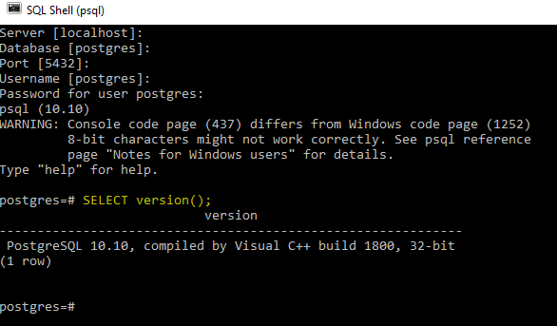

To exit the shell, enter \q and the press Enter. **Ctrl+D will also work.**



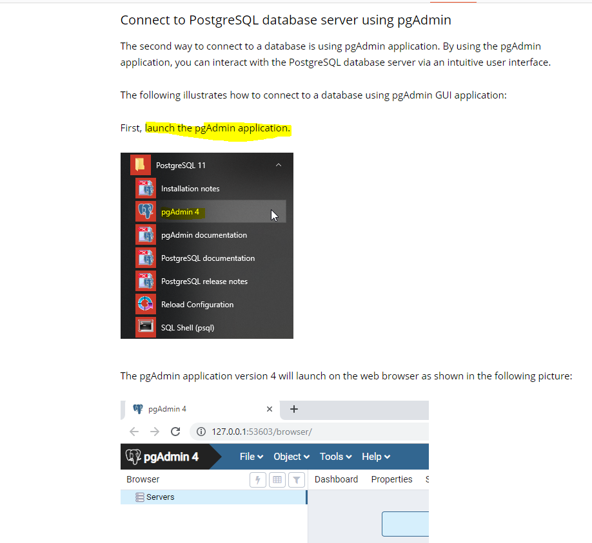

**If you expand servers with the drop down on the left, you can see the sever that you installed.**

**You will be prompted to enter your password.**

