MSDS 660 Week 4 Homework Assignment

Jeremy Beard

2022-07-27

#### Introduction

In this week’s assignment, we will be exploring a dataset found on Kaggle. This dataset explores the salaries of data scientists from different locations, experience levels, and more. This assignment will focus on one-way ANOVA analyses and also performing post hoc analyses. The post hoc analysis that I chose to perform during this assignment was the Tukey HSD pairwise comparison. My null hypothesis when performing the regression model with categorical data was that there is no significant difference between the means of the different pairwise comparisons of categorical levels of experience. My alternate hypothesis when performing the model and analysis was that there would be a significant difference between the means of the different Tukey HSD pairwise comparisons of levels of experience. This type of analysis is important because it helps tell the data analyst or data scientist whether the results they are seeing are significant or not when fitting models to data. This helps provide a degree of confidence in the conclusions reached at the end of the analysis.

In the code below, we simply load the csv file, probe the data for its size, shape, and metadata. Finally, we count the amount of null values in the dataset which in this case is zero!

# code may include summaries, head/tail, na, imputation, etc.   
  
##### MSDS660 Homework Assignment - Week 4 - ANOVA #####  
##### Jeremy Beard  
  
# Load the required libraries  
# import and load "ds_salaries.csv" data   
# It is a data science salary dataset from : https://www.kaggle.com/datasets/ruchi798/data-science-job-salaries  
dt <- read.csv("C:\\Users\\jerem\\OneDrive\\Documents\\School\\_REGIS\\2022-05_Summer\\MSDS660\\Week4\\ds_salaries.csv", sep = ",")  
  
# Convert data to data table or data frame or whatever   
dt <- as.data.frame(dt)  
  
head(dt)

## X work_year experience_level employment_type job_title  
## 1 0 2020 MI FT Data Scientist  
## 2 1 2020 SE FT Machine Learning Scientist  
## 3 2 2020 SE FT Big Data Engineer  
## 4 3 2020 MI FT Product Data Analyst  
## 5 4 2020 SE FT Machine Learning Engineer  
## 6 5 2020 EN FT Data Analyst  
## salary salary_currency salary_in_usd employee_residence remote_ratio  
## 1 70000 EUR 79833 DE 0  
## 2 260000 USD 260000 JP 0  
## 3 85000 GBP 109024 GB 50  
## 4 20000 USD 20000 HN 0  
## 5 150000 USD 150000 US 50  
## 6 72000 USD 72000 US 100  
## company_location company_size  
## 1 DE L  
## 2 JP S  
## 3 GB M  
## 4 HN S  
## 5 US L  
## 6 US L

nrow(dt)

## [1] 607

ncol(dt)

## [1] 12

str(dt)

## 'data.frame': 607 obs. of 12 variables:  
## $ X : int 0 1 2 3 4 5 6 7 8 9 ...  
## $ work_year : int 2020 2020 2020 2020 2020 2020 2020 2020 2020 2020 ...  
## $ experience_level : chr "MI" "SE" "SE" "MI" ...  
## $ employment_type : chr "FT" "FT" "FT" "FT" ...  
## $ job_title : chr "Data Scientist" "Machine Learning Scientist" "Big Data Engineer" "Product Data Analyst" ...  
## $ salary : int 70000 260000 85000 20000 150000 72000 190000 11000000 135000 125000 ...  
## $ salary_currency : chr "EUR" "USD" "GBP" "USD" ...  
## $ salary_in_usd : int 79833 260000 109024 20000 150000 72000 190000 35735 135000 125000 ...  
## $ employee_residence: chr "DE" "JP" "GB" "HN" ...  
## $ remote_ratio : int 0 0 50 0 50 100 100 50 100 50 ...  
## $ company_location : chr "DE" "JP" "GB" "HN" ...  
## $ company_size : chr "L" "S" "M" "S" ...

summary(dt)

## X work_year experience_level employment_type   
## Min. : 0.0 Min. :2020 Length:607 Length:607   
## 1st Qu.:151.5 1st Qu.:2021 Class :character Class :character   
## Median :303.0 Median :2022 Mode :character Mode :character   
## Mean :303.0 Mean :2021   
## 3rd Qu.:454.5 3rd Qu.:2022   
## Max. :606.0 Max. :2022   
## job_title salary salary_currency salary_in_usd   
## Length:607 Min. : 4000 Length:607 Min. : 2859   
## Class :character 1st Qu.: 70000 Class :character 1st Qu.: 62726   
## Mode :character Median : 115000 Mode :character Median :101570   
## Mean : 324000 Mean :112298   
## 3rd Qu.: 165000 3rd Qu.:150000   
## Max. :30400000 Max. :600000   
## employee_residence remote_ratio company_location company_size   
## Length:607 Min. : 0.00 Length:607 Length:607   
## Class :character 1st Qu.: 50.00 Class :character Class :character   
## Mode :character Median :100.00 Mode :character Mode :character   
## Mean : 70.92   
## 3rd Qu.:100.00   
## Max. :100.00

which(is.na(dt$work_year))

## integer(0)

which(is.na(dt$experience_level)) # EN entry-level, MI mid-level, SE senior, EX executive

## integer(0)

which(is.na(dt$employment_type)) # PT part-time FT full-time CT contract FL freelance

## integer(0)

which(is.na(dt$job_title))

## integer(0)

which(is.na(dt$salary))

## integer(0)

which(is.na(dt$salary_currency))

## integer(0)

which(is.na(dt$salary_in_usd))

## integer(0)

which(is.na(dt$employee_residence))

## integer(0)

which(is.na(dt$remote_ratio))

## integer(0)

which(is.na(dt$company_location))

## integer(0)

which(is.na(dt$company_size)) # S: <50, M: 50<x<250, L: 250+

## integer(0)

# it looks like the data is clean already! Thank goodness

#### Methods

The specific models and tests we are using in this week’s assignment are boxplots of the dependent variable (salary_in_usd) vs. the categorical variable (experience_level), fitting a regression model to the two variables, fitting the model to the two variables using ANOVA, and finally performing a post-hoc analysis using the Tukey HSD analysis. The significance of the results will be discussed afterward.

# run tests   
  
# Plot the dependent variable vs the categorical variables (should be a boxplot)  
# in this case, the dependent variable is salary_in_usd and i will choose the categorical   
# variable of experience_level  
par(mfrow = c(1,1))  
#specify logical order for box plots, per here: https://r-graph-gallery.com/9-ordered-boxplot.html  
dt$experience_level <- factor(dt$experience_level , levels=c("EN", "MI", "SE", "EX"))  
boxplot(salary_in_usd ~ experience_level, data = dt)

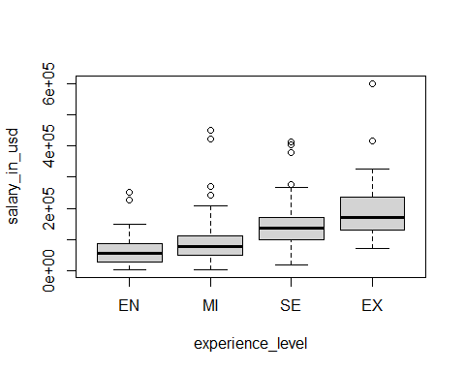

# Fit the dependent variable to the categorical variables using ANOVA  
# First I will just fit a regression model to the two variables  
fit <- lm(salary_in_usd ~ experience_level, data = dt)  
summary(fit)

##   
## Call:  
## lm(formula = salary_in_usd ~ experience_level, data = dt)  
##   
## Residuals:  
## Min 1Q Median 3Q Max   
## -129651 -39592 -7996 27930 400608   
##   
## Coefficients:  
## Estimate Std. Error t value Pr(>|t|)   
## (Intercept) 61643 6596 9.346 < 2e-16 ***  
## experience_levelMI 26353 7841 3.361 0.000826 ***  
## experience_levelSE 76974 7561 10.180 < 2e-16 ***  
## experience_levelEX 137749 13811 9.974 < 2e-16 ***  
## ---  
## Signif. codes: 0 '***' 0.001 '**' 0.01 '*' 0.05 '.' 0.1 ' ' 1  
##   
## Residual standard error: 61870 on 603 degrees of freedom  
## Multiple R-squared: 0.2434, Adjusted R-squared: 0.2397   
## F-statistic: 64.68 on 3 and 603 DF, p-value: < 2.2e-16

anova(fit)

## Analysis of Variance Table  
##   
## Response: salary_in_usd  
## Df Sum Sq Mean Sq F value Pr(>F)   
## experience_level 3 7.4277e+11 2.4759e+11 64.675 < 2.2e-16 ***  
## Residuals 603 2.3084e+12 3.8282e+09   
## ---  
## Signif. codes: 0 '***' 0.001 '**' 0.01 '*' 0.05 '.' 0.1 ' ' 1

par(mfrow=c(2,2))  
plot(fit)

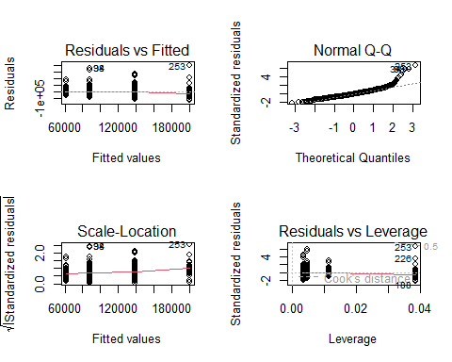

# Now I will perform a fit using ANOVA  
afit <- aov(salary_in_usd ~ experience_level, data = dt)

#### Results

In this section of the assignment, we will show the summary of the ANOVA fit, view the coefficients and plot the data, and perform the Tukey HSD post-hoc analysis discussed earlier in the assignment. The results of the post-hoc analysis were interesting. It showed that all of the pairwise comparisons created during the Tukey HSD analysis had a significant difference. This was strange as I wouldn’t expect all of the comparisons to have such low p-values. I even had to add digits to the Tukey HSD results so they wouldn’t be displayed/interpreted as zero.

# report results   
  
# View the ANOVA summary  
summary(afit)

## Df Sum Sq Mean Sq F value Pr(>F)   
## experience_level 3 7.428e+11 2.476e+11 64.68 <2e-16 ***  
## Residuals 603 2.308e+12 3.828e+09   
## ---  
## Signif. codes: 0 '***' 0.001 '**' 0.01 '*' 0.05 '.' 0.1 ' ' 1

# View the coefficients of the ANOVA fit  
coefficients(afit)

## (Intercept) experience_levelMI experience_levelSE experience_levelEX   
## 61643.32 26352.74 76973.97 137748.72

# Change the plot window to a 2x2  
par(mfrow=c(2,2))  
  
# Plot the residuals  
plot(afit)



# Perform the post hoc analysis that you were assigned.  
  
# I'm choosing to perform a TukeyHSD pairwise comparison  
tfit <- TukeyHSD(afit, conf.level = 0.95) # TukeyHSD pairwise comparison  
str(tfit)

## List of 1  
## $ experience_level: num [1:6, 1:4] 26353 76974 137749 50621 111396 ...  
## ..- attr(*, "dimnames")=List of 2  
## .. ..$ : chr [1:6] "MI-EN" "SE-EN" "EX-EN" "SE-MI" ...  
## .. ..$ : chr [1:4] "diff" "lwr" "upr" "p adj"  
## - attr(*, "class")= chr [1:2] "TukeyHSD" "multicomp"  
## - attr(*, "orig.call")= language aov(formula = salary_in_usd ~ experience_level, data = dt)  
## - attr(*, "conf.level")= num 0.95  
## - attr(*, "ordered")= logi FALSE

print(tfit,digits=15)

## Tukey multiple comparisons of means  
## 95% family-wise confidence level  
##   
## Fit: aov(formula = salary_in_usd ~ experience_level, data = dt)  
##   
## $experience_level  
## diff lwr upr p adj  
## MI-EN 26352.7381562097 6153.73307224441 46551.7432401750 0.004573630183886  
## SE-EN 76973.9746753246 57494.31226682142 96453.6370838278 0.000000000427262  
## EX-EN 137748.7202797205 102169.02009851398 173328.4204609270 0.000000000427263  
## SE-MI 50621.2365191149 36129.09685623105 65113.3761819988 0.000000000427262  
## EX-MI 111395.9821235108 78282.84380284080 144509.1204441809 0.000000000427262  
## EX-SE 60774.7456043959 28095.43455579783 93454.0566529940 0.000012421852371

par(mfrow=c(1,1))  
plot(tfit)

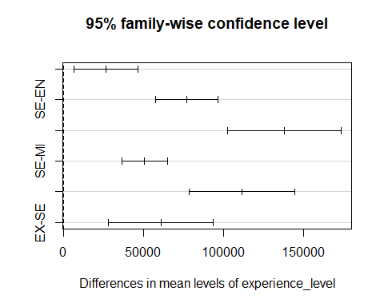

# Which post hoc analysis did you perform and which variables(s) have means that are significantly different?   
# I performed a TukeyHSD pairwise comparison post hoc analysis. This analysis showed that   
# it seems all p adj values are under p=0.05. this is interesting, this implies that  
# all differences between means are significant. I tried using difference confidence levels  
# of 0.90, 0.95, 0.97, and 0.99 and received the same p values using all of these.   
# What could be causing these universally low p values?  
  
  
# source: https://stats.stackexchange.com/questions/253588/interpreting-tukeyhsd-output-in-r

#### Conclusion

In conclusion, this week’s assignment told us that there were significant differences in the salaries earned by each level of experience (Entry, Mid-Level, Senior, Executive). The null hypothesis could be rejected and the alternate hypothesis was accepted. However, I believe further analysis is warranted as the p-values of the Tukey HSD analysis were all exceptionally low. This seems a bit strange and should be checked and possibly corrected if an error was made. Future analyses should definitely be made, iterating using insights gained from the strange p-values received in the first round of analyses. Thank you!