**Midterm Project: Carbon Dioxide Country Case Study**

Jeremy A. Beard

Regis University: Anderson College of Business and Computing

MSDS 670: Data Visualizations

John Koenig

May 29, 2023

Midterm Project: Carbon Dioxide Country Case Study

This paper seeks to explain the data visualizations created as part of the Midterm Project completed during the MSDS 670 Data Visualizations course. As part of this project, a dataset was explored and different meaningful data visualizations were created in Microsoft Excel. The dataset that was chosen was the World Bank Carbon Dioxide dataset provided in the Medium repository of class datasets (*World Bank Open Data*, n.d.). This dataset showed the carbon dioxide production of various countries and regions from the years 1960-2011. Some data is missing for certain years but this is taken into account during the time of the analysis.

**1st Visualization – Yearly Usage by Region**

The first visualization that was created was a breakdown of the production of carbon dioxide by regions. The total carbon dioxide production of each region was plotted, and the carbon dioxide production per capita was plotted. This is shown in Figure 1 and Figure 2. Figure 1 shows a plot of the total production of carbon dioxide, in thousands of tons. Figure 2 shows a plot of the production of carbon dioxide per capita. The regions are as follows: East Asia & Pacific, Europe & Central Asia, North American, Middle East & North Africa, South Asia, Latin American & Caribbean, and Sub-Saharan Africa.

The main conclusion that was drawn during the analysis of these charts was the question of region. The regions that were included seemed to be a bit arbitrary and could lead to different biases among the visualizations. In Figure 1, the East Asia & Pacific region is shown to have a high total amount of carbon dioxide production. However, this could simply be because more countries were included in this region, leading to a higher amount of carbon dioxide production. The “Per Capita” breakdown in Figure 2 is likely a more telling chart as it at least normalizes the data to each citizen.

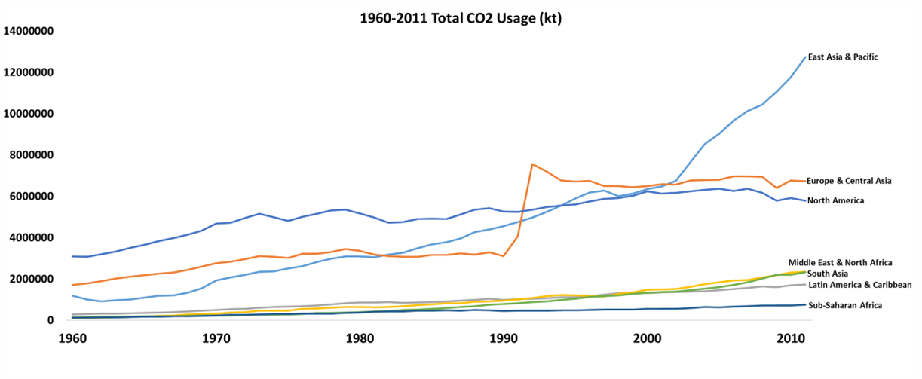

Figure 1: Total Carbon Dioxide Production by Region

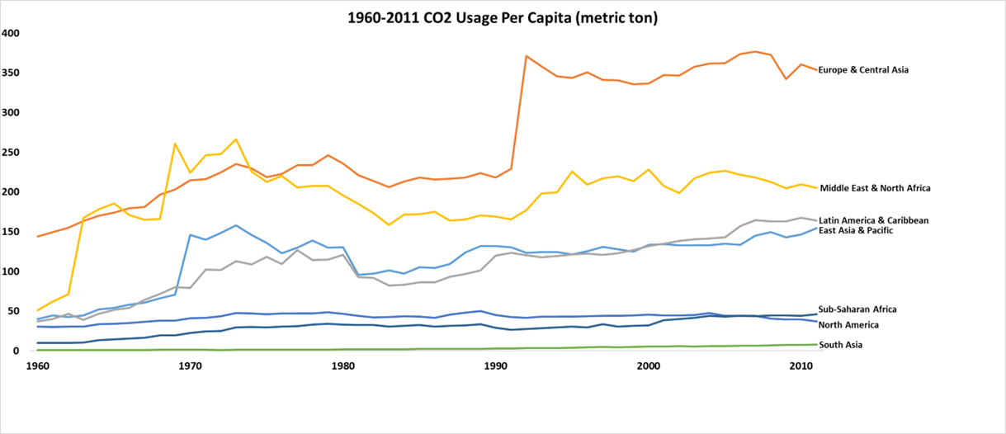

Figure 2: Carbon Dioxide Production per Capita by Region

**2nd Visualization – High-Usage Countries**

The second visualization in my opinion is the most useful visualization of the three that were created because it breaks down the carbon dioxide production by each individual country which gives more information than a breakdown by arbitrary regions. There were many countries included in the study so the visualization shown in Figure 3 only displays the top 25 results from each Total/Per Capita category to limit any crowding of the visualization. The United States is highlighted in the data in order to help tell the story of how the United States contributes to carbon dioxide emissions and what to change going forward.

The main conclusion from the visualization shown in Figure 3 is that the United States is a major contributor to the overall carbon dioxide in the atmosphere. It looks like China, USA, India, Russia, and Japan could all do more to reduce their overall emissions in order to preserve the planet for future generations.

Figure 3: Carbon Dioxide Production 2007-2011

**3rd Visualization – Total Usage by Region**

The third visualization that was created concerned the total 1960-2011 carbon dioxide production in each region. This chart was simple and breaks down the production of carbon dioxide by region, highlighting North America (where the United States is located), adding to the story that is being told about the United States’ overall contribution towards carbon dioxide emissions.

For the third visualization, a similar question of region choice still comes to mind. Why are the regions chosen the way that they are? Why are there two regions for Africa and three regions for Asia? What value do these breakdowns bring? Who is asking for this?

Figure 4: Carbon Dioxide Production 1960-2011

**Conclusion**

Overall, the data from the CO2 World Bank dataset showed that North America and especially the United States is a high contributor to the carbon dioxide present in our atmosphere. The breakdown by year from 1960 however showed a different picture as North America was a low contributor on the Figure 2 chart. Overall, the data brings up questions of how severe the impact of increasing carbon dioxide levels is, and how best to mitigate the problem overall. Working together as countries can help give life to future generations as living conditions worsen due to the increasing carbon dioxide levels.

References

*World Bank Open Data*. (n.d.). World Bank Open Data. https://data.worldbank.org/indicator/EN.ATM.CO2E.PC