**Final Project: Colorado Population Case Study**

Jeremy A. Beard

Regis University: Anderson College of Business and Computing

MSDS 670: Data Visualizations

John Koenig

June 25, 2023

Final Project: Colorado Population Case Study

This paper seeks to explain the data visualizations created as part of the Final Project completed during the MSDS 670 Data Visualizations course. As part of this project, a dataset was explored and different meaningful data visualizations were created in matplotlib, Plotly, and Microsoft Excel. The dataset that was chosen was some geographic population data centered around counties in Colorado (Wikipedia contributors, 2023). This data was scraped from the web from a Wikipedia page on counties in Colorado. This paper will explore the different insights gained from the Colorado county visualizations.

**1st Visualization – Static Choropleth Map**

The first visualization that was created was a static choropleth map using geopandas that details the population of Colorado in its various counties. This was created by merging a shapefile (*Colorado County Boundaries*, n.d.) with the processed Wikipedia data. Labels were not used on the various counties so as to not impede visibility. Figure 1 shows the cluster of crowdedness that lies in counties clustered around Denver. It is very clear to see that the high-populated areas are directly on or adjacent to I-25, the major interstate which runs north-south from Fort Collins all the way down to Colorado Springs and beyond.

Figure 1: Population Choropleth Map

The main conclusion that was drawn during the analysis of this static choropleth map was the clear association between I-25’s path and the high population areas in Colorado. It was also apparent that the major east-west interstate I-70 was associated with high populated areas as well, as higher populations were found even on the east-west area where I-70 stands. This could also be due to the relatively large size of these counties compared to Denver County or others.

**2nd Visualization – Interactive Plotly Map**

The second visualization used to explore the ins and outs of populations and population densities across all of the counties in Colorado was an interactive data visualization created using Plotly. Figure 2 shows just a snapshot of the visualization itself but lacks the interactive nature that this particular data visualization brings to the table. As the user pans across the various data bubbles with their cursor, different tooltips appear and disappear to show the user information about the county that is currently selected, such as its central location, population, and population density. These tooltips can be seen in Figure 3. This provides a deeper insight into the data than the static geopandas visualization provided in Figure 1, as this chart also shows the user population density data. **A picture containing screenshot, text, design
** Figure 2: Plotly Interactive Scattergeo Visualization

The main conclusion from this visualization is the very clear disparity of populations that exist across Colorado. Depending on one’s needs, it is very apparent where they should go whether it be in search of a populated area or a very remote area. Most of the populated areas in Colorado are centered around Denver and in general the center of the state. As one ventures out east or near the corners of the state, the populations drop very low.

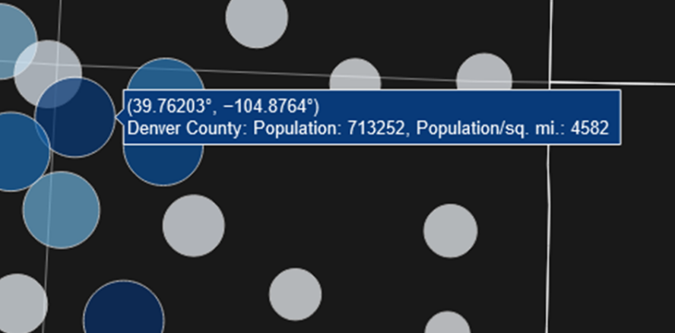

Figure 3: Population and Population Density in Tooltips

**3rd Visualization – Total Usage by Region**

The third set of visualizations that were created in order to explore population among different Colorado counties were visualizations created in Microsoft Excel. Both Figures 4 and 5 detail sets of horizontal bar charts that detail slightly different perspectives: insights into the Top 20 populated places, both by population itself as well as population density, as well as insights into the Top 20 *least*-populated places, also both by population itself as well as population density.

When Figures 4 and 5 are looked at closely, different conclusions can start to be drawn. In Figure 4, one can see that Gilpin County is highly dense relative to its population. Its population is very low but the population density of Gilpin County is much higher than its peers. Figure 5 shows that Broomfield is also quite dense compared to its general population. That leads one to believe that both Broomfield and Gilpin counties are small in area. Figure 5 also shows that El Paso County is a giant sprawling county, with a very high population but a very low relative population density.

Figure 4: Top 20 Least Populated

Figure 5: Top 20 Most Populated

**Conclusion**

Overall, the web-scraped data helps to understand the very high disparity and inequality that exists among the populations of different counties in Colorado. As one ventures outside Denver, populations die off quickly, with the corners of the state having quite low values. Figure 6 helps to show the highly populated areas (shown in red) as well as the low populations (shown in blue). With all the complaints that are heard about how people need to stop moving to Denver, perhaps solace can be found just outside its borders where the beautiful nature still exists, but none of the urban sprawl is present.

Figure 6: County Conclusions

References

*Colorado County Boundaries*. (n.d.). https://data-cdphe.opendata.arcgis.com/datasets/colorado-county-boundaries/explore

Wikipedia contributors. (2023). List of counties in Colorado. *Wikipedia*. https://en.wikipedia.org/wiki/List_of_counties_in_Colorado