Capacity Control in Boosting using a p-convex Hull
Author: Jeremy Barnes • Supervisor: Dr Bob Williamson • Examiner: Dr Michael Green • 29th October 1999
2. Capacity Control
- Capacity ≈ complexity (eg polynomial order) of hypothesis class
- Overly complex function classes overfit noisy (unreliable) data
- Use capacity control to avoid overfitting: choose capacity that leads to smallest error
Boosting (AdaBoost)
- A machine learning algorithm
- Combines many weak hypotheses into a strong hypothesis H
- Updates sample weights w to concentrate on hard samples
- Classifier weights b give differing amounts of importance to weak hypotheses
- b are on the convex hull of weak hypotheses
- AdaBoost has fixed capacity, and overfits
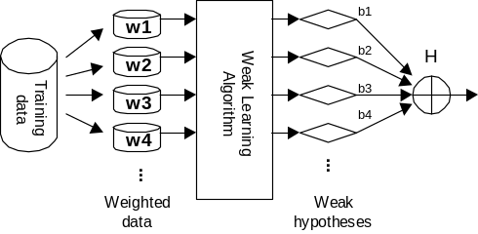
1. Machine Learning
- Problem: Given limited (input, output) observations of a process, predict the output from the input
- Example: Given personal details and credit history of current bank customers, predict if future customers will default on loans
- We use a learning machine to select the best hypothesis from a hypothesis class
- Aim: to minimise number of errors on unseen data
4. The project
- p-convex hull: capacity ∝ p
- Use a p-convex hull to implement capacity control:
- Find theoretical justification to do so
- Develop algorithms (using gradient descent framework)
- Code these algorithms efficiently in MATLAB and C
- Run lots of simulations to test practical aspects
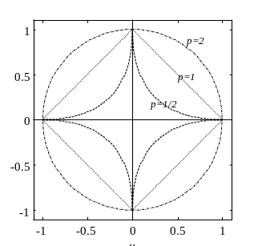
5. Results
- MATLAB toolbox: 190 .m files (10000 lines), 6 .c files (1500 lines), highly optimised
- 3 algorithms: Strict, Sloppy, Naive
- Best is sloppy: appears to outperform AdaBoost on noisy datasets (up to 25% less error)
- p-convex hull appears to implement capacity control on high-noise datasets
- Implementation problems: takes ≈10x longer than AdaBoost to train
6. Conclusions
- The p-convex hull concept is a modest improvement in high noise cases...
- ...AdaBoost is already a very good algorithm!
- Need more work on the implementation to avoid long training times
- Could possibly combine with another approach
- More testing is required
