I was responsible for writing the rcb block in VHDL. However, after the initial v0 commit, my partner and I worked together to interface the two blocks, debug, and test for corner cases.

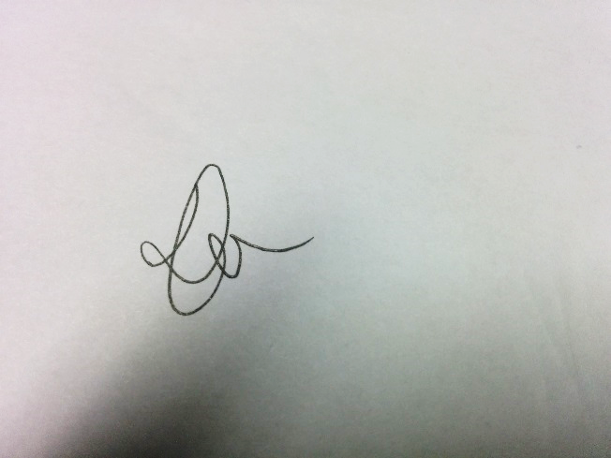

_____________________

Chak Yeung Dominic Kwok