**D.1**

-- The dates were spliced to allow for SQLite to recognise the Singapore's earliest administered vaccine date up till 30/06/2021.

SELECT location AS "Country", date AS "Observation Date", daily_vaccinations AS "Administered Vaccine"

FROM vaccinations

WHERE location = "Singapore" AND

substr(date,7)||'-'||substr(date,4,2)||'-'||substr(date,1,2) BETWEEN

(SELECT min(date)

FROM vaccinations

WHERE location = "Singapore") AND

'2021-06-30'

;

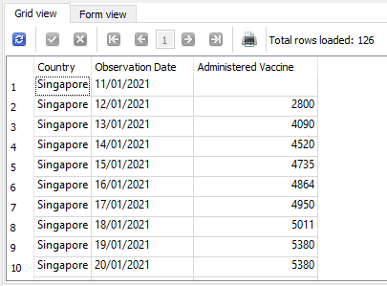

**D.2**

-- Cumulative doses for each country. This is done by summing up the daily vaccinations count for each country.

SELECT location AS "Country", SUM(daily_vaccinations) AS "Cumulative Doses"

FROM vaccinations

GROUP BY location

HAVING SUM(daily_vaccinations) AND

location IN (SELECT location FROM locations)

;

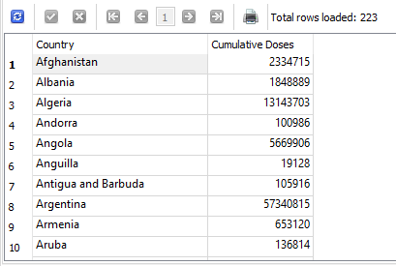

**D.3**

-- The query produces a table of countries and the vaccine types given in those countries.

SELECT DISTINCT location AS "Country", vaccine AS "Vaccine Type"

FROM vaccinations_by_manufacturer

;

**D.4**

-- As some source names have different source URLs, the query is grouped by source name and source website to account for this.

SELECT l.source_name as "Source Name", SUM(v.daily_vaccinations) AS "Total Administered Vaccines", l.source_website AS "Source URL"

FROM locations l INNER JOIN vaccinations v ON l.location = v.location

GROUP BY source_name, source_website

HAVING SUM(v.daily_vaccinations)

ORDER BY "Total Administered Vaccines" DESC

;

**D.5**

-- Joining the tables on dates in common. The beginning and ending dates recorded are different for those 4 countries.

SELECT date as "Date", a.people_fully_vaccinated AS "Australia", us.people_fully_vaccinated AS "United States", f.people_fully_vaccinated AS "France", i.people_fully_vaccinated AS "Israel"

FROM australia a INNER JOIN united_states us ON a.date = us.date

INNER JOIN france f ON us.date = f.date

INNER JOIN israel i ON f.date = i.date

;

