Chess Engine Application
Major Project Documentation
HSC Software Engineering

Student name | Jeremy Nguyen
Teacher | Mr Zhukov
Course | Software Engineering
Language | Python
Development environment | Visual Studio Code
Version control | GitHub
GitHub repository link | https://github.com/jeremycodingfr/Chess-game
Submission date | 2026
Version number | 1.0

Project aim: to build a playable desktop chess application with legal move validation, move history, undo, reset and AI-supported gameplay.

Table of Contents
Section | Page
Assessment Evidence Map | 3
Section 1 – Introduction | 4
Section 2 – Project Planning (SE-12-01) | 5
Section 3 – Technologies and Justification | 9
Section 4 – Design Documentation | 11
Section 5 – Directory Structure | 16
Section 6 – Secure Programming (SE-12-07) | 17
Section 7 – Testing (SE-12-08) | 19
Section 8 – GitHub Management | 22
Section 9 – Logbook | 23
Section 10 – Reflection and Evaluation | 24
Appendix A – Deployment | 26
Appendix B – Client Consultation | 26
Appendix C – Copyright and References | 26

Assessment Evidence Map
This table shows where the document addresses key software engineering evidence areas.
Course evidence area | Where it is addressed | Evidence included
SE-12-01: Project planning | Section 2 | Methodology, requirements, stakeholders, Gantt chart and risk management.
SE-12-07: Secure programming | Section 6 | Input control, exception handling, asset validation, race condition control and fail-safe design.
SE-12-08: Testing | Section 7 | Unit testing, integration testing, system testing, edge cases, performance checks and user testing.
Documentation quality | All sections | Clear structure, tables, diagrams, testing evidence, evaluation and future improvements.

Section 1 – Introduction

1.1 Problem Statement

Many chess engines are designed for advanced players and include complex analysis tools, large databases and difficult interfaces. This creates a problem for students, teachers and school chess clubs that need a simple chess program for learning, practice and demonstration.

The problem is also educational. A school project needs to show more than a working game. It needs to show how software engineering processes turn a user's needs into a tested product. The chess engine was therefore chosen because it contains a clear problem, strict rules, a visible interface and enough complexity to demonstrate design, coding, debugging, testing and evaluation.

This project solves this problem by developing a desktop-based chess engine application that focuses on accurate chess rules, clear interaction and structured software design. The application allows users to play chess using a graphical board, make legal moves, view move history, undo mistakes, reset the game and compete against a computer-controlled opponent.

1.2 Purpose

The purpose of the Chess Engine Application is to provide an educational chess program that demonstrates software engineering concepts through a practical product. The application is designed for students, chess club members, teachers and tournament organisers who need a clear and accessible way to play or demonstrate chess.

The intended users are students who want to practise chess, teachers who want to demonstrate rule-based programming and chess club members who need a simple digital board for practice games. The application benefits these users by providing a clear interface, fast reset, move history and an AI opponent for independent play.

The project also provides evidence of technical learning. It shows object-oriented programming, algorithm design, event handling, graphical interface design, legal move validation, artificial intelligence logic, testing, risk management and version control.

1.3 Project Scope

The current scope focuses on a local desktop application built with Python and Pygame. The project includes the core features needed for a complete chess game. Advanced features such as online multiplayer, saved accounts, cloud deployment, tournament pairing and Stockfish integration are treated as future improvements.

A clear scope was important because chess software can expand quickly into advanced analysis, online matchmaking and tournament systems. For this major project, the focus stayed on a reliable desktop product first. Future features were recorded separately so they did not distract from the core requirements of a playable and testable chess application.

In scope | Out of scope / future extension
Playable 8 by 8 chess board | Online multiplayer
Graphical chess pieces and board display | Cloud user accounts
Legal move validation | Stockfish engine integration
Turn management and game state tracking | Automated tournament pairing
Check, checkmate and stalemate detection | Full database-backed web version
AI opponent using legal move generation | PGN export, save games and timer as later extensions
Move history, undo and reset functions | Mobile app deployment

Section 2 – Project Planning (SE-12-01)

2.1 Software Methodology

The selected methodology for this project was WAgile. WAgile combines Waterfall planning with Agile feature development. This suited the project because the final product needed a clear plan, but the chess logic and interface also needed testing and improvement during development.
WAgile was more suitable than using only Waterfall or only Agile. A pure Waterfall approach would have made the project too rigid because the chess logic needed repeated testing and refinement. A pure Agile approach would have been flexible, but it would not have provided enough early documentation for a major project. WAgile solved this by using Waterfall for planning and Agile for feature development.
Method | How it applied to the project | Evaluation
Waterfall | Used during early planning to define the problem, purpose, requirements, tools, risks and timeline. | Useful because the project needed clear documentation before coding started.
Agile | Used during development by building features in small stages such as board display, movement, validation, AI and testing. | Useful because each feature could be tested and improved before the next stage.
WAgile | Combined structured planning with iterative development. | Most suitable because it met school documentation needs and supported practical debugging.
DevOps | Used through GitHub commits, backups, testing and deployment checks. | Useful because it improved project control and reduced data loss risk.

Sprint Plan

Each sprint had a clear outcome. This reduced development risk because a working version of the program existed early, even before all features were complete. It also made testing easier because new features could be checked against earlier working features.

Sprint | Main work completed | Outcome
Sprint 1 | Create board display, load piece images and set up project files. | A visible chess board was created.
Sprint 2 | Implement piece selection, movement and turn management. | Players could interact with the board.
Sprint 3 | Add legal move validation, check detection, checkmate and stalemate logic. | The game followed official chess rules more accurately.
Sprint 4 | Add AI move generation, move history, undo, reset, testing and interface refinement. | The application became playable and ready for evaluation.

2.2 Requirements Analysis

Functional requirements define what the software must do. Each requirement was linked to project success criteria so the final application could be tested against clear goals.

ID | Functional requirement | Priority | Status
FR1 | Display a standard 8 by 8 chess board. | Must | Implemented
FR2 | Display all chess pieces using graphical images. | Must | Implemented
FR3 | Allow the player to select and move pieces using mouse input. | Must | Implemented
FR4 | Validate legal movement for each chess piece. | Must | Implemented
FR5 | Reject illegal moves and maintain turn order. | Must | Implemented
FR6 | Detect check, checkmate and stalemate. | Must | Implemented
FR7 | Record move history during the game. | Should | Implemented
FR8 | Allow undo and reset functions. | Should | Implemented
FR9 | Generate AI moves from legal move options. | Should | Implemented
FR10 | Save games for later viewing. | Could | Future extension
FR11 | Add a chess timer. | Could | Future extension
FR12 | Export games as PGN. | Could | Future extension

Non-functional requirements define the quality standards of the software.

Requirement | Meaning for this project | Success measure
Performance | The board and AI should respond without noticeable delay. | Moves process quickly during normal gameplay.
Reliability | Game rules should work consistently across different games. | Legal moves, check and game-over states work correctly.
Usability | The interface should be simple enough for students to use without instructions. | Users can select pieces, make moves and read move history easily.
Maintainability | The source code should be organised into clear modules. | Files such as main, board, move, piece, AI and theme handle separate responsibilities.
Accessibility | Visual elements should be clear and readable. | Board contrast, piece visibility and move history are easy to understand.
Portability | The program should run outside the IDE using Python. | The command python src/main.py starts the application.
Security | The program should handle invalid input and file loading issues safely. | Errors do not crash the program during normal use.

2.3 Stakeholder Analysis

Stakeholder | Role or interest | Needs
Student developer | Builds, tests and documents the software. | Clear goals, working code, evidence of development and assessment quality.
Students | Use the application to play and practise chess. | Simple interface, accurate rules and clear move feedback.
Chess club | Uses the application for games and demonstrations. | Reliable gameplay and fast reset between games.
Teacher | Assesses the project and documentation. | Evidence of planning, design, secure programming, testing and evaluation.
Tournament organisers | Possible future users for school events. | Timer, game records and tournament features in future versions.

2.4 Gantt Chart

The Gantt chart shows a 10-week development timeline. It moves from research and planning to interface development, chess logic, AI, testing, deployment and evaluation.
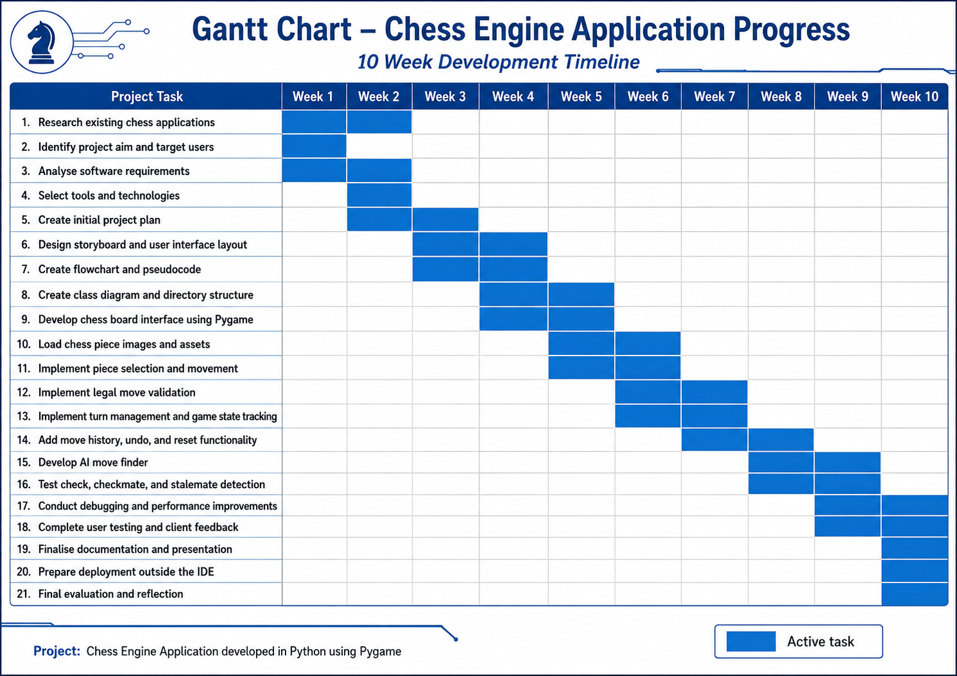
Figure 1: 10-week Gantt chart for the Chess Engine Application.

2.5 Risk Management

Risk management was reviewed during development rather than treated as a one-time planning task. When move validation and AI issues appeared during testing, they were recorded as technical risks and addressed through smaller test cases. This improved the final product because risks were linked to practical development actions.

Risk | Probability | Impact | Mitigation strategy
Legal move bugs | High | High | Test each piece type, check scenarios and end-game conditions separately.
AI not selecting valid moves | Medium | High | Force the AI to choose only from the legal move list.
Slow performance during AI calculation | Medium | Medium | Use incremental testing and simplify AI depth if needed.
Project files lost or overwritten | Medium | High | Use GitHub commits and backup copies.
Missed deadlines | Medium | High | Use weekly milestones and prioritise core requirements before extensions.
Asset loading failure | Low | Medium | Keep images and sound files in the correct directory structure.
Interface becomes hard to use | Medium | Medium | Use user feedback to refine board colours, move history and controls.

2.6 Success Criteria and Acceptance Criteria

Success criteria were used to judge whether the final software met the project aim. These criteria link the original requirements to visible evidence in the finished product and documentation.

Success criterion | Evidence required | Result
Playable chess board | The user can open the program and interact with a full 8 by 8 board. | Achieved
Accurate legal moves | The program rejects invalid movement and unsafe king positions. | Achieved through validation testing
AI-supported gameplay | The computer opponent selects from legal moves only. | Achieved
Usable interface | The board, pieces, move history, undo and reset are clear to use. | Achieved, with scrolling as a future improvement
Maintainable structure | Source files are separated by responsibility. | Achieved through modular directory structure
Assessment evidence | Documentation includes planning, design, testing, security and reflection. | Achieved through scaffolded sections

Section 3 – Technologies and Justification

3.1 IDE Selection: Visual Studio Code vs PyCharm

Option | Strengths | Limitations | Decision
Visual Studio Code | Lightweight, fast, Python extensions, terminal support, file navigation and GitHub integration. | Requires extensions for full Python support. | Selected because it matched the project needs and supported quick development.
PyCharm | Strong Python debugging, inspections and refactoring tools. | Uses more system resources and includes features not needed for this project. | Not selected because VS Code was simpler and more practical.

The IDE choice affected productivity because the project contained multiple files and assets. VS Code made it easy to move between the source folder, image assets, documentation and terminal commands. This supported efficient testing because the program could be run quickly after each code change.

3.2 Language Selection: Python vs Java vs NodeJS

The language evaluation also considered the intended user and timeframe. Python allowed the project to focus on chess logic and software design rather than low-level setup. This was suitable for a Year 12 project because the assessment rewards planning, testing and evaluation as well as code functionality.

Language | Strengths | Weaknesses for this project | Decision
Python | Readable syntax, fast prototyping, strong library support and suitable for object-oriented design. | Can be slower than compiled languages for very deep AI search. | Selected.
Java | Strong object-oriented structure and good performance. | Requires more boilerplate code and would increase development time. | Not selected.
NodeJS | Useful for web-based real-time applications. | Less suitable for a local desktop chess application. | Not selected.

3.3 Libraries and Tools

Technology | Use in the project | Justification
Python | Main programming language. | Allowed readable code and efficient development.
Pygame | Graphical interface, board rendering, image loading, mouse input and animations. | Matched the requirement for an interactive desktop game.
Multiprocessing | AI move calculation support. | Helped reduce the chance of AI calculations freezing the interface.
GitHub | Version control and backup. | Recorded progress and protected the project from data loss.
Microsoft Word | Project documentation. | Allowed structured written evidence for submission.
Microsoft PowerPoint | Project presentation. | Supported final demonstration of the solution.

3.4 Technology Evaluation

Python, Pygame and Visual Studio Code were selected because they matched the scope, timeframe and technical demands of the Chess Engine Application. Python was the strongest language choice because its syntax is readable and its object-oriented structure made the project easier to divide into clear modules such as board control, piece movement, move validation, AI selection and user interface handling. This mattered because the most difficult part of the project was not drawing the board, but maintaining an accurate game state after every move.

Python made debugging easier because logic errors could be traced through smaller functions and classes. Pygame was also appropriate because the project required a local graphical interface with mouse input, image rendering, screen updates and animation. Java had stronger compile-time checking and would be suitable for a large enterprise application, but it would have increased development time because more boilerplate code is required. NodeJS would be useful for a future online multiplayer or browser-based version, but it did not match the current desktop scope as strongly as Python and Pygame.

VS Code was selected over PyCharm because it was lightweight, supported Python extensions, integrated well with GitHub and allowed the project files to be managed clearly. Overall, the selected technology stack was effective because it supported fast development while still allowing modular design, testing, version control and future improvement.

Technology | Strength for this project | Limitation | Judgement
Python | Readable syntax, fast development and strong support for object-oriented design. | Can be slower than compiled languages for deep AI search. | Best choice for the desktop prototype.
Pygame | Handles graphics, mouse input, screen updates and game loops. | Requires manual interface design compared with full GUI frameworks. | Best fit for a visual board game.
VS Code | Lightweight editor with Python extensions, terminal access and GitHub support. | Less Python-specific automation than PyCharm. | Most practical IDE choice.
Java | Strong object-oriented structure and performance. | More verbose and slower to prototype. | Suitable alternative, but less efficient for this project.
NodeJS | Useful for future web or online multiplayer features. | Less suited to the current local desktop scope. | Better as a future extension option.

3.5 Technology Limitations and Future Technical Decisions

Although the selected stack was suitable, it also created limits. The AI strength is limited by the move-generation approach and processing speed. A deeper minimax search would increase decision quality but also increase lag if optimisation is not used. A future version could use alpha-beta pruning, move ordering or Stockfish integration to improve AI performance. A packaged executable would also improve deployment because users would not need to install Python or start the program from the command line.

Section 4 – Design Documentation

4.1 High-Level Architecture

The project uses a layered structure. Each layer has a separate responsibility, which makes the system easier to test, debug and improve.
This structure follows separation of concerns. The interface should display the game and receive input, while the engine should decide whether a move is legal. This prevents interface code from changing the rules directly. It also makes future testing easier because the logic can be checked without relying only on visual gameplay.

Layer | Responsibility | Example files or components
User Interface Layer | Displays the board, pieces, move history and game controls. | main.py, theme.py, color.py, sound.py
Game Engine Layer | Stores board state, turn state, move log, check status and game-over conditions. | game.py, board.py, move.py
Move Validation Layer | Generates and filters legal moves for each piece. | piece.py, square.py, move.py
AI Layer | Chooses a move for the computer-controlled opponent. | ai.py
Asset Layer | Stores images, sounds and visual resources. | assets or image folders

4.2 Low-Level Design

The class diagram shows the main objects used in the chess system. The design separates the board, squares, moves, pieces, players and game controller. This supports maintainability because each class has a clear responsibility.

Low-level design was important because chess contains repeated objects with different behaviour. Each piece type has its own movement rules, but all pieces also share common properties such as colour, position and capture status. Using classes helped represent these shared and specific behaviours in a manageable way.
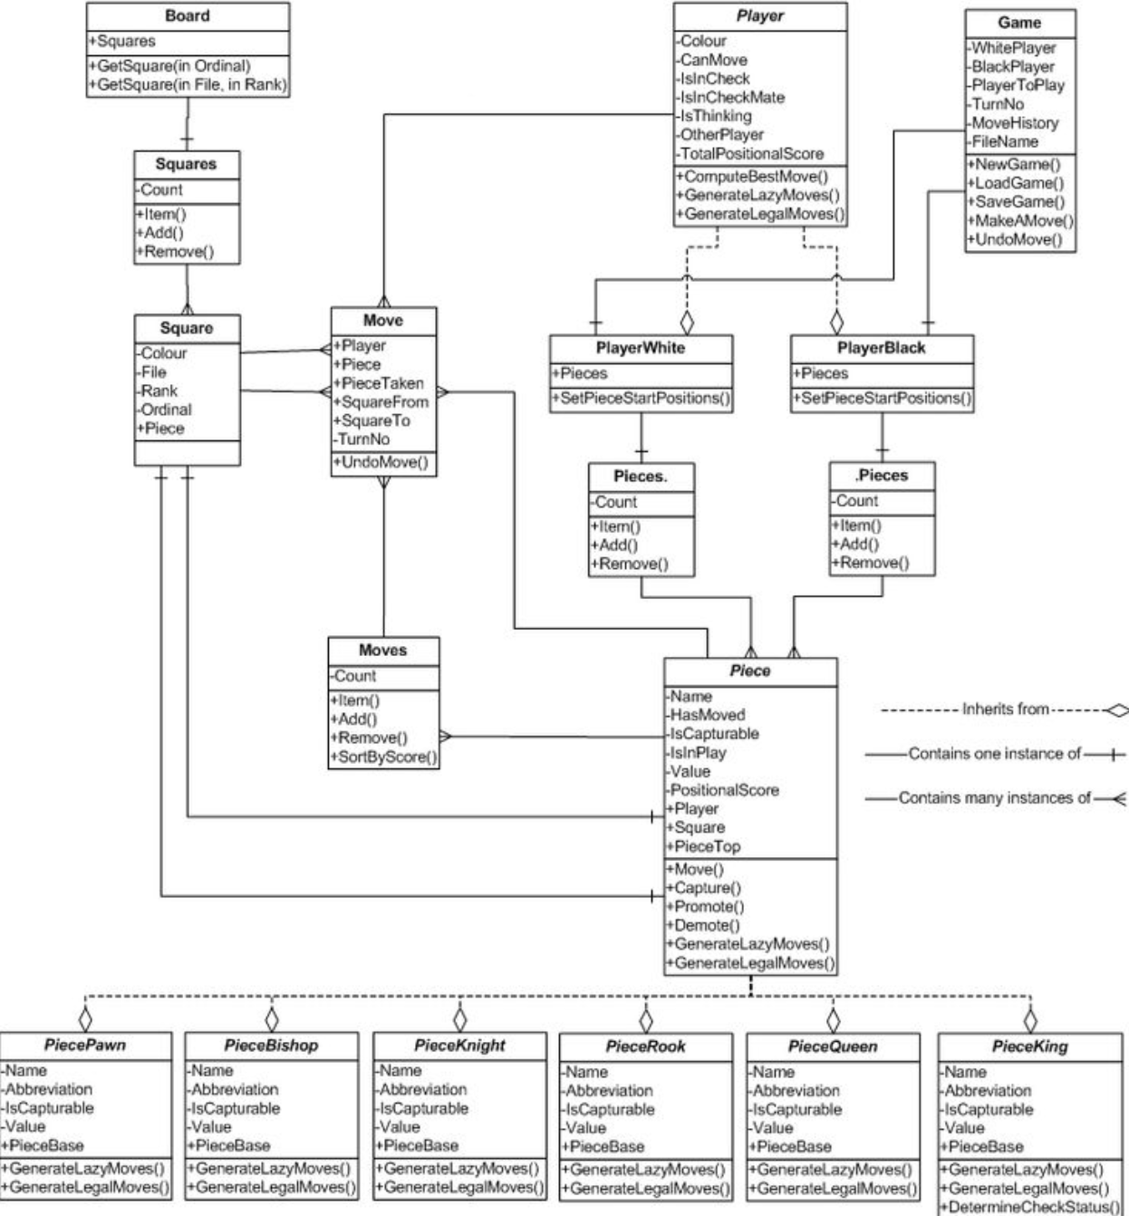
Figure 2: Class diagram showing the main objects and relationships in the chess engine.

4.3 Flowcharts

The flowchart shows the main gameplay cycle. The program loads images, creates the game state, displays the board, receives player input, validates the move, updates the board and checks whether the game has ended.

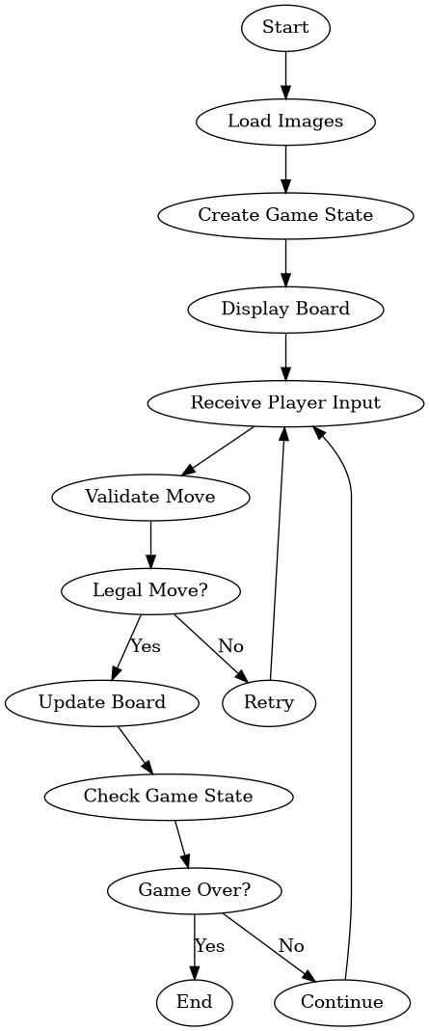
Figure 3: Main gameplay flowchart for move validation and game state updates.

4.4 Pseudocode

The pseudocode below explains the main game loop in a clear logic sequence.
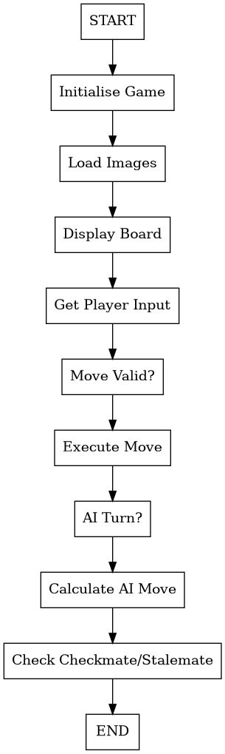
Figure 4: Pseudocode showing the main sequence of the chess application.

Text version of core pseudocode:

START
Initialise game state
Load board, pieces, sounds and theme assets
Display board and wait for player input
IF selected move is legal:
execute move
update move history
check for checkmate or stalemate
ELSE:
reject move and wait for another input
IF AI turn is active:
generate all legal AI moves
choose AI move
execute AI move
Repeat until game over
END

4.5 Wireframes and Interface Plan

The interface plan focused on a simple board layout with a move history area, reset controls, undo support and clear feedback for user actions. This helped keep the application practical for students and chess club users.

Screen area | Purpose | Design decision
Chess board | Main gameplay area. | Use a clear 8 by 8 grid with visible piece images.
Selected square highlight | Shows the piece selected by the user. | Use a visual highlight so the player understands the current action.
Move history panel | Shows previous moves. | Keep the move log readable and support future scrolling if the list becomes long.
Undo and reset controls | Allow testing and quick replay. | Provide simple controls to reduce confusion.
Game status text | Shows checkmate, stalemate or turn information. | Place status feedback near the board so users can respond quickly.

4.6 Algorithm Design and Data Flow

The main algorithm follows a controlled sequence: receive input, identify the selected piece, generate possible moves, filter illegal moves, update the board, record the move and check the new game state. This flow protects the integrity of the game because the board is not updated until the move has passed validation.

Stage | Input | Processing | Output
Player selection | Mouse click on board square | Convert screen coordinates into row and column. | Selected square or piece
Move generation | Selected piece and board state | Create moves based on piece rules. | Candidate move list
Legal filtering | Candidate moves | Remove moves that leave the king in check. | Legal move list
Move execution | Chosen legal move | Update board, turn, capture pieces and move history. | New game state
AI turn | Current board state | AI selects a legal move using its decision logic. | Computer move
Game state check | Updated board | Check for check, checkmate or stalemate. | Continue game or end result

Section 5 – Directory Structure

The directory structure uses separate files for the main interface, AI, board, pieces, moves, themes, colours, configuration and sound. This modular approach improves maintainability because each file has a focused purpose.

This design supports maintainability because a change to one feature does not require rewriting the entire program. For example, improving the AI should mainly affect the AI module, while changing the board theme should mainly affect the theme and colour modules. This makes the application easier to extend after submission.
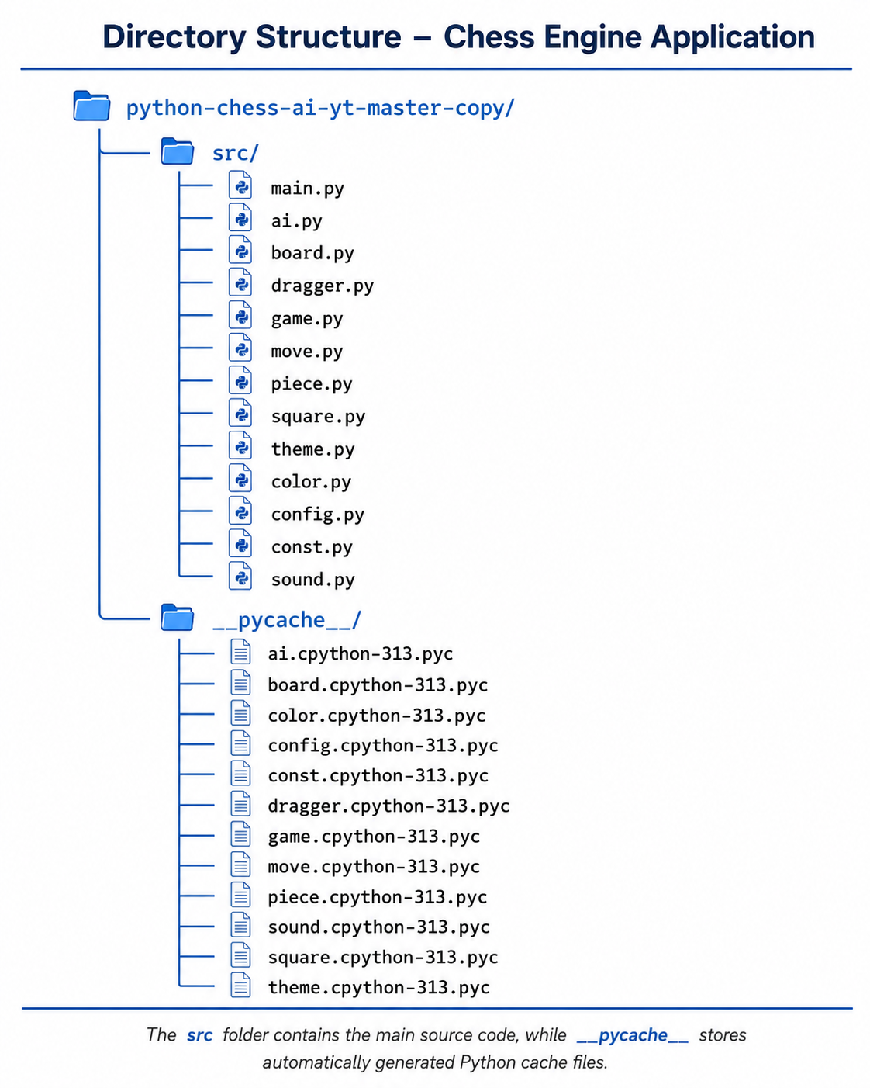
Figure 5: Directory structure for the Chess Engine Application.

File or folder | Purpose
src/main.py | Starts the program, displays the interface and manages the main loop.
src/ai.py | Controls computer move selection.
src/board.py | Represents the chess board.
src/game.py | Stores game state and controls gameplay logic.
src/move.py | Represents moves and supports move history.
src/piece.py | Defines piece behaviour and movement logic.
src/square.py | Represents board squares and piece positions.
src/theme.py and src/color.py | Control board appearance and visual themes.
src/config.py and src/const.py | Store constants and configuration values.
src/sound.py | Manages move sounds or sound effects.
__pycache__ | Automatically generated Python cache files. These are not main source files.

Section 6 – Secure Programming (SE-12-07)

The application is a desktop chess program, so the main secure programming focus is safe input handling, stable file loading, controlled AI processing and reliable error handling. The project does not use online accounts, passwords or a database in its current version.

6.1 Secure Programming Controls
Secure programming area | Risk controlled | Implementation approach
Input validation | Invalid mouse clicks or illegal board positions could crash the game or corrupt the board state. | Only allow moves that pass legal move validation before updating the board.
Legal move filtering | The king could move into check or a player could move while still in check. | Generate all legal moves and reject moves that leave the king in check.
AI move control | The AI could choose an invalid move if it bypasses validation. | Force the AI to select from the same legal move list used by human players.
Exception handling | Missing images, sound files or unexpected errors could stop the program. | Use clear file paths, test asset loading and handle failures safely.
Race condition control | AI processing could conflict with user input. | Separate AI thinking from direct user input and prevent moves while AI is processing.
Data integrity | Undo and reset could leave the board in the wrong state. | Use move logs and controlled state updates when reversing or restarting games.
Version control | Code changes could remove working features. | Use GitHub commits to restore earlier versions if a bug is introduced.

6.2 Security Limitations

The current version of the Chess Engine Application has limited security exposure because it runs as a local desktop program and does not include online accounts, payment details, multiplayer networking, cloud storage or a public database. This reduces risks such as unauthorised account access, password theft, SQL injection and server-side attacks. The main limitations relate to local execution. If image or sound files are missing, renamed or moved, the program may fail unless asset loading is handled with clear error messages. The program also depends on trusted source files, so a user should not run modified code from an unknown source. Another limitation is that the AI and interface operate within the same application environment, which means poor control of user input during AI processing could lead to state errors if not managed carefully. If the project were expanded into a web version, the security requirements would become much larger. The system would need secure authentication, password hashing, session management, HTTPS, CSRF protection, XSS prevention, database validation, rate limiting and safe error handling. For the current desktop version, the most important security priority is reliability: all user and AI actions must pass through the same legal move validation process before the board state changes.

Future web risk | Why it matters | Required control
Authentication weakness | Online users would need accounts and identity protection. | Use secure login and hashed passwords.
Database injection | Saved games or profiles could be attacked through unsafe input. | Use parameterised queries and server-side validation.
Cross-site scripting | Chat, usernames or comments could inject scripts. | Escape output and apply content security policy.
CSRF attacks | A user could be tricked into submitting unwanted actions. | Use CSRF tokens and same-site cookies.
Transport security | Login data could be intercepted online. | Use HTTPS only.
Error disclosure | Detailed errors could expose paths or server logic. | Show safe user messages and log technical errors privately.

6.3 Secure Coding Rules Used

- Keep board updates controlled through validated game logic.
- Avoid using untrusted file paths from the user.
- Do not allow AI or user moves to bypass legal move validation.
- Test edge cases where the king is in check.
- Use backups and commits before major changes.
- Keep generated Python cache files separate from source code.

6.4 Security Evaluation

The security approach was suitable for the current desktop scope because the main risks were local stability, controlled input and valid game state updates. The most important secure programming decision was to force every move, including AI moves, through the legal move validation system. This prevents the interface or AI from creating invalid board states and protects the reliability of the program.
Section 7 – Testing (SE-12-08)

Testing was completed throughout development instead of only at the end. This allowed errors to be found earlier, especially in move validation, check detection, AI move generation, undo and reset functionality.

7.1 Testing Strategy

Testing focused on both normal use and failure cases. Normal use included selecting pieces, moving pieces, capturing, undoing and resetting. Failure cases included illegal moves, check positions, pinned pieces and situations where the player had to respond to check. This approach improved the quality of the project because many chess bugs only appear in unusual board positions.

Testing type | Purpose | Example
Unit testing | Test one feature or function at a time. | Check whether a pawn can move forward one square.
Integration testing | Test whether multiple systems work together. | Select a piece through the interface and confirm the engine validates the move.
System testing | Test the whole application during full games. | Play from opening to checkmate or stalemate.
User testing | Collect feedback on usability. | Ask a user to play and comment on controls, board clarity and move history.
Regression testing | Confirm a fixed bug does not return. | Retest check scenarios after changing legal move logic.
Performance testing | Check responsiveness and lag. | Measure whether AI turns slow the interface.

7.2 Sample Test Cases

Test ID | Test case | Expected result | Status
T01 | Select a chess piece with the mouse. | The selected piece is highlighted. | Pass
T02 | Move a pawn forward one square from its starting position. | The move is accepted. | Pass
T03 | Attempt to move a pawn backwards. | The move was rejected. | Pass
T04 | Capture an opponent piece. | The captured piece is removed and the board updates. | Pass
T05 | Try to move a pinned piece exposing the king. | The move was rejected. | Pass
T06 | Put the king in check with the queen. | The game recognises checks. | Pass
T07 | Try to let the king capture a protected queen. | The move is rejected if the queen is protected. | Pass
T08 | Respond to check by capturing the attacking piece with a legal knight move. | The move is accepted if it removes the check. | Pass
T09 | Use undo after a player moves. | The previous board state returns. | Pass
T10 | Use undo after an AI move. | The correct previous game state returns. | Pass
T11 | Restart the game. | The board resets to the starting position. | Pass
T12 | AI turn begins. | The AI selects a legal move only. | Pass
T13 | Reach checkmate. | The game ends and shows the winner. | Pass
T14 | Reach a stalemate. | The game ended in a stalemate. | Pass
T15 | Move history fills many entries. | Move history remains readable or supports future scrolling. | Review
T16 | Run the program using python src/main.py. | The application opens outside the IDE. | Pass

7.3 Edge Case Testing

Edge case testing was one of the most important parts of the project. During development, some moves that should have been legal were rejected when the king was in check, while some moves that looked legal needed to be rejected because they exposed the king. These issues were fixed by testing all legal responses to check, including moving the king, capturing the attacking piece and blocking the attack.

Edge case | Why it matters | Testing action
Check | Players must be forced to remove check. | Create positions where the king is attacked and test all legal responses.
Checkmate | The game must end correctly. | Use known checkmate patterns and confirm the winner is displayed.
Stalemate | The game must recognise a draw when no legal move exists but the king is not in check. | Test a king-only stalemate setup.
Pinned pieces | A pinned piece should not expose the king. | Try moving pinned pieces and confirm invalid moves are rejected.
Castling | Special move rules must be handled accurately if included. | Test blocked castling, castling through check and legal castling.
Promotion | A pawn reaching the final rank needs promotion handling. | Move a pawn to the last rank and test promotion behaviour.
En passant | Special capture rules can create logic errors. | Set up en passant positions and test whether the capture is handled or marked as a future limitation.
50-move rule and repetition | Advanced draw rules affect full chess accuracy. | Identify as a future extension if not implemented.

7.4 Performance and Accessibility Testing
Area | Test | Success criteria
Performance | Play multiple games and observe lag after many moves. | The interface remains responsive.
AI speed | Run AI turns from different positions. | AI move selection does not freeze gameplay during normal use.
Visual clarity | Check board contrast and piece visibility. | Pieces are easy to distinguish.
Move history | Check readability after many moves. | Move history remains readable and should support scrolling in future versions.
Error recovery | Run reset and undo after complex positions. | Game state remains accurate.

7.5 Defect Log and Refinement Evidence

A defect log was used to connect testing results to improvements. This showed that testing led to changes in the software rather than only confirming that features worked.

Issue found | Cause | Improvement made | Evidence of improvement
King could appear to capture an unsafe piece | The destination square was not always checked against opponent attacks. | Legal move filtering was strengthened. | Unsafe king moves were rejected.
Some valid responses to check were not accepted | The game focused too strongly on king movement instead of all legal check responses. | Capture and block responses were tested. | Legal knight or queen responses worked correctly.
AI opened with similar moves too often | The move choice lacked variation. | AI selection logic was adjusted for better move variety. | AI play felt less repetitive.
Move history became difficult to read after many moves | The panel had limited space. | Scrollable history was identified as an improvement. | Future improvement recorded.
Interface lag appeared after UI changes | Extra drawing operations increased processing. | Rendering and update logic were reviewed. | Gameplay became smoother.

Section 8 – GitHub Management

GitHub was used to support version control, backup and development evidence. Regular commits helped show progress over time and made it safer to test changes. If a new feature introduced a bug, an earlier working version could be reviewed or restored.

Version control also supported testing. Before making major changes to the AI or legal move validation, a working version could be committed first. This meant the project could be restored if a new feature caused errors. This reduced development risk and provided evidence of steady progress.

8.1 Suggested Commit History Evidence

Version | Example commit message | Evidence shown
v0.1 | Create project structure and base files | Planning and setup.
v0.2 | Add board rendering and piece images | Interface development.
v0.3 | Add piece selection and movement | User interaction.
v0.4 | Implement legal move validation | Core engine logic.
v0.5 | Add check, checkmate and stalemate detection | Game rules.
v0.6 | Add move history and undo | Usability and testing support.
v0.7 | Add AI move generation | Artificial intelligence feature.
v0.8 | Improve interface themes and move display | User experience refinement.
v0.9 | Fix bugs from testing | Quality assurance.
v1.0 | Final deployment and documentation | Completed project release.

8.2 Repository Management Practices

- Commit after each major feature rather than only at the end.
- Keep documentation and source files organised in the repository.
- Do not commit temporary files unless required.
- Use GitHub as a backup before major refactoring or AI changes.

8.3 Version Control Evaluation

GitHub improved the project because it created a clear development history. It also encouraged smaller changes, clearer commit messages and better backup habits. In a professional software project, this would support collaboration, issue tracking and code review. In this individual project, it supported accountability and made the final documentation stronger because development progress could be demonstrated.

Section 9 – Logbook

The logbook records development progress, time spent, problems encountered and improvements made. It provides evidence that the project was managed over time rather than completed in one stage.

The logbook also helped with reflection. By recording challenges each week, it became easier to explain why specific decisions were made. For example, the decision to keep the project as a desktop application instead of an online system was based on time, complexity and security risk.

Week | Task completed | Hours | Challenge | Reflection
1 | Research chess applications and define project aim. | 3 | Choosing a realistic project scope. | A desktop chess game was more achievable than a web tournament system.
2 | Write requirements, select tools and create early design documents. | 4 | Separating must-have features from future features. | Legal move validation and playable UI became the highest priorities.
3 | Build project structure and display the chess board. | 5 | Loading images and arranging board coordinates. | A modular file structure made future changes easier.
4 | Add piece selection and basic movement. | 5 | Handling mouse input accurately. | Testing each square helped reduce selection errors.
5 | Implement legal move validation. | 7 | Different pieces required different rules. | Breaking logic into smaller functions made debugging easier.
6 | Add game state tracking, move history and undo. | 5 | Undo needed to restore accurate board state. | Move logs were useful for testing and user feedback.
7 | Add AI move generation. | 6 | AI had to use legal moves only. | Restricting AI to legal moves improved reliability.
8 | Test check, checkmate, stalemate and edge cases. | 6 | Some check responses were rejected incorrectly. | Testing with specific scenarios improved rule accuracy.
9 | Refine UI, reset function and deployment command. | 4 | Keeping the interface responsive. | Small interface improvements made the game easier to use.
10 | Complete final documentation and evaluation. | 5 | Condensing evidence clearly. | Tables and diagrams made the process easier to understand.

Section 10 – Reflection and Evaluation

10.1 Project Evaluation

The Chess Engine Application successfully met its main objective of creating a functional desktop chess game with a graphical interface and AI-supported gameplay. The final product allows users to interact with the board, make legal moves, view move history, undo moves, reset the game and play against an AI opponent.

The project was successful because the final application matched the core requirements set during planning. The product is playable, rule-based, visually interactive and supported by documentation evidence. The main limitation is that the AI is functional rather than advanced. This is acceptable for the project scope because the focus was on a complete software engineering process rather than building a professional chess engine.

The strongest part of the project was the use of structured software engineering. The project included planning, requirements analysis, methodology selection, risk management, diagrams, modular code, testing, version control and deployment checks. These processes improved the quality of the final application and made the project easier to maintain.

10.2 Major Challenges

Challenge | Why it was difficult | How it was handled
Legal move validation | Chess rules depend on the current board state and king safety. | Each move was checked against legal movement and check conditions.
Check detection | The program needed to know when the king was attacked. | Specific check scenarios were tested and corrected.
AI move generation | The AI needed to choose a move without breaking the rules. | AI choices were restricted to generated legal moves.
Undo and reset | The game state had to return accurately. | Move logs and state tracking were used to reverse or restart the game.
Performance | AI and animations could cause lag. | Features were tested progressively and simplified when needed.

10.3 Future Improvements

Improvement | Benefit
Stronger AI using minimax and alpha-beta pruning | Makes the computer opponent more challenging.
Difficulty settings | Allows beginners and advanced players to choose suitable challenge levels.
Opening book | Improves early-game AI decisions.
PGN export | Allows games to be saved and analysed later.
Chess timer | Supports school tournaments and faster games.
Scrollable move history | Improves readability during long games.
Online multiplayer | Allows users to play from different devices.
Executable deployment with PyInstaller | Allows users to run the program without opening the command line.
Stockfish integration | Adds advanced analysis and stronger move selection.
Accessibility options | Improves colour contrast and keyboard support.

10.4 Final Reflection

This project improved my understanding of how software engineering principles apply to a real software solution. At the start of development, the chess engine seemed like a simple board game, but the project showed that chess requires detailed rule logic, accurate state tracking and constant testing. Every move affected the next move, so small logic errors could create larger problems later in the game. Planning helped me define a realistic scope before coding began. The Gantt chart, requirements analysis and risk management table gave the project structure and helped me avoid spending too much time on features that were outside the main goal.

Modular design was also important because it separated the interface, board, pieces, moves, AI and configuration into smaller parts. This made the code easier to test and improve. The most challenging area was legal move validation, especially situations involving check, pinned pieces and moves that appear legal but leave the king unsafe. Testing these situations taught me that software quality depends on edge cases, not only normal use. GitHub also improved the project because each commit created a backup and showed progress over time. Overall, the final application demonstrates a clear software development lifecycle: the problem was identified, requirements were defined, the design was planned, the system was implemented, testing was completed and the final solution was evaluated. If I continued this project, I would focus on stronger AI, better accessibility, scrollable move history, PGN export and executable deployment.

10.5 Final Evaluation Against Requirements

The final evaluation compares the completed application with the original requirements. This confirms whether the project solved the identified problem and met the planned success criteria.

Requirement area | Final result | Evaluation
Core gameplay | Playable board, piece movement, turn management and captures were implemented. | Meets requirements.
Chess rule accuracy | Legal move validation, check, checkmate and stalemate were tested. | Meets requirement, with advanced draw rules suitable for future extension.
AI gameplay | AI opponent selects from available legal moves. | Meets requirement for a school-level engine.
User experience | Move history, undo, reset and visual board interaction support usability. | Meets requirement, with scrollable history as a future improvement.
Software engineering evidence | Planning, methodology, diagrams, risk management, testing, GitHub and reflection were documented. | Strong evidence for assessment.
Security and reliability | Local input control and validation protect the game state. | Suitable for desktop scope.

Appendix A – Deployment

The application was tested outside the main development environment by launching it directly through Python. This confirmed that the project files, modules and assets were organised correctly.

Deployment testing was important because a program that only works inside the IDE is not a complete solution. Running the application through the command line checked that the source path, assets and modules were organised correctly. This also showed that the application could be transferred and run as a Python project on another suitable computer.

Command used to run the project:

python src/main.py
A future deployment improvement would be to package the application into an executable file using PyInstaller. This would make the project easier to run on another computer because the user would not need to manually start the program through the command line.

Appendix B – Client Consultation

Consultation stage | Feedback received | Action taken
Planning | The client wanted a playable chess game with AI, legal move validation and move history. | Project scope and requirements were defined.
Prototype | The client tested the interface and requested clearer gameplay feedback. | Move history, highlighting and interface refinements were prioritised.
Final review | The client confirmed the application was playable and suggested stronger AI, themes and online play for future versions. | Future improvements were added to the evaluation.

Appendix C – Copyright and References

Client consultation improved the project because feedback was used to refine the product. The client did not only approve the final version. Feedback during planning and prototyping influenced feature priorities, interface clarity and future improvement choices.

Before final submission, any external assets should be checked against their licence conditions. If chess piece images, sound effects or tutorials influenced the final product, the exact source should be listed. This protects academic integrity and shows responsible software development.

The project was developed primarily using original code. External tools, libraries and resources were acknowledged to show academic integrity and responsible software development practice.

Resource | Purpose in project
Python Documentation | Programming language reference.
Pygame Documentation | Graphics, input handling and game window reference.
GitHub Documentation | Version control and repository management reference.
Visual Studio Code Documentation | Development environment support.
Microsoft Word Documentation | Project documentation formatting.
Microsoft PowerPoint Documentation | Presentation support.
Chess piece images and sound assets | Used for educational visual and audio presentation where applicable.

