ORsudoku Install Guide

This guide is primarily for Windows systems...if you are using Linux, your distro almost definitely already has Python installed, so you can skip straight to step 2.

Step 1: Install Python
a.) Download the Python installer from:
https://www.python.org/ftp/python/3.10.7/python-3.10.7-amd64.exe
b.) When the file downloads, execute it, and follow the instructions at:
https://docs.python.org/3.10/using/windows.html#installation-steps
IMPORTANT: When the installer starts, it will install by default in the directory:
c:\Users\<username>\AppData\Local\Programs\Python\Python310
This is fine, but this is not in your default path. We’ll fix that in the next step.
c.) Once Python is installed, in the Windows search bar, search for “system environment variables”. You should be given the option to “Edit the System Environment Variables”. Select this option, and you will get a pop-up that looks like this:
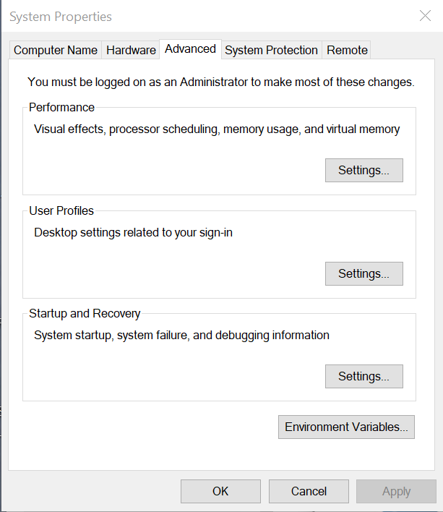

Select the “Environment Variables” button. You will get another popup like this:
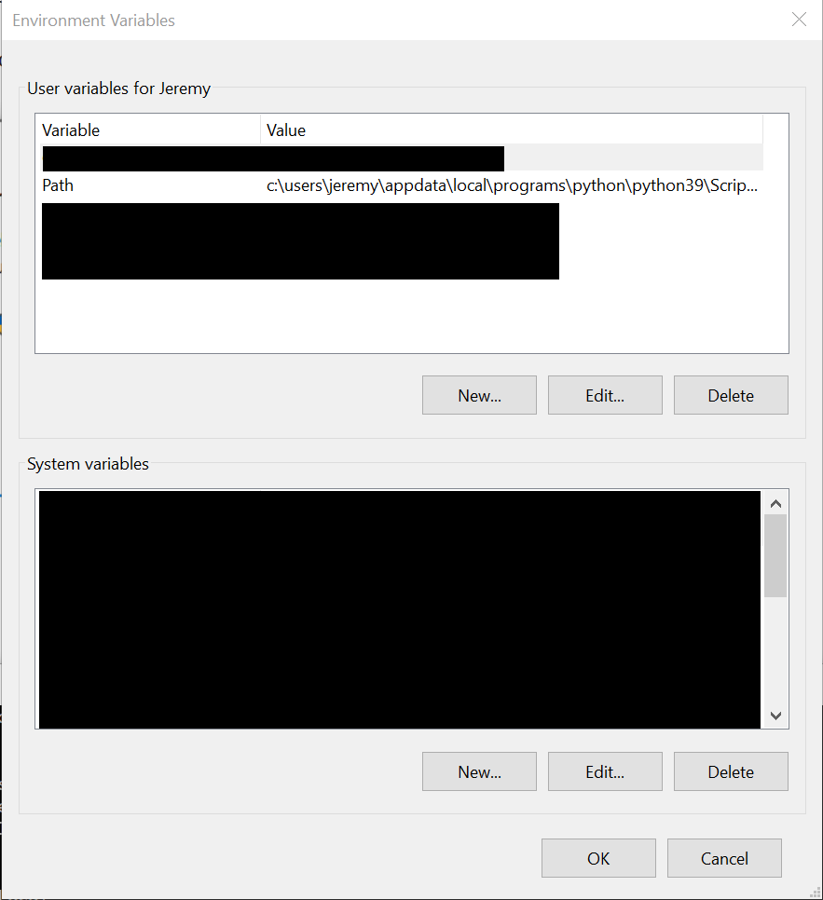
Notice the Path environment variable in the upper pane. Select it, and press Edit. You will get yet a third popup, which is the list of Path elements. Press New, and enter the directory where Python installed. Now press New again, and enter the same directory, appending “\Scripts” at the end. nce these changes are made, you can press “OK” on all three pop ups to back out.
Step 2: Install required modules
ORsudoku only requires two external packages: ORTools and colorama. To install these packages:
a.) Open a command window. You can do this by typing “cmd” in the search bar.
b.) Type the command “pip install ORTools” and press Enter. Several modules that ORTools requires may be installed along with ORTools, depending on your installed configuration. ORTools is the background engine that does the actual solving, so it’s pretty important.
c.) Type the command “pip install colorama”. colorama is used to color output for certain puzzle types, such as Doublers, Schrödinger cell, and Japanese Sum sudoku.
Step 3: Install ORsudoku
a.) If you are more comfortable in an IDE, then by all means feel free to use it, but then you don’t need these instructions.
b.) Create a working directory where you will put your puzzle files. You can do this through the File Explorer, or at the command-line with the “mkdir” command. On your command line, change into this directory with the “cd” command. To hit the easy button, just type “mkdir ORsudoku” followed by “cd ORsudoku” in your command windows.
c.) Download the ORsudoku module:
https://github.com/jeremydover/ORsudoku/blob/main/ORsudoku.py
Use your web browser to download the file, and file explorer to move it to your working directory.
Step 4: Getting started with Sudoku
a.) To get a feel for how to create models for puzzles, we recommend downloading the sample puzzle available at github:
https://github.com/jeremydover/ORsudoku/blob/main/ORsudoku.py
Again use your web browser to download the file, and file explorer to move it to your working directory.
b.) From the command line, execute “python sample.py”. It should print a solution to the encoded puzzle, then a somment that 16 solutions are found with a sample, and then a list of all 16 solutions.
c.) We recommend using Notepad++ to edit your source files.

