On-Prem Home Lab Infrastructure Build Documentation
A Start-to-Current Technical Evidence Report
Jeremy Fontenot
On-Prem Home Lab Project
Prepared for publication as technical proof on jeremyfontenot.online
Document date: June 12, 2026

Abstract
This report documents an on-premises home lab built on a Dell PowerEdge R710 running Proxmox VE. The build implements a segmented virtual infrastructure with pfSense routing, Windows Server 2022 Active Directory Domain Services, DNS, DHCP, Group Policy, role-based security groups, Remote Desktop administration, snapshot protection, backup storage, and a domain-joined Windows 10 workstation. The June 12 update expands the validated proof set to include Windows Server file services, SMB and NTFS access control, AD security group-based read/write and read-only testing, a GPO-delivered mapped drive, monitoring and logging evidence, domain controller time-service repair, final VM backups, and a SHA256-hashed evidence pack exported for documentation and website proof. The documentation is written as a technical proof package for portfolio use and is limited to evidence observed in the on-prem home lab project chats, command outputs, screenshots, and exported evidence artifacts.

Table of Contents
1. Documentation Scope and Evidence Method
2. Skill Validation Summary
3. Hardware Inventory
4. Network and Architecture Design
5. Proxmox VE Installation, Bridges, and Storage
6. pfSense Firewall VM
7. Windows Server 2022 DC01 Build
8. Active Directory Domain, OU Model, Users, and Groups
9. RDP Administration and pfSense NAT
10. Group Policy Baseline
11. On-Prem-Only Decision and Cloud Integration Deferral
12. Backup Storage and Recovery Design
13. WS01 Client Build and Troubleshooting
14. WS01 Windows 10 Domain Baseline
15. WS01 Group Policy and RDP Validation
16. Evidence Export and Proxmox Cleanup
17. Final Snapshot and Backup State
18. Evidence Artifacts and Website Proof Mapping
19. Current State and Next Steps
Fontenot, J. (2026, June 12). DC01 file services, GPO drive mapping, monitoring, and time service evidence export [Internal evidence folders]. C:\Lab-Evidence.
Fontenot, J. (2026, June 12). WS01 file share and mapped drive validation evidence export [Internal evidence folders]. C:\Lab-Evidence.
Fontenot, J. (2026, June 12). File services and GPO drive mapping phase completion note [Internal evidence file]. /root/lab-evidence/file-services-gpo-drive-map-phase-complete-20260612-204514.md.
Fontenot, J. (2026, June 12). On-prem home lab evidence export and manifest [Internal evidence package]. C:\EvidencePack\on-prem-home-lab\HomeLab-Evidence-Export-20260612-184743.zip.
Fontenot, J. (2026, June 12). On-prem home lab proof summary [Internal proof summary]. C:\EvidencePack\on-prem-home-lab\on-prem-home-lab-proof-summary.md.
Appendix A: New Chat Handoff Prompt
21. References
20. June 12 Evidence Update: File Services, Drive Mapping, Monitoring, and Evidence Pack

1. Documentation Scope and Evidence Method
This document is a fresh start-to-current build record for Jeremy Fontenot's on-prem home lab. It was created from the on-prem home lab project chat history, screenshots, command outputs, and evidence artifacts available in the current project context. It intentionally does not reuse the wording or structure of the previously attached example document. The purpose is to create a portfolio-grade proof document that can support claims on jeremyfontenot.online.
The proof standard used throughout this report is evidence-first: every major technical claim is tied to a command, validation output, screenshot, or named artifact path. Screenshots were cropped to emphasize proof-bearing content and to reduce irrelevant browser or console surroundings when possible.
Evidence type | Use in this report
Command and cmdlet history | Documents implementation steps and validates repeatable administration workflows.
Validation output | Confirms service state, connectivity, domain membership, GPO application, backups, and snapshots.
Screenshots | Provides visual proof of completed steps and troubleshooting outcomes.
Evidence artifacts | References exported folders and files such as C:\Lab-Evidence and /root/lab-evidence records.
Troubleshooting notes | Records failed paths and corrective action, including Windows 11 instability and backup device remediation.

2. Skill Validation Summary
The lab validates the following practical infrastructure skills through observable build evidence.
Skill area | Validated evidence
Virtualization administration | Proxmox VE 9.2.3 host, VM creation, VM hardware profiles, snapshots, storage configuration, backup jobs, and VM inventory validation.
Firewall and network segmentation | pfSense VM with WAN on vmbr0/Cox LAN and LAN on vmbr1/internal lab subnet 10.10.20.0/24.
Windows Server administration | Windows Server 2022 VM DC01 installed and configured with AD DS, DNS, DHCP, and GPMC roles.
Identity administration | New forest ad.jeremyfontenot.online, NetBIOS JFAD, OU model, test users, role-based groups, and delegated admin account.
Group Policy administration | Baseline GPOs created, linked, configured, remediated, forced, and validated using gpresult.
Client workstation deployment | Windows 10 Pro WS01 built, renamed, domain joined, placed in Workstations/Windows 10 OU, and validated.
Troubleshooting | Windows 11 client instability was isolated and replaced with a stable Windows 10 build; RDP, NLA, DNS, DHCP, and GPO issues were diagnosed.
Backup and recovery | Dedicated internal 1 TB backup HDD configured as backup-hdd, manual backups completed, and scheduled backups updated to protect pfSense, DC01, and WS01.
Evidence documentation | Windows and Proxmox evidence exported to C:\Lab-Evidence and /root/lab-evidence for proof-based portfolio use.

3. Hardware Inventory
The lab runs on a Dell PowerEdge R710 and includes both the original virtual machine storage and the internal backup drive added later in the build.
Component | Specification / validated use
Server | Dell PowerEdge R710
CPU | Dual Intel Xeon processors; observed WS01 guest showing Intel Xeon L5520 class CPU in Windows.
Memory | 24 GB ECC RAM. VM allocations validated: pfSense 4096 MB, DC01 4096 MB, WS01 4096 MB after Windows 10 rebuild.
Primary VM storage | 2 x 300 GB SAS HDD in RAID 1 via Dell PERC 6/i, exposed to Proxmox local-lvm for VM disks.
Dedicated backup storage | Additional internal 1 TB HDD mounted as /mnt/pve/backup-hdd and configured as Proxmox directory storage for backup content only.
Networking | 4 x 1 GbE NICs; nic0 used for Proxmox management and pfSense WAN bridge vmbr0.
Remote management | iDRAC6 Enterprise used for remote console and ISO mounting during server installation work.
Primary use case | Proxmox hypervisor, pfSense firewall, Windows Server domain controller, DNS, DHCP, GPO, Windows client deployment, snapshots, backups, and validation evidence.

4. Network and Architecture Design
The lab uses double NAT because the Cox gateway remains the upstream router. Proxmox bridges separate the upstream management/WAN network from the isolated internal lab LAN.
Node / interface | Address / network | Purpose
Cox gateway | 192.168.0.1/24 | Upstream internet and LAN gateway.
Jeremy Windows laptop | Observed 192.168.0.241 during later testing; earlier 192.168.0.238 was the initial NAT source restriction. | Administrative workstation for Proxmox and RDP access.
Proxmox management | 192.168.0.242/24 | Hypervisor web and shell management.
vmbr0 | 192.168.0.242/24 on host | Proxmox management and pfSense WAN bridge to Cox LAN.
pfSense WAN | 192.168.0.205/24 | WAN interface behind Cox LAN.
vmbr1 | No host IPv4 address | Isolated internal lab VM bridge.
pfSense LAN | 10.10.20.1/24 | Internal lab default gateway.
DC01 | 10.10.20.10/24 | AD DS, DNS, DHCP, GPMC, RDP administration.
WS01 | 10.10.20.100/24 | Domain-joined Windows 10 workstation baseline.

High-level lab topology
Internet
|
Cox Gateway - 192.168.0.1/24
|
Proxmox VE - 192.168.0.242/24
|-- vmbr0: management + pfSense WAN
|-- vmbr1: isolated internal lab bridge
|
pfSense LAN - 10.10.20.1/24
|
Internal Lab Subnet - 10.10.20.0/24
|-- DC01 - 10.10.20.10
|-- WS01 - 10.10.20.100

5. Proxmox VE Installation, Bridges, and Storage
Proxmox VE was installed on the Dell PowerEdge R710 and validated through the web UI and shell. The final running version was pve-manager/9.2.3 with kernel 7.0.6-2-pve. The ISO repository contained pfSense, Windows Server 2022, VirtIO drivers, Windows 11, and the Windows 10 ISO used for WS01.
Proxmox host validation commands
echo "=== Proxmox version ==="
pveversion

echo "=== ISO directory contents ==="
find /var/lib/vz/template/iso -maxdepth 1 -type f -printf "%f\n" | sort

echo "=== Storage status ==="
pvesm status

echo "=== Bridges ==="
grep -A5 -E '^auto vmbr0|^auto vmbr1|^iface vmbr0|^iface vmbr1' /etc/network/interfaces

Storage | Type | Final purpose
local | Directory | ISO, import, and container template content only; backup content removed.
local-lvm | LVM-thin | VM disks and snapshots for pfSense, DC01, and WS01.
backup-hdd | Directory on internal 1 TB HDD, ext4 mounted at /mnt/pve/backup-hdd | Dedicated backup target for vzdump archives.

6. pfSense Firewall VM
pfSense CE 2.8.1 was deployed as VM 100. It routes between the Cox upstream LAN and the internal lab subnet. pfSense LAN DHCP was disabled so DC01 could provide centralized DHCP services for the domain network.
Setting | Value
VM ID / name | 100 / pfsense-fw
WAN bridge | vmbr0, DHCP address 192.168.0.205/24
LAN bridge | vmbr1, static address 10.10.20.1/24
LAN DHCP | Disabled; DC01 provides DHCP.
Snapshots retained | pfsense-baseline-wan-lan; pfsense-rdp-nat-restricted.
Backup file | /mnt/pve/backup-hdd/dump/vzdump-qemu-100-2026_06_09-18_45_36.vma.zst

pfSense snapshot validation commands
qm snapshot 100 pfsense-baseline-wan-lan --description "Baseline after pfSense CE install, WAN DHCP validation, LAN 10.10.20.1/24 configuration, and DHCP disabled for Windows Server DHCP."
qm snapshot 100 pfsense-rdp-nat-restricted --description "Baseline after pfSense RDP NAT rule restricted to laptop source forwarding WAN 3389 to DC01."
qm listsnapshot 100

7. Windows Server 2022 DC01 Build
DC01 was installed as Windows Server 2022 VM 200 with VirtIO drivers, a static IP address, and core roles for AD DS, DNS, DHCP, and Group Policy management.
Setting | Value
VM ID / name | 200 / dc01
Operating system | Windows Server 2022 Standard Evaluation with Desktop Experience
IP configuration | 10.10.20.10/24, gateway 10.10.20.1, DNS 10.10.20.10
Roles | AD DS, DNS, DHCP, Group Policy Management
Domain | ad.jeremyfontenot.online
NetBIOS | JFAD

AD DS forest creation cmdlets
Install-WindowsFeature AD-Domain-Services,DNS -IncludeManagementTools

Install-ADDSForest `
-DomainName "ad.jeremyfontenot.online" `
-DomainNetbiosName "JFAD" `
-InstallDNS `
-Force

DHCP role, scope, and option configuration cmdlets
Install-WindowsFeature DHCP -IncludeManagementTools
Add-DhcpServerInDC -DnsName "dc01.ad.jeremyfontenot.online" -IPAddress 10.10.20.10
Add-DhcpServerv4Scope -Name "LAB-Servers-10.10.20.0" -StartRange 10.10.20.100 -EndRange 10.10.20.200 -SubnetMask 255.255.255.0
Set-DhcpServerv4OptionValue -ScopeId 10.10.20.0 -Router 10.10.20.1 -DnsServer 10.10.20.10 -DnsDomain "ad.jeremyfontenot.online"
Get-DhcpServerv4Scope
Get-DhcpServerv4OptionValue -ScopeId 10.10.20.0

8. Active Directory Domain, OU Model, Users, and Groups
The Active Directory structure was built under OU=JFAD to support delegated administration, workstation/server targeting, and Group Policy scoping. Baseline users and role groups were created for testing service desk, standard user, RDP, and lab administrative access patterns.
OU area | Purpose
OU=Admin,OU=JFAD | Administrative users and admin groups.
OU=Servers,OU=JFAD | Server objects, including domain controllers, member servers, and infrastructure systems.
OU=Workstations,OU=JFAD | Client systems; later includes OU=Windows 10 for WS01.
OU=Users,OU=JFAD | Standard Users, Service Desk, and Disabled Users sub-OUs.
OU=Groups,OU=JFAD | Security and distribution group organization.
OU=Service Accounts,OU=JFAD | Future service account isolation.

Group / user | Validated purpose
GG-Lab-Admins | Nested into Domain Admins to provide lab administration rights.
GG-RDP-Allowed | Nested into Remote Desktop Users for delegated RDP access.
GG-ServiceDesk | Service desk role test group.
GG-Standard-Users | Standard user role group.
jeremy.fontenot | Named admin account, member of GG-Lab-Admins and GG-RDP-Allowed.
lab.admin, sd.tech, standard.user, disabled.user | Baseline user lifecycle and access testing accounts.

Representative OU creation and validation cmdlets
New-ADOrganizationalUnit -Name "JFAD" -Path "DC=ad,DC=jeremyfontenot,DC=online" -ProtectedFromAccidentalDeletion $true
New-ADOrganizationalUnit -Name "Admin" -Path "OU=JFAD,DC=ad,DC=jeremyfontenot,DC=online" -ProtectedFromAccidentalDeletion $true
New-ADOrganizationalUnit -Name "Servers" -Path "OU=JFAD,DC=ad,DC=jeremyfontenot,DC=online" -ProtectedFromAccidentalDeletion $true
New-ADOrganizationalUnit -Name "Workstations" -Path "OU=JFAD,DC=ad,DC=jeremyfontenot,DC=online" -ProtectedFromAccidentalDeletion $true
Get-ADOrganizationalUnit -Filter * -SearchBase "OU=JFAD,DC=ad,DC=jeremyfontenot,DC=online" | Select-Object Name,DistinguishedName

9. RDP Administration and pfSense NAT
Remote Desktop administration was enabled for DC01 and tested through pfSense WAN NAT. The original design restricted the NAT rule to the trusted Windows laptop source address. Later testing required expanding source access to the full upstream LAN after the laptop address changed to 192.168.0.241.
DC01 RDP enablement and laptop NAT validation commands
reg add "HKLM\SYSTEM\CurrentControlSet\Control\Terminal Server" /v fDenyTSConnections /t REG_DWORD /d 0 /f
Enable-NetFirewallRule -DisplayGroup "Remote Desktop"
Start-Service TermService
qwinsta
netstat -ano | findstr :3389
Test-NetConnection 192.168.0.205 -Port 3389

NAT item | Value
pfSense WAN target | 192.168.0.205:3389
Redirect target | DC01 10.10.20.10:3389
Initial source restriction | 192.168.0.238/32
Later access correction | Allowed upstream LAN source because laptop IP was observed as 192.168.0.241.
Validation | Test-NetConnection to 192.168.0.205 -Port 3389 returned True before RDP login.

10. Group Policy Baseline
Baseline GPOs were created for password policy, account lockout, Windows Firewall, RDP restrictions, PowerShell logging, audit policy, Windows Update, workstation security, and server security. Domain-level policies were linked to the domain root, server policy to the Servers OU, and workstation policy to the Workstations OU.
GPO | Validated intent
GPO - Baseline - Domain Password Policy | 14-character minimum, complexity, password history 24, min age 1 day, max age 180 days, reversible encryption disabled.
GPO - Baseline - Account Lockout | Threshold 5, duration 15 minutes, observation window 15 minutes.
GPO - Baseline - Windows Firewall | Domain, Private, and Public profiles enabled.
GPO - Baseline - RDP Restrictions | RDP allowed, NLA required, high encryption level.
GPO - Baseline - PowerShell Logging | Script Block Logging, Module Logging, wildcard module logging.
GPO - Baseline - Audit Policy | Credential validation, logon/logoff, account management, directory changes, audit policy changes, process creation, and system integrity.
GPO - Baseline - Windows Update | Automatic updates enabled, 03:00 scheduled install, no auto-reboot with logged-on users, DisableDualScan enabled.
GPO - Baseline - Workstation Security | Initially linked but empty; later remediated with workstation security registry policy values.

Representative GPO creation, linking, and inheritance validation cmdlets
New-GPO -Name "GPO - Baseline - Windows Firewall"
New-GPO -Name "GPO - Baseline - RDP Restrictions"
New-GPO -Name "GPO - Baseline - PowerShell Logging"
New-GPO -Name "GPO - Baseline - Windows Update"
New-GPO -Name "GPO - Baseline - Workstation Security"
New-GPLink -Name "GPO - Baseline - Workstation Security" -Target "OU=Workstations,OU=JFAD,DC=ad,DC=jeremyfontenot,DC=online"
Get-GPInheritance -Target "OU=Workstations,OU=JFAD,DC=ad,DC=jeremyfontenot,DC=online"

Workstation Security GPO remediation cmdlets
Set-GPRegistryValue -Name "GPO - Baseline - Workstation Security" `
-Key "HKLM\Software\Policies\Microsoft\Windows NT\CurrentVersion\Winlogon" `
-ValueName "SyncForegroundPolicy" -Type DWord -Value 1
Set-GPRegistryValue -Name "GPO - Baseline - Workstation Security" `
-Key "HKLM\Software\Microsoft\Windows\CurrentVersion\Policies\System" `
-ValueName "verbosestatus" -Type DWord -Value 1
Set-GPRegistryValue -Name "GPO - Baseline - Workstation Security" `
-Key "HKLM\System\CurrentControlSet\Control\Lsa" `
-ValueName "NoLMHash" -Type DWord -Value 1
Set-GPRegistryValue -Name "GPO - Baseline - Workstation Security" `
-Key "HKLM\System\CurrentControlSet\Control\Lsa" `
-ValueName "LmCompatibilityLevel" -Type DWord -Value 5
Set-GPRegistryValue -Name "GPO - Baseline - Workstation Security" `
-Key "HKLM\Software\Microsoft\Windows\CurrentVersion\Policies\Explorer" `
-ValueName "NoDriveTypeAutoRun" -Type DWord -Value 255

11. On-Prem-Only Decision and Cloud Integration Deferral
Microsoft Entra, Cloud Sync, and Intune integration were considered but intentionally skipped. The lab was kept on-premises for this phase to preserve a focused AD DS, DNS, DHCP, GPO, pfSense, Proxmox, and backup validation scope. Azure AD Connect Provisioning Agent was uninstalled, and an on-prem-only evidence note was created.
Decision | Evidence reference
Cloud Sync / Entra integration | Skipped for this phase.
Intune | Skipped for this phase.
Provisioning agent cleanup | Azure AD Connect Provisioning Agent was removed.
Evidence path | C:\Lab-Evidence\OnPrem-Only-Decision-<timestamp>\on-prem-only-decision.md

12. Backup Storage and Recovery Design
A dedicated internal 1 TB HDD was added after it became clear that Proxmox backups require directory storage, not the original LVM-thin VM storage design. The disk was mounted as backup-hdd at /mnt/pve/backup-hdd and configured as the only backup target. An external USB M.2 attempt was rejected because the JMicron/UAS path became unstable and entered emergency read-only behavior during backup testing.
Backup target validation and manual backup commands
findmnt /mnt/pve/backup-hdd
pvesm status
ls -lh /mnt/pve/backup-hdd/dump
vzdump 200 --storage backup-hdd --mode snapshot --compress zstd
vzdump 100 --storage backup-hdd --mode snapshot --compress zstd

Backup artifact | Validated value
DC01 backup | /mnt/pve/backup-hdd/dump/vzdump-qemu-200-2026_06_09-18_39_08.vma.zst, approximately 11G.
pfSense backup | /mnt/pve/backup-hdd/dump/vzdump-qemu-100-2026_06_09-18_45_36.vma.zst, approximately 1.2G.
Backup evidence | /root/lab-evidence/proxmox-backup-validation-20260609-184748.md
Scheduled backup job | /etc/pve/jobs.cfg, job ID backup-critical-lab-vms.

13. WS01 Client Build and Troubleshooting
The original client target was Windows 11. Windows 11 installed and joined the domain, but it repeatedly became unstable, produced console and RDP issues, consumed sustained high CPU, and failed reliable RDP/SMB testing. The failed WS01 build was documented, then the AD computer object, DNS A record, DHCP lease, and Proxmox VM were removed before rebuilding with Windows 10.
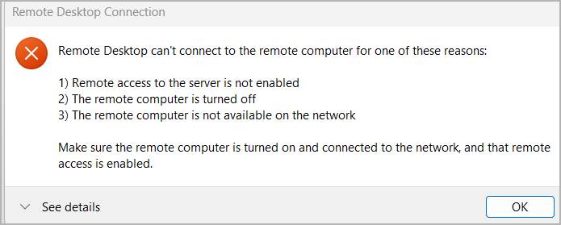
Figure 1. Initial RDP connection failure observed during client access troubleshooting.

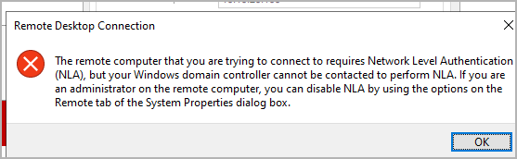
Figure 2. NLA failure observed during Windows 11 client troubleshooting.

Failed WS01 cleanup commands
# DC01 cleanup after failed WS01 build
$Computer = Get-ADComputer WS01 -ErrorAction SilentlyContinue
if ($Computer) { Remove-ADComputer -Identity $Computer.DistinguishedName -Confirm:$false }
$DnsRecord = Get-DnsServerResourceRecord -ZoneName "ad.jeremyfontenot.online" -Name "WS01" -RRType A -ErrorAction SilentlyContinue
if ($DnsRecord) { Remove-DnsServerResourceRecord -ZoneName "ad.jeremyfontenot.online" -InputObject $DnsRecord -Force }
$Lease = Get-DhcpServerv4Lease -ScopeId "10.10.20.0" | Where-Object { $_.HostName -like "WS01*" -or $_.IPAddress -eq "10.10.20.100" }
if ($Lease) { $Lease | ForEach-Object { Remove-DhcpServerv4Lease -ScopeId "10.10.20.0" -ClientId $_.ClientId -Confirm:$false } }

# Proxmox cleanup after failed WS01 build
qm stop 300 2>/dev/null || true
qm destroy 300 --purge 1 --destroy-unreferenced-disks 1
qm list

14. WS01 Windows 10 Domain Baseline
WS01 was rebuilt with Windows 10 Pro using a compatibility-focused Proxmox hardware profile: SATA disk and e1000 network adapter. This avoided the instability observed in the Windows 11/VirtIO path and produced a stable domain-joined workstation.
WS01 Windows 10 VM creation commands
VMID=300
VMNAME="ws01"
qm create $VMID --name $VMNAME --memory 4096 --cores 2 --cpu host --machine q35 --ostype win10 --bios ovmf --agent enabled=0 --net0 e1000,bridge=vmbr1 --tablet 1
qm set $VMID --efidisk0 local-lvm:1,efitype=4m,pre-enrolled-keys=1
qm set $VMID --sata0 local-lvm:80,discard=on,ssd=1
qm set $VMID --ide2 local:iso/windows10.iso,media=cdrom
qm set $VMID --boot order=ide2\;sata0
qm start $VMID

WS01 network validation, domain join, and rename cmdlets
# Pre-domain-join validation from WS01
Get-NetIPConfiguration
Get-DnsClientServerAddress -AddressFamily IPv4
Test-NetConnection 10.10.20.10 -Port 53
Test-NetConnection 10.10.20.10 -Port 88
Test-NetConnection 10.10.20.10 -Port 389
Test-NetConnection 10.10.20.10 -Port 445
Resolve-DnsName dc01.ad.jeremyfontenot.online
Resolve-DnsName ad.jeremyfontenot.online

# Join domain and rename
Add-Computer -DomainName "ad.jeremyfontenot.online" -Credential $Credential -OUPath "OU=Windows 11,OU=Workstations,OU=JFAD,DC=ad,DC=jeremyfontenot,DC=online" -Restart
Rename-Computer -NewName "WS01" -DomainCredential "JFAD\jeremy.fontenot" -Restart

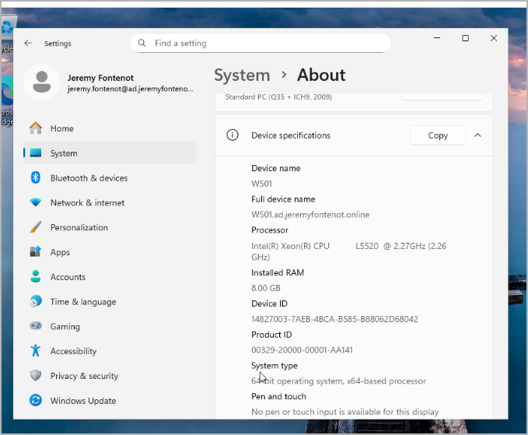
Figure 3. Cropped WS01 System > About proof showing workstation identity and hardware state after installation.

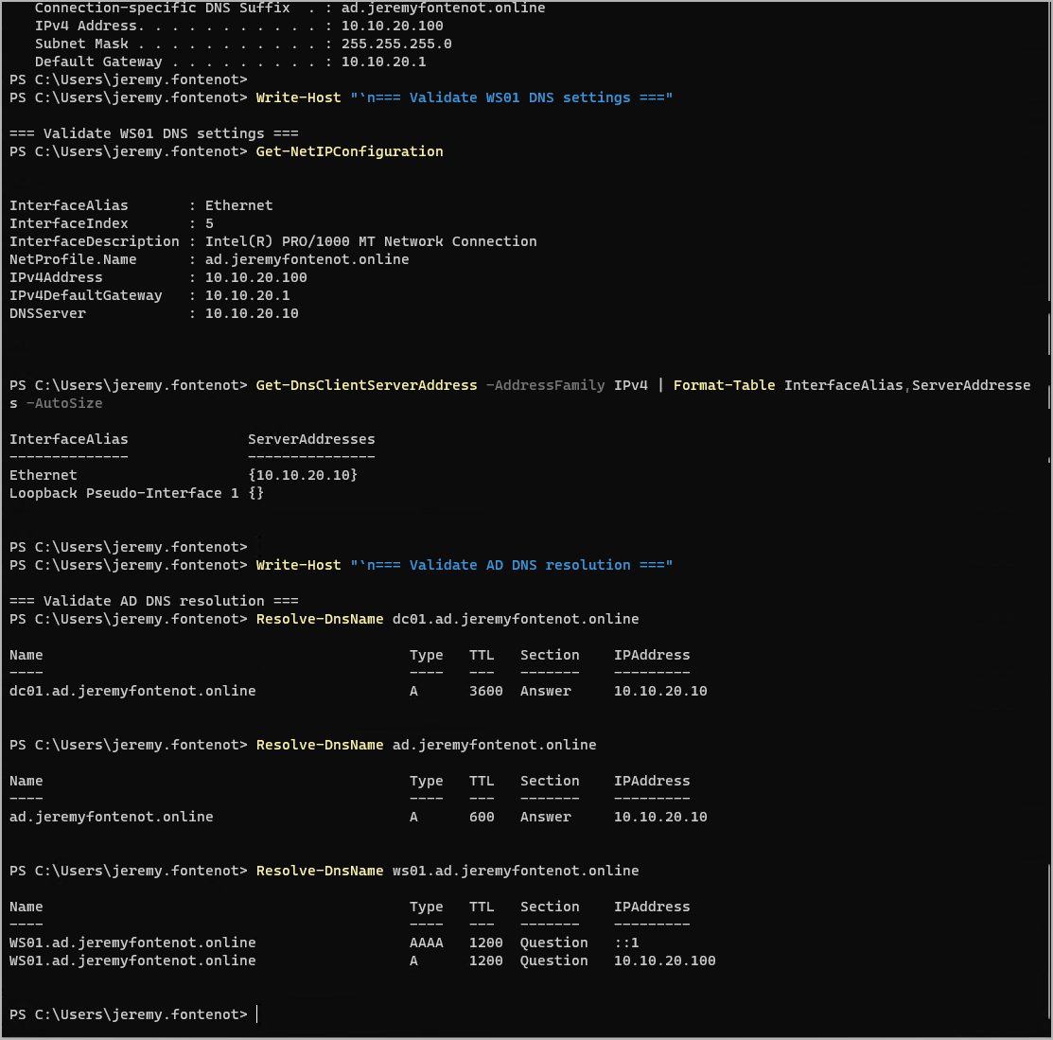
Figure 4. Cropped DNS and DHCP validation output from WS01 after domain join and DNS registration.

WS01 baseline attribute | Validated value
VMID / name | 300 / ws01
Operating system | Windows 10 Pro
Memory / CPU | 4096 MB / 2 cores
Network adapter | e1000 on vmbr1
IP configuration | 10.10.20.100/24, gateway 10.10.20.1, DNS 10.10.20.10
Domain state | WS01 joined to ad.jeremyfontenot.online; JFAD\jeremy.fontenot login validated.
OU state | CN=WS01,OU=Windows 10,OU=Workstations,OU=JFAD,DC=ad,DC=jeremyfontenot,DC=online

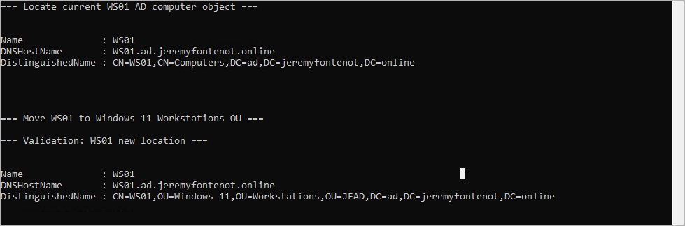
Figure 5. Active Directory validation showing WS01 location after OU movement.

15. WS01 Group Policy and RDP Validation
After WS01 was moved into the Windows 10 workstation OU, Group Policy was refreshed and gpresult was used to validate application. The Workstation Security GPO initially did not appear because it was linked but empty. The GPO was remediated with registry policy values and then appeared in gpresult as an applied computer policy.
WS01 Group Policy validation commands
gpupdate /force
gpresult /r /scope computer
gpresult /h C:\Windows\Temp\WS01-gpresult-after-workstation-security.html /f

Applied computer GPO after remediation | Purpose
Default Domain Policy | Base domain policy processing.
GPO - Baseline - Workstation Security | Workstation startup/logon, verbose status, AutoRun, UAC, NoLMHash, and NTLMv2 controls.
GPO - Baseline - Windows Firewall | Windows Firewall baseline.
GPO - Baseline - RDP Restrictions | RDP and NLA baseline.
GPO - Baseline - PowerShell Logging | PowerShell logging baseline.
GPO - Baseline - Windows Update | Update baseline.

WS01 RDP enablement and final DC01-to-WS01 validation commands
# Local RDP remediation and validation on WS01
Set-ItemProperty -Path "HKLM:\System\CurrentControlSet\Control\Terminal Server" -Name "fDenyTSConnections" -Value 0
Set-Service TermService -StartupType Automatic
Start-Service TermService
Enable-NetFirewallRule -DisplayGroup "Remote Desktop"
Get-NetFirewallRule -DisplayGroup "Remote Desktop" | Format-Table DisplayName,Enabled,Profile,Direction,Action -AutoSize
Get-NetTCPConnection -LocalPort 3389 -State Listen

# Final validation from DC01
Test-NetConnection ws01.ad.jeremyfontenot.online -Port 3389
Resolve-DnsName ws01.ad.jeremyfontenot.online

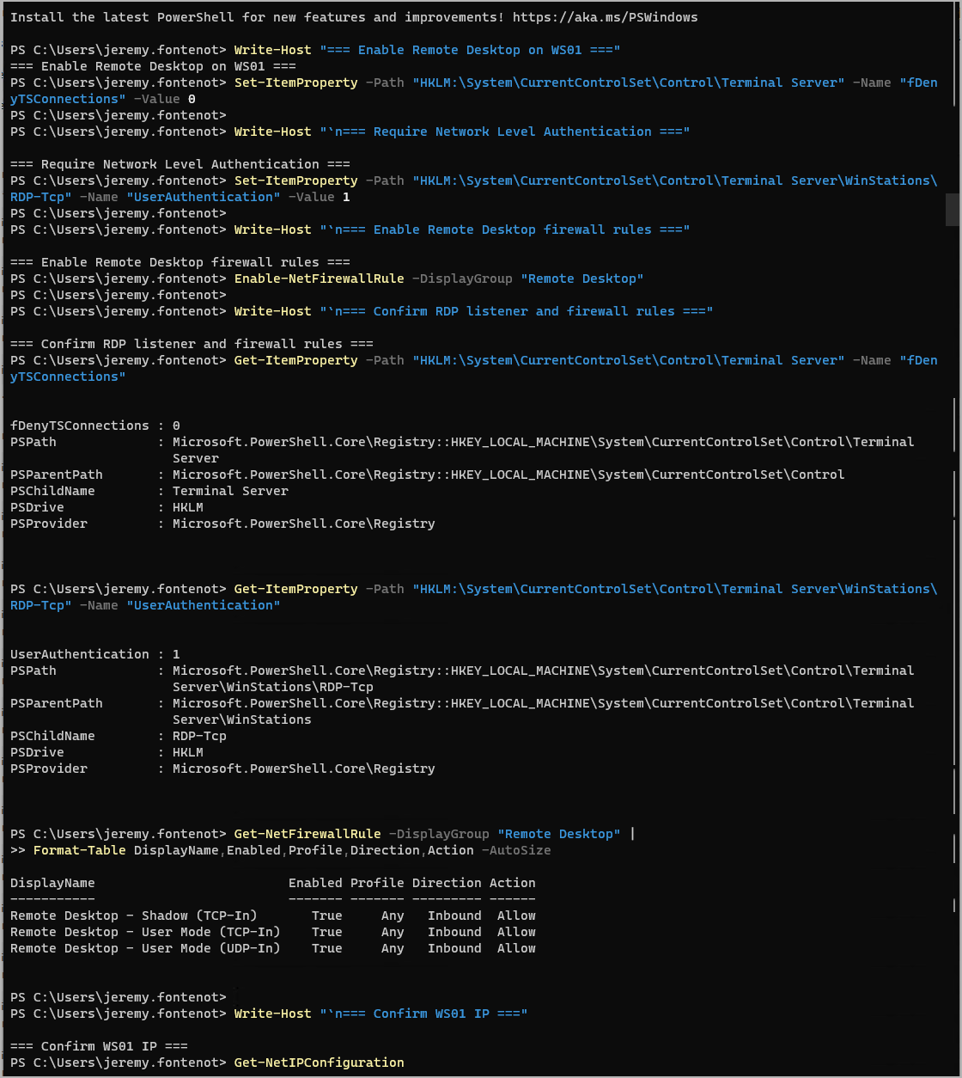
Figure 6. Cropped WS01 output showing local RDP enablement, Remote Desktop firewall rules, and network state.

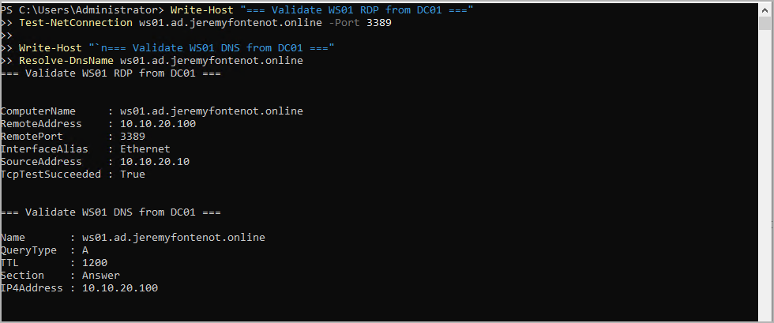
Figure 7. Cropped final RDP validation from DC01 showing TCP 3389 succeeds and DNS resolves WS01.

16. Evidence Export and Proxmox Cleanup
WS01 evidence was exported to C:\Lab-Evidence before snapshot and backup. The Proxmox VM boot path was cleaned up so WS01 boots from sata0 only and no longer depends on the Windows 10 ISO.
WS01 evidence export cmdlets
$Stamp = Get-Date -Format "yyyyMMdd-HHmmss"
$EvidenceRoot = "C:\Lab-Evidence\WS01-Windows10-Baseline-$Stamp"
New-Item -Path $EvidenceRoot -ItemType Directory -Force | Out-Null
Get-ComputerInfo | Select-Object CsName,CsDomain,CsPartOfDomain,WindowsProductName,WindowsVersion,OsHardwareAbstractionLayer | Format-List | Out-File "$EvidenceRoot\ws01-computer-domain-status.txt"
Get-NetIPConfiguration | Out-File "$EvidenceRoot\ws01-ip-configuration.txt"
Get-DnsClientServerAddress -AddressFamily IPv4 | Format-Table InterfaceAlias,ServerAddresses -AutoSize | Out-File "$EvidenceRoot\ws01-dns-client-settings.txt"
gpresult /r /scope computer | Out-File "$EvidenceRoot\ws01-gpresult-computer.txt"
gpresult /h "$EvidenceRoot\ws01-gpresult.html" /f

Proxmox WS01 boot cleanup commands
qm set 300 --boot order=sata0
qm set 300 --ide2 none
qm config 300 | grep -E "name:|memory:|cores:|cpu:|boot:|ide2:|sata0:|net0:|agent:"
qm status 300

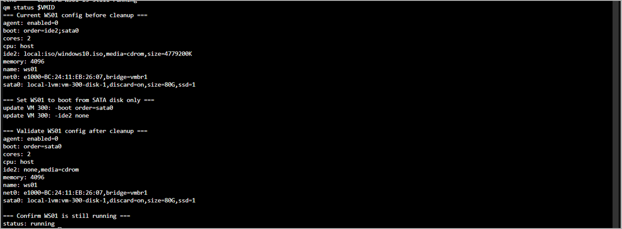
Figure 8. Cropped Proxmox output showing WS01 boot cleanup and running status.

Evidence path | Content
C:\Lab-Evidence\WS01-Windows10-Baseline-20260611-163047 | Computer/domain status, IP and DNS settings, RDP service/listener/firewall, network profile, gpresult TXT/HTML, and baseline summary.
WS01-gpresult-after-workstation-security.html | HTML proof that Workstation Security GPO and other baseline GPOs applied to WS01.
C:\Lab-Evidence\DC01-GPO-Baseline-<timestamp> | GPO inventory, reports, policy settings, OU links, audit policy, and baseline export artifacts.

17. Final Snapshot and Backup State
After WS01 validation and evidence export, a Proxmox snapshot was created, a manual vzdump backup was completed to backup-hdd, and the scheduled backup job was updated to protect VM 100, VM 200, and VM 300.
WS01 snapshot, backup, and scheduled backup commands
qm snapshot 300 "ws01-windows10-domain-gpo-baseline" --description "Windows 10 WS01 baseline after stable install, domain join to ad.jeremyfontenot.online, OU placement, DNS validation, RDP enablement, and successful workstation GPO application."
qm listsnapshot 300

vzdump 300 --storage backup-hdd --mode snapshot --compress zstd --notes-template "WS01 Windows 10 domain-joined workstation baseline backup after DNS, RDP, OU placement, and GPO validation."
ls -lh /mnt/pve/backup-hdd/dump | grep "vzdump-qemu-300"

sed -i '/^[[:space:]]*vmid /s/100,200/100,200,300/' /etc/pve/jobs.cfg
cat /etc/pve/jobs.cfg

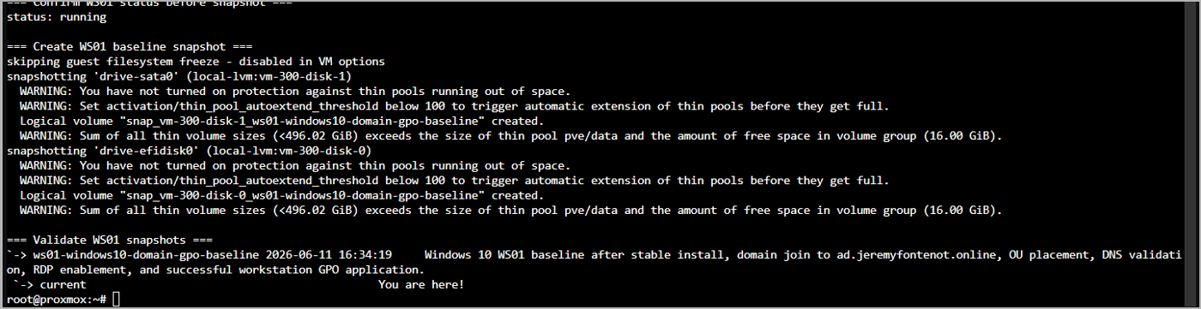
Figure 9. Cropped Proxmox output showing WS01 baseline snapshot creation and validation.

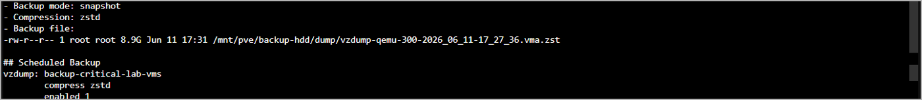
Figure 10. Cropped evidence note excerpt showing the WS01 backup file and 8.9 GB archive.

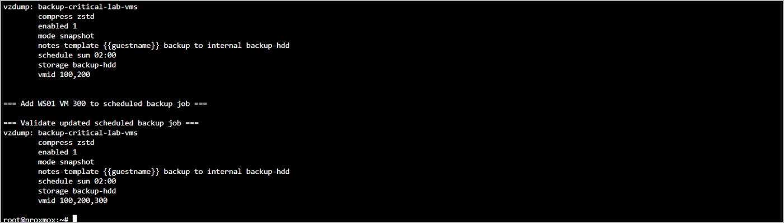
Figure 11. Cropped Proxmox output showing scheduled backup job updated to include VM 300.

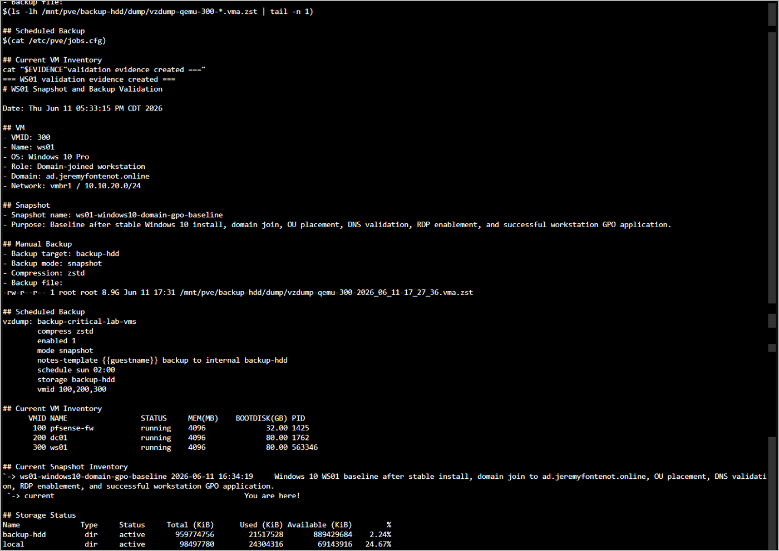
Figure 12. Cropped Proxmox evidence note documenting WS01 snapshot, backup file, scheduled job, VM inventory, and storage status.

VM | Snapshots retained | Backup state
100 pfsense-fw | pfsense-baseline-wan-lan; pfsense-rdp-nat-restricted | Manual backup completed to backup-hdd; included in scheduled job.
200 dc01 | dc01-gpo-baseline-configured; dc01-onprem-only-cleanup | Manual backup completed to backup-hdd; included in scheduled job.
300 ws01 | ws01-windows10-domain-gpo-baseline | Manual backup completed to backup-hdd; included in scheduled job.

18. Evidence Artifacts and Website Proof Mapping
The following artifacts are suitable for linking or summarizing from jeremyfontenot.online as proof of practical infrastructure work. They should be sanitized before public upload if any private data appears in screenshots or exports.
Website proof claim | Supporting evidence
Built a segmented Proxmox/pfSense/AD lab | Proxmox bridge validation, pfSense VM configuration, DC01 network configuration, and topology notes.
Configured AD DS, DNS, and DHCP | DC01 role installation commands; Get-ADDomain, Resolve-DnsName, DHCP scope and option outputs.
Created role-based AD structure | OU, user, security group, and group nesting commands and validation screenshots.
Implemented baseline GPO security controls | GPO creation/linking commands, registry policy values, gpresult reports, and evidence exports.
Troubleshot and remediated client deployment issues | Windows 11 failure screenshots, cleanup commands, Windows 10 rebuild commands, and successful WS01 validation.
Validated RDP and administrative access | RDP NAT tests, WS01 RDP listener and firewall rules, and DC01-to-WS01 TcpTestSucceeded output.
Implemented backup and recovery evidence | backup-hdd storage validation, vzdump backup files, snapshots, scheduled backup job, and evidence notes.

19. Current State and Next Steps
Area | Current validated state
Core infrastructure | Operational and validated.
pfSense VM 100 | Running, snapshot protected, backed up, included in scheduled backup job.
DC01 VM 200 | Running, AD DS/DNS/DHCP/GPO baseline configured, snapshot protected, backed up, included in scheduled backup job.
WS01 VM 300 | Running Windows 10 Pro, domain joined, OU placed, GPO validated, RDP validated, snapshot protected, backed up, included in scheduled backup job.
backup-hdd | Mounted at /mnt/pve/backup-hdd, active, used as the backup-only target.

Recommended next steps:
- Export a final Proxmox evidence bundle that includes pveversion, pvesm status, qm config for all VMs, snapshot inventories, and scheduled backup configuration.
- Create a sanitized public evidence package for jeremyfontenot.online, keeping raw exports private where needed.
- Add a second workstation or member server if future proof should cover multi-client GPO targeting, file shares, or software deployment.
- Create a restore validation exercise by restoring one VM backup into an isolated VM ID and documenting boot validation.
- Build a monitoring/logging phase using Windows Event Forwarding, Sysmon, or a lightweight monitoring platform to expand operations proof.

20. June 12 Evidence Update: File Services, Drive Mapping, Monitoring, and Evidence Pack
This section updates the report with the validated June 12, 2026 file services, mapped drive, monitoring, time synchronization, backup, and evidence packaging phase. The phase created a least-privilege Windows file share model and preserved the result in a central evidence pack suitable for documentation and website proof. The final local evidence pack is C:\EvidencePack\on-prem-home-lab\HomeLab-Evidence-Export-20260612-184743.zip and was validated with SHA256 hash 864CD48F80E08FC45676D30B209D2ADFE8DC9569D32E80ED9BF17236D5893F28.

20.1 File Services and Least-Privilege Access Control
DC01 was extended with an IT SMB share at \DC01\IT backed by C:\Shares\IT. Two AD security groups were used to enforce least-privilege access: JFAD\GG-FS-IT-RW for change/modify access and JFAD\GG-FS-IT-RO for read-only access. The initial share configuration was followed by an NTFS ACL correction so that both SMB and NTFS permissions aligned with the intended access model.
- Share path: \DC01\IT.
- Read/write group: JFAD\GG-FS-IT-RW; validated with sd.tech.
- Read-only group: JFAD\GG-FS-IT-RO; validated with standard.user.
- DC01 evidence folders: C:\Lab-Evidence\DC01-File-Services-IT-Share-20260612-154549 and C:\Lab-Evidence\DC01-File-Services-IT-Share-NTFS-Fix-20260612-154755.
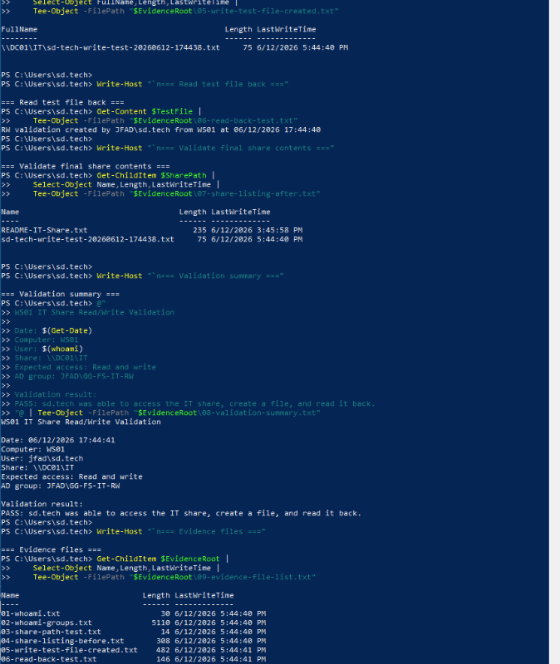
Figure 13. WS01 sd.tech validation showing membership in the read/write file share group and successful create/read testing against the IT share.
The sd.tech validation confirms the user belonged to JFAD\GG-FS-IT-RW and could access the share, create a test file, read it back, and record the evidence folder C:\Lab-Evidence\WS01-IT-Share-RW-Validation-20260612-174438.

20.2 GPO-Based IT Drive Mapping
A user-side Group Policy Object named GPO - Users - Map IT Share Drive was created and linked to OU=Users,OU=JFAD,DC=ad,DC=jeremyfontenot,DC=online. The policy creates an HKCU Run entry named MapITShareDrive that maps I: to \DC01\IT at user logon. Access remains governed by the share and NTFS permissions configured on DC01.
GPO: GPO - Users - Map IT Share Drive
GPO ID: bf48b6c9-3e5d-4860-af64-17b352072bef
Target OU: OU=Users,OU=JFAD,DC=ad,DC=jeremyfontenot,DC=online
Mapped drive: I: -> \DC01\IT
DC01 evidence: C:\Lab-Evidence\DC01-GPO-IT-Drive-Map-20260612-180844
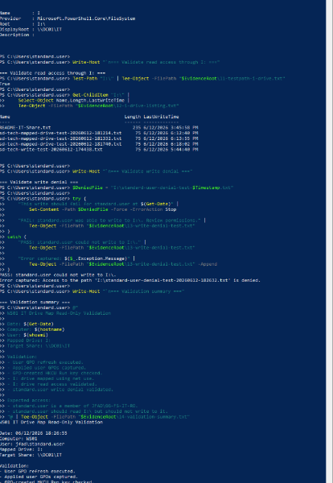
Figure 14. WS01 standard.user mapped-drive validation showing I: mapped to \DC01\IT, read access confirmed, and write denial captured.
Mapped drive validation proved both sides of the access model. The sd.tech account validated read/write access through I:, while standard.user validated read-only access and a denied write attempt. The standard.user evidence folder was C:\Lab-Evidence\WS01-IT-Drive-Map-RO-Validation-20260612-182632.

20.3 Monitoring, Logging, and Time Synchronization Evidence
DC01 monitoring and logging evidence was captured to validate operational readiness. The evidence set included OS and uptime, dcdiag health checks, DNS service status and WS01 resolution, DHCP scope and lease data, SMB share inventory, IT share permissions, NTFS ACLs, audit policy, recent Security events, PowerShell logging registry policy, PowerShell Operational events, Group Policy Operational events, and recent System warnings/errors.
- DC01 monitoring/logging evidence folder: C:\Lab-Evidence\DC01-Monitoring-Logging-Evidence-20260612-194849.
- Validated health results included dcdiag Advertising, Services, and DNS checks.
- PowerShell ScriptBlockLogging and ModuleLogging policy settings were captured.
- The W32Time finding was corrected by configuring external NTP peers and validating synchronization.
The Windows Time service initially reported a free-running system clock. It was remediated with manual peers time.windows.com,0x8 and pool.ntp.org,0x8, then validated as synchronized to pool.ntp.org with Stratum 3. Time Service events recorded valid time data and DC01 advertising as a time source. Evidence was captured in C:\Lab-Evidence\DC01-Time-Service-Fix-20260612-195240.

20.4 Backups, Proxmox Evidence, and Storage Safety
After the file services, drive mapping, monitoring, and time service work was complete, DC01 and WS01 were backed up to the dedicated backup-hdd storage target. Proxmox storage validation showed local-lvm thin data usage remained low while the dedicated backup disk had substantial free capacity. The final GPO drive mapping backup set preserved DC01 and WS01 after validation.
Final DC01 backup: /mnt/pve/backup-hdd/dump/vzdump-qemu-200-2026_06_12-20_29_46.vma.zst
Final WS01 backup: /mnt/pve/backup-hdd/dump/vzdump-qemu-300-2026_06_12-20_34_53.vma.zst
Proxmox phase note: /root/lab-evidence/file-services-gpo-drive-map-phase-complete-20260612-204514.md
Final backup evidence: /root/lab-evidence/gpo-it-drive-map-final-backup-20260612-202944.txt

20.5 Central Evidence Export, Manifest, and Hash Validation
The evidence from DC01, WS01, and Proxmox was consolidated into C:\Shares\IT\HomeLab-Evidence-Export-20260612-184743, copied to the Windows laptop, extracted, and staged for documentation. The final evidence pack contains 127 files, including 60 DC01 evidence files, 47 WS01 evidence files, and 8 Proxmox evidence files. A CSV manifest records file names, relative paths, sizes, timestamps, and SHA256 hashes.
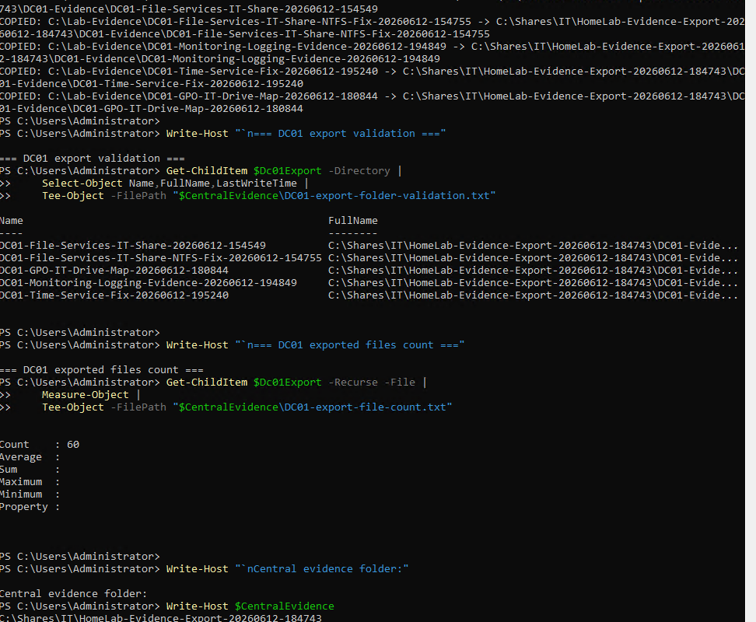
Figure 15. DC01 central evidence export validation showing the exported DC01 evidence folders and file count.
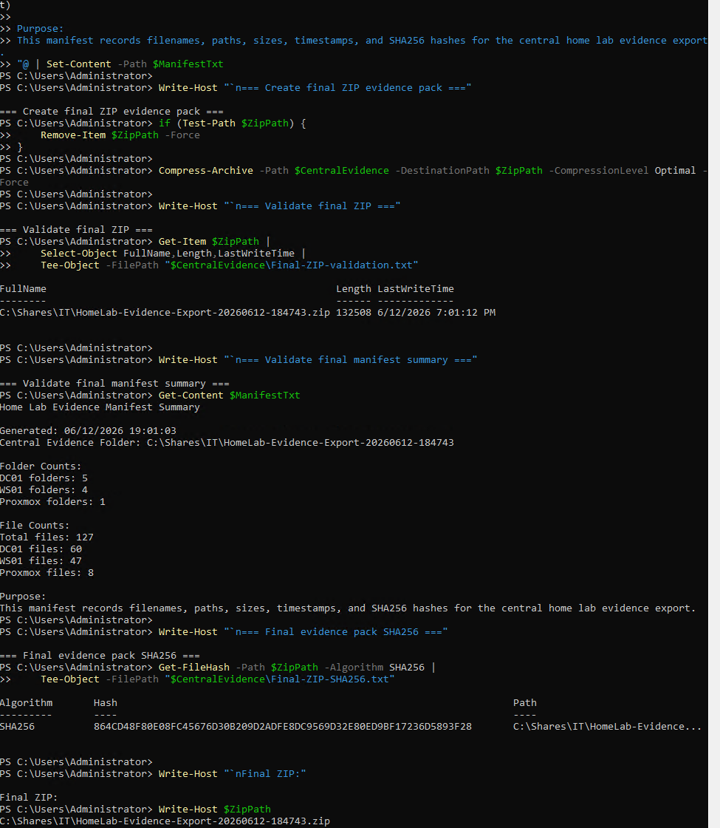
Figure 16. Final evidence ZIP creation and validation showing manifest totals and the SHA256 hash for the evidence pack.
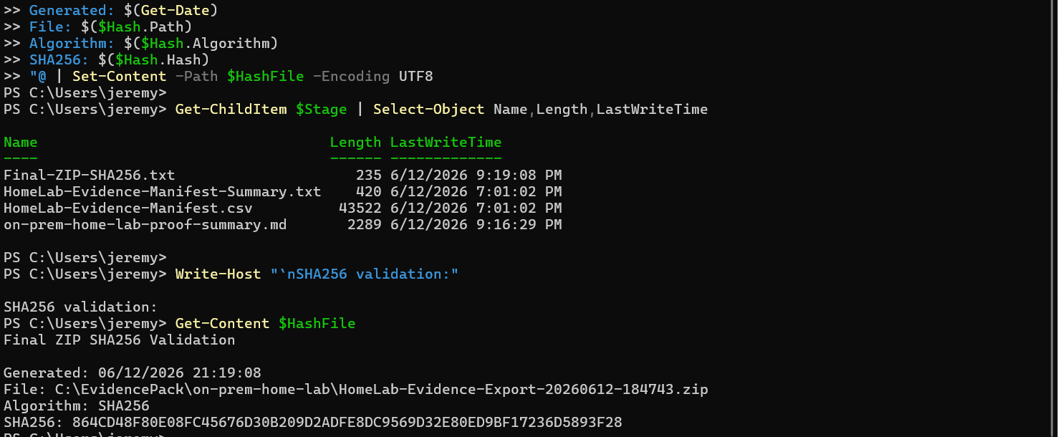
Figure 17. Windows laptop documentation staging validation showing proof summary, manifest, manifest summary, and corrected final ZIP SHA256 file.
The final exported ZIP was validated on the Windows laptop at C:\EvidencePack\on-prem-home-lab\HomeLab-Evidence-Export-20260612-184743.zip. The validated SHA256 hash was 864CD48F80E08FC45676D30B209D2ADFE8DC9569D32E80ED9BF17236D5893F28. The documentation staging folder contains the proof summary, evidence manifest, manifest summary, and final ZIP hash validation file.

20.6 Updated Skill Validation from June 12 Evidence
The June 12 phase strengthens the portfolio proof by adding validated operational administration work that goes beyond baseline domain setup. The following additional skills are now supported by named evidence artifacts and screenshots:
- Windows Server file services and SMB share administration.
- NTFS permission correction and validation.
- AD security group-based access control for read/write and read-only roles.
- GPO creation, linking, and user-side policy application.
- Mapped drive deployment to domain users.
- Least-privilege validation using sd.tech and standard.user.
- Windows monitoring/logging evidence capture for audit, Security, PowerShell, Group Policy, and System logs.
- Domain Controller Windows Time service troubleshooting and repair.
- Proxmox storage review, backup validation, evidence packaging, manifest creation, and SHA256 hash validation.

21. References
Fontenot, J. (2026, June 8-11). On-prem home lab project chat history, command outputs, and screenshots [Unpublished technical build record].
Fontenot, J. (2026, June 9). DC01-GPO-Baseline evidence export [Internal evidence folder]. C:\Lab-Evidence\DC01-GPO-Baseline-<timestamp>.
Fontenot, J. (2026, June 9). On-prem-only decision and Entra provisioning agent cleanup [Internal evidence folder]. C:\Lab-Evidence\OnPrem-Only-Decision-<timestamp>.
Fontenot, J. (2026, June 9). Proxmox backup validation evidence note [Internal evidence file]. /root/lab-evidence/proxmox-backup-validation-20260609-184748.md.
Fontenot, J. (2026, June 11). WS01 Windows 10 baseline evidence export [Internal evidence folder]. C:\Lab-Evidence\WS01-Windows10-Baseline-20260611-163047.
Fontenot, J. (2026, June 11). WS01 snapshot and backup validation evidence note [Internal evidence file]. /root/lab-evidence/ws01-backup-snapshot-validation-20260611-053315.md.
Fontenot, J. (2026, June 11). Proxmox vzdump archive for WS01 [Internal backup artifact]. /mnt/pve/backup-hdd/dump/vzdump-qemu-300-2026_06_11-17_27_36.vma.zst.

Appendix A: New Chat Handoff Prompt
You are assisting with an on-prem home lab build for Jeremy Fontenot. Continue from the completed baseline below. Work in step-by-step mode by default, using one phase command block at a time with validation and waiting for output before continuing.

Environment:
- Server: Dell PowerEdge R710
- Hypervisor: Proxmox VE 9.2.3, running kernel 7.0.6-2-pve
- Proxmox management IP: 192.168.0.242/24
- Cox upstream LAN: 192.168.0.0/24
- pfSense VM 100: pfsense-fw, WAN 192.168.0.205/24, LAN 10.10.20.1/24
- Internal lab subnet: 10.10.20.0/24
- DC01 VM 200: Windows Server 2022, 10.10.20.10/24, AD DS, DNS, DHCP, GPMC
- AD domain: ad.jeremyfontenot.online
- NetBIOS domain: JFAD
- WS01 VM 300: Windows 10 Pro, 10.10.20.100/24, domain joined and validated
- Backup target: backup-hdd mounted at /mnt/pve/backup-hdd

Completed:
1. Proxmox VE installed, updated, and validated.
2. vmbr0 and vmbr1 configured for upstream/management and isolated internal lab networking.
3. pfSense CE 2.8.1 installed and configured for WAN/LAN routing; LAN DHCP disabled.
4. DC01 installed, statically addressed, promoted to a new AD DS forest, and configured for DNS/DHCP.
5. OU structure, baseline users, role groups, named admin account, and RDP/admin delegation were created and validated.
6. Baseline GPOs were created and linked; domain password, lockout, firewall, RDP, PowerShell logging, audit, Windows Update, workstation, and server baselines were configured or remediated.
7. Microsoft Entra/Cloud Sync/Intune integration was skipped; lab remains on-prem-only for this phase.
8. Internal 1 TB HDD was configured as backup-hdd directory storage; unstable external USB M.2 backup path was removed.
9. pfSense and DC01 were snapshot-protected and backed up.
10. Windows 11 WS01 attempt was documented as failed/unstable, cleaned from AD/DNS/DHCP/Proxmox, and replaced with Windows 10.
11. WS01 Windows 10 was created, installed, renamed, domain joined, moved to OU=Windows 10,OU=Workstations,OU=JFAD, and validated.
12. WS01 DNS, DHCP, domain login, GPO application, RDP firewall/listener, and DC01-to-WS01 RDP were validated.
13. WS01 evidence exported to C:\Lab-Evidence\WS01-Windows10-Baseline-20260611-163047.
14. WS01 snapshot created: ws01-windows10-domain-gpo-baseline.
15. WS01 backup created: /mnt/pve/backup-hdd/dump/vzdump-qemu-300-2026_06_11-17_27_36.vma.zst.
16. Scheduled backup job backup-critical-lab-vms now protects VM 100, 200, and 300 every Sunday at 02:00 using snapshot mode and zstd compression.

Next recommended phase:
- Build a final evidence bundle and sanitized website proof package.
- Validate restore from backup into an isolated VM ID.
- Begin monitoring/logging or file services phase.

Appendix B: Updated June 12 Handoff Prompt
You are assisting with an on-prem home lab build for Jeremy Fontenot. Continue from the completed baseline below. Work in step-by-step mode by default, using one phase command block at a time with validation and waiting for output before continuing.

Environment:
- Server: Dell PowerEdge R710
- Hypervisor: Proxmox VE 9.2.3, running kernel 7.0.6-2-pve
- Proxmox management IP: 192.168.0.242/24
- Cox upstream LAN: 192.168.0.0/24
- pfSense VM 100: pfsense-fw, WAN 192.168.0.205/24, LAN 10.10.20.1/24
- Internal lab subnet: 10.10.20.0/24
- DC01 VM 200: Windows Server 2022, 10.10.20.10/24, AD DS, DNS, DHCP, GPMC, file services, monitoring/logging evidence, and repaired Windows Time service
- AD domain: ad.jeremyfontenot.online
- NetBIOS domain: JFAD
- WS01 VM 300: Windows 10 Pro, 10.10.20.100/24, domain joined and validated
- Backup target: backup-hdd mounted at /mnt/pve/backup-hdd

Additional completed June 12 work:
1. Created \DC01\IT file share backed by C:\Shares\IT.
2. Created GG-FS-IT-RW and GG-FS-IT-RO access groups.
3. Validated sd.tech read/write access and standard.user read-only/write-denied access.
4. Created GPO - Users - Map IT Share Drive and validated I: mapped drive behavior on WS01.
5. Captured DC01 monitoring/logging evidence, including dcdiag, DNS, DHCP, SMB, audit policy, Security logs, PowerShell logs, Group Policy logs, and System warnings/errors.
6. Corrected DC01 Windows Time service from Free-running System Clock to external NTP synchronization.
7. Created final DC01 and WS01 backups after drive mapping validation.
8. Consolidated DC01, WS01, and Proxmox evidence into C:\EvidencePack\on-prem-home-lab.
9. Created final evidence ZIP: C:\EvidencePack\on-prem-home-lab\HomeLab-Evidence-Export-20260612-184743.zip.
10. Validated final ZIP SHA256: 864CD48F80E08FC45676D30B209D2ADFE8DC9569D32E80ED9BF17236D5893F28.

Next recommended phase:
- Add the final evidence package to the website repository evidence library.
- Update jeremyfontenot.online proof pages to cite the new on-prem home lab evidence.
- Start a restore validation exercise by restoring one VM backup into an isolated VM ID and documenting boot validation.
- Optionally build a Windows Event Forwarding/Sysmon or lightweight monitoring phase.

