Harvard University Teacher Education Program
Lesson Plan Format
3-4-3

The Set-up | Unit Goals: What broad goals or essential questions are driving this unit?
The Set-up | Learning Objective(s): What will students know and be able to do by the end of class that they didn’t know or couldn’t do when they came in?
The Set-up | Materials: What do you need on hand for the lesson?
√ Is your learning objective worthwhile?
√ Does it advance the Unit Goals?
√ Have you explicitly considered content, skill and language pre-requisites and objectives?
√ Why are you teaching this objective, in this way, to these students, at this time?

The Lesson | The Hook: How will you pique students’ interest?
The Lesson | Exploration: How will students explore the new concepts?
The Lesson | Practice: How will students practice the new concepts?
The Lesson | Summary: How will students review and solidify these concepts to be able to use this knowledge or skill?
√ Do you anchor the lesson to prior knowledge?
√ Is the purpose of the lesson clear to the students?
√ Do you differentiate for language and learning needs?
  - Auditory, visual and kinesthetic modalities
  - Independent, small and large group learning
√ Do you make sure the students will be doing the heavy-lifting rather than you?
√ Do you incorporate checks for student learning?
√ Do you use visual and auditory cues?

The Close | Application: How will students incorporate the new concepts into prior knowledge and “make it their own”?
The Close | Assessment: How will you and the students assess whether the learning objectives were met?
The Close | The Preview: How does this lesson lead to the next lesson?
√ Are you getting the information you need to know where to start tomorrow?
√ How does the homework build a bridge between what came before and what comes next. And how is it linked to the learning objectives?
Harvard University Teacher Education Program
Lesson Reflection Format

- 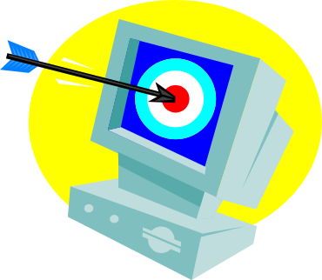 What did I intend to teach?

- 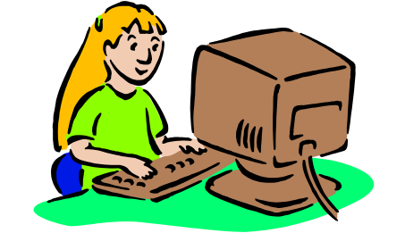 What did the students learn?

- 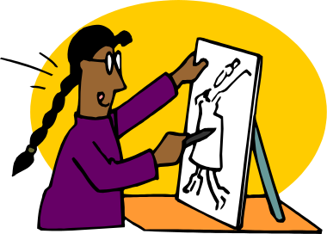 How do I know they learned it?

- 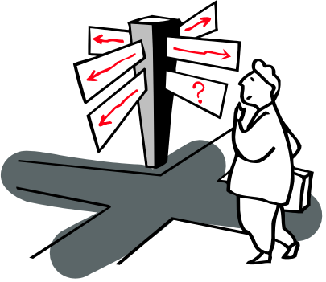 What would I do differently next time?

