

­9am **Self-Enrollment Instructions**

#### Open a web browser (Internet Explorer, Mozilla Firefox, Safari, etc.)

#### 1. In the Address field or Location bar - type in the following URL: [http://www.taskstream.com](http://www.taskstream.com/)

#### 2. Log in to your Taskstream account.

#### 3. Find the Self-Enrollment Area. Click the Enter Code button.

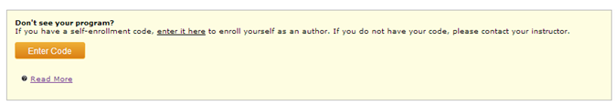

#### 4. Enter Your Code: Enter the program code below in the appropriate field and click the Search button.

|  |
| --- |
| **Your Program Code is 74GY2S** |

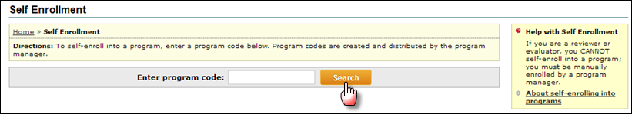

You will be able to review the program information that corresponds to the code that you entered. To be enrolled in the program, click the Enroll button. If you do not wish to be enrolled in the program at this time, click the Cancel - Do Not Enroll button.

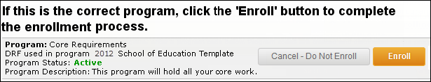

*Note: If you enroll yourself into an inactive program, the program will not show up on your home page until the Program Manager activates the program.*