Mapping the Field

Loading required package: ggplot2

Welcome! Want to learn more? See two factoextra-related books at https://goo.gl/ve3WBa

Loading required package: permute

Loading required package: lattice

This is vegan 2.6-2

Registered S3 method overwritten by 'dendextend':  
 method from   
 rev.hclust vegan

---------------------  
Welcome to dendextend version 1.16.0  
Type citation('dendextend') for how to cite the package.  
  
Type browseVignettes(package = 'dendextend') for the package vignette.  
The github page is: https://github.com/talgalili/dendextend/  
  
Suggestions and bug-reports can be submitted at: https://github.com/talgalili/dendextend/issues  
You may ask questions at stackoverflow, use the r and dendextend tags:   
 https://stackoverflow.com/questions/tagged/dendextend  
  
 To suppress this message use: suppressPackageStartupMessages(library(dendextend))  
---------------------

Attaching package: 'dendextend'

The following object is masked from 'package:permute':  
  
 shuffle

The following object is masked from 'package:stats':  
  
 cutree

Loading required package: plyr

Loading required package: scales

Attaching package: 'scales'

The following object is masked from 'package:CAinterprTools':  
  
 rescale

The following object is masked from 'package:readr':  
  
 col_factor

Loading required package: grid

Attaching package: 'dplyr'

The following objects are masked from 'package:plyr':  
  
 arrange, count, desc, failwith, id, mutate, rename, summarise,  
 summarize

The following objects are masked from 'package:stats':  
  
 filter, lag

The following objects are masked from 'package:base':  
  
 intersect, setdiff, setequal, union

Attaching package: 'purrr'

The following object is masked from 'package:scales':  
  
 discard

The following object is masked from 'package:plyr':  
  
 compact

Attaching package: 'ggfittext'

The following object is masked from 'package:cluster':  
  
 animals

# Abstract

300 word maximum.

# Keywords

Keyword 1, keyword 2… up to 6?

Start typing your introduction here. Please do not use the word “Introduction” as an initial heading, since your paper is supposed to begin with an introduction. The introduction shall present the research question including key definitions, and spell out the stakes, objectives and scope of the literature review. The last paragraph of the introduction shall list the major remaining sections, which in principle include the presentation of the method adopted for the literature review, the results obtained, the discussion of results and the conclusion. In the main text, while presenting the review method, the authors shall identify the data sources and discuss their respective quality. The discussion shall outline convergences and divergences with respect to existing literature, and also identify blindspots that are worth research consideration in future.

# Methods

Blah blah blah

# Results

Blah blah blah

# Re-run PCA on newly compiled and scaled dataframe  
analysis.pca <- PCA(analysis.scales, graph = FALSE)  
  
# Calculate HCPC  
res.hcpc <- HCPC(analysis.pca, graph = FALSE)  
  
# Create and output dendrogram of clusters by manuscriptID  
fviz_dend(res.hcpc,  
 cex = 0.7, # Label size  
 palette = iu.colors, # Color palette see ?ggpubr::ggpar  
 rect = FALSE, rect_fill = FALSE, # Add rectangle around groups  
 ggtheme = theme_minimal(),  
 #rect_border = iu.colors, # Rectangle color  
 labels_track_height = 0.8, # Augment the room for labels  
 main = "Dendrogram of Calculated Clusters") +  
 scale_x_continuous(breaks = NULL)

Warning: `guides(<scale> = FALSE)` is deprecated. Please use `guides(<scale> =  
"none")` instead.

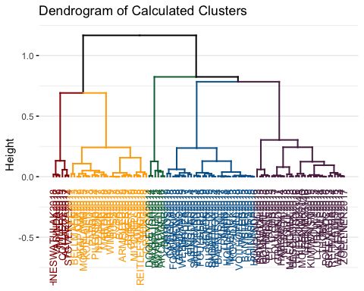

# Discussion

Blah blah blah

# Conclusion

Blah blah blah

# References

Blah blah blah

# Appendices

## Quarto

Quarto enables you to weave together content and executable code into a finished document. To learn more about Quarto see <https://quarto.org>.

## Running Code

When you click the **Render** button a document will be generated that includes both content and the output of embedded code. You can embed code like this:

1 + 1

[1] 2

You can add options to executable code like this

[1] 4

The echo: false option disables the printing of code (only output is displayed).