**Unit 4 Assignment Document**

**Submitted by**

Team West

**Submitted on**

June 9, 2020

**Team Members**

Jeremy Gallagher

Hailey Gibson

Jon-Erik Prichard

**Assignment Overview**

The Team-West Unit 4 assignment document and attachments includes:

* Screen shots of the WordWizard project Azure DevOps development management environment. Project is accessible on **Azure DevOps: WordWizard**
* Scrum, Sprint Retrospective and Sprint Review Transcripts: Project is accessible on **Git-Hub: jeremyg89/Team-West**
* Additional work product material is located in attached documents or the GiT repository:

**Project UI Graphics**: IT488_Unit_4_Team-West_GameGraphics

**Function Screen Shots**: IT488_Unit_4_Team-West_Game Functions

**Scrum and Sprint Transcripts**: IT488_Unit_4_Team-West_Transcripts

**Team-West Project Files Folder**: Team-West-master-files-060920

**WordWizard GiT Hub: Project Repository Files List**

**WordWizard Git Hub: Project Code Files List**

**WordWizard Azure: Project Completed Items Boards**

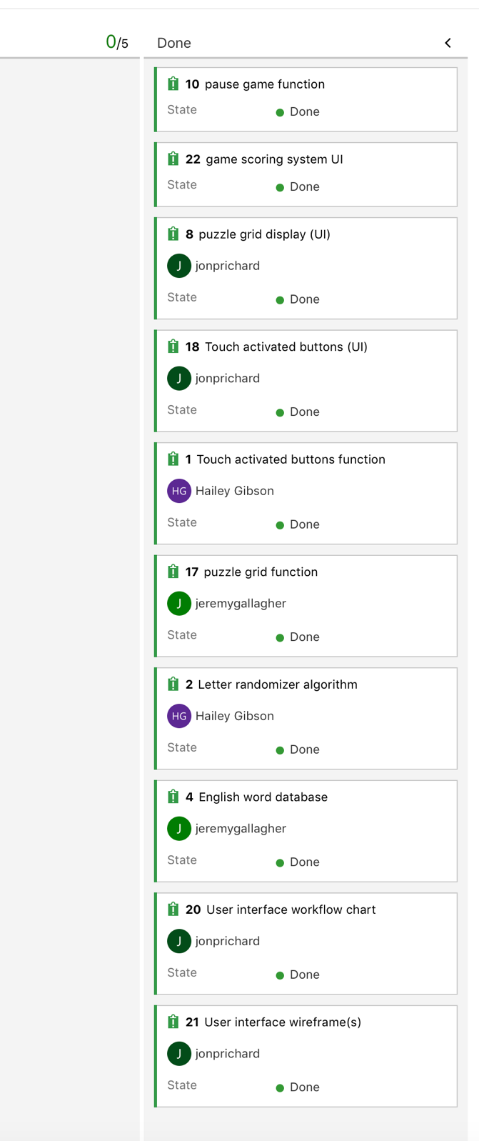

**WordWizard Azure: Sprint Burndown Screenshot**

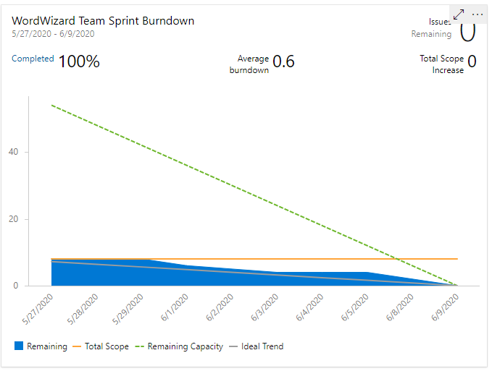

**WordWizard Emulator Screenshot: Opening Screen**

**WordWizard Emulator Screenshot: Game Grid (Unplayed)**

**WordWizard Emulator Screenshot: Game Grid (Word Played)**

