**WordWizard Game Grid Graphics**

**Submitted by**

Team West

**Submitted on**

June 9, 2020

**Team Members**

Jeremy Gallagher

Hailey Gibson

Jon-Erik Prichard

1. **WordWizard Game Graphics: Grid, Soft Drop Shadow, Not Played**

1. **WordWizard Game Graphics: Grid, Soft Drop Shadow, Played**

1. **WordWizard Game Graphics: Grid, Hard Drop Shadow, Not Played**

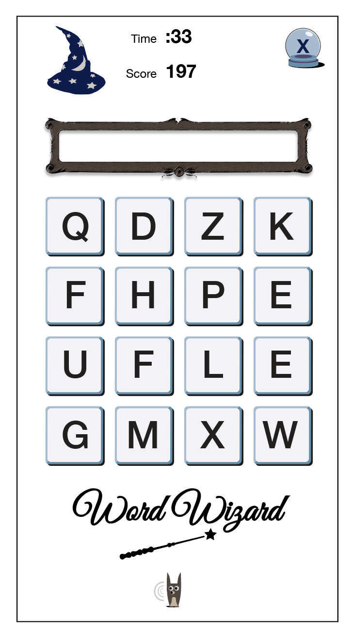

**WordWizard Game Graphics: Grid, Hard Drop Shadow, Played**

