**Unit 6 Assignment Document**

**Submitted by**

Team West

**Submitted on**

June 123, 2020

**Team Members**

Jeremy Gallagher

Hailey Gibson

Jon-Erik Prichard

**Assignment Overview**

The Team-West Unit 6 assignment document and attachments includes:

* Screen shots of the WordWizard project Azure DevOps development management environment. Project is accessible on **Azure DevOps: WordWizard**
* Scrum, Sprint Planning Session Transcripts: Project is accessible on **Git-Hub: jeremyg89/Team-West**
* Additional work product material is located in attached documents or the GiT repository:

**Scrum Transcripts**: IT488_Unit_6_Team-West_Transcripts

**Sprint 2 Review Session**: IT488_Unit_6_Team-West_ReviewRetrospective

**Server Access**: IT488_Unit_6_Team-West_ServerAccess

**Team-West Project Files Folder**: Team-West-master-files-062320

**WordWizard Sprint 2 Product Backlog (6/23/20)**

**WordWizard Sprint 2 Task Boards (6/23/20)**

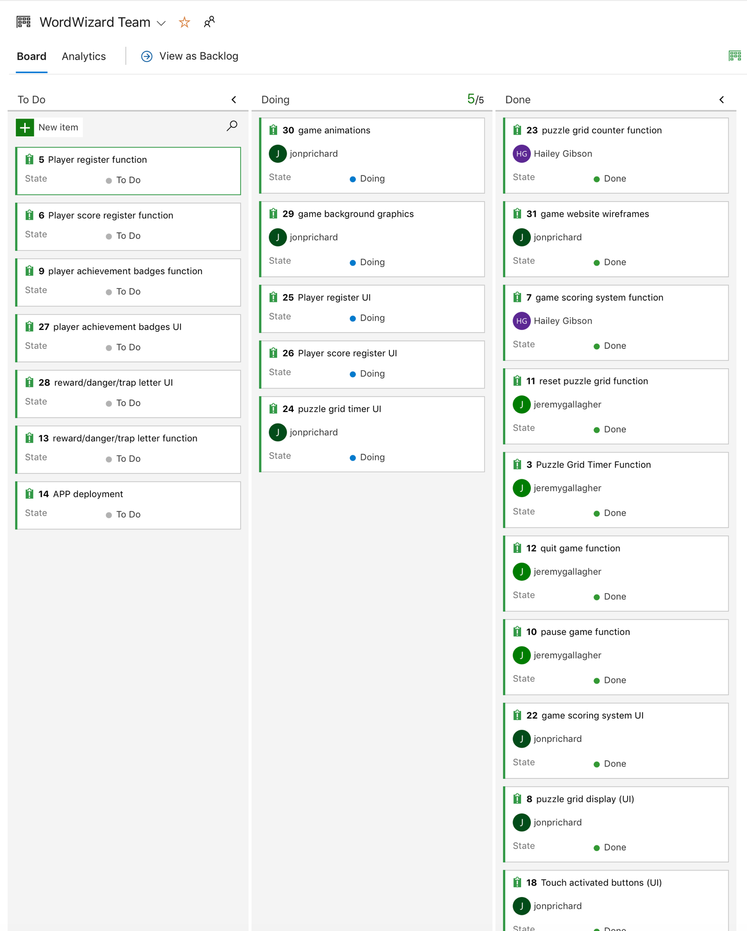

**WordWizard Sprint 2 Burndown Chart (6/23/20)**

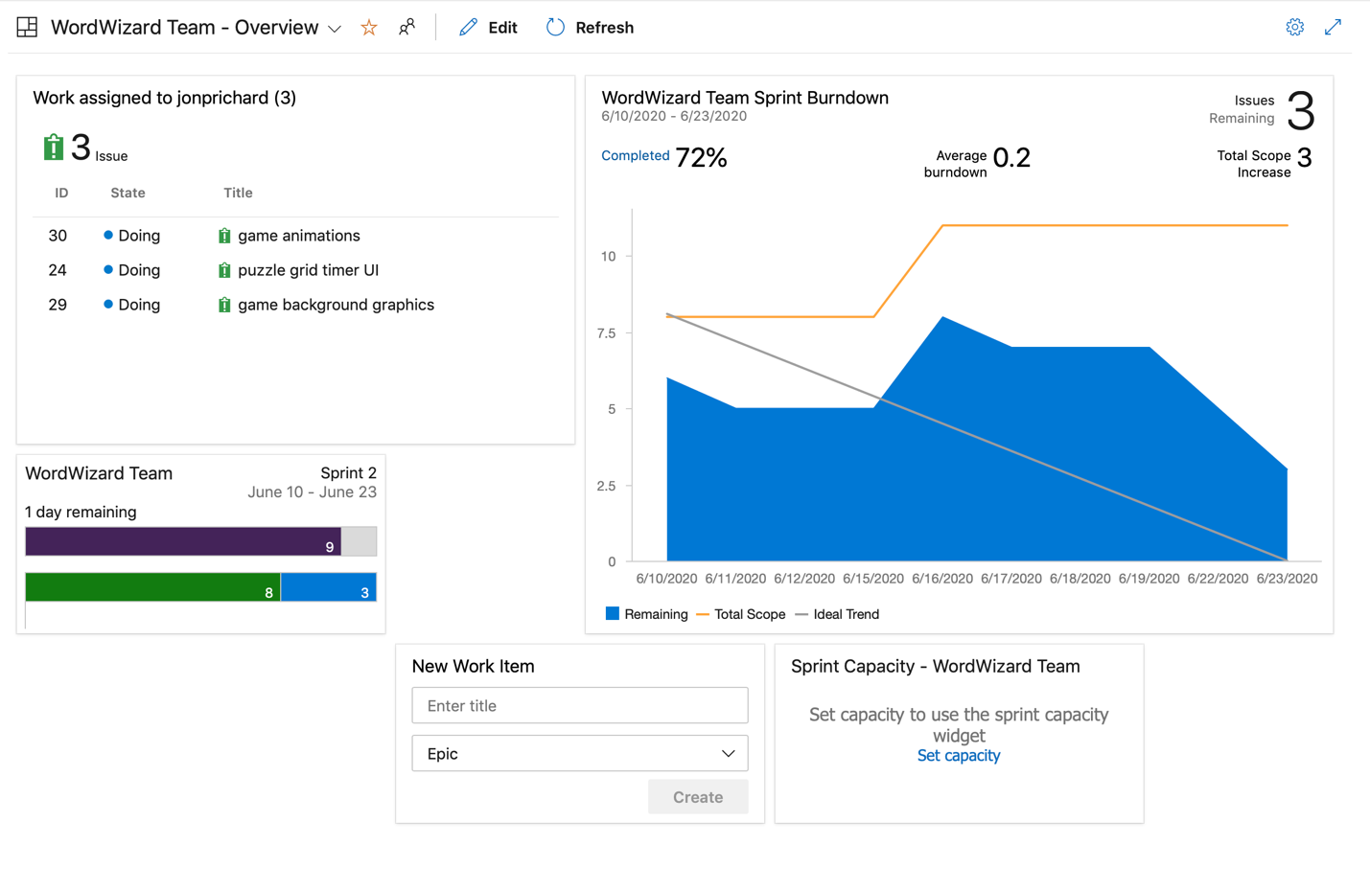

**WordWizard Character Entry Screen (as of 06/23/20)**

