Team Project:

Deliverable 1 - Proposal

CSCE 5430 (Fall 2021)

**Hand-in:**

1. A project title, group name, and group members’ names.

Project title: Hex Army

Group name: Wizard Monkeys

Group members’ name:

1. Jeremy Glebe
2. Prudhvi Krishna Jarabani
3. Jaswanth Korapati
4. Vishnu Sai Konka
5. Anand Paul Kamadana
6. Sravanthi Tummala
7. Vinay Kumar Bathula
8. Haiyi Wang
9. A project description: a detailed description of the system you plan to develop including development environments (language, platform, and so on).

“Hex Army” is a digital strategy board game built on a hexagonal grid. The game will be built primarily as a level-based player vs ai game. The game consists of a player controlling units and attempting to destroy enemy units or achieve level-specific objectives. The game is being written in JavaScript using the Phaser3 engine and a general NodeJS production environment. (CapacitorJS will be used for mobile porting) The final project will be available to play on mobile devices, either in browser or as an app.

1. A top-level plain text document called README that lists the directory (folder) structure of your project directory.

Found on the github repo.

1. A directory (folder) structure that includes areas for the project source code, planning documents, meeting minutes, and project reports.

Found on the github repo.

1. An initial set of meeting minutes (time, attendees, things discussed, and etc.).

Found on the github repo.

1. An initial planning that lays out the big timeline for your project and expected milestones. Include Gantt and/or PERT charts where appropriate. This will be modified in later deliverables. At this point, you do not have enough details to develop a complete plan, but you can do a high-level planning exercise. Please refer to the deliverable deadlines posted on the Canvas to make a plan. Use KanBan board to track the project schedule including each member’s status.

Project has three milestones. (Sep 08-Nov 10)

Milestones:

Milestone 1: Sep 28.

1.1 Environment setup, getting started with JavaScript and Phaser 3

1.2 Develop Level 1 with grid, characters, health monitor, and weapons.

1.3 Find test scenarios

Milestone 2: Oct 20.

2.1 Testing the basic functionality of the game

2.2 Develop three levels with enemy characters moving via a shortest path algorithm

2.3 Graphic design completed

2.4 Data handling (saving game progress)

Milestone 3: Nov 10.

3.1 Fully working game with 5 levels

3.2 Handle platform porting

3.3 Final testing and documentation

Gannt Chart

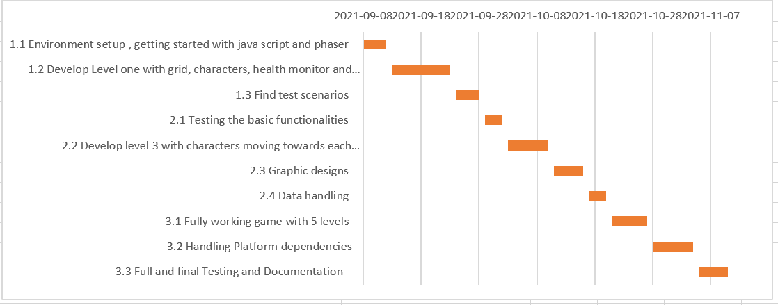

1. Risk management (content described above).

| **Risk** | **Risk Description** | **Risk Management** |
| --- | --- | --- |
| **Code Knowledge** | Lack of coding knowledge and experience. Particularly as it pertains to the language and engine we are using. | Members are responsible for learning on their own time via YouTube, Google, and practice before deadlines.  Group meetings include instructional sessions for newer programmers. |
| **Performance** | Working product below requirement or expectation | Monitor project progress, find difference between actuality and expectation timely and handle it.  Adjust project requirement and schedule |
| **Sickness** | Group members may become ill, especially with the ongoing pandemic. | Always ensure one group member is capable of taking over a task if another becomes ill. Train members as necessary. |
| **Communication** | Lack of timely and efficient communication | Use GitHub, WhatsApp, Zoom, Email to communicate  Regular meeting time, one or two times a week. |

1. A section that describes each team member’s roles for the project.

| Member name | Group role |
| --- | --- |
| Jeremy Glebe | Developer |
| Prudhvi Krishna Jarabani | Developer |
| Jaswanth Korapati | Tester |
| Vishnu Sai Konka | Documentation |
| Anand Paul Kamadana | Documentation |
| Sravanthi Tummala | Tester |
| Vinay Kumar Bathula | Data Handler |
| Haiyi Wang | Project coordinator |

1. Member contribution table (should describe who wrote what parts of the report). Add more rows as needed.

| Member name | Contribution description | Overall Contribution (%) | Note  (if applicable) |
| --- | --- | --- | --- |
| Jeremy Glebe | Project title, group name, project description, README setup, folder structure. | 25% |  |
| Prudhvi Krishna Jarabani | Initial set of meeting minutes, project planning (timeline), risk management elaboration | 25% |  |
| Haiyi Wang | Project planning (Gannt chart), risk management writeup, team member roles writeup. | 25% |  |
| Jaswanth Korapati | Meeting and group discussion participation | 5% |  |
| Vishnu Sai Konka | Meeting and group discussion participation | 5% |  |
| Anand Paul Kamadana | Meeting and group discussion participation | 5% |  |
| Sravanthi Tummala | Meeting and group discussion participation | 5% |  |
| Vinay Kumar Bathula | Meeting and group discussion participation | 5% |  |