West coast U.S. tree species evidence shifts in density but not range

Jeremiah Groom and Vicente Monleon

01 September, 2022

## Abstract

Climate change is associated with shifts in the geographic range of trees and other species globally. In North America and elsewhere the range of tree species are expected to shift at rates of meters to kilometers annually. However, empirically detecting a shift in the range of a tree species may be difficult due to the lack of quality long-term regional or national data. Evidence of range shifts is further confounded by apparently contradictory findings from separate studies that use different methods to evaluate species responses. In this study we examine U.S. Forest Service Forest Inventory Analysis plot revisit data in the states of California, Oregon, and Washington to examine shifts in occupancy and density of tree species relative to temperature and precipitation values using a design-based estimation technique. We also examine changes in plot temperature and precipitation for the ten years between visits. We found that the ranges for 49 tree species seldom shifted in the 10-year period of plot remeasurements but the density of nine out of 30 species generally increased in plots that were initially cooler and drier. Changes in plot temperatures for species were usually best modeled as uniform increases across initial plot temperatures while annual precipitation values could increase or decrease relative to initial plot precipitation values but not necessarily uniformly. These results indicate that the geographical range of tree species of west coast U.S. may not change as quickly as their ecological niches shift, although changes in density within ranges may already be underway. The results also indicate that changes in environmental conditions may differ among and within the range of species.

## Introduction

The rate of vegetation change between 2000 BCE and now is faster than during the post-glaciation period 18,000 years ago and likely caused by human impacts on plant species (Mottl et al. 2021). Scientists have documented recent range shifts for a variety of terrestrial and marine taxa that correspond to a changing climate; e.g., latitudinal or elevation range shifts or changes in densities or cores within ranges (see references in Lenoir and Svenning 2015). For tree species, proximate climate-related drivers of range shifts may reduce species’ ranges. These drivers include insect and disease outbreaks and an increase in wildfire prevalence (Stanke et al. 2021, see references in Weed et al. 2013, Jolly et al. 2015). Species range shifts can even occur in climatically unexpected directions such as towards lower elevations or latitudes (Lenoir et al. 2010). For trees, such shifts may be due to anthropogenic causes aside from climate change (e.g., fire suppression; Minnich et al. 1995, Dolanc et al. 2014). Although tree-range modeling broadly indicates that North American tree species should directionally migrate towards previously cooler regions (McKenney et al. 2007, Iverson et al. 2008, Loarie et al. 2009) and distributional shifts within ranges appear widespread (Fei et al. 2017, Murphy et al. 2010), there is scant empirical evidence that ranges are currently directionally shifting towards previously cooler regions (Zhu 2012, Sittaro 2017, Woodall 2018).

Modeling studies indicate that the ecological niches of many tree species in North America may shift substantially in the coming decades (McKenney et al. 2007, Iverson et al. 2008). Serra-Diaz et al. (2014) modeled climate-related range shifts for eight oak (*Quercus*) and pine (*Pinus*) species in California over the next 80 years and estimated that range-shift velocities would be affected by terrain, with species inhabiting relatively flat terrain experiencing faster range shifts than those in steep terrain. Loarie et al. (2009) found the same topographical relationship for the speed of temperature change within biomes, with mountainous biomes shifting on average by 0.08 km/yr while flatter biomes (mangroves, deserts, grasslands) shifting by 1.26 km/yr over the next 80 years. It is imperative that we determine whether tree species (and others) can shift their ranges with sufficient speed to match the changes underway in their niche space; otherwise, species may face substantial range contractions (McKenny et al. 2007, Iverson et al. 2008) and require management interventions to overcome dispersal barriers.

Empirically detecting shifts in tree species’ distributions and ranges is challenging because analyses based on tree plot data collected using a geographically widespread and probabilistically-based sample design with consistent measurement protocols at the same plots across many years is rare. Sampling designs and data-collection protocols enacted by governments, research institutions, or other organizations may change over time, lack methodological consistency across political boundaries, and not sample plots probabilistically. Consequently, several analytical approaches have been used to evaluate evidence of recent tree species range shifts.

One method compares the distribution of seedlings or saplings relative to adults (Sittaro et al. 2017, Zhu et al. 2012, Monleon and Lintz 2015, Woodall et al. 2013, 2018). The Migration Hypothesis (Zhu et al. 2014) predicts that the range of seedlings may shift into previously unoccupied, but newly favorable, areas and out of regions that have become unsupportive of that life stage (. This type of analysis has been done primarily by examining plot occupancy of seedlings or saplings and adults within longitudinal strips and then predicting responses by estimating means of range limits for each age type. Latitude serves as a proxy for a climate-change signal in these studies, and may be justified as models (McKenney et al. 2007, Iverson et al. 2008) indicate that climate change may be expected to result in northerly range shifts. However, seedling or saplings and adult distributions do not necessarily behave as predicted when analyses of their distributions are performed using revisit data. Sittaro et al. (2017) found evidence of seedling ranges shifting northward at a more rapid pace than adults, but they did not find that seedling ranges extended farther north than the range of adults. Woodall et al. (2018) similarly found seedlings south of adults. Zhu et al. (2014) proposed the Turnover Hypothesis to explain observed patterns: warmer and wetter conditions could increase turnover rates, promoting elevated rates of mortality and recruitment. Their analysis of 65 species in the eastern United States supported the Turnover Hypothesis over the Migration Hypothesis. Regardless, using the longitudinal strip method, Zhu et al. (2012) and Woodall et al. (2013, 2018) compared differences in the distributions between seedling/sapling and adult populations in the eastern United States but did not find evidence that the ranges of many species were shifting northward (but see Sittaro et al. 2017).

Another approach for evaluating the response of species to a changing climate is to quantify distribution shifts within ranges towards more habitable range edges instead of quantifying range edge changes (Kelly and Goulden 2008). Fei et al. (2017) and Murphy et al. (2010) found shifts in plot abundance and occupancy within tree species’ ranges in the eastern United States northward (Murphy et al.) or northward and/or westward (Fei et al.). Although these analyses do not capture changes in species geographical extents, they may be more sensitive to initial shifts in distribution. Observing distributional shifts within ranges instead of shifts in range edges may indicate that a species lacks the ability to adjust to climatic shifts (Liang et al. 2018).

Monleon and Lintz (2015) used an analytical methodology that examined design-based estimates of mean seedling vs. mature tree distributions across California, Washington, and Oregon along gradients of elevation, latitude, and average temperatures of sampling plots. Across species they found seedlings to inhabit cooler plots (based on plot means of temperatures from 1970 - 2000) than mature trees. By using plot temperature instead of latitude or elevation they avoided assumptions inherent in relying on either latitude or elevation as proxies for temperature. Their findings appear to contradict those of Zhu (2012) and Woodall et al. (2013, 2018) who did not find similar range shifts.

Research focused on range expansion of species with seedlings trailing adults (Fei et al. 2017, Sittaro et al. 2017, Woodall et al. 2018), appear counterintuitive or contradictory. The Lenoir and Svenning (2015) literature review concluded that multifaceted approaches are needed when forecasting biodiversity responses to climate in order to provide comprehensive assessments of shifts in species ranges. They recommend that researchers examine the response at trailing and leading edges of species’ ranges as well as the “optimum” within-range habitat (i.e., abundance). They also recommend that these features be examined along latitudinal, elevational, and longitudinal gradients.

Over the last decade the U.S. Forest Service Forest Inventory and Analysis Program (FIA) has repeated the collection of tree and other vegetation data from the same set of field plots on a 10-year cycle. Similar to Monleon and Lintz (2015), this study capitalizes on the probabilistic FIA sampling design and develops design-based estimates to examine changes in two metrics of treedistributions. We also examine average annual plot precipitation [and temperature?] values relative to our tree distribution metrics. By utilizing revisit data and design-based estimates, this study avoids model-based estimation assumptions, the use of proxy environmental gradients (latitude, elevation), and can directly assess changes over time instead of relying on interpretations of population features such as seedling and adult distributions.

The goal of this analysis was to evaluate the data available for the states of Washington, Oregon, and California, USA, for evidence of distribution responses for individual species of trees.. This study used a modified version of the analytical approach used by Monleon and Lintz (2015) and integrated the same pool of vegetation sampling plots.

We examined distribution responses of tree species through the use of two metrics, The first metric analyzes shifts in patterns of occupied plots between two measurement events, hereafter referred to as “occupancy shifts” and the second metric analyzes changes in the number of trees per plot, relative to change in the average annual temperature and precipitation of the populations of plots between the first and second visit, hereafter referred to as “density shifts.”

The objectives of the analyses that follow include 1) side-by-side comparisons of two metrics that represent the response of individual species of trees to temperature and precipitation across their geographic ranges within the western USA. The consistent remeasurement of plots and trees allowed 2) evaluation of the pattern of change in temperature and precipitation for each species and 3) consider how those changes influenced the observed responses in distribution.. 4) Create a data visualization dashboard to allow users to explore the outcomes of the analysis, compare results under different scenarios, and examine data by and across species. (dashboard; <https://tinyurl.com/yc8cf4k9/>).

## Methods

This study used the US National Forest Inventory datasets for all forestland in California, Washington, and Oregon, USA. The field data were collected by the FIA which generally defines forestland as an area greater than 4,050 m $​^{2}$ at least 10 percent stocked or potentially stocked with tree species, excluding urban and agricultural land uses (Reams et al. 2005). The FIA sampling design consists of a spatially balanced probability sample. The standard density of FIA plots is one ground plot every 24 km $​^{2}$. Plots were initially measured in California and Oregon between 2001 and 2010 while Washington plots were measured between 2002 and 2011. We only had access to remeasurement data between 2011 and 2019, or nine year-pairs of measurements for California and Oregon and eight for Washington (2012-2019). Consequently, the plot density for Oregon and California is one plot every 26.7 km $​^{2}$ and one plot every 30 km $​^{2}$ for Washington. To account for this difference we post-stratified the FIA plots into 25 levels based on different densities of plots among states and ancillary information such as land classification and ownership. The stratification was used as a weighting scheme for estimating the domain sampling mean annual temperature…..

The total sample size was 42,963 plots, of which 21,905 were forested and 2,745 could not be measured, because the landowner denied access or because the plot was unsafe to reach or occupy (Figure 1). A plot configuration consists of three points spaced 36.6m from a fourth center point and offset 120˚. Plots containing forest land were installed and measured by field crews. At each of the four points within a plot, trees with stem diameter greater than or equal to 12.7 cm were tallied in a 7.32 m radius circular subplot (total area 672.5 m $​^{2}$). Crews also measured trees in macroplots (18m radius including the subplot at its center) and microplots (2.1m diameter plots within subplots where seedlings and saplings were measured). For most species, stem diameter was measured at 1.37 m above the ground. Bechtold and Scott (2005) provide plot design details and measurement protocols.

### *Data*

The plot and tree data for this analysis were obtained from the Pacific Northwest Forest Inventory and Analysis Database (<https://www.fs.usda.gov/pnw/page/pnw-fia-inventory-data/>, accessed August 2022). Specifically, we relied on the TREE, PLOT, and COND tables. We imported the data into R 4.0.5 (R Core Team 2021). The analysis makes use of all FIA plots in the sample regardless of whether they were occupied by target species. We summarized the tree data to tally the number of live trees present for each species during each visit.

We only included tree data from plots in Oregon, Washington, and California that were visited twice between 9 and 11 years apart (2001-2009 and 2011-2019). We included all individuals with diameters greater than 12.7 cm and excluded all trees ≥ 18.3m (60 feet) away from plot.

For the occupancy-shift analysis we included macroplot data but excluded trees ≥ 7.3m (24 feet) from plot centers with DBH values between 61.0cm (24 inches) and 76.2cm (30 inches) because these trees were tallied differently depending on the region in which the plots were located (Thompson 2015).

In the density-shift analysis we excluded all macroplot trees to standardize interpretations of tree density. We removed *Cercocarpus ledifolius*, *Acer glabrum*, *Prunus emarginata*, and eight willow species from the analysis as these species often exhibit a shrub growth form. We also removed all trees that had been erroneously included in earlier surveys (e.g., they were located outside of plots). We coded *Abies shastensis* as *Abies magnifica* because *A. shastensis* is a hybrid. We omitted all plots with trees reported on non-forest land during both plot visits.

We included only those trees that were alive during both visits, alive at the first visit and then dead at the second, and those that reached a DBH > 12.7cm in the plot at the second visit. We reviewed all trees that had species name changes between visits to and selected the species name from the second visit as a species name change requires crew members to intentionally change the species code from what was recorded at the first visit.

Some larger-diameter trees appeared during the second visit but were not coded as missed during the first visit. If the diameter of these trees was greater than 12.7 cm plus the 99th percentile of the amount of growth observed for that species, they were coded as alive during both periods; otherwise, they were coded as ingrowth.

For the occupancy-shift analysis, a plot containing a species was coded as having the species present during both visits, completely dying out, or appearing as ingrowth within the plot. If trees that were previously alive and thenwere dead by the second revisit but ingrowth of the same species appeared, the plot was coded as containing the species alive for both visits.

For the density change analysis, the number of live trees for a species was considered during the first and second visit and a plot was labeled as having more, fewer, or the same number of live trees across visits.

We validated species identifications by comparing occupied plot distributions against species range maps. Species ranges were checked against the United States Department of Agriculture Natural Resources Conservation Service PLANTS database (<https://plants.usda.gov>, accessed August 2022) and specimen record locations provided by Discover Life (<https://www.discoverlife.org/>, accessed August 2022).

The mean annual temperature and precipitation values for each plot were derived from the spatially gridded (800 m) parameter-elevation regressions on independent slopes model (PRISM; Daly et al. 2008). We used PRISM values for the ten years prior to the first visit to each plot up to and including thesecond visit to create slope and intercept time series linear regression models with temperature and precipitation as dependent variables. e used the regression models to obtain predicted values for temperature and precipitation at the first and second visit.. This analysis assumes that the values for mean annual temperature and precipitation coinciding with the first visit represent valid indices of current conditions.It also assumes that plots have warmed in an approximately linear and constant fashion across species’ ranges, as did Monleon and Lintz (2015). However, we did not assume any pattern of how precipitation would change across species’ ranges.

We used the value of change in temperature and precipitation between the first and second visit relative to the values of the first visit to evaluate the assumptions for temperature and then to explore the pattern of changein precipitation.

### *Analysis*

We followed standard survey sampling procedures (Särndal et al. 1992) from a continuous population perspective (Cordy 1993). For the occupancy-shift analysis we computed an approximate design unbiased estimator of the weighted-domain sampling mean for either annual temperature or precipitation (eqn 8, Appendix 1) for the first and second visit (Scott et al. 2005). The weighted domains were based on the different plot densities among the three states represented in the 25 strata (see above). Because this statistic requires the difference between two ratios we estimated the difference in temperature (or precipitation) as the mean of the second visit minus the mean of the first, calculated as the difference between their respective domain ratio estimators (Wolter 1995; eqn 15, Appendix 1) . We employed the same or similar equations as Monleon and Lintz (2015) to obtain estimates of the variance and confidence intervals (eqns 16 and 17, Appendix 1).

We used a Generalized Least Squares (GLS) approach to estimate the mean difference in temperature or precipitation among all species as the average of differences for individual species, weighted by the inverse of the estimated covariance matrix. We obtained the variance-covariance matrix through bootstrapping because data for the covariance matrix were sparse and the occurrence of species was not independent (independence is lacking when multiple species are found in any given plot; see GLS equations 18 and 19 in Appendix 1).

The density-shift analysis made use of the same analysis procedure as described above except that the difference in plot temperatures (or precipitation) was calculatedby subtracting the valuesofthe set of plots at the first visit from the values of the set of plots that had more and fewer individuals by the second plot visit. This difference again requires a statistic of the difference between two ratios, the weighted domain sampling means of temperatures (or precipitation) for plots that had more and fewer individual trees at the time of the second visit (Appendix 1).

We evaluated species-level shifts in temperature and precipitation across occupied plots by creating two linear spatial error models (R package spatialreg, Bivand and Piras, 2020; Bivand et al. 2021). For the first model we derived point neighborhoods by using Gabriel graphs [that are used to evaluate the pattern of geographic variation with regard to the interconnectedness of the sampling locations where a variable has been measured (Matula and Sokal, 1980)]. In this analysis, the interconnectedness is the…. and the variable being measured is the….

With the second model we assessed spatial autocorrelation with Moran’s I test. For both models the plot-level changes in temperature or precipitation served as a dependent variable. The _______ model was an intercept-only model while the _________ included a slope parameter associated with the first visit temperature or precipitation values. For each species and metric we used AIC values to select between the two models with a preference for the spatial error intercept model unless the slope model was better supported ( $ΔAIC$ < 3) because….

Our analysis did not control for multiple comparisons. Species responses with confidence intervals overlapping with zero were considered not significant but do not necessarily imply a lack of response (Type-II error) and “significant” responses may be spurious (Type-I error). We encourage readers to interpret “significant” individual responses as suggesting that patterns potentially exist.

### *Data visualization*

Our dashboard (<https://tinyurl.com/yc8cf4k9/>) enables viewers to compare different analyses, observe maps of species plot distributions, and view different displays of temperature and precipitation value distributions by species. The dashboard also includes analysis results that make use of second-visit temperature and precipitation values as well as a comparison of variance estimates derived via bootstrap and estimatesapproximated using a Taylor linearization method.

# Results

### *Occupancy shift analysis*

During the first and/or second visit 49 species occupied 15,390 plots in total with each species occupying at least 57 plots at each visit (Table 1). Of the forty nine species, 29 were gymnosperms. For 36 species there was a reduction in the number of plots (range = 1 to 77 plots) that they were recorded in at the second visit , one species with no change, and 13 species with an increase in the number of plots they were recorded in at the second visit (range = 1 to 43 plots).

Twenty three of the species exhibited negative changes in their range-wide plot temperature means between visits, indicating a distributional range shift towards areas that were previously cooler (Figure 2). The remaining 26 species exhibited mean shifts towards plots that were previously warmer. Two of the species had 95% confidence intervals that did not overlap zero, which suggests a significant shift in range. During the second visit *Pseudotsuga menziesii* occupied, on average, plots that were previously warmer, while *Quercus agrifolia* occupied plots that were previously cooler. Two significant findings out of 49 at α = 0.025 is expected to occur by chance alone with abinomial probability of 0.12 or 12 out of 100 times.

For the precipitation occupancy-shift analysis, 23 species exhibited negative changes between visits in precipitation which suggests a shift toward plots that were previously drier. The only species with a 95% confidence interval that did not overlap zero was Port Orford cedar (*Chamaecyparis* lawsoniana) (Figure 2)whichsuggests a shift in range towards plots that previously received more annual precipitation (i.e., wetter plots). One significant finding out of 49 can be expected to occur by chance alone about 35 times out of 100(?).

Indeed, the 95% confidence intervals for the GLS means across all species for temperature and precipitation were very narrow relative to the spread of distributions for individual species but both encompassed zero (Figure 2). These results do not provide evidence of a collective shift of all species towards regions that were previously cooler or wetter. nor do they provide evidence of an overall shift towards regions that were previously warmer or drier.

### *Density change analysis*

Thirty of the 49 species included in the analysis occurred in at least 60 plots with increases and decreases in the number of individuals of a particular species (Table 1). Twenty of those species were gymnosperms. The species density change analysis for temperature found that for 19 out of 30 species the difference in mean density estimates (higher density plot mean minus lower density plot mean) were negative, indicating density shifts towards plots that were previously cooler (Figure 3). Nine of the species had 95% confidence intervals that did not overlap with zero, suggesting a statistically significant difference at the multiple-comparison unadjusted α = 0.05. The difference in mean temperature for *Pinus contorta* and *Pseudotsuga menziesii* was positive, which is consistent with a density shift towards areas that were previously warmer . Seven species (*Abies concolor, Abies magnifica, Calocedrus decurrens, Pinus ponderosa, Thuja plicata, Acer macrophyllum, Quercus kelloggii*) had a negative mean difference in temperature and 95% confidence intervals that did not include zero, consistent with a density shift towards areas that were previously cooler. Nine significant findings out of 30 at α = 0.025 is unexpected by chance (binomial p < 0.001). Seven of the nine species exhibiting temperature-associated density shifts were gymnosperms.

The density change analysis for precipitation found that the densities sof nineteen species shifted positively towards previously drier plots (Figure 3). The CI’s for seven of those species (*Abies concolor, Abies grandis, Pinus contorta, Pseudotsuga menziesii, Arbutus menziesii, Quercus garryana, Quercus kelloggii*) did not contain zero. One species, *Quercus douglasii*, had plot densities shift towards plots that were previouslywetter and a 95% CI that did not contain zero. This number of significant findings at α = 0.025 is unlikely due to chance alone (binomial p < 0.001). Four of the eight species with density shifts associated with precipitation were gymnosperms.

The overall GLS estimates for the mean difference in temperature (and precipitation) between plots that had more and fewer trees was negative in both cases, with confidence intervals that did not include zero (for temperature, mean = -0.057 °C, 95% CI = -0.007 °C to -0.108 °C; for precipitation, mean = -32.044 °C, 95% CI = -18.806 °C to -45.282 °C). Unlike Figure 2, these GLS confidence interval ranges are visible when plotted (Figure 3).

### *Plot changes in precipitation and temperature*

The analysis using the spatial error models found from intercept-only models that temperature and precipitation on average increased (40 and 32 statistically significant intercept values [α = 0.025] out of 49 species, respectively; Table 3). None of the intercept-only models for temperature had statistically significant negative intercept estimates.

A majority of species’ plot precipitation values had positive intercept values that were statistically significant for the intercept-only models, although seven species exhibited significant negative mean values.

The precipitation change models for two species were better fit with positive slopes with precipitation values from the first plot visit while 25 improved with negative slopes. Individual species’ plot temperature and precipitation data along with geographic plot distributions may be accessed in the dashboard.

### *Additional results*

We found as many or more significant species results when the analysis made use of second-visit plot temperature or precipitation values. This occurred when a bootstrap confidence interval was used to estimate variance instead of the Taylor linearization approximation. Some species reported above exhibited confidence intervals that included zero under these other scenarios. These results are viewable at the dashboard. We are not reporting these results further for purposes of brevity and clarity.

# Discussion

We did not find strong evidence of tree species occupancy shifts associated with temperature or precipitation. Shifts in means for individual species towards warmer/cooler or wetter/drier plots were approximately evenly split among species, a finding more firmly established by the GLS confidence intervals (Figure 2). The results for plot density changes demonstrated that for several species their within-plot densities increased in plots that were previously cooler and/or decreased in plots that were previously warmer following a ten-year remeasure period. We found a similar pattern with precipitation, where most “significant” density changes were towards previously drier plots and/or away from previously wetter plots. The GLS findings for the density change analysis indicated that, across species, plots that experienced changes in density were associated with plots that were previously cooler or drier.

The analysis using the spatial error models verified a general assumption that temperatures were increasing across plots, and predominantly found that changes in temperature were generally best modeled as increasing equally across plots regardless of initial plot temperature values. We had no starting expectations regarding how mean annual precipitation would change across species’ ranges. It appears that frequently annual precipitation increased across plots, and that annual precipitation often increased most (or decreased least) in initially drier plots and less so in initially wetter plots. Consequently, the interpretation of the results is uncertain for the occupancy and density changes in relation to temperature and precipitation..

Our design-based analysis did not simultaneously allow for the inclusion of both first-visit plot values and changes in plot values for temperature or precipitation. When considering initial-visit plot temperatures, the spatial error analysis confirmed that we were generally safe to assume that mean temperature increases were even across all plots (although temperature increases were not the same across species). Therefore, interpretation of the analysis did not depend on temperature change as a function of initial plot temperatures. The same was not true for precipitation. Several species, on average, were associated with a decrease in plot precipitation between the first and second visit although mean precipitation values increased for most species. Unlike temperature, plot precipitation change was often negatively associated with first-visit plot precipitation values. A majority of species on average experienced precipitation increases (or less of a decrease) at their initially drier plots. Thus, a shift in a species’ density towards initially drier plots may reflect a density shift towards relatively wetter (where “relatively wetter” = increase in precipitation) plots. This pattern was observed for most “significant” species and may have represented recruitment in portions of species’ ranges that would be most affected by increases in precipitation.

Our findings are roughly consistent with those from other empirically-based analyses of species’ responses to climate change in North America. Tree species’ ranges in eastern North America are not generally shifting (Zhu 2012, Sittaro 2017, Woodall 2018), although the density of species within their ranges may be (Fei et al. 2017, Murphy et al. 2010). Murphy et al. found that eastern U.S. tree species densities were greatest (“leaning” distributions; Breshears et al. 2008) towards the northern (i.e., assumed cooler, but see Figure 1A in Fei et al. [2017]) margins. Fei et al. (2017) found that changes in moisture appeared to be a stronger driver of species’ density shifts than temperature, and that angiosperm densities appeared more related to moisture than temperature while gymnosperms were the opposite. We did have more angiosperms exhibit temperature-associated density shifts than gymnosperms, but with precipitation changes our results were inconsistent with those of Fei et al. as we found equal numbers of angiosperms and gymnosperms exhibiting precipitation-associated density shifts.

Density analysis results for two species were at odds with findings from Monleon and Lintz (2015). We found that plot densities were generally increasing in cooler plots for *Abies concolor* and *Calocedrus decurrens.* However, Monleon and Lintz (2015) found that the seedlings of these species occupied warmer plots on average than mature trees. The Turnover Hypothesis (Fei et al. 2017) may account for the discrepancy, as potentially seedlings of both species may be germinating but failing to survive in previously warmer, wetter plots. Another non-exclusive explanation is that seedlings of both species may have appeared in warmer areas as a consequence of their shade tolerance and fire intolerance as a byproduct of fire suppression efforts (Minnich et al. 1995, Dolanc et al. 2014). These seedlings may have failed to thrive in the expanded range, or conceivably recent fires since the mid-2000s have changed the distribution of seedlings.

Species occupancy shift models indicate that, given predicted and observed climatic changes, we should expect tree species’ ranges to shift over time (Iverson et al. 2008, Serra-Diaz et al. 2014). The west coast states of the continental United States have been affected by conditions that generally differed from those in the 20 $​^{th}$ century, which may have an effect on the distribution of species. All three states have been experiencing increasing frequencies of droughts (Ficklin et al. 2015), wildfires (Westerling et al. 2006), and impacts from pests in non-coastal mountain ranges (Hicke et al. 2016). Hydrologic regimes have shifted in all three states, with longer summer and fall periods of minimal precipitation (Holden et al. 2018), smaller snowpacks, and shorter snowpack durations (Mote et al. 2017). Temperatures have generally increased in all three states (Westerling et al. 2006, Abatzoglou 2014). We therefore presume that many of the species we examined are experiencing conditions that make persistence in many places more difficult. However, our analysis failed to detect actual range shifts.

There may be several non-exclusive explanations for our lack of range-shift detection. One explanation is that our analysis lacked statistical power. The analysis tested the data for evidence of range shifts based on revisited plots that a species appeared or disappeared entirely given a revisit period of 10 years. This revisit time period may have been too short given the occupancy-shift metric we were applying. Monleon and Lintz (2015) may have detected initial range-shifts by examining seedlings which then failed, within our study’s timeframe, to manifest as colonization by trees. In other words, the species in this analysis may not be capable of migrating as quickly as the shift in their ecological niche, rendering our occupancy-shift detection approach inconclusive within the short 10-year revisit period.

Geographical changes of tree species may be constrained if species ranges abut and intermingle with other tree species ranges. Zhu (2012), Sittaro et al. (2017), and Woodall et al. (2018) performed range-shift analyses in eastern North America and similarly did not find strong evidence of plot occupancy range shifts of trees. This same constraint may enable within-range density shifts, observed in this study and by Fei et al. (2017) and Murphy et al. (2010). Liang et al. (2018) modeled the ability of trees to migrate in the northeastern US given existing forest cover and fragmentation. They found that it was unlikely that species could shift their ranges fast enough to match the velocity of change in their ecological niche associated with by projected changes in climate. They explain that it may be difficult for seeds to disperse into previously marginal habitat and germinate under an existing forest canopy, and compete for light against existing seedlings. Even with substantial disturbance, Liang et al. hypothesize that existing seed banks may out-compete incoming seeds. Similarly, existing seedbanks may enable density increases at the favorable margins of a species’ range.

A final explanation is that our range-shift analysis used possibly useful but incomplete metrics. Monleon and Lintz (2015) established that examining species shifts in west-coast USA states with previous plot temperature averages was likely superior to using elevation or latitude as proxies for climate change. Our species range-shift examination relied on a similar temperature metric and examined range-shifts relative to a precipitation metric. It may be that other metrics would better capture actual species range shifts, including different quantifications of temperature and precipitation. Other metric possibilities include pathogen and wildfire extent (e.g., using information similar to Hicke et al. 2016) and other species-specific habitat metrics (e.g., land use habitat modification; Lenoir et al. 2010).

A closer consideration of density change analysis for(?) species with atypical findings highlights certain issues and complexities that confound broad-scale interpretations of our findings across species. One issue is that a species may experience different ecological pressures across its range. For instance, we found that *Pinus contorta* and *Pseudotsuga menziesii* both shifted in density towards previously warmer and drier areas. Both species appeared to experience, on average, elevated precipitation in the initially drier plots, potentially enhancing recruitment relative to initially wetter plots. We found the density shifts towards initially warmer plots surprising. *P. contorta* is expected to lose habitat in the future as a consequence of climate change (Coops and Waring 2011), although subspecies may respond differently from one another and may potentially be able to undergo range expansion (Oney et al. 2013). Similarly, Bell and Gray (2016) found that warmer and wetter regions were conducive for positive changes in *P. menziesii* biomass while different factors elsewhere in the species range promoted biomass increases. Therefore, the results from the occupancy shift and density shift analysis for these species (and others) may be overly simplistic, as our results likely blend the effects of different regional ecological pressures (see citations in both Lenoir et al. 2010 and Lenoir and Svenning 2015). In effect, given the broad geographic sample of plots, the findings for some species (whether positive or negative associations with temperature and precipitation) may represent examples of Simpson’s Paradox, combining different sub-regional responses into a potentially misleading overall response.

Another issue is that species may encounter different environmental pressures, complicating interspecific generalizations or comparisons. *Quercus douglasii* exhibited a density shift towards initially wetter plots, unlike other species with “significant” density shifts related to precipitation. This shift may have been predominantly driven by drought conditions, as precipitation generally decreased across the plots it inhabits and plots that were previously drier may have been more susceptible to drought stress. We note for this species that regions with the lowest initial precipitation (see dashboard) matched areas of dieback (see Figure 1 in McLaughlin et al. 2020). Additionally, the actual response of the species may have been driven mainly or in part by changes in subsurface hydrology in addition to changes in precipitation (McLaughlin et al. 2020). We find several considerations here: Observed changes in precipitation were neither unidirectional across species nor always constant across plots within species’ ranges. Thus, changes in precipitation may indeed be affected by climate change but vary in frequency and magnitude regionally.. For the plots inhabited by *Quercus douglasii* there was a decrease in precipitation while for other species there was an increase in precipitation that varied in magnitude. Also, environmental variables such as mean annual temperature and precipitation alone are incomplete factors that influence the geographic range of species distribution. The interaction of temperature and precipitation might also be important along with a variety of ecological conditions that can affecting the distribution of a species.

We anticipate that future FIA plot revisit data sets will enable analyses with greater ability to detect and quantify changes in species’ ranges. More time will pass for the environment to change and for species to respond. Analyses with data from the third remeasurement cycle of FIA plots may be more conclusive for the occupancy-shift analysis if predictions for changes in temperature and precipitation stay consistent with observations. . Nonetheless, the first set of revisit data provides the information to develop and test analytical methods for detecting and quantifying changes in geography of individual species. Future analysis must also include factors such as the prevalence and distribution of pests and diseases, impacts of fire and harvest, regional differences in tree growth, and size- or age-related mortality patterns.

## Conclusion

These findings indicate that geographical range of tree species within the contiguous west coast states of the US have not experienced profound shifts in response to the temperature and precipitation metrics used in this analysis, although the density of individuals for some species may be changing within the range they currently exist. There may be several reasons why a shift in tree species range was not detected. However, of critical importance is that the species we examined so far did not demonstratee a change in distribution concomitant with the velocity of ecological niche shifts currently driven by climate change. Given the expected changes in geographical niches, these findings point towards contractions in species ranges (McKenney et al. 2007).

The summaries in this study of species range and density shifts across large geographical areas in relation to plot precipitation and temperature values provide information that is useful across a large-scale of geography to managers and researchers. The results of this analysis are best interpreted at the level of individual species provided by the analytical dashboard in combination with autecological information.

## Literature Cited

Abatzoglou, J.T., Rupp, D.E. and Mote, P.W., 2014. Seasonal climate variability and change in the Pacific Northwest of the United States. Journal of Climate, 27(5), pp.2125-2142.

Araujo, M.B., New, M. 2006. Ensemble forecasting of species distributions. Trends in Ecology and Evolution. Vol 22, No. 1: pp. 42-47

Bechtold, W.A., and C.T. Scott. 2005. The Forest Inventory and Analysis plot design. In: The Enhanced Forest Inventory and Analysis Program – National Sampling Design and Estimation Procedures, W.A. Bechtold and Paul L. Patterson, Ed. United States Department of Agriculture Forest Service General Technical Report SRS-80.

Bell, D.M. and Gray, A.N., 2016. Assessing intra-and inter-regional climate effects on Douglas-fir biomass dynamics in Oregon and Washington, USA. Forest Ecology and Management, 379, pp.281-287.

Bivand, R., G. Millo, and G. Piras. 2021. “A Review of Software for Spatial Econometrics in R.” Mathematics, 9(11)

Bivand, R.; Piras, G. Spatialreg: Spatial Regression Analysis. 2020. Available online: <https://CRAN.R-project.org/package=spatialreg> (accessed on 9 August 2022).

Breshears, D.D., Huxman, T.E., Adams, H.D., Zou, C.B. and Davison, J.E., 2008. Vegetation synchronously leans upslope as climate warms. Proceedings of the National Academy of Sciences, 105(33), pp.11591-11592.

Coops, N.C. and Waring, R.H., 2011. A process-based approach to estimate lodgepole pine (Pinus contorta Dougl.) distribution in the Pacific Northwest under climate change. Climatic Change, 105(1), pp.313-328.

Cordy, C.B., 1993. An extension of the Horvitz—Thompson theorem to point sampling from a continuous universe. Statistics & Probability Letters, 18(5), pp.353-362.

Daly, C., M. Halbleib, J.I. Smith, W.P. Gibson, M.K. Doggett, G.H. Taylor, J. Curtis, and P.P. Pasteris. 2008. Physiographically sensitive mapping of climatological temperature and precipitation across the conterminous United States. International Journal of Climatology: a Journal of the Royal Meteorological Society, 28(15), pp.2031-2064.

Dolanc, C.R., Safford, H.D., Dobrowski, S.Z. and Thorne, J.H., 2014. Twentieth century shifts in abundance and composition of vegetation types of the S ierra N evada, CA, US. Applied Vegetation Science, 17(3), pp.442-455.

Fei, S., Desprez, J.M., Potter, K.M., Jo, I., Knott, J.A. and Oswalt, C.M., 2017. Divergence of species responses to climate change. Science Advances, 3(5), e1603055.

Ficklin, D.L., Maxwell, J.T., Letsinger, S.L. and Gholizadeh, H., 2015. A climatic deconstruction of recent drought trends in the United States. Environmental Research Letters, 10(4), 044009.

Hicke, J.A., Meddens, A.J. and Kolden, C.A., 2016. Recent tree mortality in the western United States from bark beetles and forest fires. Forest Science, 62(2), pp.141-153.

Holden, Z.A., Swanson, A., Luce, C.H., Jolly, W.M., Maneta, M., Oyler, J.W., Warren, D.A., Parsons, R. and Affleck, D., 2018. Decreasing fire season precipitation increased recent western US forest wildfire activity. Proceedings of the National Academy of Sciences, 115(36), pp.E8349-E8357.

Iverson LR, Prasad AM, Matthews SN, Peters M (2008) Estimating potential habitat for 134 eastern US tree species under six climate scenarios. Forest Ecology and Management, 254, 390–406.

Jolly, W.M., Cochrane, M.A., Freeborn, P.H., Holden, Z.A., Brown, T.J., Williamson, G.J. and Bowman, D.M., 2015. Climate-induced variations in global wildfire danger from 1979 to 2013. Nature communications, 6(1), pp.1-11.

Kelly, A.E. and Goulden, M.L., 2008. Rapid shifts in plant distribution with recent climate change. Proceedings of the National Academy of Sciences, 105(33), pp.11823-11826.

Lenoir, J., Gégout, J.C., Guisan, A., Vittoz, P., Wohlgemuth, T., Zimmermann, N.E., Dullinger, S., Pauli, H., Willner, W. and Svenning, J.C., 2010. Going against the flow: potential mechanisms for unexpected downslope range shifts in a warming climate. Ecography, 33(2), pp.295-303.

Lenoir, J. and Svenning, J.C., 2015. Climate-related range shifts–a global multidimensional synthesis and new research directions. Ecography, 38(1), pp.15-28.

Liang, Y., Duveneck, M.J., Gustafson, E.J., Serra-Diaz, J.M. and Thompson, J.R., 2018. How disturbance, competition, and dispersal interact to prevent tree range boundaries from keeping pace with climate change. Global Change Biology, 24(1), pp.e335-e351.

Loarie, S.R., Duffy, P.B., Hamilton, H., Asner, G.P., Field, C.B. and Ackerly, D.D., 2009. The velocity of climate change. Nature, 462(7276), pp.1052-1055.

Matula, D.W., and Sokal, R.R., 1980. Properties of Gabriel Graphs Relevant to Geographic Variation Research and the Clustering of Points in the Plane. Geographical Analysis vol. 12, no. 3: 205-222

McKenney DW, Pedlar JH, Lawrence K, Campbell K, Hutchinson MF (2007) Potential impacts of climate change on the distribution of North American trees. BioScience, 57, 939–948.F22

McLaughlin, B.C., Blakey, R., Weitz, A.P., Feng, X., Brown, B.J., Ackerly, D.D., Dawson, T.E. and Thompson, S.E., 2020. Weather underground: Subsurface hydrologic processes mediate tree vulnerability to extreme climatic drought. Global Change Biology, 26(5), 3091-3107.

Minnich, R.A., Barbour, M.G., Burk, J.H. and Fernau, R.F., 1995. Sixty years of change in Californian conifer forests of the San Bernardino Mountains. Conservation Biology, 9(4), pp.902-914.

Monleon, V.J., and H.E. Lintz. 2015. Evidence of tree species’ range shifts in a complex landscape. PLoS One, 10(1), p.e0118069.

Mote, P.W., Li, S., Lettenmaier, D.P., Xiao, M. and Engel, R., 2018. Dramatic declines in snowpack in the western US. Climate and Atmospheric Science, 1(1), pp.1-6.

Mottl, O., Flantua, S.G., Bhatta, K.P., Felde, V.A., Giesecke, T., Goring, S., Grimm, E.C., Haberle, S., Hooghiemstra, H., Ivory, S. and Kuneš, P., 2021. Global acceleration in rates of vegetation change over the past 18,000 years. Science, 372(6544), pp.860-864.

Murphy, H.T., VanDerWal, J. and Lovett-Doust, J., 2010. Signatures of range expansion and erosion in eastern North American trees. Ecology Letters, 13(10), pp.1233-1244.

Oney, B., Reineking, B., O’Neill, G. and Kreyling, J., 2013. Intraspecific variation buffers projected climate change impacts on Pinus contorta. Ecology and evolution, 3(2), pp.437-449.

Parmesan, C., Yohe, G., 2003. A globally coherent fingerprint of climate change impacts across natural systems. Nature 421, 37–42.

R Core Team. 2021. R: A Language and Environment for Statistical Computing. R Foundation for Statistical Computing. Vienna, Austria. <https://www.R-project.org>

Reams, G.A, W.D. Smith, M.H. Hansen, W. A. Bechtold, F.A. Roesch, and G.G. Moisen. The forest inventory and analysis sampling frame. In: The Enhanced Forest Inventory and Analysis Program – National Sampling Design and Estimation Procedures, W.A. Bechtold and Paul L. Patterson, Ed. United States Department of Agriculture Forest Service General Technical Report SRS-80.

Särndal CE, Swensson B, Wretman J (1992) Model Assisted Survey Sampling. New York: Springer-Verlag. 694 p.

Scott, C.T., W. A. Bechtold, G.A. Reams, W.D. Smith, J.A. Westfall, M.H. Hansen, and G.G. Moisen. 2005. Sample-based estimators used by the Forest Inventory and Analysis National Information Management System. In: The Enhanced Forest Inventory and Analysis Program – National Sampling Design and Estimation Procedures, W.A. Bechtold and Paul L. Patterson, Ed. United States Department of Agriculture Forest Service General Technical Report SRS-80.

Serra‐Diaz, J.M., Franklin, J., Ninyerola, M., Davis, F.W., Syphard, A.D., Regan, H.M. and Ikegami, M., 2014. Bioclimatic velocity: the pace of species exposure to climate change. Diversity and Distributions, 20(2), pp.169-180.

Sittaro, F., Paquette, A., Messier, C. and Nock, C.A., 2017. Tree range expansion in eastern North America fails to keep pace with climate warming at northern range limits. Global Change Biology, 23(8), pp.3292-3301.

Stanke, H., Finley, A.O., Domke, G.M., Weed, A.S. and MacFarlane, D.W., 2021. Over half of western United States’ most abundant tree species in decline. Nature Communications, 12(1), pp.1-11.

Thompson, J. 2015. PNW-FIADB Users Manual: A data dictionary and user guide for the PNW-FIADB database. Forest Inventory and Analysis, Pacific Northwest Research Station, Portland, Oregon.

Walther, G.-R., Berger, S., Sykes, M.T., 2005. An ecological ‘‘footprint’’ of climate change. Proc. Roy. Soc. London B 272, 1427–1432.

Weed, A.S., Ayres, M.P. and Hicke, J.A., 2013. Consequences of climate change for biotic disturbances in North American forests. Ecological Monographs, 83(4), pp.441-470.

Westerling, A.L., Hidalgo, H.G., Cayan, D.R. and Swetnam, T.W., 2006. Warming and earlier spring increase western US forest wildfire activity. science, 313(5789), pp.940-943.

Wolter, K.M. 1985. Introduction to Variance Estimation. New York: Springer-Verlag. 427 p.

Woodall, C.W., Westfall, J.A., D’Amato, A.W., Foster, J.R. and Walters, B.F., 2018. Decadal changes in tree range stability across forests of the eastern US. Forest Ecology and Management, 429, pp.503-510.

Woodall, C.W., Zhu, K., Westfall, J.A., Oswalt, C.M., D’amato, A.W., Walters, B.F. and Lintz, H.E., 2013. Assessing the stability of tree ranges and influence of disturbance in eastern US forests. Forest Ecology and Management, 291, pp.172-180.

Zhu, K., Woodall, C.W. and Clark, J.S., 2012. Failure to migrate: lack of tree range expansion in response to climate change. Global Change Biology, 18(3), pp.1042-1052.

Zhu, K., Woodall, C.W., Ghosh, S., Gelfand, A.E. and Clark, J.S., 2014. Dual impacts of climate change: forest migration and turnover through life history. Global change biology, 20(1), pp.251-264.

## Figure Legends

Figure 1. Distribution of 21,905 forested FIA plots in the states of Oregon, Washington, and California.

Figure 2. Estimated mean occupancy-shift temperature and precipitation differences between plot measurements for 49 species. For temperature and precipitation, mean changes greater than zero indicated that the species’ range was on average warmer or wetter, respectively, during the second visit. The two plots include a vertical band representing the 95% GLS confidence interval for estimates of overall temperature or precipitation change among species.

Figure 3. Estimated mean temperature and precipitation differences between plots with more and fewer living trees upon the second visit for 30 species (density shift). Mean changes greater than zero indicated that more trees for a species were found in warmer/wetter plots (and/or fewer trees were found in cooler/drier plots), on average. Both plots include a vertical band representing the 95% GLS confidence interval for estimates of the overall difference in plot temperature or precipitation between plots with more and fewer trees.

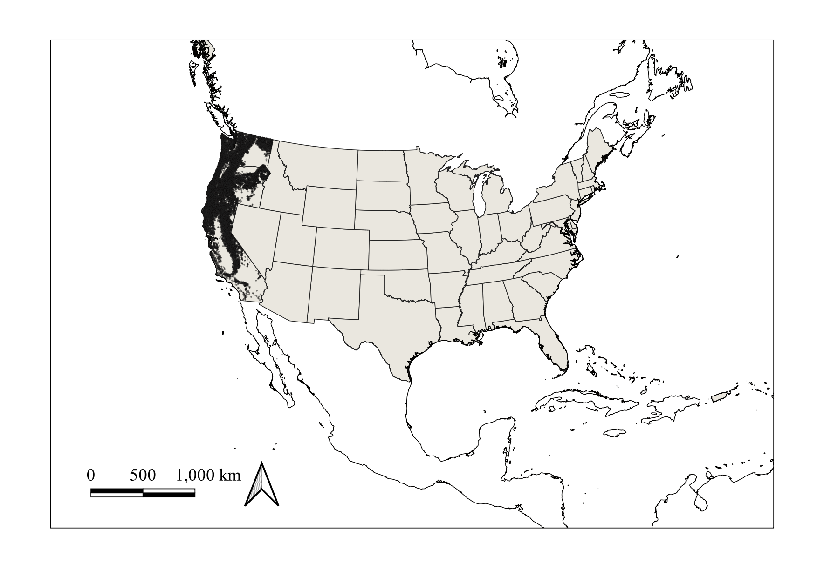

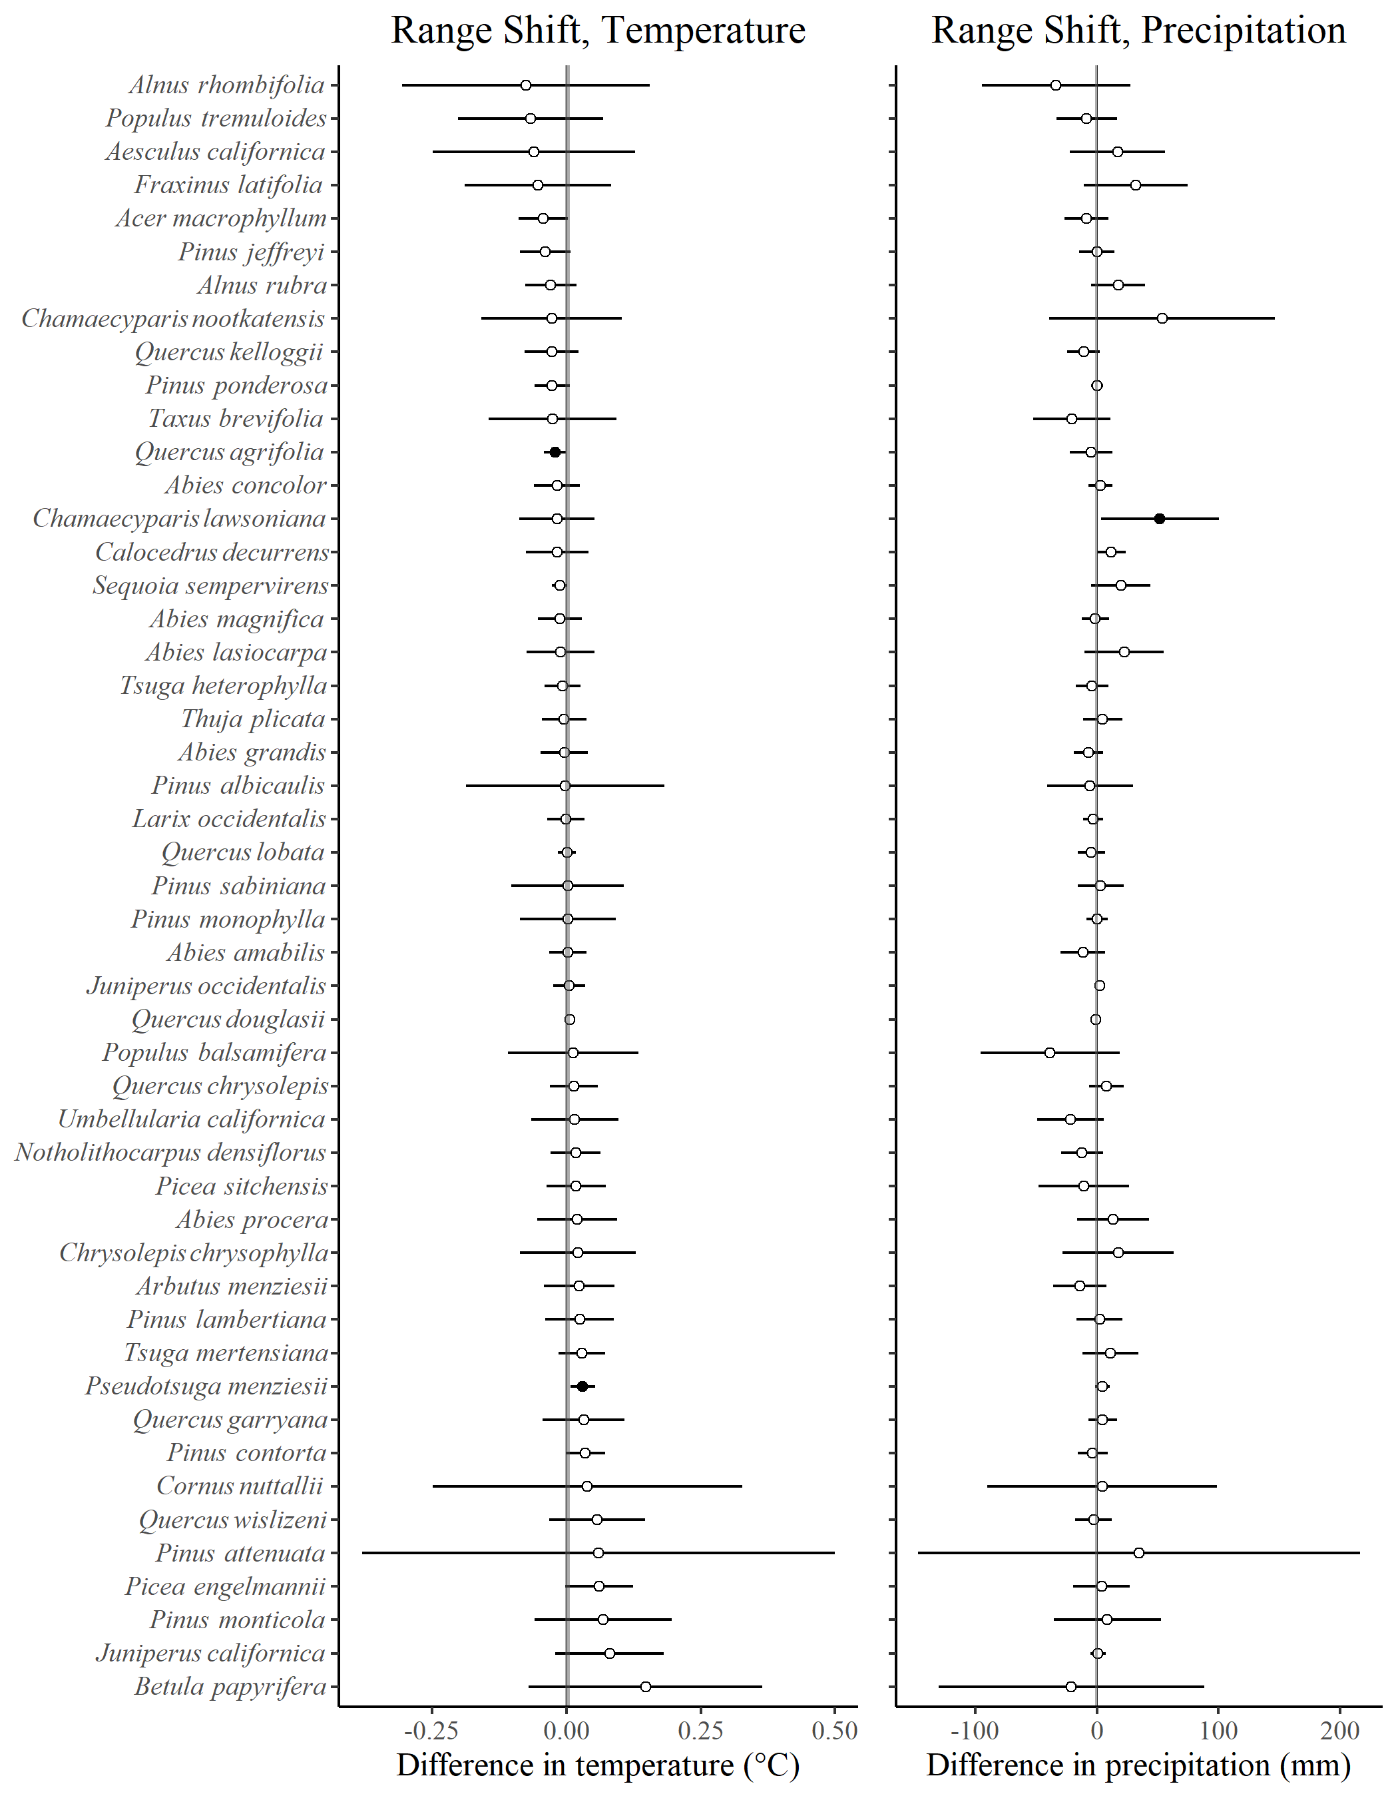

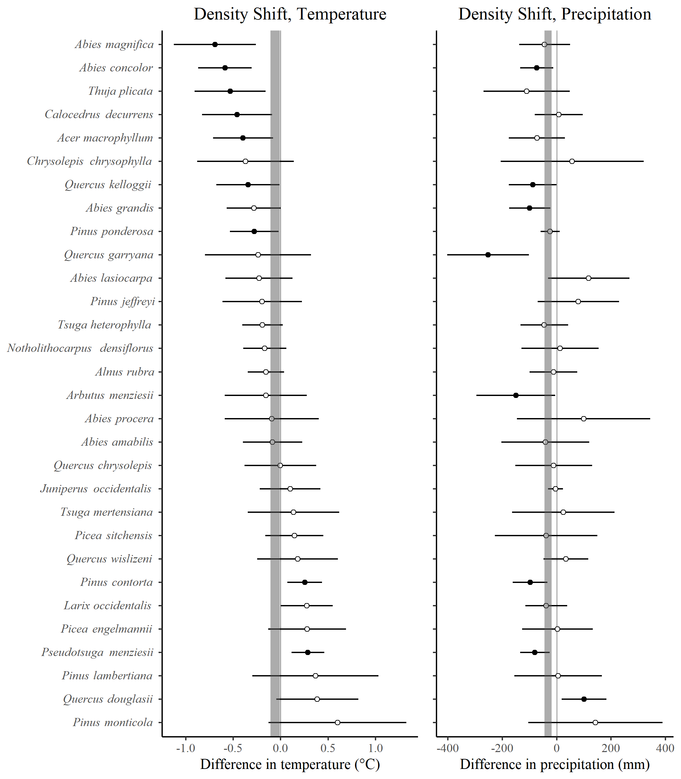

Table 1. Species included in the analysis. The column named Symbol is the FIA species code. Columns named First Visit and Second Visit provide the number of plots occupied by a species during those visits. Columns named Lost and Gained are the number of plots that lost or gained at least one individual of a given tree species.

| Species | Symbol | First Visit | Second Visit | Lost | Gained |
| --- | --- | --- | --- | --- | --- |
| *Abies amabilis* | ABAM | 1163 | 1171 | 365 | 494 |
| *Abies concolor* | ABCO | 2016 | 1954 | 752 | 721 |
| *Abies grandis* | ABGR | 1768 | 1754 | 544 | 693 |
| *Abies lasiocarpa* | ABLA | 774 | 723 | 320 | 266 |
| *Abies magnifica* | ABMA | 579 | 582 | 200 | 165 |
| *Abies procera* | ABPR | 401 | 423 | 83 | 151 |
| *Chamaecyparis lawsoniana* | CHLA | 85 | 81 | 17 | 14 |
| *Chamaecyparis nootkatensis* | CHNO | 112 | 116 | 24 | 23 |
| *Juniperus californica* | JUCA7 | 64 | 65 | 5 | 8 |
| *Juniperus occidentalis* | JUOC | 1020 | 1013 | 130 | 295 |
| *Larix occidentalis* | LAOC | 1059 | 1056 | 278 | 207 |
| *Calocedrus decurrens* | CADE27 | 1329 | 1302 | 309 | 360 |
| *Picea engelmannii* | PIEN | 749 | 704 | 221 | 214 |
| *Picea sitchensis* | PISI | 269 | 261 | 92 | 62 |
| *Pinus albicaulis* | PIAL | 203 | 181 | 77 | 41 |
| *Pinus attenuata* | PIAT | 83 | 77 | 43 | 22 |
| *Pinus contorta* | PICO | 2255 | 2193 | 885 | 868 |
| *Pinus jeffreyi* | PIJE | 637 | 622 | 144 | 154 |
| *Pinus lambertiana* | PILA | 991 | 914 | 227 | 121 |
| *Pinus monticola* | PIMO3 | 604 | 605 | 159 | 144 |
| *Pinus ponderosa* | PIPO | 4581 | 4606 | 1238 | 1425 |
| *Pinus sabiniana* | PISA2 | 195 | 185 | 41 | 46 |
| *Pinus monophylla* | PIMO | 203 | 193 | 56 | 49 |
| *Pseudotsuga menziesii* | PSME | 8269 | 8258 | 2673 | 2731 |
| *Sequoia sempervirens* | SESE3 | 240 | 242 | 48 | 84 |
| *Taxus brevifolia* | TABR2 | 220 | 206 | 44 | 33 |
| *Thuja plicata* | THPL | 1461 | 1487 | 220 | 473 |
| *Tsuga heterophylla* | TSHE | 2745 | 2788 | 823 | 1120 |
| *Tsuga mertensiana* | TSME | 743 | 754 | 184 | 246 |
| *Acer macrophyllum* | ACMA3 | 941 | 941 | 237 | 297 |
| *Aesculus californica* | AECA | 79 | 74 | 25 | 17 |
| *Alnus rubra* | ALRU2 | 1318 | 1286 | 663 | 458 |
| *Alnus rhombifolia* | ALRH2 | 71 | 66 | 28 | 19 |
| *Arbutus menziesii* | ARME | 839 | 803 | 314 | 157 |
| *Betula papyrifera* | BEPA | 80 | 70 | 45 | 16 |
| *Chrysolepis chrysophylla* | CHCHC4 | 345 | 328 | 120 | 108 |
| *Cornus nuttallii* | CONU4 | 95 | 84 | 30 | 26 |
| *Fraxinus latifolia* | FRLA | 57 | 65 | 13 | 29 |
| *Notholithocarpus densiflorus* | NODE3 | 650 | 643 | 279 | 258 |
| *Populus tremuloides* | POTR5 | 119 | 106 | 60 | 23 |
| *Populus balsamifera* | POBAT | 168 | 167 | 30 | 42 |
| *Quercus agrifolia* | QUAG | 199 | 194 | 65 | 33 |
| *Quercus chrysolepis* | QUCH2 | 851 | 821 | 228 | 283 |
| *Quercus douglasii* | QUDO | 340 | 335 | 68 | 60 |
| *Quercus garryana* | QUGA4 | 334 | 332 | 89 | 107 |
| *Quercus kelloggii* | QUKE | 896 | 847 | 327 | 171 |
| *Quercus lobata* | QULO | 62 | 60 | 9 | 5 |
| *Quercus wislizeni* | QUWI2 | 207 | 197 | 86 | 68 |
| *Umbellularia californica* | UMCA | 264 | 277 | 39 | 117 |

Note: Native species not reported above because, for the occupancy shift analysis, they occupied fewer than 50 plots: *Cupressus bakeri, Cupressus sargentii, Cupressus macnabiana, Juniperus osteosperma, Juniperus scopulorum, Larix lyallii, Picea breweriana, Pinus balfouriana, Pinus coulteri, Pinus flexilis, Pinus muricata, Pinus radiata, Pinus sylvestris, Pinus washoensis, Pinus longaeva, Pseudotsuga macrocarpa, Sequoiadendron giganteum, Torreya californica, Acer negundo, Acer platanoides, Ailanthus altissima, Betula occidentalis, Eucalyptus globulus, Fraxinus velutina, Juglans hindsii, Liquidambar styraciflua, Malus fusca, Platanus racemosa, Populus fremontii, Prosopis glandulosa, Prunus virginiana, Prunus avium, Quercus engelmannii, Robinia pseudoacacia*, and *Olneya tesota*.

Table 2. Summary of spatial simultaneous autoregressive error model estimation of changes in plot temperature and precipitation across species’ ranges between the first and second visits (see text). Column “Metric” is the average positive or negative (+, -) change in either temperature or precipitation ($Δ$ T, $Δ$ P). Intercept is the number of significant (p < 0.025) intercept estimates for an intercept-only model. “Slope +/-” is the number of species which were better described with a slope model with positive or negative slope parameter estimates, with the initial visit plot temperature/precipitation value serving as the model’s independent variable.

| Metric | Intercept | Slope + | Slope - |
| --- | --- | --- | --- |
| + $Δ$ T | 40 | 5 | 3 |
| - $Δ$ T | 0 | 0 | 0 |
| + $Δ$ P | 32 | 2 | 16 |
| - $Δ$ P | 7 | 0 | 9 |