Supplemental material for: Tree growth, mortality, and climatic water deficit in west-coast states, USA
Jeremiah D. Groom, Bryce Frank
2026-05-13

Table S1: Decadal diameter growth estimates by state and overall for analysis species (cm/decade). Mean estimates with confidence intervals and plot number are provided. Estimates are not made for states with fewer than 10 plots. Ecological category abbreviations (Category) are provided in the text.
Species Name | Category | California | Oregon | Washington | All
Abies amabilis | STC |  | 2.08 (1.86, 2.35; 199) | 2.46 (2.31, 2.62; 571) | 2.38 (2.25, 2.52; 770)
Abies concolor | HEC | 3.58 (3.48, 3.69; 1198) | 3.53 (3.34, 3.73; 381) |  | 3.56 (3.48, 3.66; 1580)
Abies grandis | STC | 5.74 (4.90, 7.44; 27) | 3.89 (3.68, 4.12; 630) | 3.74 (3.44, 4.06; 385) | 3.88 (3.70, 4.07; 1042)
Abies lasiocarpa | HEC |  | 1.82 (1.63, 2.05; 126) | 1.78 (1.59, 1.98; 343) | 1.78 (1.62, 1.96; 470)
Juniperus occidentalis | DTC | 1.71 (1.57, 1.85; 339) | 1.67 (1.54, 1.82; 460) |  | 1.69 (1.59, 1.79; 799)
Larix occidentalis | FAC |  | 2.47 (2.15, 2.83; 248) | 2.34 (2.13, 2.58; 377) | 2.37 (2.21, 2.55; 625)
Calocedrus decurrens | DTC | 2.64 (2.49, 2.79; 836) | 3.31 (2.97, 3.65; 301) |  | 2.76 (2.62, 2.89; 1137)
Picea engelmannii | HEC |  | 3.45 (3.10, 3.80; 163) | 2.65 (2.42, 2.87; 265) | 2.88 (2.67, 3.10; 429)
Pinus contorta | FAC | 1.70 (1.56, 1.85; 356) | 2.03 (1.90, 2.18; 659) | 1.66 (1.53, 1.83; 322) | 1.86 (1.76, 1.95; 1337)
Pinus jeffreyi | DTC | 2.86 (2.61, 3.12; 648) | 3.29 (1.99, 5.06; 15) |  | 2.85 (2.60, 3.12; 663)
Pinus lambertiana | STC | 3.81 (3.59, 4.05; 710) | 3.68 (3.22, 4.18; 138) |  | 3.79 (3.58, 3.99; 848)
Pinus monticola | FAC | 2.09 (1.89, 2.31; 222) | 2.55 (2.08, 3.05; 128) | 4.01 (3.45, 4.59; 88) | 2.50 (2.30, 2.71; 438)
Pinus ponderosa | DTC | 3.83 (3.54, 4.14; 1126) | 3.28 (3.14, 3.42; 1475) | 3.54 (3.35, 3.72; 671) | 3.49 (3.37, 3.62; 3272)
Pseudotsuga menziesii | FAC | 4.01 (3.85, 4.17; 1428) | 4.64 (4.50, 4.79; 2606) | 4.34 (4.17, 4.50; 2204) | 4.42 (4.32, 4.51; 6238)
Thuja plicata | STC |  | 3.58 (3.20, 4.04; 319) | 3.49 (3.27, 3.73; 745) | 3.51 (3.31, 3.70; 1067)
Tsuga heterophylla | STC | 4.38 (3.10, 6.01; 35) | 3.63 (3.43, 3.81; 769) | 3.29 (3.14, 3.43; 1190) | 3.39 (3.27, 3.51; 1994)
Tsuga mertensiana | HEC | 1.57 (1.40, 1.74; 80) | 1.39 (1.27, 1.53; 224) | 1.55 (1.43, 1.69; 232) | 1.48 (1.39, 1.56; 536)
Acer macrophyllum | RMH | 1.37 (0.96, 1.74; 184) | 3.00 (2.72, 3.30; 348) | 4.26 (3.92, 4.60; 241) | 3.21 (2.99, 3.45; 773)
Alnus rubra | RMH | 3.09 (2.64, 3.56; 56) | 3.40 (3.11, 3.66; 479) | 3.73 (3.49, 3.97; 579) | 3.57 (3.40, 3.74; 1114)
Arbutus menziesii | DTH | 1.74 (1.59, 1.88; 410) | 1.55 (1.42, 1.71; 267) | 1.43 (0.72, 2.61; 13) | 1.64 (1.55, 1.75; 690)
Notholithocarpus densiflorus | DTH | 1.84 (1.74, 1.93; 442) | 1.46 (1.29, 1.65; 122) |  | 1.77 (1.68, 1.87; 564)
Quercus chrysolepis | DTH | 1.13 (1.04, 1.21; 692) | 1.04 (0.86, 1.25; 83) |  | 1.12 (1.04, 1.20; 775)
Quercus kelloggii | DTH | 1.44 (1.35, 1.54; 762) | 1.19 (1.02, 1.38; 89) |  | 1.42 (1.34, 1.50; 851)

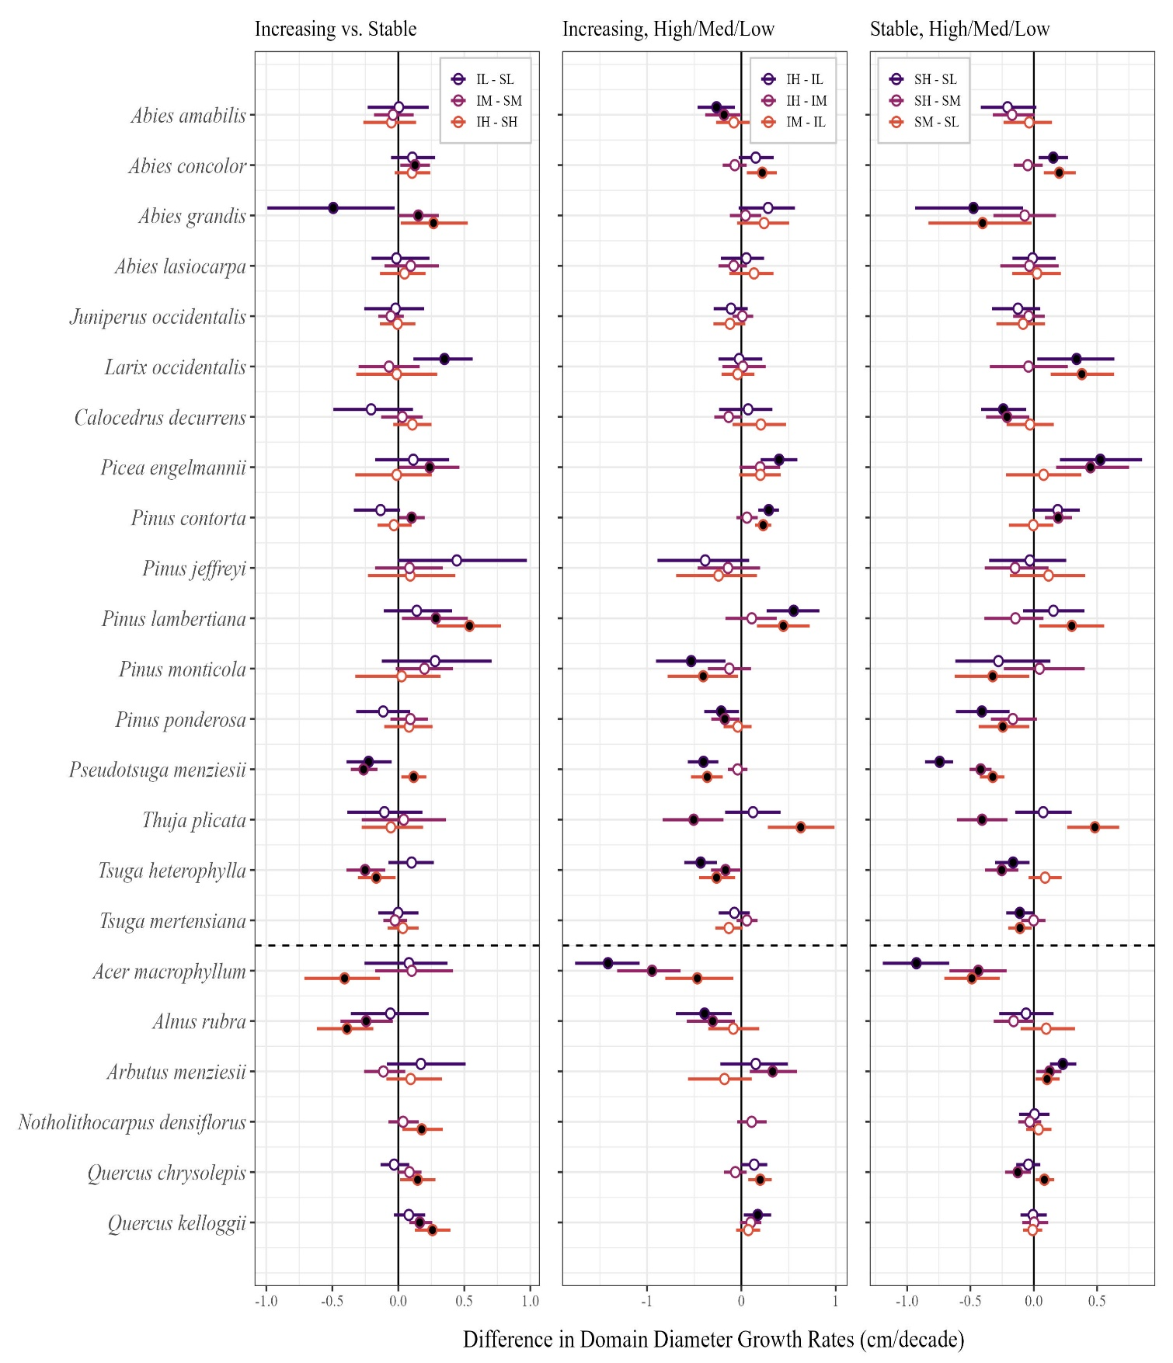
Figure S1: Differences in mean diameter growth rates (cm/decade) between domains by species. Domain abbreviations are described in the legend for Figure 1. See each column legend for the key of domain differences. Mean domain differences (circles) with 95% CIs (bars) that do not intersect zero are filled. Species above the dashed line are conifers; those below are hardwoods.

Table S2: Summary statistics for the difference in plot CWD values between visits by species. The number of species' plots (n), minimum, mean, median, and maximum CWD values are provided, along with the 5%, 25%, 75%, and 95% quantiles (q).
Species | n | Minimum | q05 | q25 | Mean | Median | q75 | q95 | Maximum | UCI | LCI
Abies amabilis | 798 | -1.8 | 0.1 | 1.8 | 3.9 | 3.9 | 5.8 | 8.4 | 11.8 | 4.1 | 3.8
Abies concolor | 1,723 | -8.8 | 0.4 | 3.4 | 5.8 | 5.5 | 8.4 | 11.1 | 17.5 | 5.9 | 5.6
Abies grandis | 1,129 | -4.2 | 0.1 | 3.2 | 5.1 | 5.3 | 7.3 | 9.5 | 12.7 | 5.3 | 5.0
Abies lasiocarpa | 539 | -0.5 | 1.3 | 4.1 | 5.8 | 5.8 | 7.7 | 10.1 | 13.2 | 6.0 | 5.6
Juniperus occidentalis | 827 | -7.9 | 1.6 | 3.8 | 5.4 | 5.2 | 7.2 | 9.5 | 15.8 | 5.6 | 5.2
Larix occidentalis | 662 | -0.4 | 2.4 | 4.7 | 6.2 | 6.2 | 7.5 | 9.5 | 12.1 | 6.3 | 6.0
Calocedrus decurrens | 1,223 | -3.0 | 0.2 | 3.2 | 5.9 | 5.7 | 8.8 | 11.5 | 17.5 | 6.1 | 5.7
Picea engelmannii | 488 | -0.4 | 2.7 | 4.9 | 6.4 | 6.3 | 8.1 | 10.1 | 13.4 | 6.6 | 6.2
Pinus contorta | 1,440 | -11.7 | 1.4 | 4.1 | 5.9 | 5.7 | 7.6 | 10.9 | 18.1 | 6.0 | 5.7
Pinus jeffreyi | 695 | -8.8 | -1.2 | 2.2 | 4.8 | 4.8 | 7.6 | 11.1 | 17.1 | 5.1 | 4.6
Pinus lambertiana | 964 | -5.1 | 0.2 | 2.9 | 5.5 | 5.2 | 8.2 | 11.4 | 17.5 | 5.8 | 5.3
Pinus monticola | 477 | -10.3 | 0.3 | 3.5 | 5.7 | 5.6 | 7.9 | 11.3 | 18.1 | 6.0 | 5.4
Pinus ponderosa | 3,480 | -5.9 | 1.1 | 3.8 | 5.6 | 5.5 | 7.5 | 10.3 | 16.8 | 5.7 | 5.5
Pseudotsuga menziesii | 6,425 | -4.5 | -0.7 | 1.8 | 4.1 | 4.0 | 6.2 | 9.3 | 15.2 | 4.2 | 4.0
Thuja plicata | 1,081 | -4.5 | -1.1 | 1.1 | 3.6 | 3.5 | 6.1 | 8.8 | 13.3 | 3.8 | 3.5
Tsuga heterophylla | 2,049 | -4.5 | -1.0 | 0.8 | 3.2 | 2.9 | 5.4 | 8.1 | 13.3 | 3.3 | 3.1
Tsuga mertensiana | 562 | -0.6 | 0.8 | 3.3 | 5.3 | 4.9 | 7.0 | 10.9 | 17.5 | 5.5 | 5.0
Acer macrophyllum | 825 | -4.5 | -1.5 | 0.8 | 3.3 | 3.1 | 5.4 | 9.8 | 15.2 | 3.6 | 3.1
Alnus rubra | 1,206 | -4.5 | -1.6 | 0.1 | 2.4 | 2.1 | 4.1 | 7.5 | 12.8 | 2.5 | 2.2
Arbutus menziesii | 759 | -2.7 | -0.3 | 1.6 | 3.3 | 3.1 | 4.5 | 8.7 | 13.7 | 3.5 | 3.1
Notholithocarpus densiflorus | 594 | -2.6 | -0.3 | 1.5 | 2.9 | 2.7 | 4.2 | 6.8 | 12.2 | 3.1 | 2.8
Quercus chrysolepis | 840 | -9.0 | -0.4 | 2.1 | 4.6 | 4.1 | 7.0 | 11.0 | 16.8 | 4.9 | 4.4
Quercus kelloggii | 951 | -6.4 | 0.6 | 3.1 | 5.9 | 5.6 | 8.9 | 11.8 | 17.5 | 6.2 | 5.7

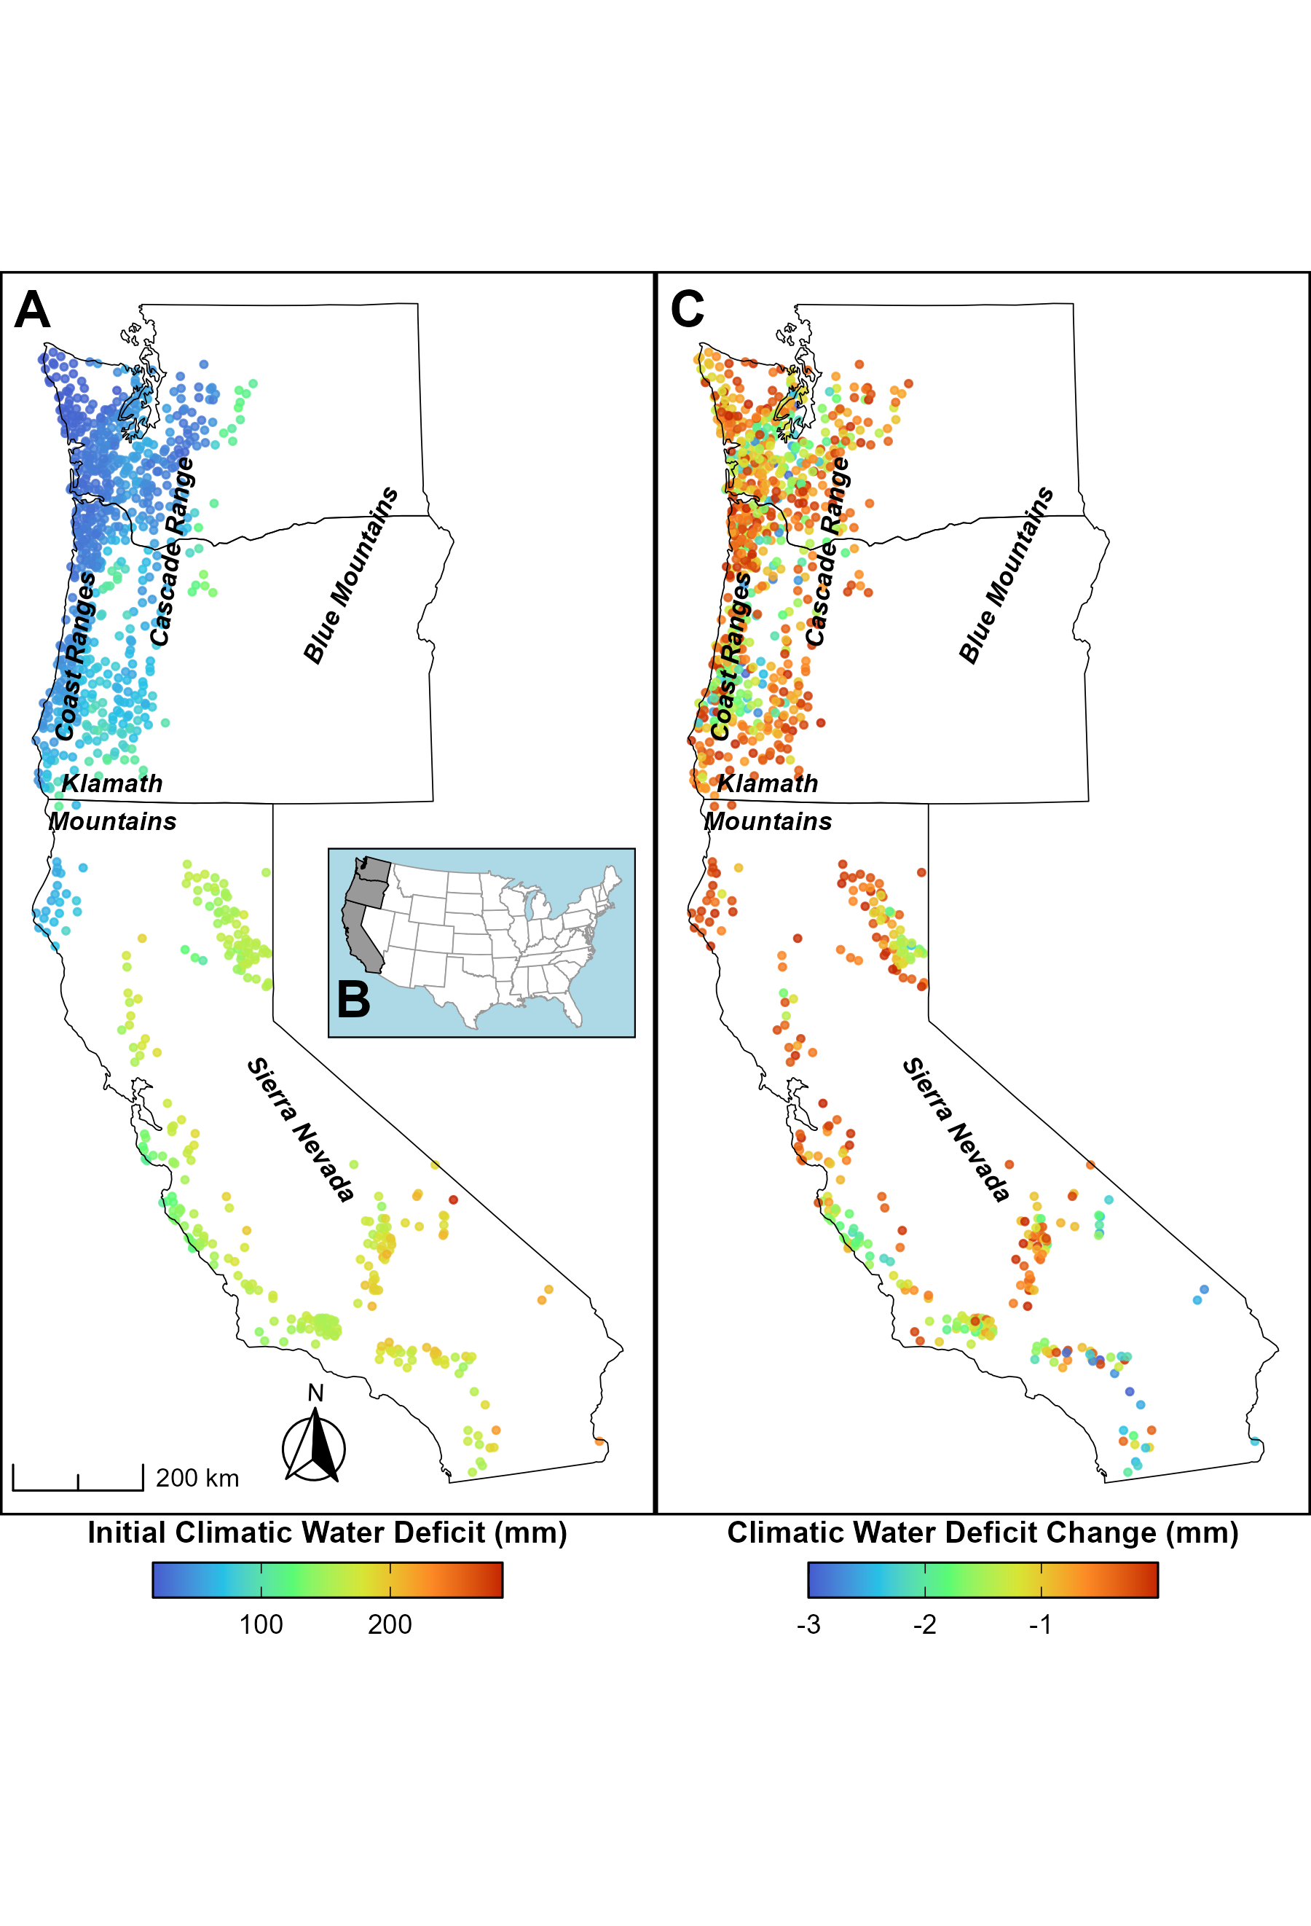
Figure S2: Public FIA plot locations for plots with negative CWD values. The initial CWD values for those plots are displayed in A while the negative delta CWD values are displayed in B. The inset map (B) shows the locations of the study states within the USA: From north to south, Washington, Oregon, and California.

Table S3: Linear regression model output for the linear fit of initial and delta CWD plot data (green line in Figure S1). Variable name CWD refers to initial CWD value.
 | Estimate | Standard Error | t value | Pr(>|t|)
(Intercept) | 2.373 | 0.073 | 32.666 | 0.0000 | ***
CWD | 0.023 | 0.001 | 33.904 | 0.0000 | ***
Signif. codes: 0 <= '***' < 0.001 < '**' < 0.01 < '*' < 0.05
Residual standard error: 3.103 on 11440 degrees of freedom
Multiple R-squared: 0.0913, Adjusted R-squared: 0.09122
F-statistic: 1149 on 11440 and 1 DF, p-value: 0.0000

Table S4: Linear regression model output for the third-order polynomial fit of initial and delta CWD plot data (orange line in Figure S1). Variable name CWD refers to initial CWD value.
 | Estimate | Standard Error | t value | Pr(>|t|)
(Intercept) | 3.87e+00 | 2.73e-01 | 1.42e+01 | 3.05e-45
CWD | -8.57e-02 | 1.05e-02 | -8.17e+00 | 3.34e-16
CWD^2 | 1.76e-03 | 1.18e-04 | 1.49e+01 | 1.57e-49
CWD^3 | -7.44e-06 | 4.05e-07 | -1.83e+01 | 4.07e-74
Signif. codes: 0 <= '***' < 0.001 < '**' < 0.01 < '*' < 0.05
Residual standard error: 2.999 on 11438 degrees of freedom
Multiple R-squared: 0.1513, Adjusted R-squared: 0.1511
F-statistic: 679.6 on 11438 and 3 DF, p-value: 0.0000

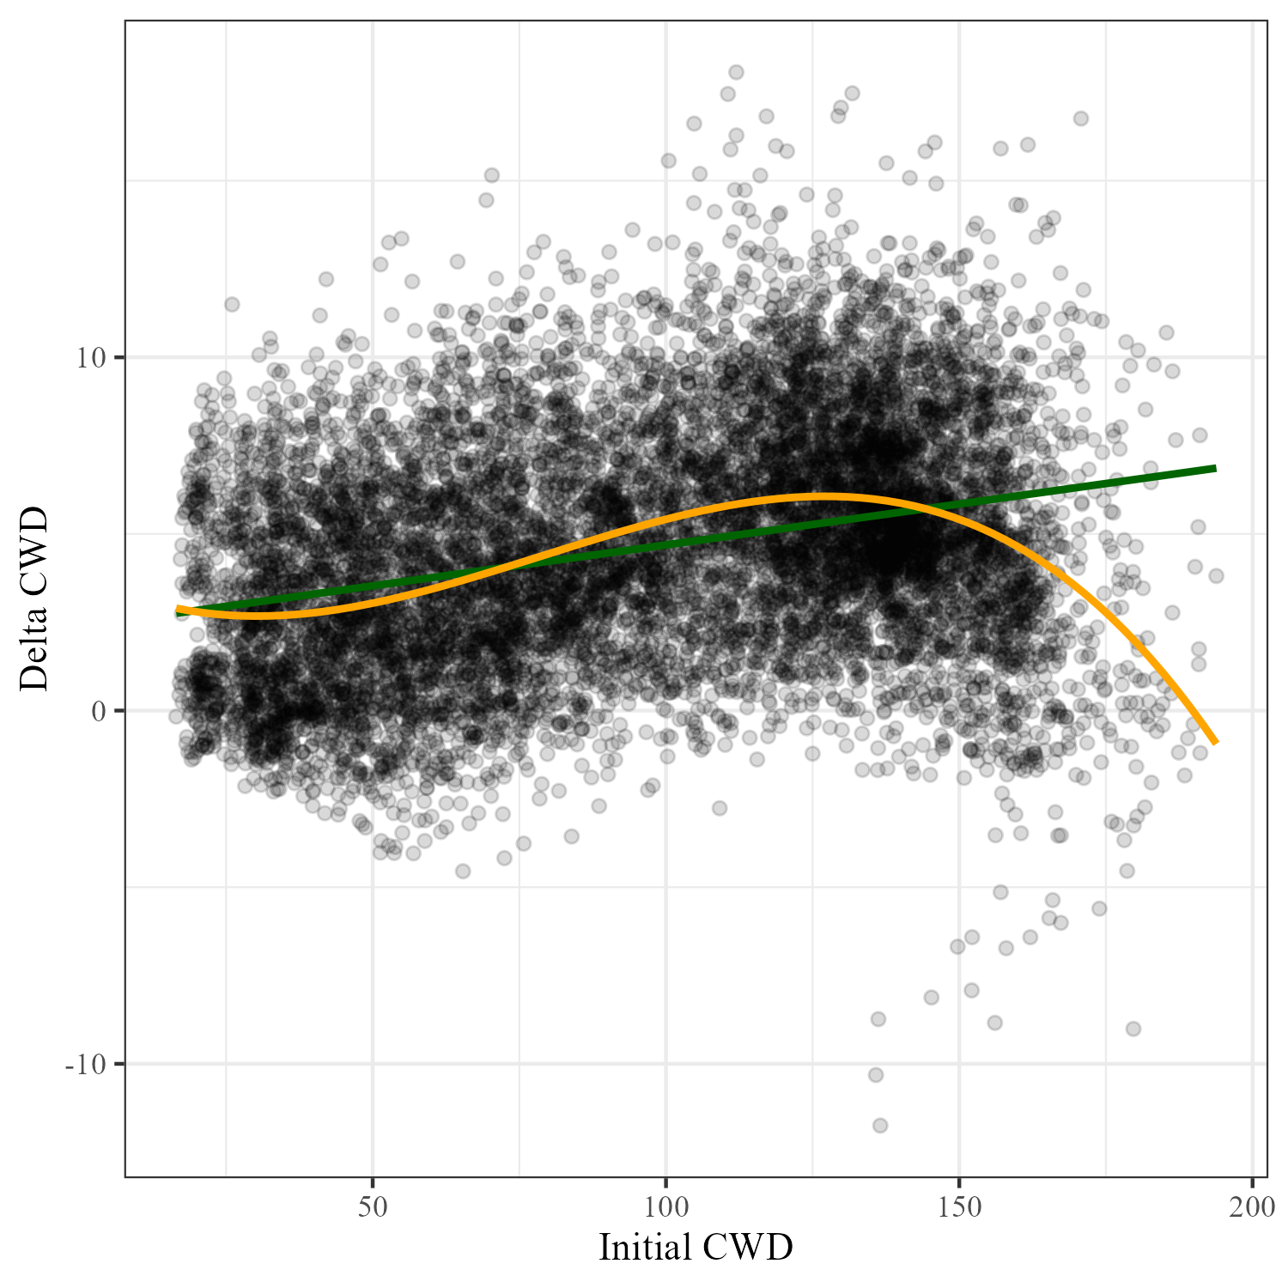
Figure S3: Initial CWD and Delta CWD values for all FIA plots occupied by analysis species. The green line is a linear fit of the values while the orange line is a third-order polynomial fit of the points.

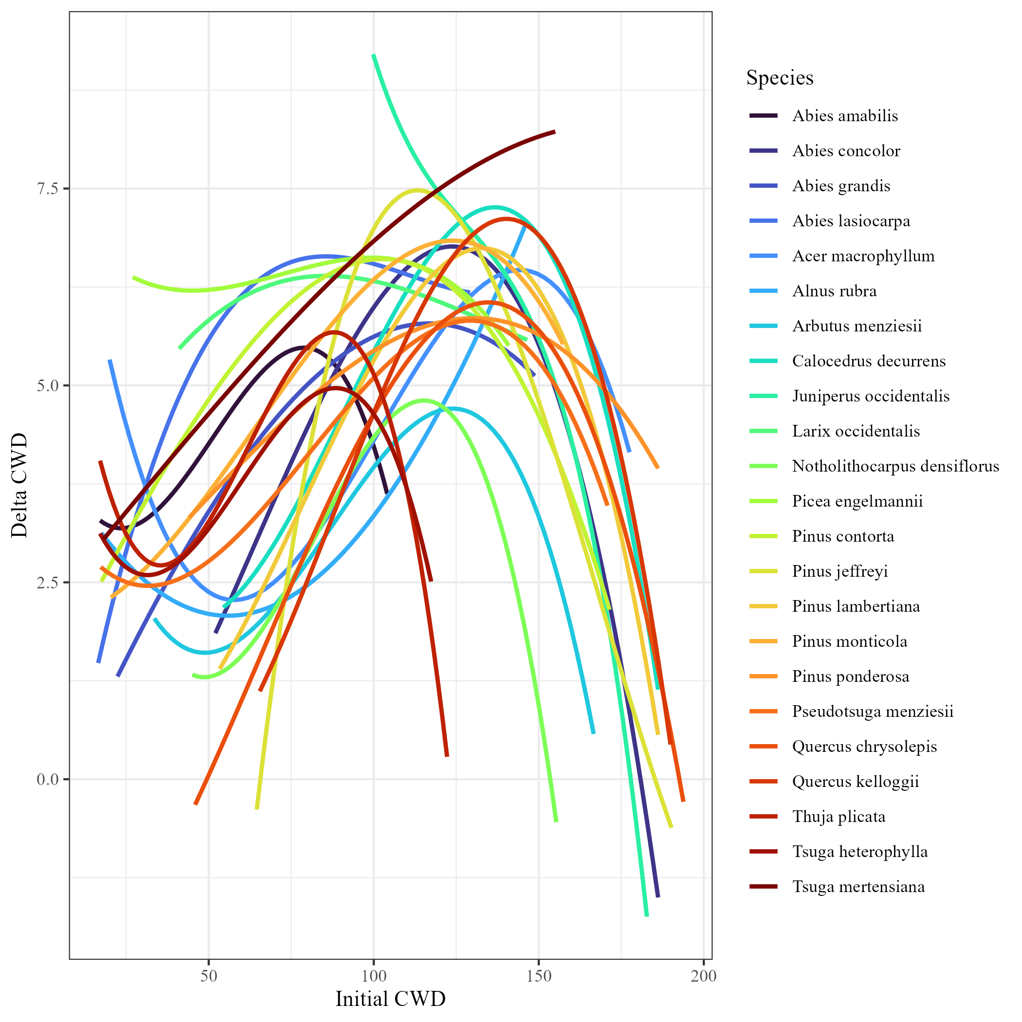
Figure S4: Third-order polynomial fits for initial CWD and delta CWD values for FIA plots occupied by individual species.

Table S5: Summary statistics for initial-visit plot CWD values by species. The number of species' plots (n), minimum, mean, median, and maximum CWD values are provided, along with the 5%, 25%, 75%, and 95% quantiles (q).
Species | n | Minimum | q05 | q25 | Mean | Median | q75 | q95 | Maximum | UCI | LCI
Abies amabilis | 798 | 17.1 | 21.0 | 29.3 | 43.2 | 40.7 | 53.5 | 75.4 | 104.1 | 44.4 | 42.0
Abies concolor | 1,723 | 52.0 | 71.9 | 107.4 | 124.0 | 129.7 | 142.7 | 160.4 | 186.2 | 125.2 | 122.7
Abies grandis | 1,129 | 22.4 | 53.4 | 72.8 | 96.7 | 99.1 | 119.6 | 136.9 | 148.8 | 98.3 | 95.1
Abies lasiocarpa | 539 | 16.5 | 30.2 | 47.5 | 67.5 | 65.1 | 85.8 | 110.2 | 129.2 | 69.6 | 65.3
Juniperus occidentalis | 827 | 99.8 | 132.0 | 143.2 | 149.6 | 151.3 | 157.2 | 163.2 | 182.8 | 150.3 | 148.9
Larix occidentalis | 662 | 41.0 | 60.8 | 77.1 | 98.3 | 99.6 | 119.0 | 134.7 | 146.5 | 100.2 | 96.5
Calocedrus decurrens | 1,223 | 54.4 | 69.7 | 94.6 | 120.6 | 125.2 | 144.2 | 162.9 | 186.2 | 122.3 | 119.0
Picea engelmannii | 488 | 27.0 | 41.1 | 58.1 | 79.9 | 76.3 | 101.2 | 121.5 | 140.9 | 82.2 | 77.6
Pinus contorta | 1,440 | 17.5 | 50.3 | 83.3 | 107.5 | 117.3 | 132.3 | 143.1 | 171.4 | 109.1 | 105.9
Pinus jeffreyi | 695 | 64.6 | 90.8 | 131.8 | 142.2 | 147.4 | 158.5 | 170.2 | 190.2 | 144.0 | 140.5
Pinus lambertiana | 964 | 53.3 | 71.6 | 96.3 | 118.9 | 121.6 | 139.4 | 161.9 | 186.2 | 120.7 | 117.2
Pinus monticola | 477 | 20.3 | 47.0 | 71.9 | 97.8 | 94.9 | 125.1 | 144.3 | 157.4 | 100.6 | 94.9
Pinus ponderosa | 3,480 | 44.1 | 84.8 | 114.9 | 127.2 | 131.7 | 141.3 | 158.1 | 186.2 | 127.9 | 126.5
Pseudotsuga menziesii | 6,425 | 17.3 | 30.2 | 52.0 | 81.3 | 77.7 | 111.3 | 138.6 | 170.8 | 82.2 | 80.5
Thuja plicata | 1,081 | 17.1 | 21.0 | 33.3 | 49.8 | 48.5 | 63.3 | 84.7 | 122.2 | 51.0 | 48.6
Tsuga heterophylla | 2,049 | 17.1 | 20.8 | 30.5 | 45.3 | 42.2 | 57.8 | 78.5 | 117.4 | 46.1 | 44.5
Tsuga mertensiana | 562 | 18.0 | 24.8 | 41.3 | 65.0 | 62.2 | 81.0 | 124.5 | 155.0 | 67.5 | 62.5
Acer macrophyllum | 825 | 19.9 | 34.2 | 48.4 | 72.5 | 65.2 | 90.4 | 133.9 | 177.5 | 74.6 | 70.4
Alnus rubra | 1,206 | 17.5 | 22.9 | 33.5 | 46.2 | 43.6 | 54.1 | 82.6 | 146.4 | 47.2 | 45.2
Arbutus menziesii | 759 | 33.5 | 62.1 | 76.0 | 93.6 | 90.8 | 107.2 | 137.5 | 166.6 | 95.3 | 92.0
Notholithocarpus densiflorus | 594 | 45.0 | 56.1 | 69.7 | 83.8 | 79.7 | 92.8 | 127.9 | 155.3 | 85.5 | 82.2
Quercus chrysolepis | 840 | 45.9 | 72.6 | 95.4 | 121.6 | 121.9 | 145.0 | 177.5 | 193.8 | 123.7 | 119.4
Quercus kelloggii | 951 | 65.5 | 88.2 | 113.2 | 129.4 | 129.1 | 146.4 | 168.4 | 189.9 | 131.0 | 127.9

