AIRSEED TECHNICAL INTERVIEW v1 [EST: 60-90min]

Name: Jeremy Jie Huang
Email: jh3627@stern.nyu.edu
Time Started: 2:00pm ET

Your mission, should you choose to accept it, is to answer the following questions below within an estimated 60-90 minutes.

After you complete the following questions, please make sure to forward these questions as an attachment to interview@airseed.com. Also please make sure to attach your resume as well.

(1) The FUN in Functions:

What does the following function do?
int foo(n)
{
if (n == 1)
return 1;

return (foo(n-2) + foo(n-1));
}

It finds the nth number in a Fibonacci series.

(2) Programming -- Tree Operations

You’re a given a binary tree with unique integer values on each node. However, the child pointers on each node may point to ancestor nodes, introducing cycles into the binary tree. Write a function that takes in the root node of the tree and prints out the cycles, if any, in the binary tree. The only operations available on each node are node.left (returns another Node or null), node.right, and node.value (returns the integer value of the node). Pseudocode is fine.

Example: http://i.imgur.com/7S5fZe5.png
cycles: [1, 2, 4], [5], [3,6]

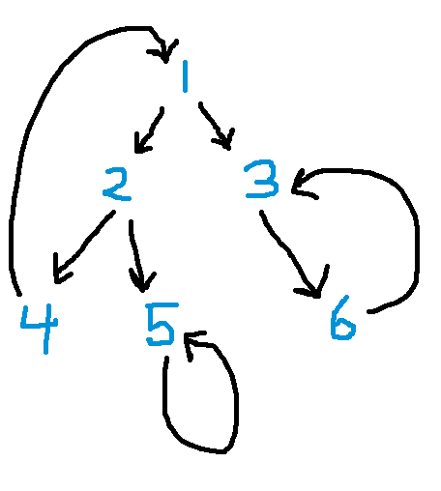

vector<Node *> s;

void DFS(Node * root){
if(root != NULL && std::find(s.begin(),s.end(),root) == s.end()){
s.push(root);
if(std::find(s.begin(),s.end(),root.left) != s.end())
{
Node *start = root.left;
Node *end = root;
printCycle(start,end);
}else if(std::find(s.begin(),s.end(),root.right) != s.end())
{
Node *start = root.right;
Node *end = root;
printCycle(start,end);
}
DFS(root.left);
DFS(root.right);
s.pop_back();
}
}

void printCycle(Node *start,Node *end)
{
while(start != end){
cout << start->val <<endl;
start ++;
}
cout << start->val <<endl;
}

(3) Working with Large Datasets
You are given F1, F2, ... F10 large files, each with 100M+ lines. How would you merge F1, F2, ... F10 to one larger file ‘F’ such that ‘F’ contains 1st line from each file, followed by 2nd line from each file, and so on. Hardware constraints: 1-2 CPU, 4-8G RAM, TB storage.

Since we only have 4-8G RAM, we can only load one file at a time as a file with 100M + lines of text has approximately 8G size (assume each line has 20 words which is about 80 characters. So the size of a file = 80*100M bytes = 8GB). We create a table in our database indexed by the row number. We can read the nth line from each of the 10 Files and combine them to form a chunk of text before putting the chuck of text into the nth row of our data base. To generate F, we can simply iterate through all 100M + rows of our database,read the content of each row and write to file F.

(4) Data Collection & Storage Design
How would you collect and store data to generate a list of your active friends on Facebook since last week? Activity can be defined as posting, commenting, liking, etc.

I have only a few hundred friends on FB so using a set is enough to store all of those data. I would do the following:

- Sort all my friends’ activities by time and scrap the all my friends’ activities since a week ago.
- Initialize a set called myActiveFriends.
- Iterate through each activity, get the name of the friend of that activity and put that name into myActiveFriends if it is not in the set.
- Print all the names in the set.

(5) Feature Design -- Search
You’ve been asked to improve a given search experience by suggesting related searches as the user types the query. How would you build the search suggestion feature and how would you determine which searches to suggest?

- Then for each query that users input, we can generate a list of similar queries that we have in our database. We do that possibly by measuring the amount of linguistic similarities between the input query and our stored search queries and rank them from being most similar to lease similar to the input query. We can calculate some similarity index by, for instance, the percentage of characters that are the common subsequences of two queries or by tokenizing the queries and measuring the number of key words that two different queries have in common. We can also assign statistical weights to each key words. For phrases like “how to buy a camera”, “buy” and “camera” should have a higher weight than other tokens because they are more specific, or statistically low to appear. If both “buy” and “camera” appears in the user input query, the suggestion “how to buy a camera” should rank higher than other suggestions that don't have those key words.

- We can further improve the accuracy by counting the number of clicks the user click on a specific suggestion and use that number to re-rank our suggestions. For instance, for a query “how to buy ”, and a list of suggestions of “how to buy camera”, “how to buy iphones ” and so on, if we find that there are proportionally more people clicking on “how to buy iphones” than other suggestions, we should increase the rank of “how to buy iphones” in the list of suggested search queries.

