Jeremy Immanuel Putra Tandjung
Professor Wooyoung Kim
CSS 422
05/23/2020

Q1. Consider the logic gate circuit shown below

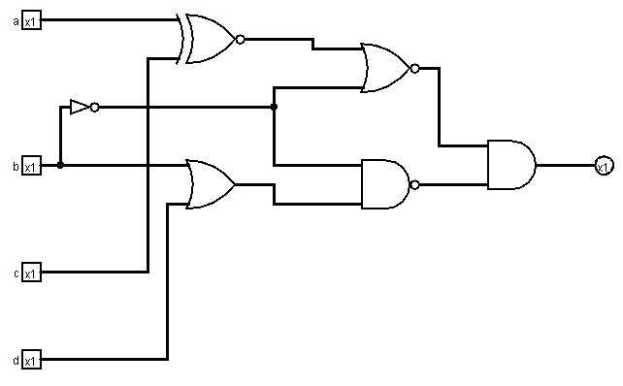
(1) ~( ~( a ^ c ) + ~b ) * ~( (b + d) * ~b )

(2)

(3) Also attached on canvas submission
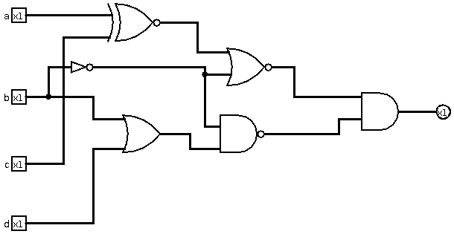
(4) I apologize for the dark header, as the logisim on my ubuntu defaults to dark mode even when I changed my ubuntu system theme to light mode.

a b c d | x

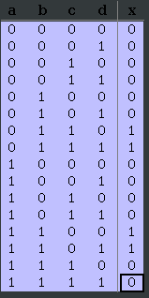

Q2. Design a combinational circuit system.

(1)

(2) & (3)

A K-map

A = y + xz

B K-map

B = ~x~y + ~y~z + xyz

C K-map

C = ~xz + x~z = x ^ z

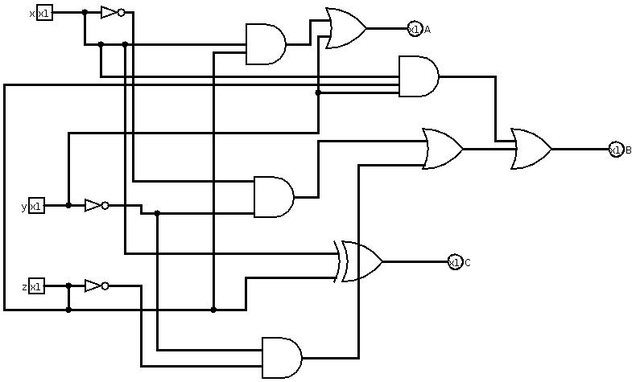
(4) Also attached in canvas submission

(5) x y z | A B C
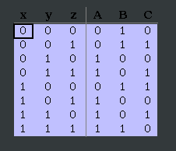

Q3. Combinational circuit and Full Adder

(1)

(2) S K-map

S = ~x~yz + ~xy~z + xyz + x~y~z

(3) C K-map

C = xy + yz + xz

(4) ( x ^ y ) ^ z == ~x~yz + ~xy~z + xyz + x~y~z

( x ^ y ) ^ z = (~xy+ x~y) ^ z
= ~(~xy+ x~y)z + (~xy+ x~y)~z
= (x + ~y)(~x + y)z + ~xy~z + x~y~z
= x~xz + xyz + ~x~yz + ~yyz + ~xy~z + x~y~z
= x~xz + xyz + ~x~yz + ~yyz + ~xy~z + x~y~z
= xyz + ~x~yz + ~xy~z + x~y~z

(5) xy + ( x ^ y ) z == xy + yz + xz

xy + ( x ^ y ) z = xy(1+z) + x~yz + ~xyz
= xy + xyz + x~yz + ~xyz
= xy + xz(y+~y) + ~xyz
= xy + xz + ~xyz
= xy(1+z) + xz + ~xyz
= xy + xyz + xz + ~xyz
= xy + xz + xyz + ~xyz
= xy + xz + yz (x+~x)
C = xy + yz + xz

(6)
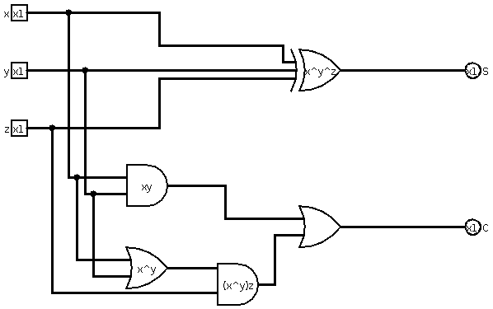

Q4. Design a sequential circuit

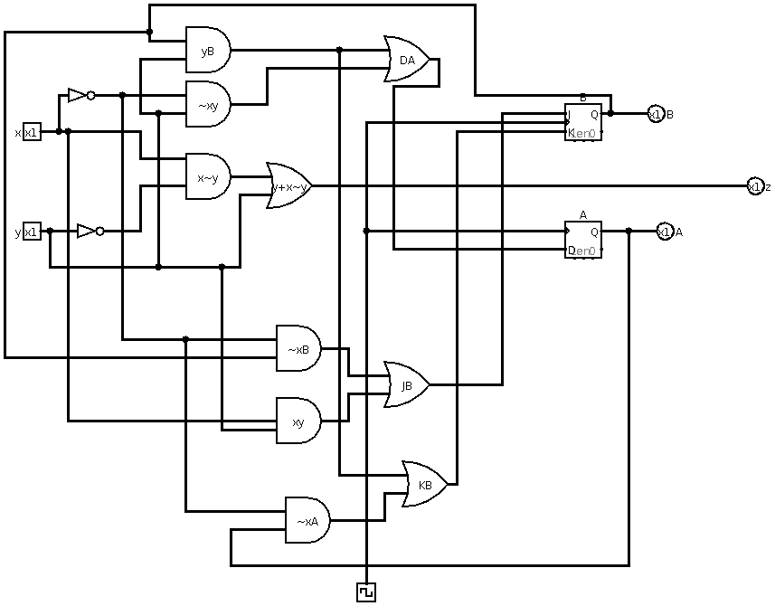

Q5.

(2) Excitation table

(3)
J2 K-map

J2 = ~Q1~Q0

K2 K-map

K2 = ~Q1~Q0

J1 K-map

J1 = ~Q0

K1 K-map

K1 = ~Q0

J0 K-map

J0 = 1

K0 K-map

K0 = 1

(4)
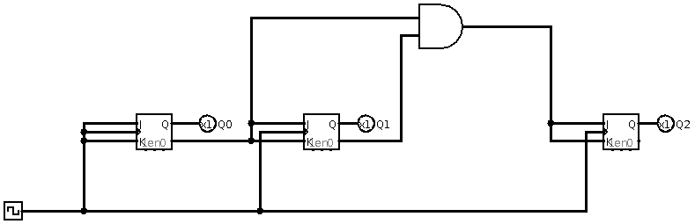
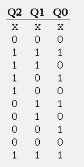
(5)

Extra Credit

