Register Page Test Cases

The register page has several .NET validators, as well as additional C# code, that make sure that all the fields and files being uploaded are valid.

There is a regular expression validator on the e-mail field that checks that what the user enters is a valid e-mail (no whitespace characters, has an @ sign and has a dot somewhere after the @ sign.)



no white space allowed



requires an @ sign and a . followed by characters

There is a comparison validator on the password fields which make sure that the two passwords match:



There are several required field validators on the required fields (such as e-mail, password, first name, last name) that check that all required fields are filled in:

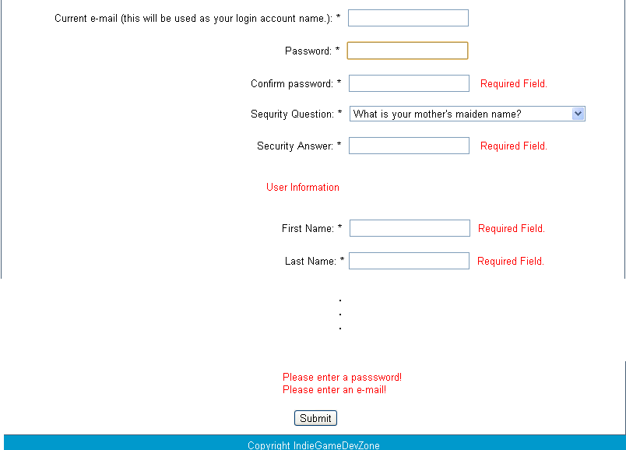

The validators work in real-time so the user will know ahead of time whether they input the right information. A validated form, without checks for username and image format, looks like so:

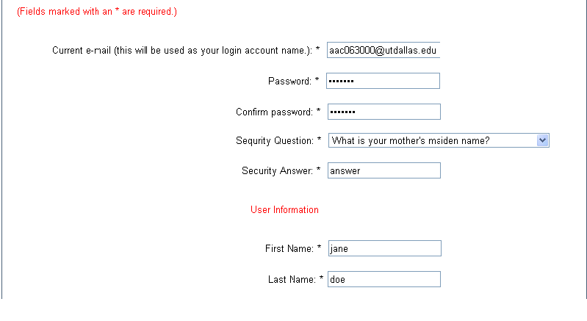

If all the fields are properly filled in, the server checks that the username (e-mail) does not already exist on the server:



The final check makes sure that files being uploaded to the server are images, in .jpg, .png, or .gif form, and not other formats.



If everything is filled out correctly, the page will redirect to the login page (not in this screenshot as it is a demonstration) and upload the images specified to the Images folder.

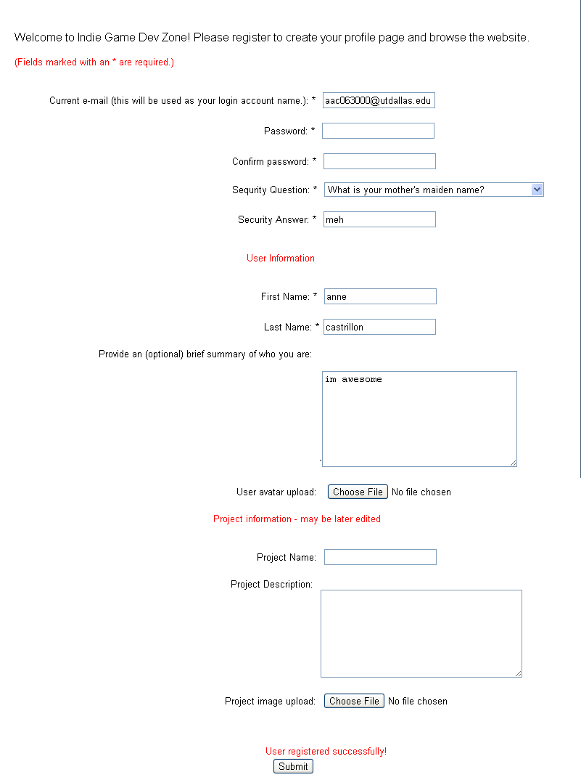

To avoid collision, images uploaded to the server are renamed to a randomly generated name using the Guid.NewGuid.ToString() format. The filenames look like this:

