Browse Page

All the game projects submitted to the site are displayed to the users in the ‘Browse’ page. The way to navigate among different sections of the ‘Browse’ page is also accessed from this page.

Figure : Browse Page Design
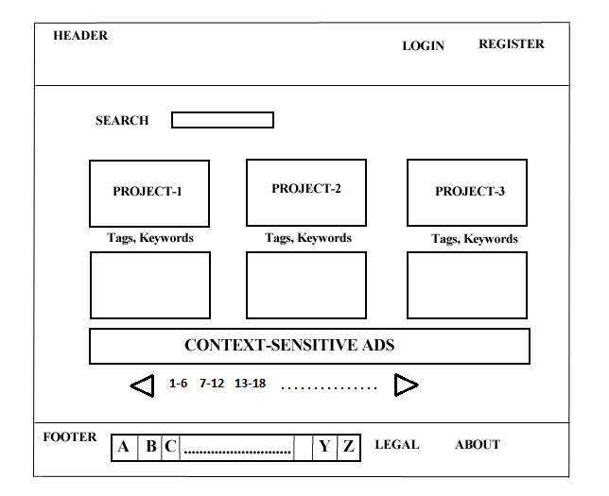

The original design of the ‘Browse’ page had the ‘alphabetical sort paging’ to aid in pagination. The alphabetical page sort would sort all the submitted projects in an alphabetical arrangement.

Eg: Clicking on ‘C’ would list all the game projects that are submitted to the website starting with the letter ‘C’.

Figure : Browse Page Implementation Screenshot

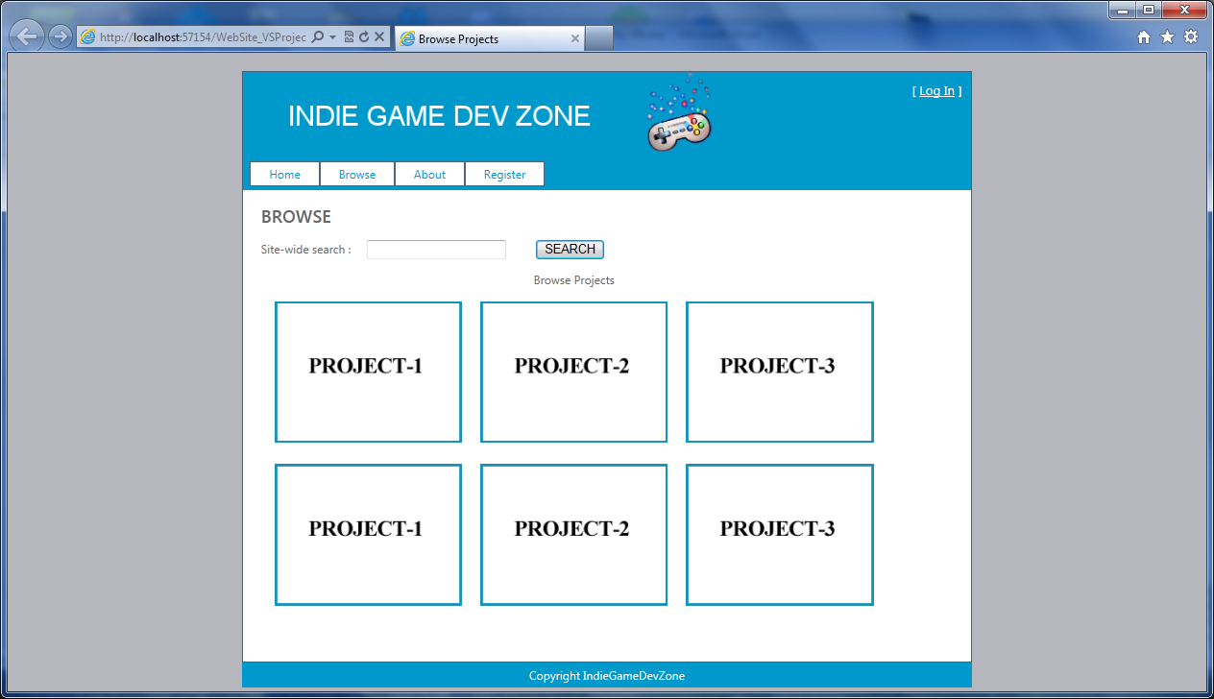

In the actual front-end UI implementation we just implement the ‘next n-projects pagination’. This way, we can specify how many projects are to be displayed per page and see the next ‘n’ projects clicking on the corresponding navigation link.

The alphabetical sort pagination was not implemented as it would have spurious data displayed on the ‘Browse’ page when there are no projects submitted to the website starting with a particular alphabet (when queried on the same alphabet). Also, the running time of the SQL queries to perform alphabetical sort paging would be slower compared to the running time of ‘next n-projects pagination’.

The projects displayed on the ‘Browse’ page are actually links to the project descriptions. Clicking on a project from the ‘Browse’ page takes the user to the particular project’s details page. The ‘Browse’ page just provides a brief outline about the different projects in a graphical manner. The complete details are available to the user once he clicks on a specific project.

The ‘Search Bar’ provides a way for the user to search for specific projects that are submitted to the website (site-wide search). This would aid immensely in navigation and the user can quickly access the relevant information.

The project-related keywords/tags have not been implemented in the actual front-end as this requires additional metadata to be stored along with each record in the database (Added overhead for each record). This can be packaged as a feature add-on for the website in the future (to enrich the user-experience).

The context-sensitive ads provide additional revenue for the website. The ads are displayed based on the user’s browsing history as well as the user’s cache/cookies.

