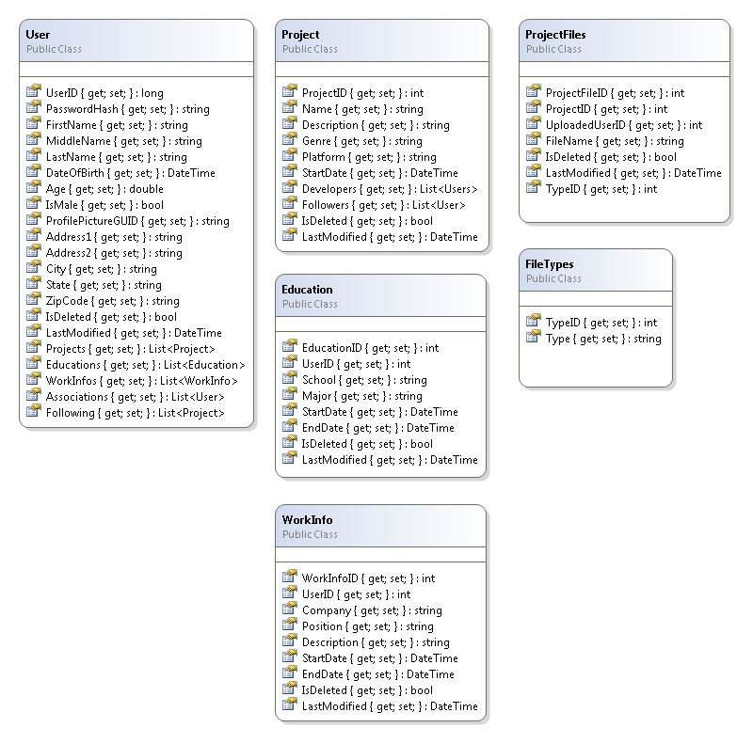
Class Diagram

User: Along with basic demographic information, such as name, date of birth, address, places of employment [workinfo], education experience [education], etc., Users have one-to-many User-Project Associations, which link them to different projects on the site, thereby giving them edit/modify access. Users can also be Associated to other users, which allows users to keep up with friends/colleagues/associates in a similar way to social media's “friending”. Users also have a list of projects they are considered to be “following”, in which they could possibly be alerted to any changes or modifications or advances in a project they are not a part of, perhaps in a notifications area.

The 'login' mechanism will be handled by accepting a username (email) and password, hashing the password and comparing the hash to the hash stored in the database for the given username. Upon match, the user's information is loaded into session and they are 'logged in'. By storing the user information in session we can more quickly alter the site to allow for the more advanced features of a logged in user for particular pages depending on the user.

Project: Projects are managed/updated by the reverse of the User-Project association. In addition they store basic information on the project such as name, description, genre, platform, and when the project was began. In addition projects have Project-File associations which associate uploaded files, which could be images or screenshots, code samples, videos, installable demos, etc.

