STEPS TO RUN THE SPOILER ALERT PROGRAM

Step 1: Environment setup

Window or

Linux

Step 2: Copy the *main.c* file to the environment from where you want to run.

You may want to copy it to a folder in your local machine like //Submission/main.c

Step 3: Open the Command window: Start > enter ‘cmd’ > select Command Prompt

Step 4: Navigate to the folder to where you copied the *main.c* file

(In Window, when you need to access the *System32* folder located in *"C:\Windows,"* type *"cd windows\system32\"*)

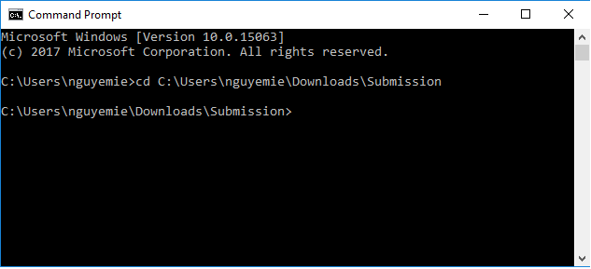

Step 5: Compile and Run the program using the commands below

In Window, use:

gcc main.c –o main <enter>

main > result.csv <enter>

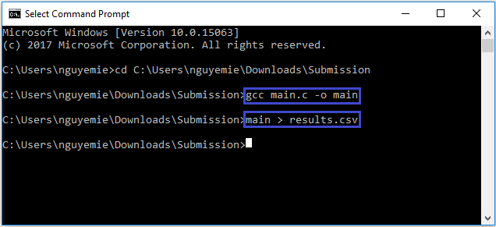

In Linux, use:

gcc main.c -o main <enter>

./main > results.csv <enter>

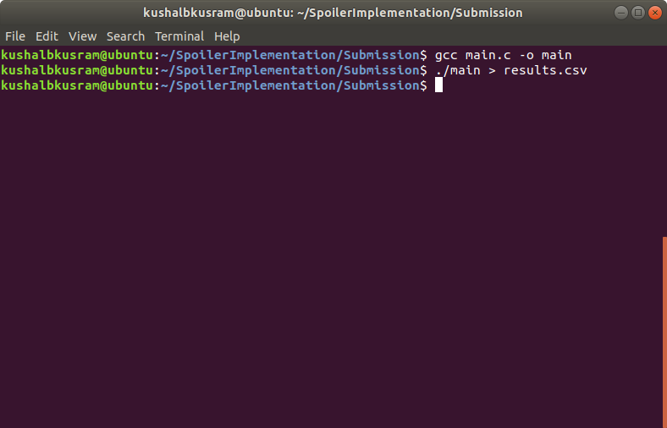

Step 6: View the results

The *results.csv* file will be created in the same folder with the *main.c* file

Open the *results.csv* file, you will see a list of numbers which are the time measurement between ‘store’ and ‘load’ instructions in the program.

You can plot these numbers into a graph using Excel to view them easily. We put the *results_SpoilerTeam.****xlsx*** file which already includes the graph in case you don’t want to perform the plot step.

Step 7: Enjoy your output.