CAD-GENERAL INFORMATION - The CAD (Computer Aided Design) section describes a number of different program features which can be used in support of opto-mechanical design and optical component fabrication. All commands in this section are issued from the program CMD level. The program performs all its CAD output to the specific files. These files may be imported to compatible CAD programs from outside this program.

3D-DXF COMMANDS - The 3D-DXF commands allow the user to create 3D-DXF polyline representations of the current lens configuration as well as rays traced through that lens. The resultant DXF files may be imported to compatible CAD programs from outside this program.

DXF NEW - The "DXF NEW" command initializes the program for new 3D DXF output. WARNING: Any existing 3D DXF data in the file DXF3D.DXF will be deleted when the "DXF NEW" command is issued.

DXF LAYER (8-character layer name) - The "DXF LAYER" command is used to specify the name of the current DXF layer name. The default layer is named: LAYER001. Issued with a “?”, the current layer name is displayed. Layer names must be exactly 8 characters in length.

DXF GLBSURF , global surface number - The "DXF GLBSURF" command is used to specify the surface number, which will be used as the global origin for all DXF coordinates. Issued with a “?”, the current DXF global surface number will be displayed. The default global surface number is usually 1 unless the thickness assigned to surface 1 is infinite.

DXF PROFY , i , j and DXF PROFX , i , j - The "DXF PROFY" and "DXF PROFX" commands are used to output the YZ and XZ-plane lens surface profiles to the current 3D DXF file. These profiles are the projections of the surface's local coordinate system Y and X-axes upon the lens surface. Each profile is bounded by the explicit or implicit clear aperture on that surface. A blank space will be left if there is an assigned obscuration.

DXF PROF , i , j , theta - The"DXF PROF" command is a general form of the commands "DXF PROFX" and "DXF PROFY". It is used to output surface profiles in any azimuthal orientation to the current #d DXF file. The third numeric word "theta" specifies the azimuthal orientation angle. "Theta" is measured positive, counter-clockwise from the local surface positive x-axis to the local surface positive y-axis. "Theta" can be assigned any angle between 0.0 and 360.0 degrees. The default value for "theta" is 0.0. This is equivalent to a "DXF PROFX" command. A "DXF PROFY" command may be simulated with "theta" set to 90.0 degrees. The profile is bounded by the explicit or implicit clear aperture on that surface. A blank space will be left if there is an assigned obscuration.

DXF EDGEY , i , j and DXF EDGEX , i , j - The "DXF EDGEY" and "DXF EDGEX" commands are used to output edges connecting non-air spaces. The edges connect the ends of surface profiles.

DXF CLAP , i , j , k - The "DXF CLAP" command is used to output surface clear apertures projected onto the surface to the current 3D DXF file. The optional third numeric word "k" is used to specify fractional clear aperture display The default value for "k" is 1.0. "k" may be set to any value greater than 0.0 and less than or equal to 1.0.

DXF RAY , i , j - The "DXF RAY" command causes the most recent ray traced to be added to the current 3D DXF file. Ray data will be added from lens surface "i" to lens surface "j" .The internal operation of the "DXF RAY" command is such that if the ray to be output is a failed ray, the ray will be represented through the optical system up to the surface for which ray data becomes unreliable. Rays may fail for any of the valid failure reason recognized by the program including ray failures due to blockages by clear apertures and obscurations when the "RAY CAOB" command is used to trace the ray. Prior to issuing a “DXF RAY” command, the “FOB” and “RAY” or “RAY CAOB” commands must be issued to generate the ray data.

DXF LINE - The "DXF LINE" command allows the user to add a 3D line from coordinates X1, Y1, Z1 to coordinates X2, Y2 and Z2. The coordinates of these two points are always considered to be represented in the global coordinate system of the current optical system graphic in which the origin is either located at the vertex of surface 0 (for finit conjugate object points) or the vertex of surface 1 (for infinite conjugate object points). The coordinates of these two points are assigned using the following six commands. By default, both points are located at 0,0,0 when the program starts or when a new plot is initiated.

X1 or Y1 or Z1 or X2 or Y2 or Z2 - The "X1", "Y1", "Z1", "X2", "Y2" and"Z2" commands allows the user to specify the starting and ending coordinates of the next 3D line to be drawn. By default, the values are 0,0,0 when the program starts and when a DXF file is initiated.

DXF TERMINATION

DXF END - The "DXF END" command stops all DXF output to the DXF3D.DXF file.

OPTICAL COMPONENT DRAWINGS - In support of the fabrication of single lenses, the following commands may be used in order to generate single lens engineering drawings. Except for the beginning surface number, all inputs to this set of commands have sensible default values.

PARTDRAW , n - The "PARTDRAW" command initializes and initiates lens part drawing. The starting surface number "n" must be explicitly entered. The lens drawn will start at surface "n" and end at surface "n+1" in the current lens database. The "PARTDRAW" command may be followed by the entry of optional values as shown in the table below. A "PARTGO" command must be used to indicate that no more options are to be entered and that the lens part drawing should be generated and placed in the NEUTRAL.DAT file. After the "PARTGO" command is issued, the part drawing may be displayed to the screen with a "DRAW" command or sent to a graphics file or hardcopy device with a "GRAOUT" command. "DRAW" and "GRAOUT" are described fully in the GRAPHICS section of this manual. All tolerance defaults shown in "inches" will be automatically converted to mm, cm or meters as needed depending upon the current system units. All part diameters and diameters-to-flat are taken from the lens database.

COMMAND | DEFAULT | DESCRIPTION
DIATOL , v | +/- 0.002 inch. | Outer diameter tolerance.
RADTOL , v1 , v2 | +/- 0.1% of radius or +/- 4 fringes if flat. | Radius tolerance for each surface.
RADTLF , v1 , v2 | +/- 0.1% of radius or +/- 4 fringes. | Radius tolerance in fringes for each surface.
FRNG , v1 , v2 | 1 fringe | Fringes of irregularity.
THITOL , v | +/- 0.002 inch. | Thickness tolerance.
CLERAP , v | OD value minus 0.08 inch. | Clear aperture of surfaces.
SURFQUAL , v | (blank) | Surface quality, up to 20 alpha/numeric characters.
FRNGDIA , v1 , v2 | CLERAP | Diameter at which delta R per fringe is calculated for each surface.
CENTER , v | +/- 0.002 inch. | Surface to surface centration error.
BRKEDG , v | 0.01 inch. | Break edges.
SURFCOAT , v | (blank) | Coating drawing number, up to 20 alpha/numeric characters.
SAGTOL , v1 , v2 | +/- 0.002 inch. | Sag tolerance for each surface.
PRPNTL , v1 , v2 | +/- 1.00 arc-sec | Tolerance of flat perpendicularity to optical axis for each surface in arc-sec.  (This is the NORM. box)
TITLE , v | (blank) | Drawing title, up to 32 alpha/numeric characters.
DWGNO , (dwgno) | (blank) | Drawing number, up to 12 alpha/numeric characters.
SURFMATL , v | Material specified in lens database. | Surface material, up to 13 alpha/numeric characters.
GLSCD , v1 , v2 | Stored in lens database glass catalog. | Glass code, each 3 digits.
WAVEL , v | For visible systems, 0.5461 microns. For non-visible systems, the control wavelength CW. | Wavelength for fringe and EFL, BFL, FFL calculations.

Any combination of above listed commands may be issued in any order. Incorrect values may be overwritten by issuing the command again with correct input. If only one value is entered for "SAGTOL" or "PRPNTL", it will apply to both surfaces. A single value for OD becomes the outer diameter of the lens. "RADTOL" and RADTLF" override each other.

PARTQUIT - The "PARTQUIT" command terminates all part drawing.

PARTGO - The "PARTGO" command causes a lens part drawing to be generated and stored in the neutral plot file NEUTRAL.DAT. It may be displayed on the screen or stored in alternate graphics file formats or printed using the "DRAW" and "GRAOUT" commands described in the GRAPHICS section of this manual.

DRAWING NOTES - The drawing notes used for various lens drawings are stored in ASCII format in the NOTES subdirectory beneath the main program directory. 11 drawing notes currently exist. The first line of each file contains an integer designating the number of lines in the note. This is always one less than the number of lines in the file. The user may change these but really, they should not be touched without making backup copies. Bad notes with incorrect counts can cause the program to crash. Notes 12 through 25 are blank and may be used by the user to add custom notation to the part drawing. The current notes are:

File NOTE1A.DAT (used for polycrystalline ZNS)
8

1. MATERIAL: POLYCRYSTALLINE OPTICAL GRADE ZINC SULFIDE (ZNS),

CHEMICAL VAPOR DEPOSITED (CVD), STRESS FREE, FINE ANNEALED.

THE AVERAGE TRANSMITTANCE THROUGH A POLISHED, UNCOATED 0.20

IN. THICK (MIN.), NOMINAL SIZE SAMPLE CUT FROM THE SAME LOT
OF MATERIAL AS THE LENS BLANK SHALL NOT BE LESS THAN:

A. 2.0 - 5.0 MICROMETERS 70%

B. 7.5 - 10.0 MICROMETERS 71%
C. 11.25 MICROMETERS 60%

File NOTE1B.DAT (used for polycrystalline Germanium)
8

1. MATERIAL: POLYCRYSTALLINE OPTICAL GRADE (5-30 OHM-CM) N-TYPE

GERMANIUM, STRESS FREE, FINE ANNEALED. THE TRANSMITTANCE

THROUGH A POLISHED, UNCOATED 0.20 IN. THICK (MIN.) NOMINAL

SIZE SAMPLE CUT FROM THE SAME LOT OF MATERIAL AS THE LENS
BLANK SHALL NOT BE LESS THAN:

A. 2.5 - 10.0 MICROMETERS 46%

B. 10.0 - 11.0 MICROMETERS 45%
C. 11.0 - 11.5 MICROMETERS 43%

File NOTE1C.DAT (used for polycrystalline ZNSE)

6
1. MATERIAL: POLYCRYSTALLINE OPTICAL GRADE ZINC SELENIDE (ZNSE),

CHEMICAL VAPOR DEPOSITED (CVD), STRESS FREE, FINE ANNEALED.

THE AVERAGE TRANSMITTANCE THROUGH A POLISHED, UNCOATED 0.20

IN. THICK (MIN.), NOMINAL SIZE SAMPLE CUT FROM THE SAME LOT

OF MATERIAL AS THE LENS BLANK SHALL NOT BE LESS THAN 70%
AVERAGED OVER 2.0 TO 12.0 MICROMETERS

File NOTE1D.TXT (used for material not listed here and not in the standard manufacturer supplied glass catalogs)
1
1. MATERIAL: (SEE ATTACHED SHEET)

File NOTE1E.DAT (used for AMTIR-1)

12
1. MATERIAL: OPTICAL GRADE AMTIR-1 OR EQUIVALENT THAT MEETS

THE FOLLOWING SPECIFICATIONS:

A. STRIA FREE.

B. BUBBLE AND INCLUSION FREE WHEN OBSERVED THROUGH A 10X

INFRARED MICROSCOPE.

C. TRANSMITTANCE THROUGH A POLISHED, UNCOATED 0.20 IN.

THICK (MIN.) NOMINAL SIZE SAMPLE CUR FROM THE SAME MELT
RUN AS THE LENS BLANK SHALL NOT BE LESS THAN:

2.0 - 10.5 MICROMETERS 67%
11.0 MICROMETERS 65%
11.5 MICROMETERS 63%
12.0 MICROMETERS 62%

File NOTE1F.DAT (used for visible glasses in all of the standard glass catalogs)

2

1. MATERIAL: GLASS OPTICAL TYPECLASS 1, GRADE B,

FINE ANNEALED, PER MIL-G-174

File NOTE2.DAT
1

2. ELEMENT IN ACCORDANCE WITH MIL-0-13830

File NOTE3.DAT
2

3. SURFACE MARKED "P" POLISHED. ALL OTHERS GROUND WITH 220

GRIT SIZE OR EQUIVALENT

File NOTE4.DAT
2

4. CLEAR APERTURE : ENTRANCE:

EXIT:

File NOTE5.DAT
1

5. SURFACE QUALITY (PER MIL-C-48497):

File NOTE6.DAT (visible band materials)
10

6. RADIUS OF CURVATURE OF FINISHED PART SHALL BE WITHIN THE

TOLERANCE RANGE SPECIFIED.

WHEN USING A TEST GLASS ( @ 0.5461 MICROMETER NOMINAL):

A. TO MEASURE IRREGULARITY, SURFACE OF FINISHED PART SHALL

FIT TEST GLASS WITHIN 4 TIMES THE IRREGULARITY CALL OUT.

B. TO CALCULATE SURFACE RADIUS, INCLUDE FRINGE COUNT

DEPARTURE FROM MEASURED TEST GLASS RADIUS AND
UNCERTAINTY OF THE TEST GLASS RADIUS MEASUREMENT.
FOR R. R/FRINGE= AT DIA.
R. R/FRINGE= AT DIA.

FILE NOTE6A.DAT (used for both surfaces flat)
4

6. FLATNESS OF FINISHED PART SHALL BE WITHIN THE

4 TIMES THE IRREGULARTITY CALLOUT OVER THE ENTRANCE

AND EXIT DIAMETERS WHEN USING A TEST GLASS AT
AT A NOMINAL WAVELENGTH (MICRONS) =

File NOTE6B.DAT (surface 1 flat, surface 2 not flat)
16

6. RADIUS OF CURVATURE OF FINISHED PART SHALL BE WITHIN THE

TOLERANCE RANGE SPECIFIED.

WHEN USING A TEST GLASS (NOMINAL WAVELENGTH (MICRONS) =

A. TO MEASURE IRREGULARITY, SURFACE OF FINISHED PART SHALL

FIT TEST GLASS WITHIN 4 TIMES THE IRREGULARITY CALL OUT.

B. TO CALCULATE SURFACE RADIUS, INCLUDE FRINGE COUNT

DEPARTURE FROM MEASURED TEST GLASS RADIUS AND

UNCERTAINTY OF THE TEST GLASS RADIUS MEASUREMENT.

FOR: SURFACE 1, FLAT TO WITHIN 4 TIMES THE

IRREGULARITY CALLOUT
AT: DIA.=

FOR: SURFACE 2

DELTA-R/FRINGE=

AT: DIA.=

File NOTE6C.DAT (surface 1 not flat, surface 2 flat)
16

6. RADIUS OF CURVATURE OF FINISHED PART SHALL BE WITHIN THE

TOLERANCE RANGE SPECIFIED.

WHEN USING A TEST GLASS (NOMINAL WAVELENGTH (MICRONS) =

A. TO MEASURE IRREGULARITY, SURFACE OF FINISHED PART SHALL

FIT TEST GLASS WITHIN 4 TIMES THE IRREGULARITY CALL OUT.

B. TO CALCULATE SURFACE RADIUS, INCLUDE FRINGE COUNT

DEPARTURE FROM MEASURED TEST GLASS RADIUS AND

UNCERTAINTY OF THE TEST GLASS RADIUS MEASUREMENT.

FOR: SURFACE 1

DELTA-R/FRINGE=

AT: DIA.=

FOR: SURFACE 2, FLAT TO WITHIN 4 TIMES THE

IRREGULARITY CALLOUT
AT: DIA.=

File NOTE6D.DAT (neither surface flat)

16

6. RADIUS OF CURVATURE OF FINISHED PART SHALL BE WITHIN THE

TOLERANCE RANGE SPECIFIED.

WHEN USING A TEST GLASS (NOMINAL WAVELENGTH (MICRONS) =

A. TO MEASURE IRREGULARITY, SURFACE OF FINISHED PART SHALL

FIT TEST GLASS WITHIN 4 TIMES THE IRREGULARITY CALL OUT.

B. TO CALCULATE SURFACE RADIUS, INCLUDE FRINGE COUNT

DEPARTURE FROM MEASURED TEST GLASS RADIUS AND

UNCERTAINTY OF THE TEST GLASS RADIUS MEASUREMENT.

FOR: SURFACE 1

DELTA-R/FRINGE=

AT: DIA.=

FOR: SURFACE 2

DELTA-R/FRINGE=

AT: DIA.=

File NOTE7.DAT
1

7. DATUM -A- IS THE LINE CONNECTING THE TWO CENTERS OF CURVATURE

File NOTE8.DAT
2

8. CENTERING ERROR TO BE LESS THAN :

REFERENCED TO DIA. =

File NOTE9.DAT
1

9. BREAK EDGES, FACE WIDTH MAX.=

File NOTE10.DAT
1

10. COAT CLEAR APERTURES PER:

File NOTE11.DAT
4

11. REF. ONLY @ NOMINAL WAVELENGTH (MICRONS):

EFL =

BFL =
FFL =

SAMPLE PART DRAWING - The following sample drawing was created by retrieving the COOKE TRIPLET distributed with the program and then issuing the following string of commands: PARTDRAW 2;PARTGO;DRAW

The drawing was output to a monochrome Bit Map file (BMP) and imported into this manual using the command: GRAOUT BMP.

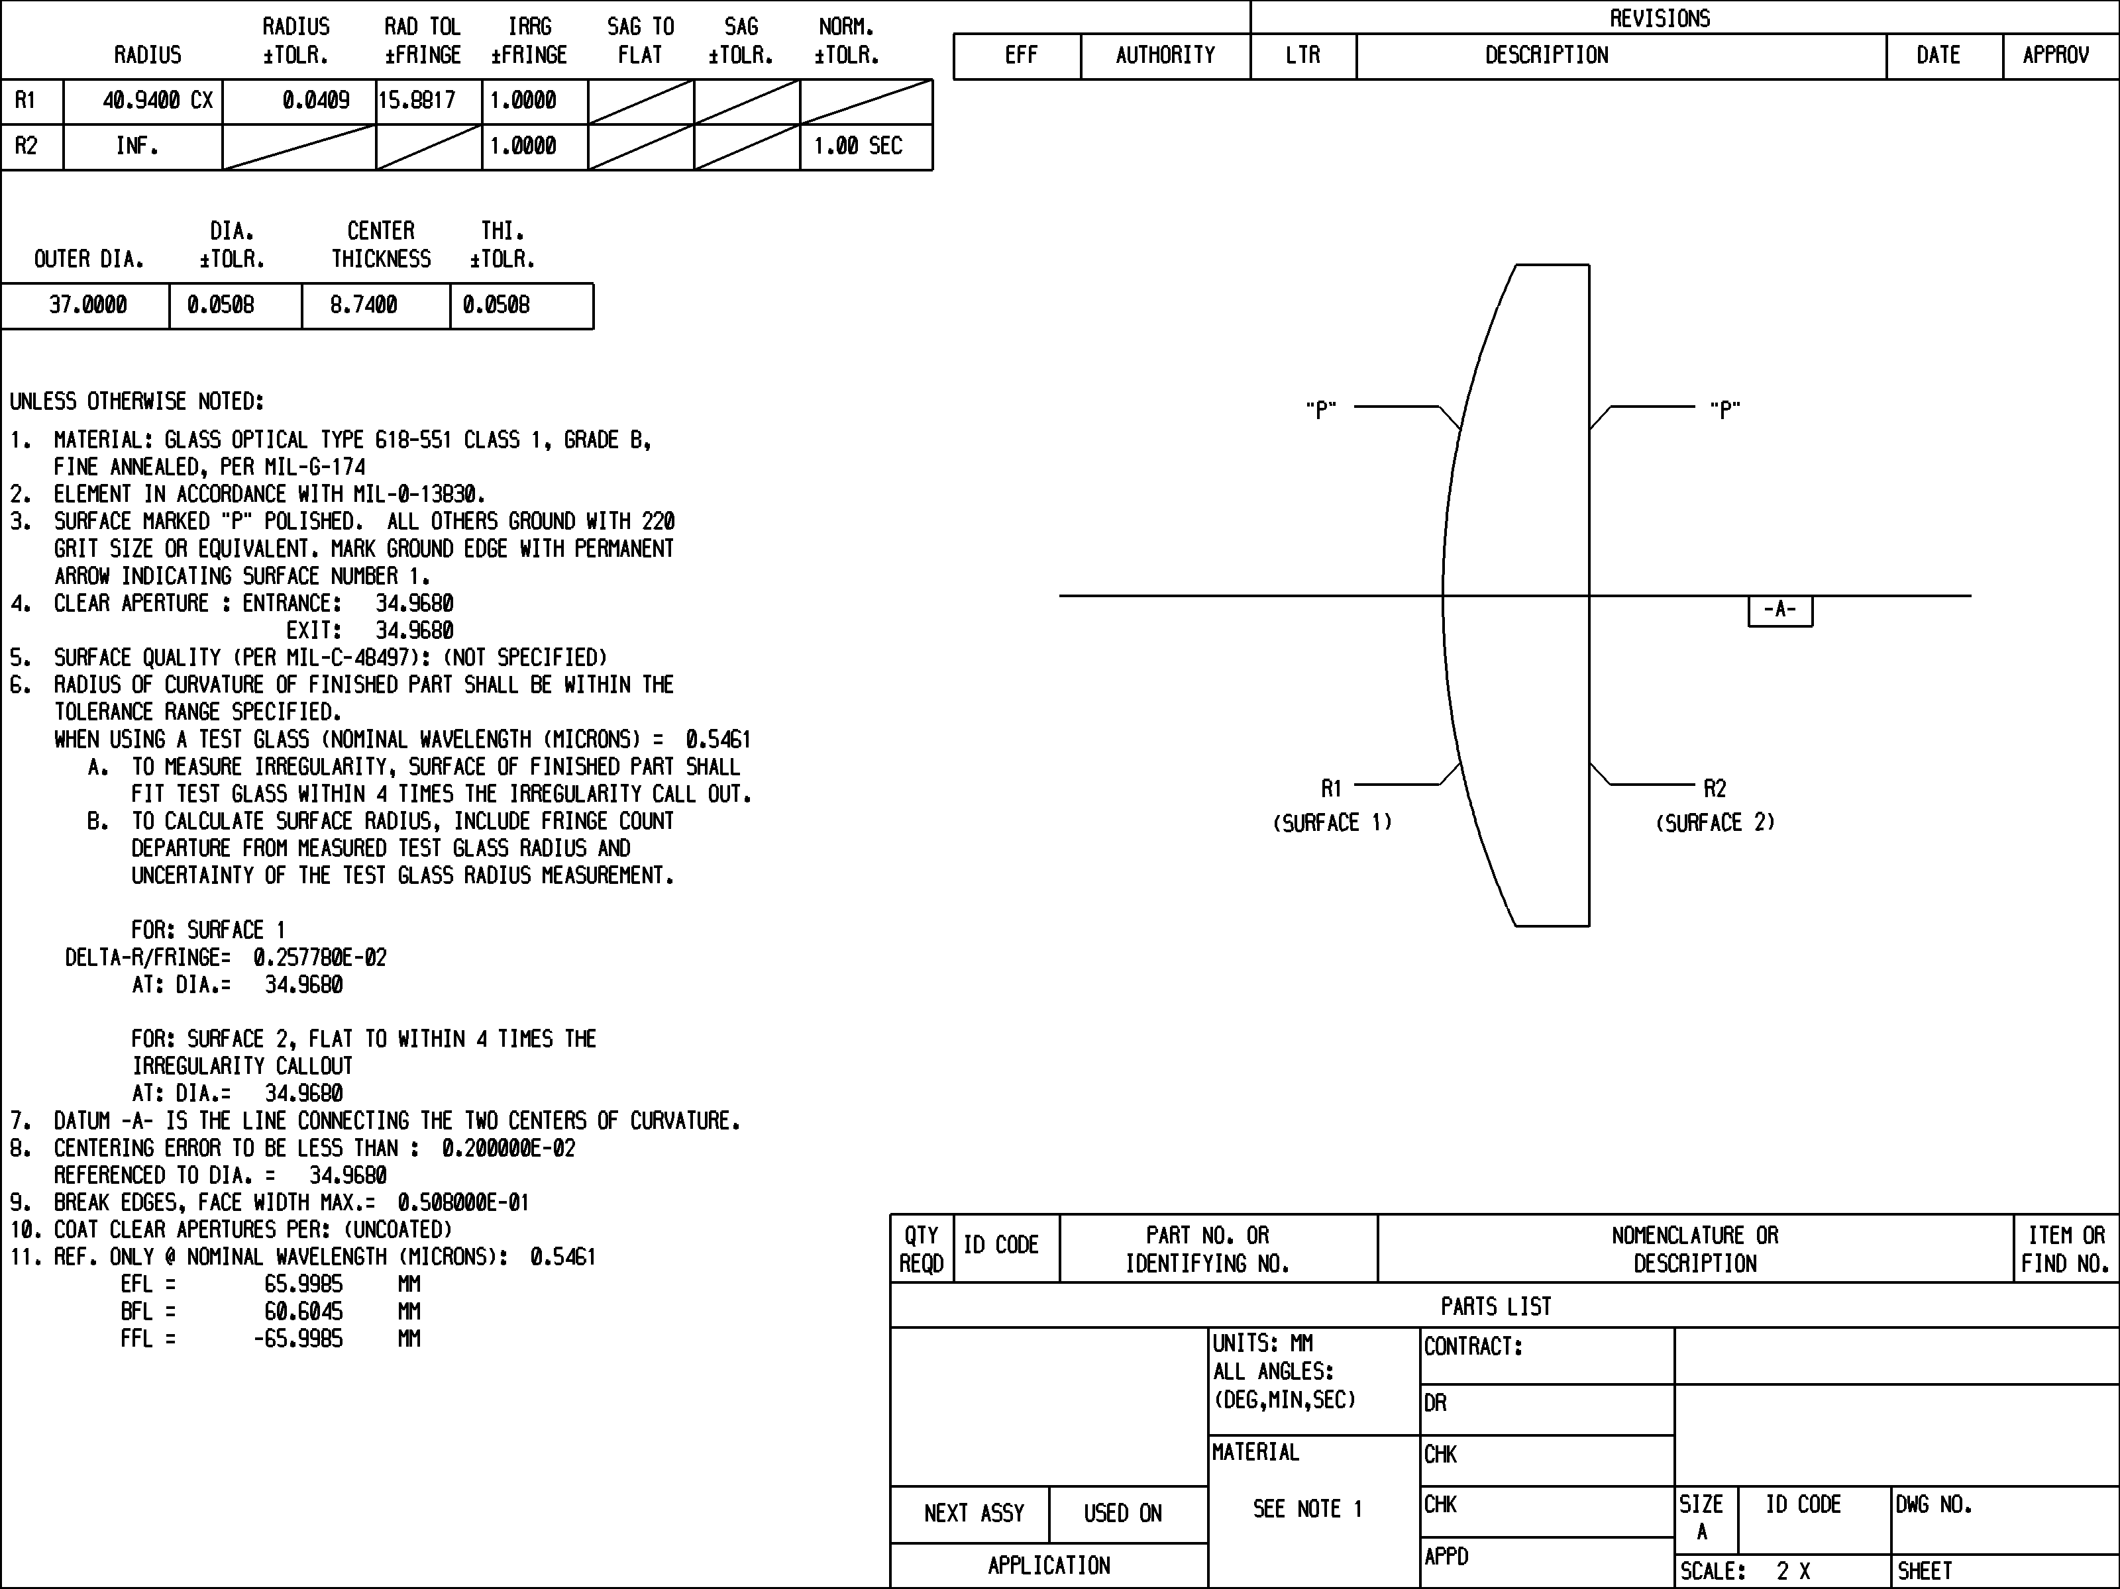

Sample Lens Part Drawing

TEST PLATE FITTING - The test plate fitting of an optical design is one of the more important phases of preparing a design for fabrication. The "TPLATE" command allows the user read/copy access to all currently installed testplate lists.

TPLATE (testplate list name) - The "TPLATE" command causes the built-in full screen edit program to open the designated testplate list. After the list is opened, any testplate radius may be copied into the Windows Clipboard and later pasted into the program command line as input to a "TESTRD" or "TESTCYL" command. Issued with the "?", the currently available testplate list names are displayed. Issued with the "LIST" qualifier, the command causes the names of the current testplate lists to be displayed along with their associated qualifier words.

TESTRD , surf# , testplate radius value - The "TESTRD" command causes surface designated by "surf#" to have its radius of curvature set to the "testplate radius value in millimeters". If the current lens database units are not millimeters, then the input testplate radius value will be converted from millimeters to the current lens database units and then assigned to the lens surface. Before the assignment is made, any curvature solve or pikup which would control the radius is removed. If the surface curvature is a current variable, that variable is removed from the variables list.

TESTCYL , surf# , testplate cylinder radius value - The "TESTCYL" command causes surface designated by "surf#" to have its toric radius of curvature set to the "testplate cylinder radius value in millimeters". If the current lens database units are not millimeters, then the input testplate cylinder radius value will be converted from millimeters to the current lens database units and then assigned to the lens surface. Before the assignment is made, any curvature solve or pikup which would control the toric radius is removed. If the surface toric curvature is a current variable, that variable is removed from the variables list.

All testplate values in the testplate databases are expressed in millimeters. Make sure to convert these units into the units being used in the lens database being testplated.

