INTRO1-GENERAL INFORMATION - This program is an advanced, interactive optical design and analysis program. It is used in the design and analysis of all forms of optical systems. All titles and some data in tables are shown in BOLD BLUE. The entire text is 9pt. Times New Roman.

INSTALLATION - For information concerning installation on your computer, please refer to the installation instructions provided separately.

GETTING STARTED - This manual is the "PROGRAM REFERENCE MANUAL" accessible from the program Help menu. It completely describes all features and commands. There are two separate "TUTORIAL" manuals, also available in PDF form from the Help menu. There are also "prompting" guides available in the program HELP menu.

CASE SENSITIVITY - All program textual command input is case insensitive. Input may be in upper or lower case. All input is converted to upper case before it is processed. The basic input mode of this program is textual. Menus are provided for the more commonly used features.

COMMANDS - All program commands and some command-like auxilliary words are indicated in this manual in BOLD RED text.

EXAMPLES - All program examples are indicated in this manual in BOLD GREEN text.

GRAPHICAL USER INTERFACE - The program Graphical User Interface is intended to be used by both new users and experienced users, occasional users and regular users, amatuer users and professional users. It provides a powerful sub-set of the command driven capabilities of the program in an intuitive format. It is not intended as a replacement for the command interface and certainly is not a replacement for the macro and scripting capabilities inherent in the command interface. The user is wise to enjoy the GUI and as the occasion permits, explore the command interface. Switching between the two interfaces is as simple as moving the cursor to the command line at the bottom of the main program window and issuing a command followed by the ENTER key.

USER INTERFACE - After installation, a shortcut to the program icon can be made and placed on DESKTOP. When it is double clicked, the program loads and begins to run. The user will see the program output window, below which appears a one line "command box" with a command history option via mouse or up and down arrow keys. All typed input to the program is enetered in that input box. All textual output, which is intended to be displayed to the screen, will be placed in the main output window. This output window automatically scrolls as more and more output is placed in it. At any time, output may be selected with the mouse or by use of the "select all" menu option and copied into the CLIPBOARD or printed. The output window scrolling capacity is only limited by computer memory. The output window history can be cleared at any time issuing the "CLS" command. The selection of some of the menu items causes various program documentation documents to be opened and displayed using Adobe Acrobat Reader. There are command prompting guides, a tutorial, a reference manual and a list of new features in each previous program release dating back to version 4.00in the HELP menu. Hardcopy text output is performed either by copying text from the output window and pasting it into a word processor or by using the "OUTPUT LP" and "PRINT" commands described in the CMD section of this manual. (the "OUTPUT LP" and "PRINT" commands are only available in the distribution of the program which is under full user support). All others will need to copy and paste using the CLIPBOARD. Text output may also be printed using the “PRINT” option in the File Menu.Whenever a command generates screen graphics, those graphics are displayed in a separate window. This window may be moved, re-sized, minimized, maximized or copied into the CLIPBOARD using standard windows techniques. Graphics hardcopy and file output is available via the "GRAOUT" command described in the GRAPHICS section of this manual.

PROGRAM CAPACITIES - The fully supported version of the program, supports lens databases of up to 500 surfaces, 999 macros, each of which may have 1024 macro lines, and 75 alternate lens configurations. These limits can easily be extended should the user require greater capacity.

PROGRAM ORGANIZATION - This program has a command-driven user interface. This choice of interface provides maximum user freedom, speed and control over program execution. Some of the more common program operations are supported in the GUI interface. Program commands may be issued and executed in an immediate interactive mode from the keyboard, they may be strung together in an input data file and read from within the running program or they may be composed into internal macro programs using the built-in macro programming language and editor. Macros can be stored on disk and executed from within the running program at any time. Macro programs (macros and macro functions) can call other macro programs in nests up to 20 levels deep. Once created, these macros look and feel exactly like hard coded program commands. There are also special macro specific commands which enable a macro to be much more than just a string of program commands. Full details are given in the MACRO section of this manual.

ORGANIZATION OF COMMAND INPUT - Program command input is performed through a succession of text commands, each of which may consist of up to 140 characters, including blanks. All program commands will have one of the following formats:
1) Command Word
2) Command Word + Qualifier Word
3) Command Word + Alphanumeric String
4) Command Word + Qualifier Word + Alphanumeric String
5) Command Word + from 1 to 5 Numeric Words
6) Command Word + from 1 to 5 Numeric Word + Alphanumeric String
7) Command Word + Qualifier Word + from 1 to 5 Numeric Words
8) Command Word + Qualifier Word + from 1 to 5 Numeric Words + Alphanumeric String
9) Command Word + ? (special interrogator character)
10) Command Word + Qualifier Word + ? (special interrogator character)

All commands MUST ALWAYS begin with a COMMAND WORD.

COMMAND AND QUALIFIER WORDS - Command and qualifier words may consist of up to eight alphanumeric or other special characters, except the characters ";" and ",". The use of ";" will be covered later. The comma "," and the blank " " are used as special command delimiters and may not be part of the input, except when they appear as part of an alphanumeric string once that string has begun. The command word is always the first entry on a command line. Macro names follow the same rules as command words, being limited to 8 characters. The command words and qualifier words may begin with any allowed character. The qualifier word, if specified, always follows a command word. The first character in a command word, qualifier word or macro name may not be a digit (0 through 9), a plus "+" or minus "-" sign, a question mark "?" or a decimal point ".". Leading blanks are discarded.

NUMERIC WORDS (NUMERIC INPUT - Up to five numeric words may be used in a single program command, though many commands do not use all five words. Each numeric word may be represented by no more than 23 characters, including a decimal point and an "E" or "D" representing exponential notation. Input is otherwise free format. All numeric words are stored internally in double precision. Numeric data is held internally and transferred in a D23.15 format whenever it is written to or read from disk in an ASCII format. If explicit exponential notation is not used, a plus or minus sign can be used to indicate the start of an exponent. If exponential notation is used, a plus sign is optional. A blank following a "D" or "E" is treated as a plus sign. The exponent may contain one to three digits but must not have a magnitude greater than 300. A decimal point may occur anywhere prior to the start of an exponent. In the absence of a decimal point, an implied decimal point is understood to follow the rightmost digit before the exponent. Leading plus signs are optional.

SPECIAL CHARACTER (" ; ") - The semicolon " ; " character is used as a virtual carriage return. It allows for up to 20 program commands to be issued per 140-character input line. This character can be issued from any program level, including from within the macro editor. It is ALWAYS executed immediately. The semicolon is not available as part of string input. Use a comma instead.

THE ALPHANUMERIC STRING - Alphanumeric string input can consist of up to eighty (80) alphanumeric or special characters, excluding ";". Alphanumeric strings may be input as upper or lower case. In the case of the comment and message commands ("C" and "M"), the case of the input is remembered. For all other program commands, program input is automatically converted to upper case before being processed by the main program input parser.

SEPARATORS - A command word and a qualifier word may be separated from one another by one to eight blank spaces. A command word or a command word/qualifier word pair may be separated from the first numeric word by either one to eight blank spaces, a comma or a comma and one to eight blank spaces. Default numeric input is always indicated by no numeric input word or by a succession of commas. The formal rule for separating a command word or a command word/qualifier word combination from a following alphanumeric string is to use a blank space or a comma following the command word or command word/qualifier word pair. This space or comma is then followed by the alphanumeric string. The result of using ,, to specify default input varies from command to command.

COMMAND EXAMPLES
1) WRITE - (Command Word)
2) WRITE ALL - (Command Word + Qualifier Word)
3) SET , 25.4 - (Command Word + Numeric Word #1)
4) SET A 25.4 - (Command Word + Qualifier Word + Numeric Word #1)
5) M, THE ANSWER IS WRONG - (Command Word + Alphanumeric String)
6) NSUB DV , 12.3 , 4.5 , 6.0,,, - (Command Word + Qualifier Word + Numeric Input with default values for numeric words 4 and 5)

COMMAND DESCRIPTIONS - Program commands are always shown in upper case. Each command is presented in a command shadowed box followed by a complete description of that command, its use and its effects. In a textual reference, commands are delimited by double quotation marks. For example, the command which lists all of the surface data in the current lens would be denoted in text by "RTG ALL". Minimum use of command shorthand will be used in this manual to denote required versus optional input. If a particular input to a command is optional, that fact is simply stated in the description which follows the command box. An attempt has been made to write this manual in simple, plain Engish.

PROGRAM PROMPT - When operating in the command interface mode,the program screen prompt is a three-character string followed by a colon ":". At this prompt, commands may be typed in followed by the press of the <ENTER> key. The three-character string preceding the colon indicates the current program level. The program levels corresponding to the various prompts are listed in the following table.

PROMPT CHARACTER STRING | PROGRAM LEVEL
CMD | MAIN or COMMAND
SPE | SPECTRAL ANALYSIS
MAC | MACRO INPUT
MED | MACRO EDIT (MEDIT)
LEN | LENS INPUT
ULN | LENS UPDATE
SPS | SPECIAL SURFACE (SPSRF)
USP | UPDATE SPECIAL SURFACE
FIT | SPECIAL FUNCTION FITTING
CFG | CONFIGS INPUT
UCF | UPDATE CONFIGS
MER | MERIT FUNTION INPUT
UMR | UPDATE MERIT FUNCTION
VAR | VARIABLES INPUT
UVB | UPDATE VARIABLES
TVB | TOLERANCE VARIABLES INPUT
UTV | UPDATE TOLERANCE VARIABLES
CMP | COMPENSATION VARIABLES INPUT
UCP | COMPENSATION VARIABLES UPDATE
TOP | TOLERANCE OPERAND INPUT
UTP | TOLERANCE OPERAND UPDATE
FOC | FOCRIT (FOCUS CRITERIA) INPUT
UFC | FOCRIT UPDATE

PROGRAM ORGANIZATIONAL STRUCTURE - The organizational structure of the program is conceptually very simple. When the program begins running, a prompt symbol will be displayed on the computer screen. At this prompt, you enter a program command and press the <RETURN> or <ENTER> key on the keyboard. Depending on the nature of the command issued, some action will be taken by the program. This action may or may not result in output. When the program begins, it is always at the CMD level. This is the main, or top, level of the program. Beneath this level are sub-levels which are used to manage the lens data, optimization files, tolerancing, macro programming, etc. The organizational flow of the program is best understood by examining the figure below. Solid lines represent paths along which the user travels while using the program. Dashed lines represent internal automatic data flow during program operation.

Program Road Map

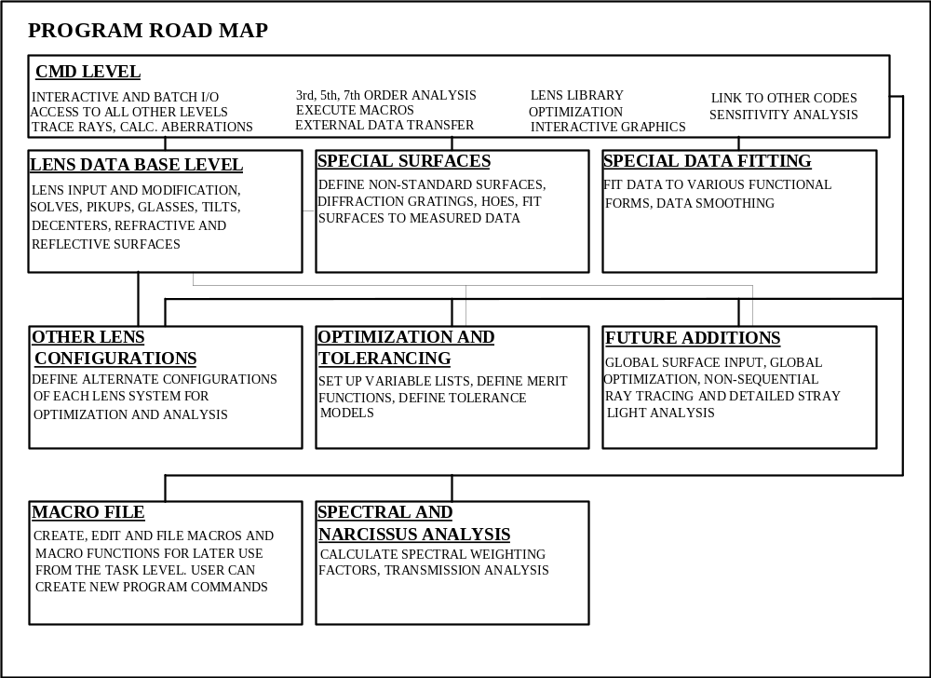

PROGRAM DISK DIRECTORY STRUCTURE - During the program installation process, the root or main directory is created on the target disk drive. A default root directory name is supplied if you do not specify one. Several sub-directories are created beneath the main directory. These directories house the following classes of files:

DIRECTORY NAME | FILE CLASSES STORED
\LIBSPO | All the files associated with ray spot diagrams.
\LIBAUT | All the files associated with the optimization process.
\LIBGLA | All of the optical material glass catalogs are stored here in binary and ASCII format. Located here are the .EXE files which rebuild a binary glass catalog file from the ASCII version. This allows the user to update the glass catalogs. The procedure for doing this update is described in the file GLAUP.DOC which is also stored in this directory.
\LIBLxx (These are the directory names of the manufacturer lens libraries.) | All the files associated with the lens manufacturer lenses are stored in these directories.

PROGRAM FILES - The following files are stored in the main program directory or in one of its sub-directories:

PRINTER.TXT | Printer file created by the program.
PUNCHFILE.DAT | Auxiliary data transfer file created by the program.
CARDTEXT.DAT | Auxiliary data transfer file created by the program.
EDITTEXT.DAT | Editor file used with a DOS editor and the "EDIT" command.
DEFAULTS.DAT | A user-created file containing program commands which the user wishes to run automatically when the program starts. The commands included in the default version of this file are: "OUT TP" and "IN TP" .
TAB.DAT | Table Writer file
DATA.DAT | Functional fitting data file
SPD.DAT, LSF.DAT | MTF, Line Spread Function files
RAYS.DAT, FIELDS.DAT | Field and ray definition files
AUTO.DAT, AUTO2.DAT | Optimization save files
OPDDAT.DAT | OPD fitting files
APMAP.DAT | Pupil apodization file
FOOT1.DAT | Beam footprint file

BATCH MODE OPERATION - The program is primarily intended to be used in an interactive setting. There are; however, situations where the program may need to be run in a BATCH mode. To do this, prepare an ASCII file named BATCH.DAT which contains all of the program commands which are to be executed. Place it in the main program directory. Include an "EXIT" statement as the last entry in this file. Next, either type "PRG BATCH" at the DOS command prompt or at the RUN line. The program will execute all of the commands in the BATCH.DAT file.

THE PROGRAM AS A SUBROUTINE - In some special situations, the program may be available as a callable subroutine. If you don't have the program in that form, then you probably are not going to get the program in that form. When the program is callable as a subroutine, all screen input and output operations are turned off. Graphics output is limited in that no program manipulation of the NEUTRAL.DAT file is possible via the VIE and GRAOUT commands. No operating system commands can be executed in this mode from inside the program. All such actions are to be programmed by the user in non-program related subroutines. When the program is run as a subroutine, it automatically runs in the above described BATCH mode.

OPTICAL DEFINITIONS - The following section has been asked for by several users. It is intended to provide a short review of the "optical definitions" assumed by the program.

Local Optical Axes - The program assumes, at the origin or "vertex" of every surface in a lens prescription, that there exists a right handed rectangular "local" coordinate system. In the absence of surface tilts and decentrations, the positive local Z-axis is perpendicular to the surface and points to the right. The positive Y-axis is "up" and the positive X-axis is "into" the page or screen.

Sequential Database - The pth of rays traced through lens database sequential. From surface 0, "the object surface" to "surface 1" to "surface 2" and to each next surface and then to the final surface in the database. The relative positions of each surface may be established in either a "local" sense or a "global" sense. Most of the time, the "local" sense is the easiest way to establish these relationships. In the "local" sense, surface 1 is positioned relative to surface 0, surface 2 relative to surface 1 and so on. The relative position of a "following" surface is established with a "thickness" or TH specification and by decentration and surface tilt commands relative to the previous surface.

Surface Tilts - A following surface may be reoriented with repect to the previous surface by assigning surface tilts. When this is done, the order in which the tilts are applied is generally ALPHA (about the X-axis), then BETA about the new Y-axis and then GAMMA about the new Z-axis. There are exceptions. The angular sign conventions are such that ALPHA and BETA are left-handed positive and GAMMA is right-handed positive. Figures illustrating these conventions can be found in the Lens Database section of this manual This sign convention agrees with CODE-V and ACCOS-V. In ZEMAX, the ALPHA and BETA sign conventions are right-handed positive.

Paraxial Optical Axis - Paraxial optical ray tracing is the result of a linearization of the trigonometric ray tracing equations in which the SINE and TANGENT of all angles is replace by their angular value in radians and the COSINE is replace by 1.0. The paraxial ray trace ignores surface decentrations and tilts. The paraxial optical axis therefore passes through the center of all lens database surfaces.

Real Optical Axis - The real optical axis has more than one definition depending upon program ray trace settings.

If real ray aiming is turned off with the AIMRAY OFF command (not the default condition), then the real ray optical axis is defined by the path of the ray which originates at the center of the object surface (generally surface 0) and passes through the center of surface 1. The path of this ray, through the rest of the surfaces is considered to be the "gut ray" and defines the optical axis of the system.

If real ray aiming is turned on with the AIMRAY ON command (the default condition), then:

If there is no clear aperture assigned to the "reference surface", the real optical axis is defined by the path of the ray which originates at the center of the object surface (generally surface 0) and passes through the center of the "reference surface". The ray is iteratively aimed during this process. The path of this ray, through the rest of the surfaces is considered to be the "gut ray" and defines the optical axis of the system. The reference surface (see the REFS command) may be assigned to be any surface betweem the object surface and the image surface. In almost all cases, it should be the same surface defined to be the aperture stop (see the ASTOP command).

If there is a clear aperture assigned to the "reference surface", the real optical axis is defined by the path of the ray which originates at the center of the object surface (generally surface 0) and passes through the center of the clear aperture assigned to the "reference surface". The ray is iteratively aimed during this process. This clear aperture may even be decentered and tilted and the ray will still go through the center of the clear aperture. The path of this ray, through the rest of the surfaces is considered to be the "gut ray" and defines the optical axis of the system. The reference surface (see the REFS command) may be assigned to be any surface betweem the object surface and the image surface. In almost all cases, it should be the same surface defined to be the aperture stop (see the ASTOP command).

Real Ray Trace - Real single trigonometric rays are traced with the paradigm of reference object heights (or angles) and reference aperture heights (see the SCY, SCX, SAY and SAX commands). These are single X and Y values are stored with the lens. To specify a location in the object surface from which rays originate, the FOB (Fractional OBject height) command is used to establish a starting point relative to the reference object height (or angle) values. FOB input values may be of any value and are not limited to lie betweem -1 and 1. The RAY command is then used to specify the relative position in the reference surface, vie the reference aperture heights through which a ray will pass (if ray aiming is on) or the relative position in surface 1 if ray aiming is off.

Reflections - Every time a ray strikes and interacts with a reflector, the ray's local n-direction cosine is essentially reversed and the sign of the refractive index is reversed. This is common practice in all optical design programs.

